Original Research Article
Popillia cyanea Hope, 1831 (Coleoptera: Scarabaeidae): A New and Emerging Pest of Cowpea (Vigna unguiculata) in Garhwal range

ABSTRACT
The present study reports the occurrence of Popillia cyanea Hope, 1831 (Coleoptera: Scarabaeidae) feeding on cowpea (Vigna unguiculata L.) for the first time in Uttarakhand, India. Field observations during the 2025 growing season revealed severe defoliation symptoms caused by adult beetles, particularly on flower, young leaves and tender shoots. The infestation was observed in the early morning and late evening hours, with the beetles aggregating in small groups on foliage. Characteristic metallic-green coloration and typical scarab morphology confirmed the species identity. The feeding activity resulted in skeletonized leaves and reduced photosynthetic area, leading to significant growth retardation and yield loss. This finding suggests a shift in host preference and highlights P. cyanea as an emerging pest of economic importance on cowpea in this region. Further investigations on its seasonal incidence, host range, and management strategies are warranted to mitigate future outbreaks.
KeywordsPopillia cyanea, Cowpea (Vigna unguiculata), Defoliation damage, Emerging pest, Uttarakhand
INTRODUCTION
Cowpea (Vigna unguiculata L.) is a highly valued leguminous crop grown extensively across tropical and subtropical regions of the world. It is cultivated for its multipurpose use as a vegetable, pulse, fodder, and green manure crop. In India, cowpea is an integral part of traditional farming systems, particularly in dryland and rainfed areas, due to its ability to fix atmospheric nitrogen, improve soil fertility, and provide nutritious food for humans and livestock. Despite its resilience, cowpea productivity often suffers from several biotic stresses, among which insect pests pose a major challenge to sustainable cultivation.
More than 100 species of insects have been reported to attack cowpea at various growth stages, causing considerable yield reduction. Among these, foliage feeders and pod borers are the most destructive, leading to partial or complete defoliation of plants. The defoliation results in a marked reduction in photosynthetic activity and ultimately affects pod formation and seed filling. Continuous pest incidence throughout the growing season has forced farmers to depend heavily on chemical insecticides, which not only increase production costs but also create ecological and health concerns.Scarab beetles belonging to the genus Popillia (Family: Scarabaeidae, Subfamily: Rutelinae) are known for their polyphagous nature and voracious feeding habit. Adult beetles typically attack the foliage of a wide range of host plants including cereals, ornamentals, fruit trees, and vegetables. The characteristic feeding behavior of Popillia species involves scraping and consuming the leaf lamina, leaving behind only the network of veins, which gives a typical skeletonized appearance to the damaged leaves. The larvae of some species, commonly called “white grubs,” inhabit the soil and feed on plant roots, further aggravating crop losses.
Popillia cyanea Hope, 1831 is a metallic-green scarab beetle widely distributed throughout India and adjoining Southeast Asian countries. It has been observed as a pest of roses, maize, sugarcane, and several ornamental and fruit crops. However, until recently, no published record existed regarding its infestation on cowpea in India. During recent field surveys conducted in cowpea fields of Uttarakhand, adult P. cyanea beetles were observed feeding actively on young leaves and tender shoots, resulting in severe foliar damage. The beetles aggregated in groups during the early morning and late evening hours, indicating a specific feeding rhythm and aggregation behavior.The present investigation has recorded, for the first time, the occurrence of Popillia cyanea feeding on cowpea in Uttarakhand, India. This new host association not only broadens the known host range of the species but also signifies its potential as an emerging pest of economic importance in pulse-based cropping systems. The increasing adaptability of P. cyanea to new hosts highlights the need for systematic monitoring, accurate identification, and the development of eco-friendly management strategies to prevent possible outbreaks in the near future.
MARERIAL AND METHODS
Field surveys were conducted during the kharif season of 2025 in cowpea (Vigna unguiculataL.) fields located at the Genetic and Plant Breeding Research Farm, College of Hill Agriculture, Ranichauri,Uttrakhand and in different cowpea-cultivated plots in nearby localities of the Garhwal region, Uttarakhand, India. The crop was grown under natural field conditions without the application of insecticides. Adult beetles were observed feeding on cowpea foliage and flowers during the early morning and late evening hours. The affected plants exhibited characteristic symptoms of leaf skeletonization, wherein only the network of veins remained intact while the lamina was completely removed. In addition, feeding damage on flower petals and tender buds was also recorded, indicating that the beetles prefer both vegetative and reproductive parts of the plant.
Specimens of the suspected insect were carefully collected using an insect sweep net and preserved in 70% ethanol for laboratory examination. Morphological identification was carried out based on external characters, including body color, elytral pattern, and antennal club structure, following standard taxonomic keys for Scarabaeidae. For confirmation, the collected specimens were submitted to the Zoological Survey of India (ZSI), Kolkata, where the insect was identified and authenticated as Popillia cyanea Hope, 1831 (Coleoptera: Scarabaeidae).
Environmental parameters such as temperature, humidity, and crop stage were recorded at the time of collection. Photographs of both field infestation and adult beetles were taken using a digital camera for documentation. The extent of defoliation and feeding pattern were visually assessed and recorded for qualitative analysis. The collected data were used to describe the nature of damage, host plant association, and behavioral observations of P. cyanea under field conditions.

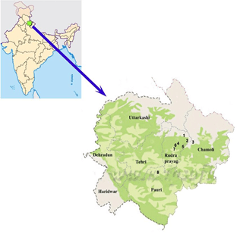 | 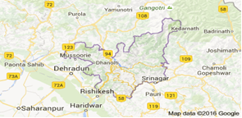
 | 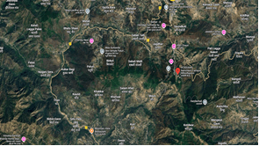
https://www.google.com/maps/place/Ranichauri,+Uttarakhand,+India
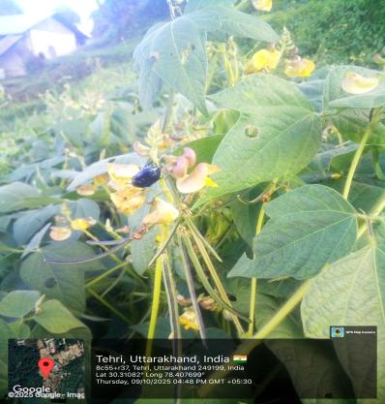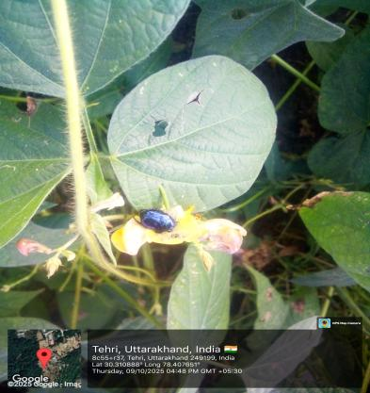
Fig. 1a Fig. 1b
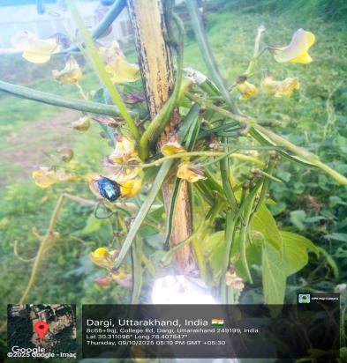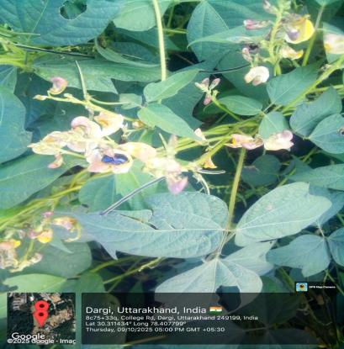
Fig.1c Fig. 1d
Fig 1(a,b,c,d)Adults beetle Popilliacyanea feeding on cowpea

OBSEVATION AND DISCUSSION
During the field survey conducted in cowpea fields of Tehri Garhwal Uttarakhand, adult beetles of Popillia cyanea Hope, 1831 (Coleoptera: Scarabaeidae) were found actively feeding on the foliage and flowers of the crop. The beetles were metallic green with a coppery tinge on the elytra, measuring approximately 10–12 mm in length. They were mostly observed in aggregations on young leaves and tender shoots, showing peak activity during the early morning (6:30–8:00 a.m.) and late evening (5:30–7:00 p.m.) hours.
The characteristic feeding damage appeared as leaf skeletonization, where only the veins of the leaf lamina remained intact while the mesophyll tissue was completely scraped off. The affected leaves turned brown, dried up rapidly, and eventually shed from the plant. In severe infestations, plants exhibited a scorched appearance with considerable loss of foliage, thereby reducing photosynthetic area and affecting plant vigor. In addition to foliage feeding, the beetles were also seen nibbling on the flower petals and tender floral buds, which could potentially interfere with pollination and pod setting.The occurrence of P. cyanea on cowpea marks a new host association for this scarab beetle in India. Previously, Popillia cyanea had been recorded feeding on ornamental plants such as roses, as well as on maize and certain fruit trees. The present finding indicates an expansion of its host range and adaptation to leguminous crops like cowpea. The shift in feeding preference might be associated with the availability of succulent foliage during the monsoon season and the presence of overlapping habitats where cowpea is cultivated near alternate host plants.
Field observations also revealed that adult beetles exhibited a gregarious behavior, feeding collectively on specific portions of the canopy. Such aggregation not only intensifies localized damage but also facilitates mating and subsequent egg-laying in nearby soil. Although larval damage (root feeding by grubs) was not recorded in the present study, it cannot be ruled out in future investigations, since other Popillia species are known to have soil-dwelling larvae that feed on plant roots.The increasing occurrence of P. cyanea in cowpea fields suggests that the species may be in the process of establishing itself as a potential emerging pest of this crop in Uttarakhand. Considering the ecological adaptability of scarab beetles and their polyphagous feeding habits, continuous monitoring is essential to assess their population dynamics, life cycle, and host preference under changing agro-ecological conditions. Integrated pest management (IPM) approaches, including light trapping, conservation of natural predators, and judicious use of eco-friendly insecticides, may be required to prevent the establishment of this pest on a large scale.
CONCLUSION
The present study reports, for the first time, the occurrence of Popillia cyanea Hope, 1831 (Coleoptera: Scarabaeidae) feeding on cowpea (Vigna unguiculata L.) in Uttarakhand, India. Adult beetles were observed causing typical foliar skeletonization and flower damage, resulting in a reduction of photosynthetic surface and potential yield loss. The identification of the species was authenticated by Dr. Devanshu Gupta, Scientist–D and Officer In-Charge, Coleoptera Section, Zoological Survey of India (ZSI), Kolkata.
This new host association broadens the known host range of P. cyanea and highlights its potential as an emerging pest of economic importance in pulse-based cropping systems. The beetle’s polyphagous feeding behavior, adaptability to different ecological conditions, and preference for tender plant parts make it a possible threat to cowpea cultivation in the region.
It is, therefore, essential to undertaken detailed studies on the biology, life cycle, population dynamics, and seasonal abundance of this species. Further, eco-friendly management strategies such as pheromone or light traps, conservation of natural enemies, and use of botanical insecticides should be explored to prevent large-scale infestations. Early detection and timely intervention will be critical in mitigating possible outbreaks of P. cyanea on cowpea and other leguminous crops in the future.
REFERENCES
Ali, M., & Kumar, S. (2006)Pulses: importance, production and constraints. Indian Journal of Pulses Research, 19, 1–13.
Arrow, G. J. (1917)The fauna of British India, including Ceylon and Burma: Coleoptera Lamellicornia (Part II). Taylor and Francis, London.
Atwal, A. S., & Dhaliwal, G. S. (2009)Agricultural pests of South Asia and their management. Kalyani Publishers, New Delhi.
Balthasar, V. (1963)Monographie der Scarabaeidae und Aphodiidae der palaearktischen und orientalischen Region. Prague.
Bindra, O. S. (1968)Insect pests of pulse crops in India. Indian Farming, 18, 12–15.
Chandra, K., Gupta, D., & Uniyal, V. P. (2015)Scarabaeidae (Coleoptera) of Uttarakhand, India. Journal of Threatened Taxa, 7, 6981–6995.
Dhaliwal, G. S., Jindal, V., & Dhawan, A. K. (2010)Insect pest problems and crop losses: Changing trends. Indian Journal of Ecology, 37, 1–7.
Hope, F. W. (1831)Descriptions of new species of Coleoptera. Zoological Miscellany, 1, 1–34.
Jackai, L. E. N., & Daoust, R. A. (1986)Insect pests of cowpeas. Annual Review of Entomology, 31, 95–119.
Kumar, R., & Lal, S. S. (1996)Feeding behavior and damage potential of scarab beetles. Indian Journal of Entomology, 58, 345–352.
Pathania, M., & Chandel, R. S. (2018)Scarab beetles as emerging pests in agro-ecosystems. Indian Journal of Entomology, 80, 1011–1022.
Potter, D. A., & Held, D. W. (2002)Biology and management of the Japanese beetle. Annual Review of Entomology, 47, 175–205.
Sharma, H. C. (2010)Cowpea insect pests and their management. Journal of SAT Agricultural Research, 8, 1–8.
Singh, S. R., Jackai, L. E. N., Dos Santos, J. H. R., &Adalla, C. B. (1990)Insect pests of cowpea. In Insect pests of tropical food legumes (pp. 43–89). John Wiley & Sons.
Sreedevi, K., & Reddy, D. J. (2013)Seasonal incidence of defoliator pests in cowpea. Legume Research, 36, 263–267.

