Original Research Article
Role of Maize Silk in Host Plant Resistance to Fall Armyworm: Evidence from Survival and Developmental Bioassays

Abstract
Maize (Zea mays L.) is a globally important cereal crop whose productivity is severely constrained by FAW (Spodoptera frugiperda J.E. Smith), a destructive and invasive pest. Host plant resistance offers an eco-friendly and sustainable approach for its management, and antibiosis plays a crucial role by adversely affecting insect growth and reproduction. The present study evaluated the antibiosis component of resistance in selected maize genotypes at the R3 stage (silking) under controlled laboratory conditions. Silk tissues collected 10–12 days after silking were offered to neonate larvae, and their effects on survival and development were assessed by recording larval survival percentage, larval weight and duration, pupation percentage, pupal weight and duration, adult emergence, adult longevity, and fecundity. Significant differences were observed among the genotypes, reflecting variability in their resistance responses. Resistant genotypes (MIL 9-1230, MIL 9-1309, MIL 9-1308) (R) exhibited reduced larval survival, prolonged development, lighter larval and pupal weights, and lower adult emergence and fecundity, indicating strong antibiosis effects. Moderately resistant genotypes (MIL 9-1179, MIL 9-1260) (MR) expressed intermediate levels of resistance, while susceptible genotypes (Sarhad HSRB, VS 144) (S) supported higher larval survival, rapid development, heavier pupae, and greater fecundity. These results clearly demonstrate that silk tissues play an important role in mediating resistance and that genotypic variation exists in antibiosis expression against FAW. The identification of resistant and moderately resistant genotypes provides valuable sources for breeding programs aimed at developing cultivars with durable resistance, thereby contributing to sustainable management of this invasive pest.

Introduction
Maize (Zea mays L.) is a vital cereal crop worldwide, valued for its diverse applications in food, livestock feed, fodder, and recently in the ethanol industry. It is cultivated in 170 countries, in an area of 203.47 million hectares, with a production of 1,163.50 million metric tons per year (FAOSTAT 2023). India stands fourth in terms of area and fifth in production, with 35.67 million metric tons from 11.30 million hectares and an average yield of 3.3 metric tons per hectare (APEDA 2024). Despite its global significance, maize production is heavily influenced by various biotic and abiotic stresses. Among them, FAW is a major invasive insect pest in African and Asian countries and has emerged as a significant threat to food and nutritional security.
While most resistance studies against FAW have focused on leaf tissues, reproductive systems like maize silks are important but understudied. Silks serve an important function in fertilization and kernel set, but they are also highly susceptible to larval feeding. Damage to silks can impair pollination, diminish seed formation, and enhance subsequent ear infestation, all of which contribute to yield loss. Maize silk display host plant resistance, which has the potential to protect reproductive success and yield stability.
Previous research has shown that the biochemical and morphological properties of silks can affect insect survival and development. Maysin, a flavone glycoside found in silk, has antibacterial efficacy against the corn earworm (Helicoverpa zea) and FAW (Waiss et al., 1979). Similarly, resistance mechanisms in some maize lines have been related to silk features such tight husks, elongated silk channels, and high silk wetness, which limit larval nutrition and access into developing ears (Wiseman et al., 1977; Wiseman et al., 1981). Wiseman and Widstrom (1986) also discovered that ear-feeding pests prefer and perform better on resistant silk tissues, highlighting the importance of reproductive structures in plant defense.
Despite these findings, subsequent assessments of FAW-resistant cultivars indicated that resistance in leaves is not always expressed in silks, implying that tissue-specific defense mechanisms may differ between genotypes (Nuambote-Yobila et al., 2023). This information gap underlines the necessity for more targeted research into maize silk to better understand their role in host plant resilience.
The present study aims to evaluate the survival and developmental parameters of FAW larvae fed on silks of diverse maize genotypes. By specifically assessing silk tissues, this work provides insights into the genotypic variability of resistance expression and contributes to breeding strategies for developing maize cultivars with enhanced resilience against FAW at reproductive stages.

Materials and methods:
Study area
The field experiments were carried out in well-drained black loamy soil at the Winter Nursery Centre (WNC), ICAR-Indian Institute of Maize Research, Hyderabad (17.3254N, 78.4004E, and 527-meter MSL), India. The mean maximum and minimum temperatures recorded at WNC during the experimental period were 32◦C and 15◦C, respectively.

Rearing of FAW culture
Neonate FAW larvae were collected from diseased maize plants at the Winter Nursery Centre, Hyderabad, India, to generate an initial lab culture. The larvae were raised under controlled conditions, including a 16-hour light/8-hour dark photoperiod, a temperature of 28 ± 1 °C, and a relative humidity of 65 ± 10%. During the first five days, larvae were kept in groups of 50-100 in plastic jars with a 2-3 mm layer of chickpea flour, a casein-based artificial diet (Singh and Rembold, 1992). Following this initial stage, the larvae were individually transplanted to 12-well plates (Hi-Media) to avoid cannibalism, with each well measuring 2.5 cm in diameter and 2.3 cm in depth, and raised until pupation. Pupae were arranged in clusters of 25-50 in plastic jars filled with soil. Upon adult emergence, 10 pairs of FAW moths were released into oviposition cages measuring 30 × 23 cm (length × diameter) and provided with a 10% honey solution on a cotton swab for feeding. Blotting paper strips were suspended inside the cages as oviposition substrates, replaced daily, and the eggs collected were sterilized with a 10% formalin solution. The sterilized eggs were allowed to hatch, and the neonate larvae were transferred to plastic jars containing the artificial diet using a hairbrush. These laboratory-reared neonate larvae were subsequently utilized for artificial infestation in the screening experiments.
Plant Material and Genotypes
A total of seven maize genotypes were used for the antibiosis experiment. These genotypes were not chosen at random but were selected based on an initial screening for FAW resistance at the seedling and vegetative stages. The selection was made to represent both resistant, moderately resistant and susceptible responses observed during preliminary evaluations. The selected genotypes included MIL 9-1230, MIL 9-1308, and MIL 9-1309 (which were identified as resistant in earlier screening and VS 144, Sarhad HSRB, MIL 9-1179, and MIL 9-1260 (which were identified as susceptible or moderately susceptible). The genotypes were raised under controlled conditions, and maize silk tissues were collected at R3 (silking) stage for laboratory bioassays.

Effect of selected genotypes on the subsequent survival and development of FAW
To assess the antibiosis component of resistance to FAW under controlled laboratory conditions, plants were grown in the field. This experiment specifically focused on the R3 stage (silking stage) of the tested maize genotypes. For each petri dish, one neonate larva was released on silk using a camel hair brush. The silk tissue was collected at 10-12 days after silking of each genotype kept in plastic rearing jars. The effect of silk on the survival and development of FAW was also evaluated. The silk was changed once in two days. There were a total of 20 petri dishes per replication, and the experimental design followed a completely randomized layout with five replications. To maintain optimal conditions, the silk was changed every two days, and any insect faeces and exuviae were promptly removed to uphold aseptic conditions within the petri dish. The assessment involved recording various biological attributes, including the percent larval survival after 10 days from the initial release, larval weight (mg), larval period (days), percent pupation (%), pupal weight (mg), pupal period (days), percent adult emergence (%), adult longevity (%), and fecundity. This comprehensive approach aimed to provide insights into the antibiosis resistance mechanism against FAW, with a focus on understanding how the tested maize genotypes affected key life cycle stages and biological attributes of the FAW larvae under these controlled laboratory conditions.
Statistical analysis
The data collected from the tested maize genotypes were subjected to analysis of variance (ANOVA) in a completely randomized design (CRD) using SAS version 9.3. The significance of differences between treatment means was judged by using Tukey's HSD test at P≤0.05.

Effect of silk tissues of selected maize genotypes on survival and development of FAW.
The average larval weight of FAW varied significantly when fed on silk tissues of different maize genotypes, ranging from 38.85 mg/larvae (MIL 9-1230) (Figure 1) to 86.03 mg/larvae (VS 144) (Table 1). Specifically, when compared to other genotypes, FAW larvae, when reared on silk of two genotypes, viz.MIL 9-1308 and MIL 9-1309, exhibited significantly lower larval weights, with mean values of 43.27 mg and 39.12 mg, respectively. In contrast, two genotypes, viz., Sarhad HSRB and VS 144, showcased higher mean larval weights of 74.06 mg and 86.03 mg, respectively, compared to other genotypes. The remaining genotypes, MIL 9-1260 and MIL-9-1179, displayed average larval weights ranging between 79.25 mg and 69.94 mg/larvae. The analysis of variance revealed significant differences among the genotypes (F =11.62, HSD = 27.15, p =<0.0001), confirming the observed variation in larval weight across different maize genotypes.
The mean larval period of FAW larvae varied across different maize genotypes and varied from 21.10 days (MIL 9-1260) to 24.00 days (MIL 9-1230) (Table 1). Notably, FAW exhibited a significantly prolonged larval period of 24.00 days, 23.00 days, and 24.10 days when fed on three genotypes, viz., MIL 9-1230, MIL 9-1308, and MIL 9-1309, respectively, compared to other genotypes. Conversely, two genotypes, viz., Sarhad HSRB and VS 144, showcased lower mean larval periods of 23.20 days and 21.86 days, respectively, compared to other genotypes. The remaining genotypes, MIL 9-1179 and MIL 9-1260, displayed an average larval period of 23.00 days and 21.10 days, respectively. The analysis of variance revealed no significant differences among the genotypes (F =3.43, HSD = 2.66, p =0.0137).
The mean percentage of FAW larval survival varied among different maize genotypes, ranging from 64.06% (MIL 9-1230) to 85.00% (MIL 9-1179) (Table 1). Significantly lower percentages of larval survival of 64.06% was observed when larvae fed on MIL 9-1230 compared to other genotypes. In contrast, two genotypes, viz. VS 144 and MIL 9-1179 showcased higher mean percentages of larval survival, which were 77.00% and 85.00%, compared to other genotypes. The remaining genotypes, MIL 9-1260 and Sarhad HSRB, displayed an average percentage of larval survival of 74.00%. The analysis of variance revealed significant differences among the genotypes (F =11.12, HSD = 8.59, p<0.0001), confirming the observed variation in larval survival across different maize genotypes.
The mean pupal weight of FAW larvae varied across different maize genotypes, ranging from 63.40 mg (MIL9-1230) to 101.28 mg (Table 1). Specifically, two genotypes, viz MIL 9-1230 and MIL 9-1308, exhibited significantly lower pupal weights, with mean values of 63.40 mg and 64.27 mg, respectively, compared to other genotypes. The pupal weight of FAW larvae fed on the remaining genotypes, Sarhad HSRB and VS 144(Plate 1) is 83.30 mg and 84.26 mg/pupae, respectively. The analysis of variance revealed significant differences among the genotypes (F =11.29, HSD = 19.41, p=<0.0001), confirming the observed variation in pupal weight across different maize genotypes.
The mean pupal period of FAW larvae varied across different maize genotypes, ranging from 5.40 days (MIL 9-1308) to 7.40 days (MIL 9-1230) (Table 1). Notably, two genotypes, viz MIL 9-1230, and MIL 9-1260, exhibited significantly higher pupal periods of 7.40 days, and 7.20 days, respectively. In contrast, genotype, viz., MIL 9-1179 showcased a lower mean pupal period of 6.40 days, respectively. The pupal period of FAW larvae fed on the remaining genotypes VS 144 and Sarhad HSRB were 7.00 and 6.80 days. The analysis of variance revealed significant differences among the genotypes (F =4.42, HSD = 1.47, p=<0.0001), confirming the observed variation in the pupal period across different maize genotypes.
The mean percentage of pupal survival for FAW larvae varied among different maize genotypes, ranging from 64.06% (MIL 9-1230) to 85.00% (MIL9 -1179) (Table 1). Significantly lower percentages of pupal survival of 64.06% was observed when larvae fed on MIL 9-1230 compared to other genotypes. In contrast, two genotypes, viz. VS 144 and MIL 9-1179 showcased higher mean percentages of pupal survival, which were 77.00% and 85.00%, compared to other genotypes. The remaining genotypes, MIL 9-1260 and Sarhad HSRB, displayed an average percentage of larval survival of 74.00%. The analysis of variance revealed significant differences among the genotypes (F =11.12, HSD = 8.59, p<0.0001), confirming the observed variation in larval survival across different maize genotypes.
The mean adult emergence of FAW larvae varied across different maize genotypes, ranging from 1.40 days (MIL 9-1230) to 3.80 days (MIL 9-1179) (Table 1). Notably, three genotypes, viz., MIL 9-1230, MIL 9-1308, and MIL 9-1309, exhibited significantly lower adult emergence, with mean values of 1.40 days,2.40 days, and 2.60 days, respectively, compared to other genotypes. Conversely, genotype (MIL 9-1179) showed higher longevity, 3.80 days. The adult emergence of FAW larvae fed on the remaining genotypes viz., Sarhad HSRB and VS 144, showed moderate mean adult emergence, with values of 3.60 days and 3.40 days, compared to other genotypes. The analysis of variance revealed significant differences among the genotypes (F =11.18, HSD = 1.15, p <0.0001), confirming the observed variation in mean adult emergence across different maize genotypes.
The mean percentage of adult emergence for FAW larvae varied across different maize genotypes, ranging from 44.34% (MIL 9-1308) to 65.77% (MIL 9-1179) (Table 1). Specifically, three genotypes, viz., MIL 9-1230, MIL 9-1308, and MIL 9-1309, exhibited significantly lower percentages of adult emergence, with values of 45.39%, 44.34%, and 46.8%, respectively, compared to other genotypes. In contrast, two genotypes, viz. MIL 9-1179 and MIL 9-1260 showcased higher mean percentages of adult emergence, 65.77% and 59.54%, respectively, compared to other genotypes. The percentage of adult emergence for FAW larvae fed on the remaining genotypes, VS 144 and Sarhad HSRB, is 58.56% and 55.83%, respectively. The analysis of variance revealed significant differences among the genotypes (F =7.93, HSD = 13.43, p<0.0001), confirming the observed variation in percent adult emergence across different maize genotypes.
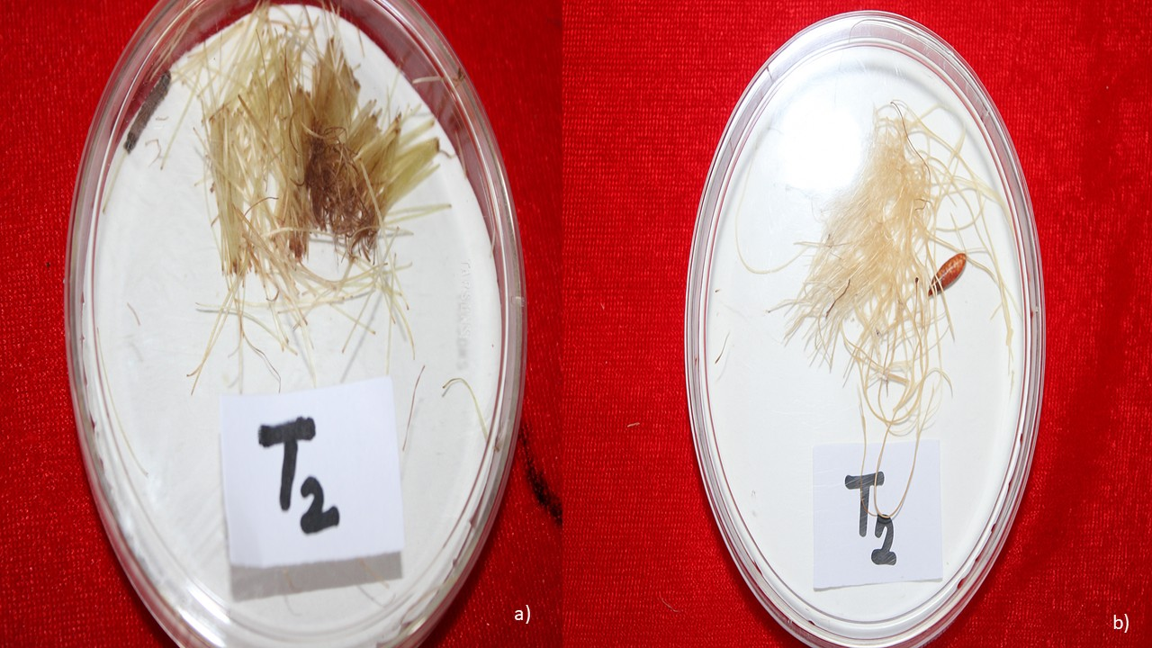
b)
a))
Figure 1 : Larva (a) and pupa (b) fed on silk tissues of genotype MIL 9-1230
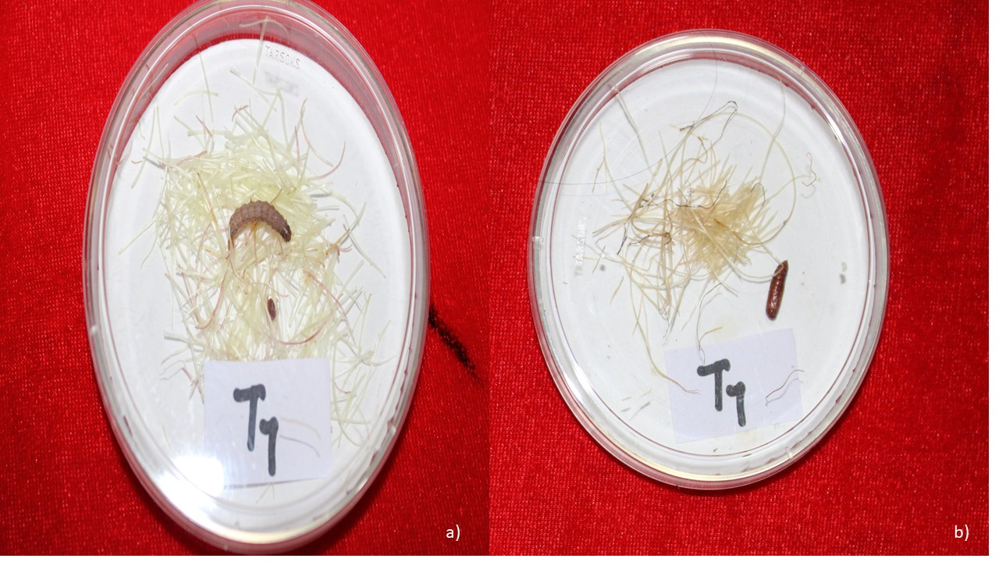
Figure 2 Larva (a) and pupae (b) fed on silk of genotype VS 144
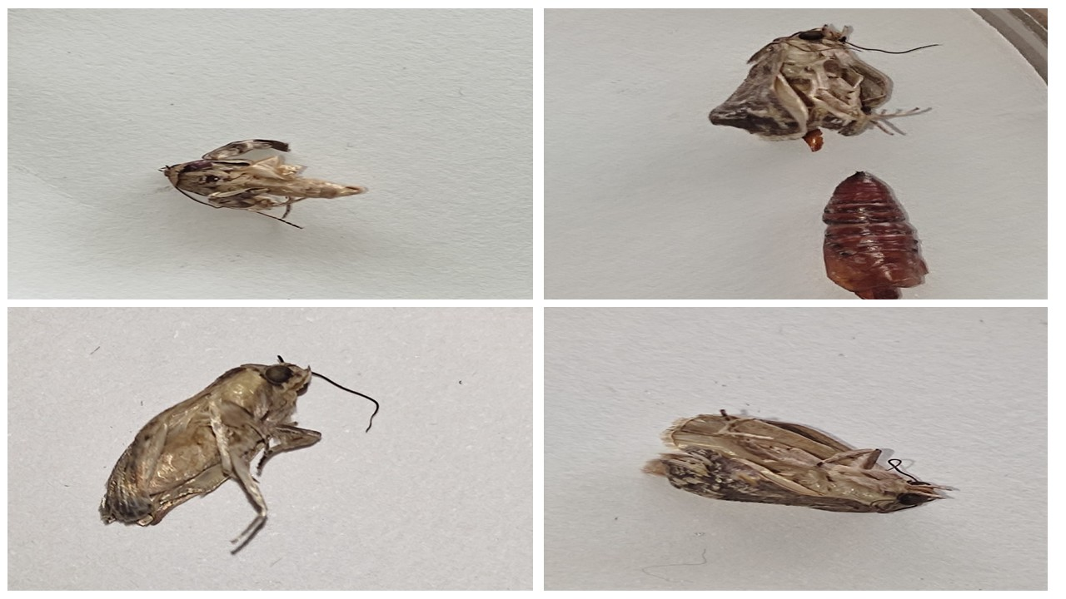
Plate 1 : Malformed adults when fed on resistant genotypes.

Discussion
The present study demonstrated significant variation in the antibiosis effects of maize silks on the survival and development of FAW larval weight, developmental duration, pupal weight, adult emergence, and fecundity differed considerably among genotypes, indicating that silk tissues contribute to differential resistance expression. Specifically, genotypes such as MIL 9-1230, MIL 9-1308, and MIL 9-1309 adversely affected larval performance by reducing larval weight, prolonging the larval period, and lowering pupal survival and adult emergence. Conversely, genotypes such as VS 144, Sarhad HSRB, and MIL 9-1179 supported higher larval survival and development, suggesting that their silks are more favorable for FAW growth and thus exhibit little to no antibiosis.
These findings corroborate earlier reports that maize silks can significantly influence lepidopteran pest biology. Waiss et al. (1979) identified maysin, a flavone glycoside in maize silks, as a key biochemical factor conferring antibiotic effects against the corn earworm (Helicoverpa zea). High maysin concentrations were associated with reduced larval growth and survival, which is consistent with the reduced FAW performance observed on resistant genotypes in this study. Similarly, Wiseman et al. (1977, 1981) and Wiseman & Widstrom (1986) demonstrated that silk tissues from resistant maize genotypes, including Zapalote Chico, reduced larval feeding and development of ear-feeding pests. The extended larval duration and reduced pupal weights observed in our resistant genotypes align with the antibiosis effects reported in these earlier studies.
In addition to biochemical defenses, morphological attributes of silk tissues have been implicated in resistance. Traits such as tight husks, elongated silk channels, and greater silk density can physically hinder larval entry and feeding (Wiseman et al., 1977). While such traits were not directly measured in the present study, the observed differences in FAW performance across genotypes may reflect an interplay of both biochemical and structural defenses in silks.
In our study, resistant genotypes such as MIL 9-1230 and MIL 9-1308 exhibited strong antibiosis in silks, whereas susceptible genotypes like VS 144 and Sarhad HSRB supported high larval growth and survival. Interestingly, not all genotypes that showed resistance in leaves expressed resistance in silks, echoing the results of Nuambote-Yobila et al. (2023), who reported that silk tissues may not always reflect the antibiosis and antixenosis observed in vegetative tissues. This highlights the tissue-specific nature of maize defense responses and underscores the importance of incorporating silk resistance into breeding programs aimed at comprehensive protection against FAW.
The prolonged larval and pupal periods observed in resistant genotypes are particularly relevant for integrated pest management. Slower larval development exposes insects to natural enemies for longer periods, potentially enhancing biological control effectiveness. Reduced pupal weights and lower adult emergence rates also imply decreased reproductive potential, thereby suppressing subsequent pest generations. These antibiosis effects highlight the importance of incorporating silk resistance into maize breeding programs.
Overall, the present findings reinforce the significance of silks as a defensive tissue against FAW. The observed genotypic variability suggests that silks could serve as an important selection criterion in breeding programs aimed at developing cultivars with stable resistance at reproductive stages. Future work should focus on quantifying silk biochemical constituents such as flavonoids and phenolics, as well as evaluating structural traits, to unravel the specific mechanisms underlying silk-mediated resistance to FAW.
Conclusion:
The results of this study showed that maize silks are essential for mediating resistance to antibiotics against FAW. Significant differences were found across the seven genotypes that were assessed in terms of adult emergence, pupal weight, development, and larval survival. Strong antibiosis effects were demonstrated by genotypes like MIL 9-1230, MIL 9-1308, and MIL 9-1309, which consistently decreased larval growth, extended developmental length, and decreased pupal and adult survival. However, as a result of their vulnerability, VS 144, Sarhad HSRB, MIL 9-1260 and MIL 9-1179 promoted greater larval growth and survival. These results demonstrate the tissue-specificity of resistance expression in maize and the distinct role silks play in the defense mechanism as a whole.
Acknowledgements The authors express their gratitude to the Director, ICAR-IIMR, Ludhiana for providing facilities to carry out the research work. The Head of the Department of Entomology and Dean of the College of Agriculture, Iroisemba, Central Agricultural University, Imphal, is also acknowledged for supporting the research work. The authors also acknowledge CIMMYT, India for providing a DH induction facility

Table 1 Effect of silk tissues of selected maize genotypes on survival and development of FAW under controlled laboratory conditions
S. No | Genotype | Larval weight (mg) | Larval period (days) | Pupal weight (mg) | Pupal period (days) | Adult emergence (days) | %Larval survival | %Pupation | %Adult Emergence
1 | MIL9-1179 | 69.94±8.48ab | 23.00±0 ab | 101.28±5.11a | 6.40±0.4ab | 3.80±0.38a | 85.00±1.59a | 85.00±1.59a | 65.77±2.51a
2 | MIL9-1230 | 38.85±3.87c | 24.00±0a | 63.40±3.45c | 7.40±0.25a | 1.40±0.25d | 64.06±3.14c | 64.06±3.14c | 45.39±5.4c
3 | MIL9-1260 | 79.25±6.6a | 21.10±0.27b | 84.60±3.61a | 7.20±0.2a | 3.40±0.25abc | 74.00±1.88b | 74.00±1.88b | 59.54±2.54ab
4 | MIL9-1308 | 43.27±3.7bc | 23.00±0.87ab | 64.27±3.92bc | 5.40±0.25b | 2.40±0.25cd | 73.00±3.01b | 73.00±3.01b | 44.34±3.86c
5 | MIL9-1309 | 39.12±2.94c | 24.10±0.51a | 64.45±1.1bc | 7.14±0.1a | 2.60±0.25bc | 71.00±1bc | 71.00±1bc | 46.48±1.6bc
6 | Sarhad HSRB | 74.06±5.93a | 23.20±0.98ab | 83.30±3.88ab | 6.80±0.38ab | 3.60±0.25ab | 74.00±1.88b | 74.00±1.88b | 58.56±4.74ab
7 | VS-144 | 86.03±7.02a | 21.86±0.88ab | 84.26±5.95a | 7.00±0.45a | 3.40±0.25abc | 77.00±1.23ab | 77.00±1.23ab | 55.83±3.79abc
 | F-VALUE | 11.62 | 3.43 | 11.29 | 4.42 | 11.18 | 11.12 | 11.12 | 7.93
 | Tukey’s HSD | 27.153 | 2.6651 | 19.412 | 1.4718 | 1.1599 | 8.5926 | 8.5926 | 13.437
 | P | <.0001 | 0.0137 | <.0001 | 0.0038 | <.0001 | <.0001 | <.0001 | <.0001

Means within a column followed by different letters are significantly different. Each value represents the mean of five replications.

References:
- Waiss, A. C., Chan, B. G., Elliger, C. A., Wiseman, B. R., McMillian, W. W., Widstrom, N. W., Zuber, M. S., & Keaster, A. J. (1979). Maysin, a flavone glycoside from corn silks with antibiotic activity toward corn earworm. Journal of Economic Entomology, 72(2), 256–258. https://doi.org/10.1093/jee/72.2.256
- Wiseman, B. R., Widstrom, N. W., & McMillian, W. W. (1977). Ear characteristics and mechanisms of resistance among selected corns to corn earworm. Florida Entomologist, 60(2). https://journals.flvc.org/flaent/article/view/57477/55150
- Wiseman, B.R., Widstrom, N.W., McMillian, W.W. (1981). Resistance of maize silks to corn earworm feeding. Journal of Economic Entomology, 74(5), 645–648. https://doi.org/10.1093/jee/74.5.645
- Wiseman, B. R., & Widstrom, N. W. (1986). Mechanisms of Resistance in 'Zapalote Chico' Corn Silks to Fall Armyworm (Lepidoptera: Noctuidae) Larvae. Journal of Economic Entomology, 79(5), 1390–1393. https://doi.org/10.1093/jee/79.5.1390
- Nuambote-Yobila, M., Osei, K., Sallah, P.Y.K., Manu-Aduening, J.A., Adzawla, W., Offei, S.K., & Obeng-Antwi, K. (2023). Screening maize genotypes for resistance to FAW(Spodoptera frugiperda): Comparative performance of leaves, silks and grains. Agronomy, 13(2), 488. https://doi.org/10.3390/agronomy13020488.
- FAO. (2024). Agricultural production statistics 2010–2023. Food and Agriculture Organization of the United Nations. https://www.fao.org/statistics/highlights-archive/highlights-detail/agricultural-production-statistics-2010-2023/en
- APEDA. (2024). *Maize*. https://apeda.gov.in/Maize

