Original Research Article
Morpho-Molecular Characterization of Antagonistic Bacillus spp. Isolated from Different Rice (Oryza sativa L.) Cultivars across Tamil Nadu and Telangana, India.

ABSTRACT
The rice rhizosphere harbors diverse beneficial microorganisms with significant potential for biological disease management. The present study aimed to isolate and characterize antagonistic Bacillus spp. from rice-growing regions of Tamil Nadu and Telangana, India, using morphological, biochemical, and molecular approaches. A total of twenty Bacillus isolates were recovered through systematic field surveys and standard isolation techniques. Morphological characterization revealed the variability in colony and cellular traits, while biochemical analyses confirmed functional diversity among the isolates, including starch hydrolysis, siderophore production, catalase activity, and nitrate reduction. Molecular identification of the potent isolate AUBA-5 based on 16S rRNA gene sequencing confirmed its affiliation with the genus Bacillus, and the sequence was deposited in GenBank under accession number PX737087.1. Phylogenetic analysis further validated its taxonomic placement within the Bacillus clade. The concordance between phenotypic and molecular characterization highlights the reliability of the integrated approach adopted in this study. Overall, the findings demonstrate the presence of diverse antagonistic Bacillus spp. in rice rhizosphere soils and underscore their potential for development as location-specific bioinoculants for sustainable rice disease management.
Keywords: Bacillus spp.; rice rhizosphere; morphological characterization; biochemical traits; 16S rRNA gene; biocontrol.
1. INTRODUCTION
Rice (Oryza sativa L.) is one of the most important staple crops worldwide and plays a vital role in ensuring food security, particularly in India.(Varma et al., 2017) However, rice productivity is significantly constrained by soil-borne pathogens and associated diseases, leading to considerable yield losses. Conventional disease management practices relying on chemical pesticides pose environmental risks, promote pathogen resistance, and disrupt beneficial soil microflora, highlighting the need for sustainable and eco-friendly alternatives. (Mali et al., 2023) Among the beneficial rhizosphere microorganisms, species of the genus Bacillus have gained considerable attention due to their strong antagonistic activity against plant pathogens, ability to form endospores, and adaptability to diverse agro-climatic conditions. Bacillus spp. suppress phytopathogens through multiple mechanisms, including the production of antibiotics, lytic enzymes, siderophores, and induction of systemic resistance in host plants. Their spore-forming nature also makes them suitable candidates for the development of stable bioformulations. (Shaikh & Sayyed 2014; Ijaz et al., 2019). The rice rhizosphere harbors a rich and diverse microbial community, and native Bacillus strains are often more effective as biocontrol agents due to their superior rhizosphere competence and ecological fitness. Accurate identification and characterization of these native isolates are essential for understanding their functional potential and for selecting efficient strains for biological disease management. While morphological and biochemical traits provide preliminary identification, molecular tools such as 16S rRNA gene sequencing offer precise and reliable taxonomic resolution. (Xu & Kovács 2024; Nikunjkumar 2012). In this context, the present study aimed to isolate antagonistic Bacillus spp. from the rice rhizosphere of major rice-growing regions of Tamil Nadu and Telangana, India, and to characterize them using morphological, biochemical, and molecular approaches. The integration of phenotypic and genotypic analyses was undertaken to ensure accurate identification and to identify promising native Bacillus isolates with potential application in sustainable rice disease management.
2. MATERIALS AND METHODS
2.1 Survey and Sample Collection
A field survey was conducted in major rice-growing areas of Tamil Nadu and Telangana, India, to collect rhizosphere soil samples for the isolation of antagonistic Bacillus spp. sampling sites were selected from different districts representing diverse agro-climatic conditions and rice cultivars. Healthy rice plants were carefully uprooted, and rhizosphere soil adhering to the roots was collected, pooled, and transferred to sterile polythene bags. The samples were transported to the laboratory under cooled conditions and processed within 24 h for bacterial isolation and characterization.
2.2 Isolation of Bacillus spp.
Isolation of Bacillus spp. was carried out using standard serial dilution and plating techniques. Rhizosphere soil samples (10 g) were suspended in 90 mL of sterile distilled water and shaken vigorously for 10 minutes. The suspension was serially diluted up to 10⁻⁶. An aliquot of 0.1 mL from appropriate dilutions was spread plated on Nutrient Agar (NA) plates (Travers et al., 1987; Fangio et al., 2010). To selectively enrich spore-forming Bacillus spp., the soil suspensions were heat-treated at 80 °C for 10 minutes before plating. Plates were incubated at 28 ± 2 °C for 48 hours. Distinct colonies exhibiting typical Bacillus-like morphology were selected and purified by repeated streaking on NA plates. Pure cultures were maintained on NA slants at 4 °C for short- term use and preserved in 50% glycerol at −80 °C for long-term storage (Cornea et al., 2002; Miljaković et al., 2020).
2.3 Morphological Characterization
Morphological characterization of antagonistic Bacillus isolates was performed by observing colony characteristics on NA plates after 48 hours of incubation at 28 ± 2 °C. Parameters such as colony size, shape, margin, elevation, surface texture, and pigmentation were recorded. Cell morphology and Gram reaction were determined by Gram staining and microscopic observation under oil immersion (100×). Endospore formation was assessed using the Schaeffer–Fulton spore staining technique, employing malachite green as the primary stain and safranin as the counterstain. (Montanari, et al., 2004; Rocha, et al., 2023; Lu, et al., 2018).
2.4 Biochemical Characterization
Biochemical characterization of the selected antagonistic Bacillus isolates was carried out following standard bacteriological procedures. The tests included Gram staining, Siderophore estimation, starch hydrolysis, citrate utilization, catalase activity, Nitrate reduction, Chitinase Production and methyl red test. All tests were performed in triplicate, and results were recorded based on standard interpretations. (Koni, & Ellar, 1994; Rajashekhar, et al., 2017).
2.5 Molecular Identification of Bacillus Isolates
Genomic DNA was extracted from 24-hour-old Bacillus cultures grown in nutrient broth using a modified cetyltrimethylammonium bromide (CTAB) method. The quality and concentration of the extracted DNA were assessed using a NanoDrop spectrophotometer. The 16S rRNA gene was amplified using universal bacterial primers 27F (5′-AGAGTTTGATCCTGGCTCAG-3′) and 1492R (5′-GGTTACCTTGTTACGACTT-3′). PCR amplification was carried out in a 25 μL reaction mixture containing 12.5 μL of 2× PCR Master Mix, 0.5 μL of each primer (10 μM), 2 μL of template DNA, and nuclease-free water to make up the final volume. The PCR conditions consisted of an initial denaturation at 95 °C for 3 minutes, followed by 35 cycles of denaturation at 95 °C for 30 seconds, annealing at 55 °C for 30 seconds, extension at 72 °C for 90 seconds, and a final extension at 72 °C for 10 minutes. The amplified PCR products were resolved on 1% agarose gel stained with ethidium bromide and visualized under UV illumination. The expected amplicons (~1.5 kb) were purified and sequenced bi-directionally. The obtained sequences were edited and assembled using BioEdit software and compared with reference sequences available in the NCBI GenBank database using BLASTn. Phylogenetic analysis was performed using MEGA software (version 12) employing the Neighbor-Joining method with 1000 bootstrap replications to assess the reliability of the branching pattern. (Avşar, et al., 2017; Ruiz-Sánchez, et al., 2016, Bhandari, et al., 2013).
3. RESULTS AND DISCUSSION
3.1. Survey and Isolation of Bacillus spp.
A systematic survey was conducted in major rice-growing regions of Tamil Nadu & Telangana to isolate antagonistic Bacillus spp. from the rice rhizosphere. Soil samples were collected from different rice cultivars across diverse agro-climatic zones, and bacterial isolation was carried out using standard serial dilution and plating techniques. From the surveyed locations, a total of twenty Bacillus isolates were successfully recovered and designated as AUBA-1 to AUBA-20 based on their place of collection and sequence of isolation (Table 1). The highest number of isolates were obtained from Tamil Nadu, followed by Telangana indicating a rich population of Bacillus spp. in rice-growing soils of these regions. The wide distribution of isolates across different districts and cultivars highlights the ecological adaptability of Bacillus spp. to varied soil environments and cropping systems.
Table 1. Survey and Morphological characterization of isolates of Bacillus sp.
Sl. No | State | District | Area | Colour of colony | Margin | Elevation | Cell Shape | Isolate Identification code
1 | Tamil Nadu | Cuddalore | Thidalveli | Milky White | Undulate | Slightly raised | Rod | AUBA-1
2 | Tamil Nadu | Cuddalore | Saliyanthoppu | Milky White | Slimy | Convex | Rod | AUBA-2
3 | Tamil Nadu | Cuddalore | Sivapuri | Creamy white | Undulate | Slightly convex | Irregular rod | AUBA-3
4 | Tamil Nadu | Cuddalore | Kadavacheri | Creamy white | Slimy | Flat | Rod | AUBA-4
5 | Tamil Nadu | Cuddalore | Usuppur | Pale White | Serrated | Umbonate | Rod | AUBA-5
6 | Tamil Nadu | Cuddalore | Vallampadugai | Creamy white | Slimy | Flat | Irregular rod | AUBA-6
7 | Tamil Nadu | Cuddalore | Velakudi | Milky White | Undulate | Convex | Rod | AUBA-7
8 | Tamil Nadu | Cuddalore | Perampattu | Milky White | Serrated | Flat | Irregular rod | AUBA-8
9 | Tamil Nadu | Ariyalur | Pathupullividuthi | Milky White | Slimy | Raised | Rod | AUBA-9
10 | Tamil Nadu | Thanjavur | Thirumanur | White | Serrated | Flat | Irregular rod | AUBA-10
11 | Telangana | Ranga Reddy | Kadthal | White | Serrated | Slightly raised | Rod | AUBA-11
12 | Telangana | Nagarkurnool | Achampet | White | Undulate | Convex | Rod | AUBA-12
13 | Telangana | Mahabubnagar | Makthal | White | Slimy | Slightly convex | Irregular rod | AUBA-13
14 | Telangana | Ranga Reddy | Rajendranagar | Pale White | Serrated | Flat | Rod | AUBA-14
15 | Telangana | Jagtial | Polasa | Creamy white | Slimy | Umbonate | Rod | AUBA-15
16 | Telangana | Mancherial | Makulapet | Creamy white | Serrated | Flat | Irregular rod | AUBA-16
17 | Telangana | Karimnagar | Gangadhara | Pale White | Serrated | Convex | Rod | AUBA-17
18 | Telangana | Warangal | Atmakur | White | Slimy | Flat | Irregular rod | AUBA-18
19 | Telangana | Peddapalli | Eligedu | Pale White | Serrated | Raised | Rod | AUBA-19
20 | Telangana | Nizamabad | Dharmaram | Milky White | Slimy | Flat | Rod | AUBA-20

Table 2. Biochemical analysis of antagonistic Bacillus spp.
Isolate | Gram staining | Starch hydrolysis | Citrate utilization | Chitinase production | Methyl red test | Siderophore estimation | Catalase production | Nitrate reduction
AUBA-1 | + | + | + | - | - | - | + | +
AUBA-2 | + | + | + | - | - | + | + | -
AUBA-3 | + | - | + | - | - | + | - | +
AUBA-4 | + | + | + | - | - | + | + | +
AUBA-5 | + | + | + | - | - | + | + | +
AUBA-6 | + | + | + | - | - | + | + | +
AUBA-7 | + | + | - | - | - | + | + | -
AUBA-8 | + | + | + | - | - | - | + | +
AUBA-9 | + | - | + | - | - | - | + | +
AUBA-10 | + | + | + | - | - | + | + | -
AUBA-11 | + | + | - | - | - | + | - | +
AUBA-12 | + | + | + | - | - | - | + | -
AUBA-13 | + | - | + | - | - | + | + | +
AUBA-14 | + | + | + | - | - | + | + | +
AUBA-15 | + | + | - | - | - | + | + | -
AUBA-16 | + | + | + | - | - | + | - | +
AUBA-17 | + | - | - | - | - | + | - | +
AUBA-18 | + | + | + | - | - | + | + | +
AUBA-19 | + | + | - | - | - | - | + | -
AUBA-20 | + | + | + | - | - | + | + | +

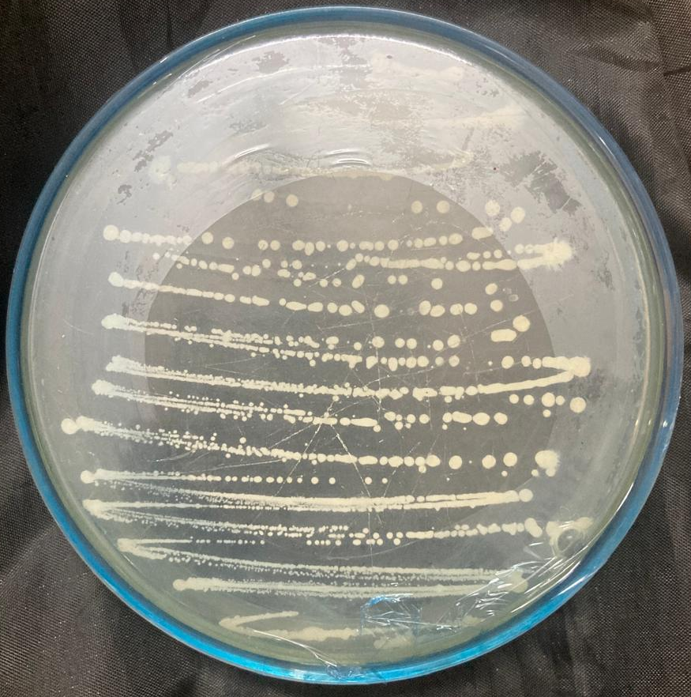  Fig. 1. Axenic culture of Bacillus subtilis (AUBA-5) | 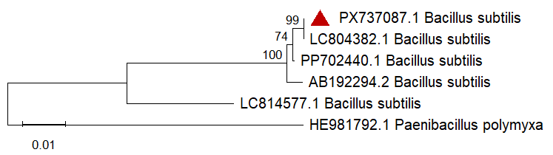  Fig. 2. Phylogenetic tree of Bacillus isolates based on 16S rRNA gene sequences. The tree was constructed using the Neighbor-Joining method with 1,000 bootstrap replications to infer the evolutionary relationships among the isolates.

The recovery of isolates from multiple locations emphasizes their potential suitability for use as region-specific biocontrol agents, as indigenous strains are often better adapted to local field conditions. (Fangio, Roura, & Fritz 2010; de Oliveira Nascimento et al., 2016).
3.2. Morphological Characterization of Bacillus spp.
Morphological characterization of the twenty Bacillus isolates revealed considerable variation in colony morphology and cellular characteristics when grown on nutrient agar (Table 1). Colony color ranged from milky white to creamy white and pale white, which is typical of Bacillus spp. Variations were also observed in colony margins, including undulate, serrated, and slimy forms. Colony elevation differed among isolates, with flat, slightly raised, convex, and umbonate growth patterns recorded. Such diversity in elevation and margin characteristics reflects phenotypic heterogeneity among the isolates, possibly influenced by genetic variation and environmental adaptation. Microscopic examination confirmed that all isolates were rod-shaped, with some showing irregular rod morphology, a feature commonly associated with Bacillus spp., particularly during different growth phases or sporulation. The consistent rod-shaped nature of the isolates supports their preliminary identification as members of the genus Bacillus. Overall, the observed morphological diversity among the isolates suggests the presence of multiple Bacillus species within the rice rhizosphere across the surveyed regions. Similar morphological variability among Bacillus spp. isolated from cereal crops has been reported previously, reinforcing the importance of combining morphological traits with biochemical and molecular analyses for accurate identification. (Haque, & Russell 2005; Hasibuan, Safni, & Lubis 2018).
3.3. Biochemical Characterization of Antagonistic Bacillus spp.
Biochemical analysis of the twenty antagonistic Bacillus isolates further confirmed their identity and functional variability (Table 2). All isolates were Gram-positive, a defining characteristic of the genus Bacillus, confirming the preliminary morphological identification. Most isolates showed positive starch hydrolysis, indicating the production of extracellular amylase enzymes, which contribute to nutrient cycling in the rhizosphere. Citrate utilization was positive in a majority of isolates, suggesting their metabolic versatility and ability to utilize citrate as a carbon source. None of the isolates showed methyl red positivity, indicating the absence of stable acid production during glucose fermentation, which is typical of many Bacillus spp. Chitinase activity was absent in all isolates; however, a significant number exhibited siderophore production, which plays a crucial role in iron sequestration and suppression of phytopathogens through competitive exclusion. Siderophore-producing Bacillus strains are well known for their indirect antagonistic mechanisms against soil-borne pathogens. Catalase activity was observed in most isolates, reflecting their ability to detoxify reactive oxygen species and survive under oxidative stress conditions commonly encountered in the rhizosphere. Nitrate reduction ability, observed in several isolates, further indicates their role in nitrogen transformation and soil fertility enhancement. The observed biochemical variability among the isolates suggests functional diversity, which is essential for effective biocontrol and plant growth promotion. Isolates exhibiting multiple beneficial traits such as starch hydrolysis, siderophore production, catalase activity, and nitrate reduction may possess enhanced rhizosphere competence and antagonistic potential. Overall, the combined morphological and biochemical characterization confirmed that the isolates belong to the genus Bacillus and demonstrated considerable diversity among strains isolated from different rice cultivars and geographical locations. This diversity forms a strong foundation for subsequent molecular identification and evaluation of antagonistic efficacy, ultimately aiding in the selection of promising native Bacillus strains for sustainable rice disease management. (Sawant et al., 2022; Alokika, Kumar, & Singh, 2023; Sihotang, et al., 2025)
3.4. Molecular Characterization of Antagonistic Bacillus sp. (AUBA-5) by 16S rRNA Gene Analysis
The molecular identity of the potent antagonistic isolate AUBA-5 was confirmed through 16S rRNA gene sequencing. PCR amplification yielded a single amplicon of the expected size, and the resulting sequence was deposited in the GenBank database under the accession number PX737087.1. BLAST analysis revealed that the 16S rRNA gene sequence of AUBA-5 shared >99% similarity with authenticated Bacillus species, confirming its affiliation with the genus Bacillus. Phylogenetic analysis based on the neighbor-joining method showed that isolate AUBA-5 clustered closely with reference Bacillus spp., forming a well-supported clade. This clustering pattern validated the taxonomic placement of AUBA-5 and demonstrated its evolutionary relatedness to agriculturally important Bacillus strains. The molecular identification of AUBA-5 corroborated the results obtained from morphological and biochemical analyses, including Gram-positive rod-shaped cells, starch hydrolysis, catalase activity, and siderophore production. Such concordance between phenotypic and genotypic characteristics strengthens the reliability of the identification. The confirmed molecular identity and phylogenetic position of AUBA-5 highlight its potential as a native antagonistic Bacillus isolate with possible applications in sustainable rice disease management. ( Sagar, et al., 2024; Wulff, et al., 2002; Azizoglu et al., 2021)
Conclusion
The present study documented the isolation and comprehensive morpho-molecular characterization of antagonistic Bacillus spp. from the rice rhizosphere of Tamil Nadu and Telangana. Considerable diversity was observed among the isolates in terms of morphological and biochemical traits, reflecting their ecological adaptability. Molecular identification using 16S rRNA gene sequencing confirmed the taxonomic identity of the potent isolate AUBA-5 as a member of the genus Bacillus (GenBank accession no. PX737087.1). The concordance between phenotypic and molecular analyses validated the reliability of the characterization approach. The presence of key functional traits such as siderophore production, enzymatic activity, and stress tolerance highlights the biocontrol potential of native Bacillus isolates. These findings provide a strong foundation for further evaluation of selected strains under greenhouse and field conditions. Ultimately, the study supports the development of location-specific Bacillus-based bioinoculants for sustainable rice disease management.
Reference

Alokika, Kumar, V., & Singh, B. (2021). Biochemical characteristics of a novel ethanol-tolerant xylanase from Bacillus subtilis subsp. subtilis JJBS250 and its applicability in saccharification of rice straw. Biomass Conversion and Biorefinery, 13(3), 1937-1949. https://doi.org/10.1007/s13399-020-01257-0
Avşar, C., Koyuncu, H., & Aras, E. S. (2017). Isolation and molecular characterization of Bacillus spp. isolated from soil for production of industrial enzymes. Biological and Chemical Research. https://unis.sinop.edu.tr/en/akademisyenler/cumhur-avsar/yayin-detayi/isolation-and-molecular-characterization-of-bacillus-spp-isolated-from-soil-for-production-of-industrial-enzymes-biological-and-chemical-research/
Azizoglu, Z. B., Yilmaz, S., Azizoglu, U., Karabörklü, S., Temizgul, R., & Ayvaz, A. (2021). Molecular characterization of the chitinase genes of native Bacillus thuringiensis isolates and their antagonistic activity against three important phytopathogenic fungi. Biologia, 76(9), 2745-2755. https://doi.org/10.1007/s11756-021-00802-0V
Bhandari, V., Ahmod, N. Z., Shah, H. N., & Gupta, R. S. (2013). Molecular signatures for Bacillus species: demarcation of the Bacillus subtilis and Bacillus cereus clades in molecular terms and proposal to limit the placement of new species into the genus Bacillus. International Journal of Systematic and Evolutionary Microbiology, 63(Pt_7), 2712-2726. https://doi.org/10.1099/ijs.0.048488-0
Cornea, C. P., Grebenisan, I., Mateescu, R., Vamanu, E., & Campeanu, G. (2003). Isolation and characterization of new Bacillus spp. strains – useful as biocontrol agents of plant pathogens. Romanian Biotechnological Letters, 8(1), 1115-1122. https://www.rombio.eu/vol-8-no-1-january-february-2003/
Nascimento, I. O., Rodrigues, A. A. C., Moraes, F. H., Sousa, F. A. de, Corsi, M. C. F., & Catarino, A. M. (2016). Isolation, identification and in vitro evaluation of Bacillus spp. in control of Magnaporthe oryzae comparing evaluation methods. African Journal of Agricultural Research, 11(19), 1743-1749. https://doi.org/10.5897/AJAR2016.10931
Fangio, M. F., Roura, S. I., & Fritz, R. (2010). Isolation and identification of Bacillus spp. and related genera from different starchy foods. Journal of Food Science, 75(4), M218-M221. https://doi.org/10.1111/j.1750-3841.2010.01566.x
Haque, A., & Russell, N. J. (2005). Phenotypic and genotypic characterisation of Bacillus cereus isolates from Bangladeshi rice. International Journal of Food Microbiology, 98(1), 23-34. https://doi.org/10.1016/j.ijfoodmicro.2004.04.025
Hasibuan, M., Safni, I., Lisnawita, & Lubis, K. (2018). Morphological characterization of several strains of the rice-pathogenic bacterium Burkholderia glumae in North Sumatra. IOP Conference Series: Earth and Environmental Science, 122(1), 012044. https://doi.org/10.1088/1755-1315/122/1/012044
Ijaz, M., Ali, Q., Ashraf, S., Kamran, M., & Rehman, A. (2019). Development of future bioformulations for sustainable agriculture. Microbiome in plant health and disease: challenges and opportunities, 421-446.
Koni, P. A., & Ellar, D. J. (1994). Biochemical characterization of Bacillus thuringiensis cytolytic δ-endotoxins. Microbiology, 140(8), 1869-1880. https://doi.org/10.1099/13500872-140-8-1869
Lu, Z., Guo, W., & Liu, C. (2018). Isolation, identification and characterization of novel Bacillus subtilis. Journal of Veterinary Medical Science, 80(3), 427-433. https://doi.org/10.1292/jvms.16-0572
Mali, M., Meghalatha, K., Anuradha, K., Kumar, V., Lakshmi, P. H. P., Karmakar, S., Lakra, D. S., Rudraboyina, S. K., Akanand, & Chandrakar, G. (2023). The future of rice farming: A review of natural and eco-friendly practices. International Journal of Environment and Climate Change, 13(11), 4240-4249. https://doi.org/10.9734/ijecc/2023/v13i113604
Miljaković, D., Marinković, J., & Balešević-Tubić, S. (2020). The significance of Bacillus spp. in disease suppression and growth promotion of field and vegetable crops. Microorganisms, 8(7), 1037. https://doi.org/10.3390/microorganisms8071037
Montanari, G., Borsari, A., Chiavari, C., Ferri, G., Zambonelli, C., & Grazia, L. (2004). Morphological and phenotypical characterization of Bacillus sporothermodurans. Journal of Applied Microbiology, 97(4), 802-809. https://doi.org/10.1111/j.1365-2672.2004.02371.x
Nikunjkumar, B. D. (2012). Molecular identification of bacteria using 16s rDNA sequencing. Gujarat University, Gujarat, India.
Rajashekhar, M., Shahanaz, E., & Kalia, V. K. (2017). Biochemical and molecular characterization of Bacillus spp. isolated from insects. Journal of Entomology and Zoology Studies, 5(5), 581-588. https://www.entomoljournal.com/archives/2017/vol5issue5/
Rocha, G. T., Queiroz, P. R. M., Grynberg, P., Togawa, R. C., de Lima Ferreira, A. D. C., Do Nascimento, I. N., Gomes, A. C. M. M., & Monnerat, R. (2023). Biocontrol potential of bacteria belonging to the Bacillus subtilis group against pests and diseases of agricultural interest through genome exploration. Antonie van Leeuwenhoek, 116(7), 599-614. https://doi.org/10.1007/s10482-023-01822-3
Ruiz-Sánchez, E., Mejía-Bautista, M. Á., Serrato-Díaz, A., Reyes-Ramírez, A., Estrada-Girón, Y., & Valencia-Botín, A. J. (2016). Antifungal activity and molecular identification of native strains of Bacillus subtilis. Agrociencia, 50(2), 133-148. https://www.scielo.org.mx/scielo.php?script=sci_arttext&pid=S1405-31952016000200133
Sagar, A., Rai, S., Sharma, S., Perveen, K., Bukhari, N. A., Sayyed, R. Z., & Mastinu, A. (2024). Molecular characterization reveals biodiversity and biopotential of rhizobacterial isolates of Bacillus spp. Microbial Ecology. https://doi.org/10.1007/s00248-024-02397-w
Sawant, S. B., Mishra, M. K., Prabhukarthikeyan, S. R., Senapati, A. K., & Samal, K. C. (2022). Biochemical characterization of Bacillus species isolated from rice rhizosphere in Odisha. Oryza, 59, 470–482. https://doi.org/10.35709/ory.2019.56.2
Shaikh, S. S., & Sayyed, R. Z. (2014). Role of plant growth-promoting rhizobacteria and their formulation in biocontrol of plant diseases. In N. K. Arora (Ed.), Plant microbes symbiosis: applied facets (pp. 337-351). Springer India. https://doi.org/10.1007/978-81-322-2068-8_18
Sihotang, S., Butar-Butar, A. D. P., Nasution, L., Rahma, H., Trizelia, T., Saragih, M., Kuswardani, R. A., Listiana, I., & Napitupulu, B. S. (2025). Isolation, Morphological Characterization, Biochemistry, and Antagonistic Activity of Endophytic Bacteria from Rice Against Xanthomonas oryzae pv. Oryzae. Biology, Medicine, & Natural Product Chemistry, 14(2), 825-829. https://doi.org/10.14421/biomedich.2025.142.825-829
Travers, R. S., Martin, P. A., & Reichelderfer, C. F. (1987). Selective process for efficient isolation of soil Bacillus spp. Applied and environmental microbiology, 53(6), 1263-1266. https://doi.org/10.1128/aem.53.6.1263-1266.1987
Varma, P. (2017). Rice productivity and food security in India: A study of the System of Rice Intensification. Springer Singapore. https://doi.org/10.1007/978-981-10-3692-7
Wulff, E. G., Mguni, C. M., Mansfeld-Giese, K., Fels, J., Lübeck, M., & Hockenhull, J. (2002). Biochemical and molecular characterization of Bacillus amyloliquefaciens, B. subtilis and B. pumilus isolates with distinct antagonistic potential against Xanthomonas campestris pv. campestris. Plant Pathology, 51(5), 574-584. https://doi.org/10.1046/j.1365-3059.2002.00753.x
Xu, X., & Kovács, Á. T. (2024). How to identify and quantify the members of the Bacillus genus?. Environmental Microbiology, 26(2), e16593. https://doi.org/10.1111/1462-2920.16593

