Original Research Article

Age Concerning Sexuality and Spermiogram in Malpura Rams in Semi-tropicals

Abstract
AIMS: We aimed to evaluate the effect of age on sexual behavior and semen quality in Malpura rams raised and maintained in the semi-tropical region of northwest India. PLACE OF STUDY: Animal Physiology and Biochemistry Division, ICAR-Central Sheep and Wool Research, Avikanagar, Rajasthan.
METHODOLOGY: Rams were divided into two groups: G1 (2-3 years, n=13) and G2 (6-7 years, n=13). Semen was collected biweekly over six weeks during May-June 2024. A total of 198 ejaculates were analyzed for volume, consistency, sperm concentration, mass motility, viability, and morphology. Amongst the sexual behaviors, time to mount, number of mounts, ejaculation time, nudging, pawing, and flehmen response were observed.
RESULTS: The older rams (G2) mounted more quickly (2 ± 0.35 s vs. 3 ± 0.48 s) and exhibited more frequent nudging and higher pawing behavior than the younger rams in GI. Semen volume was significantly lower in G1 (0.71 ± 0.10 ml vs. 1.15 ± 0.14 ml, p<0.05), with a higher percentage of watery samples (10.71% vs. 0%). However, sperm concentration, mass motility, viability, and morphology showed no significant differences.
CONCLUSION: While aging reduces semen volume, possibly due to diminished seminal vesicle and accessory gland efficiency, Malpura rams aged 6-7 years remain viable for breeding owing to comparable sperm quality and enhanced sexual behavior.
Keywords: Age, Malpura, Rams, Semen, Sexual Behavior

- Introduction
Reproductive efficiency is a critical factor in livestock management. Among the small ruminants reared in the semi-arid plains of Rajasthan, the Malpura breed of sheep is known for its mutton quality and coarse wool production. Malpura rams are known for their hardiness, which allows them to thrive in the harsh climatic conditions of the semi-arid region. The breed’s adaptability, combined with its dual-purpose nature, makes it an integral part of the local farming systems in the region under low-input conditions where feed scarcity and heat stress are major constraints in animal production. Semen quality and sexual behavior are crucial factors for fertilizing ability, influencing herd fertility and farm productivity (Khan et al., 2024). As rams mature, notable changes occur in their sexual behavior and semen quality that can significantly impact reproductive performance. These changes are influenced by various factors, including hormonal fluctuations, physical development, and environmental conditions that ultimately govern their fertility rates in breeding programs.
In the realm of sustainable livestock production, extending the productive lifespan of breeding stock could be an important strategy for enhancing economic viability and resource efficiency. Prolonged longevity in high-performing breeding animals can significantly mitigate the costs associated with herd renewal (Byun et al., 2012). Specifically, when genetically superior individuals maintain reproductive efficacy over extended periods, fewer replacement animals need to be raised, potentially reducing operational expenses. The onset of reproductive senescence has been shown to occur between 5 and 6 years of age (Mysterud et al., 2002). Sheep are culled at an average age of 5 years (Hoffman and Valencak, 2020), and the pattern is followed in the region of this study. As a result, careful management of rams at different life stages can help maximize their reproductive potential, thereby ensuring the success of breeding programs. Age is known to affect semen characteristics, with older animals often exhibiting reduced reproductive performance due to declines in sperm quality in canines (Zmudzińska et al., 2022), roosters (Haryuni et al., 2022), and bulls (Satrio et al., 2024). Understanding the mechanisms of reproductive aging can extend the breeding utility of valuable rams, optimizing their use in artificial insemination and natural mating programs.
While it is well established that rams attain their optimal breeding age between 2 and 3 years, the reproductive viability and suitability of rams older than 5 years for breeding purposes remain largely unexplored. Thus, we aimed to evaluate the effects of age on sexual behavior and semen quality in Malpura rams, comparing younger (2-3 years) and older (6-7 years) individuals. The objective was to assess key semen characteristics (volume, consistency, sperm concentration, mass motility, viability, and morphology) and sexual behaviors (time to mount, number of mounts, ejaculation time, nudging, pawing, and flehmen response) to determine their suitability for breeding across age groups.

- Materials and methods
2.1 Experimental Designand Animals
The study was conducted over six weeks during May-June 2024 at the Experimental Animal Farm of the Indian Council of Agricultural Research-Central Sheep and Wool Research Institute, Avikanagar, located in the semi-arid region of India. The location is at an altitude of 320m above mean sea level, Longitude 75°28´E and Latitude 26°26´N. The annual temperatures range between 3 and 46°C, with annual relative humidity (RH) between 10% and 85%. Twenty-six healthy Malpura rams were randomly assigned to two groups based on age: G1 (2-3 years, n=13, body weight 53.05±1.4 kg) and G2 (6-7 years, n=13, body weight 51.91±1.8 kg). The rams were maintained under standard management conditions, with access to concentrate feed at a rate of 150g/animal/day, green fodder (millet grass, green oats, sorghum, or hybrid napier as per availability in the farm), chopped dry fodder (Cenchrus ciliaris), and clean drinking water ad libitum. All experimental procedures on rams conformed to the guidelines as approved by the Institute Animal Ethics Committee.
2.2 Semen Collection and Analysis
Semen was collected biweekly using a sterile standard artificial vagina(AV). The outer rubber of AV was 6-8″ long, having a 1.57″ diameter, and an inner latex liner 10-12″long of 1.5″ diameter. The temperature of the AV was maintained between 42-43°C. A total of 198 ejaculates were evaluated for volume, consistency, sperm concentration, mass motility, viability, and morphology. Semen was kept at 37°C and evaluated immediately upon collection. The volume of the semen (ml) was recorded directly from the precisely graduated 5 ml conical collection cups of borosilicate glass in which semen was collected by AV. Consistency, i.e., the concentration of semen visualized through the naked eye against natural light, was assessed by slightly tilting the collection cup. Consistency was graded as thick, medium, thin, and watery. Sperm concentration was determined in a photocolorimeter (×10⁶/ml) previously standardized for concentration against OD. Mass motility of the spermatozoa was assessed by observing wave motions of a freshly collected semen drop at a low magnification (10×) and scored on a scale from 0 (no motility) to 5 (excellent motility). Viability was assessed as percentages of live and dead sperms determined from a fixed-smear stained with eosin-nigrosin. Two hundred sperms were calculated from different fields in the stained smear. The colored head sperm was calculated as a dead sperm, while a colorless head sperm was considered as a live sperm (Fig.1).

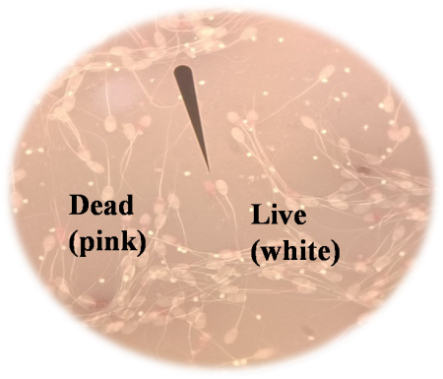
Fig.1 Plasmalemma integrity of ram sperm-Eosin Nigrosin staining
The slide prepared with eosin-nigrosin stain was used to examine the sperm morphology. For each slide, two hundred spermatozoa were examined and evaluated for head, mid-piece, and tail abnormalities (Fig.2).
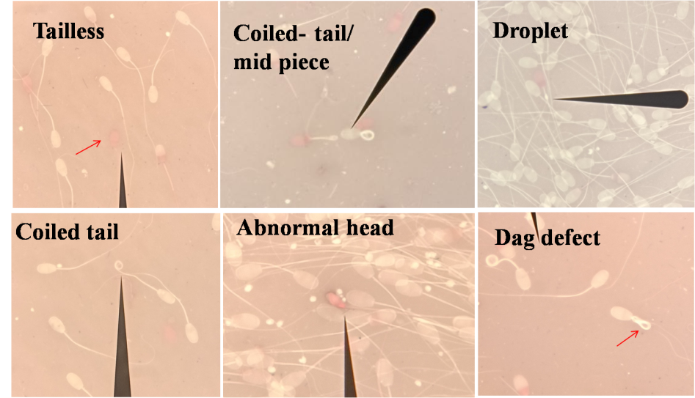
Fig.2 Assessment of Sperm plasmalemma integrity, Morphology (Eosin-Nigrosin stain)

2.3 Sexual Behavior Assessment
The rams were released one by one and allowed to mount the dummy before semen collection, during which sexual behaviors were observed. During the semen collection sessions, the behavior observed included: time to mount (time from release to mounting in seconds), number of mounts (total mounts attempted before ejaculation), ejaculation time (time from successful mounting to ejaculation in seconds), nudging and pawing (frequency of dominance assertion behaviors), flehmen response (lip curl facilitating odorant transport to the vomero-nasal organ).

2.4 Statistical Analysis
Data were analyzed using a t-test to compare means between groups for semen parameters and sexual behaviors. Morphological abnormalities were compared using a chi-square test. Significance was set at p<0.05. Results are presented as mean ± standard error.

3. Results
3.1 Sexual Behavior
Results of the intensity of different sexual behaviors observed in the two groups are presented in Fig 3. Older rams (G2) mounted more quickly than younger rams. The number of mounts and ejaculation time were similar, and the differences were not significant between the groups. Older rams exhibited more frequent nudging and a higher incidence of pawing. The flehmen response frequency was comparable, and the differences were not significant between groups.
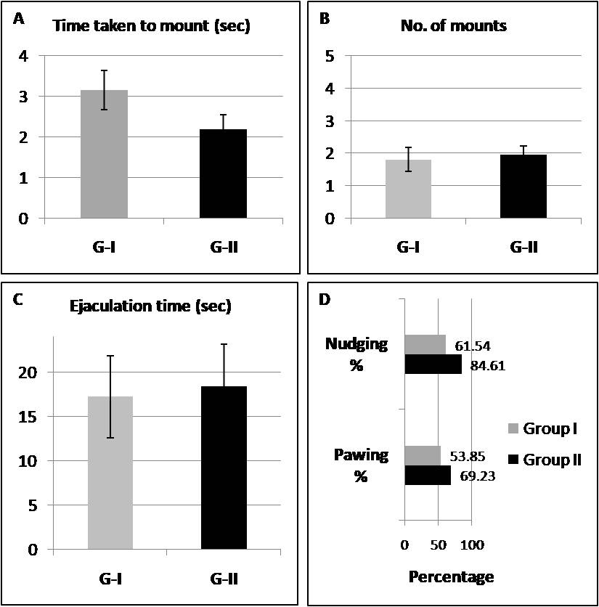
Fig. 3 (A-D) Sexual behavior of Malpura rams. Time taken to mount (sec), Number of mounts, Ejaculation time (sec), Percentage of Group I (younger) and Group II (older) rams showing nudging and pawing behavior.

3.2 Semen Quality
The basic semen quality parameters in different age groups of Malpura rams are given in Table 1. Younger rams produced significantly higher semen volumes compared to older rams (p<0.05). Sperm concentration was numerically higher in older rams, although the difference was not significant. Semen consistency varied, with 1.71% of samples from older rams classified as watery compared to none in younger rams. Mass motility scores were similar between groups. Sperm viability did not differ significantly. Morphological abnormalities were slightly higher in older rams, but not statistically significant.
Table 1: Basic semen characteristics of Malpura rams of different age groups
Parameter | G1 (2-3 years) | G2 (6-7 years) | p-value
Semen volume (ml) | 1.15 ± 0.14 | 0.71 ± 0.10* | <0.05
Concentration (10⁹/ml) | 3.85 ± 0.34 | 4.03 ± 0.47 | >0.05
Viability (%) | 76.38 ± 1.35 | 74.69 ± 3.62 | >0.05
Head abnormalities (%) | 0.56 ± 0.15 | 0.91 ± 0.36 | 0.64
Mid-piece abnormalities (%) | 0.67 ± 0.08 | 1.98 ± 0.87 | 0.16
Tail abnormalities (%) | 0.46 ± 0.07 | 1.15 ± 0.43 | 0.14

4. Discussion
The findings reveal that aging influences some of the reproductive parameters in Malpura rams. The quicker mounting time and increased nudging and pawing behavior in older rams suggest an increased sexual vigor, possibly due to greater experience gained over the years or an instinct of dominance in the rams. These behaviors align with previous studies indicating that older rams may exhibit more assertive pre-copulatory behaviors. Older rams demonstrate superior sexual behavior traits, including more frequent tail rising, vocalizations, and ejaculations compared to younger rams. This is supported by studies showing that rams aged three years or older outperform two-year-old rams in these behaviors, also characterized by longer ejaculation durations and higher ejaculation efficiency, indicating more effective mating capabilities (Yilmaz et al., 2009). Maturation process in rams leads to improved sexual performance, as evidenced by the increased frequency of mounts and mount attempts in older rams compared to younger ones (Price et al., 1991). Older rams also have higher testosterone levels and larger scrotal circumferences, which are associated with enhanced sexual behavior. For instance, older Egyptian rams showed better sexual performance and larger scrotal circumferences than younger ones (Mostafa & Farghal, 2019).
The Flehmen response is linked to the detection of estrus through the vomeronasal organ, which is crucial for mating behaviors in rams(Hart, 1983). Studies have shown that flehmen response frequency does not significantly differ between rams exposed to different mating stimuli, such as recently mated versus non-mated rams (Maina & Katz, 1997). This consistency suggests that the olfactory-driven flehmen response is a stable behavior, not easily altered by external stimuli or age. In a study of native sheep, semen volume peaked at three years and then stabilized, suggesting that older rams may experience a decline in seminal fluid production (Hassan et al., 2010). The significant reduction in semen volume in older rams observed in the present study corroborates the findings in other species, viz., Landrace boars (Sumardani et al., 2019), stallions (Multigner et al., 1999), and men (Molina et al., 2010), where aging impacts seminal vesicle and accessory gland function. This reduction may limit the number of inseminations possible per ejaculate, affecting breeding efficiency in artificial insemination programs. In another study, aged rams (7.5 years) were found more likely to be suitable for breeding ahead of the younger aged groups (1 and 2.5 years) (Hedia and El-Shalofy, 2021).
The absence of significant differences in sperm concentration, mass motility, viability, and morphology between the older and younger rams in the current study indicates that older Malpura rams retain adequate sperm quality for breeding, consistent with studies in other breeds. Previous studies have also reported no significant differences in sperm concentration and motility between younger (2-3 years) and older (6-7 years) rams (Buša et al., 2019; Andreeva & Stefanov, 2020). In a study involving rams aged 6 years, sperm motility and concentration were found to be satisfactory, supporting the notion that older rams can still produce viable sperm (Petrean et al., 2023). Morphological assessments have also shown no significant age-related differences, suggesting retention of normal sperm structure in older rams (Belkhiri et al., 2017).
Visual evaluation of the ejaculate with respect to color can be a good index for sperm concentration. The higher incidence of watery semen in older rams may reflect reduced seminal plasma contributions, potentially linked to age-related declines in accessory gland function. While morphological abnormalities were slightly higher in older rams, the lack of statistical significance suggests minimal impact on fertility, as such abnormality rates are found to be generally acceptable for breeding.
The current study was conducted in a single breed of this region. To enhance the reliability and comprehensiveness of the findings, the authors suggest that future research needs to be undertaken in different breeds of each geographical region. Additionally, animals beyond 7 years may be included in a large sample study in order to mark the most sustainable age for culling.

5. Conclusion
Older Malpura rams (6-7 years) exhibit more frequent and intense sexual behaviors compared to younger rams (2-3 years). However, aging significantly reduces semen volume, likely due to decreased seminal vesicle and accessory gland efficiency. The comparable sperm concentration, mass motility, viability, and morphology between age groups show that Malpura rams aged 6-7 years remain suitable for breeding. The study supports the continued use of older rams in breeding programs, potentially extending their productive lifespan and enhancing farm efficiency.

COMPETING INTERESTS

The authors declare that no competing interests exist.

References
Andreeva, M., & Stefanov, R. (2020). Study of the relationship between the age of the rams and the quality of their ejaculates obtained outside the breeding season. 36(4), 437–445. https://doi.org/10.2298/BAH2004437A
Belkhiri, Y., Bouzebda-Afri, F., Bouzebda, Z., & Mouffok, C. (2017). Age and Season Effects on Sexual Parameters in Mature Rams Used in Artificial Insemination Center (Algeria). 18(1). http://www.univ-soukahras.dz/eprints/2017-1192-7cee3.pdf
Buša, D., Macháč, M., Baláži, A., Svoradová, A., Vašíček, J., Jurcik, R., &Chrenek, P. (2019). Sperm motility of rams from two Slovak sheep breeds: short communication. Slovak Journal of Animal Science, 52(04), 178–180. https://sjas.ojs.sk/sjas/article/view/603
Corbett, J. L. (2001). Variation in wool growth with physiological state. University New England Publishing Unit, Armidale, 79-98.
Hart, B. L. (1983). Flehmen Behavior and Vomeronasal Organ Function (pp. 87–103). Springer US. https://doi.org/10.1007/978-1-4757-9652-0_5
Haryuni, N., Hartutik, H., Widodo, E., Tribudi, Y. A., &Wahjuningsih, S. (2022). Impact of Aging on Sperm Quality of Sentul Roosters. Indonesian Journal of Animal and Veterinary Sciences. https://doi.org/10.14334/jitv.v27i4.3015
Hassan, M. R., Pervage, S., Ershaduzzaman, M., & Talukder, M. (2010). Influence of age on the spermiogramic parameters of native sheep. Journal of The Bangladesh Agricultural University, 7(2), 301–304. https://doi.org/10.3329/JBAU.V7I2.4738
Hedia, M., & El-Shalofy, A. S. (2021). Ageing affects plasma steroid concentrations and testicular volume, echotexture and haemodynamics in rams. Andrologia. https://doi.org/10.1111/AND.14309
Khan, M. Z., Chen, W., Naz, S., Liu, X., Liang, H., Chen, Y., Kou, X., Liu, Y., Ashraf, I., Han, Y., Peng, Y., Wang, C., & Zahoor, M. I. (2024). Determinant genetic markers of semen quality in livestock. Frontiers in Endocrinology, 15. https://doi.org/10.3389/fendo.2024.1456305
Kumar, A., Chauhan, I., Misra, S. S., &Gowane, G. R. (2016). Mortality, culling and replacement in Sirohi goats in an organized farm. Indian Journal of Small Ruminants. 22(1), 50-52.
Molina, R., Martini, A. C., Martini, A. C., Tissera, A., Olmedo, J., Senestrari, D., Fiol de Cuneo, M., Fiol de Cuneo, M., Ruiz, R. D., & Ruiz, R. D. (2010). Semen quality and aging: analysis of 9.168 samples in Cordoba. Argentina. ArchivosEspañoles de Urología, 63(3), 214–222. https://doi.org/10.4321/S0004-06142010000300007
Mostafa, A. S., &Farghal, M. M. (2019). A study on the effect of age, breed and season on sexual behaviour, testosterone concentrations and scrotal circumference in Egyptian rams. 26(1), 91–100. https://doi.org/10.21608/JVMR.2019.43340
Petrean, A. B., Gog-Bogdan, S., Berean, D., Popescu, S., & Popescu, S. (2023). Assessment of some microscopic parameters of ram semen correlated with the age of the animals. https://doi.org/10.61900/spjvs.2023.01.04
Price, E. O., Estep, D. Q., Wallach, S. J. R., & Dally, M. R. (1991). Sexual performance of rams as determined by maturation and sexual experience. Journal of Animal Science, 69(3), 1047–1052. https://doi.org/10.2527/1991.6931047X
Rather, M. A., Bashir, I., Kuthu, B. A., Baba, J. A., & Hamadani, A. (2021). Factors affecting greasy fleece yield in Kashmir Merino sheep. Indian Journal of Small Ruminants, 27(1), 126-128.
Satrio, F. A., Karja, N. W. K., Setiadi, M. A., Kaiin, E. M., Pardede, B. P., &Purwantara, B. (2024). Age-dependent variations in proteomic characteristics of spermatozoa in Simmental bull. Frontiers in Veterinary Science, 11. https://doi.org/10.3389/fvets.2024.1393706
Sumardani, N. L. G., Budaarsa, K., Putri, T. I., &Puger, A. W. (2019). Age Affects Semen Volume and Sperm Motility of Landrace Boars at Baturiti Artificial Insemination Center, Tabanan, Bali JurnalVeteriner, 20(3), 324. https://doi.org/10.19087/JVETERINER.2019.20.3.324
Yilmaz, A., Karakuş, F., &Yeşilova, A. (2009). Sexual behavioral characteristics of Norduz and Karakas rams and their changes with age. Journal of Agricultural Sciences, 15(3), 270–276. https://doi.org/10.1501/TARIMBIL_0000001100
Zmudzińska, A., Wisniewski, J., Młynarz, P., Olejnik, B., &Mogielnicka-Brzozowska, M. (2022). Age-Dependent Variations in Functional Quality and Proteomic Characteristics of Canine (Canis lupus familiaris) Epididymal Spermatozoa. International Journal of Molecular Sciences, 23(16), 9143. https://doi.org/10.3390/ijms23169143
Hoffman, J. M., &Valencak, T. G. (2020). A short life on the farm: aging and longevity in agricultural, large-bodied mammals. GeroScience, 42(3), 909–922. https://doi.org/10.1007/s11357-020-00190-4
Byun S (2010) Genes assoicated with variation in longevity and fecundity in sheep. Lincoln University
Byun, S. O., Forrest, R. H., Frampton, C. M., Zhou, H., &Hickford, J. G. H. (2012). An association between lifespan and variation in insulin-like growth factor I receptor in sheep. Journal of animal science, 90(8), 2484-2487.
Mysterud, A., Steinheim, G., Yoccoz, N. G., Holand, Ø., & Stenseth, N. C. (2002). Early onset of reproductive senescence in domestic sheep Ovis aries. Oikos, 97(2), 177-183.

