First report of panurgine bee (Hymenoptera: Apoidea: Andrenidae) from India.

ABSTRACT
An investigation of insect pollinators in the Trans-Himalayan cold desert of Kargil (Ladakh) revealed a new record, Melitturgaclavicornis (Latreille, 1806) (Andrenidae: Panurginae), from India, marking the first documented occurrence of a panurgine bee in the country. Before this study, its distribution ranged from Europe to Afghanistan in Asia. We can infer that the species' range has extended into the Indian Himalayas. According to European assessments, this species is listed as near threatened on the IUCN Red List. Consequently, it becomes even more vital to protect it and its habitat. Its occurrence in India holds particular significance for conservation efforts. Melitturgaclavicornis (Latreille, 1806) was collected from flowers of buckwheat, alfalfa, apricot, and apple during their flowering seasons from 2020 to 2023. The highest abundance was observed in alfalfa (Medicago falcata and Medicago sativa) fields. Based on this study, we can also assert that this species is responsible for pollinating all the major crops found in Ladakh. The collection sites are indicated on the QGIS map, and photographs of the specimens are also included.
Keywords: Kargil, Melitturgaclavicornis, new data, pollinator, solitary bees, species distribution
- INTRODUCTION
The genus Melitturga belongs to the tribe Melitturgini within the subfamily Panurginae of the family Andrenidae (Michener, 2007). M. clavicornis is a medium-sized, ground-nesting solitary bee. In the Trans-Himalayan region of Kargil district, various flowering fruit crops, field crops, and wild flora primarily rely on solitary and social bees for pollination. Bees (Hymenoptera: Apoidea: Anthophila), a lineage that includes over 20,000 described species, are the most important group of insect pollinators (Michener, 2007; Potts et al., 2010; Ascher & Pickering, 2025). Bees facilitate the pollination of 87% of native flowering plants (Ollerton et al., 2011) and 75% of commercially cultivated crops (Klein et al., 2007). They are the main agents for pollen transfer among most wild and field crop flowering plants (Gallai et al., 2009; Ollerton et al., 2011; vanbergen, 2013; Dirzo et al., 2014; IPBS, 2019). Wild bee species are vital not only for the sexual reproduction of hundreds of thousands of wild plant species (Ollerton et al., 2011), but also for the yield of approximately 85% of all cultivated crops (Gallai et al., 2009; Garibaldi et al., 2013; IPBS, 2019). To date, in the entire history of bee taxonomy studies in India, only the genus Andrena has been identified within the family Andrenidae, which falls under the subfamily Andreninae. However, this study reports, for the first time, another genus, Melitturga, of the Andrenidae family, included under the subfamily Panurginae. Currently, there are a total of 20 Melitturga species worldwide. According to the assessment in Europe, by Michez& Nieto (2013), this species is listed as Near Threatened in the IUCN Red List of Threatened Species. Considering the importance of the pollination services provided by solitary bees, it is essential to conserve their populations and maintain a diverse range of both solitary and social bee species.
- MATERIAL AND METHODS
2.1 Study site:Genus Melitturga bees were collected from Kargil, Ladakh, and its various sub-regions (Fig.1). The area where the bees were collected experiences an arid climate. The Trans-Himalayan biogeographic zone is characterised by its extreme climate, sparse vegetation, unique flora and fauna, glacial landforms, and cultural significance shaped by the challenging environment of high altitudes in the Himalayan range.
2.2 Host plant:In spring and summer, Melitturga bees were captured using an insect sweep net from pseudocereal crop buckwheat, fruit crops such as apricot, apple, and almond, as well as from field crop alfalfa flowers between 2019 and 2023. During the flowering periods of fruit and field crops, this ground-nesting bee was observed as one of the active flower visitors.
2.3 Sample collection and taxonomic identification:The specimens were collected using sweep nets from various localities during different flowering seasons. They were pinned, preserved, and identified to species level using available keys (Michener, 2007; Proshchalykin et al., 2016; Michez et al., 2019). The second author at Allahabad University verified the species. The specimens were examined under a Leica S9i stereo microscope. All identified specimens are stored in the entomology laboratory and invertebrate museum at Panjab University, Chandigarh, India.
3. RESULTS
3.1 Systematic Account
Sub family: Panurginae Leach, 1815
Tribe: Melitturgini Michener, 1944
Genus: MelitturgaLatreille, 1809
Type species: Melitturgaclavicornis (Latreille, 1806)
3.2 Morphological Characters
3.2.1 Female:Length ranging from 12 to 14 mm, and the entire body is black; wings have a brownish hue. The thorax has light yellow hair covered; the vertex is adorned with short, yellow-white hairs. First and second segments of abdomen with sparse light golden hairs, second to fourth segments have short, thin and low light yellowish hairs on the sides, fifth segment on top is covered with long, white-yellowish hairs, sixth segment is entirely coated with white, yellow, thick hairs. Pollen carried in hind legs mainly; scopa confined to tibia and basitarsus (Fig. 2).
3.2.2 Male:Body length 12-14mm, head rounded at the front, with exceptionally large eyes, the distance between eyes at the top is nearly three times narrower than the width of the eye. The foreskin is convex and elongated. Short, club-shaped antennae adorn the head, Foreskin, upper lip, upper part of forehead, and scape in the antennal segment, yellow from the frontal side and wider from the apex. Eyes converge at the top of head, distance between their posterior ocelli being less than that between the two ocelli together. Vertex is very short due to large eyes. Body densely covered with light golden hairs from thorax to abdomen (Fig. 2).
3.2.3 Distribution:Spain, France, Germany, Switzerland, Italy, Austria, Croatia, Czech Republic, Hungary, Slovakia, Poland, Lithuania, Estonia, Romania, Moldova, Ukraine, European Russia, Turkey, Georgia, Azerbaijan, Kazakhstan, Uzbekistan, Kyrgyzstan, China, Armenia, Afghanistan, Iran (Grace, 2010; Ascher & Pickering, 2025).
3.2.4 Material studied:India: Ladakh, Kargil: Tumail colony (34°32'10"N 76°09'24"E) 2,927 m, 29.06.2020, 5 ♂ 4 ♀; SarchayKanoor (34°27'03"N 76°04'05"E) 2804 m, 23.08.2020, 2 ♂ 3 ♀; MarpodoksSaliskote (34°23'48"N 75°58'54"E) 3,069 m, 25.08.2020, 3 ♂ 1 Kurbathang (34°31'36"N 76°09'10"E) 2,855 m, 24.06.2021, 5 ♂ 4 ♀; Chutumaildoks (34°33'23"N 76°11'07"E) 3,026 m, 26.06.2021, 2♂ 3 ♀; ApatiThangjuk (34°34'14"N 76°12'19"E) 3,327 m, 29.06.2021, 3♂ 3 ♀; Shilikchay (34°34'33"N 76°07'33"E) 2,653 m and AkchamalMangbore (34°33'37"N 76°09'03"E) 2,739m, 04.05.2022, 2♂ 2 ♀; Tumail colony and near the airport side (34°32'10"N 76°09'24"E) 2,927 m, 25.06.2023, 5 ♂ 4 ♀.Ahsan Ali collected all the specimens.
3.2.5 Host plant:Alfalfa (Medicago falcata), Buckwheat (Fagopyrum esculentum), Apricot and Apple.
4. DISCUSSION
The genus Melitturga and its single species, M. clavicornis, are reported for the first time from India. This finding increases the number of genera in the Andrenidae family in India to two, previously represented only by the genus Andrena. The data supporting this study are openly accessible in BOLD Systems at https://v3.boldsystems.org/index.php/Taxbrowser_Taxonpage?taxid=247046 (Bold Systems, 2025) and in Discover Life at https://www.discoverlife.org/mp/20m?kind=Melitturga (Ascher & Pickering, 2025). In natural surroundings, M. clavicornis can be easily identified by the large eyes and hovering flight of males, as well as the short, bulging flagellum and pale clypeus observed in both sexes. Nonetheless, the sexes can be distinguished based on morphological features: the male has a densely covered body with a light colour, while the female’s clypeus is yellow, the antenna scape is brown, the abdomen is black, and the thorax is covered with light yellow hairs. This species shares a close relationship with plants in the legume family and is an excellent pollinator for alfalfa flowers. In several countries, M. clavicornis has been reported only from alfalfa flowers; however, in this study, it was also observed on buckwheat, apricot, and apple flowers. High-altitude regions pose challenges for pollinators, but a variety of insects—including bees, flies, butterflies, and beetles—as well as some birds, contribute to pollination in these environments. Understanding the interactions between these pollinators and the plants they visit is vital for conserving biodiversity and maintaining ecosystem health in high-altitude regions such as the Trans-Himalayas.
CONCLUSION
Pollinators play an important role in the reproduction of flowering plants in terrestrial ecosystems. Most active and effective flower visitors are insects, particularly bees. Prior to this research, only one genus, Andrena, belonging to the family Andrenidae, had been reported from India. The genus Melitturga is the second genus under the family Andrenidae considered among the most active pollinators of fruit and field crops. The present research provides the first record of Melitturgaclavicornis from India, documented in the Kargil district of the Union Territory of Ladakh. High abundance of this species was observed on field crops such as alfalfa and buckwheat during their flowering periods. Future investigation should focus on more extensive and systematic surveys to uncover additional new records or species from this largely unexplored region.
DISCLAIMER (ARTIFICIAL INTELLIGENCE)
Author(s) hereby declare that NO generative AI technologies such as Large Language Models (ChatGPT, COPILOT, etc) and text-to-image generators have been used during writing or editing of this manuscript.
ACKNOWLEDGEMENTS
The first author is thankful to the University Grants Commission (UGC) in New Delhi for awarding fellowships. Deepest gratitude to the Chairperson of the Department of Zoology at Panjab University, Chandigarh, for providing laboratory facilities. Thanks are extended to Dr. Ranjana Jaiswara for access to the stereo zoom microscope and to Mr. Monaal for assistance with photograph stacking. We are also grateful to the Warden of the Wildlife Department of Ladakh, U.T., for permission to conduct this research.
COMPETING INTERESTS
Authors have declared that no competing interests exist.
REFERENCES
Ascher, J. S., & Pickering, J. (2025). Discover Life bee species guide and world checklist (Hymenoptera: Apoidea: Anthophila). http://www.discoverlife.org/mp/20q?guide=Apoidea_species
Bold Systems. (2025). Melitturgaclavicornis, Public data portal record list. https://v3.boldsystems.org/index.php/Taxbrowser_Taxonpage?taxid=247046
Dirzo, R., Young, H. S., Galetti, M., Ceballos, G., Isaac, N. J. B., & Collen, B. (2014). Defaunation in the Anthropocene. Science. https://doi.org/10.1126/science.1251817
Gallai, N., Salles, J. M., Settele, J., &Vaissière, B. E. (2009). Economic valuation of the vulnerability of world agriculture confronted with pollinator decline. Ecological Economics, 68(3), 810–821. https://doi.org/10.1016/j.ecolecon.2008.06.014
Garibaldi, L. A., Steffan-Dewenter, I., Winfree, R., Aizen, M. A., Bommarco, R., Cunningham, S. A., Kremen, C., Carvalheiro, L. G., Harder, L. D., Afik, O., Bartomeus, I., Benjamin, F., Boreux, V., Cariveau, D., Chacoff, N. P., Dudenhöffer, J. H., Freitas, B. M., Ghazoul, J., Greenleaf, S., Hipólito, J., Holzschuh, A., Howlett, B., Isaacs, R., Javorek, S. K., Kennedy, C. M., Krewenka, K., Krishnan, S., Mandelik, Y., Mayfield, M. M., Motzke, I., Munyuli, T., Nault, B. A., Otieno, M., Petersen, J., Pisanty, G., Potts, S. G., Rader, R., Ricketts, T. H., Rundlöf, M., Seymour, C. L., Schüepp, C., Szentgyörgyi, H., Taki, H., Tscharntke, T., Vergara, C. H., Viana, B. F., Wanger, T. C., Westphal, C., Williams, N., & Klein, A. M. (2013). Wild Pollinators Enhance Fruit Set of Crops Regardless of Honey Bee Abundance. Science, 339(6127), 1608–1611. https://doi.org/10.1126/science.1230200
IPBES. (2019). Global assessment report on biodiversity and ecosystem services of the Intergovernmental Science-Policy Platform on Biodiversity and Ecosystem Services (E. S. Brondizio, J. Settele, S. Díaz, & H. T. Ngo, Eds.). IPBES secretariat. https://doi.org/10.5281/zenodo.3831673
Klein, A. M., Vaissière, B. E., Cane, J. H., Steffan-Dewenter, I., Cunningham, S. A., Kremen, C., &Tscharntke, T. (2007). Importance of pollinators in changing landscapes for world crops. Proceedings of the Royal Society B: Biological Sciences, 274(1608), 303–313. https://doi.org/10.1098/rspb.2006.3721
Michener, C. D. (2007). The bees of the world. The Johns Hopkins University Press. https://doi.org/10.56021/9780801885730
Michez D, Nieto A (2013). Melitturgaclavicornis(Europe assessment). The IUCN Red List of Threatened Species 2013: e.T13317630A13318494. Accessed on 15 August 2025. https://www.iucnredlist.org/species/13317630/13318494
Michez, D., Rasmont, P., Terzo, M., & Vereecken, N. J. (2019). Bees of Europe. N.A.P Editions. https://www.nap-editions.com/en/hymenoptera/10-bees-of-europe-hymenoptera-of-europe-1.html
Ollerton, J., Winfree, R., & Tarrant, S. (2011). How many flowering plants are pollinated by animals?. Oikos, 120(3), 321–326. https://doi.org/10.1111/j.1600-0706.2010.18644.x
Potts, S. G., Biesmeijer, J. C., Kremen, C., Neumann, P., Schweiger, O., & Kunin, W. E. (2010). Global pollinator declines: Trends, impacts and drivers. Trends in Ecology & Evolution, 25(6), 345–353. https://doi.org/10.1016/j.tree.2010.01.007
Proshchalykin, M. Y., Astafurova, Y. V., &Osytshnjuk, A. Z. (2016). The species-group names of bees (Hymenoptera: Apoidea, Apiformes) described from Crimea, North Caucasus, European part of Russia and Ural. Part I. Families Colletidae and Halictidae. Far Eastern Entomologist, 312, 1–20. http://www.biosoil.ru/fee/list-of-issues
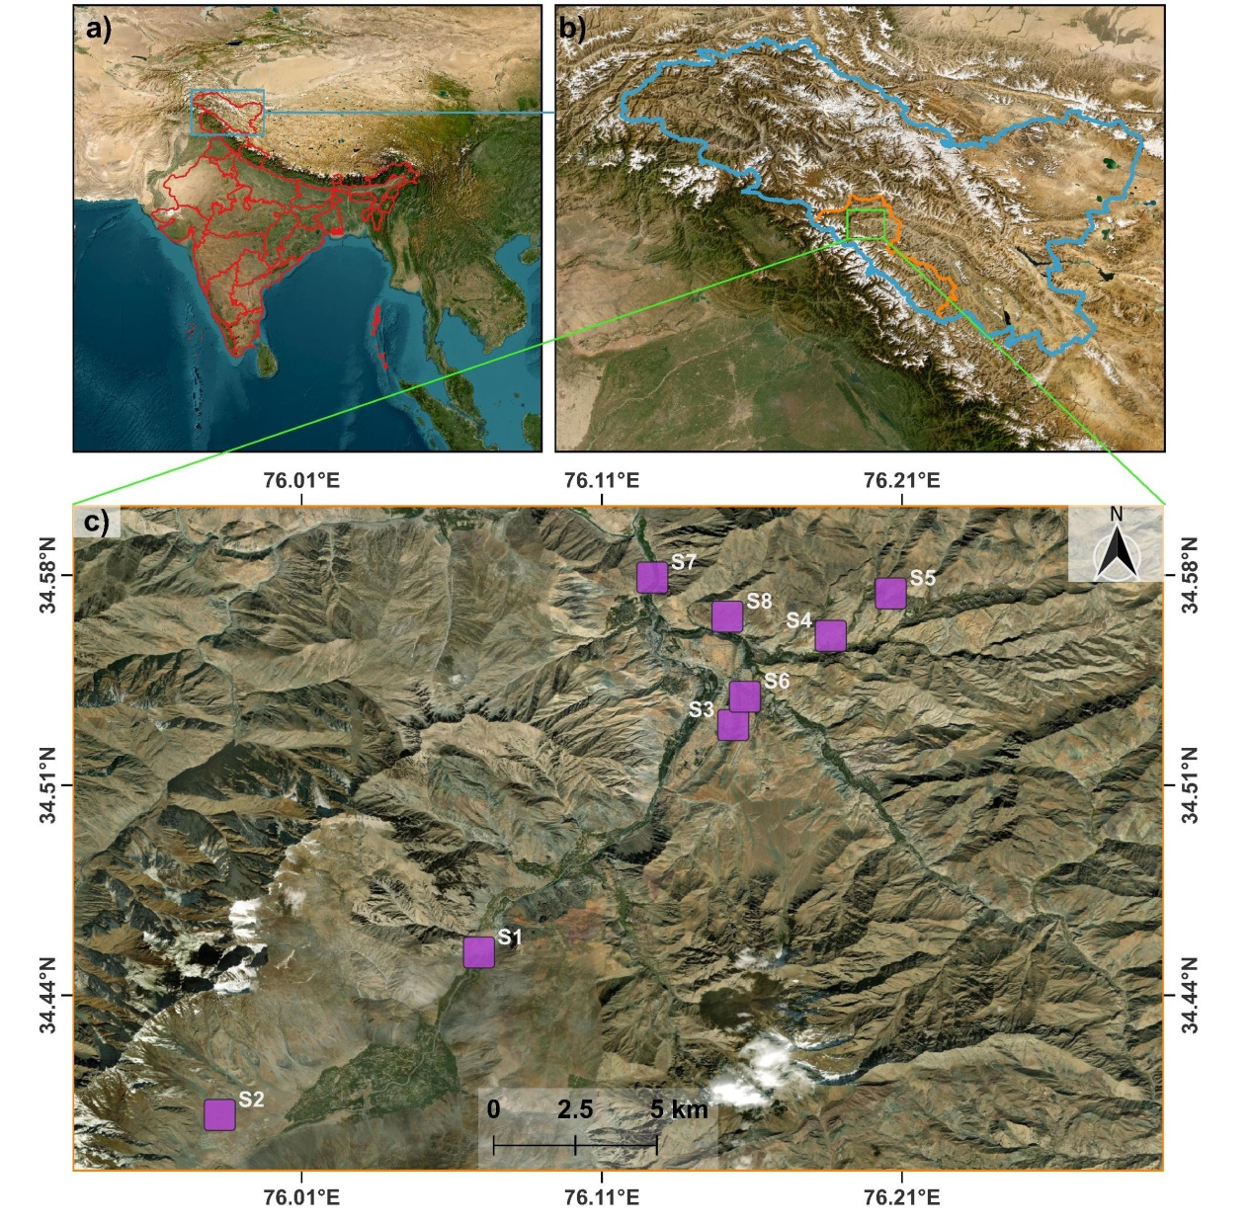
Vanbergen, A. J., Baude, M., Biesmeijer, J. C., Britton, N. F., Brown, M. J. F., Bryden, J., Budge, G. E., Bull, J. C., Carvell, C., Challinor, A. J., Connolly, C. N., Evans, D. J., Feil, E. J., Garratt, M. P., Greco, M. K., Heard, M. S., Jansen, V. A. A., Keeling, M. J., Kunin, W. E., Marris, G. C., Memmott, J., Murray, J. T., Nicolson, S. W., Osborne, J. L., Paxton, R. J., Pirk, C. W. W., Polce, C., Potts, S. G., Priest, N. K., Raine, N. E., Roberts, S., Ryabov, E. V., Shafir, S., Shirley, M. D. F., Simpson, S. J., Stevenson, P. C., Stone, G. N., Termansen, M., & Wright, G. A. (2013). Threats to an ecosystem service: Pressures on pollinators. *Frontiers in Ecology and the Environment*, *11*(5), 251–259. https://doi.org/10.1890/120126

Fig. 1. Q GIS map represented the collection sites of M. clavicornis. (a)Map of India. (b) Map of Ladakh marked with Kargil district boundary in orange colour. (c) Satellite imagery of the study sites and magenta colour square demonstrated collection sites in Kargil district.

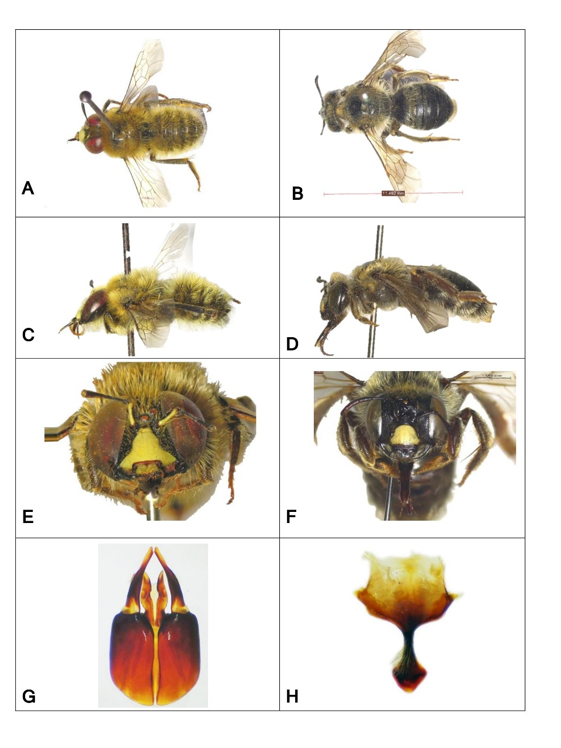
Fig. 2.Melitturgaclavicornis (Latreille, 1806). A male dorsal habitus B female dorsal habitus C male profile habitus, D female profile habitus, E male head, F female head G male genital capsule dorsal view, H male sternum 8.

