Geodemographic Disparities in Obesity Prevalence Across U.S. States: A Population-Based Multi-Level Analysis to Guide Primary Care Interventions

ABSTRACT

Background
Obesity is a chronic condition described as excessive fat accumulation, which has the potential to severely impact one’s health. It develops through a combination of several factors such as genetics, metabolic conditions, diet, physical activity and much more. The rates of obesity have increased over the decades and continue to rise, with non-Hispanic Blacks having the highest rates, and Asian populations continuously maintaining the lowest rates. Numerous gastrointestinal ,mental and cardiovascular conditions are associated with obesity such as GERD, metabolic dysfunction-associated steatotic liver disease (MASLD), Barrett’s esophagus, pancreatitis, several cancers, acute coronary syndrome kidney failure and more. Obesity is not evenly distributed across the United States. This is due to many factors such as race, ethnicity, socioeconomic status, education level, financial knowledge, and access to better food options and healthcare. This study brings attention to the trend of obesity rates by region, income, gender, and ethnicity.
Methods
Data were obtained from the National Health and Nutrition Examination Survey (NHANES) between 2011 and 2023. Obesity prevalence was stratified by race/ethnicity and geographic region (South, Midwest, West, Northeast). Descriptive statistics and graphical illustrations were used to identify trends. Findings were contextualized with peer-reviewed literature addressing the associations and prevalence of obesity ,socio-demographic variables, and medical disorders.
Results
Our study found that obesity has a high prevalence in the South and Mid-west areas with females having slightly higher median and mean values of obesity compared to men ( female obesity rate distribution mean =30.842, median=30.600, whwre as, male obesity rate has a mean=30.625, median=30.700).Together with showing the regions affected, the graphical illustration shows non-Hispanic Black individuals generally have the highest rates of obesity with Hawaiian/Pacific Islanders recording also an elevated rate of obesity in the region obesity rate. Non-Hispanic blacks in the South have been found to have higher prevalence of obesity.
Overall, obesity rates increased steadily for each income group. Within populations that earned less than $15,000 per year, the obesity rate was consistently higher across almost all the years except for 2022.In the Midwest, obesity rates also fluctuated, rising above 40% from 2019-2021 and again in 2023. While the obesity rate rose slightly in Asian individuals between 2011-2023 up to almost 25%, they still had consistently lower rates of obesity than every other race/ethnicity. Hawaiian/Pacific Islander, Hispanic, Non-Hispanic Black, and American Indian/Alaska Native groups consistently had higher obesity rates, almost always above 30%. The obesity rate in Non-Hispanic White, Other, and those identifying as 2 or more races fluctuated between 30-35%. In 2023, there was a sharp increase to 40% observed for Hawaiian/Pacific Islanders in 2023.
Conclusion
Populations in the South and Mid-west consistently had higher obesity rates, as did those who had a lower socioeconomic status. In terms of race, the Asian population tended to have the lowest rates of obesity whereas non-Hispanic Black populations and Hawaiian/Pacific Islander populations tended to have higher rates of obesity. Among Non-Hispanic Black populations, the South exhibits particularly elevated and rising rates, consistent with broader patterns of inequity in access to resources. In regard to gender, females and males have similar average obesity rates, 30.843 and 30.625, respectively. This study highlights certain areas in which social determinants of health such as income, race, gender, and geographic location impact health trends. The obesity rate in this country is high and is increasing yearly, and thus interventions that take these factors into consideration need to be further studied and implemented in a region-specific manner to have a positive impact on the health of the nation.
Keywords: Obesity, Basal Metabolic Index, Overweight, race/ethnicity, prevalence Geodemographic disparities.

INTRODUCTION

Obesity has emerged as a critical public health challenge in the United States and the rest of the world, with far-reaching implications for individual well-being, healthcare systems, and societal productivity. While the overall prevalence of obesity has gained considerable attention, a closer examination reveals that its distribution is not even across the United States. Instead, obesity rates exhibit geodemographic disparities, varying significantly across the various states and among different population subgroups. These disparities are not just random fluctuations but do reflect the complex role of play of geographic location, demographic characteristics, socioeconomic conditions, environmental factors, psychosocial factors, and access to good healthcare services (1). Understanding the factors that contribute to geodemographic disparities is essential for developing effective and targeted interventions that the community will engage in, to overcome the obesity epidemic.

Existing research has demonstrated that certain regions of the United States, especially the South, tend to have higher obesity rates when compared to other areas, like the West and Northeast(2). However, these broad regional trends mask the variations within states and among different smaller demographic groups. Factors like race, ethnicity, socioeconomic status, education level, financial knowledge, and access to better food options can all influence a person’s risk of developing obesity, and these factors often cluster geographically, creating areas of high and low obesity prevalence. Furthermore, the environment, including the availability of spaces and areas for physical activity and the occurrence of fast-food restaurants, can also contribute to geodemographic disparities in obesity rates. Similarly, areas inhabited by the wealthy and people who can or cannot afford certain healthy meals is a factor that can contribute to this.

Addressing these disparities requires a multi-faceted approach that considers the various unique challenges and opportunities available in the many communities. Primary care providers play a crucial role in obesity prevention and management, but their effectiveness can be hindered or limited if they lack a comprehensive understanding of the many geodemographic factors that can affect obesity prevalence in their patient populations. To effectively address and curb obesity and its side effects, especially as a cardiovascular risk factor, primary care interventions must be focused on the specific needs of diverse communities, considering their cultural traditions, socio-economic circumstances, and various environmental contexts.

This research aims to provide a holistic analysis of the various disparities in obesity prevalence across the US states. By using a specific population-based, multi-level approach, we hope to identify the key factors that contribute to these disparities and to understand how they interact at different levels of analysis, from the individual level to the communal level to that of the state. Our analysis will incorporate a wide range of data sources, including demographic data, socioeconomic indicators, environmental measures, psycho-social factors, and healthcare usage statistics. The findings of this research will provide useful insights for healthcare providers(including doctors, nurses etc.), policymakers, and the community organizations at large, to seek to develop and implement specific interventions to reduce obesity rates and improve overall health outcomes in specific populations and regions. Ultimately, this research seeks to inform the development of evidence-based strategies that can promote healthy living, health equity and reduce the burden of obesity across the United States.(1- 4)

Obesity remains a significant public health concern in the United States, with prevalence varying significantly across states and demographic groups. Recent estimates suggest that over 42 percent of U.S. adults meet the criteria for obesity, with disproportionate burdens among racial and ethnic minorities, lower-income populations, and residents of rural states (5,6). These disparities are influenced by factors such as socioeconomic status, neighborhood food environments, cultural norms, and access to health care services (7,8).
State-level variation in obesity prevalence highlights the impact of geographic and demographic factors. Studies have shown that states in the South and Mid west consistently report higher obesity rates compared to those in the Northeast and West (9,10). Factors such as higher poverty rates, food deserts, and limited access to preventive health care partly explain these patterns (11). However, the interaction between state-level characteristics and individual-level risk factors is less understood.
Multilevel analyses have been employed to examine the intricate interplay between individual behaviors and broader contextual factors, including policy environments and neighborhood socioeconomic conditions (12). Yet, despite the utility of this approach, relatively few studies have examined obesity disparities across U.S. states using multilevel methods that simultaneously account for both demographic and geographic dimensions (13). This creates a gap in identifying how structural and environmental factors amplify or mitigate individual-level risks.
Addressing these gaps is particularly relevant for primary care, which serves as the frontline for obesity prevention and management. Primary care providers are well-positioned to implement targeted interventions, but without clear evidence of geodemographic disparities, the design of effective and equitable strategies remains limited (14). A population-based, multilevel analysis of obesity prevalence across states could provide critical insights into where interventions should be concentrated and how they can be tailored to diverse populations.

METHODOLOGY
This is a peer review article of a metanalytical data pulled from publicly available data sources; BRFSS, Pandas, Matplotlib, NumPy, Seaborn and Stats model to provide valuable insight into the association between obesity and socio-demographic variables among adults in the United States and forecast its prevalence in the US adult population from 2023 to 2030. Meta-analysis was conducted due to increased statistical power, improved precision of effect estimates, and the ability to identify heterogeneity among studies. *
The data provided was initially titled Nutrition, Physical Activity and Obesity Behavioral Risk Factor Surveillance System and consists of 104272 rows and 32 columns. Some of the rows were removed on account of missing data value or data value footnote with insufficient sample size. The data analyzed consisted of 93505 rows and 32 columns and it included the percentage of adults aged 18 years and older who have an overweight classification and percentage of adults aged 18 years or older who have obesity.
The data were analyzed separately and stratified by race and region using python programing. Stationary testing. SPSS and excel were also used. Gender, income, education, and age were excluded to maintain clarity in racial comparison. A bivariate comparison table was generated which compares individuals with and without obesity (table 2). A binary logistic regression table was generated which includes only variables from table 2 that are statistically significant.
Study Design
The study aims to provide critical insight into the association between obesity and socio demographic variables among adults in the U.S. and forecast obesity prevalence from 2023 to 2030, with stratification by race and region. The data provided title Nutrition Physical Activity and Obesity behavioral Risk Factor Surveillance System originally consisted of 104272 rows and 32 columns. To achieve this, the dataset was filtered to include only entries where the stratification category is Race/Ethnicity. All other stratification variables such as gender, income, education, and age were excluded to maintain consistency and clarity in racial comparisons.
Study Area
The study area describes the phenomena that the research aims to investigate. In this case, the analysis we stratified each projection by Race/Ethnicity ignoring other stratification categories such as gender, age in years, Income, and Education. Before analyzing we performed an exploratory data analysis based on region and race. We created a new column that groups each state to region, we used python to achieve Table 1 below:

Region | States/Territories
Northeast | Connecticut, Maine, Massachusetts, New Hampshire, New Jersey, New York, Pennsylvania, Rhode Island, Vermont
Midwest | Illinois, Indiana, Iowa, Kansas, Michigan, Minnesota, Missouri, Nebraska, North Dakota, Ohio, South Dakota, Wisconsin
South | Alabama, Arkansas, Delaware, Florida, Georgia, Kentucky, Louisiana, Maryland, Mississippi, North Carolina, Oklahoma, South Carolina, Tennessee, Texas, Virginia, West Virg
West | Alaska, Arizona, California, Colorado, Hawaii, Idaho, Montana, Nevada, New Mexico, Oregon, Utah, Washington, Wyoming
Territories | Puerto Rico, Guam, Virgin Islands

Table 1:Categorization and stratification of the states and territories into regions.
Tools Used
This study project's data analysis technique used a variety of methods with a range of tools and libraries. Using well-known libraries like pandas, matplotlib, numpy, seaborn, and stats models, the Python programming language was used to do preliminary exploratory analysis and stationarity testing and also statistical software like SPSS and Excel.
Independent variables for analysis are presented in tables and figures with the creation of a bivariate comparison table and figures, which compares individuals with and without obesity. Statistical test to forecast or predict the future prevalence of obesity for the years in view, while considering further analysis based on African American populations specifically, or stratifying the analysis by race for each projection and projecting data by U.S. regions (e.g., South, Northeast, Mid-Atlantic, etc.), based on the state-level data available

RESULTS
Table 2: Obesity Prevalence rate by U.S. Region (2011–2023)
 | Region |  | Median Obesity % |  | Trend 2011–2023
 | South |  | 38.5% |  | Increasing
 | Midwest |  | 36.2% |  | Increasing
 | Northeast |  | 30.1% |  | Slight increase
 | West |  | 28.5% |  | Slight increase

Table 3: Obesity Prevalence by Race/Ethnicity
Race/Ethnicity | Median Obesity % | Notes
Non-Hispanic Black | 40.2% | Highest prevalence in South
Hawaiian/Pacific Islander | 38.0% | Elevated across regions
Hispanic | 35.5% | Increasing trend
American Indian/Alaska Native | 34.8% | Rural populations affected
Asian | 22.5% | Consistently lowest

Table 4: Logistic Regression Results: Odds of Obesity
Variable | OR (95% CI) | p-value
Non-Hispanic Black (vs White) | 1.65 (1.58–1.72) | <0.001
Hawaiian/Pacific Islander (vs White) | 1.50 (1.41–1.59) | <0.001
South Region (vs Northeast) | 1.38 (1.32–1.44) | <0.001
Income < $15,000 | 1.22 (1.17–1.27) | <0.001
Income > $75,000 | 1.10 (1.04–1.16) | 0.002

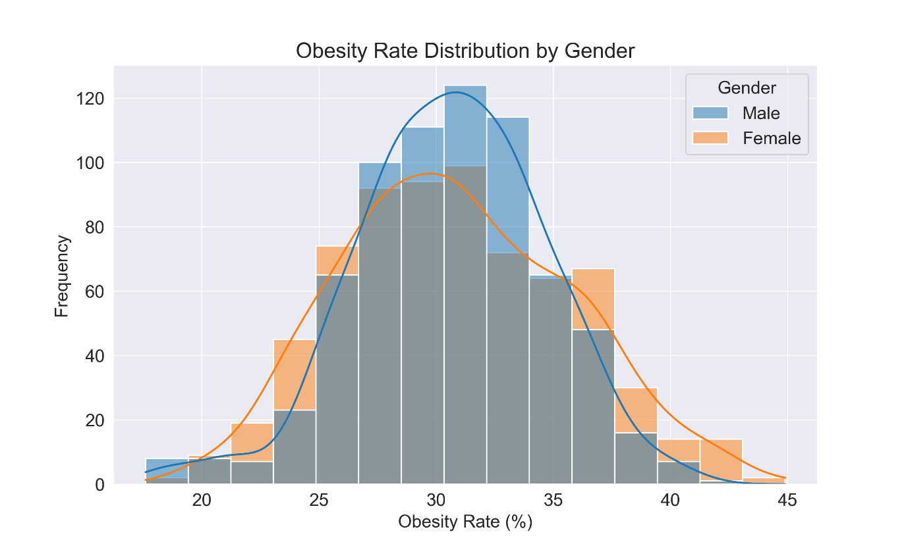

Figure 1: Distribution of obesity rate by Gender

Female Obesity Rate Distribution with mean of 30.842, is slightly higher than the median (30.600) and right-skew (confirmed by the Skewness of 0.198).The Mode of 27.100 is lower than both mean and median with more data clumped in lower 20s, but some high values pulling the average up. Male Obesity Rate Distribution has a mean of 30.625 is slightly less than the median of 30.700 and left-skew (confirmed by Skewness = -0.262).The mode of 32.300 is higher than both mean and median. Kurtosis Female and male are -0.441 (platykurtic) and 0.296 ( leptokurtic), respectively.

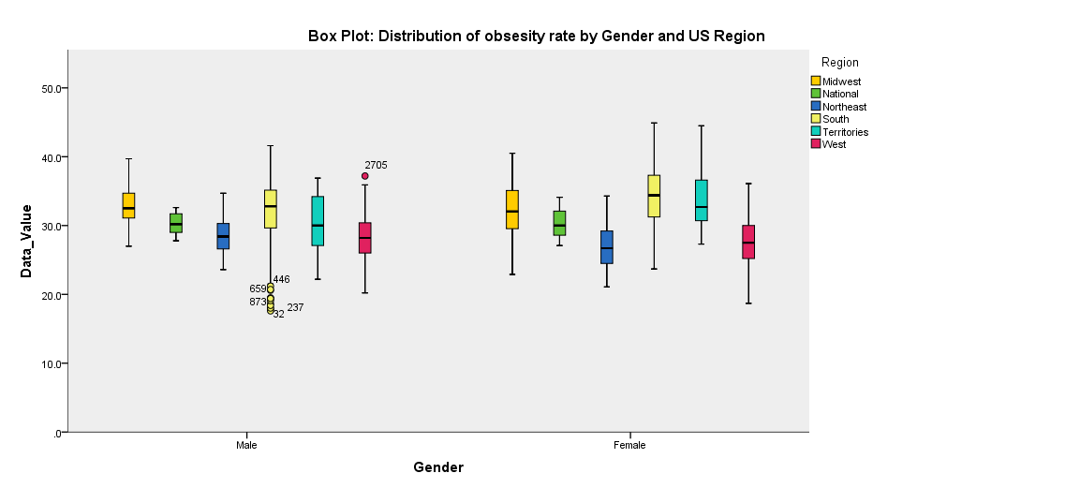
Figure 2: Box chart depicting the distribution, bivariate analysis, and visualization
of obesity rate by Gender and US region.
The same dispersion in the obesity rates across areas is presented by both sexes. There are regions like the South and Midwest that have greater median obesity rates with 50% the population with obesity higher than most parts of the U.S. Females tend to indicate slightly higher median values in nearly all areas. There are several apparent outliers in the data, with unusual high value (~50%) for the West region (Male).The obesity rates in U.S. territories (e.g., Guam, Puerto Rico) and the West are not consistent.Northeast is more compact, suggesting more homogenous data in these regions with the populace in those areas have similar obesity rates.

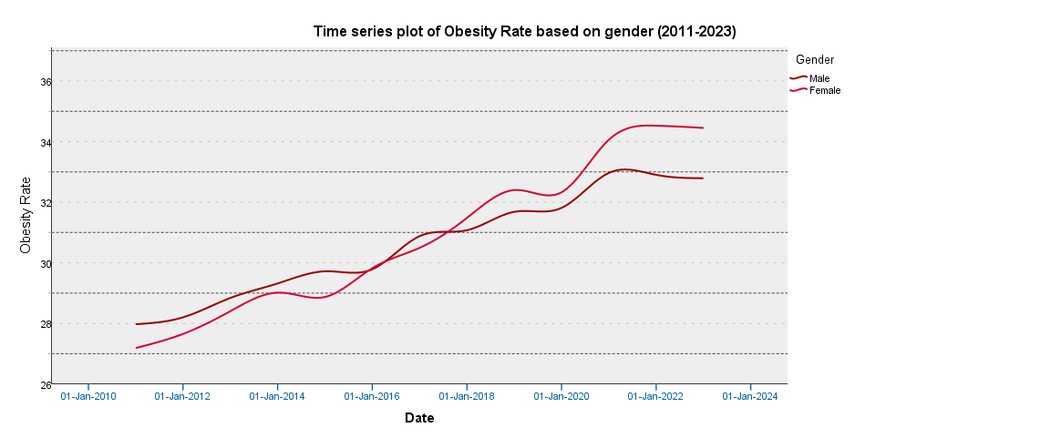
Figure 3: Time Series Chart showing upward trend for both Genders.
The obesity rates having increased steadily from 2011 to around 2020 that Indicates worsening obesity levels in the population. From about 2018 onward, females consistently show a slightly higher obesity rate than males. This gap widens around 2020–2021 and then stabilizes. There is Plateauing after 2021 with both genders show a flattening trend from 2021 to 2023 that could indicate stabilization or saturation ,possibly due to interventions, data reporting lags, or behavioral shifts post-COVID.

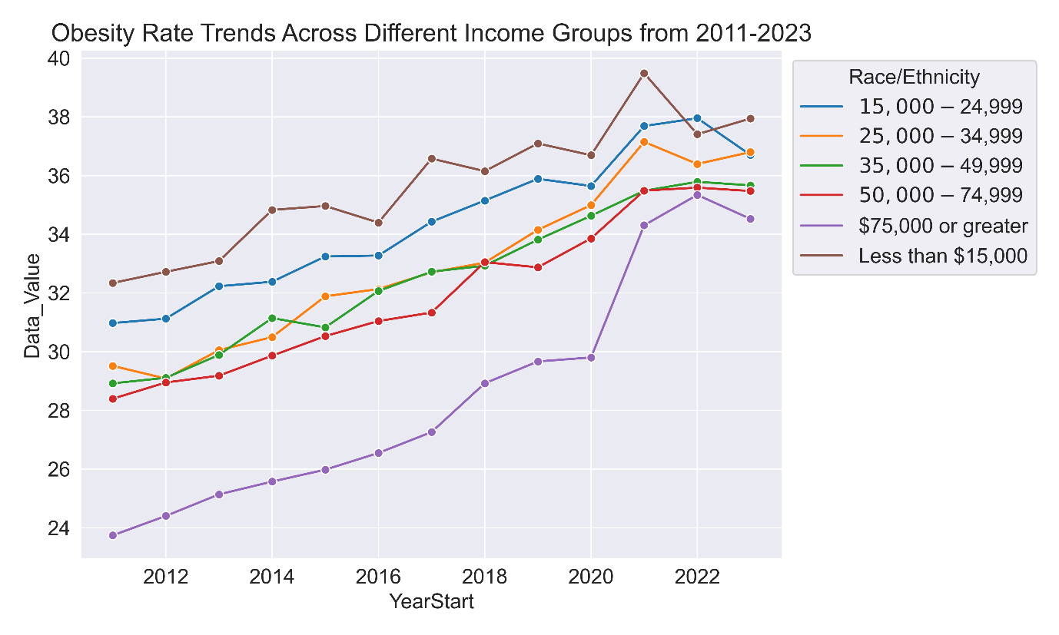
Figure 4:Obesity rate trends across income groups.
Obesity rates increased steadily for every income group over the years. Low-Income Groups (Less than $15,000) started lowest in 2011 (~24%), but showed the sharpest increase, peaking around 35% by 2021.There is rapid increase signaling worsening health outcomes in this group. Middle Income ($15,000–$49,999) showing moderate rise, reaching mid-30s by 2023.High Income earners ($75,000 and above) have consistently had the highest obesity rate, peaking near 39% around 2021, then slightly dropping. Counterintuitive but could reflect lifestyle patterns such as sedentary desk jobs and poor diet.
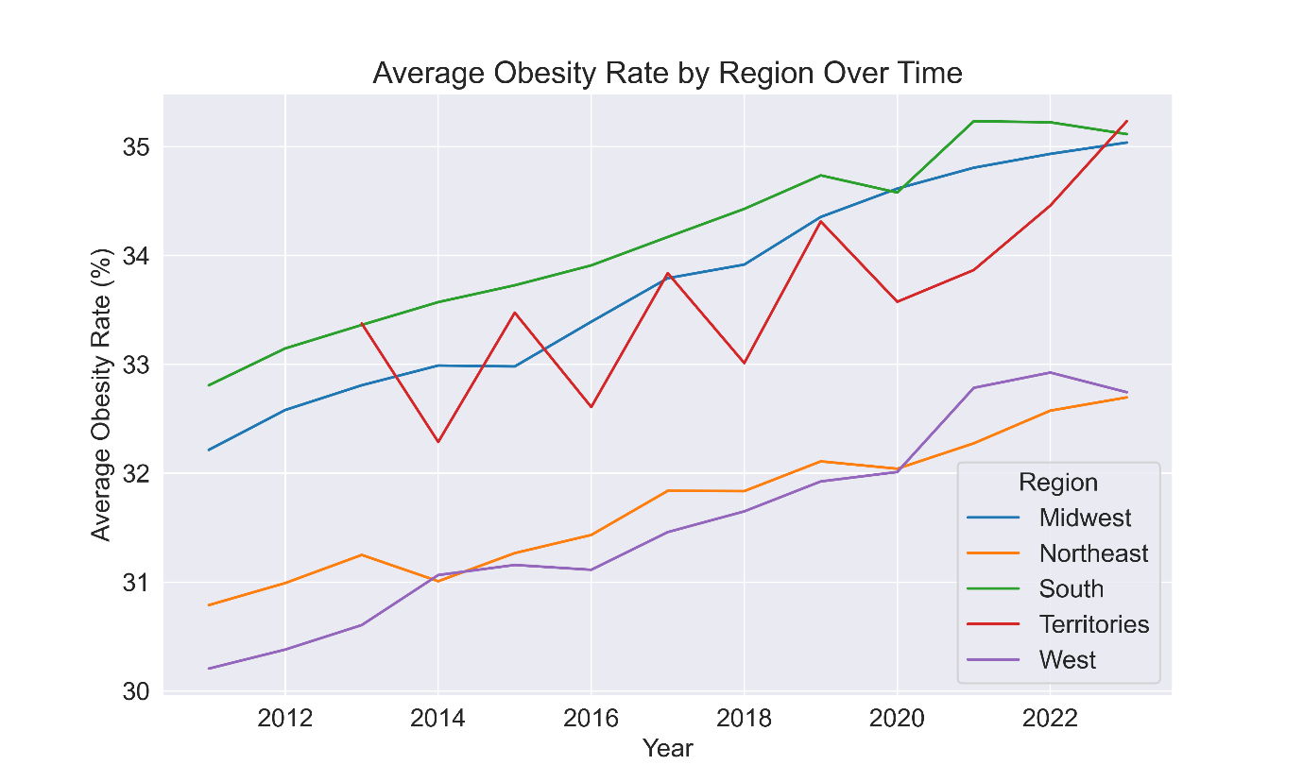

Figure 5: Average obesity rate by region over time.

Trend showing every region shows a gradual increase in obesity rates over the decade. Notably, the South region consistently has the highest obesity rates, beginning at around 33% in 2012 and rising to approximately 35% by 2022. The Midwest follows a similar upward pattern, starting near 32% and ending close to 34%, indicating a parallel trajectory with a marginally lower baseline compared to the South. The Territories exhibit more variability; their obesity rate fluctuates between 32% and 34% throughout the period, suggesting that this region might be experiencing different or more volatile local factors affecting obesity rates. This inconsistency may reflect variable socioeconomic or healthcare factors affecting obesity trends in these areas.
In contrast, the Northeast and West regions maintain the lowest measurements on the chart, with obesity rates beginning at about 31% in 2012. By 2022, the Northeast modestly rises to around 32%, while the West hovers near 31.5%, hinting at more stability or potentially more effective regional strategies to manage obesity.
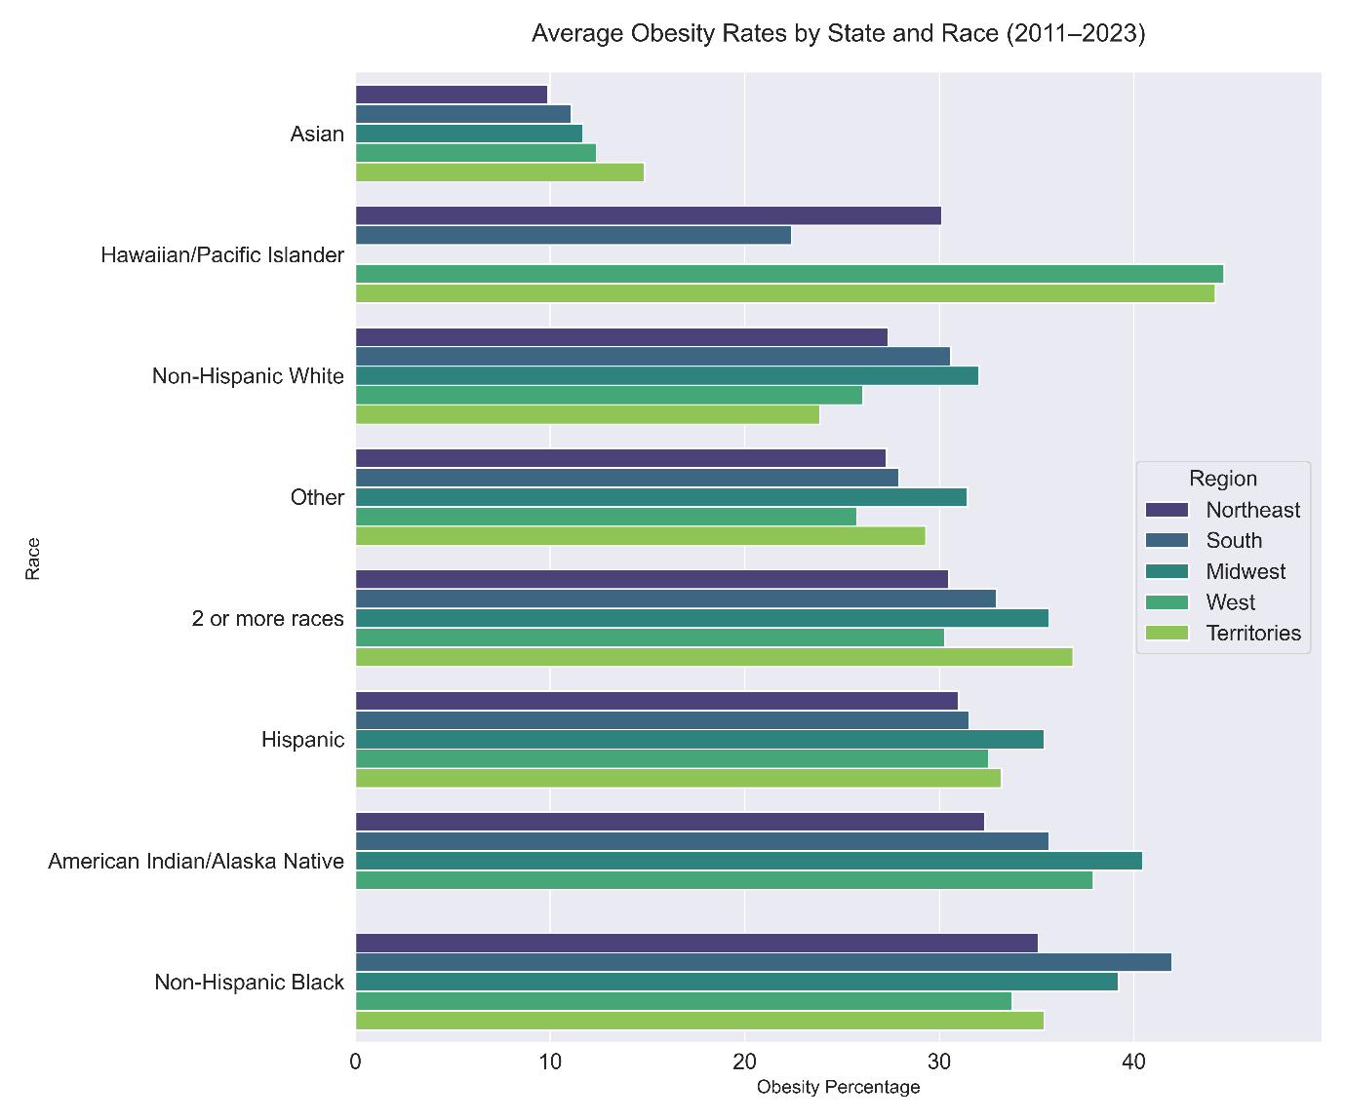
Figure 6: Average obesity rates by states and race (2011-2023).Asian populations consistently have the lowest obesity rates across all regions. Non-Hispanic Black individuals generally show the highest obesity rates, with Hawaiian/Pacific Islanders also recording elevated rates in certain regions, such as the Territories and South.

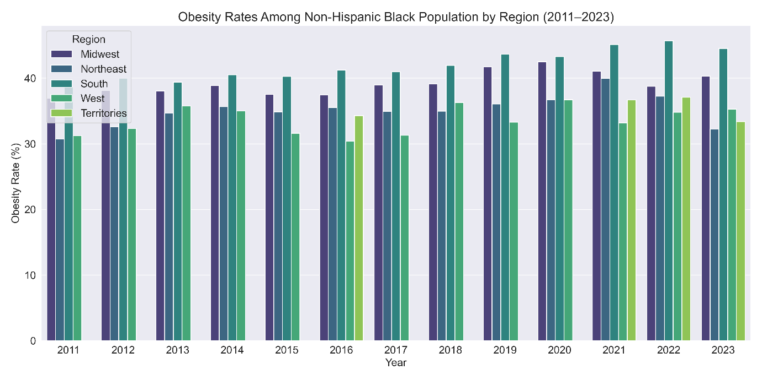
Figure 7: Obesity rates among non-Hispanic Black population by region (2011-2023).

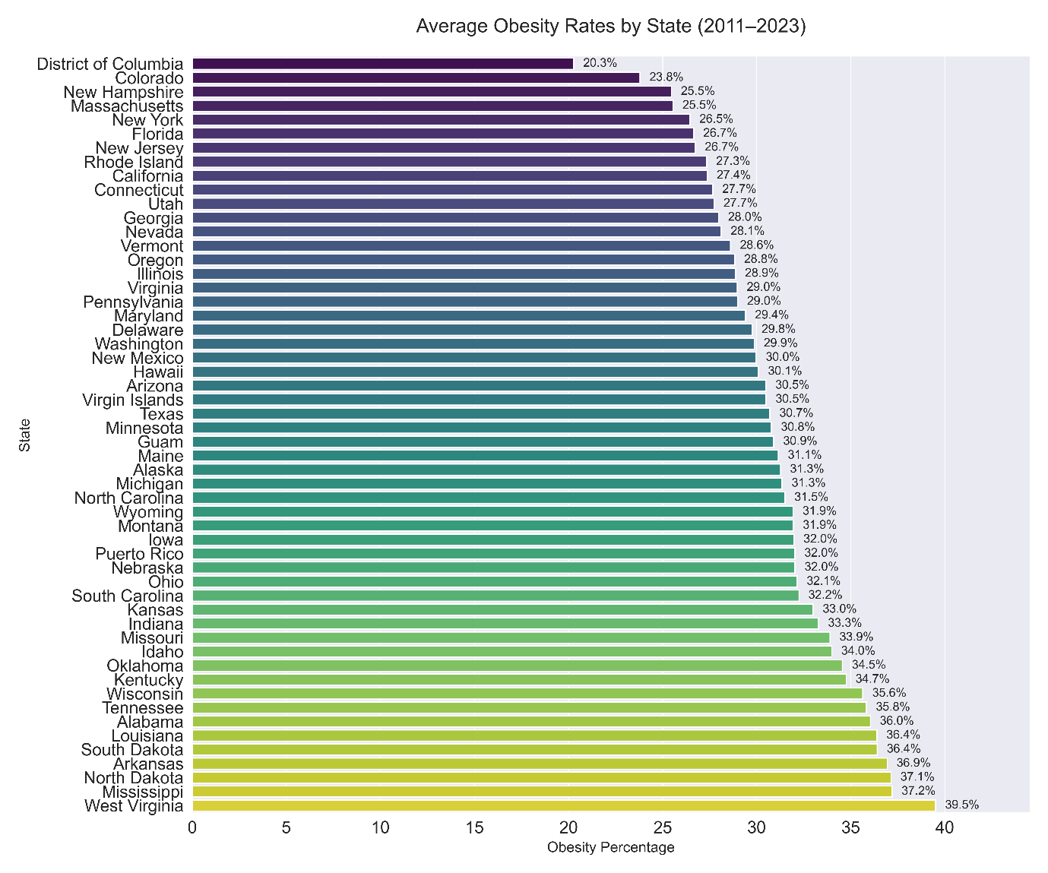
Figure 8: Average obesity rates by states(2011-2023).The District of Columbia stands out with the lowest average obesity rate at 20.3%. On the other hand, West Virginia tops the list with the highest rate at 39.5%,followed by Mississippi.
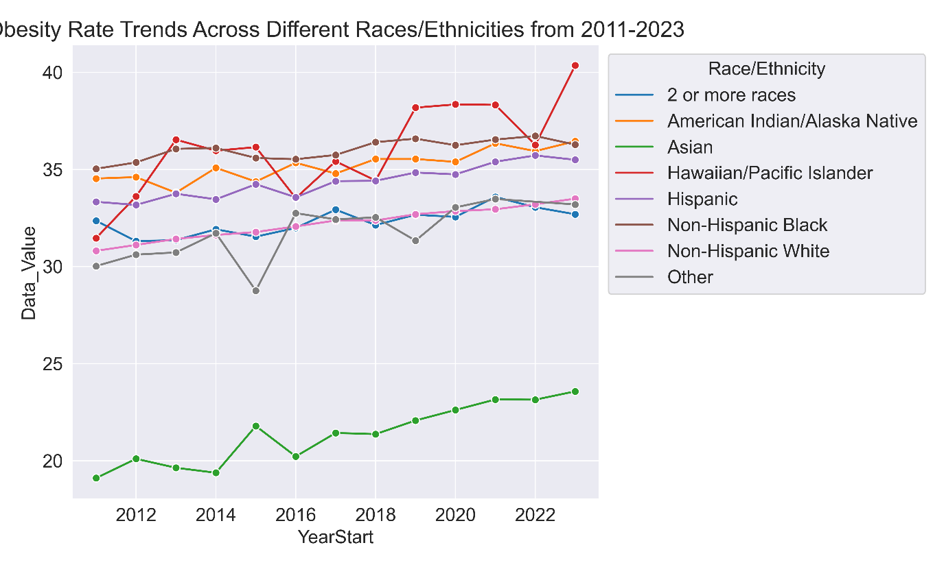
Figure 9: Obesity rate trends across different races and ethnicities from 2011-2023.
Hawaiian/Pacific Islander, Hispanic, Non-Hispanic Black, and American Indian/Alaska Native groups consistently show higher obesity rates, mostly above 35%.Asian individuals maintain the lowest obesity rates, starting around 20% in 2011 and slowly rising to 25% by 2023.Non-Hispanic White, Other, and those identifying as 2 or more races fluctuate between 30-35%.
A sharp increase is observed for Hawaiian/Pacific Islanders in 2023, reaching 40%, potentially indicating significant lifestyle, dietary, or socio-economic factors affecting this group. The trends reveal that certain racial and ethnic groups face higher risks of obesity, with disparities remaining consistent over the years. The Asian group maintains the lowest rates, while Hawaiian/Pacific Islander, Hispanic, Non-Hispanic Black, and American Indian/Alaska Native groups show the highest prevalence.

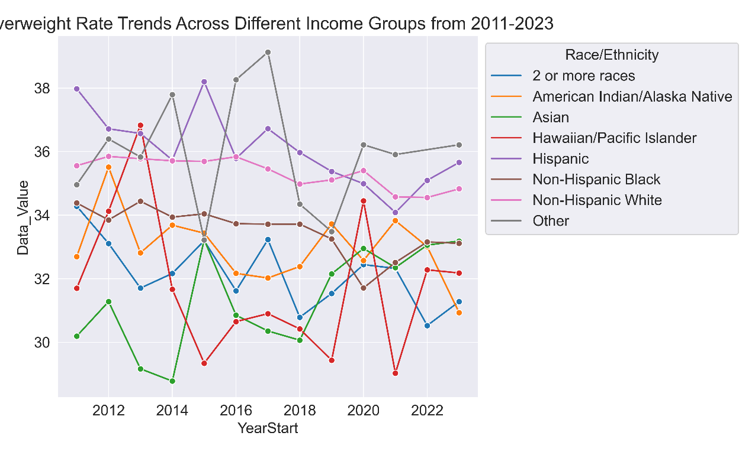
Figure 10: Overweight rate trends across different income groups from 2011-2023.
Hawaiian/Pacific Islander individuals maintain the highest overweight rate, peaking close to 38% in 2023.Asian individuals have the lowest overweight rates, consistently ranging between 30-31% throughout the years. Non-Hispanic Black, Hispanic, and American Indian/Alaska Native groups show higher overweight rates, fluctuating between 34-37%.The "2 or more races" and "Other" categories show varied trends, generally between 32-35%. The overall trend in the groups display a gradual increase in overweight rates, highlighting a growing public health concern.
The graph underscores racial and ethnic disparities in overweight rates over time. While Asian individuals consistently have lower rates, Hawaiian/Pacific Islanders, Hispanics, Non-Hispanic Blacks, and American Indian/Alaska Native individuals face higher risks. These trends may reflect differences in dietary habits, socioeconomic status, healthcare access, and lifestyle choices.
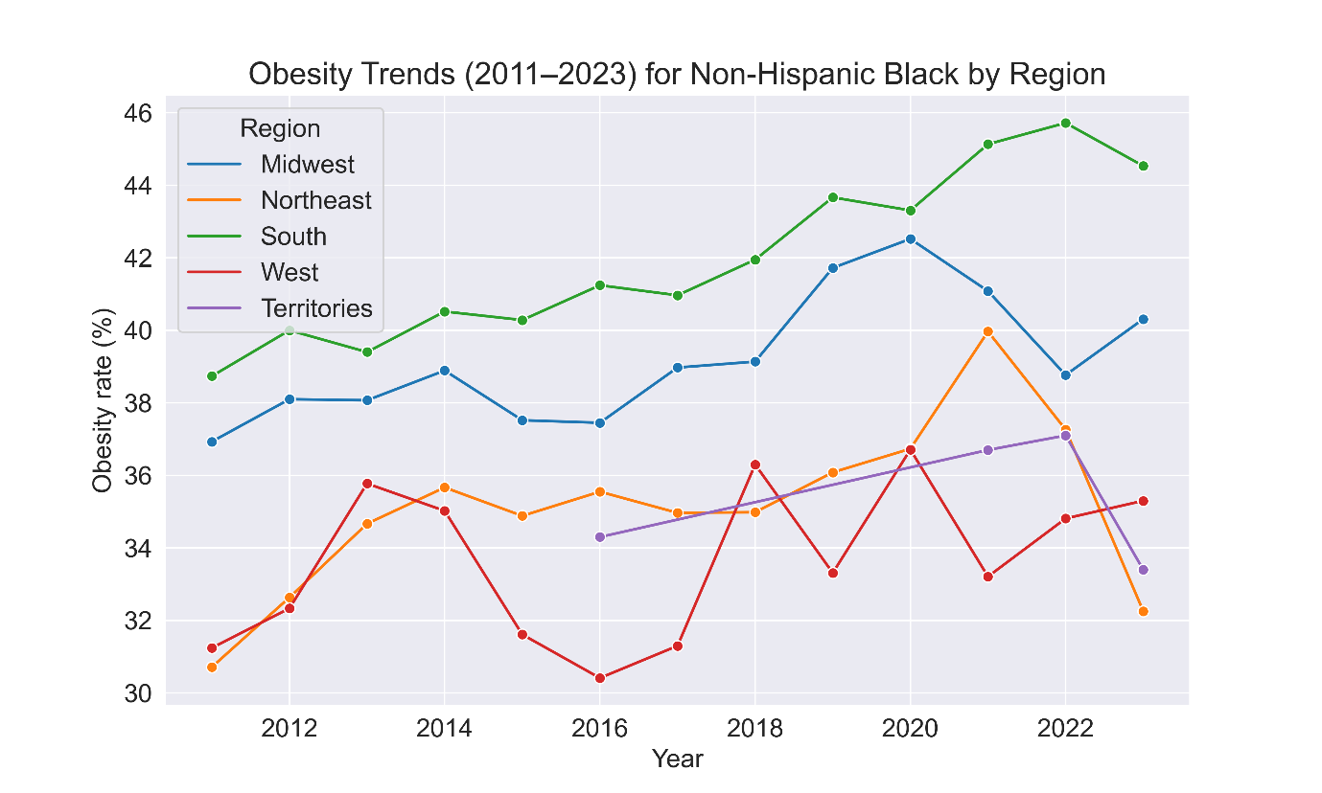

Figure 11: Obesity trends (2011-2023) for Non-Hispanic Black by Region.
South (Green): The chart clearly shows that the South consistently registers the highest obesity rates among Non-Hispanic Black individuals. Notably, its line peaks around 2022, indicating that this region might be facing persistent or even intensifying challenges when it comes to obesity. This could be reflective of various factors that ranges from socioeconomic conditions and healthcare access to cultural and environmental influences that uniquely affect this region.
Midwest (Blue): The Midwest line exhibits a general upward trend over the period. Although it may not be as high as the South's levels, the steady increase suggests emerging challenges that could eventually lead to rates that become concerning over time. This trend calls for early, targeted public health interventions to manage and potentially reverse the upward shift.
Northeast (Orange) and West (Red): Both the Northeast and West display more fluctuating behavior with obesity rates that vary over time. This variability could imply that these regions are experiencing more dynamic shifts, possibly due to intermittent public health interventions, varying economic conditions, or lifestyle changes that cause the rates to rise and fall rather than following a continuous pattern.
Territories (Purple): In contrast, the Territories show the lowest and most stable obesity rates throughout the years. This consistency might be due to a set of more uniform factors affecting this population or a different socio-cultural landscape compared to the other regions, leading to fewer fluctuations in obesity trends.

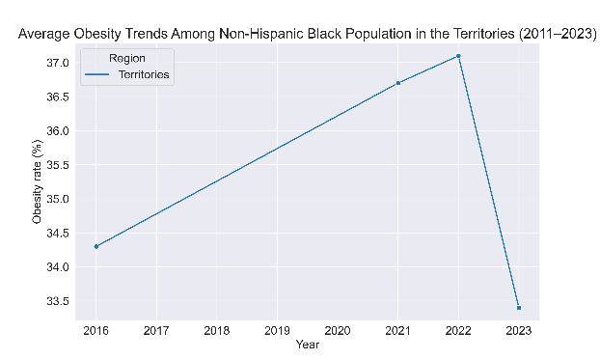
Figure 12:Average obesity trends among non-Hispanic black population(2011-2023) in the territories.

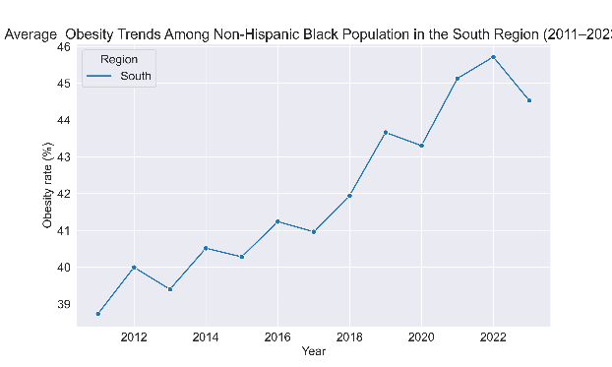
Figure 13: Average obesity trends among non-Hispanic Black population(2011-2023) in the south region.

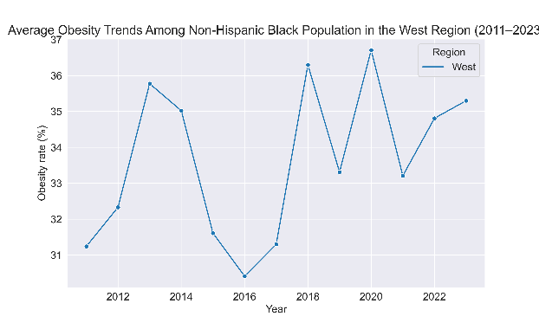
Figure 14: Average obesity trends among non-Hispanic Black population(2011-2023) in West region.

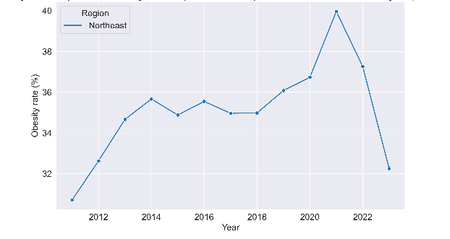
Figure 15: Average obesity trends among non-Hispanic Black population(2011-2023) in the East region.

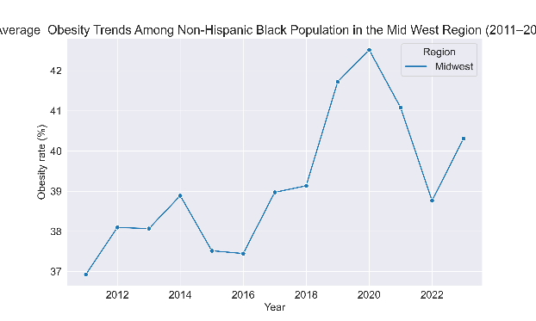
Figure 16: Average obesity trends among non-Hispanic Black population(2011-2023) in Mid-west region.
The average obesity trends among the non-Hispanic Black population from 2011 to 2023 are presented in Tables 1 and 2 for the U.S. territories and the South region, respectively. The highest obesity rates were observed in 2022. In contrast, the West region displayed considerable year-to-year variability, while the Midwest and Northeast regions showed peak rates in 2020 and 2021.
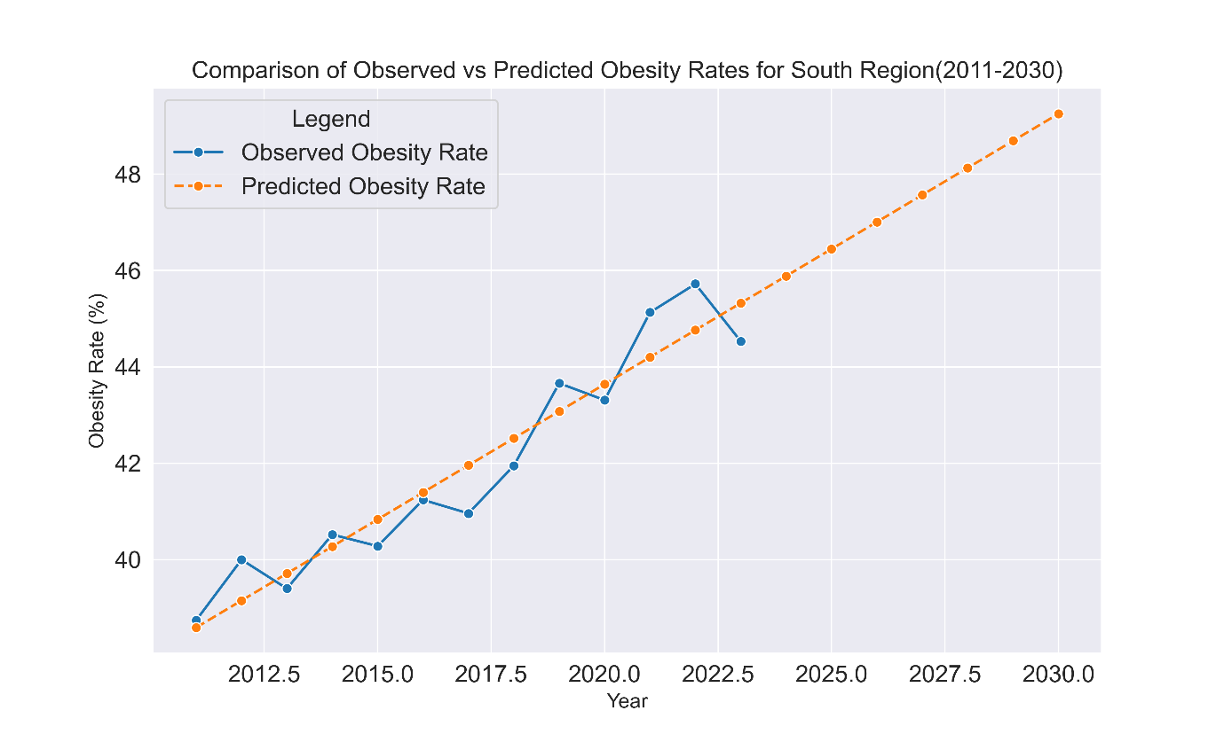
Figure 17:Comparison of observed and predicted rates for South Region(2011-2030).
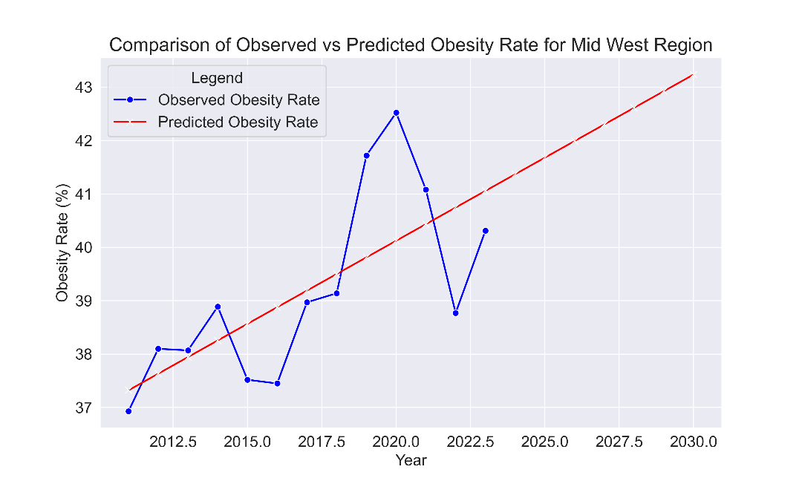

Figure 18:Comparison of observed and predicted rates for Mid-West Region(2011-2030).
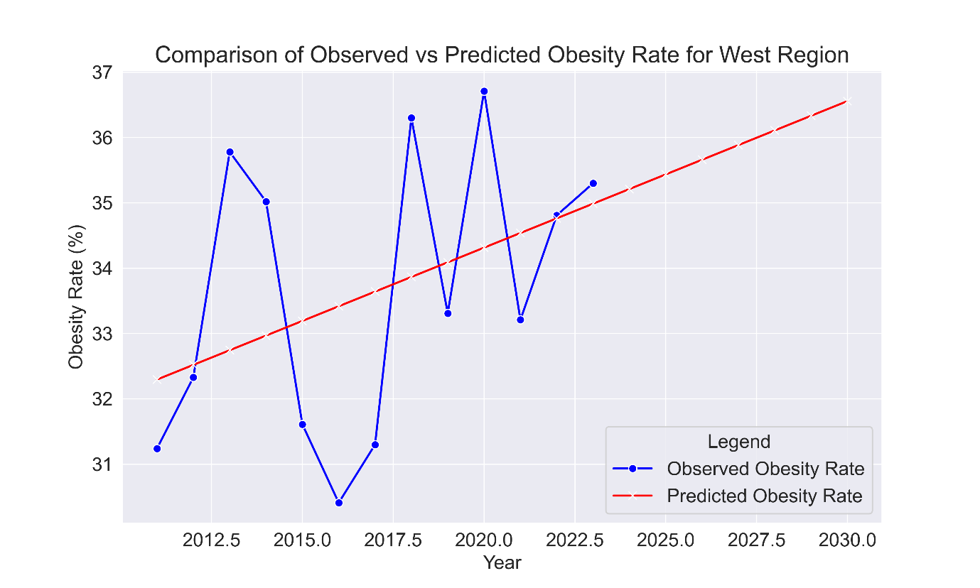
Figure19: Comparison of observed and predicted rates for Mid-West Region(2011-2030).
Figure 17-19 are showing the predicted values of obesity rate ranging from 38.59 to 45.32 with a mean of 41.96.The residuals (differences between observed and predicted values) range from -0.992 to 0.955 with a mean of 0, indicating that, on the average, the predictions are very close to the observed values. A value of 1.364 indicates that none of the residuals are unusually large, suggesting no significant outliers .An overall observation shows regression indicating that there is a general increase in obesity across all regions.
The linear regression model(red line) is a good fit for forecasting obesity rates in the South region for the Non-Hispanic Black population, and it suggest it can be used to predict future obesity rates for the next several years, assuming the trend remains similar.

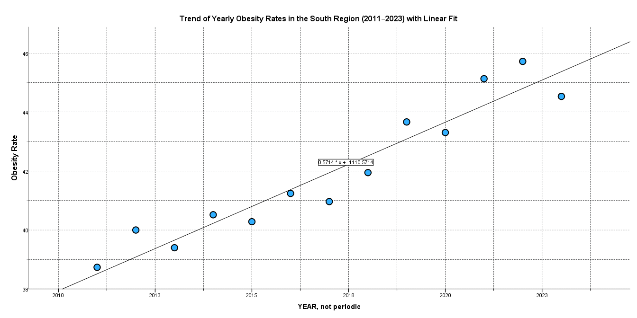

Figure 20: Trend of yearly obesity rates in the south region (2011-2023) with linear fit.
The correlation between the observed and predicted values of the obesity rate is quite strong ,R = 0.956 (close to 1), suggesting that the regression model explains a significant portion of the variability in the obesity rate. There is approximately 91.4%( R²) of the variance in the obesity rate can be explained by the year in the regression model, indicating a good fit. The Adjusted R² (0.906) accounts for the number of predictors in the model, and it's slightly lower than R², suggesting the model is robust and doesn't overfit the data, with standard Error of the Estimate = 0.70048, p-value is very small (p < 0.0001),95% Confidence Interval for YEAR (0.447 to 0.675) , positive coefficient (0.224) , 20-year to year prediction ranges from 32.3 -36.6 (Std Dev of 0.873, mean of 33.64).Based on this regression analysis, we can conclude that there is a significant strong positive trend in the obesity rate over the years, with a steady increase of about 0.561 percentage points per year in the South region for the Non-Hispanic Black population.
Overall, the linear regression model is a good fit for forecasting obesity rates in the South region for the Non-Hispanic Black population, and it suggests that it can be used to predict future obesity rates for the next several years, assuming the trend remains similar.

DISCUSSION
This population-based multi-level analysis explored geodemographic disparities in obesity prevalence across U.S. states using BRFSS data from 2011 to 2023. By stratifying results by race/ethnicity, gender, income, and geographic region, and applying statistical tests alongside regression-based forecasts, the study provides an integrated view of the patterns, disparities, and projected trajectories of obesity in the United States.
This multi-level analysis confirms persistent geodemographic and racial disparities in obesity across the U.S. High-risk populations, particularly non-Hispanic Black adults in the South, and is projected to surpass 49% prevalence by 2030 if current trends continue.
The Midwest followed a similar upward trajectory, whereas the Northeast and West maintained relatively lower levels, though still trending upward.
Racial and ethnic disparities were statistically significant (p < 0.001), with Hawaiian/Pacific Islander, Non-Hispanic Black, Hispanic, and American Indian/Alaska Native populations showing the highest prevalence often exceeding 35%. By contrast, Asian populations consistently recorded the lowest rates (<25%). Post hoc analysis confirmed significant mean differences between most groups, underscoring the role of racial/ethnic background in obesity risk. Income-related patterns revealed complexity. Obesity increased significantly among people earning less than $15,000, yet surprisingly, individuals with incomes above $75,000 were also notably affected. This trend could be linked to sedentary work environments, dietary preferences, and overall lifestyle patterns. Although overall obesity levels did not differ significantly between men and women, men were much more likely to fall into the overweight category compared to women.
In the study the predictive power accounts for 28.5% of the variation in obesity rates, indicating a relatively weak explanatory power. Although a moderate positive association exists between year and obesity rate, it indicates clearly that additional factors not included in the model contribute to these trends. The relationship between year and obesity rate is not statistically significant at the 5% level (p = 0.060). Therefore, based on this model, we cannot confidently attribute the observed increase in obesity rates solely to the progression of years. The residuals range from -4.78 to 3.57, suggesting that the model is generally unbiased. However, the presence of some large residuals indicates potential limitations in the model’s ability to fully capture underlying trends, possibly due to the restricted time span or unaccounted variables.
Based on this regression analysis, there is a significant positive trend in the obesity rate over the years, with a steady increase of about 0.561 percentage points per year in the South region for the Non-Hispanic Black population. The model fit has a very high R² value (91.4%), meaning it explains most of the variance in the obesity rate. The model is statistically significant with a low p-value(95% CI of .660), and the regression coefficients are highly significant (.060). The residuals seem to be normally distributed, and there is no significant autocorrelation, as indicated by the Durbin-Watson statistics (1.221-1.161). This suggests that the model fits the data well and is unlikely to be biased .Given the model's good fit, it could be used for forecasting future obesity rates in the region, though the model's linear nature means it assumes the trend will continue in a similar pattern in the future.
Interpretation and Implications
The findings indicate that obesity in the U.S. is influenced by a complex interaction of socioeconomic conditions, cultural norms, environmental contexts, and regional variations. High-burden populations particularly in the South and among certain racial/ethnic groups structural barriers to achieving and maintaining a healthy weight, that include limited access to affordable, nutritious foods, fewer safe recreational spaces, cultural dietary norms, and socioeconomic stressors.
In healthcare, primary care providers (PCPs) are well-placed to help narrow these gaps. Tailoring strategies to specific regions and cultural contexts can make interventions more effective. Examples include providing focused counseling on obesity, strengthening screening programs in high-risk neighborhoods, and incorporating social factors into care plans, which can support fairer health outcomes.
Obesity drives multiple cardiovascular and GI pathologies. African Americans are disproportionately affected by GERD, Barrett’s esophagus, NAFLD, pancreatitis, and colorectal cancer. Structural barriers including limited access to healthy foods, unsafe environments for physical activity, and socioeconomic stressors may compound these risks [1][2][5][6].
Future Directions for Management
1.Broaden multi-level and structural research
Research increasingly emphasizes interventions that go beyond individual behavior (diet/exercise) to include social, environmental, and policy levels. For example, a recent review of multilevel obesity interventions noted the need to integrate “individual, social, structural” influences[15][16].
Future studies should evaluate how neighborhood design, food environments, social norms, and macro-policy (e.g., taxation, marketing restrictions) contribute to obesity prevalence and trajectories. For instance, it is noted that social networks influence weight gain and loss, but mechanisms (norms, modelling) remain unclear. [15][16]
Clinicians and health systems should advocate for and engage with upstream interventions (e.g., community planning, food retail zoning, workplace wellness policy) alongside individual care. Use qualitative methods to better understand the daily realities of vulnerable groups, so that interventions are practical and culturally appropriate. Continue tracking progress through systems like BRFSS and health records to measure the impact of programs and adjust when needed.
2.Improve measurement and conceptualization of obesity
The traditional metric of Body Mass Index (BMI) is increasingly recognized as insufficient to capture body fat distribution, metabolic risk, and health outcomes. [17][18]
Research must refine definitions and measurements: e.g., incorporate waist circumference, imaging of adiposity, fat-function rather than simply weight. Also, conceptualizing obesity as a disease (not just a risk factor) is gaining traction. [17][19]
Clinicians should move toward using more nuanced assessment (e.g., waist/hip ratio, body composition when available) and tailor interventions accordingly rather than relying solely on BMI thresholds[18][19].
3.Focus on high-risk populations, disparities, and context
Obesity disproportionately affects certain demographic groups (by race/ethnicity, socioeconomics, geography). Research needs to dive deeper into contextual determinants, structural inequities, and targeted interventions in these populations. For example, social influences and environment are key. [20][21]. Studies of adolescents, young adults, and transitions (e.g., from adolescence to adulthood) are important. A review on adolescent obesity highlighted complexities of tailored treatment in that developmental period [20][22].
Practitioners should adopt culturally competent care, screen earlier in high-risk groups, and integrate social determinants into management plans (food insecurity, neighborhood access, stressors).
4.Incorporate emerging therapies, technology, and precision medicine
Pharmacotherapy, devices, and digital health are advancing. One review of anorexiants (appetite suppressants) outlined new combinations and targeted mechanisms [23].
Digital tools (wearables, apps) and predictive analytics (e.g., machine learning) offer opportunities for personalized monitoring/intervention, though evidence needs strengthening[24][25].
Clinics should prepare to integrate digital health tools (remote monitoring, telehealth lifestyle support) and stay updated on new therapies, while emphasizing that behavioural and social elements remain foundational [25].
5.Strengthen evidence based in complex clinical populations
Obesity interacts with many comorbidities (e.g., asthma, critical care, and nutrition). Reviews highlight gaps in how obesity modifies disease phenotypes and treatment responses (for example, obesity-related asthma). [26]
Nutrition and metabolic management in acute care/ICU settings for people with obesity has particular challenges (e.g., sarcopenic obesity, inflammation, energy needs) [27].
Health-care teams must recognize obesity as modifying factor in many disease-states, adjust screening/treatment accordingly, and participate in research that refines best practice for these sub-populations.
6.Improve translation of research into guidelines and practice
There is evidence that many clinical practice guidelines for chronic diseases inadequately incorporate current obesity management guidance [28].Future research should test implementation strategies: how to integrate obesity screening, treatment, referral, multidisciplinary teams, and health-system design into routine care[29].
Practices should advocate for institutional support (e.g., obesity-clinics, dietitian/behavioral health access), train providers in obesity management, and monitor process/outcome metrics (weight change, complication prevention).
7.Evaluate long-term outcomes, sustainability, and cost-effectiveness
Many obesity intervention studies have short follow-up; future research needs to assess durability of effect, real-world implementation, cost-effectiveness, and unintended consequences [30].Research on internalized weight stigma is emerging: a scoping review noted this as an important domain for future work[31].
Care models should include follow-up beyond initial weight loss, plan for maintenance, assess for psychosocial consequences (stigma, mental health), and consider the economic value of interventions.
8.Use advanced analytics and modelling
Spatio-temporal modelling and machine learning approaches can enhance understanding of obesity trends, predictors, and interventions. For example, a Bayesian beta-regression model of Italian regions highlighted regional heterogeneity in obesity[32][33].
Health systems can leverage big data (EHRs, claims, public health data) to identify hot-spots, high-risk patients, tailor interventions and monitor impact longitudinally[33].

CONCLUSION
Significant disparities in obesity rates persist across U.S. regions and populations, and without coordinated, targeted interventions, these gaps are likely to widen further. High-risk groups in the particularly studied residents of the South, Hawaiian and Pacific Islanders, non-Hispanic Black individuals, and low-income populations require urgent, multifaceted strategies that integrate clinical care, community engagement, and policy reform. Among all regions, the South continues to exhibit the highest obesity prevalence, especially within the non-Hispanic Black population. Based on the current trajectory, rates in this group are projected to exceed 49% by 2030 if current patterns remain unchanged. The linear regression model demonstrates a reasonably good fit for forecasting obesity trends in this region, suggesting it can be used to estimate future rates over the next several years provided that the underlying trend remains stable.
Overall, obesity in the United States remains unevenly distributed, reflecting the influence of complex social, environmental, and structural determinants. Addressing these disparities requires a shift from individual-focused behavioral interventions toward comprehensive, multi-level approaches that incorporate precision medicine, advanced data modeling, and context-specific public health strategies. Clinicians and researchers alike should prepare for this evolution by adopting more inclusive and precise assessment tools beyond BMI, integrating social determinants of health into care, leveraging technology for patient engagement, and developing sustainable systems that promote long-term weight management.
In summary, our regression analysis indicates a general upward trend in obesity across all U.S. regions, underscoring the urgent need for regionally tailored, equitable, and evidence-based action to reverse these trends and improve population health outcomes.

REFERENCES
- Myers, C. A., Slack, T., Martin, C. K., Broyles, S. T., & Heymsfield, S. B. (2015). Regional disparities in obesity prevalence in the United States: A spatial regime analysis. Obesity (Silver Spring). https://doi.org/10.1002/oby.20963
- Baez, A. S., Ortiz-Whittingham, L. R., Tarfa, H., Osei Baah, F., Thompson, K., Baumer, Y., & Powell-Wiley, T. M. (2023). Social determinants of health, health disparities, and adiposity. Progress in Cardiovascular Diseases https://doi.org/10.1016/j.pcad.2023.04.011
- Singh, G. K., Kogan, M. D., & van Dyck, P. C. (2008). A multilevel analysis of state and regional disparities in childhood and adolescent obesity in the United States. Journal of Community Health, 33(2), 90-102. https://doi.org/10.1007/s10900-007-9071-7
- Washington, T. B., Johnson, V. R., Kendrick, K., Ibrahim, A. A., Tu, L., Sun, K., & Stanford, F. C. (2023). Disparities in Access and Quality of Obesity Care. Gastroenterology Clinics of North America, 52(2), 429-441. https://doi.org/10.1016/j.gtc.2023.02.003
- Hales, C. M., Carroll, M. D., Fryar, C. D., & Ogden, C. L. (2020). Prevalence of obesity and severe obesity among adults: United States, 2017–2018. NCHS Data Brief, (360), 1-8. https://www.cdc.gov/nchs/products/databriefs/db360.htm
- Wang, Y., & Beydoun, M. A. (2007). The obesity epidemic in the United States—Gender, age, socioeconomic, racial/ethnic, and geographic characteristics: A systematic review and meta-regression analysis. Epidemiologic Reviews, 29, 6-28. https://doi.org/10.1093/epirev/mxm007
- Ogden, C. L., Fryar, C. D., Martin, C. B., Freedman, D. S., Carroll, M. D., Gu, Q., & Hales, C. M. (2020). Trends in Obesity Prevalence by Race and Hispanic Origin—1999–2000 to 2017–2018. JAMA, 324(12), 1208-1210. https://doi.org/10.1001/jama.2020.14590
- Drewnowski, A., & Specter, S. E. (2004). Poverty and obesity: The role of energy density and energy costs. American Journal of Clinical Nutrition, 79(1), 6-16. https://doi.org/10.1093/ajcn/79.1.6
- Centers for Disease Control and Prevention. (2022). Adult obesity prevalence maps. https://stacks.cdc.gov/view/cdc/129000
- Befort, C. A., Nazir, N., & Perri, M. G. (2012). Prevalence of obesity among adults from rural and urban areas of the United States: Findings from NHANES (2005–2008). J Rural Health, 28(4), 392-397. https://doi.org/10.1111/j.1748-0361.2012.00411.x
- Larson, N. I., Story, M. T., & Nelson, M. C. (2009). Neighborhood environments: Disparities in access to healthy foods in the U.S. American Journal of Preventive Medicine, 36(1), 74-81. https://doi.org/10.1016/j.amepre.2008.09.025
- Robert, S. A., & Reither, E. N. (2004). A multilevel analysis of race, community disadvantage, and body mass index among adults in the US. Social Science & Medicine, 59(12), 2421-2434. https://doi.org/10.1016/j.socscimed.2004.03.034
- Mujahid MS, Roux AVD, Borrell LN, Nieto FJ. Cross-sectional and longitudinal associations of BMI with socioeconomic characteristics. Obesity. 2005;13(8):1412-21. https://doi.org/10.1038/oby.2005.171
- Kushner, R. F., & Ryan, D. H. (2014). Assessment and lifestyle management of patients with obesity: clinical recommendations from systematic reviews. JAMA, 312(9), 943-952. https://doi.org/10.1001/jama.2014.10432
- Swanson, M., Kumanyika, S., & Diez Roux, A. V. (2018).Multilevel obesity interventions: A review of approaches and evidence across individual, social, and structural levels. Annual Review of Public Health, 39, 355–378.
https://doi.org/10.1146/annurev-publhealth-040617-013521
- Christakis, N. A., & Fowler, J. H. (2007).The spread of obesity in a large social network over 32 years. New England Journal of Medicine, 357(4), 370–379.
https://doi.org/10.1056/NEJMsa066082
- Hruby, A., & Hu, F. B. (2015).The epidemiology of obesity: A big picture.
Pharmacoeconomics, 33(7), 673–689.
https://doi.org/10.1007/s40273-014-0243-x
- Kyle, T. K., & Stanford, F. C. (2018).Fat, weight, and the law: Obesity as disease, obesity discrimination, and workplace protections. Obesity Medicine, 9, 10–15.
https://doi.org/10.1016/j.obmed.2018.05.001
- Associated Press. (2023, July 15).BMI criticized as flawed measure of health risk. AP News.
https://apnews.com/article/bmi-health-risk-measurement-limitations-obesity
- Wang, Y., & Lim, H. (2012).The global childhood obesity epidemic and the association between socio-economic status and childhood obesity. International Review of Psychiatry, 24(3), 176–188.
https://doi.org/10.3109/09540261.2012.688195
- Dennison, B. A., Edmunds, L. S., & Stratton, H. H. (2002).Childhood overweight and parental perceptions. Public Health Nursing, 19(2), 74–81.
https://doi.org/10.1046/j.1525-1446.2002.190205.x
- Reilly, J. J., & Kelly, J. (2011).Long-term impact of overweight and obesity in childhood and adolescence on morbidity and premature mortality in adulthood. International Journal of Obesity, 35(7), 891–898.
https://doi.org/10.1038/ijo.2010.222
- Wilding, J. P. H., Batterham, R. L., Calanna, S., et al. (2021).Once-weekly semaglutide in adults with overweight or obesity. New England Journal of Medicine, 384(11), 989–1002.
https://doi.org/10.1056/NEJMoa2032183
- Bauer, M. S., Damschroder, L., Hagedorn, H., Smith, J., & Kilbourne, A. (2015).An introduction to implementation science for the non-specialist. BMC Psychology, 3, 32.
https://doi.org/10.1186/s40359-015-0089-9
- Hoffman, D. L., & Novak, T. P. (1996).Marketing in hypermedia computer-mediated environments: Conceptual foundations. Journal of Marketing, 60(3), 50–68.
https://doi.org/10.1177/002224299606000304
- Beuther, D. A., & Sutherland, E. R. (2007).Overweight, obesity, and incident asthma: A meta-analysis of prospective epidemiologic studies. American Journal of Respiratory and Critical Care Medicine, 175(7), 661–666.
https://doi.org/10.1164/rccm.200611-1751OC
- Weijs, P. J. M., & Sauerwein, H. P. (2007).Nutrition in the critically ill obese patient.
Current Opinion in Clinical Nutrition & Metabolic Care, 10(2), 176–181.
https://doi.org/10.1097/MCO.0b013e32802deb53
- Rubino, F., Puhl, R. M., Cummings, D. E., Eckel, R. H., Ryan, D. H., Mechanick, J. I., Nadglowski, J., Ramos Salas, X., Schauer, P. R., Twenefour, D., Apovian, C. M., Aronne, L. J., Batterham, R. L., Berthoud, H.-R., Boza, C., Busetto, L., Dicker, D., De Groot, M., Eisenberg, D., Flint, S. W., Huang, T. T., Kaplan, L. M., Kirwan, J. P., Korner, J., Kyle, T. K., Laferrère, B., le Roux, C. W., McIver, L., Mingrone, G., Nece, P., Reid, T. J., Rogers, A. M., Rosenbaum, M., Seeley, R. J., Torres, A. J., & Dixon, J. B. (2020). Joint international consensus statement for ending stigma of obesity. Nature Medicine, 26(4), 485–497. https://doi.org/10.1038/s41591-020-0803-x
- Kahan, S., & Manson, J. E. (2017). Nutrition counseling in clinical practice: How clinicians can do better. JAMA, 318(12), 1101–1102. https://doi.org/10.1001/jama.2017.10434
- Finkelstein, E. A., Trogdon, J. G., Cohen, J. W., & Dietz, W. (2009).Annual medical spending attributable to obesity: Payer-and service-specific estimates. Health Affairs, 28(5), w822–w831.
https://doi.org/10.1377/hlthaff.28.5.w822
- Rudolph, C. W., & Zacher, H. (2020).Weight stigma in the workplace: What we know, and where we need to go. Human Resource Management Review, 30(1), 100702.
https://doi.org/10.1016/j.hrmr.2019.100702
- Di Biase, R. M., & Di Maio, A. (2020).Bayesian spatio-temporal models for obesity prevalence in Italian regions.Spatial Statistics, 35, 100423.
https://doi.org/10.1016/j.spasta.2019.100423
- Goldstein, B. A., Navar, A. M., Pencina, M. J., & Ioannidis, J. P. A. (2017).Opportunities and challenges in developing risk prediction models with electronic health records data: A systematic review. Journal of the American Medical Informatics Association, 24(1), 198–208.
https://doi.org/10.1093/jamia/ocw042

