Original Research Article
Prevalence of intestinal helminthiasis among patients referred for coproparasitological examination at the Ouakam Military Hospital between 2015 - 2016 in Senegal

ABSTRACT
Background: Intestinal helminthiasis is a public health problem in developing countries, affecting more than two billion people. The aim of this study was to determine the prevalence of intestinal helminthiasis in patients referred for coproparasitological stool analysis at the Ouakam Military Hospital.
Methods: Direct examination of fresh samples and the modified Ritchie concentration method were performed on 519 samples received between January 2015 through December 2016.
Findings: Total of 519 sample, 36 were positive, representing a prevalence rate of 6.94%. Male patients were the most infested of 7.17% compared with 6.74% for female patients. Adults aged 45 to 60 and children under 15 were the most infested, with prevalences of 10.29% and 7.65% respectively. The helminths encountered were Ascaris lumbricoides (86%), Taenia saginata/solium (8%), Dicrocoelium dentriticum (3%) and Hymenolepis nana (3%).
Conclusion: The results of our study show that intestinal helminthiasis is still present in Dakar, even if the rate is low and the study was only conducted in one hospital.

Keywords: Helminthiasis, Intestinal, Prevalence, Dakar, Coproparasitological

1. Introduction
Helminthiasis refers to parasitic diseases caused by intestinal parasitic worms, known as helminths (Guillaume, 2007). These can be divided into three main class groups: nematodes, trematodes and cestodes. Nematodes are roundworms with unsegmented bodies covered in hard integuments. They have a direct development cycle but can sometimes use an obligate or facultative intermediate host. Trematodes are flatworms with unsegmented bodies and a digestive tract without an anus, requiring two distinct intermediate hosts, most often an aquatic mollusc. Cestodes are flatworms, hermaphrodites whose bodies are divided into three parts: the head or scolex bearing the attachment organ, the neck, and the body or strobile formed of rings or proglottids requiring an intermediate host (Hedley & Wani, 2015). Contamination occurs mainly through the ingestion of contaminated food and water (oro-faecal contamination). These parasites are therefore closely linked to faecal contamination and are particularly common among populations in tropical developing countries where faecal hygiene is inadequate or non-existent (Parija et al., 2017).
Intestinal helminthiasis is a public health problem in developing countries, affecting more than 2 billion people. Today, intestinal helminthiasis is one of the neglected tropical diseases, symptomatic of poverty and poor living conditions (Bethony et al., 2006). Those most affected are the poorest populations living in remote rural areas, slums or conflict zones. With little political impact, these diseases receive little attention and struggle to rise to the top of public health priorities (Ndiaye et al., 2013). Although mortality from these infections is relatively low and complications are uncommon, many cases nevertheless require hospital care. These complications, which include malabsorption, diarrhoea, blood loss, loss of working capacity, etc., constitute social and health problems, particularly in Senegal. Thus, these endemic intestinal parasitic infections are closely linked to economic and social development processes (Hotez et al., 2008). Gap research…?????
The objective of this study is to determine the prevalence of intestinal helminthiasis in patients referred for parasitological examination of stool samples (KAOP: cysts, amoebas, eggs, parasites) at the Ouakam Military Hospital and to study their distribution according to age and gender.
2. Materials and Methods
2.1. Study setting and population
This study was conducted at the medical analysis laboratory of the Ouakam Military Hospital (HMO) located in the Almadies district west of the capital, Dakar. The study population consisted of patients referred to the laboratory for parasitic coproparasitology between January 2015 and December 2016, corresponding to a study period of two years. This was a retrospective study (from January 2015 to December 2015) and a prospective study (from January 2016 to December 2016).
Stool samples were collected in transparent, sterile plastic pots (Figure 1) at the laboratory or transported directly if the sample was taken at other hospital clinical departments.
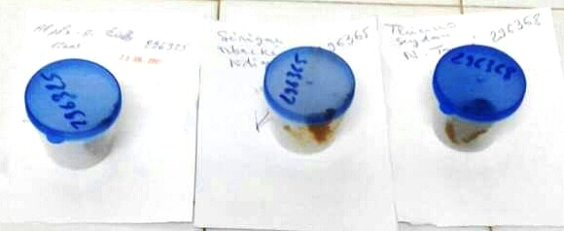
Figure 1: KAOP pots
2.2. Laboratory examination
The search for intestinal helminths was carried out by direct examination in fresh state and by examination after concentration using the modified Ritchie method (Guillaume, 2007). This is a two-phase method for concentrating protozoan cysts and helminth eggs. It involves diluting a small amount of stool in a stemmed glass containing a 10% formalin solution, then straining the solution into a conical-bottomed tube (Figure 2) using a fine-mesh sieve (gauze). An equal volume of ether is then added and the tube is closed so that the mixture can be emulsified by vigorous shaking for 30 seconds. The tube is opened slightly to allow the gas to escape, then closed again and centrifuged at 1,500 rpm. Finally, discard the supernatant (3 layers) and collect the pellet with a Pasteur pipette, then examine it between a slide and cover slip at ×100 and ×400 magnification.
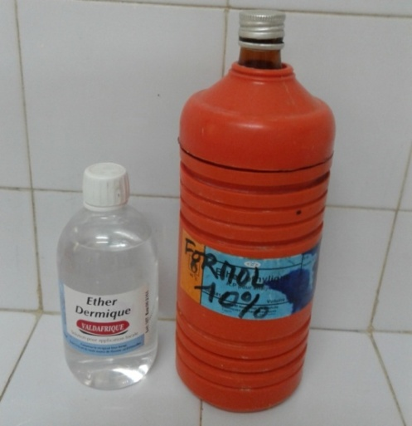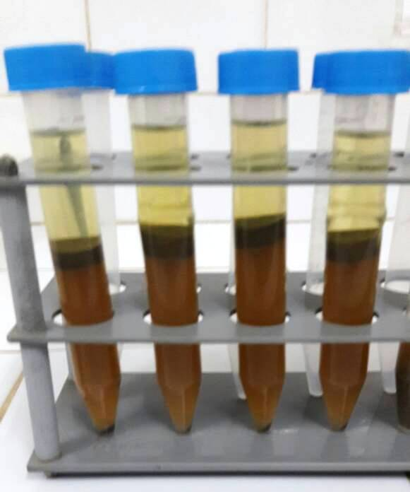

Figure 2: Ether and Formol 10% (Left)/Conical-bottom tubes (Right)
2.3. Observation under an optical microscope
The identification of parasitic species under an optical microscope was based on the use of standardised identification sheets available on the workbench (Figure 3 & 4). This made it possible to recognise the morphological characteristics of the helminth eggs observed. These sheets include criteria such as shape, size, colouring and shell structure, as well as the presence of integuments or opercula specific to each species. In this context, the study focused on the helminth eggs most frequently encountered in hospitals, particularly those responsible for common intestinal infections. This approach not only enabled rapid and reliable identification of the parasites present in the samples, but also provided better guidance for epidemiological data by highlighting the predominant species in the population studied.
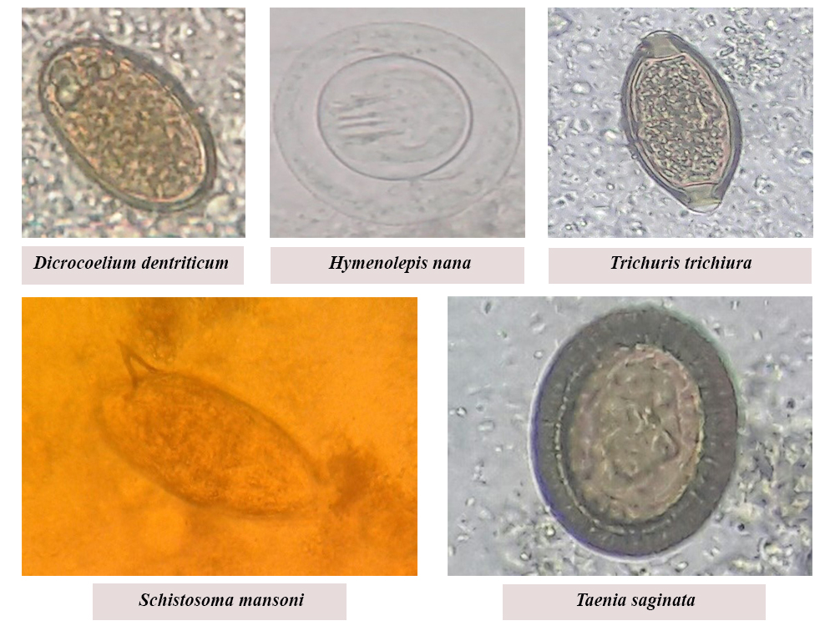
Figure 3: Lab bench sheet 1 for identifying helminth eggs
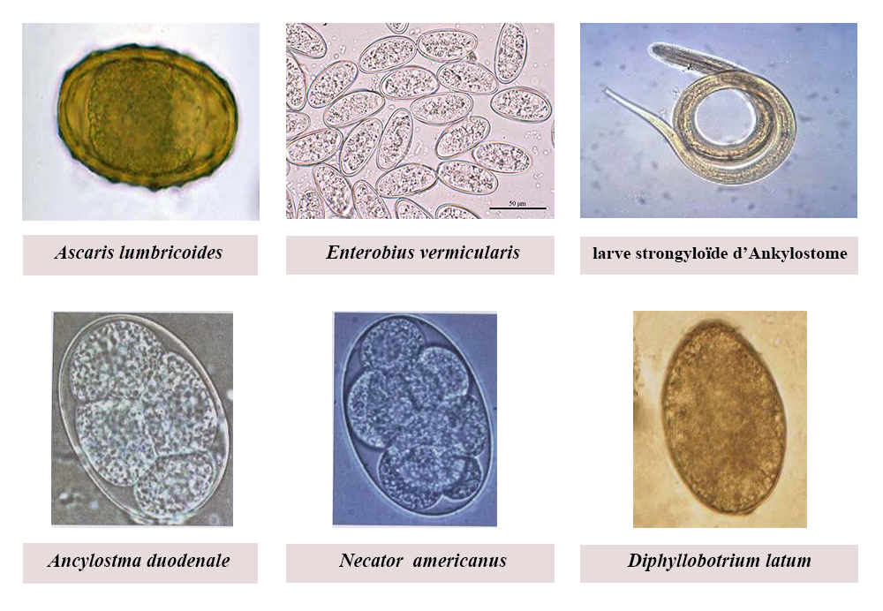 Figure 4: Lab bench sheet 2 for identifying helminth eggs

2.3.1. Trichuris trichiura
The eggs have a very distinctive shape (Figure 3): yellow-orange in colour, they are ovoid, measuring 50 to 65µm long and 23 to 30µm wide, with a thick brown shell and a mucous cap at each end, giving them a ‘lemon’ appearance. They are not embryonated in freshly emitted faeces (Caumes et al., 2005).

2.3.2. Enterobius vermicularis
The eggs, which are colourless and smooth, have an asymmetrical oval shape (Figure 4). They measure 50 to 60 μm in length and 30 to 32 μm in width (ANOFEL, 2014).

2.3.3. Ascaris lumbricoides
Oval in shape (Figure 4), they measure 40 to 50 μm wide by 60 to 70 μm long. At ×400 magnification, a double brown shell is clearly visible: a smooth, thick, yellowish inner shell surrounded by a thick, bumpy, mahogany-coloured outer structure (Desoubeaux & Chandenier, 2012).

2.3.4. Ancylostoma duodenale and Necator americanus
The eggs are light in colour, ovoid and symmetrical with a smooth, thin shell (Figure 4). Ancylostma duodenale eggs measure 60 to 65 μm in length and 40 μm in width, while Necator americanus eggs are slightly larger (70 μm) (Guillaume, 2007).

2.3.5. Strongyloides stercoralis
The eggs (50 to 55 μm in diameter) are rarely found in stool samples. The rhabditoid larva is characterised by: a double oesophageal bulge, a short mouthpart, and a slightly tapered posterior end (Figure 4). The genital bud is usually clearly visible. Only the strongyloid larva is parasitic. It has a single oesophageal bulge and a truncated bifid tail. It has no sheath (ANOFEL, 2014).

2.3.6. Fasciola hepatica
The eggs are oval-shaped with a fairly thick smooth shell and an operculum at one end that does not deform the egg (Figure 3). They are yellow-brown in colour and measure 140 µm long and 80 µm wide (Guillaume, 2007).

2.3.7. Dicrocoelium dentriticum
The eggs are 45 µm long and 25 µm wide. They are oval, asymmetrical, operculated (Figure 3) and are excreted with faeces (Andriamanantena et al., 2005).

2.3.8. Schistosoma mansoni
The egg is light yellow in colour, transparent, oval in shape with a lateral spur (Figure 3). The shell is thin, light yellow and fairly rough. The living ciliated embryo is mobile inside the egg (Guillaume, 2007).

2.3.9. Taenia saginata/solium
The eggs are spherical, measuring 30 to 40 µm, surrounded by a double shell (Figure 3): the outer shell is hyaline, and the inner shell is brown, thick and striated, enclosing the embryo, hence its name embryophore (Delpy et al., 2005). It is a hexacanth embryo with six hooks (Guillaume, 2007).

2.3.10. Hymenolepis nana
The egg is oval in shape (Figure 3), dark brown in colour and measures 30 to 40 µm. The shell has a thin, smooth, colourless outer layer and an oval section with two nipples and two poles from which 4 to 5 filaments extend between the two shells (Guillaume, 2007).

2.3.11. Diphyllobotrium latum
The eggs are ovoid in shape (Figure 4), measuring 70 µm long and 45 µm wide, and are brown in colour (Guillaume, 2007).

2.4. Data collection
The data were recorded in logbooks specially designed for parasitological stool examinations. These logbooks provided information on the date, age, gender and results of the examinations.

2.5. Data entry and analysis
The data were entered using Excel and then analysed using Epi-Info 7 software. This software enabled us to characterise the number of patients by season, year, gender and age group. It also enabled us to analyse the number of positive stool samples by year, season and gender. All calculations were performed with a 95% confidence interval. And the P-value set at 5% allowed us to determine the significance of the results.

3. Results and Discussion
3.1. Results

3.1.1. Characteristics of the study population
During the study period, the laboratory received 519 patients for parasitological stool examination, with 47.01% in 2015 and 52.99% in 2016. The majority of patients were women, accounting for 54.34% compared to 45.66% for men, giving a sex ratio of 0.84 (Table 1).
Table 1: Distribution of the study population by year and gender
Parameters | Number | % | IC 95%
Years
2015 | 244 | 47.01% | 42.66 % | 51.41 %
2016 | 275 | 52.99% | 48.59 % | 57.34 %
Gender
Woman | 282 | 54.34% | 49.94 % | 58.67 %
Man | 237 | 45.66% | 41.33 % | 50.06 %

By grouping patients into age brackets of 15 years, in line with previous studies, we found that patients under the age of 15 were in the majority at 32.76%, followed by patients aged between 15 and 30 (Figure 5).

Figure 5: Distribution of patients by age group
Patients are divided into five age groups: 0–15 years, 15–30 years, 30–45 years, 45–60 years, and ≥ 60 years.

3.1.2. Overall prevalence of intestinal helminth infections
Of the 519 samples examined, only 36 were positive, representing a prevalence of 6.94% (Table 2).
Table 2: Distribution of the study population according to results
Result | Number | % | IC 95%
Positive | 36 | 6.94% | 4.97 % | 9.56 %
Negative | 483 | 93.06% | 90.44 % | 95.03 %

3.1.3. Distribution of intestinal helminthiasis by gender
Male patients were the most infested, with a rate of 7.17% compared to 6.74% for female patients. However, the difference was not statistically significant (P-value=0.42).

3.1.4. Distribution of intestinal helminthiasis by age
Patients aged 45–60 and those under 15 were the most infested, with prevalences of 10.29% and 7.65%, respectively. Adults over 60 were the least affected (Figure 6).

Figure 6: Distribution of positive stool samples by age group

3.1.5. The species of helminths found
The parasitological examination found four helminths with the following frequencies: Ascaris lumbricoides 86%, Taenia saginata/solium 8%, Dicrocoelium dentriticum and Hymenolepis nana 3% each (Figure 7).

Figure 7: Frequencies of the different species encountered
Distribution of the different species of helminths detected during the study, namely Ascaris, Dicrocoelium, Hymenolepis and Taenia, expressed as a percentage

3.2. Discussion
The objective of this study was to determine the prevalence of intestinal helminthiasis among patients referred for parasitological stool examination between 2015 and 2016 at the Ouakam Military Hospital. After analysing our database, our results showed an overall prevalence of 6.94%. This rate is slightly higher than that found by Seck et al. (2015) which was 6.40% in a study conducted between 2008 and 2013 in the same hospital. However, it is significantly higher than that observed by Sylla et al. (2013) was 4.45% in a study on the epidemiological aspect of intestinal parasitic infections at the Fann National Hospital Centre in Dakar. However, also in Dakar, at the Le Dantec University Hospital Centre, the prevalence rate found by Ndiaye et al. (2013) which was 20.3%, is far higher than that found in our study. Similarly, in 2008 in northern Senegal (Richard-Toll), a very high prevalence rate of 40% was observed by Faye et al. (2008) in their study on the interaction between malaria and intestinal helminthiasis. All these results combined show a significant decrease in intestinal helminth carriage in Senegal from 2004 to 2016. In West Africa, specifically in Ivory Coast, a rate of 36.5% was observed by Menan et al. (1997). Ten years later, in 2007, a rate of 8% was observed in Burkina Faso (Cissé et al., 2011). This confirms the decline in intestinal helminthiasis. This decline is thought to be due to the tendency of populations to systematically treat themselves for parasites without first undergoing a parasitological examination of their stools. Antihelminthic drugs are less expensive than parasitological stool tests. In addition, there are national deworming campaigns.
In our study, male patients were the most infested, with no statistically significant difference. These results are corroborated significantly by studies by Ndiaye et al. (2013). Similarly, in Ivory Coast, the same trend can be observed in a study conducted by Menan et al. (1997). Unlike our study, this one only looked at school-aged children. However, this trend was reversed in studies conducted by Sylla et al. (2013) with a female majority infested without significant difference. Similarly, in 2010 in Morocco, Rahmouni (2010) had conducted a study in schools in Rabat-Salé and found that females predominated among those infested.
Furthermore, in our study, the age groups most affected were those between 45 and 60 years old and those under 15 years old, with a prevalence of 10.29% and 7.65% respectively. These adults, who rank first, are among the least affected in studies by Ndiaye et al. (2013) and Sylla et al. (2013). Furthermore, children under the age of 15, who ranked second, were the most infested in studies of Seck et al. (2015) with 8.70%. This significant parasite carriage among children was also observed by Ndiaye et al. (2013) and Sylla et al. (2013) with 34.5% and 28.7% respectively. The same is true in certain countries in the sub-region where studies have been conducted on school-age children. In southern Ivory Coast, for example, 37.5% of infestations were observed in the commune of Agboville (Agbaya et al., 2004). In addition, in south-western Nigeria, percentages of 32.9% and 25.4% were observed among malnourished and well-nourished children, respectively (Oninla et al., 2010). Indeed, this high rate of infestation among children can be explained by the fact that they are most in contact with the soil. In addition, their personal and food hygiene is more neglected than in other age groups.
For the helminth species found in our study, Ascaris lumbricoides was the predominant species. This is similar to the results observed in studies conducted by Seck et al. (2015). Similarly, the predominance of this species has been observed by Ndiaye et al. (2013) and Sylla et al. (2013) in Dakar and by Ribes et al. (2005) in school-aged patients in Haiti. In contrast, Ascaris lumbricoides is rarely observed in Tunisia, with a prevalence of 0.03% (Cheikhrouhou et al., 2009) and Morocco with 4.48% (Mostafi et al., 2011). In both countries, Enterobius vermicularis is the predominant species. This species is absent from our study. This could be explained by the fact that we did not use the Graham test, also known as the anal tape test. This test is more sensitive for diagnosing pinworms. The predominance of Ascaris lumbricoides could be explained by its mode of infestation via contaminated food, which does not require an intermediate host.
The second most common species was Taenia saginata/solium, with a low percentage of 8%. This position can be explained by the high consumption of rare or undercooked meat linked to the proliferation of “dibiteries” (small street shops selling meat). As for the species Hymenolepis nana, it was observed in only one patient, who came from Mauritania.
Finally, the species Schistosoma mansoni has not been observed. Indeed, bilharzia is particularly prevalent in northern and south-eastern Senegal (Ndiaye et al., 2009). Which could explain its absence from our study.

4. Conclusion
The results of our study show that intestinal helminthiasis is still present in Dakar, even though the rate is low and the study was only conducted in one hospital. Ascaris lumbricoides is the main species found in patients. Among these patients, adults aged 45 to 60 and children are the most infested. As our study focused only on patients referred to the HMO for parasitic coprology, it would not be objective to generalise our results to the entire population. To definitively eradicate these parasitic infections in the Dakar region and even throughout the country, a parasitic diagnosis campaign covering a larger area should be carried out to determine their prevalence within the entire population. Another campaign aimed at deworming those infected could therefore be considered.

REFERENCES
Agbaya, S. S. O., Yavo, W., Menan, E. I. H., Attey, M. A., Kouadio, L. P., & Koné, M. (2004). Intestinal helminthiasis in school-aged children: Preliminary results of a prospective study in Agboville in southern Côte d'Ivoire. Cahiers d’études et de recherches francophones / Santé, 14(3), 143-147.
Andriamanantena, D., Rey, P., Perret, J.-L., & Klotz, F. (2005). Distomatoses. EMC - Maladies Infectieuses, 2(2), 105-118. https://doi.org/10.1016/j.emcmi.2005.03.001
ANOFEL. (2014). Medical parasitology. Generalities and definitions UMVF - Google Search. French Association of Teachers of Parasitology and Mycology (ANOFEL).
Bethony, J., Brooker, S., Albonico, M., Geiger, S. M., Loukas, A., Diemert, D., & Hotez, P. J. (2006). Soil-transmitted helminth infections: Ascariasis, trichuriasis, and hookworm. The Lancet, 367(9521), 1521-1532. https://doi.org/10.1016/S0140-6736(06)68653-4
Caumes, J.-L., Bronstein, J.-A., & Klotz, F. (2005). Trichocephalus and trichocephaliasis. EMC - Maladies Infectieuses, 2(3), 140-145. https://doi.org/10.1016/j.emcmi.2005.04.002
Cheikhrouhou, F., Trabelsi, H., Sellami, H., Makni, F., & Ayadi, A. (2009). Intestinal parasitoses in the Sfax region (Southern Tunisia): A retrospective study. Rev. Tun. Infectiol, 3(2), 14-18.
Cisse, M., Coulibaly, S., & Guiguemde, R. (2011). Epidemiological aspects of intestinal parasitoses reported in Burkina Faso from 1997 to 2007. Tropical Medicine, 71(3), 257-260.
Delpy, R., Guisset, M., & Klotz, F. (2005). Adult cestodiasis. EMC - Infectious Diseases, 1(2), 11-32. https://doi.org/10.1016/j.emcmi.2004.10.001
de Ribes, G. C., Fline, M., Desormeaux, A. M., Eyma, E., Montagut, P., Champagne, C., Pierre, J., Pape, J. W., Raccurt, C. P., & others. (2005). Intestinal helminthiasis in schools in Haiti in 2002. Bull Soc Pathol Exot, 98(2), 127-132.
Desoubeaux, G., & Chandenier, J. (2012). Intestinal nematodiasis: Epidemiological and clinical aspects and diagnosis. Revue Francophone des Laboratoires, 2012(440), 39-55. https://doi.org/10.1016/S1773-035X(12)71364-3
Faye, B., Ndiaye, J. L., Tine, R. C., Lo, A. C., & Gaye, O. (2008). Interaction between malaria and intestinal helminthiasis in Senegal: Influence of intestinal parasite carriage on the intensity of Plasmodium infection. Bulletin de la Société de pathologie exotique, 101(5), 391‑394.
Guillaume, V. (2007). Parasitology: Self-assessment, practical exercises. De Boeck.
Hotez, P. J., Brindley, P. J., Bethony, J. M., King, C. H., Pearce, E. J., & Jacobson, J. (2008). Helminth infections: The great neglected tropical diseases. The Journal of Clinical Investigation, 118(4), 1311‑1321. https://doi.org/10.1172/JCI34261
Lucy Hedley & Robert L Serafino Wani. (2015, October 20). Helminth infections: Diagnosis and treatment. The Pharmaceutical Journal. https://pharmaceutical-journal.com/article/ld/helminth-infections-diagnosis-and-treatment
Menan, E. I. H., Nebavi, N. G. F., Adjetey, T. A. K., Assavo, N. N., Kiki-Barro, P. C., & Kone, M. (1997). Profile of intestinal helminthiasis in school-aged children in the city of Abidjan. BULLETIN-SOCIETE DE PATHOLOGIE EXOTIQUE, 90, 51‑54.
Ndiaye, D., Diouf, M., Diédhiou, Y., Touré, M., Sembene, M., & Ndir, O. (2009). Study of the prevalence of intestinal schistosomiasis in schools in the Saint Louis, Matam and Tambacounda regions of Senegal. Dakar Med, 54, 59-65.

Ndiaye, D., Ndiaye, M., Gueye, P. A. L., Badiane, A., Fall, I. D., Ndiaye, Y. D., Faye, B., Ndiaye, J. L., Tine, R., & Ndir, O. (2013). Prevalence of intestinal helminth infections diagnosed at Le Dantec Hospital in Dakar, Senegal. Médecine et Santé Tropicales, 23(1), 35-38.
Oninla, S. O., Onayade, A. A., & Owa, J. A. (2010). Impact of intestinal helminthiases on the nutritional status of primary-school children in Osun state, south–western Nigeria. Annals of Tropical Medicine & Parasitology, 104(7), 583‑594.
Parija, S. C., Chidambaram, M., & Mandal, J. (2017). Epidemiology and clinical features of soil-transmitted helminths. Tropical Parasitology, 7(2), 81‑85. https://doi.org/10.4103/tp.TP_27_17
Rahmouni, H. (2010). Portage parasitaire intestinal chez l’enfant scolarisé dans la Wilaya de Rabat Salé. [Thesis]. http://ao.um5.ac.ma/xmlui/handle/123456789/2021
Seck, M. C., Faye, B., Mbow, M., Ndiaye, M., Sow, A., Cisse, C., Niang, M.M., Lo,G., Badiane, A.S., Diongue, K., Ndiaye, I., Ndiaye, Y.D., Deme, A.B., Mbengue, B., Dieye, A., Ndiaye, D., & Ndir, O. (2015). Prévalence des helminthoses intestinales chez les ptients adressés pour coprologie parasitaire à l’hôpital militaire de ouakam, Dakar. Médecine d’Afrique Noire, 569‑574.
Sylla, K., Tine, R. C. K., Sow, D., Faye, B., Ndiaye, J. L., Niane, A. K., Gaye, O., & Dieng, Y. (2013). Aspects épidémiologiques des parasitoses intestinales diagnostiquées au laboratoire de parasitologie-mycologie du Centre National Hospitalier de Fann, Dakar. Médecined’Afrique Noire, 339‑346.

