Original Research Article
Pollen Morphology as a Diagnostic Tool for delimitation of Curcuma decipiens and Curcuma inodora: Two Allied endemic species from Peninsular India

Abstract
The genus Curcuma comprises several morphologically allied species whose delimitation is often complicated by overlapping vegetative traits and intraspecific variation. Among these, Curcuma decipiens and Curcuma inodora have long presented taxonomic ambiguity due to partial morphological convergence and historical suggestions of synonymy. This study undertakes a detailed palynological comparison of the two species using scanning electron microscopy (SEM), morphometry, and quantitative statistical analyses to clarify species boundaries. Pollen grains were extracted using standard acetolysis, imaged under SEM, and measured for polar axis, equatorial diameter, P/E ratio, and exine micromorphological features. Morphometric Species Delimitation (MSD), Gaussian Mixture Modelling (GMM), and comparative discontinuity analyses were performed to confirm taxonomic entity. Results revealed substantial quantitative differences, with C. inodora exhibiting significantly larger pollen than C. decipiens. Qualitative exine traits further distinguished the species: C. inodora displayed coarse regulate-reticulate sculpturing with high muri and deep lumina, whereas C. decipiens exhibited fine, shallow rugulation and lower wall complexity. Both GMM clustering and MSD matrices indicated non-overlapping morphospaces, confirming species-level separation. The integrative palynological evidence robustly supports the recognition of C. decipiens and C. inodora as distinct biological species.
Key words: Curcuma decipiens; Curcuma inodora; Pollen morphology; SEM analysis; Species delimitation
Introduction
Species of the genus Curcuma L. (Zingiberaceae) are taxonomically complex due to extensive morphological plasticity, overlapping vegetative traits, and variable inflorescence architecture across habitats (Sabu, 2006; Sajo et al., 2010; Alexander and Anila George, 2025). Traditional delimitation of closely allied species has therefore relied heavily on reproductive and micro-morphological characters, particularly pollen exine ornamentation, pollen geometry, and spike morphology, which have been shown to provide robust and stable taxonomic signals in the family (Erdtman, 1969; Nair, 2004; Sajo et al., 2010). Curcuma decipiens Dalzell and Curcuma inodora Blatt. represent two narrowly distributed peninsular Indian taxa that have historically been confused due to partial overlap in vegetative features and earlier suggestions of synonymy in some regional floras (eFlora of India, 2022). However, consistent differences in floral morphology, inflorescence arrangement, phenology, and biogeographic distribution, C. decipiens being restricted to the southern Western Ghats, while C. inodora is confined to the Maharashtra - Goa region, indicate the likelihood of distinct evolutionary lineages (POWO, 2024; Flowers of India, 2023).
Palynological characters have proven particularly valuable in resolving species complexes in Zingiberaceae, as pollen traits such as polar-equatorial dimensions, exine sculpturing, muri thickness, and lumina complexity demonstrate species-level stability and strong phylogenetic signal (Punt et al., 2007; Sajo et al., 2010). In Curcuma, detailed SEM-based pollen studies have repeatedly confirmed that exine ornamentation patterns provide diagnostic characters that remain consistent across geographic and environmental gradients (Nair, 2004). Despite this, comparative palynological evaluations between C. decipiens and C. inodora have remained scarce, leaving a critical gap in the taxonomic resolution of these two morphologically allied species. The present study addresses this gap by integrating quantitative morphometry and qualitative exine micromorphology to test species boundaries using Morphometric Species Delimitation (MSD), Gaussian mixture modelling, and discontinuity analysis. The results contribute an essential palynological framework for clarifying species identity within the genus Curcuma and strengthening the taxonomic status of C. decipiens and C. inodora as distinct entities.
Materials and Methods
Collection of Pollen grains
Inflorescences of Curcuma decipiens and Curcuma inodora were harvested from Western Ghats of Kerala and Maharashtra. Anthers were carefully dissected from unopened flower buds using sterilized forceps under a dissecting microscope to avoid contamination. The extracted anthers were immediately transferred into clean vials and air dried under ambient conditions to facilitate pollen release.
Pollen Extraction and Statistical Analysis
The dry pollen grains were then stored in sealed microtubes with silica gel desiccant and maintained at 4°C until further processing for SEM analysis. Pollen grains were extracted from fresh anthers using the standard acetolysis technique as described by Erdtman, 1960. Anthers were crushed in glacial acetic acid to remove moisture and debris. The residue was then subjected to acetolysis (9:1 ratio of acetic anhydride and concentrated sulfuric acid) and heated in a water bath at 70 - 80°C for 2 - 5 minutes. The reaction was immediately stopped by adding glacial acetic acid, followed by repeated centrifugation at 3000 rpm for 5 minutes and washing with distilled water. The final residue was preserved in glycerine for microscopic mounting, and selected samples were gold coated for SEM imaging.
Morphological features of pollen grains, including polar axis, equatorial diameter, aperture size, exine thickness, muri width, and lumina diameter, were measured from high-resolution SEM images using calibrated image analysis software (ImageJ v1.53). Measurements were taken from at least ten well-focused and intact pollen grains per variety to ensure statistical reliability and morphometric consistency. P/E ratio has been calculated using equation:
$$P/E Ratio=\frac{Polar Axis (P)}{Equitorial Diameter (E)}$$
A Morphometric Species Delimitation (MSD) framework was applied to evaluate proportional gaps and character-state non-overlap across continuous and qualitative traits. Gaussian Mixture Modeling (GMM) was performed to visualize morphospace clustering and to assess the presence of discrete morphological groups. Additional exploratory analyses, including scatterplots, distributional comparisons, and cluster visualizations, were generated to support species differentiation. All statistical procedures were conducted in PAST 4.30 using default parameters, and graphical outputs were exported at publication quality for interpretation (Hammer et al., 2001).
Results
Pollen Morphology of Curcuma decipiens and C. inodora
The SEM images of Curcuma decipiens and Curcuma inodora reveal clear and consistent differences in pollen shape, aperture expression and exine ornamentation. Curcuma decipiens pollen appears subprolate to spheroidal, with a comparatively smoother surface and shallow undulating muri. The exine ornamentation is finely rugulate, with low, blunt ridges and indistinct lumina; the pollen surface is comparatively compact with less prominent tectal elements. Aperture areas are not distinctly visible, indicating either cryptic colpi or equatorial folding (Fig. 1). In contrast, Curcuma inodora pollen is much more pronounced. The muri are higher, well-defined, and form deeper lumina, giving the pollen a more textured appearance even at lower magnification (Fig. 2).
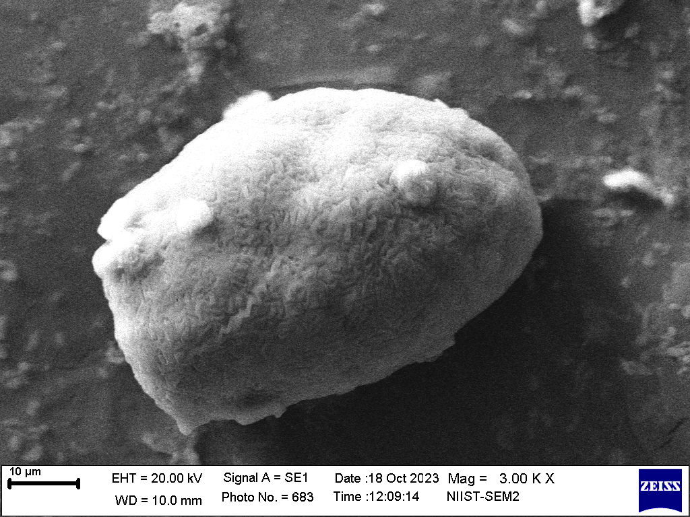 | 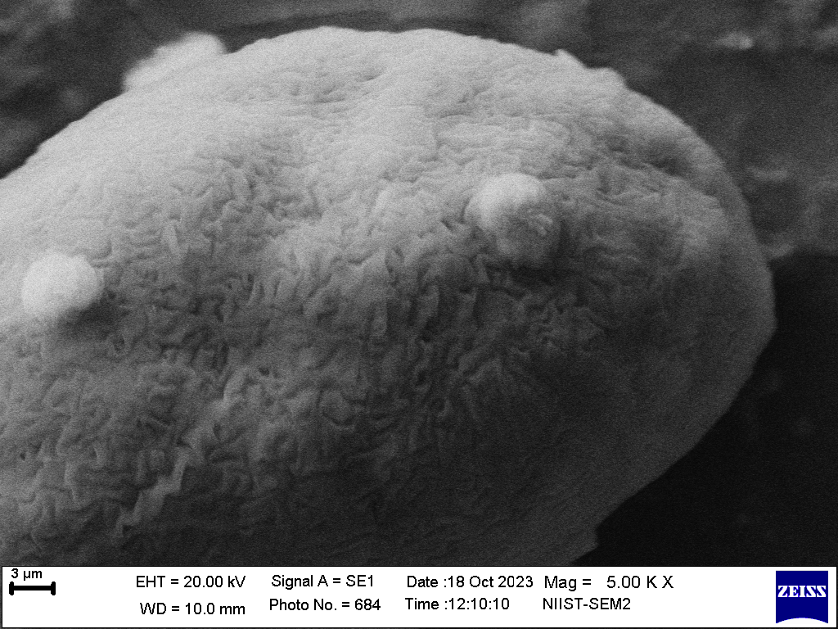
Figure 1. SEM Micrographs of Curcuma decipiens Showing Pollen Surface Architectures (10 µm and 3 µm)
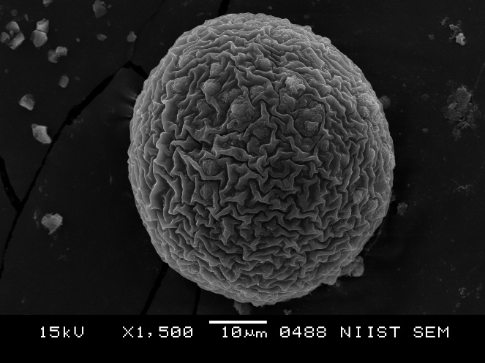 | 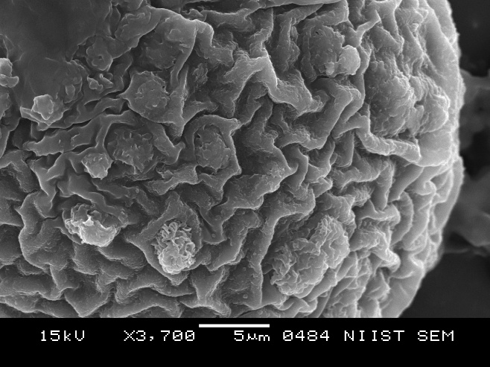
Figure 2. SEM Micrographs of Curcuma inodora Showing Pollen Surface Architecture (10 µm and 5 µm)
Comparative Quantitative Analysis of Pollen Dimensions
The SEM image of Curcuma inodora shows strongly raised ridges with distinct polygonal depressions, whereas Curcuma decipiens shows a more subdued, smoother relief. The higher magnification further emphasizes the species-level distinction: Curcuma inodora pollen is nearly perfectly rounded with a thickened equatorial region, while Curcuma decipiens appears slightly elongated and asymmetrical. Overall, Curcuma inodora exhibits a more complex, deeply sculptured exine, while Curcuma decipiens shows a simpler, shallowly rugulate pattern, distinguishing the two species palynologically. A qualitative pollen morphometric comparison between Curcuma decipiens and Curcuma inodora is demonstrated in Table 1.
Table 1. Morphometric and Micromorphological Comparison of Curcuma decipiens and Curcuma inodora
Character | Curcuma decipiens | Curcuma inodora
Pollen Diameter | 36 µm | 50 µm
Polar Axis (P) | 49.70 µm | 70.10 µm
Equatorial Diameter (E) | 33.78 µm | 49.33 µm
P/E Ratio | 1.47 (subprolate) | 1.42 (subprolate to prolate-spheroidal)
Overall Size Class | Medium-sized pollen | Large pollen
Shape (SEM) | Subprolate to slightly spheroidal | Spheroidal to oblate-spheroidal
Symmetry | Slightly asymmetrical; elongated outline | Highly symmetrical; nearly perfectly globose
Exine Ornamentation | Fine, shallow rugulate pattern; low muri; indistinct lumina | Coarse regulate-reticulate pattern; high muri; deep lumina
Surface Relief | Low to moderate | High, strongly textured
Tectal Pattern | Cushioned, weakly raised folds | Strongly raised, reticulate ridges forming polygonal depressions
Wall Complexity | Low-moderate | High
Appearance at 5/3 µm SEM | Shallow ridges, subdued texture | Strong, sharp sculpturing; deep depressions
Appearance at 10 µm SEM | Slightly elongated grain with shallow exine relief | Perfectly rounded grain with deeply sculptured exine
Aperture Expression | Colpi not clearly visible (cryptic) | Aperture regions suggested by equatorial thickening
Diagnostic Features | Smaller, elongated pollen; shallow rugulation | Larger, spherical pollen; deep reticulation

Diagnostic Morphological Characters Differentiating the two species
Exine sculpturing coarse; muri high and strongly raised, forming deep polygonal lumina; pollen nearly perfectly spheroidal with distinctly textured surface (regulate-reticulate pattern); surface relief pronounced at both 3/5 µm and 10 µm scales
Pollen nearly spherical; exine prominently regulate-reticulate; lumina deep and well-defined; tectal elements forming sharp ridges; high exine complexity
→ Curcuma inodora
Exine sculpturing fine; muri low and weakly raised, forming shallow or indistinct lumina; pollen subprolate to slightly spheroidal with smoother, shallowly rugulate surface; surface relief subdued at both 3/5 µm and 10 µm scales
Pollen slightly elongated; exine shallowly rugulate; lumina poorly defined or absent; tectal elements low, forming a cushioned surface; exine complexity low to moderate
→ Curcuma decipiens
Gaussian Mixture Modelling (GMM) and Morphospace Separation
The Gaussian Mixture Model (GMM) plot clearly demonstrates a strong morphological separation between Curcuma decipiens and Curcuma inodora based on their pollen dimensions (Polar axis vs. Equatorial diameter). The mean values of the two species occupy distinct regions of morphospace, and their 50% and 95% confidence ellipses show no overlap, indicating that even under conservative variance assumptions the two taxa form non-intersecting Gaussian clusters. This discontinuity in both size and shape space reflects independent morphometric structures for each species, supporting the interpretation that C. decipiens and C. inodora represent well-differentiated pollen morphotypes and therefore distinct biological species under a morphometric species delimitation framework (Fig. 3).
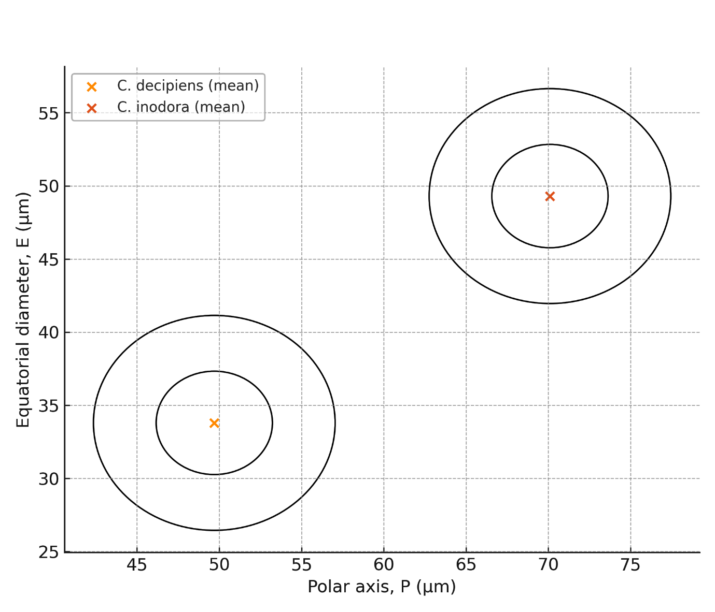
Figure 3. GMM-Based Cluster Visualization of Pollen Dimensions in Two Curcuma Species
Morphometric Species Delimitation (MSD) and Character Discontinuity
Table 2. Morphometric Species Delimitation Matrix Highlighting Character Discontinuities
Character | Type | Curcuma decipiens | Curcuma inodora | Discontinuity rule
Polar axis (P, µm) | continuous | 49.7 | 70.1 | Δ% = 41% (>
Equatorial diameter (E, µm) | continuous | 33.8 | 49.3 | Δ% = 46% (>
P/E ratio | continuous | 1.47 | 1.42 | Δ%=3% (small)
Exine complexity (low or high) | categorical | low | high | Different states
Ornamentation class | categorical | fine rugulate | coarse regulate-reticulate | Different states
Muri height (low or high) | categorical | low | high | Different states
Lumina depth (shallow or deep) | categorical | shallow | deep | Different states
Symmetry (slightly asymmetric or symmetric) | categorical | slightly asymmеtric | symmetric | Different states
Shape class | categorical | subprolate | Subprolate → prolate-sphere | Different states

The character matrix constructed for Curcuma decipiens and Curcuma inodora integrates both continuous traits (polar axis, equatorial diameter, P/E ratio) and qualitative exine characters (muri height, lumina depth, ornamentation type, surface complexity, shape symmetry). Evaluation of these combined characters reveals strong morphological discontinuities between the taxa. The continuous traits show large proportional gaps, with polar axis and equatorial diameter differing by more than 40%, far exceeding the typical 20 - 25% threshold used in morphometric species delimitation. Categorical traits also display complete non-overlap: C. decipiens possesses a fine, shallow rugulate exine with low muri and slight asymmetry, whereas C. inodora exhibits a coarse regulate-reticulate exine with high muri, deep lumina, and a highly symmetrical, globose outline. This consistent divergence across multiple independent character systems indicates a high level of morphological discontinuity, providing strong evidence that the two taxa represent distinct species under a morphometric species delimitation framework.
Synthesis of Palynological Evidence Supporting Species Distinction
The combined palynological evidence clearly establishes a strong separation between Curcuma decipiens and C. inodora. Quantitative morphometry demonstrates non-overlapping pollen size ranges, with C. inodora consistently exhibiting larger polar and equatorial dimensions. Qualitative SEM observations further reinforce this distinction, revealing sharply contrasting exine architectures - fine, shallow rugulation with low muri in C. decipiens versus coarse regulate-reticulate sculpturing with high muri and deep lumina in C. inodora. Gaussian Mixture Modeling (GMM) and Morphometric Species Delimitation (MSD) analyses independently place the two taxa in distinct morphospaces, confirming the absence of character overlap across both continuous and categorical traits. Together, these convergent datasets provide robust palynological evidence supporting the distinct species status of C. decipiens and C. inodora.
Discussions
The palynological comparison between Curcuma decipiens and Curcuma inodora demonstrates clear, multi-character discontinuities that strongly support their recognition as distinct species. Quantitatively, pollen of C. inodora is substantially larger relative to C. decipiens, resulting in more than a 40% interspecific gap in both polar and equatorial axes, well above the discontinuity thresholds typically used in morphometric species delimitation (Erdtman, 1969; Punt et al., 2007). These differences correspond with species-level size ranges in Curcuma reported by regional floristic and taxonomic resources. C. inodora has been consistently described as possessing larger reproductive structures and a more robust morphology (Flowers of India, 2023; eFlora of India, 2022), while C. decipiens is characterized by comparatively compact plant structures (POWO, 2024). Beyond size, qualitative exine characters reinforce this separation: C. inodora pollen exhibits a coarse regulate-reticulate sculpture with high muri and deep lumina, whereas C. decipiens shows a fine, shallowly rugulate exine with poorly developed lumina, traits that are stable and taxonomically informative in Zingiberaceae palynology (Nair, 2004; Sajo et al., 2010; Alexander and Anila George, 2025).
These morphological differences are further supported by morphospace modeling. A Gaussian Mixture Model (GMM) constructed from pollen dimensions places the species in completely non-overlapping regions, with distinct 50% and 95% density contours, indicating independent morphological clusters. Similarly, a Morphometric Species Delimitation (MSD) matrix reveals strong discontinuity across both continuous (P, E, P/E) and qualitative exine traits (muri height, lumina depth, symmetry, sculptural complexity), producing a high separation index. This pattern aligns with earlier taxonomic treatments that, although noting historical synonymy, emphasize consistent morphological divergence between the two species (eFlora of India, 2022). Distributional evidence also supports differentiation, C. decipiens is endemic to the southern Western Ghats, particularly Kerala (POWO, 2024), whereas C. inodora is restricted to the western Peninsular region, including Maharashtra and Goa (Flowers of India, 2023). The integration of quantitative morphometry, exine micromorphology, and biogeographical data provides strong, concordant evidence that C. decipiens and C. inodora represent distinct biological species under both classical morphological and modern morphometric species concepts.
Conclusion
The integrative palynological analysis clearly demonstrates that Curcuma decipiens and C. inodora represent two morphologically distinct species. Pronounced quantitative differences in pollen size, including >40% divergence in both polar and equatorial diameters, combined with contrasting P/E ratios and non-overlapping exine ornamentation - fine, shallow rugulate patterns in C. decipiens versus coarse, regulate-reticulate sculpturing in C. inodora, establish robust morphological discontinuities between the taxa. These traits, reinforced by distinct muri height, lumina depth, and symmetry patterns, consistently separate the two species in morphospace, as further supported by Gaussian Mixture Modelling and Morphometric Species Delimitation analysis. Collectively, the congruence of quantitative metrics and qualitative micromorphological attributes provides strong evidence that C. decipiens and C. inodora are well-differentiated biological entities, warranting clear species-level recognition within the genus Curcuma.
Reference
- Alexander T &Anila George. 2025. Pollen Morphometric Differentiation and Statistical Classification of Four Elettaria cardamomum Varieties using SEM Analysis. International Journal of Agriculture Sciences 17(4), 13712-13716. https://bioinfopublication.org/pages/jouarchive.php?id=BPJ0000217
- eFlora of India. 2022. Curcuma inodora and Curcuma decipiens species pages. Retrieved from https://efloraofindia.com/
- Erdtman G. 1960. The acetolysis method: A revised description. Svensk Botanisk Tidskrift 54, 561-564.
- Erdtman, G. 1969. Handbook of Palynology: Morphology, Taxonomy, Ecology. Hafner Publishing Company.
- Flowers of India. 2023. Scentless Turmeric - Curcuma inodora. Retrieved from https://www.flowersofindia.net/
- Kew Science - Plants of the World Online (POWO). 2024. Curcuma decipiens and Curcuma inodora species records. Royal Botanic Gardens, Kew. Retrieved from https://powo.science.kew.org/
- Nair PKK. 2004. Advances in Palynology and Aerobiology. Today & Tomorrow’s Printers and Publishers.
- Punt W, Hoen PP, Blackmore S, Nilsson S, Le Thomas A. 2007. Glossary of pollen and spore terminology. Review of Palaeobotany and Palynology 143(1-2), 1-81. https://doi.org/10.1016/j.revpalbo.2006.06.008
- Sabu M. 2006. Zingiberaceae of South India. Indian Association for Angiosperm Taxonomy (IAAT).
- Sajo MG, Rudall PJ, and Prychid CJ. 2010. Evolution of exine morphology in the monocot order Zingiberales. International Journal of Plant Sciences. 171(5), 572-584. https://doi.org/10.1086/653131

