Striga-Resistant Sorghum: A Managed Screening Reveals Promising Genotypes

Abstract
Sorghum (Sorghum bicolor L. Moench) is a major staple crop in sub-Saharan Africa. In Niger (West Africa), despite being the second most cultivated cereal, sorghum yields remain low and are exacerbated by Striga infestation in smallholder farming systems. The development of new sorghum varieties resistant to Striga is one of the objectives of the crop improvement program in Niger. This study aimed to evaluate the resistance and tolerance of sorghum genotypes developed within the Niger breeding program under managed Striga infestation. Eighteen genotypes, derived from crosses between elite but susceptible varieties and the resistant donor SRN39, were phenotyped in a pot assay under low-fertility sandy soil. The number of Striga plants was recorded at 45, 60, and 90 days after sowing, along with sorghum and Striga biomass traits. Two-way ANOVA revealed highly significant genotypic effects for Striga counts and biomass loss in sorghum. Significant variation was observed among genotypes, allowing classification into resistant, moderately resistant, tolerant, and susceptible groups. The combined use of molecular markers, Striga counts, and biomass loss proved effective for identifying superior genotypes. These results provide promising candidate lines for deployment in Striga-infested areas of the Sahel and support future multi-location evaluations to ensure resistance stability.
Please put keywords

Introduction
Sorghum (Sorghum bicolor) is a versatile C4 cereal that originated in East Africa (De Wet & Harlan, 1971). Sorghum is a staple crop for many people in sub-Saharan Africa, also used as animal feed and fuel. Its area of production extends from humid and semi-arid regions around the world (Doggett, 1988; Smith & Frederiksen, 2000). The wide adaptation allows sorghum to grow in marginal lands and harsh environments (Harlan & de Wet, 1972). The diversity and adaptation of sorghum may enhance its resilience in specific climatic zones and cultural practices, making it a promising food and bioenergy source for people around the world. Developing countries account for 90% of the cultivated area and 70% of global production. Sorghum, along with millet, is a staple cereal in the Niger Republic. It is grown on 3.7 million hectares and represents about 32.7% of national cereal production in 2024 (MAGEL, 2025). Sorghum strongly contributes to the population’s food security through its significant production. However, despite the large cultivated area, production remains low, and yields tend to plateau, rarely exceeding 500 kg.ha⁻¹ in farmer fields (MAGEL, 2025). Abiotic factors (poor soil and scarce rainfall) and biotic factors (pests and weeds) limit sorghum production (Smith & Frederiksen, 2000). The parasitic weed Striga hermonthica is among the main factors responsible for low yield. A Striga infestation can cause yield losses reaching 70% in smallholder farming systems (Ejeta, 2007). After germination, Striga roots form a nodule called a haustorium, which fuses with the host's roots, establishing a connection between its vascular system and that of the host (Ejeta & Gressel, 2007; Belay, 2018). Through this connection, the “witchweed” draws water, minerals, and organic substances necessary for its development and affects the metabolism and photosynthetic activity of its host (Scholes & Press, 2008). The SRN39 and N13 varieties possess resistance to this parasitic plant but are not adapted to certain climatic conditions in Africa (Haussmann et al., 2001; Gobena et al., 2017). The mechanism via low germination stimulant, well-known in SRN39 sorghum, is a means of resistance controlled by a recessive allele (lgs1-1) (Ejeta, 2005, 2007; Gobena et al., 2017). Therefore, it is more than necessary to find varieties resistant to this parasitic plant to ensure an increase in sorghum production in Striga-infested areas, especially in sub-Saharan Africa. As part of the crop improvement program of the agronomic research institution of Niger, one of the objectives of the program is to develop improved sorghum varieties resistant to Striga via low germination stimulation and adapted to the Sahel region. We evaluated sorghum genotypes from the breeding program under managed Striga infestation to better understand the performance of sorghum under Striga infestation. Candidate genotypes will be useful for farmers in Striga hotspots and spillover regions of the Sahel.

Materials and Methods

Plant Material
The plant material consists of Striga seeds originating from the village of Bazaga, Birni N’Konni department, and 18 sorghum (Sorghum bicolor) genotypes mostly derived from crosses of elite varieties Sepon82 (G15), MR732 (G16), and Mota Maradi (G17) susceptible to Striga and the donor variety SRN39 (G18) for resistance to Striga provided by the sorghum breeding program in Niger and genotyped via Kompetitive Allele Specific PCR (KASP) markers (Maina et al., 2025).

Methodology
The soil used was low-fertility sandy soil (poor in nutrients). For each treatment, four (4) repetitions were used (control and infested). Sowing was performed with 5 sorghum seeds per pot and per treatment during the off-season 2022 (October - December). For the infested treatment, the Striga Infestation was carried out in 2 steps. The first step, Striga infestation, was done at sowing by adding approximately the same amount of Striga seeds to the sorghum seeds in each pot. The second Striga infestation occurred after a pre-conditioning phase of the latter. Pre-conditioning consists of soaking Striga in water (sterilized distilled water) for 10 days, shaking the tubes every two days (Bellis et al., 2020). This pre-conditioning process breaks Striga dormancy. This phase allows the seed to imbibe water while waiting for the conditioning phase, which enables the weed to acquire the ability to germinate and be ready when the host plant releases the germination-stimulating hormone called Strigolactone in the case of sorghum (Gobena et al., 2017). Watering in pots was done regularly to prevent drought stress. We performed weeding manually when weeds other than Striga plants were observed. After sorghum germination, at 15 days after sowing, thinning to 2 plants was done, then to one plant at 21 days after sowing. We performed two-way Anova on the data collected (Table 1), using R version 4.3.3 (R Core Team, 2013).
Table 1: List of parameters for phenotyping
Trait | Abbreviation
Number of Striga plants at 45 days after sowing | NS45
Number of Striga plants at 60 days after sowing | NS60
Number of Striga plants at 90 days after sowing | NS90
Dry biomass of Striga plants at harvest (g) | BSS
Dry biomass of sorghum for the control (g) | BS_C
Dry biomass of sorghum for the treatment (g) | BS_In
Sorghum biomass loss | PPB
Sorghum biomass loss divided by 100 | PPBC

Results and discussion
Given the constantly changing climate, it is critical for agricultural development to establish varieties resistant and tolerant to abiotic and biotic stress in order to produce satisfactory yields. The objective of this study was to genotype 18 Sorghum bicolor genotypes to determine their status for S. hermonthica resistance markers and to evaluate their resistance when subjected to stress from the S. hermonthica.
Analysis of Phenotypic Data
The evaluation of 18 sorghum genotypes under Striga infestation reveals sorghum responses with distinct mechanisms of tolerance and resistance. We characterize each genotype based on the Striga plants, as well as sorghum above- and below-ground biomass in both control and infested pots, using the average across repetitions (Table 2). Analysis of Striga counts across three periods (45, 60, and 90 days after sowing) reveals distinct patterns of the parasite establishment and development. Genotypes with less number of Striga counts on average, such as G10 (0.5, 0.5, 0.5), G16 and G18 (0, 0, 0), demonstrate putative resistance to Striga. These suggest a possible minimal production of germination stimulants or an effective pre-attachment barrier, preventing parasite development. In contrast, genotypes like G04 (8, 15.5, 15.5) and G14 (3.5, 9.5, 13) show not only a high number of Striga plants at 60 and 90 days after sowing, but also increasing or sustained counts over time, indicating complete susceptibility and successful parasite development. G03—which showed a negative biomass loss—had moderate early counts (10.5, 3, 1) that declined by 90 days, aligning with its low final Striga biomass (1.55 g). Similarly, G02 exhibited very high early counts (5.5, 16.5, 11) yet ended with reduced Striga biomass (4.32 g). Genotypes with peaks at 45–60 days (e.g., G02, G04) experience early and intense parasite pressure, whereas others with later peaks may reflect delayed but eventual susceptibility.
The presence of Striga shoots at 45 DAS, 60 DAS in the Mota Maradi variety (G17) and the absence of the Striga in the same variety at 90 DAS is due to the death of the host plant. The variety has a short cycle between 60 and 65 days; it would be preferable to take into account the reproduction cycle time of each variety to be studied in future trials. This disappearance of Striga is explained by the hemiparasitic nature of the weed (Gobena et al., 2017).
Table 2: Effects of Striga infestation on sorghum biomass
Genotype | NS45 | NS60 | NS90 | BS_C | BS_I | Percentage_loss | Striga_biomass
G01 | 1 | 2 | 4 | 49.42 | 60.42 | -0.18 | 4.15
G02 | 5.5 | 16.5 | 11 | 34.19 | 2.19 | 0.93 | 4.32
G03 | 10.5 | 3 | 1 | 39.42 | 49.36 | -0.55 | 1.55
G04 | 8 | 15.5 | 15.5 | 27.00 | 43.17 | -2.04 | 9.28
G05 | 7.5 | 11.5 | 8.5 | 77.06 | 30.50 | 0.65 | 6.16
G06 | 6 | 5.5 | 4.5 | 57.71 | 11.71 | 0.82 | 5.31
G07 | 3 | 4 | 4.5 | 38.57 | 14.07 | 0.68 | 5.78
G08 | 9 | 8 | 6.5 | 65.81 | 1.69 | 0.98 | 3.38
G09 | 1.5 | 3 | 4.5 | 40.67 | 25.31 | 0.49 | 4.81
G10 | 0.5 | 0.5 | 0.5 | 57.85 | 41.39 | 0.16 | 1.63
G11 | 3 | 3.5 | 4 | 35.76 | 31.34 | 0.49 | 5.89
G12 | 5.5 | 4 | 3.5 | 38.64 | 33.69 | 0.27 | 3.01
G13 | 1 | 2 | 3.5 | 81.24 | 29.51 | 0.59 | 3.21
G14 | 3.5 | 9.5 | 13 | 28.64 | 28.53 | -0.18 | 3.96
G15 | 5 | 8 | 7 | 69.19 | 4.715 | 0.96 | 4.13
G16 | 0 | 0 | 0 | 41.55 | 84.91 | -3.12 | 0
G17 | 7.5 | 9 | 0 | 29.785 | 0 | 1 | 4.01
G18 | 0 | 0 | 0 | 54.065 | 55.85 | -1.75 | 0
p-values | p ≤ 0.001 | p ≤ 0.01 | p ≤ 0.01 | p ≤ 0.05 | p ≤ 0.001 | p ≤ 0.001 | p ≤ 0.01
The data collected at 60 DAS show that the average number of Striga plants is higher compared to the other two dates and that all host plants are still viable. This motivated our choice to consider this date as a reference for evaluating resistance in terms of Striga number, and thus genotypes are classified from most resistant to most susceptible (Figure 1). Genotypes G01 and G02, both derived from the cross of SRN39 and MR732, showed one to be resistant and the other susceptible in molecular analyses (Maina et al., 2025). Phenotypic analysis confirms the molecular analyses for these two genotypes. Genotypes G02, G04, and G15, which were classified among the resistant ones at 45 DAS, are found among the susceptible ones at 60 DAS because at 45 DAS their Striga plants had not reached their maximum number (Figure 1). The number of Striga recorded at 45 DAS is very positively correlated with the number recorded at 60 DAS, which in turn is highly positively correlated with the number recorded at 90 DAS, and these last two are very positively correlated with the collected dry biomass of Striga (Figure 2). These results show that Striga biomass increases with the number of Striga plants, and sorghum biomass decreases when Striga biomass increases due to parasitism and nutrient intake from the host plant (Abusin et al., 2017). The biomass loss of 82.17% for the susceptible reference variety G06 (BTx623) confirms previous studies that Striga can cause yield loss of up to 70% (Ejeta, 2005). Genotypes G04 and G05, resistant based on the KASP markers (Maina et al., 2025), show a high Striga number in the pot assay. The average Striga number associated with the percentage of biomass loss (Table 2) allowed grouping these varieties into categories of putative resistance, tolerance, and susceptibility. Genotypes that did not allow any Striga plant to germinate are considered resistant (e.g., G18 and G16). Further studies may confirm the status of G16, whether it is due mechanism of resistance other than lgs1 or soil conditions in a controlled environment (pot assay). Genotypes that have one to two Striga plants but show no Striga symptoms are resistant, such as G01 and G10. Genotypes that have three to four Striga plants but show no developmental delay are moderately resistant, such as G03 and G12. Genotypes that have several Striga plants at their base but were not affected are considered tolerant (G04 and G14). Genotypes that have a Striga number of 3–5 and were slightly affected, such as G07, G09, G11, and G13, are moderately tolerant. Genotypes that have more than five (5) Striga plants and were damaged are considered susceptible: G02, G05, G06, G08, G15, and G17.
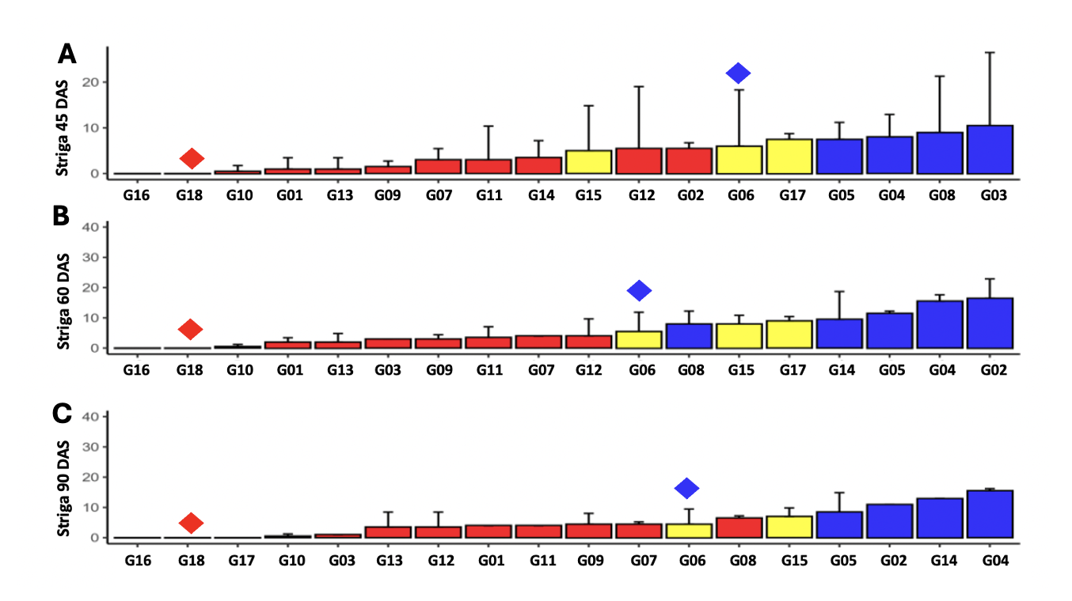
Figure 1: Striga count at 45 (A), 60 (B), and 90 (C) days after sowing sorghum in pot assay. Classification based on the ascending number of Striga plants. Red diamond shapes represent the position of the resistant genotype, and blue diamond shapes represent the position of the susceptible genotype. Red, blue, and yellow bars represent the putative resistant progenies, putative susceptible progenies, and parental lines, respectively.
Influence of Striga on sorghum biomass
In terms of biomass loss, we consider genotypes that lost greater than or equal to 70% of their biomass as susceptible genotypes. Indeed, research should be pushed towards advanced phenotyping to better understand Striga resistance and its mechanism of infestation for future product developments. Also, since there are several resistance mechanisms described in previous studies (Haussmann et al., 2001; Ejeta, 2007; Scholes & Press, 2008), this study focused only on low production of Strigolactone (lgs1). Thus, the three combined parameters (lgs1-1 status, number of germinated Striga plants, and biomass loss) allowed the identification of 6 best-performing genotypes (e.g., G01, G07, G09, G11, G13, G18). The resistance of genotypes G04 and G05 remains to be re-evaluated due to their high Striga number despite not reaching significant biomass loss.
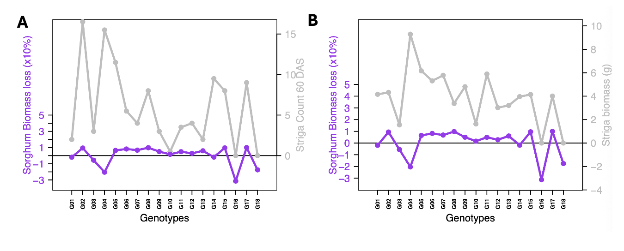
Figure 2: Effect of Striga on sorghum biomass. Biomass reduction compared to Striga plants (A) and Striga dry biomass (B).
Conclusion:
The field test result is also limited by environmental effects. Indeed, a genotype can be susceptible in one location and appear resistant in another because Striga ecotypes can vary depending on study zones. A sorghum plant can produce a high amount of Strigolactone, thus harboring several Striga plants and having another mechanism of resistance, like the case of N13, which has mechanical resistance. Multi-location field evaluations and controlled pot assays using Striga ecotypes collected from diverse agro-ecological zones of Niger are required to assess the stability and durability of resistance. To further enhance resistance in the identified resistant genotypes, additional introgression of genes conferring mechanical resistance is needed to increase the likelihood of escape from Striga parasitism. In addition, the development and validation of molecular markers tightly linked to other sources of resistance will facilitate efficient identification and selection of resistant genotypes through marker-assisted selection (MAS) in breeding and pre-breeding pipelines.

COMPETING INTERESTS DISCLAIMER:
Authors have declared that they have no known competing financial interests OR non-financial interests OR personal relationships that could have appeared to influence the work reported in this paper.

References
Abusin, R., Eltayeb, M., Hassan, M., & Babiker, A. (2017). Integrated Management of Striga hermonthica on Sorghum. Asian Journal of Advances in Agricultural Research, 4, 1–8. https://doi.org/10.9734/AJAAR/2017/38141
Belay, F. (2018). Breeding Sorghum for Striga Resistance: A Review. Journal of Natural Sciences Research, 8, 1-8–8
Bellis, E.S., Kelly, E.A., Lorts, C.M., Gao, H., DeLeo, V.L., Rouhan, G., Budden, A., Bhaskara, G.B., Hu, Z., Muscarella, R., Timko, M.P., Nebie, B., Runo, S.M., Chilcoat, N.D., Juenger, T.E., Morris, G.P., dePamphilis, C.W., & Lasky, J.R. (2020). Genomics of sorghum local adaptation to a parasitic plant. Proceedings of the National Academy of Sciences, . https://doi.org/10.1073/pnas.1908707117
De Wet, J.M.J., & Harlan, J.R. (1971). The Origin and Domestication of Sorghum bicolor. Economic Botany, 25, 128–135
Doggett, H. (1988). Sorghum. 2nd Edition.
Ejeta, G. (2005). Integrating biotechnology, breeding and agronomy in the control of the parasitic weed Striga spp. in sorghum. Tuberosa R., Phillips R.L., Gale M.,. Proceedings of the International Congress Bologna, Italy, 239-251.
Ejeta, G. (2007). Breeding for Resistance in Sorghum: Exploitation of an Intricate Host–Parasite Biology. Crop Science, 47, S-216-S-227. https://doi.org/10.2135/cropsci2007.04.0011IPBS
Ejeta, G., & Gressel, J. (2007). Integrating New Technologies for Striga Control: Towards Ending the Witch-Hunt. World Scientific Publishing Co Pte Ltd, Singapore, SINGAPORE.
Gobena, D., Shimels, M., Rich, P.J., Ruyter-Spira, C., Bouwmeester, H., Kanuganti, S., Mengiste, T., & Ejeta, G. (2017). Mutation in sorghum LOW GERMINATION STIMULANT 1 alters strigolactones and causes Striga resistance. Proceedings of the National Academy of Sciences, 201618965. https://doi.org/10.1073/pnas.1618965114
Harlan, J.R., & de Wet, J.M.J. (1972). A Simplified Classification of Cultivated Sorghum1. Crop Science, 12, 172. https://doi.org/10.2135/cropsci1972.0011183X001200020005x
Haussmann, B.I.G., Hess, D.E., Omanya, G.O., Reddy, B.V.S., Welz, H.G., & Geiger, H.H. (2001). Major and Minor Genes for Stimulation of Striga hermonthica Seed Germination in Sorghum, and Interaction with Different Striga Populations. Crop Science, 41, 1507–1512. https://doi.org/10.2135/cropsci2001.4151507x
MAGEL. (2025). Rapport d’évaluation de la campagne agricole d’hivernage 2024 et Perspectives Alimentaires 2024-2025
Maina, F., Faye, J.M., Kena, A.W., Diatta, C., Tankari, M.I., Ardaly, O.A., Diakite, O.S., Ibrahim, A.M., Moussa, O.A., Harou, A., Abdou, R., Sene, J.P., Bodian, S., Ndour, M., Sambakhe, D., Sine, B., Kadanga, P., Akata, E., Ouedraogo, N., Annor, B., Tetteh, I.T., Yahaya, M.A., Diallo, A., Kakeeto, R., Kisilu, R.K., Kondombo, C.P., Legesse, T., Mbulwe, L., Mutaliano, J., Mwenda, E.T., Naoura, G., Mafouasson, H.N.A., Opare-Obuobi, K., Abdulmalik, R.O., Runo, S., Abdelhalim, T.S., Yalaukani, L., Masanga, J., McLaughlin, C.M., Lasky, J.R., Harder, A.M., Healey, A.L., Lovell, J.T., Osei-Obeng, P., Marla, S.R., Felderhoff, T.J., Hamidou, F., Fonceka, D., Chejerla, M.K.V., Nébié, B., Tamerlan, M.N., Alakonya, A., Rathore, A., Deshpande, S., Gandhi, H., Banda, L., Rhodes, D.H., Cruet-Burgos, C., VanGessel, C.J., & Morris, G.P. (2025). Delivering trait-enhanced varieties to African smallholders through a pangenomic breeding network 2025.08.07.667917. https://doi.org/10.1101/2025.08.07.667917
R Core Team. (2013). R: A Language and Environment for Statistical Computing
Scholes, J.D., & Press, M.C. (2008). Striga infestation of cereal crops – an unsolved problem in resource limited agriculture. Current Opinion in Plant Biology, 11, 180–186. https://doi.org/10.1016/j.pbi.2008.02.004
Smith, C.W., & Frederiksen, R.A. (2000). Sorghum, Origin, History, Technology and Production. Wiley Series in Crop Science. Texas A & M University.

