Original Research Article

From Highlands to Wetlands - A Longitudinal Transformation of Water Quality in the Pamba River, Southwest India

Abstract
The Pamba River is a major west-flowing river of Kerala that supports domestic water supply, agriculture, fisheries, pilgrimage activities, and wetland ecosystems. The present study assesses the spatial variation in physicochemical water quality along two hydrologically contrasting stretches of the river: the highland region of Seethathodu Panchayat and the terminal lowland region of Kainakari Panchayat, during the post-monsoon season of 2023. Surface water samples were collected from six sites in each stretch and analysed for key physicochemical parameters, including temperature, turbidity, pH, dissolved oxygen, nutrients, alkalinity, hardness, calcium, and magnesium, following standard methods. To interpret spatial variability and controlling factors, an integrated analytical framework comprising descriptive statistics, independent sample t-tests, Pearson correlation analysis, principal component analysis (PCA), hierarchical cluster analysis (CA), and Water Quality Index (WQI) was employed. The results revealed significant spatial differences in temperature, turbidity, and dissolved oxygen between the highland and lowland stretches, while nutrient concentrations showed relatively uniform distribution during the post-monsoon period. Multivariate analyses clearly distinguished the two river stretches, highlighting the influence of geomorphology, wetland interaction, and anthropogenic pressure on downstream water quality. Although both stretches fell under the “good” water quality category based on WQI, moderate downstream deterioration was evident. The study provides a robust baseline for future seasonal monitoring and supports integrated river management strategies for the Pamba River basin.
Keywords: Pamba River, Water quality assessment, Multivariate statistical analysis, Highland-lowland gradient, Water Quality Index (WQI).
1. Introduction
Rivers are dynamic freshwater systems that integrate climatic, geological, and anthropogenic influences across their catchments, making them highly sensitive indicators of environmental change. Spatial variation in river water quality is strongly governed by longitudinal gradients in altitude, hydrology, land use and human activity, as conceptualized by the River Continuum Concept, which predicts systematic changes in physicochemical characteristics from headwaters to downstream reaches (Vannote et al., 1980). In tropical river systems, these gradients are further modified by monsoonal rainfall, wetland connectivity and intense human dependence on riverine resources, often resulting in pronounced upstream-downstream contrasts in temperature, turbidity, dissolved oxygen, and nutrient dynamics (Peters & Meybeck, 2000; Dodds & Whiles, 2020; Allan & Castillo, 2021). Consequently, integrated assessments combining univariate statistics, multivariate techniques, and index-based approaches such as the Water Quality Index (WQI) are increasingly employed to diagnose spatial variability, identify dominant controlling factors, and support river basin management (Singh et al., 2004; Tyagi et al., 2013; Muniz & Oliveira-Filho, 2023; Alexander, 2025).
The Pamba River, one of the major west-flowing rivers of Kerala, plays a crucial role in sustaining domestic water supply, agriculture, fisheries, pilgrimage activities, and wetland ecosystems, particularly through its connectivity with the Vembanad Lake system. Previous studies have documented spatial and seasonal deterioration of water quality in the Pamba River, especially in its lowland reaches, attributed to urban discharge, agricultural runoff, pilgrimage-related pressure, and prolonged water residence time in wetlands (Jalal & Kumar, 2013; Lekshmi et al., 2020; Roy & Kizhakkethottam, 2024; Jiss Mariya Jose & Ambili 2021). However, comprehensive studies explicitly comparing hydrologically contrasting highland and terminal lowland stretches using a combination of descriptive statistics, inferential testing, correlation analysis, PCA, cluster analysis, and WQI remain limited. In this context, the present study aims to evaluate the spatial variation in physicochemical water quality between the highland Seethathodu Panchayat and the lowland Kainakari Panchayat during the post-monsoon season, employing robust statistical and multivariate tools to elucidate longitudinal gradients and provide a scientifically sound baseline for river management and conservation planning in the Pamba River basin (Hering et al., 2010; Withers et al., 2020).
2. Materials and Methods
2.1. Description of the Study Area
The present study was carried out during the post-monsoon season of 2023 at two hydrologically contrasting stretches of the Pamba River, representing the highland region and the terminal lowland region, separated by approximately 100 km along the river course. The two contrasting stretches of the Pamba River, encompassing the highland catchment of Seethathodu Panchayat in Pathanamthitta District (1000-2000 m MSL), characterized by hilly terrain with forested valleys and grassland-dominated upper reaches, and the terminal lowland region of Kainakari Panchayat in Alappuzha District, which lies 1.3-3.0 m below mean sea level at the confluence of the Pamba River and Vembanad Kayal (Fig.1).
Figure 1. Location map of the Pamba River basin showing sampling sites at Seethathodu and Kainakari Panchayats
2.2. Water sampling and Analysis
Six sampling sites were selected from each Panchayat based on accessibility, hydrological representativeness and land-use characteristics (Table 1). Geographic coordinates of all sites were recorded using GPS to ensure spatial accuracy. Surface water samples were collected following standard protocols and analysed for key physicochemical parameters, including temperature, turbidity, pH, dissolved oxygen, nitrate, phosphate, alkalinity, hardness, calcium and magnesium (APHA, 2017). These parameters were selected to capture both natural longitudinal gradients and anthropogenic influences operating along the river continuum.
Table 1. Sampling locations of the Pamba River at Seethathodu (highland) and Kainakari (lowland) Panchayats
Sample No. | Seethathodu Panchayat | Kainakari Panchayat
W1 | Kakkadu | Kuppappuram
W2 | Angamuzhi | Pandicherry
W3 | Seethathodu | Chennankari
W4 | Moozhiyar | Ponga
W5 | Angamuzhi | Kainakari Panchayat office
W6 | Moonnukallu | Vembanad Kayal
2.3. Statistical and Multivariate Analysis
To interpret spatial variability and identify controlling factors of water quality, a combination of univariate and multivariate statistical analyses was applied. Descriptive statistics (mean, standard deviation, range, and coefficient of variation) were used to assess parameter variability within and between river stretches. Independent sample t-tests (Welch’s test) were employed to evaluate statistically significant differences between highland and lowland sites. Pearson correlation analysis was conducted separately for each Panchayat to examine inter-relationships among water quality variables. Principal Component Analysis (PCA) was applied on standardized data to identify dominant gradients governing water quality variation, while Hierarchical Cluster Analysis (Ward’s method, Euclidean distance) was used to classify sampling sites based on similarity patterns. In addition, a Water Quality Index (WQI) was computed using the weighted arithmetic index method to provide an integrated assessment of overall water quality status. All statistical analysis were carried out using windows based PAST 4.3 and Excel software. Although, the present study based on a single post-monsoon season, the application of complementary statistical approaches enabled robust spatial discrimination of water quality conditions between the highland and lowland stretches of the Pamba River.
3. Results
3.1. Physicochemical Status of Water Quality in Highland and Lowland Stretches
The water quality of the Pamba River in Seethathodu Panchayat reflects typical highland riverine conditions characterized by relatively low temperatures, very low turbidity, and near-neutral to slightly alkaline pH. Dissolved oxygen levels are generally high, indicating good aeration and minimal organic pollution, which is consistent with the forested catchment, steep gradients, and limited anthropogenic pressure in this region. Nutrient concentrations such as nitrate and phosphate remain low, suggesting minimal agricultural or domestic runoff. Alkalinity and hardness values are also low to moderate, reflecting the dominance of natural weathering processes rather than external inputs (Table 2).
Table 2. Average values of water quality parameters of Pampa River in Seethathodu panchayat during the Post -Monsoon Season.
Location No. | Temperature(⁰C) | pH | Turbidity (NTU) | DO (Mg/L) | CO₂ (Mg/L) | Acidity (Mg/L) | Alkalinity (Mg/L) | NO₃ (Mg/L) | PO₄ (Mg/L) | Ca (Mg/L) | Mg (Mg/L) | Hardness (Mg/L)
W₁ | 22.5 | 0.523 | 7.35 | 8.5 | 4.4 | 7.5 | 35 | 0.028 | 0.124 | 4.8 | 0.25 | 8
W₂ | 26.7 | 0.212 | 7.55 | 6.1 | 11.0 | 10 | 50 | 0.043 | 0.162 | 4.8 | 0.76 | 4
W₃ | 23.3 | 0.435 | 8.32 | 6.1 | 2.0 | 7.5 | 35 | 0.018 | 0.141 | 7.2 | 0.46 | 8
W₄ | 30.6 | 0.754 | 7.70 | 5.5 | 4.0 | 15 | 50 | 0.010 | 0.134 | 8.0 | 0.57 | 12
W₅ | 23.5 | 0.283 | 7.05 | 6.3 | 11.0 | 12.5 | 35 | 0.011 | 0.143 | 4.8 | 0.64 | 8
W₆ | 20.4 | 0.819 | 7.20 | 8.4 | 13.5 | 12.5 | 40 | 0.015 | 0.152 | 3.2 | 0.62 | 12

In contrast, the water quality in Kainakari Panchayat, located at the terminal lowland stretch near the Vembanad Kayal, shows clear signs of downstream transformation influenced by backwater interaction, wetland dominance, and intense human activity. Higher water temperatures and turbidity values reflect shallow depths, sediment resuspension, and mixing with canal and backwater systems. The pH exhibits wider fluctuations, while dissolved oxygen levels are comparatively lower than in the highland stretch, indicating increased organic load and reduced re-aeration. Elevated concentrations of nutrients, hardness, calcium and magnesium suggest cumulative inputs from agriculture, domestic sources, and prolonged water residence time in wetlands (Table 3).
Table 3. Average values of water quality parameters of Pampa River in Kainakari panchayat during the Post -Monsoon Season
Location No. | Temperature(⁰C) | pH | Turbidity (NTU) | DO (Mg/L) | CO₂ (Mg/L) | Acidity (Mg/L) | Alkalinity (Mg/L) | NO₃ (Mg/L) | PO₄ (Mg/L) | Ca (Mg/L) | Mg (Mg/L) | Hardness (Mg/L)
W₁ | 28.0 | 6.52 | 2.5 | 5.0 | 11.0 | 12.5 | 45 | 0.027 | 0.155 | 4.08 | 2.32 | 14
W₂ | 28.1 | 8.15 | 5.2 | 4.7 | 8.8 | 10.0 | 45 | 0.026 | 0.148 | 16.83 | 5.46 | 42
W₃ | 28.5 | 6.44 | 8.4 | 5.3 | 13.2 | 12.5 | 30 | 0.028 | 0.154 | 4.80 | 3.55 | 18
W₄ | 28.5 | 7.38 | 2.7 | 5.7 | 8.8 | 7.5 | 25 | 0.021 | 0.151 | 4.80 | 6.54 | 12
W₅ | 28.5 | 7.11 | 3.2 | 4.8 | 11.0 | 12.5 | 45 | 0.028 | 0.148 | 13.62 | 5.99 | 28
W₆ | 29.5 | 6.52 | 2.8 | 5.4 | 11.0 | 17.5 | 20 | 0.029 | 0.134 | 4.80 | 4.79 | 12
3.2. Descriptive Statistics of Water Quality Parameters
The descriptive statistics of water quality parameters at Seethathodu Panchayat indicate relatively stable and less disturbed highland river conditions (Table 4). Water temperature showed a moderate mean value of 24.5 °C, with a wider range and a CV of 14.75 %, reflecting altitude-controlled thermal variability. Turbidity values were consistently low, although the high coefficient of variation (48.65 %) indicates localized fluctuations linked to micro-habitat differences. The pH remained near neutral to slightly alkaline with very low variability (CV = 6.01 %), suggesting good buffering capacity. Dissolved oxygen exhibited relatively high mean concentration with moderate variability, supporting well-oxygenated conditions typical of upland streams. Nutrients such as nitrate and phosphate occurred at low concentrations, though nitrate showed higher variability (CV = 60.67 %), indicating minor spatial differences in nutrient input.
Table 4. Combined descriptive statistics of selected water quality parameters of the Pamba River at Seethathodu and Kainakari Panchayats
 | Seethathodu |  |  |  |  | Kainakari
Parameter | Mean | SD | Range | CV (%) | Mean |  | SD | Range | CV (%)
Temperature (°C) | 24.50 | 3.61 | 10.20 | 14.75 | 28.52 |  | 0.53 | 1.50 | 1.86
Turbidity (NTU) | 0.50 | 0.25 | 0.61 | 48.65 | 4.13 |  | 2.31 | 5.90 | 55.92
pH | 7.53 | 0.45 | 1.27 | 6.01 | 7.02 |  | 0.67 | 1.71 | 9.56
DO (mg/L) | 6.82 | 1.29 | 3.00 | 18.98 | 5.15 |  | 0.38 | 1.00 | 7.45
NO₃ (mg/L) | 0.021 | 0.013 | 0.033 | 60.67 | 0.026 |  | 0.003 | 0.008 | 10.87
PO₄ (mg/L) | 0.143 | 0.013 | 0.038 | 9.34 | 0.148 |  | 0.008 | 0.021 | 5.13
SD: Standard Deviation; CV: Coefficient of Variation
In contrast, the lowland Kainakari Panchayat displayed greater anthropogenic and wetland-induced variability in water quality parameters (Table 4). Temperature remained consistently high with very low variability (CV = 1.86 %), reflecting uniform lowland climatic influence. Turbidity showed a substantially higher mean and pronounced variability (CV = 55.92 %), indicating sediment resuspension and canal-backwater mixing. The pH values exhibited wider fluctuations compared to the highland stretch. Dissolved oxygen concentrations were comparatively, reflecting reduced re-aeration and increased organic load. Nutrient concentrations (NO₃ and PO₄) were slightly elevated but exhibited relatively low variability, suggesting continuous and diffuse nutrient inputs from surrounding wetlands and human activities.
3.3. Spatial Variability Illustrated by Box-and-Whisker Plots
The box-and-whisker plots clearly demonstrate the spatial contrast between the two River stretches (Fig. 2). Seethathodu shows compact boxes and shorter whiskers for most parameters, indicating low dispersion and stable water quality. In contrast, Kainakari exhibits wider interquartile ranges and occasional outliers, particularly for turbidity and pH, reflecting dynamic hydrological conditions and anthropogenic influence (Fig. 3). The visual separation in temperature, turbidity and dissolved oxygen distributions highlights the longitudinal transformation of water quality from the highland source region to the lowland terminal zone of the Pamba River.
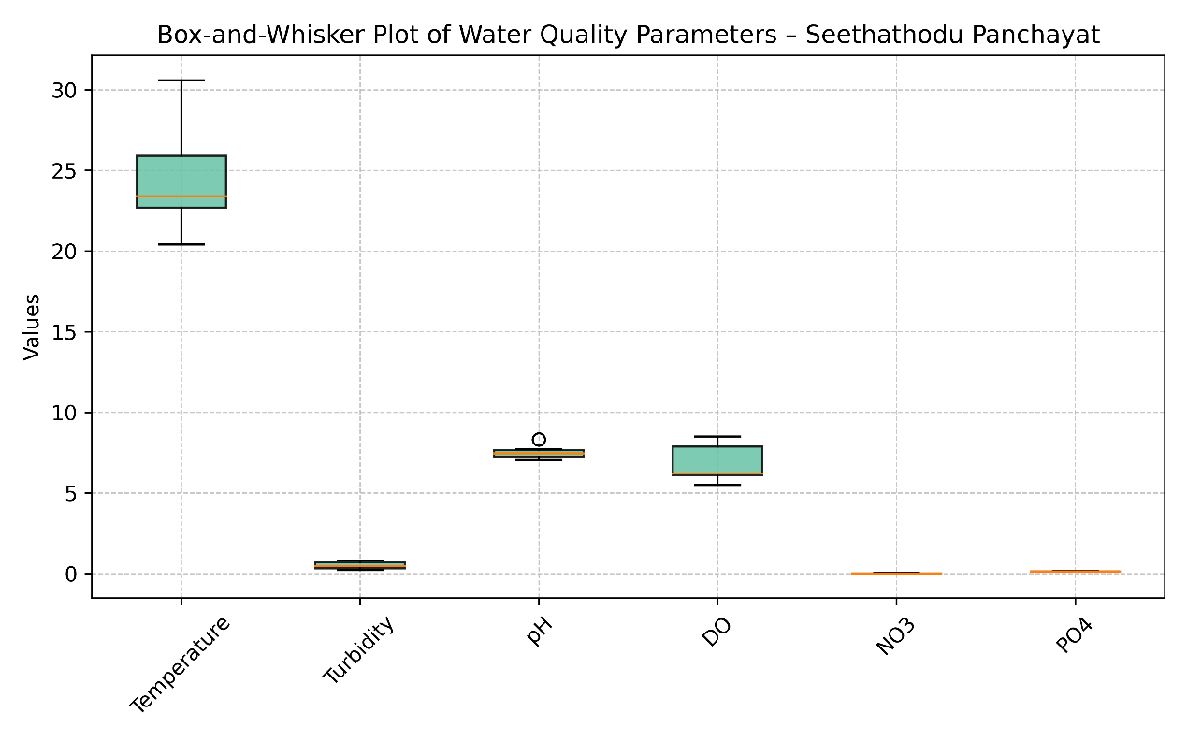
Figure 2. Box-and-whisker plot showing the distribution of water quality parameters in the Pamba River at Seethathodu Panchayat.
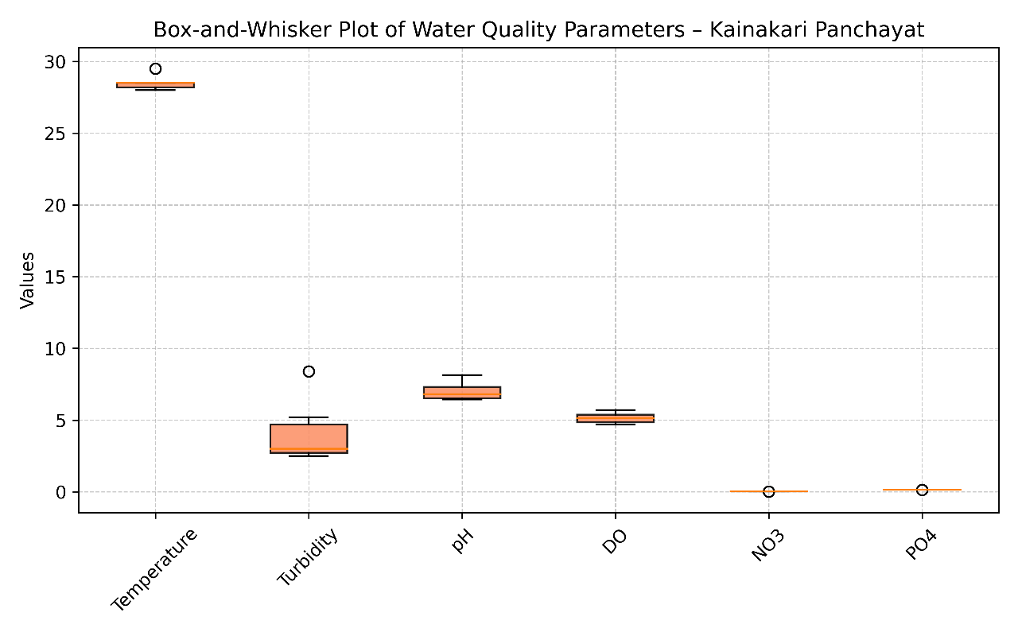
Figure 3. Box-and-whisker plot showing the distribution of water quality parameters in the Pamba River at Kainakari Panchayat.
3.4. Independent Sample t-Test for Highland–Lowland Comparison
The independent sample t-test revealed statistically significant spatial differences between the highland and lowland stretches of the Pamba River for temperature, turbidity, and dissolved oxygen (p < 0.05). Higher temperatures and turbidity levels in Kainakari reflect lowland wetland influence and sediment resuspension, while significantly higher dissolved oxygen concentrations in Seethathodu indicate well-aerated upland conditions. In contrast, pH, nitrate and phosphate did not show significant differences, suggesting relatively uniform nutrient availability during the post-monsoon period across the river continuum (Table 5).
Table 5. Independent sample t-test comparing water quality parameters between Seethathodu and Kainakari
Parameter | t-value | p-value | Significance (α = 0.05)
Temperature (°C) | -2.694 | 0.0413 | Significant
Turbidity (NTU) | -3.824 | 0.0118 | Significant
pH | 1.538 | 0.1592 | Not significant
Dissolved Oxygen (mg/L) | 3.026 | 0.0239 | Significant
Nitrate (mg/L) | -1.071 | 0.3289 | Not significant
Phosphate (mg/L) | -0.905 | 0.3922 | Not significant
3.5. Correlation Structure among Water Quality Variables
In the highland Seethathodu stretch, a strong negative correlation between temperature and dissolved oxygen (r = -0.774) highlights the dominant influence of thermal regime on oxygen solubility under upland conditions. Turbidity showed moderate negative association with nitrate, indicating dilution effects or limited nutrient input. In contrast, the lowland Kainakari stretch exhibited a very strong negative correlation between temperature and phosphate (r = -0.869), reflecting nutrient dynamics influenced by wetland retention and biological uptake. Moderate correlations among nutrients and dissolved oxygen in Kainakari suggest enhanced biogeochemical interactions under longer water residence time and anthropogenic influence (Table 6).
Table 6. Merged Pearson correlation matrix of water quality parameters for Seethathodu and Kainakari Panchayats
 |  | Temp. | Turbidity | pH | DO | NO₃ | PO₄
Temp. | Seethathodu | 1.000 | -0.032 | 0.284 | -0.774 | 0.024 | -0.040
Temp. | Kainakari | 1.000 | -0.154 | -0.394 | 0.496 | 0.320 | -0.869
Turbidity | Seethathodu | -0.032 | 1.000 | -0.034 | 0.362 | -0.549 | -0.317
Turbidity | Kainakari | -0.154 | 1.000 | -0.050 | -0.088 | 0.246 | 0.325
pH | Seethathodu | 0.284 | -0.034 | 1.000 | -0.472 | 0.060 | -0.076
pH | Kainakari | -0.394 | -0.050 | 1.000 | -0.372 | -0.495 | 0.043
DO | Seethathodu | -0.774 | 0.362 | -0.472 | 1.000 | 0.102 | -0.210
DO | Kainakari | 0.496 | -0.088 | -0.372 | 1.000 | -0.462 | -0.137
NO₃ | Seethathodu | 0.024 | -0.549 | 0.060 | 0.102 | 1.000 | 0.399
NO₃ | Kainakari | 0.320 | 0.246 | -0.495 | -0.462 | 1.000 | -0.356
PO₄ | Seethathodu | -0.040 | -0.317 | -0.076 | -0.210 | 0.399 | 1.000
PO₄ | Kainakari | -0.869 | 0.325 | 0.043 | -0.137 | -0.356 | 1.000

3.6. Principal Component Analysis of Water Quality Parameters
The PCA biplot clearly distinguishes the highland Seethathodu and lowland Kainakari sampling sites along the first two principal components (Fig. 4). PC1, accounting for 43.88 % of the total variance, is primarily influenced by temperature and turbidity, which load positively and are strongly associated with the Kainakari sites, reflecting lowland wetland influence and increased sediment dynamics. In contrast, dissolved oxygen shows an opposing loading, closely associated with Seethathodu sites, indicating well-aerated highland conditions. PC2, explaining 19.26 % of the variance, is influenced by pH and nutrient variables (NO₃ and PO₄), suggesting secondary controls related to biogeochemical processes and localized inputs. The clear spatial separation of sampling points in the ordination space confirms longitudinal differentiation in water quality along the Pamba River from source to terminal stretch.
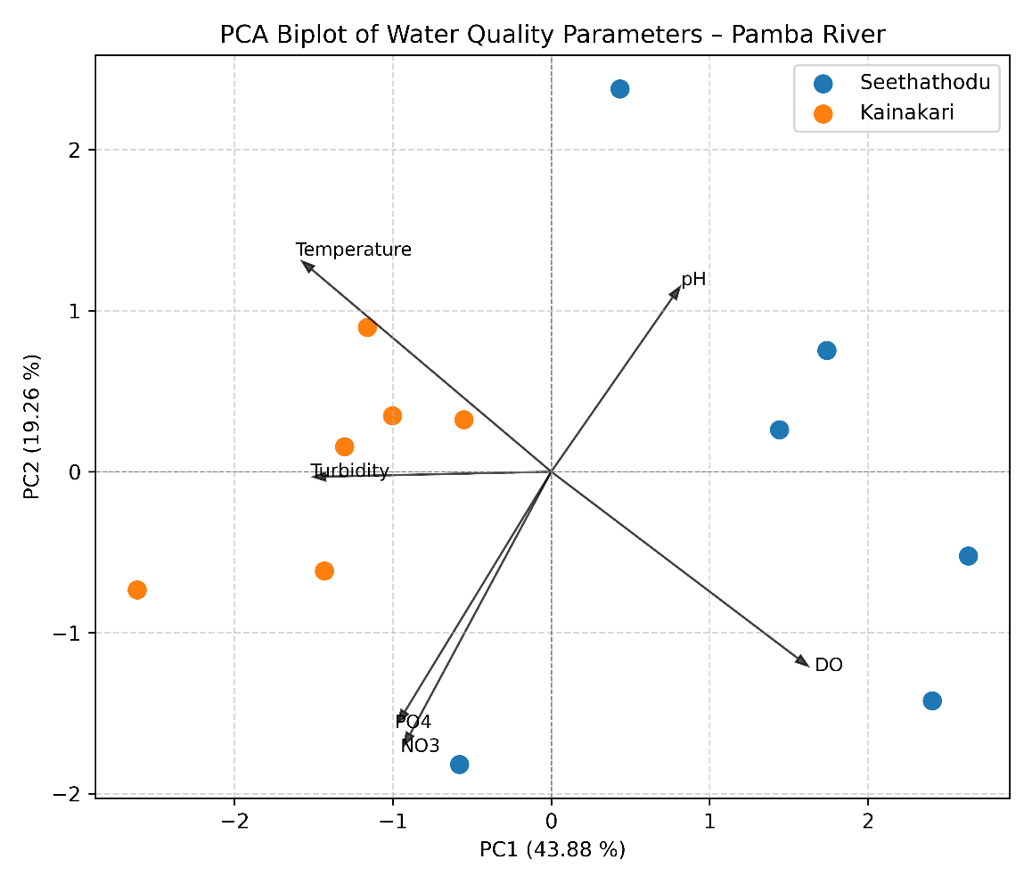
Figure 4. Principal Component Analysis (PCA) biplot illustrating spatial variation in water quality between highland and lowland stretches of the Pamba River
3.7. Hierarchical Cluster Analysis of Sampling Sites
The dendrogram clearly segregates the sampling sites into two major clusters, corresponding to the highland Seethathodu (S1-S6) and lowland Kainakari (K1-K6) stretches of the river (Fig. 5). The Seethathodu cluster is characterized by higher dissolved oxygen and lower turbidity and temperature, reflecting well-aerated upland conditions. In contrast, the Kainakari cluster groups sites influenced by higher temperature, turbidity and nutrient enrichment, indicative of wetland interaction and downstream anthropogenic inputs. The strong agreement between cluster patterns and PCA ordination confirms a distinct longitudinal differentiation of water quality along the Pamba River.
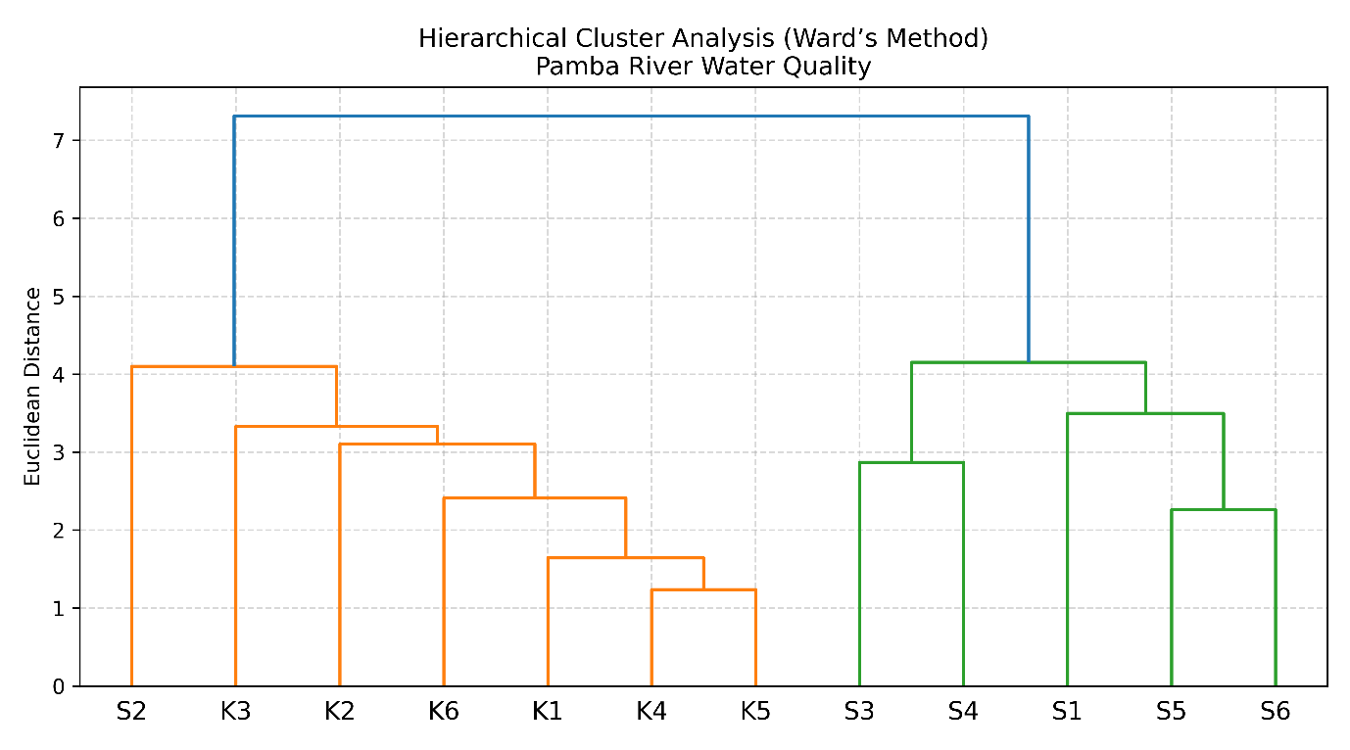
Figure 5. Hierarchical cluster dendrogram (Ward’s method, Euclidean distance) showing similarity patterns among sampling sites of the Pamba River.
3.8. Water Quality Index (WQI) Assessment
The Water Quality Index values indicate that the Pamba River water at both Seethathodu and Kainakari Panchayats falls under the “Good” water quality category during the post-monsoon season (Table 7). The comparatively lower WQI value observed at Seethathodu (38.15) reflects better water quality conditions, driven by lower turbidity, higher dissolved oxygen, and minimal nutrient enrichment associated with forested highland catchments. In contrast, the slightly elevated WQI value at Kainakari (41.75) suggests moderate downstream influence of wetland interaction, sediment resuspension, and anthropogenic activities, though the water quality remains within acceptable limits. The progressive increase in WQI from the highland to the lowland stretch highlights the longitudinal transformation of water quality along the Pamba River continuum, corroborating the results of multivariate analyses.
Table 7. Water Quality Index (WQI) values and classification of the Pamba River at Seethathodu and Kainakari Panchayats
Location | WQI Value | Water Quality Class | Status
Seethathodu Panchayat (Highland) | 38.15 | Good | Suitable for drinking after conventional treatment
Kainakari Panchayat (Lowland) | 41.75 | Good | Suitable for drinking after conventional treatment

4. Discussions
The spatial variation in water quality observed along the Pamba River reflects a clear highland - lowland gradient driven by geomorphology, hydrology, and land-use characteristics. The highland stretch at Seethathodu exhibited lower temperature and turbidity, higher dissolved oxygen, and relatively stable pH, consistent with forested catchments, steeper slopes, and limited anthropogenic pressure. Similar physicochemical signatures have been reported for upland river systems where rapid flow and effective reaeration maintain high oxygen levels and low suspended solids (Vannote et al., 1980; Allan & Castillo, 2021; Sajudeen et al., 2020). In contrast, the lowland Kainakari stretch showed elevated temperature, turbidity, hardness, and nutrients with comparatively reduced dissolved oxygen, reflecting wetland dominance, backwater interaction with Vembanad Kayal, and prolonged water residence time. Comparable downstream degradation patterns have been documented in tropical lowland rivers subjected to canal networks, sediment resuspension, and diffuse anthropogenic inputs (Peters & Meybeck. 2000; Withers et al., 2020; Jalal & Kumar, 2013).
The independent sample t-test revealed statistically significant differences in temperature, turbidity, and dissolved oxygen, highlighting the stronger longitudinal control on physical parameters compared to nutrients during the post-monsoon season. The lack of significant nutrient differences between stretches may be attributed to monsoonal flushing and basin-wide dilution, a phenomenon frequently reported in monsoon-dominated river systems (Tyagi et al., 2013; Dodds & Whiles, 2020). Pearson correlation analysis revealed distinct process controls in each stretch: the strong negative temperature - DO relationship in Seethathodu reflects solubility-driven oxygen dynamics under upland conditions, while the very strong negative temperature-phosphate relationship in Kainakari suggests wetland-mediated nutrient retention and biological uptake. Such contrasting correlation structures underscore the role of hydrological connectivity and thermal regime in regulating short-term water quality variability (Singh et al., 2004; Allan & Castillo, 2021).
Multivariate analyses provided an integrated perspective on the controlling gradients of water quality. PCA clearly separated highland and lowland sites along PC1, dominated by temperature, turbidity, and dissolved oxygen, while PC2 captured secondary influences of pH and nutrients. The strong concordance between PCA ordination and hierarchical cluster analysis confirms robust spatial segregation of sampling sites based on physicochemical similarity, a pattern widely recognized in river water quality assessments employing multivariate techniques (Singh et al., 2004; Muniz & Oliveira-Filho, 2023). The Water Quality Index further corroborated these findings, indicating overall good water quality at both locations, with relatively better conditions in the highland stretch and moderate downstream deterioration in the lowland region. The convergence of descriptive, inferential, multivariate, and index-based assessments reinforces the reliability of the results and highlights the effectiveness of integrated statistical frameworks for diagnosing water quality gradients in tropical river basins such as the Pamba River (Tyagi et al., 2013; Hering et al., 2010; Roy & Kizhakkethottam, 2024).
5. Conclusion
The present study clearly demonstrates a pronounced longitudinal variation in water quality along the Pamba River, shaped by contrasting geomorphological settings and hydrological processes between the highland Seethathodu and lowland Kainakari regions. Integrated evaluation using descriptive statistics, inferential testing, correlation analysis, principal component analysis, cluster analysis, and the Water Quality Index revealed that physical parameters - particularly temperature, turbidity and dissolved oxygen, exert stronger spatial control than nutrients during the post-monsoon season. The highland stretch exhibited relatively pristine conditions with good oxygenation and low turbidity, while the lowland stretch reflected moderate downstream alteration associated with wetland interaction, backwater influence, and anthropogenic pressures, though overall water quality remained within the “good” category. The strong concordance among univariate, multivariate and index-based approaches underscore the robustness of the findings and highlights the value of integrated statistical frameworks for river water quality assessment. These results provide a reliable baseline for future seasonal monitoring and offer critical insights for sustainable management and conservation planning of the Pamba River system.

Ethical Approval: This article does not contain any studies with human participants or animals performed by the author.
Data Availability: The datasets generated and/or analysed during the current study are available from the corresponding author upon reasonable request.

References
- Alexander T. (2025). Ecological Assessment of Physico-Chemical Variability in the Kuttanad Wetlands Using Integrated Statistical Tools. International Journal of Recent Advances in Multidisciplinary Topics, 6(10): 34 – 42. https://journals.ijramt.com/index.php/ijramt/issue/view/98
- Allan, J. D., & Castillo, M. M. (2021). Stream ecology: Structure and function of running waters (3rd ed.). Springer Nature. https://doi.org/10.1007/978-3-030-61286-3
- APHA, (2017). Standard Methods for the Examination of Water and Wastewater, 23rd edn., American Public Health Association, Washington, DC. https://www.standardmethods.org/
- Cheng, B., Liu, X., Guo, K., Rastegarnia, A. (2025).
Investigating factors affecting the quality of water resources by multivariate analysis and soft computing approaches. Scientific Reports, 15, 28925. https://doi.org/10.1038/s41598-025-13380-x
- Dodds, W. K., & Whiles, M. R. (2020). Freshwater ecology: Concepts and environmental applications of limnology (3rd ed.). Academic Press. https://doi.org/10.1016/C2018-0-02145-2
- Geetha Raveendran Nair, A. N., Shamsudeen, S. D., Mohan, M. G., & Sankaran, A. (2023). Basin-Scale Streamflow Projections for Greater Pamba River Basin, India integrating GCM ensemble modelling and flow accumulation-weighted LULC overlay in deep learning environment. Sustainability, 15(19), 14148. https://doi.org/10.3390/su151914148
- Hering, D., Borja, A., Carstensen, J., Carvalho, L., Elliott, M., Feld, C. K., Heiskanen, A.-S., Johnson, R. K., Moe, J., Pont, D., Solheim, A. L., & van de Bund, W. (2010). The European Water Framework Directive at the age of 10: A critical review of the achievements with recommendations for the future. Science of the Total Environment, 408, 4007–4019. https://doi.org/10.1016/j.scitotenv.2010.05.031
- Jalal, F. N., & Kumar, S. M. (2013). Water quality assessment of Pamba River of Kerala, India in relation to pilgrimage season. Journal of Pollution Research, 3(1): 341–347. http://ijrce.org/download.php?file=341-347.pdf
- Jiss Mariya Jose and Ambili T. R. (2021). A Comparative Study on the water quality of Selected Rivers in Kerala. Devagiri Journal of Science 7(1), 01-18. https://www.devagirijournals.com/uploads/pack/107_avila.admin_11837806221024.pdf
- Lekshmi, S., Athira Somarajan, Merlin Danie, Vishak Sasidhar (2020). Water quality analysis of River Pamba using WQI method and GIS mapping. International Journal of Engineering Research & Technology. 9(6) 349 - 367. https://www.ijert.org/research/water-quality-analysis-of-river-pamba-using-wqi-method-and-gis-mapping-IJERTV9IS060349.pdf
- Masudur Rahman, Ramkrishno Das, Nazia Hassan, Kushal Roy, Farhana Haque and Md. Ali Akber (2014). Environmental study on water quality of Mayur River with reference to suitability for irrigation. International Journal of Environmental Sciences 4(6): 1150-1167. https://www.indianjournals.com/ijor.aspx?target=ijor:ijes&volume=4&issue=6&article=006
- Muniz, D. H. F. & Oliveira-Filho, E. C. (2023). Multivariate statistical analysis for water quality assessment: A review. Hydrology, 10(10), 196. https://doi.org/10.3390/hydrology10100196
- Nair, S. N. K. S. (2023). Biodiversity conservation in Pampa River basin (Report). Kerala State Biodiversity Board & Pampa Parirakshana Samithy. Retrieved from https://keralabiodiversity.org/wp-content/uploads/2023/02/cabomba_report.pdf
- Peters, N. E., & Meybeck, M. (2000). Water quality degradation effects on freshwater availability: Impacts of human activities. Water International, 25(2), 185–193. https://www.tandfonline.com/doi/abs/10.1080/02508060008686817
- Roy, A., & Kizhakkethottam, J. J. (2024). Real-time water quality monitoring of River Pamba (India) using Internet of Things. E3S Web of Conferences, 477, 00093. https://doi.org/10.1051/e3sconf/202447700093
- Sajudeen, P. A., Jayachandran, K., & Ashiq, M. (2020). Pilgrimage and depleting water quality: A preliminary study from River Pamba. Ecology, Environment and Conservation, 869-872. https://www.envirobiotechjournals.com/archieved_issues.php
- Singh, K. P., Malik, A., Mohan, D., & Sinha, S. (2004). Multivariate statistical techniques for the evaluation of spatial and temporal variations in water quality of Gomti River (India) - A case study. Water Research, 38(18), 3980-3992. https://doi.org/10.1016/j.watres.2004.06.011
- Tyagi, S., Sharma, B., Singh, P., & Dobhal, R. (2013). Water quality assessment using water quality index. American Journal of Water Resources, 1(3), 34–38.
https://doi.org/10.12691/ajwr-1-3-3
- Vannote, R. L., Minshall, G. W., Cummins, K. W., Sedell, J. R., & Cushing, C. E. (1980). The river continuum concept. Canadian Journal of Fisheries and Aquatic Sciences, 37(1), 130–137. https://doi.org/10.1139/f80-017
- Withers, P. J. A., & Jarvie, H. P., (2008). Delivery and cycling of phosphorus in rivers: A review, Science of the Total Environment 400 (1-3): 379-395. https://doi.org/10.1016/j.scitotenv.2008.08.002

