EFFECT OF IBA AND SEASONAL VAIRIATION ON RHIZOGENSIS OFNERIUM OLEANDER‘VARIEGATA’ THROUGH CUTTINGS

ABSTRACT
The experiment was conducted at the field of the Division of Floriculture and Landscape Architecture, Sher-e-Kashmir University of Agricultural Science & Technology, Shalimar Srinagar. The design of the experiment was CRD with 3 replications to evaluate the influence of different concentrations of Indole-3-butyric acid (IBA) and seasonal timing on the rooting performance of variegated Nerium oleander L. cuttings. Five treatments comprising 0 ppm (control), 500 ppm, 1000 ppm, 2000 ppm, and 3000 ppm IBA were applied to semi-hardwood cuttings during different seasons to assess their effect on rooting percentage, root number, root length, and plant growth. The treatment produced the highest number of primary roots (2.12, 12.56), secondary roots (5.32, 25.65), root length (3.32 cm, 11.67 cm), rooting percentage (10%, 95%) diameter of primary root (0.02mm, 0.8mm) survival% (30%, 95%) in variegated Nerium in summer season respectively. It also resulted in the shortest days to rooting in summer season 20.12 days and35.73 days in autumn season. The highest biochemical contents were observed in summer season cuttings treated with IBA at 3000 ppm yielding the maximum total nitrogen (1.00%, 3.20%) and (1.24%, 7.24%) sugar contents. Phenol content was found highest (1.00%, 1.64%) in summer season cuttings treated with IBA at 3000 ppm. Results indicated that both IBA concentration and season significantly influenced the rooting parameters. Among the treatments, 3000 ppm IBA showed the highest rooting percentage, longest root length, and maximum number of roots per cutting, particularly when applied during the summer season. Seasonal variation played a crucial role, with spring and early summer favouring better rooting compared to autumn. The study highlights the importance of optimizing both IBA concentration and timing to achieve efficient propagation of variegated Nerium oleander L., thus providing valuable insights for commercial production and landscape utilization.

Keywords: ​Cuttings, IBA, Variegated Nerium oleander, Seasonal Variation Propagation.

Introduction
Plant propagation is a fundamental human endeavour. When people were able to reproduce and cultivate a small number of domesticated plant species that could be used for food, shelter, clothing, recreation, and aesthetic fulfilment, early civilization emerged. Genetic selection is used in both plant breeding and plant propagation(Ref). Reviving patterns of genetic differences in their different forms that are beneficial to people is the responsibility of plant breeders. Plant propagators' job is to spread the chosen cultivars while preserving the genetic traits of the original population (Hartman et al., 2015). Plants naturally spread through seeds. Other natural reproduction methods include suckering, layering, and root sprouting. Plants of commercial and aesthetic value are propagated by humans using a variety of methods, such as vegetative propagation using cuttings. Cuttings can be made from the vegetative parts of the plant, including the stems, modified stems (rhizomes, tubers, corms, and bulbs), leaves, or roots. Herbaceous, hardwood, semi-hardwood, and softwood are the four types of stem cuttings. Hardwood cuts are made with mature, dormant, strong wood after the leaves have fallen. Hardwood cutting is among the most straightforward and affordable vegetative propagation techniques. Hardwood cuttings are simple to prepare and require little to no specialized equipment to root throughout the dormant season (Hambrick et al., 1991; Fourrier,1984).
Ornamental horticulture plays a vital role in enhancing environmental aesthetics, psychological well-being, and biodiversity (Huxley, 1992)kindly cite this : https://www.researchgate.net/publication/353769089_Recent_trends_in_propagation_of_horticulture_crops_and_application_of_Genomics_tools_in_plant_Breeding) . Among ornamentals, Nerium oleander L., commonly known as oleander, is valued for its hardiness, long blooming period, and decorative appeal. Belonging to the family Apocynaceae, it is native to the Mediterranean and Asia but is now widely cultivated in tropical and subtropical regions (Pagen, 1987). The variegated form, with cream or white margins on green leaves, enhances its landscape value and provides year-round ornamental interest (Langford & Boor, 1996. Oleander is extensively used in hedges, screens, and avenue plantations due to its rapid regrowth and tolerance to pruning (Schuch, 2009). Its cultivars vary in flower colour and foliage types, and breeding efforts aim to develop genotypes with novel growth habits, pathogen resistance, and stress tolerance (Bella et al., 2006; Mackay et al., 2005). Propagation is mainly clonal through cuttings to maintain varietal traits (Hartmann et al., 2002). Beyond its ornamental role, Nerium oleander exhibits diverse pharmacological properties, including antibacterial (Derwich et al., 2010), antimicrobial (Hussain et al., 2004), anti-inflammatory and antinociceptive (Erdemoglu et al., 2003), and antitumor activity (Ali et al., 2010). It is also used in traditional medicine across South Asia for its antibacterial effects (Srinivasan et al., 2001). However, propagation through seed results in variability, making cutting-based propagation with rooting hormones like IBA more reliable (Pagen, 1988).
The Apocynaceae family includes the evergreen shrub species Nerium oleander var. Variegata L (Oleander), which is indigenous to northern Africa and the Mediterranean. Because of its long-lasting and copious flowering, as well as its resilience to heat, salinity, and drought, it is frequently planted as an ornamental in warm temperate and subtropical locations
IBA and NAA aid in promoting adventitious rooting in cuttings, while exogenous auxins are crucial for improving the quality and rooting efficiency of stem cuttings (Copes and Mandel, 2000). According to Dirr and Heuser (2006), the administration of rooting hormones improves the quantity and quality of adventitious roots, facilitates the start of adventitious roots, and raises the overall percentage of rooting. IBA has a rooting- promoting function because it is converted to IAA in plant tissue.
The time of year or season in which cuttings are collected can have a significant impact on rooting. There is an ideal time of year for rooting for many species (Hartmann et al., 2002). The difference in growth according to planting dates is based on total carbohydrate and total nitrogenlevels and the C/N ratio has been reported to influence the adventitious rooting of some species. These materials provide the carbon and energy needed for the production of proteins and nucleic acids as well as other materials necessary for root development. Although cuttings with higher carbohydrate content typically have a higher rooting percentage, these levels might vary significantly based on the time of year. Woody plants frequently have seasonal variations in rooting efficiency, so it is necessary to determine the best time of year for each species to root (Yamamoto et al., 2013). Despite a continually rising demand for these plants, no research on Nerium oleander var. Variegata L. propagation in Kashmir circumstances has been published.

Materials and Methodology
The present experiment was carried out on Nerium oleander var. variegata with the aim of evaluating the influence of indole-3-butyric acid (IBA) concentrations and seasonal variation on rooting behaviour and associated biochemical traits. The study was laid out in a Completely Randomized Design (CRD) with three replications, consisting of 15 treatment combinations derived from two factors: five levels of IBA (0, 500, 1000, 2000, and 3000 ppm) and three different planting seasons (spring, summer, and autumn). Each treatment comprised 20 stem cuttings, making it statistically robust for comparative analysis. The experiment focused on both morphological and biochemical parameters to gain comprehensive insights into the propagation efficiency of the crop. Morphological observations included days taken for root initiation, number and length of primary and secondary roots, root diameter, number of cuttings successfully rooted, and survival percentage of rooted cuttings. In addition, leaf samples were analyzed for nitrogen, total sugars, and phenolic content to assess the physiological and metabolic responses under different treatment conditions. Such an approach integrates growth performance with biochemical profiling, thereby facilitating a better understanding of the role of growth regulators and seasonal influence in optimizing vegetative propagation of oleander.
Result and Discussion
Nerium oleander L. variegata began to generate root initials earlier as a result of higher IBA concentrations. At 2000 ppm of IBA treatment, the shortest time to root emergence (25.20 day) was achieved, and under control, the longest time to root emergence (31.54 day) was achieved.(kindly add the image)
The greatest number of primary adventitious roots (10.14), the greatest number of secondary adventitious roots (22.00), the longest primary root length per cutting (10.29 cm) the highest values for all root parameters were observed in Nerium oleander L treated with IBA @ 3000 ppm.Conversely, under control, the smallest lengthof primary root per cutting ( 3.61 cm )the smallest number of secondary adventitious roots ( 7.76 cm) the smallest number of primary adventitious roots (3.24).The smallest diameter of primary root (0.46mm) was recorded under control, whereas the greatest diameter of primary roots (2.29 mm) was achieved with IBA@3000 ppm.IBA@3000 ppm treated cuttings had thehighest rooting percentage (76.3), while control cuttings had the lowest rooting percentage (40.9).(Make a table and add the images for the better impact)
The results obtained in this study conform with various researchers like Bharathy (2001) in carnation(Dianthus caryophyllusL.)cuttings, Banday (2003) in Osmanthus fragrans Lour., Ginkgo biloba L., Prunus glandulosa Thunb., and Aloysiatriphylla Britt., Tripathi et al. (2003) in poinsettia cuttings, and Tantray (2004) in Olea europea. Bharmal et al. (2005) in Chrysanthemum and Khan et al. (2004) in Rosa bourboniana.
Cuttings planted in the Autumn Season(September) took the longest time to develop roots (30.34 day), whereas cuttings put in the Summer Season (July) took the shortest time (25.26 day).Cuttings planted in the Summer Season (July) had the highest number of primary adventitious roots (8.36), the highest number of secondary adventitious roots (17.47), the longest primary root length ( 8.57 cm) and maximum primary root diameter (1.80) .In contrast, plants planted in the Autumn Season of September had the lowest number of primary adventitious roots (4.82), the lowest number of secondary adventitious roots(11.45 ), the shortest primary root length(6.22), and the lowest primary root diameter(1.01 mm).
Planting Nerium oleander L. during the Summer Season (July) produced the highest rooting percentage (68.3%), whereas planting during the Autumn Season (September) produced the lowest rooting percentage (43.3%).Nerium oleander L. rooted cuttings showed the highest survival rate (82.23 %) when planted in the Summer Season (July) and the lowest survival rate (51.37%) when planted in the Autumn Season (September). These observations align with the findings ofBharathy et al. (2004). Moe (1973) have observed similar results in rose cv. Nozomi and Bharathy etal. (2004) in carnation. Singh (2001) on Jasminum sambac 'Double Mogra' stem cuttings who also emphasized the role of seasonal factors in root development.(Images)

Maximum values for total nitrogen (0.80%), total phenol (8.01%) and total sugar (7.63%) were observed in cuttings treated with 3000 ppm IBA, whereas minimum total nitrogen (0.32%), total phenol (4.26%) and total sugar (4.09%) was observed in untreated cuttings under control (0ppm IBA).Maximum values for total nitrogen (0.71%), total phenol (7.03%) and total sugar (6.73%) were observed in summer planted cuttings, whereas minimum total nitrogen (0.40%), total phenol (4.83%) and total sugar (4.32%) was observed in Autumn planted cuttings.
These results indicate that both IBA concentration and planting season play a crucial role in determining the rooting success of Nerium oleander cuttings. The best outcomes are achieved when optimal hormone levels coincide with favourable environmental conditions. Similar interaction effects have been documented in earlier studies on other woody ornamental species, further validating the importance of synchronized hormone application and seasonal timing invegetative propagation. Similar interaction effectshave been reported by (Rolston et al., 1996). Ramdayal et al. (2001) and Gupta et al. (2002) also noted similar outcomes with Bougainvillea cuttings.

Conclusion
Application of IBA at the concentration of 3000ppm was found optimum for improving all rooting characteristics and physiological parameters of cuttings of Neriumoleander var. Variegata.
Summer season (July) was found best time for planting of cuttings of Nerium oleander var. Variegata for successful rooting of cuttings with improved rooting characteristics. Kindly add the explanantion of the each of the images of the graph pasted. And add more contents to this section.

Table 1-Effect of IBA Concentration and Seasonal Variation on Rooting and Biochemical Parameters of Variegated Oleander (Nerium oleander L.)
Treatment | Dttr | Nopr | Nosr | Lopr | Nocr | Dopr | Sprc | Tnc | Tpc | Tsc
T1 | 30.41 | 2.76 | 8.29 | 3.46 | 0.43 | 0.02 | 0.46 | 0.45 | 3.13 | I .49
T2 | 29.41 | 4.62 | 12.41 | 6.64 | 0.57 | 0.03 | 0.55 | 0.48 | 3.39 | 2.55
T3 | 27.83 | 6.7 | 17.76 | 7.53 | 0.57 | 0.04 | 0.7 | 0.57 | 4.24 | 3.57
T4 | 25.87 | 8.51 | 20.35 | 8.45 | 0.72 | 0.05 | 0.82 | 0.68 | 4.88 | 4.62
T5 | 27.31 | 10.15 | 21.29 | 9.22 | 0.82 | 0.05 | 0.85 | 0.73 | 5.15 | 5.52
T6 | 28.72 | 4.7 | 9.49 | 4.27 | 0.43 | 0.03 | 0.5 | 0.54 | 3.54 | 2.24
T7 | 26.56 | 6.54 | 11.32 | 7.32 | 0.63 | 0.05 | 0.62 | 0.57 | 4.49 | 4.44
T8 | 25.43 | 7.95 | 13.58 | 9.29 | 0.75 | 0.05 | 0.7 | 0.63 | 5.37 | 5.56
T9 | 22.47 | 10.17 | 17.52 | 10.51 | 0.85 | 0.07 | 0.8 | 0.74 | 6.17 | 6.22
T10 | 23.55 | 12.45 | 25.47 | 11.48 | 0.92 | 0.08 | 0.9 | 0.93 | 7.22 | 7.24
T11 | 35.49 | 2.26 | 5.52 | 3.1 | 0.12 | 0.01 | 0.32 | 0.24 | 2.24 | 1.24
T12 | 32.65 | 3.74 | 7.37 | 4.51 | 0.23 | 0.02 | 0.37 | 0.33 | 3.35 | 2.22
T13 | 30.34 | 4.48 | 9.68 | 5.35 | 0.42 | 0.03 | 0.5 | 0.43 | 4.24 | 3.25
T14 | 27.26 | 5.81 | 15.43 | 7.98 | 0.58 | 0.04 | 0.58 | 0.54 | 4.42 | 4.22
T15 | 25.58 | 7.83 | 19.25 | 10.19 | 0.67 | 0.06 | 0.65 | 0.63 | 5.14 | 5.24
CD<_ (0.05) | 1.126 | 0.647 | 1.757 | 0.551 | 5.069 | 0.291 | 5.082 | 0.005 | 0.072 | 0.698

Figure 1: Days Taken to Rooting
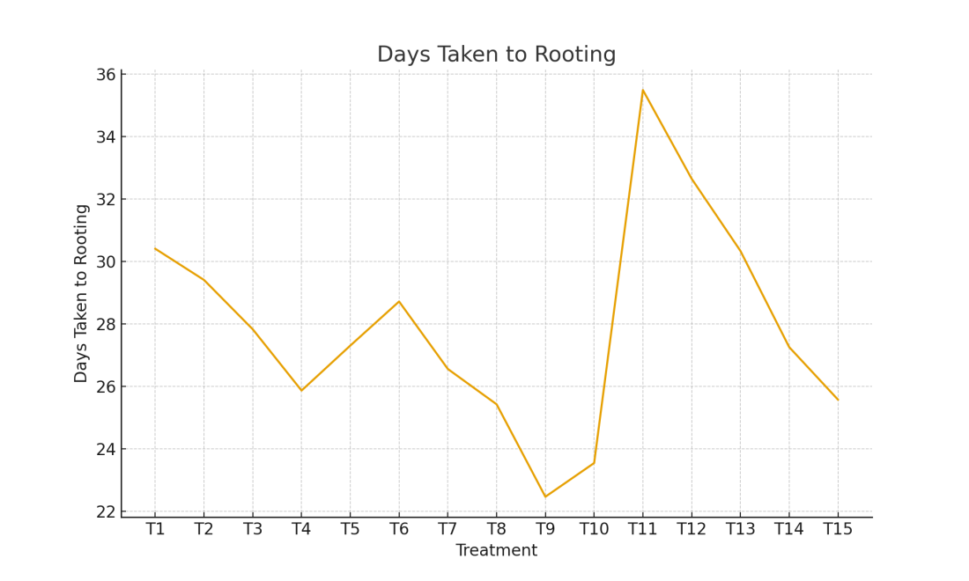
Figure 2: Number of Primary Roots
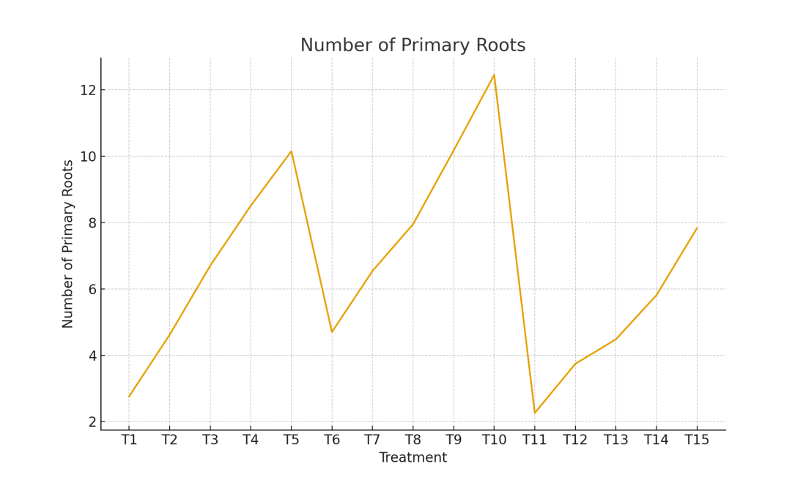
Figure 3: Number of Secondary Roots
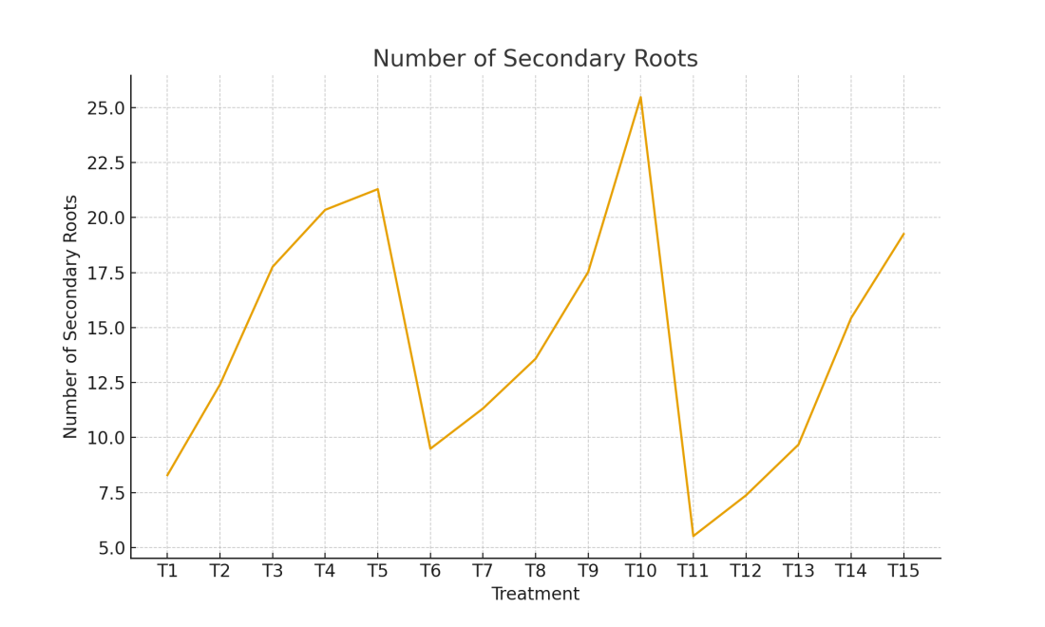
Figure 4: Length of Primary Roots (cm)
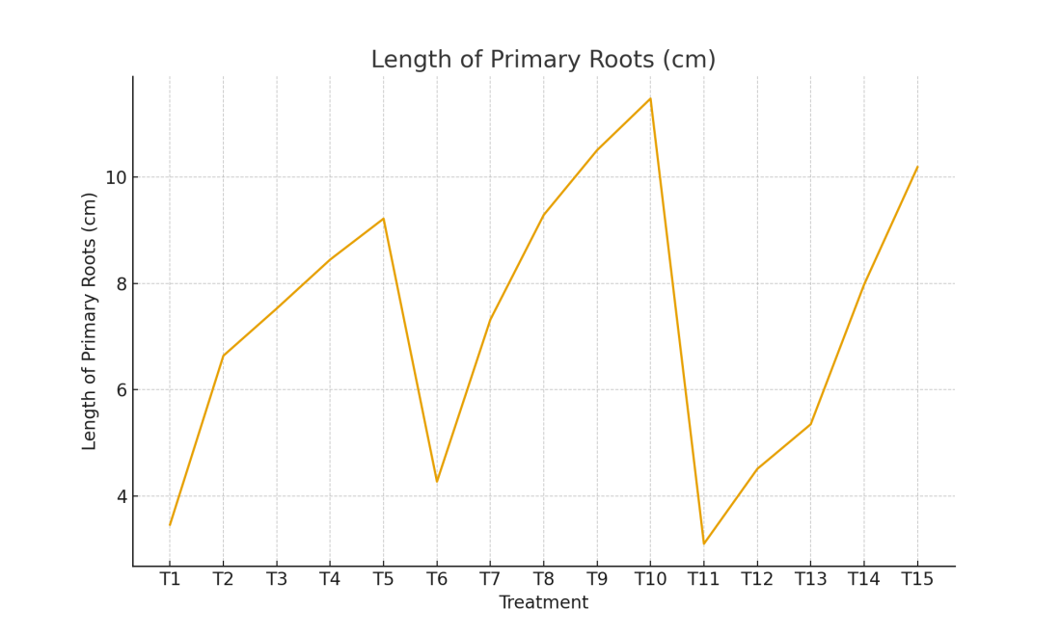
Figure 5: Number of Cuttings Rooted Successfully
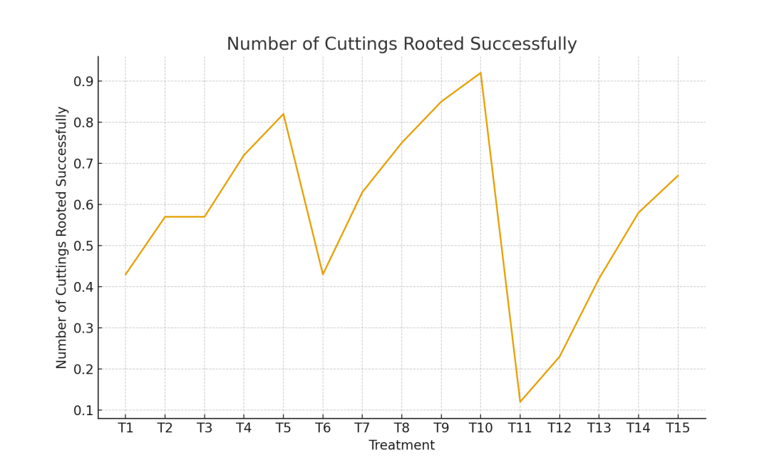
Figure 6: Diameter of Primary Root (mm)
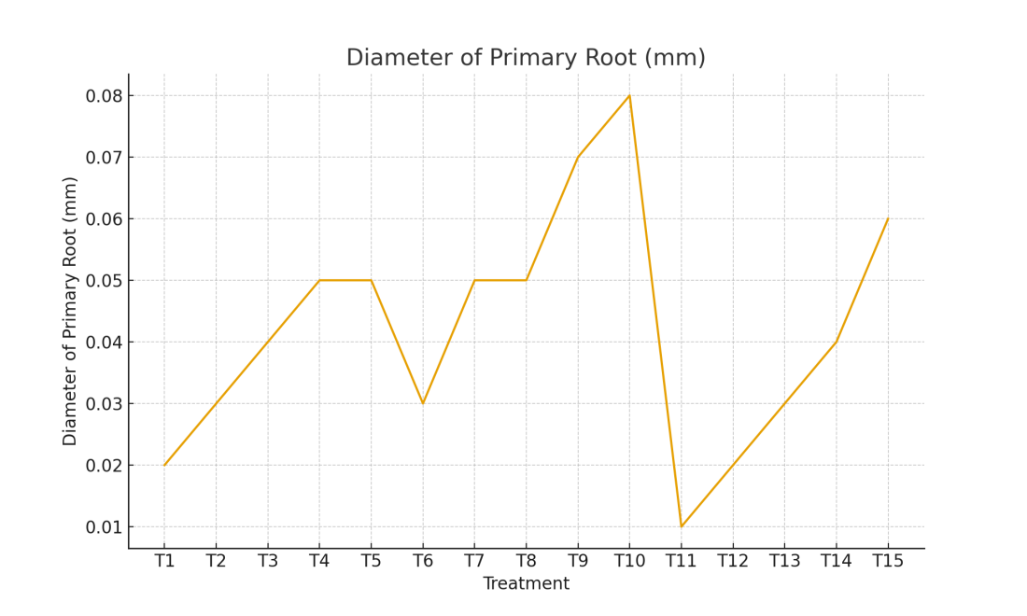
Figure 7: Survival Percentage (%)
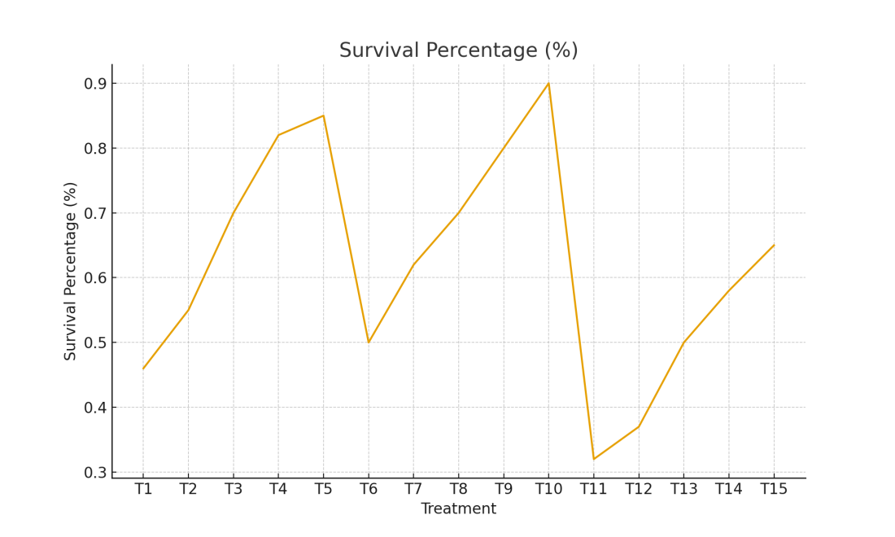
Figure 8: Total Nitrogen Content (%)
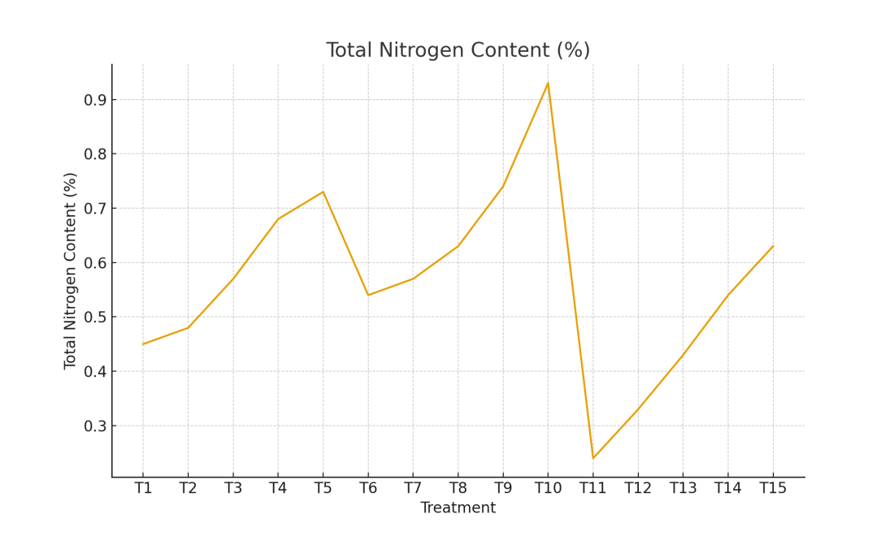
Figure 9: Total Phenol Content (%)
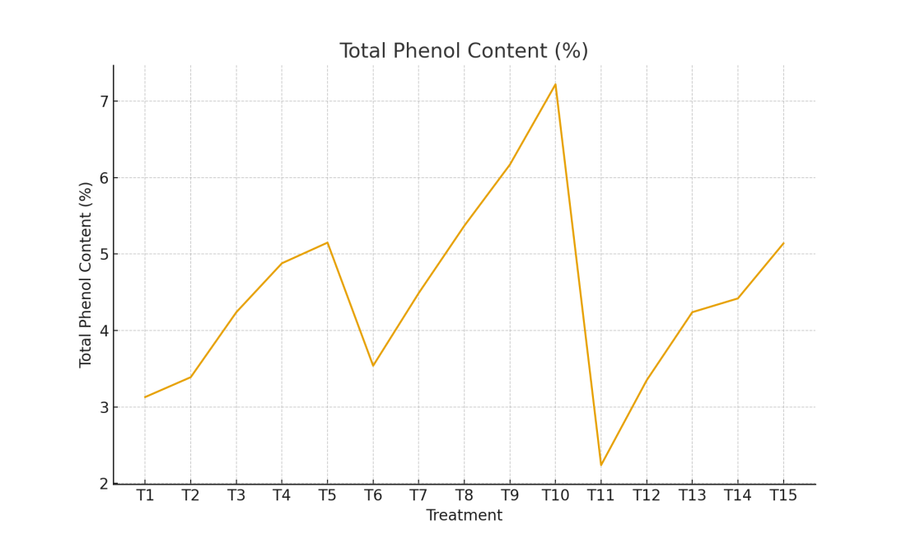
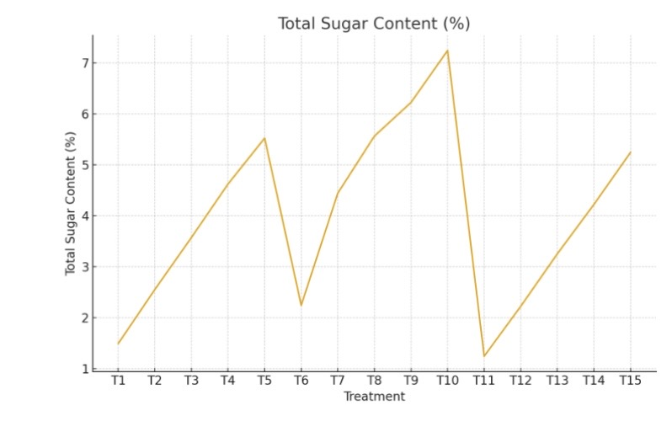
Figure 10: Total Sugar Content (%)

References
- Ali, H. F. M., El-Ella, F. M. A., & Nasr, N. F. (2010). Screening of chemical analysis, antioxidant antimicrobial and antitumor activities of essential oil of oleander (Nerium oleander) flower. International Journal of Biological Chemistry, 4(4), 190–202. https://doi.org/10.3923/IJBC.2010.190.202
- Banday, S. H. 2003. Studies on propagation ofsome woody landscape plants from summerleafy stem cuttings. M.Sc. Thesis submitted to SKUAST (K) Shalimar.
- Bella, P., V. Catara, C. Guarino and G. Cirvilleri. 2006. Evaluation of oleander accessions for resistance to Pseudomonas savastanoipv. nerii. Journal of Plant Pathology 88: 273– 278.
- Bharathy, P. V. 2001. The effect of plant growthregulators on rooting of cuttings in Carnation (Dianthus caryophyllus L.). M.Sc. Thesis submitted to N. A.U., Navsari.
- Bharathy, P. V., Sonawane, P. C., & Sasnu, A. (2003). Effect of different planting media on rooting of cuttings in carnation (Dianthus caryophyllus L.). Journal of Maharastra Agricultural Universities, 28(3), 343-344.
- Bharmal, V. S., Ranpise, S. A. and Darwade, R. T. 2005. Effect of different levels of indole butyric acid (IBA) on rooting, growth and flower yield of Chrysanthemum cv. Sonali Tara. Orissa Journal of Horticulture 33(2): 36-41.
- Copes, D. L., & Mandel, N. L. (2000). Effects of IBA and NAA treatments on rooting Douglas-fir stem cuttings. New Forests, 20(3), 249-257. https://doi.org/10.1023/A:1006752717350
- Derwic, E., Benziane, Z. and Boukir, A. 2010. Antibacterial activity and chemical composition of the essential oil from flowers of Nerium oleander. Journal of Environmental, Agricultural and Food Chemistry 9(6): 1074–1084.
- Dirr, M. A., & Heuser, C. W., Jr. (2006). The reference manual of woody plant propagation: From seed to tissue culture (2nd ed.). Timber Press. https://blackwells.co.uk/bookshop/product/Reference-Manual-of-Woody-Plant-Propagation-by-Michael-A-Dirr-author-Charles-W-Jr-Heuser-author/9781604690040
- Erdemoglu, N., Küpeli, E., & Yeşilada, E. (2003). Anti-inflammatory and antinociceptive activity assessment of plants used as remedy in Turkish folk medicine. Journal of Ethnopharmacology, 89(1), 123–129. https://doi.org/10.1016/s0378-8741(03)00282-4
- Fourrier, B. (1984). Hardwood cutting propagation at McKay nursery. *Combined Proceedings International Plant Propagators Society*, *34*, 540-543. https://www.ipps.org/Proceedings.htm
- Gupta, V. M., Banerji, B. K., & Datta, S. K. (2002). Effect of auxin on the rooting and sprouting behaviour of stem cuttings of Bougainvillea cv. Los Banos Variegata 'Silver Margin' under mist. Haryana Journal of Horticultural Sciences, 31(1-2), 42-44.
- Hambrick, C. E., Davies, F. T., & Pemberton, H. B. (1991). Seasonal changes in carbohydrate/nitrogen levels during field rooting of Rosa multiflora 'Brooks 56' hardwood cuttings. Scientia Horticulturae, 46(1-2), 137-146. https://doi.org/10.1016/0304-4238(91)90099-K
- Hartmann, H. T., Kester, D. E., Davies, F. T. and Geneve, R. L. 2002. Plant Propagation, Principles and practices 8th edition. Prentice Hall Publishers pp 293-295.
- Hartmann, H. T., Kester, D. E., Davies, F. T., & Geneve, R. L. (2014). *Hartmann & Kester's Plant Propagation: Principles and Practices* (8th ed.). Pearson. https://www.pearson.com/uk/higher-education/products-and-services/products/hartmann-kester-s-plant-propagation-principles-and-practices-8-e-hartmann-kester-davies-geneve/9781292020884.html
- Hussein, B. A., Goran, Y. A. and Khurshid, R. M. Q. 2015. Effect of different concentrations of IBA on rooting ability and shooting in Olive (Oleaeuropaea L., cv. Dgel) cuttings. International Conference and Workshop on Basic and Applied Sciences 11(1): 50-52.
- Huxley, A. (Ed.). (1992). The new Royal Horticultural Society dictionary of gardening. Macmillan Press.
- Khan, M. A., Ziaf, K., & Ahmad, I. (2004). Effect of various hormones and different rootstocks on rose propagation. Pakistan Journal of Biological Sciences, 7(10), 1643-1646. https://doi.org/10.3923/pjbs.2004.1643.1646
- Langford, S. D., & Boor, P. J. (1996). Oleander toxicity: An examination of human and animal toxic exposures. Toxicology, 109(1), 1–13. https://doi.org/10.1016/0300-483x(95)03296-r
- Mackay, W. A., Arnold, M. A., & Parsons, J. M. (2005). Nerium oleander L. `Cranberry Cooler', `Grenadine Glace', `Pink Lemonade', `Peppermint Parfait', `Raspberry Sherbet' and `Petite Peaches and Cream'. HortScience, 40(1), 265–268. https://doi.org/10.21273/HORTSCI.40.1.265
- Moe, R. (1973). Propagation, growth and flowering of potted roses. Acta Horticulturae, 31, 157-166. https://doi.org/10.17660/ActaHortic.1973.31.4
- Pagen, F. J. J. (1987). Series of revisions of Apocynaceae. XX. Oleanders: Nerium L. and the Oleander cultivars. Agricultural University Wageningen Papers, 87(2), 1–113. https://library.wur.nl/WebQuery/wurpubs/653665
- Pagen, F. J. J. (1987). Series of Revisions of Apocynaceae XX. Oleanders; Nerium L. and the Oleander Cultivars. Agricultural University Wageningen. https://library.wur.nl/WebQuery/wurpubs/fulltext/290321
- Ramdayal, P., Gupta, A. K., Saini, R. S. and Sharma, J. R. 2001. Effect of auxin on the rooting of cutting in BogainvilleavarMaryPalmer. Haryana Journal of Horticultural Sciences 30: 215-216.
- St. Hilaire, R., Fierro Berwart, C. A., & Pérez-Muñoz, C. A. (1996). Adventitious root formation and development in cuttings of Mussaenda erythrophylla L. Schum. & Thonn. HortScience, 31(6), 1023–1025. https://doi.org/10.21273/HORTSCI.31.6.1023
- Schuch, U. K. (2009). Pruning shrubs in the low and mid-elevation deserts in Arizona. University of Arizona Cooperative Extension. https://extension.arizona.edu/sites/extension.arizona.edu/files/pubs/az1499.pdf
- Singh, A. K. 2001. Effect of auxins on rooting and survival of Jasmine (Jasminumsambac) stem cuttings. Progressive Horticulture 33(2):174-177
- Srinivasan, D., Nathan, S., Suresh, T., & Perumalsamy, P. L. (2001). Antimicrobial activity of certain Indian medicinal plants used in folkloric medicine. Journal of Ethnopharmacology, 74(3), 217-220. https://doi.org/10.1016/s0378-8741(00)00345-7
- Tantary, F. A. 2004. Studies on propagation of olive (Oleaeuropea) through stem cuttings under Kashmir conditions. M.Sc. Thesis submitted to SKUASTK, Shalimar, Srinagar pp.34-38.
- Tripathi, A. N., Pandey, G. and Shukla, P. K. 2003.Effect of auxins on rooting behaviour of Euphorbia pulcherrima Wild. ProgressiveHorticulture 5:111-113.
- Yamamoto, L. Y., Koyama, R., Borges, W. F. S., Antunes, L. E. C., Assis, A. M. D., & Roberto, S. R. (2013). Substratos no enraizamento de estacas herbáceas de amora-preta Xavante. Ciência Rural, 43(1), 15-20. https://doi.org/10.1590/S0103-84782012005000135
- Add the citation https://www.researchgate.net/publication/353769089_Recent_trends_in_propagation_of_horticulture_crops_and_application_of_Genomics_tools_in_plant_Breeding according to the citation used above in the text.

