Original Research Article

Quantifying Climate Variability and Its Influence on Vegetation Dynamics in Tanzania

Abstract
Understanding how climate variability influences tropical vegetation is critical for informing sustainable land management, biodiversity conservation, and climate-change adaptation strategies. This study quantifies the long-term spatio-temporal dynamics of vegetation health in Tanzania from 2000 to 2024 by integrating high-resolution remote-sensing datasets, including EVI, LST, rainfall and ET. Using Google Earth Engine (GEE), we applied rigorous quality control, Savitzky-Golay noise filtering, and spatial harmonization to generate annual and seasonal time series. Long-term trends were assessed using Sen’s slope estimator and the Mann–Kendall significance test, while vegetation cover was quantified using FVC derived from dichotomous modelling. Results show a pervasive and statistically significant warming trend across all seasons, contrasted by regionally heterogeneous rainfall increases, particularly during the DJFMA and MAM seasons. EVI and FVC analyses reveal mixed vegetation trajectories, with widespread degradation across central, southeastern, and western regions, despite a modest overall national improvement. Correlation and lag analyses indicate that LST exerts the strongest immediate suppressive effect on vegetation (ρ = –0.78), whereas rainfall and ET exhibit both instantaneous and delayed influences, with a notable five-year ecological memory effect. These findings demonstrate that vegetation dynamics in Tanzania are governed by a dual climatic control system: acute thermal stress and long-term hydrological legacy effects. The study underscores the need for multi-year water management, targeted conservation, and heat-mitigation strategies to enhance ecosystem resilience in Tanzania’s climate-vulnerable landscapes.
Keywords: Vegetation dynamics, Enhanced Vegetation Index, Land Surface Temperature, Rainfall variability, Tanzania

1 Introduction
Vegetation is crucial for terrestrial environments by acting as the planet's primary carbon sink and oxygen source, while also regulating regional climate through evapotranspiration and moisture control (Chaturvedi et al., 2025; Houghton, 2007; Miralles et al., 2025). It critically manages the water cycle by promoting infiltration and stabilizing soil against erosion, enriching it with vital organic matter for all life (Wang et al., 2018; Wiesmeier et al., 2019). This essential role is magnified by the sheer scale of plant life, terrestrial plants collectively comprise more than 90% of global biomass, and the world's forests alone uptake around one-third of human-induced carbon emissions, highlighting their indispensable influence on the entire planetary system (Forzieri et al., 2022).
Tropical climates, situated near the Equator, are characterized by consistently high temperatures and abundant rainfall, leading to the world's most biologically diverse and carbon-rich ecosystems. These regions are globally critical because their immense vegetation cover plays an outsize role in regulating the planetary climate and hydrological cycles (Friedlingstein et al., 2023). Tanzania particularly contains vast stores of Miombo woodlands and rainforests that serve as immense reservoirs of carbon and biodiversity essential for planetary climate regulation (Mwakalukwa et al., 2024). Thus, understanding the spatio-temporal patterns and drivers of vegetation cover dynamics in these Tanzania is essential, as monitoring how and why vegetation changes across space and time provides the critical data needed to inform effective conservation, sustainable land-use planning, and targeted climate change mitigation strategies.
Variability in rainfall and temperature profoundly impacts global vegetation dynamics by controlling plant physiological processes and geographic distribution (O’Sullivan et al., 2020). Changing precipitation patterns dictate soil moisture and productivity in water-limited regions, while temperature dictates growth rates, the length of the growing season, and overall biome boundaries. Despite the recognized pressure on Tanzania's tropical vegetation, several critical knowledge gaps remain in the scientific understanding necessary for effective planning, particularly concerning the climatic influence. Existing regional studies have monitored localized degradation (Kambi et al., 2025; Kashaigili et al., 2010), but a comprehensive national-level, high-resolution assessment of the long-term spatio-temporal trends and synchronicity among Enhanced Vegetation Index (EVI), Land Surface Temperature (LST), and rainfall is currently lacking across the entire country and there is a significant gap in the quantified statistical assessment of the relationship between EVI and the primary climate parameters.
To address these gaps, this study sets forth the following objectives, i. Identifying the spatiotemporal distribution and trends in annual and seasonal EVI, rainfall, and LST using relevant remote sensed data products. ii. Comparing the spatiotemporal pattern of vegetation change across the country and quantifying the relative influence of climate change on the observed vegetation dynamics.

Data and Methodology

Characteristics of the Study Area
Tanzania is located in East Africa between latitudes 1°S and 12°S, longitudes between 29°E and 41°E, covering approximately 945,100 km² (Kabanda, 2024). The country exhibits highly diverse physical, climatic, and ecological conditions, making it an ideal setting for assessing long-term vegetation dynamics and their relationship with climate and hydrological variability. Tanzania’s elevation ranges from coastal lowlands along the Indian Ocean to high mountains and volcanic highlands, including Mount Kilimanjaro (Figure 1). This topographic diversity strongly influences spatial patterns of temperature, rainfall, and vegetation productivity. Tanzania experiences a tropical climate with marked regional variations. The northern and eastern regions are predominantly bimodal rainfall zones, receiving rainfall during the “Masika” (March-May) and the “Vuli” (October-December). In contrast, the central, western, and southern parts experience a unimodal rainfall pattern, mostly concentrated between December and April (Borhara et al., 2020). Temperature variation also reflects the country’s elevation gradients, with higher LST observed in lowland and semi-arid zones. Tanzania's vegetation is diverse, largely consisting of miombo woodlands in the western and southern parts of the country. The landscape also features a variety of other vegetation types, including savanna woodlands, coastal mangrove swamps, tropical rainforests high-altitude forests on mountain ranges like Kilimanjaro. Other vegetation types include grasslands, shrublands, and semi-desert areas.
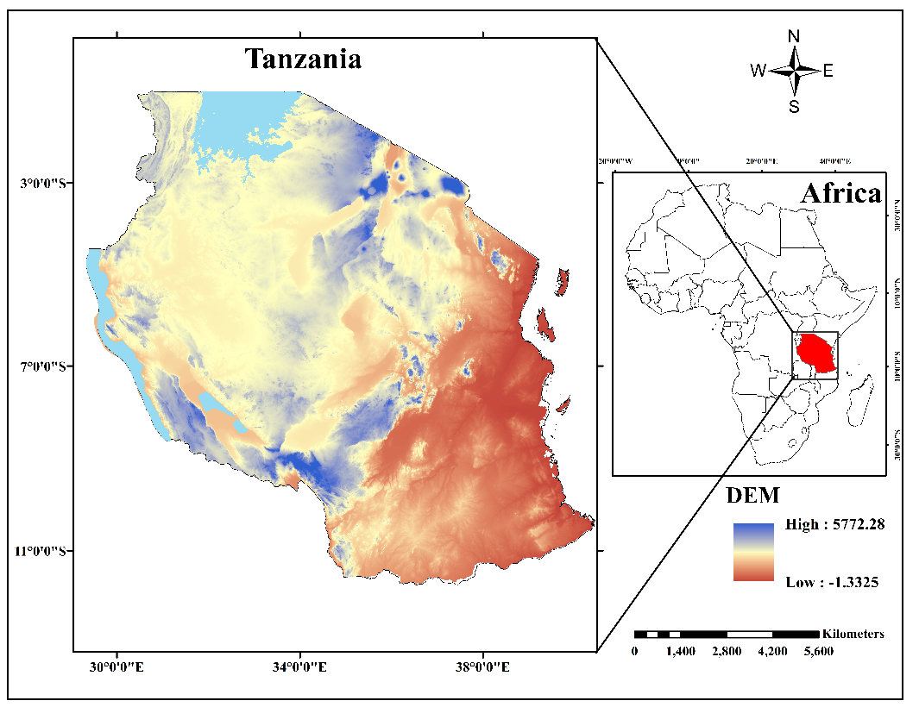
Figure 1 Study area map of Tanzania and its location in Africa showing the DEM of the country.

2.2 Datasets
Several high-resolution remote sense datasets have been utilized in the study covering a period from 2000 to 2024, Table 1 shows the description of each dataset.
Table 1 Details of data sources used in this study.
Dataset | Product ID | Band | Period | Resolution
Vegetation | MODIS/061/MOD13Q1 | Enhanced Vegetation Index | 2000-2024 | 250m
Rainfall | Ucsb-Chg/Chirps/Daily | Precipitation | 2000-2024 | 0.05⁰
Land surface temperature | MODIS/061/MOD11A1 (Terra and Aqua) | LST_Day_1 km | 2000-2024 | 1⁰ x 1⁰
Evapotranspiration | MODIS/061/MOD16A2GF | Total evapotranspiration | 2000-2024 | 0.005⁰
DEM | USGS/SRTMGL1_003 | elevation | 2000 | 30m

2.3 Data Pre-processing and Temporal Aggregation
All data processing, filtering, and pre-aggregation were conducted using the Google Earth Engine (GEE) cloud-computing platform. This process began with rigorous quality control (QC) and scaling. Specifically, the 16-day composite Enhanced Vegetation Index (EVI) values were scaled by dividing by 10,000, and high-confidence observations were retained by masking out pixels flagged as poor or marginal quality using the Summary band. The 8-day Land Surface Temperature (LST) values were scaled by 0.02 and converted from Kelvin to degrees Celsius by subtracting 273.15. The Rainfall and evapotranspiration (ET) products, which are already in physical units, were processed by explicitly casting all input images to a 32-bit floating point format to ensure numerical stability.
To generate a continuous and reliable time series, the filtered EVI and LST data underwent noise reduction and gap-filling using the Savitzky-Golay (S-G) filtering technique (Savitzky et al., 1964). This non-linear digital filter fits a low-degree polynomial to the time series data within a moving window, effectively smoothing the data and replacing masked or invalid values with a temporally consistent estimate. Following smoothing, all variables were spatially harmonized to enable pixel-wise comparison. The target resolution was set to 250m, matching the native resolution of the MODIS EVI data, which represents the highest resolution available in the MODIS suite used. Bicubic Interpolation was employed as the resampling method for all variables (LST, EVI, Rain, ET and DEM), as it uses a weighted average of the 4 by 4 nearest pixels, providing smoother transitions and better preservation of local feature details than simpler interpolation methods. Finally, all datasets were projected to a consistent geographical coordinate system.
The final step in pre-processing involved temporal aggregation. The high-frequency data were first aggregated to a monthly temporal scale, using summation for flow variables (Rain and ET) to capture total monthly values, and the mean for state variables (EVI and LST) to capture average monthly conditions. These monthly composites were then aggregated into four continuous time series (N=25) for the entire study period, the Annual Mean (ANNUAL), the Masika Season (MAM) (March, April, May), the Vuli Season (OND) (October, November, December), and the DJFMA Season (DJFMA) (December to April). For the DJFMA period, which spans two calendar years, the aggregated value was consistently assigned to the time step of the year in which the period predominantly fell.

2.4 Spatial-Temporal Trend Analysis and Trend Categorization
Annual and seasonal pixel-wise long-term spatio-temporal trends were performed by employing non-parametric Sen’s slope estimator and quantifying the corresponding statistical significance level test at 95% confidence using the Mann-Kendall test. These methods were used in the study because the Sen’s slope estimator is resistant to the influence of outliers and missing values and the Mann-Kendall test does not require the data to follow any distribution and also not influenced by missing or extreme values.
The Mann-Kendall test statistic S is defined as:
$S=\sum_{i=1}^{n-1}{\sum_{j=i+1}^{n}{sgn(x_{j}-x_{i}}})$ 1
Where the sign function is defined as:
$sgn\left(x_{j}-x_{i}\right)=\left\{\begin{aligned}+1 x_{j}-x_{i}>0 \\ 0 x_{j}-x_{i}=0 \\ -1 x_{j}-x_{i}<0\end{aligned}\right.$ 2
The standardized test statistic Z is calculated as:
$Z=\left\{\begin{aligned}\frac{S}{\sqrt{Var(S)}} (S>0) \\ 0 (S=0) \\ \frac{S+1}{\sqrt{Var(S)}} (S<0)\end{aligned}\right.$ 3
With the variance of S calculated as:
$Var\left(S\right)=\frac{n(n-1)(2n+5)}{18}$ 4
Where n is the number of observations in the time series.
A two-tailed significance test was used to assess the reliability of the observed trends, where a Z-value exceeding ±1.96 indicated a statistically significant trend at the 95% confidence level (α = 0.05). This threshold follows the criteria established by (Yuan et al., 2013). To better interpret the spatial and temporal dynamics of vegetation, each pixel in the study area was classified into one of five trend categories based on the magnitude of the Theil-Sen slope (β) and the statistical significance of the Mann-Kendall Z-statistic (|Z|). This dual-criteria approach ensures that both the direction and reliability of the trend are considered. The classification scheme used in this study is summarized in Table 2.
Table 2 Mann-kendall test trend categories.
β | Z | Trend class | Trend features
β ≥ 0.0005 | |Z| ≥ 1.96 | 5 | Significant improvement
β ≥ 0.0005 | |Z| < 1.96 | 4 | Slight improvement
|β| < 0.0005 | |Z| < 1.96 | 3 | Stable and unchanged
β < - 0.0005 | |Z| < 1.96 | 2 | Slight degradation
β < - 0.0005 | |Z| ≥ 1.96 | 1 | Severe degradation

2.5 Fractional Vegetation Cover (FVC) Estimation
Fractional Vegetation Cover (FVC) quantifies the proportion of a land surface that is covered by green vegetation and is widely recognized as an essential variable for land surface characterization and ecosystem monitoring. In this study, FVC was estimated using the Image Element Dichotomous Model (He et al., 2023; Ning et al., 2023), which assumes that the spectral reflectance of a mixed pixel is a linear combination of contributions from two endmembers i.e., bare soil and full vegetation. To apply the model, the EVI data was used. To avoid subjectivity associated with using predefined fixed values for EVI_{soil} and EVI_{veg}, In this study, the EVI values with 95% and 0.5% confidence levels were assigned to EVI_{max} and EVI_{min}, corresponding to EVI_{veg} and EVI_{soil}.
FVC for each pixel was then calculated using Equation 5,
$FVC=\frac{EVI-{EVI}_{soil}}{{EVI}_{veg}-{EVI}_{soil}}$ 5

2.6 Spatio-Temporal Correlation Analysis
To quantify the relationship between vegetation dynamics and the driving climate variables, the Spearman's rank correlation coefficient was computed. The Spearman method, a non-parametric measure, was selected due to its robustness against non-normally distributed data and its ability to measure monotonic relationships without assuming linearity (Liu et al., 2022). The correlation coefficient was calculated between the annual and seasonal EVI time series and the corresponding time series for rainfall, LST and ET.

Results

3.1 Rainfall Distribution and Trends
The rainfall distribution across the study region for the period 2000 to 2024 exhibited marked spatial heterogeneity, with an overall mean annual precipitation of 1024.43 mm. Spatially, the highest annual totals were concentrated in the coastal regions and high-altitude areas of the southwest, while central and mid-western inland regions consistently recorded the lowest amounts (Figure 2a). Inter-annual variability was substantial (Figure 2i), fluctuating from a minimum of 708.73 mm in the exceptionally dry year of 2005, to a maximum of 1305.75 mm observed in 2022. Seasonally, precipitation is strongly dominated by the DJFMA period, which contributed 804.08 mm (almost 78%) of the mean annual total. The remaining rainfall was distributed between the MAM season (398.1 mm) and the OND season (298.98 mm) (Figure 2b-d). Analysis of the linear trends revealed an overall statistically significant increasing trend in national rainfall of almost 100 mm/year. This significant annual increase was spatially concentrated over the coasts, extending towards the south-western parts of the country and regions around Lake Victoria (Figure 2e), with a largely similar pattern observed during the major DJFMA season (Figure 2h). The Masika (MAM) season showed a distinct significant increase in precipitation over the southwest extending into the southern regions (Figure 2f). Conversely, the Vuli (OND) rainfall (Figure 2g) depicted a non-significant decrease across the majority of the country during the study period, with isolated areas around the southwestern parts of Lake Victoria being the only exceptions to register a significant positive trend.
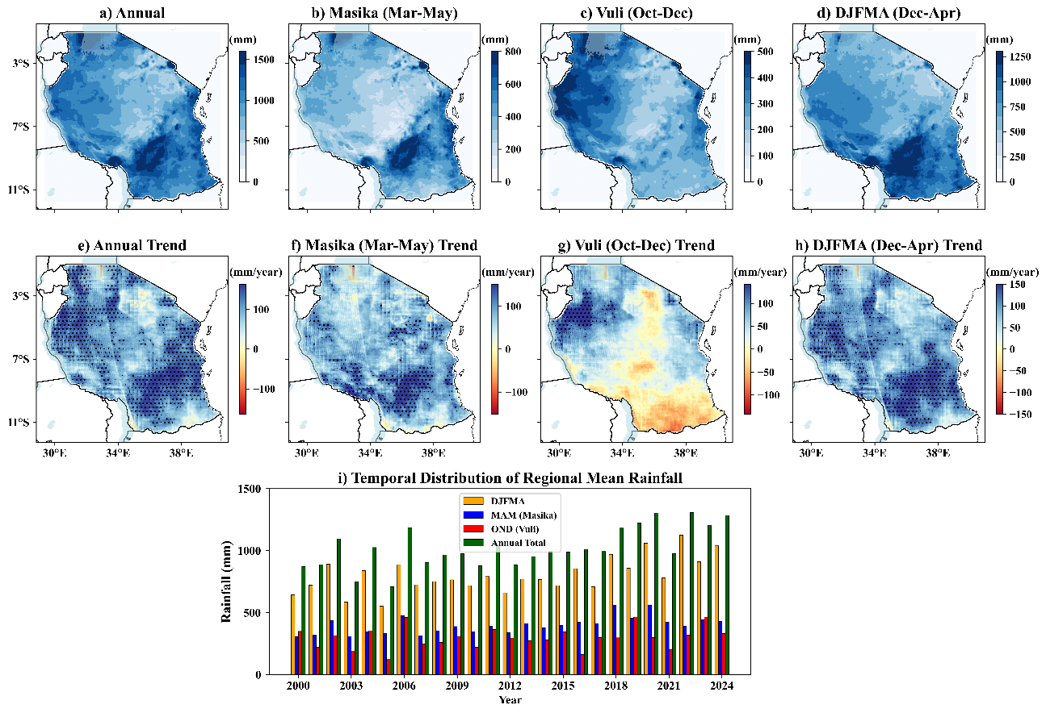
Figure 2 (a-d) Spatial distribution of annual and seasonal rainfall, (e-h) Spatial trend in annual and seasonal rainfall, i) Temporal distribution of annual rainfall (Hatching shows significant trends at p < 0.05).

3.2 Land Surface Temperature Distribution and Trends
The spatiotemporal analysis of LST reveals a pervasive warming pattern across the study period (Figure 3). Annually, mean LST varied broadly across the landscape, with temperatures ranging from approximately 25⁰C in the southern highlands to over 35⁰C in the coast regions of Indian ocean towards northern and northeastern regions (Figure 3a). Seasonally, the Masika (MAM) period was the coolest, with mean temperatures primarily between 22.5⁰C and 35⁰C (Figure 3b), reflecting the cooling influence of the peak rainy season. Conversely, the Vuli (OND) season presented the highest temperatures, with peak LST values exceeding 35⁰C in localized hot spots distributed over a larger part of the country (Figure 3c). The temporal distribution confirmed that annual LST has generally increased over the period, with the OND and DJFMA seasons consistently registering the highest mean temperatures each year (Figure 3i). Crucially, the trend analysis (Figure 3e-h) indicated a dominant and widespread statistically significant warming across the country. Annually, most regions demonstrated a positive LST trend, with significant warming observed across vast areas of the central and western interior (Figure 3e). Seasonally, this warming signal was most pronounced during the Vuli (OND) period, where strong and significant temperature increases were recorded throughout nearly all districts (Figure 3g). The DJFMA season also showed substantial significant warming, particularly along the coastal and southern belt of the country (Figure 3h). The Masika (MAM) season exhibited a more mixed pattern (Figure 3f), showing significant warming trends over the coasts and southern parts, while some cooling or stable patches were observed in the northeast.
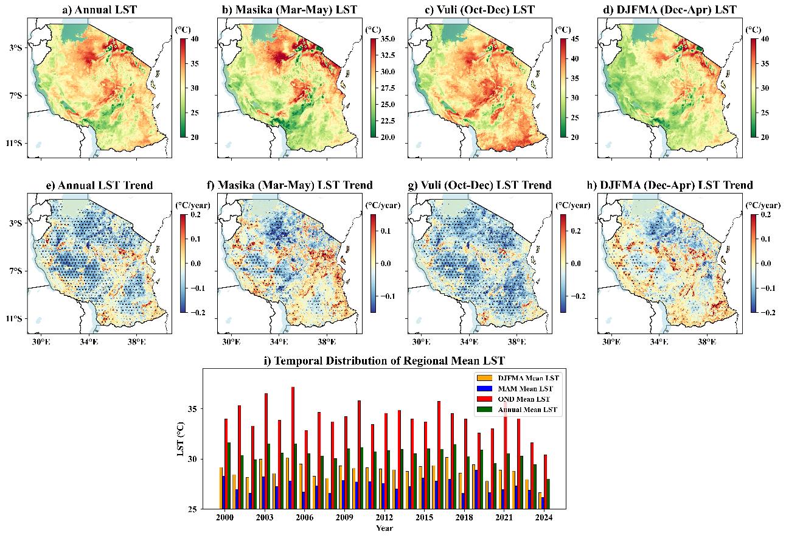
Figure 3 (a-d) Spatial distribution of annual and seasonal LST, (e-h) Spatial trend in annual and seasonal LST, i) Temporal distribution of annual LST (Hatching shows significant trends at p < 0.05).

3.3 Vegetation Health (EVI) Distribution and Trends
The Enhanced Vegetation Index (EVI), used as a proxy for vegetation health and productivity, exhibits clear spatial and seasonal variability across the study area (Figure 4). Annually, the highest EVI values (up to 0.6) characterize the high-productivity regions such as the western and southwestern forest zones and the coastal areas (Figure 4a). Conversely, the central arid and semi-arid interior consistently recorded the lowest EVI values, often less than 0.2. Seasonally, vegetation cover peaks during the Masika (MAM) season, with maximum EVI values recorded nationally (Figure 4b), a clear response to the major rainfall period. The Vuli (OND) and DJFMA seasons show lower, intermediate EVI values, reflecting the post-rain recession and the main dry season, respectively (Figure 4c-d).
Analysis of the EVI trends over the 24-year period reveals a spatially heterogeneous pattern of both greening and degradation (Figure 4e-h). Annually, there is a pronounced and significant signal of vegetation degradation (browning) concentrated over the central-eastern and southeastern regions (Figure 4e). Conversely, significant greening trends (EVI increase) were localized primarily in the far western areas and certain parts of the southern coast. The seasonal breakdown shows that the significant browning signal is most dominant during the Vuli (OND) short rainy season (Figure 4g). The DJFMA season also recorded significant mixed trends, balancing greening in the southwest with browning in the central belt (Figure 4h). In contrast, the main growing season, MAM, showed a relatively stable trend with only localized and less severe significant changes (Figure 4f).
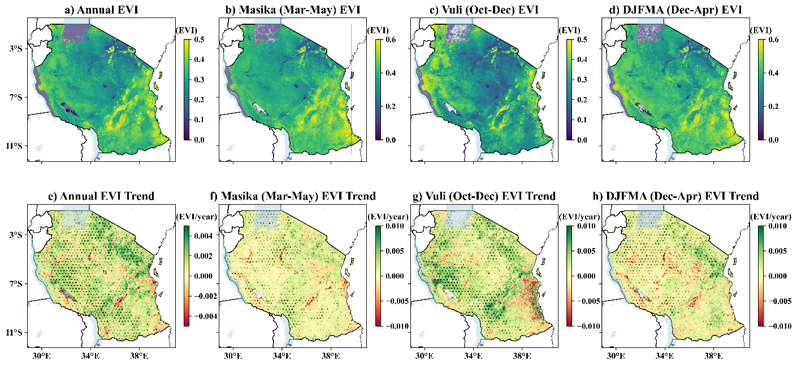
Figure 4 (a-d) Spatial distribution of annual and seasonal EVI, (e-f) Spatial trend in annual and seasonal EVI (Hatching shows significant trends at p < 0.05).

3.4 Spatiotemporal Pattern of Vegetation Change
Analysis of the Fractional Vegetation Cover (FVC) trends provides a quantitative measure of long-term land degradation and restoration across the country (Figure 5). Overall, the mean annual FVC exhibited a statistically significant positive trend over the study period, increasing at a rate of 0.0032 per year (p < 0.05), as shown by the linear regression (R² = 0.299). This finding suggests that, on average, the total fraction of vegetation cover improved slightly across the country. However, this aggregate mean masks profound spatial heterogeneity in land condition (Figure 5a-d). Spatially, significant FVC degradation (browning and red areas) was widespread, particularly concentrated in the central regions, southeastern regions as well as parts of the western regions of the country, regardless of the season. Conversely, significant improvement (greening, light green areas) was mainly confined to the southwestern highlands, the northeastern regions, and isolated pockets along the northern coast.
The quantification of area coverage confirms this mixed signal (Figure 5i). Over the 24-year period, 40% of the landmass showed some degree of FVC improvement (including Slight and Significant Improvement), while almost 22% of the landmass experienced FVC degradation (Slight and Severe Degradation). Annually, the most dominant category was Slight Improvement (~48%), followed by significant improvement (~27%). Critically, severe degradation affected approximately 5% of the total area annually.
Seasonally, the highest mean FVC and the largest extent of improvement were observed during the Vuli (OND) season, which also recorded the strongest positive trend (0.0042/yea, R² = 0.246). Despite this overall improvement signal, the seasonal maps confirm that the areas vulnerable to FVC degradation are consistent across all periods, pointing to persistent underlying environmental or anthropogenic stressors in those specific regions. The DJFMA season showed a lower positive trend (0.0006/year, R² = 0.007) with a higher proportion of degraded land compared to MAM.
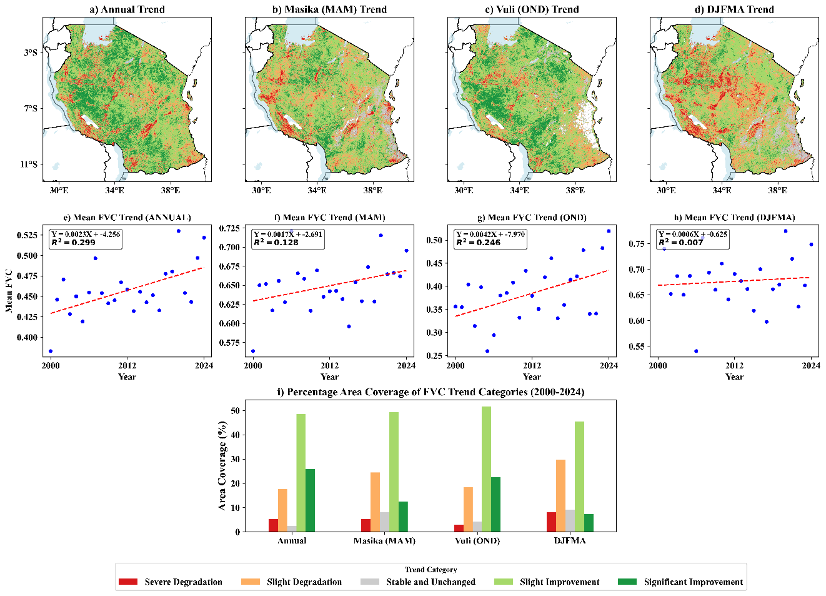
Figure 5 (a-d) Spatial trend in annual and seasonal FVC, (e-h) Scatter plots of annual and seasonal mean FVC, i) Percentage area coverage of FVC trend categories.

3.5 Spatial Relationship Between Climatic Variables and Vegetation
The spatial distribution of correlation coefficients (ρ) reveals contrasting influences of rainfall and temperature on vegetation health across the country (Figure 6). The correlation between EVI and Rainfall is overwhelmingly positive across all seasons (Figure 6a-d), with strong significance (ρ > 0.5) dominating the moisture-limited central and northern regions, confirming precipitation as the primary driver of productivity. Conversely, a strong and pervasive negative correlation (ρ < -0.5) is evident between EVI and LST across the vast majority of the country (Figure 6e-h), underscoring the severe and widespread negative constraint of thermal stress on vegetation health.
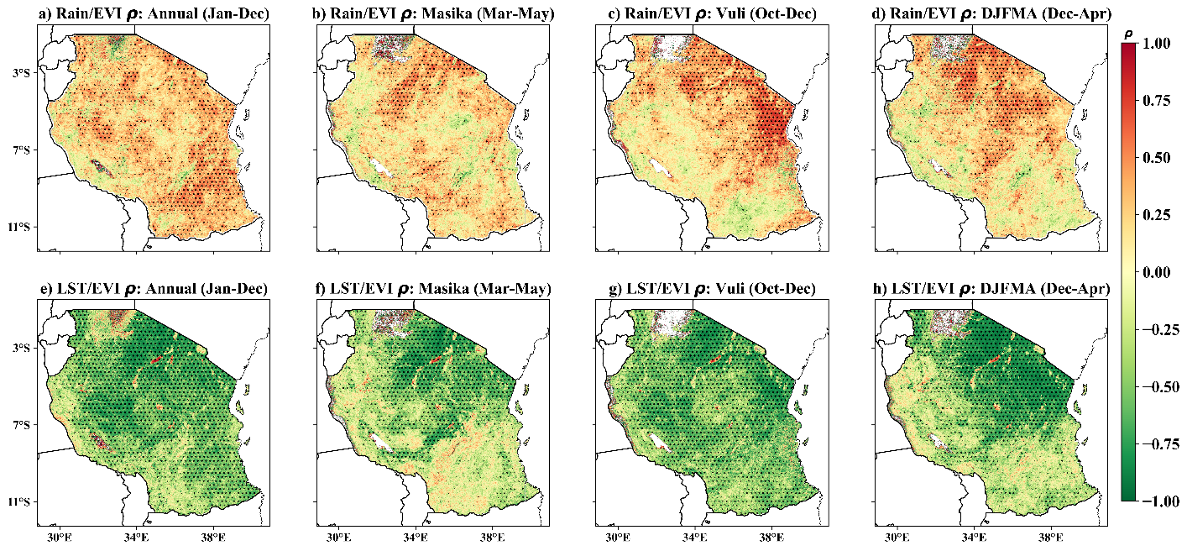
Figure 6 Spatio-temporal correlation coefficient plots for Tanzania between 2000 and 2024, (a-d) Annual and seasonal relationship between rainfall and EVI, (e-h) Annual and seasonal relationship between LST and EVI (Hatching shows significant correlations at p < 0.05).

3.6 Temporal Lagged Relationships Climatic Variables and Vegetation
The Annual cross-correlation heatmap (Figure 7) provides critical insight into the memory and delayed response of the ecosystem to climatic drivers. Analysis of the time lags indicates that the maximum influence of LST on FVC is overwhelmingly immediate, occurring at Lag 0 (ρ= -0.78, p < 0.05). Beyond the contemporaneous relationship, no other significant relationships were observed, confirming that LST acts primarily as an immediate suppressor of vegetation productivity through thermal stress. In contrast, the influence of rainfall on FVC demonstrated a more complex pattern, the strongest relationship was contemporaneous (Lag 0, ρ= 0.64, p < 0.05$), yet significant positive correlations were also observed at Lag -4 (ρ= 0.46) and critically at Lag +5 (ρ= 0.54). This significant positive correlation at Lag +5 suggests a long-term carry-over effect, where antecedent rainfall from five years prior continues to influence current annual FVC by potentially replenishing deeper moisture reserves or supporting slow-growing perennial species. Similarly, relationship between ET to FVC showed its maximum influence at Lag 0 (ρ= 0.72, p < 0.05), with significant positive lagged correlations also appearing at Lag +4 (ρ= 0.59) and Lag +5 (ρ= 0.56), signifying that the ecosystem’s current FVC condition remains highly predictable based on the active hydrological cycling five years earlier. Furthermore, the strong and significant positive correlation observed in the Rainfall to ET interaction at Lag -4 (ρ= 0.68) indicates a multi-year memory in the regional water system, where the current rate of ecosystem water use is significantly driven by antecedent rainfall that occurred up to four years prior.
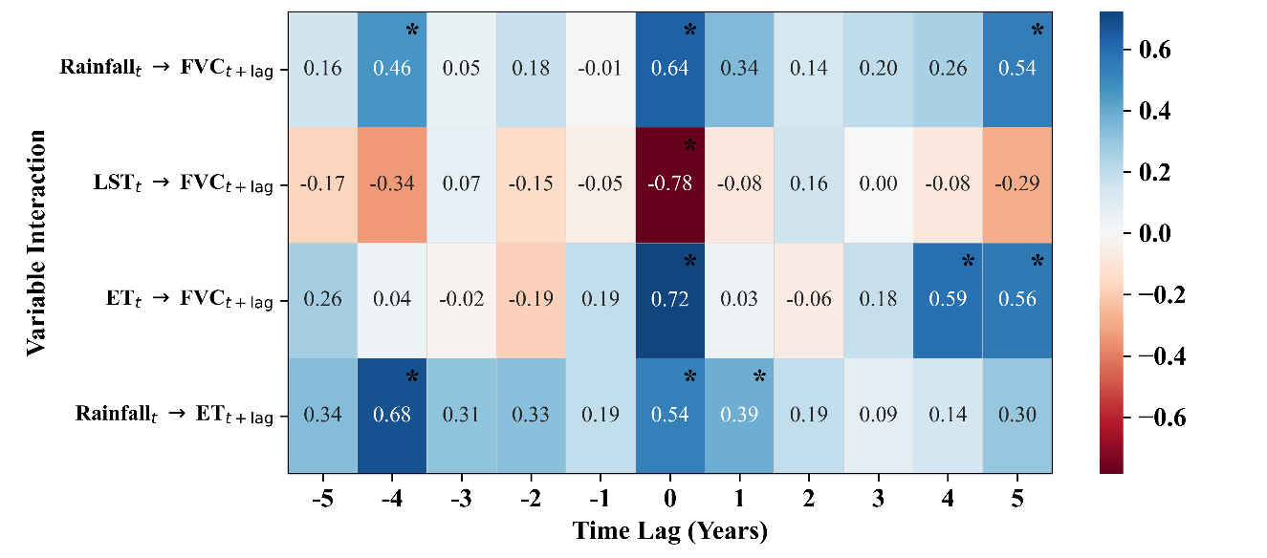
Figure 7 Heatmap of lagged annual cross-correlations of key environmental variables (Rainfall, LST, ET, EVI, FVC) (a star shows significant correlations at p < 0.05).

3.7 Quantification of Relative Influence of Climatic Variables on Vegetation Cover
The quantification of the relative influence of the climatic and hydrological drivers by comparing their annual anomaly patterns with the annual FVC anomaly is depicted in the combined anomaly time series (Figure 8). Visually inspecting the time series shows a strong inverse relationship between the FVC anomaly and the LST Anomaly (Figure 8a). In years characterized by extreme heat (high positive LST anomaly, e.g., 2000, 2005), the FVC anomaly consistently registered its largest negative values, confirming LST as the most dominant immediate constraint on vegetation health. Conversely, the FVC Anomaly demonstrated a strong direct relationship with the rainfall anomaly (Figure 8b), with positive FVC growth corresponding well to positive rainfall surges (e.g., 2017, 2020, 2023). However, the most consistent and highest congruence was observed between the FVC anomaly and the ET anomaly (Figure 8c). ET, which reflects the active water consumption by the ecosystem, tracked the FVC trajectory most closely, peaking with high FVC years (e.g., 2021, 2024) and dropping during FVC reduction years. The robust statistical correlations confirmed this visual assessment in section 5.6, LST exhibited the highest negative correlation (ρ= -0.78), while ET showed the highest positive correlation (ρ= 0.72) with annual FVC, indicating that thermal stress (LST) is the primary factor limiting FVC, and active ecosystem water use (ET) is the best integrated predictor of annual FVC productivity.
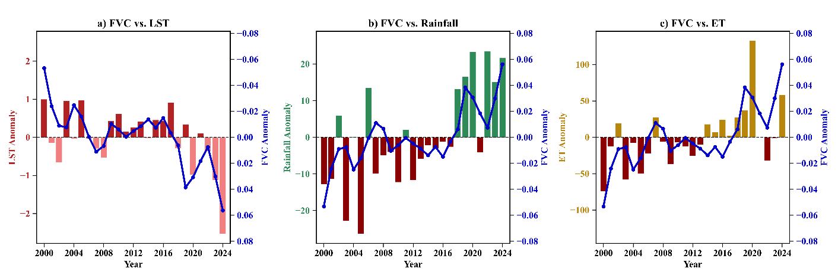
Figure 8 Annual anomalies of FVC in relation to LST, Rainfall, and ET from 2000-2024.

Discussion
The analysis of 24 years of climate and vegetation data provides a comprehensive diagnosis of land surface dynamics and their climatic drivers, yielding three critical insights, a pervasive, dominant warming trend, a highly heterogeneous and localized pattern of land degradation and a multi-year memory in the ecosystem's response to water availability. The statistically significant warming trend found across the country, particularly during the Vuli (OND) and DJFMA seasons (Figure 3), aligns with regional and global climate models that project increased thermal stress and higher frequency of heat waves in East Africa (Das et al., 2023). This widespread warming of up to 0.2⁰C/year contrasts sharply with the localized, though statistically significant, positive trend in annual rainfall of 100 mm/year (Figure 2), indicating that the system is becoming simultaneously warmer and regionally wetter, but the increased heat appears to negate the positive impact of increased precipitation. This suggests a fundamental shift in the energy balance of the land surface, promoting higher potential evapotranspiration rates and exacerbating drought conditions even in years of near-average rainfall.
The overall positive national mean trend in Fractional Vegetation Cover (FVC) (Figure 5e) superficially suggests landscape resilience, however, this finding is severely undermined by the spatial heterogeneity of change. The results clearly show that over 22% of the landmass, concentrated heavily in central regions, southeastern regions as well as parts of the western regions of the country, experienced significant FVC degradation (Figure 5a) classified as severe browning, (Makunga et al., 2017) reported similar findings in western regions of the country. This pattern strongly implicates human activities, such as uncontrolled grazing, deforestation and agriculture, which compromise the soil's structure and ability to retain moisture, rendering these areas highly vulnerable to even slight climatic fluctuations. Conversely, the significant improvement (greening) in the southwestern highlands and certain coastal areas likely reflects regions with higher inherent resilience, steeper slopes limiting intensive agriculture, or successful localized conservation efforts.
The most decisive finding concerns the relative influence of the climatic drivers. Cross-correlation analysis (Figure 7) confirmed that LST acts as the single most critical and immediate constraint on vegetation health, with the highest negative correlation at Lag 0. This instantaneous suppressive effect, further corroborated by the anomaly analysis (Figure 8a), implies that even when moisture is available, extreme heat directly inhibits photosynthetic activity and causes stomatal closure (Zahra et al., 2023), leading to immediate productivity loss and driving the most severe degradation signals. In sharp contrast, the maximum influence of rainfall on FVC was observed not only at Lag 0 but also significantly at a long-term Lag +5, indicating a five-year memory or legacy effect in the ecosystem. This substantial time lag suggests that the health of deep-rooted perennial species, essential for soil stability (Jin et al., 2025), is governed by cumulative deep soil moisture recharge over multiple seasons, with antecedent rainfall from five years prior still contributing to current biomass. Finally, the high congruence between the FVC anomaly and the ET anomaly (Figure 8c), with a correlation of ρ= 0.72, establishes ET not as a driver, but as the most effective integrated proxy for the actual productivity of the ecosystem, accurately reflecting the combination of available energy (LST) and available moisture (Rainfall) being actively utilized for growth.

Conclusion
This study has confirmed that the land surface dynamics over the past two decades across the study area are governed by a dual control mechanism, i.e., the immediate, intense constraint of thermal stress and the slow multi-year recovery potential driven by antecedent rainfall. Specifically, the pervasive warming trend, exemplified by the annual LST and its strong inverse correlation with FVC is the primary factor limiting immediate vegetation productivity, especially in moisture-limited regions. Conversely, the significant positive influence of rainfall at a five-year time lag highlights the crucial importance of long-term water management and conservation efforts focused on enhancing deep soil infiltration, which sustains the ecosystem's resilience against short-term droughts. Given the widespread and continuing pattern of severe degradation in the arid/semi-arid rangelands, land management policies must shift from reacting to current drought conditions to proactive, multi-year planning that prioritizes water harvesting and afforestation with deep-rooted species to leverage the long-term rainfall memory identified in this research. Future research should prioritize disaggregating the degradation signal to separate human-induced land-use change from climate-driven effects to target effective policy interventions.
Data Availability Statement
All the datasets used in this study can be accessed through the GEE platform freely https://code.earthengine.google.com .
Conflicts of Interest
The authors declare that they have no competing interests.

References

Chaturvedi, M., Lakshmi, S., Kumar, D., & Gupta, J. (2025). Carbon Cycling and Climate Feedback in Terrestrial Ecosystems. In Green Equilibrium (pp. 97–117). https://doi.org/10.1007/978-981-96-3993-9_5

Das, P., Zhang, Z., Ghosh, S., Lu, J., Ayugi, B., Ojara, M. A., & Guo, X. (2023). Historical and projected changes in Extreme High Temperature events over East Africa and associated with meteorological conditions using CMIP6 models. Global and Planetary Change, 222, 104068. https://doi.org/10.1016/j.gloplacha.2023.104068

Forzieri, G., Dakos, V., McDowell, N. G., Ramdane, A., & Cescatti, A. (2022). Emerging signals of declining forest resilience under climate change. Nature, 608(7923), 534–539. https://doi.org/10.1038/s41586-022-04959-9

Friedlingstein, P., O’Sullivan, M., Jones, M. W., Andrew, R. M., Bakker, D. C. E., Hauck, J., Landschützer, P., Le Quéré, C., Luijkx, I. T., Peters, G. P., Peters, W., Pongratz, J., Schwingshackl, C., Sitch, S., Canadell, J. G., Ciais, P., Jackson, R. B., Alin, S. R., Anthoni, P., … Zheng, B. (2023). Global Carbon Budget 2023. https://doi.org/10.5194/essd-2023-409

He, X., Zhang, F., Cai, Y., Tan, M. L., & Chan, N. W. (2023). Spatio-temporal changes in fractional vegetation cover and the driving forces during 2001–2020 in the northern slopes of the Tianshan Mountains, China. Environmental Science and Pollution Research, 30(30), 75511–75531. https://doi.org/10.1007/s11356-023-27702-x

Houghton, R. A. (2007). Balancing the Global Carbon Budget. Annual Review of Earth and Planetary Sciences, 35(1), 313–347. https://doi.org/10.1146/annurev.earth.35.031306.140057

Jin, J., Ding, X., Li, F., Jia, Z., Wei, H., Li, J., & Li, M. (2025). Impact of Deep-Rooted Vegetation on Deep Soil Water Recharge in the Gully Region of the Loess Plateau. Water, 17(2), 208. https://doi.org/10.3390/w17020208

Kambi, S. H., Mbilinyi, B., & Silungwe, F. (2025). Assessment of Precipitation and Temperature Variability on Land Suitability for Surface Irrigation in Kilosa District, Morogoro, Tanzania. Asian Journal of Environment & Ecology, 24(5), 51–67. https://doi.org/10.9734/ajee/2025/v24i5694

Kashaigili, J. J., & Majaliwa, A. M. (2010). Integrated assessment of land use and cover changes in the Malagarasi River Catchment in Tanzania. Physics and Chemistry of the Earth, Parts A/B/C, 35(13–14), 730–741. https://doi.org/10.1016/j.pce.2010.07.030

Liu, Y., Liu, H., Chen, Y., Gang, C., & Shen, Y. (2022). Quantifying the contributions of climate change and human activities to vegetation dynamic in China based on multiple indices. Science of The Total Environment https://doi.org/10.1016/j.scitotenv.2022.156553

Makunga, J. E., & Misana, S. B. (2017). The Extent and Drivers of Deforestation and Forest Degradation in Masito-Ugalla Ecosystem, Kigoma Region, Tanzania. Open Journal of Forestry. https://doi.org/10.4236/ojf.2017.72018

Miralles, D. G., Vilà‐Guerau de Arellano, J., McVicar, T. R., & Mahecha, M. D. (2025). Vegetation–climate feedbacks across scales. Annals of the New York Academy of Sciences, 1544(1), 27–41. https://doi.org/10.1111/nyas.15286

Mwakalukwa, E. E., Meilby, H., & Treue, T. (2024). Carbon storage in a dry Miombo woodland area in Tanzania. Southern Forests: A Journal of Forest Science, 86(2), 115–124. https://doi.org/10.2989/20702620.2024.2319185

Ning, L., Peng, W., Yu, Y., Xiang, J., & Wang, Y. (2023). Quantifying vegetation change and driving mechanism analysis in Sichuan from 2000 to 2020. Frontiers in Environmental Science. https://doi.org/10.3389/fenvs.2023.1261295

O’Sullivan, M., Smith, W. K., Sitch, S., Friedlingstein, P., Arora, V. K., Haverd, V., Jain, A. K., Kato, E., Kautz, M., Lombardozzi, D., Nabel, J. E. M. S., Tian, H., Vuichard, N., Wiltshire, A., Zhu, D., & Buermann, W. (2020). Climate‐Driven Variability and Trends in Plant Productivity Over Recent Decades Based on Three Global Products. Global Biogeochemical Cycles, 34(12). https://doi.org/10.1029/2020GB006613

Savitzky, A., & Golay, M. J. E. (1964). Smoothing and Differentiation of Data by Simplified Least Squares Procedures. Analytical Chemistry. https://doi.org/10.1021/ac60214a047

Wang, L., Wei, X., Bishop, K., Reeves, A. D., Ursino, N., & Winkler, R. (2018). Vegetation changes and water cycle in a changing environment. Hydrology and Earth System Sciences, 22(3), 1731–1734. https://doi.org/10.5194/hess-22-1731-2018

Wiesmeier, M., Urbanski, L., Hobley, E., Lang, B., von Lützow, M., Marin-Spiotta, E., van Wesemael, B., Rabot, E., Ließ, M., Garcia-Franco, N., Wollschläger, U., Vogel, H.-J., & Kögel-Knabner, I. (2019). Soil organic carbon storage as a key function of soils - A review of drivers and indicators at various scales. Geoderma, 333, 149–162. https://doi.org/10.1016/j.geoderma.2018.07.026

YUAN Lihua, JIANG Weiguo, SHEN Wenming, LIU Yinghui, WANG Wenjie, TAO Liangliang, ZHENG Hua, & LIU Xiaofu. (2013). The spatio-temporal variations of vegetation cover in the Yellow River Basin from 2000 to 2010. Acta Ecologica Sinica, 33(24). https://doi.org/10.5846/stxb201305281212
Zahra, N., Hafeez, M. B., Ghaffar, A., Kausar, A., Zeidi, M. A., Siddique, K. H. M., & Farooq, M. (2023). Plant photosynthesis under heat stress: Effects and management. Environmental and Experimental Botany, 206, 105178. https://doi.org/10.1016/j.envexpbot.2022.105178

