Original Research Article
PROXIMATE AND FUNCTIONAL PROPERTIES OF COMPLEMENTARY FOOD FROM MALTED SORGHUM, MAIZE AND SOYBEANS

Abstract
Complementary foods are crucial for infants´ nutritional development and they play a vital role in bridging nutritional gaps during weaning phase. Numerous infants in developing countries particularly Nigeria, suffer from protein-energy malnutrition due to inadequate access to essential nutrients, including protein, fibre, iron, amino acids and calcium. This study was aimed at evaluating the proximate and functional properties of complementary foods made from malted sorghum, maize, and soybean blends.
The results revealed significant variations in water absorption capacity which ranged from 28.60% to 25.20% this improves the textural ability of the complimentary food samples. The value of foaming capacity ranged from 1.95 to 2.95%. Foaming capacity gives indication of increase in volume upon introduction of air or gas into slurry of a given food, this shows that the samples will give a fluffy texture. The bulk density of the samples ranged from 0.54 to 0.59g/cm³. Low bulk density enhances flowability and ease of food packaging. Dispersibility of the flours ranged from 85.25 to 90.95%. Dispersibility ensures uniform mixing and blending which enhances product stability, shelf life and texture consistency. The moisture content of the flours ranged from 6.66% to 13.52% . Lower moisture content, is a desirable quality because it indicates a better shelf life due to reduced water activity. Protein content ranged from 22.4% to 24.7%, highlighting the importance of soybean as a protein source. Carbohydrate content was highest in Sample A (60.7%) and lowest in Sample B (54.9%). There were significant differences (p$<0.05$) in carbohydrate content of all the samples. Sensory evaluation showed that Sample A (60% sorghum, 20% maize, 20% soybean) was most preferred in terms of appearance (7.84), taste (7.28), aroma (7.48), and mouth feel (7.56) indicating its overall acceptability. A nutrient-rich complementary food has been developed by blending locally sourced food materials to enhance nutritional value with sensory satisfaction and potentially reducing the prevalence of protein-energy malnutrition
- INTRODUCTION
Complementary foods are typically made from a combination of cereal grains, legumes, fruits, and vegetables. Common ingredients used in the production of complementary foods include sorghum, maize, soybean, millet, rice, and beans. The formulation and processing techniques used to develop complementary foods have significant implications on their nutritional quality, sensory attributes, and functional properties (Ndagire et al., 2021). Complimentary foods are foods given to infants and young children to supplement breast milk or formula milk and provide additional nutrients as the child transitions to solid foods. The World Health Organization (WHO) defines complementary feeding as the process of introducing solid, semi-solid, or soft foods to an infant's diet while continuing to breastfeed. Complementary foods should be nutritionally adequate, safe, and culturally acceptable (WHO, 2020). Complementary foods are crucial in meeting the nutritional requirements of infants and young children, especially when breast milk or formula milk alone is insufficient. Adequate complementary feeding is essential for optimal growth and development, as nutrient deficiencies during this stage can result in stunting, malnutrition, and related health issues (Moretti et al., 2020).
In many regions, especially in developing countries, malnutrition among infants and young children is of significant concern. One of the approaches to addressing this issue is through the development of nutritious complementary foods that can support healthy growth and development during the weaning period. Sorghum, maize, and soybean are commonly available and affordable ingredients with promising nutritional profiles. The focus on locally sourced ingredients gains even greater significance compared to imported complementary foods. It is found that in low- and middle-income countries, imported complementary foods can be significantly more expensive than locally produced options. This puts a strain on household budgets, especially for families facing food insecurity. It also emphasizes the challenges of reaching remote areas with essential supplies, including complementary foods. This creates disparities in access to proper nutrition for children in these regions.
2.0 MATERIALS AND METHODS
The materials for this study, sorghum, maize and soybeans were purchased from Wazo market in Ogbomoso.
2.1 Preparation of malted sorghum flour
Malted sorghum flour was produced according to Ajanaku et al., 2018. Two (2) kg of sorghum were sorted and cleaned. The cleaned grains were thoroughly washed and soaked in water for 12 hours to reach a moisture level of 42-46%. The hydrated grains were then spread on a moist jute bag, and allowed to germinate for four days. Non-germinated grains were discarded, and the germinated seeds was dried at 60°C in a cabinet dryer to achieve a moisture content of 10-12%. The dried, rootless grains was gently brushed off, milled into flour, sieved, and packaged in an airtight container until ready for use. The production flow chart for alted sorghum flour is shown in figure 1.
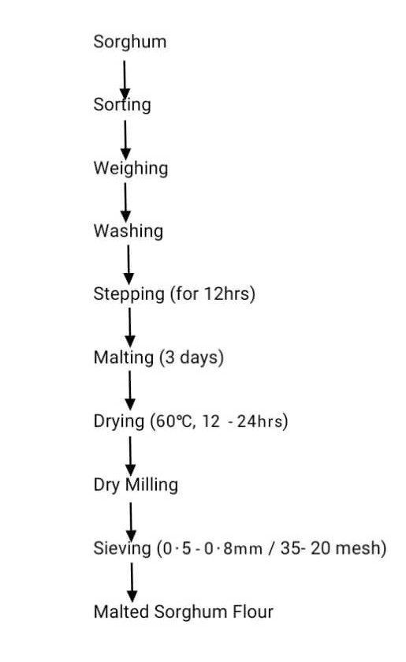
Figure 1: Preparation of malted sorghum flour

2.2 Preparation of Maize Flour
Maize flour was produced according to (FAO 2012), 3kg of maize grain were thoroughly cleaned, sorted and soaked in distilled water for 72 hours, with the water being changed every 24 hours to minimize odor from fermentation. The grains were then milled in a hammer mill at medium speed for 10 minutes. The resulting slurry was passed through a 150 µm sieve, and the suspension was allowed to stand for 4 hours to settle. The supernatant was decanted, and the remaining slurry was dried at 60°C for 24 hours in a cabinet dryer and then dry to obtain a powdered form, sealed in polyethylene bags until analysis. The production flow chart for maize flour is shown in figure 2
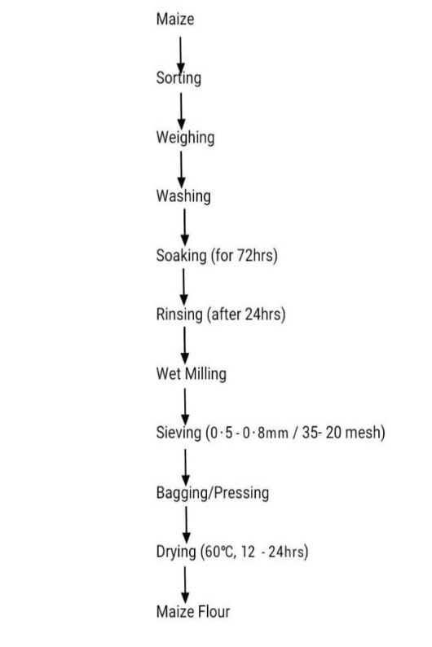\
Figure 2: Preparation of maize flour
2.3 Preparation of Soybean flour
Soybean flour was produced according to Kinyua et al., 2016, involved sorting. Two (2) kg of soybeans was thoroughly cleaned to remove dirt and other extraneous materials such as stones and sticks, then dehulled, washed and oven-dried. The soybeans were decorticated, winnowed, and milled into fine flour using a hammer mill, and then sieved through a 250 µm aperture sieve, the flour was packed and sealed in polyethylene bags until analysis. The production flow chart for soybean flour is shown in Figure 3.

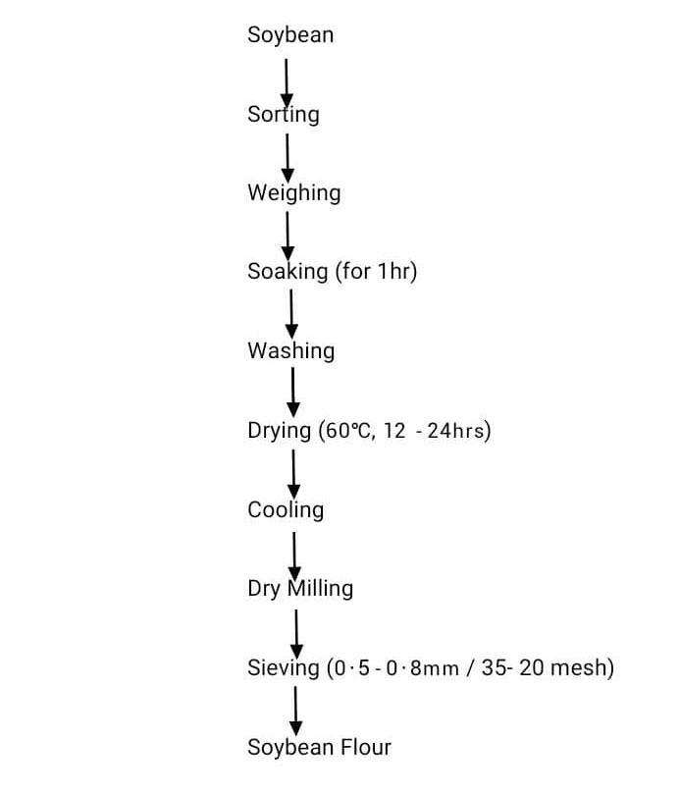

Figure 3: Preparation of soybean flour
Formula Blend: 60% sorghum, 20% maize, 20% soybean
50% sorghum, 30% maize, 20% soybean
40% sorghum, 40% maize, 20% soybean
30% sorghum, 50% maize, 20% soybean

Proximate Composition in complementary food samples
The analysis of crude protein, fat, ash, and crude fiber was conducted according to established methods AOAC(2010). Carbohydrate content was determined by calculating the difference, and the energy value was assessed using the Atwater factor formula.
Moisture content, crude fat, crude protein, crude fiber, and total ash was determined according to the official methods of analysis of AOAC International 2010.
Determination of Functional Properties
Water absorption Capacity
Water absorption capacity was determined according to Akinwande et al (2008). The crucibles and centrifuge tubes was dried in the oven at 105º C for 20 minutes and allowed to cool in desiccators, after cooling, the crucible and the centrifuge tubes was weighed. 1g of each of the sample was weighed into the tube and 10mls of distilled water will be added and stirred gently with a stirring rod for 30 minutes. The tube containing the paste will be centrifuged at 4000rpm for 30 minutes. The supernatants was decanted into crucibles and dried in the oven at 100 ºC until the supernatant was dried off. The residue remaining in the tubes was weighed and the crucible after drying with the supernatant
$$ater absorption capacity=\frac{\left(weight of tube+residue after centrifuge\right)-(weight of empty tube)}{weight of sample} x 100$$
Swelling capacity
Swelling capacity was determined using the method described by Akinwande et al. (2008). 1g of flour sample was into 15ml centrifuge tube. 10ml of distilled water was added and mixed gently. The slurry was heated in a water bath at a temperature of 85 º C for 15 minutes. During heating, the slurry was stirred gently to prevent clumping of the flour. On completion of 15 minutes, the tube containing the paste was centrifuged at 3000rpm for 10 minutes. The supernatant was decanted and weighed immediately after centrifuging. The weight of the sediment was then taken and recorded. The moisture content of the sediment gel was used to determine the dry matter content of the gel.
$$Swelling power \left(\frac{g}{g}\right)=\frac{weight of the paste}{weight of the dry flour}$$

Bulk density
The bulk density of the flour samples was determined by weighing 50g of the sample into 100ml graduated cylinder, then, gently tapping the bottom several times on a laboratory bench, until no further diminution of the sample level. After this, the final volume is expressed as g/ml (Nwosu, 2013).
$$Bulk Density=\frac{weight of sample (g)}{weight of sample (ml)} x 100$$
Dispersibility
This was determined by the method described by Jasmina et al (2020). 10g of each samples was suspended in 200ml measuring cylinder and distilled water was added to reach the 100ml mark. The set-up was stirred vigorously and allowed to settle for 3hrs. The volume of settled particles was recorded and subtracted from 100. The difference was reported as percentage dispersibility.
Dispersibility = 100 – volume of settled particles
Foam capacity
The foam capacity (FC) and foam stability (FS) by Kilara et al (2019) were determined as described with slight modification. The 1.0 g flour sample was added to 50 mls distilled water at 30 ± 2°C in a graduated cylinder. The suspension was mixed and shaken for 5 min to foam. The volume of foam at 30 sec after whipping was expressed as foam capacity using the formula:

$$Foam capacity=\frac{volume of foam AW}{volume of foam BW} x 100$$
Where, AW = after whipping, BW = before whipping.
The volume of foam was recorded one hour after whipping to determine foam stability as per percent of initial foam volume.
Sensory Evaluation
Sensory evaluation was conducted on the complementary sample to assess texture, taste, aroma, mouthfeel, and overall acceptability (Tufa et al., 2016).
RESULTS AND DISCUSSION
Proximate composition analysis of complementary food from malted sorghum, maize and soybean
Table 1 presents the proximate analysis of complementary food made from varying ratios of malted sorghum, maize, and soybean.The proximate composition analysis gives insight into the nutritional values of the samples.

The moisture content of the flours ranged from 6.66 % to 13.52% . Lower moisture content, as seen in Sample D 6.66%, indicates a better shelf life due to reduced water activity. There were significant differences (p$<$ $0.05)$ in the moisture content of the samples. In a similar study by Adebiyi et al. (2021) on complementary foods formulated from sorghum, millet, and soybean, moisture content ranged between (7.0% and 11.2%), similar to the findings in this study.
The ash content of the flours ranged from 0.89% to 1.89% with higher ash content in Sample A due to the mineral-rich nature of sorghum. There were significant difference p$<$ $0.05$ in all the samples. This suggests that increasing sorghum content in food blends can improve mineral availability. The ash content of a food material could be used as an index of mineral constituents of the food (Sanni et al. 2008) Legumes have been reported to be good sources of ash. The ash

Table 1: Proximate Analysis of the complementary food samples

 | Moisture (%) | Ash (%) | Fiber (%) |  | Fat (%) | Protein (%) | Carbohydrate (%)
A | 7.57 ±0.12^{b} | 1.89±0.05ª | 1.92±0.02ª | 5.52±0.00^{d} |  | 22.40±0.02^{d} | 60.70±0.17ª
B | 13.52±0.15ª | 1.42±0.06^{c} | 1.66±0.03^{c} | 5.78±0.01^{c} |  | 22.60±0.09^{c} | 54.90±0.33^{d}
C | 7.16±0.04^{c} | 0.89±0.01^{d} | 1.80±0.02^{b} | 6.52±0.03ª |  | 24.10±0.03 | 59.50±0.05^{b}
D | 6.66±0.05^{d} | 1.63±0.03^{b} | 1.90±0.01ª | 6.12±0.01^{b} |  | 24.70±0.03 | 58.90±0.08^{c}

Values are mean ± standard derivatives of triplicate readings
Means within the same column with different superscript are significantly different (p<0.05)
Key:
A = 60% sorghum, 20% maize, 20% soybean
B = 50% sorghum, 30% maize, 20% soybean
C = 40% sorghum, 40% maize, 20% soybean
D = 30% sorghum, 50% maize, 20% soybean

content of the composite flour reported in this study is similar to the ash content (2.9%) of composite flour produced from maize-soy flour (Edema et al. 2005). Nonetheless, the ash content of 100% malted sorghum flour has an ash content of 1.65% which is higher than the ash content of malted sorghum blends indicating a slight reduction in mineral content and this decrease may affect nutritional value and product quality (Bolarinwa et al., 2015).
Fibre content of the flour ranged from 1.92% (Sample A) to 1.90% (Sample D). There were significant differences p$<0.05$ in al the sample. Dietary fibre promotes digestive health, and the fibre-rich sorghum contributed significantly to the higher fibre content in these samples. Comparable results were found in a study by (Mbaeyi-Nwaoha et al. 2018), where complementary foods made from sorghum, millet, and soybean had fibre content ranging from 1.5% to 2.1%, further supporting the crucial role of sorghum in enhancing dietary fibre. The result for fibre in this study is lower compared to the 100% malted sorghum flour 3.64% in (Bolarinwa et al. 2015) study which may decrease digestive health benefits. Fat content of the flour varied significantly across the samples, ranging from 5.52% (Sample A) to 6.52% (Sample C). A similar trend was observed in the study by (Adebiyi et al. 2021), where fat content increased with the addition of maize and millet which range from 5.2% to 6.8%. Sample C exhibited the highest fat content. There were significant differences p$<0.05$ in all the samples. The fat content in the flour blends is significantly higher to the 100% malted sorghum flour 2.46% by (Bolarinwa et al., 2015) which may lead to enhanced energy density and increased calorie intake.
Protein content ranged from 22.4% (Sample A) to 24.7% (Sample D). Soybean, which is rich in protein, was a common factor across all samples, contributing significantly to the high protein levels. There were significant differences p$<0.05$ in all the samples.
Carbohydrate content was highest in Sample A (60.7%) and lowest in Sample B (54.9%). There were significant differences p$<0.05$ in all the samples. The high carbohydrate content in sorghum and maize ensures that these blends provide ample energy, making them suitable as complementary foods The carbohydrate content in the flour blends is lower compared to 78.18% of 100% malted sorghum flour (Bolarinwa et al., 2015) this reduction may lead enhanced nutrient density due to added ingredients.
Functional Properties of complementary food from malted sorghum, maize and soybean
The functional properties of complementary food from malted sorghum, maize and soybean are presented in Table 2 which provide valuable information on their sustainability for complementary food applications, focusing on characteristics that influence texture, stability, nutritional delivery and overall product performance (Oyewole et al., 2022).
Data on the water absorption capacity ranged from 28.60 to 25.20$\%$ while Sample D had the lowest value of 25.20$\%$. There were significant differences (p$<0.05)$ in Sample A and D and no significant differences (p$<0.05)$ in Sample B and C.
The water absorption capacity (WAC) is important in the development of ready to eat foods, and a high WAC may assure product cohesiveness (Housson et al., 2002), a low WAC product will be easily digestible. The WAC of the composite flour (28.60 to 25.20%) obtained in this study is lower than the values (18 to 72%) reported for sorghum-fermented cassava flour blend (Osungbaro et al., 2010). Low WAC of the composite flour could be due to high starch content of maize flour in Sample C and D which improves textural ability of the mixes. However the results for malted sorghum flour blends exhibited higher WAC (28.60 to 25 20%) compared to 100% malted sorghum flour (1.97%) (Bolarinwa et al.,2015). This variation highlights the influence of formulation on WAC.

Table 2: Functional properties of complementary food samples
Samples | Water Absorption Capacity$(\%)$ | Swelling Capacity ($\%$) | Bulk Density  (g/cm³) | Dispersibility  (%) | FoamCapacity ($\%$)
A | 28.60±0.30ª | 1.10±$0.02$ª | 0.54±0.02^{b} | 85.25±0.68^{b} | 1.95±0.05^{b}
B | 26.37±0.25^{b} | 1.13±0.01ª | 0.56±0.00^{b} | 81.96±0.17^{c} | 0.96±0.05^{c}
C | 26.47±0.85^{b} | 1.04±0.00^{b} | 0.61±0.19ª | 85.76±0.55^{b} | 2.94±0.79ª
D | 25.20±0.10^{c} | 1.06±0.20^{b} | 0.59±0.00ª | 90.95±0.65ª | 2.95±0.06ª

Values are mean ± standard derivatives of triplicate readings
Means within the same column with different superscript are significantly different (p<0.05)

A = 60% sorghum, 20% maize, 20% soybean
B = 50% sorghum, 30% maize, 20% soybean
C = 40% sorghum, 40% maize, 20% soybean
D = 30% sorghum, 50% maize, 20% soybean

0.54 to 0.59g/cm². Sample C had the highest value of 0.61 g/cm² while Sample A had the value of 0.54 g/cm². There were no significant differences (p$<$ $0.05)$ in Sample A and B and there were no significant differences (p$<$ $0.05)$in Sample C and D. Bulk density is an important factor in determining food packaging material, handling and application in the food industry. The BD of our result is notably lower than the reported value (0.67 g/cm²) for 100% malted sorghum flour (Bolarinwa et al., 2015). The lowered Bulk Density enhance flowability and reduced storage. Dispersibility of the flours ranged from 85.25 to 90.95%. Sample D had the highest value of 90.95% and Sample B had the lowest value of 81.96%. There were significant differences (p$<$ $0.05)$ in all the samples. Dispersibility ensures uniform mixing and blending which enhances product stability, shelf life and texture consistency (Patel et al.,2022).
The value of foaming capacity ranged from 1.95 to 2.95%. Sample D had the highest value of 2.95% while Sample B had the lowest value of 0.965%. There were significant differences (p$<$ $0.05)$ in Sample A and B and there were no significant differences (p$<$ $0.05)$ in Sample C and D. Foaming capacity gives indication of increase in volume upon introduction of air or gas into slurry of a given food or its dispersion. Foods with good foaming properties are useful as aerating agent in whipped toppings creams and sponge cake (Adebowale et al., 2005).

Sensory Evaluation Analysis
The sensory evaluation in Table 3 assessed appearance, taste, aroma, mouth feel, and overall acceptability of the samples, with scores ranging from 6.92 to 7.84.
The appearance of Sample A (7.84) had the highest value, indicating a more appealing visual quality. The higher sorghum content (60%) might have contributed to its distinctive appearance. Sample D (7.36) scored the lowest.
The taste of all the samples were rated fairly well for taste, with Sample A (7.28) and Sample B (7.32) receiving the highest ratings. The balanced combination of sorghum, maize, and soybean in these samples may have contributed to better flavor profiles. The sensory analysis revealed that malted sorghum blends (7.24 to 6.92) had a significantly better taste profile than 100% malted sorghum flour (6.94) as reported by Bolarinwa et al. (2015) supporting the development of creative flavor combinations and enhancing consumer preference.
The aroma of Sample A also received the highest aroma value (7.48), followed by Sample B (7.24). The higher soybean content (20% in all samples) likely contributed to the pleasant aroma. Sorghum flour blends (7.48 to 7.04) showed enhanced aroma characteristics relative to 100% malted sorghum flour (7.41) aligning with research by Bolarinwa et al., (2015) indicating improved sensory appeal. The mouthfeel of Sample A (7.56) scored the highest in mouthfeel, followed closely by Sample B (7.08). Sorghum's texture might have contributed to the smoother, more desirable mouthfeel in Sample A.
Despite variations in individual sensory parameters, all samples scored similarly for overall acceptability, with Sample A (7.80) being the most preferred. The balanced nutrient profile and appealing sensory attributes made it the most acceptable formulation, while Sample D (7.48) was the least preferred, though still rated well. In comparison with Bolarinwa et al.(2015) study which reported an overall acceptability of 6.70 of 100% malted sorghum flour, the result showed notably higher ratings (7.80 to 7.48) for sorghum blend suggesting improved consumer satisfaction, enhanced product appeal and potential growth.
Notably, Sample A had the highest sorghum content and was the most acceptable in term of sensory analysis likely due to its rich carbohydrate and ash content along with high water absorption capacity level which is the highest. Sample D with the best protein content, lower carbohydrate and fat content exhibited distinct pasting characteristics and enhanced functional properties compared to the other samples implying a balance in nutritional composition based on ingredient ratios. Sample A to D In conclusion, the deviation in flour ratios significantly enhanced the pasting and functional properties as well as the nutritional composition and sensory characteristic of complementary foods. A balance between nutrient content, pasting properties and functional properties is important for improving health benefits and consumer satisfaction.

Table3: Sensory Evaluation of the complementary Food Samples

Sample | Appearance | Taste | Aroma | Mouthfeel | Overall acceptability
A | 7.84±0.68ª | 7.28±0.74ª | 7.48±0.71ª | 7.56±0.82ª | 7.80±0.57ª
B | 7.44±0.58^{b} | 7.32±0.69ª | 7.24±0.72^{b} | 7.08±0.70^{b} | 7.64±0.56ª
C | 7.48±0.58^{b} | 7.08±0.70ª | 7.08±0.57^{b} | 7.12±0.73^{b} | 7.64±0.64ª
D | 7.36±0.64 | 6.92±0.075ª | 7.04±0.84^{b} | 7.12±0.66^{b} | 7.48±0.58ª

Values are mean ± standard derivatives of triplicate readings
Means within the same column with different superscript are significantly different (p<0.05)

A = 60% sorghum, 20% maize, 20% soybean
B = 50% sorghum, 30% maize, 20% soybean
C = 40% sorghum, 40% maize, 20% soybean
D = 30% sorghum, 50% maize, 20% soybean
CONCLUSION
The results obtained in this study indicated that a highly nutritious complementary food has been produced from malted sorghum, maize and soybean composite flour. Industrial production of this flour will greatly increase the utilization of sorghum in developing countries where the crop has not been optimally utilized. The complementary food could also serve as cheaper alternative complementary food to imported complementary foods. In addition, consumption of products produced from the flour would help to solve the problem of malnutrition in Africa.
REFERENCE
Abioye, V.F., Ade-Omowaye, B.I.O., Babarinde, G.O., Adesigbin, M.K., (2011) Chemical, physico-chemical and sensory properties of soy-plantain flour. Afric J Food Sci 5: (No) 176-180.
Adebiyi, J. A., Adenusi, A. F., and Fahunsi D. G., (2021). "Nutritional and sensory evaluation of sorghum, maize, and millet-based complementary foods." Journal of Food Science and Technology, 58(5): 1462–1471.
Adebowale, Y. A., Adeyemi, I. A., and Oshodi, A. A. (2005): Functional and physicochemical properties of flours of six Mucuna species. African journal of Biotechnology, 4 (12):1461-1468.
Ajanaku, K. O., Adetunji, J. B., and Salami, A. T. (2018). Nutritional and sensory evaluation of sorghum-based complementary foods. Journal of Nutrition and Food Sciences, 8(4): 1-5. https://doi.org/10.4172/2155-9600.1000664.
Akinwande, B.A., Abiodun, O.A., Adeyemi, I.A., Akanbi, C.T (2008). Effect of steaming methods and time on the physical and chemical properties of flour from yam tubers. Nigeria Food Journal, 26 (2):97-105.
Bolarinwa, I.F., Olaniyan, S.A., Adebayo, L.O., Ademola, A.A., (2015) Malted Sorghum-Soy Composite Flour: Preparation, Chemical and Physico -Chemical Properties. J Food Process Technol, 6:467
Edema, M.O., Sanni, L.O., Sanni, A.I., (2005). Evaluation of maize-soybean flour blends for sour maize bread production in Nigeria. Afri J Biotechnol 4: 911-918.
Falade, K.O and Olugbuyi, AO., (2010) "Effects of maturity and drying method on the physico-chemical and reconstitution properties of plantain flour" International Journal of Food Science and Technology
FAO. (2017). Sorghum and millets in human nutrition. Rome: Food and Agriculture Organization of the United Nations.
Housson, P., Ayenor, G.S. (2002) Appropriate processing and food functionality. In Processing of the International Symposium on Food Processing for Nutrition, Safety, and Quality
Mbaeyi-Nwaoha, I. E., Chika, D. O., Paulinus, U.O., Felix, I.E., (2018). "Proximate and sensory evaluation of complementary food blends from sorghum, millet, and soybean." Nigerian Food Journal, 36(1), 90-98.
Nwosu, J. N. (2013): Production and Evaluation of biscuits from blends of Bambara Groundnut and Wheat flour, international of Food and Nutrition Science 2.
Osungbaro, T.O., Taiwo, O., Jimoh, D., Osundeyi, E. (2010) Functional and pasting properties of starches extracted from cassava, yam and plantain. Journal of Food, Agriculture and Environment, 8(2), 74-79.
Oyewole, O.B., and Odunfa, S.A. (2022). Functional properties of malted sorghum, maize and soybean blends for complementary foods. Journal of Food Science and Technology, 59(2), 539-548.
Ruales J, Valencia S, Nair B, M. (1993), Effect of thermal treatment on the nutritional content of quinoa (Chenopodium quinoa Wild) protein plants Foods for Human Nutrition, 44(2), 165-172.
Sanni, S.A, Adebowale, A.A, Olayiwola, I.O, Maziya, D. (2008) Chemical composition and pasting properties of iron fortified maize flour. J Food Agric Environ 6:172-175.
World Health Organization; UNICEF. Strengthening Action to Improve Feeding of Infants and Young Children 6–23 Months of Age in Nutrition and Child Health Programmes: Geneva, 6–9 October 2008. Report of Proceedings. Available online: https://iris.who.int/bitstream/handle/10665/44034/9789241597890%20eng.pdf;jsessionid=87A00C0BA248EC40EE35A22A2 E9984DB?sequence=1 (accessed on 4 September 2023).

