Ethnobotanical Study of Domesticated Edible Plants in Mali and Biochemical Characterization of Mangifera indica L.

.

ABSTRACT

Introduction: In Mali, several domesticated edible plants are commonly used for their nutritional and therapeutic properties. But their usage are poorly documented in terms of their chemical composition and pharmacological properties. This highlights the urgent need for ethnobotanical, phytochemical, and pharmacological investigations.
Aims: This study aimed to establish an ethnobotanical inventory of domesticated edible plants in Bamako and surrounding areas, document their therapeutic uses, and evaluate the phytochemical composition and biological activities of the most relevant species.
Place and Duration of Study: The ethnobotanical survey was conducted in Bamako (District of Bamako), Kati, and Sanankoroba (Koulikoro region), in Mali, from November 7, 2022, to March 2, 2023.
Methodology: Samples (roots, stem bark, and leaves) of Mangifera indica L. were collected and subjected to qualitative phytochemical screening using the coloring and precipitation reactions Antioxidant and anti-amylase activities were assessed using DPPH and α-amylase inhibition assay.
Results: The survey documented 253 domesticated edible plant species distributed across 24 families leaded by Anacardiaceae (66.07%), Caricaceae (12.65%), and Rutaceae (11.10%). Mangifera indica L. was identified as the most domesticated plant and the second most frequently used species for diabetes treatment. Phytochemical screening revealed that tannins, flavonoids, coumarins, terpenes, and reducing sugars were detected in all organs of M. indica (roots, stem bark, and leaves) across both aqueous and hydroalcoholic extracts. Saponins were absent in all tested organs. The strongest antioxidant activity was observed in the hydroalcoholic extract of the stem bark (IC₅₀ = 1.88 ± 0.41 μg/mL), while the aqueous leaf extract exhibited the highest α-amylase inhibition (IC₅₀ = 3.34 ± 0.09 μg/mL).
Conclusion: This study highlights the hidden therapeutic objective of the domestication of food plants, particularly in the management of diabetes.

Keywords: Diabetes, Mangifera indica L., antidiabetic, antioxidant, ethnobotanical survey, Mali

1. INTRODUCTION

Humans have long maintained close relationships with plants, the nature and extent of which vary widely according to their uses [1]. These relationships involve medicinal plants, edible plants, species of cultural or artisanal significance, as well as plant resources used for firewood, charcoal production, and construction purposes [2] [3]. In addition, ornamental plants have attracted human interest primarily for their role in enhancing and improving the living environment [4]. Ornamental plant species also possess therapeutic properties and are used in the management of various diseases, including malaria, hypertension, dermatoses, and diabetes [5]. This is the reason why many plants are increasingly domesticated, especially in urban areas.

Chronic metabolic diseases, such as diabetes, are characterized by imbalances in carbohydrate, lipid, or protein metabolism, leading to severe complications including cardiovascular, renal, ocular, and neurological damage [6]. Diabetes, in particular, stems from persistent hyperglycemia due to insulin deficiency or resistance to this hormone, with normal fasting blood glucose levels ranging from 0.8 to 1.2 g/L [7]. Other conditions like obesity, dyslipidemia, or arterial hypertension exacerbate these risks by promoting systemic inflammation and vascular disorders.

In sub-Saharan Africa, metabolic diseases pose a growing public health challenge, with type 2 diabetes being the most prevalent. The International Diabetes Federation (IDF) estimates that 25 million adults in the African Region had diabetes in 2025, with a high proportion (73%) of cases remaining undiagnosed [8]. The region faces a projected 129% increase in type 2 diabetes by 2045, exacerbating existing challenges [9]. Urbanization, dietary shifts, and sedentary lifestyles accelerate this epidemic, also affecting obesity and associated metabolic syndromes [10]. Investigating urban areas and local management strategies, including ethnobotanical and traditional approaches, is therefore essential.

Curiously following the increasing of metabolic prevalence, we have observed for several years an intensive domestication of food plant species by local populations in Bamako and surrounding. To understand this trend, a fundamental interrogation arises: what’s the real motivation of growing domestication interest of edible plant? Data curated from the literature reported that the edible plant species hold major sociocultural and socio-economic importance in addition to their nutritional value [12]. They are valued for therapeutic properties [13], which are especially crucial for rural populations and increasingly for urban communities. These plants with a significant role in combating malnutrition and metabolic diseases [14], are often consumed as snacks, vegetables, spices, or condiments, and represent an effective means of poverty reduction [15]. While some edible plants have shown promising medicinal properties [16–19], it's crucial to approach their use with caution, as the safety and effectiveness of many traditional remedies are not fully established. Although widely used by diabetic patients in Mali [16, 19], many local preparations remain poorly documented in terms of their chemical composition and pharmacological properties. This highlights the urgent need for ethnobotanical, phytochemical, and pharmacological investigations to provide a scientific basis for their therapeutic claims.
The present study aims to identify domesticated edible plants and to understand the profound motivations of their intensive domestication in addition to their potential therapeutic applications in metabolic diseases management. A particular emphasis is placed on Mangifera indica L. (mango tree), a widely distributed and highly consumed species, whose biochemical properties warrant detailed characterization.

2. material and methods

2.1 Study Sites
The ethnobotanical survey was conducted in three different urban areas: Bamako (District of Bamako), Kati, and Sanankoroba (Koulikoro Region), in Mali, from November 7, 2022, to March 2, 2023 (Fig. 1). These locations were selected due to their high domestication rates of edible plant species. Plant collection was carried out in Dougourakoro, a neighborhood of Bamako located in Commune V. Dougourakoro is well known for its lively atmosphere and bustling market, which is an important commercial hub of the city. The area lies at an elevation of 349 meters, with geographic coordinates of 12°28′31″ N and 7°27′18″ W (12.4753, –7.455 in decimal degrees).
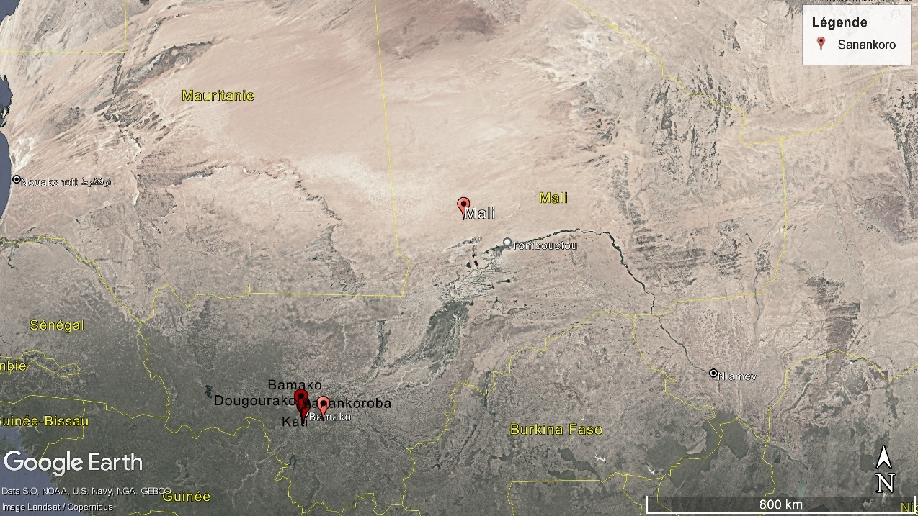
Fig. 1: Location map of the ethnobotanical survey sites (Kati, Bamako, Sanankoroba) and the plant material collection site (Dougourakoro, Mali).

2.2 Material
The biological material consisted of leaves, trunk bark, and root bark of Mangifera indica L. (mango), collected in Dougourakoro on January 10, 2024. The samples were carefully washed and air-dried for several days at room temperature at the Laboratory of Food Biochemistry and Natural Substances (LBASNa), Faculty of Sciences and Techniques (FST), University of Sciences, Techniques, and Technologies of Bamako (USTTB).
After drying, the samples were ground by an electronic grinder. The resulting powders were sieved and stored in conditions protected from light and moisture to prevent sample degradation. These powders were subsequently used for characterization studies. Fig. 2 below shows the biological samples used for characterization.

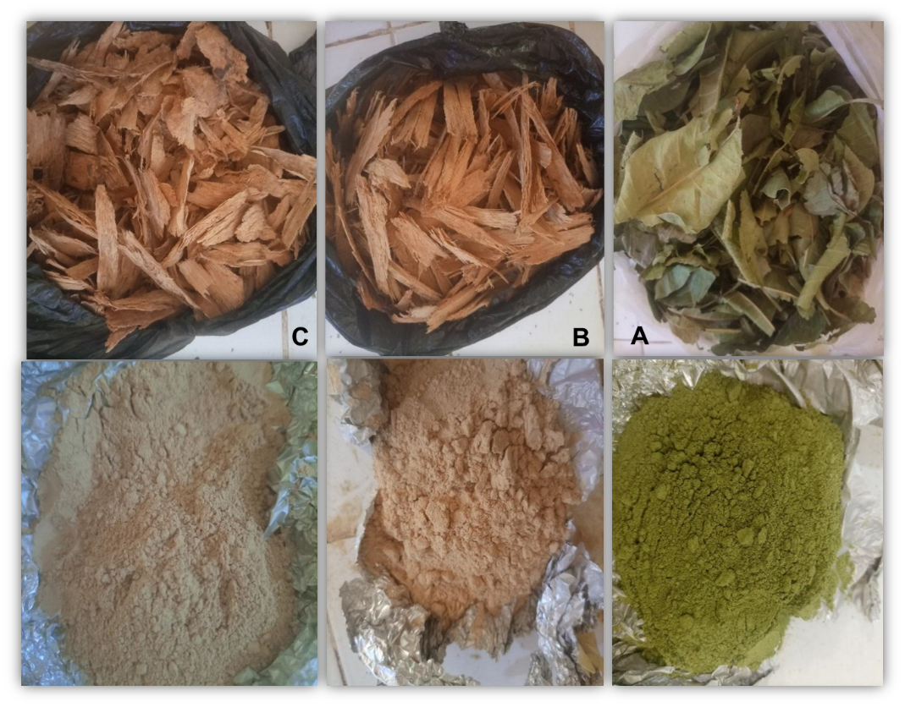
Fig. 2. Biological samples of Mangifera indica L. used for characterization. (A) Leaves: dried (top) and powdered (bottom). (B) Trunk bark: dried (top) and powdered (bottom). (C) Root bark: dried (top) and powdered (bottom).

2.3 Methods

2.3.1 Ethnobotanical Survey
The study population consisted of members of various families in Bamako, and its surrounding areas. Data were collected using a structured questionnaire from November 7, 2022, to March 2, 2023. It involved visiting household door-to-door and asking questions about domesticated plants, their uses, and those specifically employed in the traditional treatment of diabetes, including the plant parts used, preparation methods, and modes of administration.

2.3.2 Phytochemical Screening
For the characterization of chemical groups, four types of extracts were prepared: Aqueous maceration (AM), Hydroalcoholic maceration (HAM), Aqueous decoction (AD) and Hydroalcoholic decoction (HAD). To determine the presence or absence of specific secondary metabolites, standard procedures were employed as described by (Bruneton, 2009) (Harbone, 1998) slightly modified by [20].
2.3.3 DPPH Radical Scavenging Assay
The antioxidant activity was evaluated using the DPPH (2,2-diphenyl-1-picrylhydrazyl) method, following the protocol described by Williams et al. (1995), with slight modifications according to [17]. Briefly, 50 µL of each extract solution at different concentrations was added to 1.95 mL of ethanolic DPPH solution (0.024 g/L). A negative control was prepared by mixing 50 µL of ethanol with 1.95 mL of the DPPH solution. The mixtures were incubated for 30 min in the dark at room temperature, and absorbance was measured at 515 nm against a blank using a spectrophotometer. Ascorbic acid, prepared under the same conditions, was used as a positive control. The antioxidant activity, corresponding to the radical scavenging effect on DPPH, was expressed as the percentage of inhibition (PI) calculated according to the formula:
$$PI\left(0/0\right)=\frac{A_{0}-A_{1}}{A_{0}}×100$$
where A₀ is the absorbance of the control (DPPH solution without extract) and A₁ is the absorbance in the presence of the extract.
The IC₅₀​ values (concentration required to inhibit 50% of the DPPH radical) were determined from the linear regression curve plotting inhibition percentage against extract concentration.
2.3.4 Antidiabetic Activity (α-Amylase Inhibition Assay)
The antidiabetic potential was assessed using the α-amylase inhibition assay, following the protocol described by Williams et al. (1995), with slight modifications according to [21]. Briefly, different concentrations of each extract solution were mixed with 100 µL of starch solution and incubated for 10 min. Subsequently, 100 µL of α-amylase solution was added, followed by a second incubation of 10 min. Then, 200 µL of DNS (3,5-dinitrosalicylic acid) reagent was added, and the mixture was boiled in a water bath for 5 min. After cooling to room temperature, 2 mL of distilled water was added, and absorbance was measured at 540 nm.
The inhibitory activity against α-amylase was expressed as a percentage of inhibition (PI), calculated using the following formula:
$$PI\left(0/0\right)=\frac{A_{0}-A_{1}}{A_{0}}×100$$
where A₀ is the absorbance of the control (α-amylase without extract) and A₁​ is the absorbance in the presence of the extract.
The IC₅₀ values (concentration required to inhibit 50% of α-amylase activity) were determined from the linear regression curve obtained by plotting the percentage of inhibition against extract concentration.
2.3.5 Data Analysis
Survey data were processed using Microsoft Excel version 2019. For the statistical analysis of quantitative variables, Minitab version 18.1 was employed. Analysis of variance (ANOVA) was performed to compare mean values of the different variables, and Fisher’s test was applied at a probability threshold of p=0.05.

3. results and discussion

3.1 Domesticated Plant Species and Their Uses.
Our survey was conducted among 101 households, of which 84 practiced plant domestication, while 17 did not. The different domesticated plants and their citation counts are presented in Table 1 below. The different plants identified belong to a total of 25 major plant families, of which the Anacardiaceae family was the most cited, due to the Mango Tree (Mangifera indica L.). The Anacardiaceae family is known to contain a variety of bioactive compounds, such as flavonoids, tannins, and phenolic acids, which have demonstrated therapeutic properties [21–23]. In addition, the survey revealed that leaves were the most frequently cited part, accounting for 50.4%, mainly by decoction. This was followed by barks at 27.2%. Seeds and fruits were also commonly cited at 12.8%, while roots represented only 7.2%. This high frequency of leaves usage can be attributed to the ease of access and collection of leaves, their renewability throughout the year, and their established richness in secondary metabolites and bioactive compounds [21, 24, 25]. The domesticated plants are also used for their therapeutic properties. Our survey revealed that these plants are primarily used to treat malaria (50 citations), followed by diabetes (24 citations) and hypertension (14 citations).

Table 1. Domesticated Plants species and Percentage of Citations from the survey
Scientific Names | Families | Common Names (French/Bambara) | Number of citations | Percentage (%)
Mangifera indica L | Anacardiaceae | Manguier / Mangoro sun | 66 | 66.06
Carica papaya L | Caricaceae | Papayer / mandjé sun | 32 | 12.64
Citrus (Limon) | Rutaceae | Citronnier / lémouroukoumouni sun | 28 | 11.09
Mentha L | Lamiaceae | Menthe / nanayé sun | 19 | 7.50
Moringa oleifera L | Moringaceae | Moringa / bachiyirini | 18 | 7.11
Musa L | Musaceae | Bananier / namassa sun | 15 | 5.92
Citrus sinensis L | Rutaceae | Orangier / lémourouba sun | 10 | 3.95
Annona muricata | Annonaceae | Corossolier/ sunsun sun | 9 | 3.55
Psidium guajava | Mirtaceae | Goyavier / bouyaki sun | 9 | 3.55
Cymbopogon citratus | Poaceae | Citronnel / binblouni | 7 | 2.76
Aloe vera L | Xanthorrhoeaceae | Aloe vera / aloe vera sun | 6 | 2.37
Tamarindus indica | Fabaceae | Tamarin / tomi sun | 4 | 1.58
Spinacia oleracea | Amaranthaceae | Epinard / pinari sun | 3 | 1.18
Punica granatum | Punicaceae | Grenadier / grenadini sun | 3 | 1.18
Hibiscus L | Malvaceae | Hibiscus / da sun | 3 | 1.18
Abelmoschus esculentus | Malvaceae | Gombo / gan sun | 3 | 1.18
Daucus carota | Apiaceae | Caotier / caroti sun | 3 | 1.18
Persea americana | Lauraceae | Avocatier / avoca yiri | 2 | 0.79
Manihot esculenta | Euphorbiaceae | Manioc / banaku sun | 2 | 0.79
Phoenix dactylifera | Arecaceae | Dattier / tamaro yiri | 2 | 0.79
Ziziphus | Zingiberaceae | Jujubier / tomonon sun | 1 | 0.39
Olea europaea | Oleaceae | Olive / olive sun | 1 | 0.39
Solanum lycopersicum L | Solanaceae | Tomate / tamati sun | 1 | 0.39
Ipomoea batatas | Convulvulaceae | Patate / wosso sun | 1 | 0.39
Vitis vea | Vitaceae | Raisin / toubabou pekou sun | 1 | 0.39
Parkia biglobosa | Fabaceae | Porkia / néré | 1 | 0.39
Zingibier officinale | Rhamnaceae | Jingembre / yanmakou sun | 1 | 0.39
Allium cepa L | Liliaceae | Oignon / djaba sun | 1 | 0.39
Citrus maxima | Rutaceae | Pamplemousse / pampulemusi sun | 1 | 0.39

3.2 Antidiabetic Plants among Domesticated edible Plant Species.

Fig. 3 highlights the most cited antidiabetic plants among domesticated edible plant species.

Fig. 3. Number of citations for antidiabetic Plants among domesticated Species

The Figure shows that Moringa stands out as the most frequently cited plant, with a total of 38 citations followed by Papaya (13 citations), Aloe Vera (12 citations), and Mango (12 citations). Results highlight importance of these plants in local usage, justifying a more in-depth investigation of their phytochemical and biological properties. As the mango tree (Mangifera indica L.) emerged as the most frequently cited species among domesticated edible plants (Table 1) and ranked among the most commonly employed species in the treatment of diabetes (Fig.3), it was selected for further investigations.

3.3 Phytochemical Investigation of Mangifera indica L. (Mango Tree).
The results of the phytochemical screening of the ethanolic and aqueous extracts from the three plant organs (leaves, bark, and roots) are summarized in Table 2.

Table 2. Phytochemical characterization of Mangifera indica L.
Phytochemical groups | Aqueous solution |  |  | Ethanolic Solution
Phytochemical groups | Leaves | Barks | Roots | Leaves | Barks | Roots
Alkaloids | - | + | - | - | + | -
Tannins | + | + | + | + | + | +
Flavonoids | + | + | + | + | + | +
Mucilage | + | + | + | - | - | +
Coumarins | + | + | + | + | + | +
Saponins | - | - | - | - | - | -
Terpenoids | + | + | + | + | + | +
Reducing Sugars | + | + | + | + | + | +
(+): presence et (-): absence
The phytochemical screening of Mangifera indica L. revealed that the plant contains tannins, flavonoids, coumarins, terpenes, and reducing sugars, while saponins were absent in all organs. Alkaloids are detected only in the barks (aqueous and hydroalcoholic extracts), but absent in leaves, consistent with Liberata et al. [26]. Saponins are absent in all organs. These results indicated that M. indica is a valuable source of polyphenols (tannins, flavonoids, coumarins) and terpenes through the leaves and barks. These results are consistent with recent studies that have shown the leaves to be the richest organs in secondary metabolites and bioactive compounds [20, 23, 27]. Nevertheless, the use of barks and roots poses a sustainability problem, as harvesting can severely harm the tree's health, or even kill it.

3.4 Antiradical and Anti-amylase Activities (IC₅₀) of M. indica Extracts.
Table 3 summarizes the IC₅₀ values obtained for the antiradical activities of the extracts.

Table 3. Summary of Antiradical Activity (DPPH Assay, expressed as IC₅₀)
Organs | Extract | DPPH, IC₅₀ (μg/ml)
Leaves | Aqueous | 2.97±0.22^{b}
Leaves | Ethanolic | 2.27±0.65^{bc}
Barks | Aqueous | 2.13±0.51^{bc}
Barks | Ethanolic | 1.88±0.41^{c}
Roots | Aqueous | 2.80±0.55^{b}
Roots | Ethanolic | 4.20±0.53ª
P-value |  | .001
*Values followed by different letters are significantly different at P < .05

Analysis of this table reveals that the extracts from all parts of M. indica exhibit a very good antiradical activity, with IC₅₀ values ranging between 1.88±0.41 and 4.20±0.53 μg/ml. The ethanolic extracts of the trunk bark show the most potent inhibitory effect on DPPH free radicals, with IC₅₀ values of 1.88±0.41 (p<0.05). Our results of IC₅₀ values are lower than those obtained by Kitbumrungsart et al. [28] and Nga et al. [29], who worked with the trunk of M. indica and obtained IC₅₀ values of 68.27±0.50 µg/ml and 0.03 mg/ml, respectively. The difference could be explained by the methods and varieties of plants.

Table 4 summarizes the IC₅₀ values obtained for the antiradical activities of the extracts.

Table 4. Summary of anti-α-amylase activity (expressed as IC₅₀)
Organs | Extract | DPPH, IC₅₀ (μg/ml)
Leaves | Aqueous | 3.34±0.09^{d}
Leaves | Ethanolic | 4.86±0.19^{b}
Barks | Aqueous | 4.34±0.41^{c}
Barks | Ethanolic | 4.83±0.20^{b}
Roots | Aqueous | 7.19±0.30ª
Roots | Ethanolic | 4.45±0.20^{bc}
P-value ˂ |  | .001
*Values followed by different letters are significantly different at P < .001

The analysis of this table shows that extracts from all parts of M. indica exhibit a very strong anti-α-amylase activity, with IC₅₀ values ranging from 3.34±0.09 to 7.19±0.30 μg/mL. The aqueous leaf extract demonstrated the highest inhibitory potential, with an IC₅₀ of 3.34±0.09 μg/mL (p < 0.05). This anti-amylase activity is more significant than the results obtained by Sekar et al. [30], who found IC₅₀ values of 287.57 µg/ml and 318.1 µg/ml for ripe and unripe mangoes, respectively. The α-amylase inhibitory capacity is much more active in the leaves compared to other parts of the mango tree, which could explain the high use of this plant part by diabetic individuals. These results corroborate the data obtained from the surveys regarding the traditional use of M. indica in the management of numerous diseases, particularly diabetes. These lower IC₅₀ registered with α-amylase support the involvement of Manguifera’s extracts in the regulation of diabetes. This potential regulation of α-amylase’s activity could rely on their composition in phenolic compound which are closely incriminated in the α-amylase’s regulation and therefore in the management of diabetes [13]. However, more in-depth investigations, especially on the content of phytochemical groups and other hypoglycemic activities, are necessary to confirm the mechanism mechanistic of action of the bioactive substances of M. indica.

4. Conclusion

The survey of this study revealed that the vast majority of households in Bamako and around practice plant domestication, including a high diversity of edible species belonging to 25 plant families, with Anacardiaceae being the most cited, mainly due to the prominence of Mangifera indica L. These plants are domesticated for various reasons including nutrition, shade provision, and especially for its medicinal properties. The phytochemical analysis of the M. indica, a valued plant identified among the edible plants, highlighted the presence of numerous phytochemical groups which reinforce the antioxidant and antidiabetic potential of M. indica. Together, these results help to explain the increasing domestication of edible plants such as M. indica in the traditional management of metabolic diseases, particularly diabetes, in addition to their broader household benefits in Bamako and surrounding areas. Future studies should focus on the quantitative determination of the major phytochemical groups identified in M. indica, as well as on the biochemical characterization of domesticated edible plants. Further evaluation and comparison of their inhibitory effects on α-amylase and other key metabolic enzymes would also be valuable to better assess their therapeutic potential.

Consent

Prior informed consent was obtained from all participants before data collection. The purpose of the study was clearly explained, participation was voluntary, and participants were informed of their right to withdraw at any stage. To ensure confidentiality, no personal identifiers are disclosed.

DISCLAIMER (ARTIFICIAL INTELLIGENCE)
Authors hereby declare that generative AI technologies such as Large Language Models, etc. have been used during the writing or editing of manuscripts. This explanation will include the name, version, model, and source of the generative AI technology and as well as all input prompts provided to the generative AI technology.
Details of the AI usage are given below:
We disclose that ChatGPT (OpenAI, GPT-4) was used during the preparation of this manuscript to assist in improving the quality of written English, including grammar, clarity, and style.

References

1. Lamy, E. (2024). Ethnobotany: Preserving Plants Cultural Significance for Sustainable Medicine and Conservation. *Medicinal & Aromatic Plants*, *13*(3), 1-2. https://doi.org/10.35248/2167-0412.24.13.498
2. Essandoh, P. K., Dali, G. L. A., & Bryant, I. M. (2023). Medicinal plant use and integration of traditional healers into health care system: A case study at Ankasa Forest Reserve and catchment communities in Ghana. Ethnobotany Research and Applications, 26(15), 1–24. https://doi.org/10.32859/era.26.15.1-24
3. Perumal, G. (2010). Ethnomedicinal Use of Pteridophyte from Kolli Hills, Namakkal District, Tamil Nadu, India. Ethnobotanical Leaflets https://opensiuc.lib.siu.edu/ebl/vol2010/iss2/5/
4. Dembélé, F., Samaké, S., Togola, I., & Karembé, M. (2021). Etudes ethnobotanique et phytochimique d'espèces ornementales utilisées au Mali: cas de Terminalia catappa (L.) dans le district de Bamako. International Journal of Applied Research, 7(6), 01–07. https://doi.org/10.22271/allresearch.2021.v7.i6a.8616
5. Samake, S., Togola, I., Diarra, N., Samake, M., & Sanogo, R. (2020). Etude Ethnobotanique Et Screening Phytochimique De Plantes Ornementales A Usage Therapeutique Du District De Bamako, Mali. International Journal of Advanced Research, 8, 251–262. https://doi.org/10.21474/IJAR01/11487
6. Diawara, A., Coulibaly, D. M., Hussain, T. Y. A., Cisse, C., Li, J., Wele, M., Diakite, M., Traore, K., Doumbia, S. O., & Shaffer, J. G. (2023). Type 2 diabetes prevalence, awareness, and risk factors in rural Mali: a cross-sectional study. Scientific Reports, 13(1), 3718. https://doi.org/10.1038/s41598-023-29743-1
7. DDiawara, A., Traore, M., Diabaté, O., Kintu, C., Saeed, A. A., Abiola, J. O., Cisse, C., Traore, K., Wele, M., Nash, O., Doumbia, S. O., Abbas, T. Y., Shaffer, J. G., Diakité, M., Fatumo, S., & Soremekun, O. (2024). Genetically proxied inhibition of kidney function pathways and increased risk of type 2 diabetes in Africans: A Mendelian randomization study. Res Sq. https://doi.org/10.21203/rs.3.rs-3956597/v1
8. International Diabetes Federation. (2025). *IDF Diabetes Atlas (11th ed.)*. Brussels, Belgium: International Diabetes Federation. https://diabetesatlas.org/resources/idf-diabetes-atlas-2025/
9. Goedecke, J. H., & Mendham, A. E. (2022). Pathophysiology of type 2 diabetes in sub-Saharan Africans. Diabetologia, 65, 1967–1980. https://doi.org/10.1007/s00125-022-05795-2
10. Motala, A. A., Mbanya, J. C., Ramaiya, K., Pirie, F. J., & Ekoru, K. (2022). Type 2 diabetes mellitus in sub-Saharan Africa: challenges and opportunities. Nature Reviews Endocrinology, 18(4), 219–229. https://doi.org/10.1038/s41574-021-00613-y
11. Konaré, M. A., Diarra, N., Cissé, C., Traoré, D. A. K., Togola, I., Kassogué, A., Sanogo, R., & Ouattara, A. S. (2020). Evaluation of the biological activities of leaf and bark extracts of Ficus platiphylla Delile, a medicinal plant used in Mali. Journal of Medicinal Plants Research, 14(3), 118–128. https://doi.org/10.5897/JMPR2019.6874
12. Konaré, M. A., Keita, S., Somda, M. K., Togola, I., Diarra, N., & Sanogo, R. (2023). Antibacterial Activities of Extracts from Four Wild Food Fruits. European Journal of Nutrition & Food Safety, 15(1), 62–71. https://doi.org/10.9734/ejnfs/2023/v15i11289
13. Konaré, M. A., Condurache, N. N., Togola, I., Păcularu-Burada, B., Diarra, N., Stănciuc, N., & Râpeanu, G. (2023). Valorization of Bioactive Compounds from Two Underutilized Wild Fruits by Microencapsulation in Order to Formulate Value-Added Food Products. Plants, 12(2), 267. https://doi.org/10.3390/plants12020267
14. Hussain, S. T., Muhammad, S., Khan, S., Hussain, W., & Pieroni, A. (2023). Ethnobotany for food security and ecological transition: wild food plant gathering and consumption among four cultural groups in Kurram District, NW Pakistan. Journal of Ethnobiology and Ethnomedicine, 19, Article 35. https://doi.org/10.1186/s13002-023-00607-9
15. Betti, J. L., & Yemefa'a, S. R. (2011). Contribution à la connaissance des produits forestiers non ligneux du parc national de Kalamaloué, Extrême-Nord Cameroun: Les plantes alimentaires. International Journal of Biological and Chemical Sciences. https://doi.org/10.4314/ijbcs.v5i1.68105
16. Sissoko, L., Diarra, N., Nientao, I., Stuart, B., Togola, A., Diallo, D., & Willcox, M. L. (2023). Moringa oleifera leaf powder for type 2 diabetes: a pilot clinical trial. African Journal of Traditional, Complementary and Alternative Medicines, 17(2), 29–36. https://doi.org/10.21010/Ajtcamv17i2.3
17. Togola, I., Konare, M. A., Cisse, C., & Diarra, N. (2023). Anti-Inflammatory and Anti-cancer Activities of Leaf Extracts from Three Datura Species Found in Mali. Journal of Applied Life Sciences International, 26(6), 88–97. https://doi.org/10.9734/JALSI/2023/v26i6630
18. Konaré, M. A., Cissé, C., Togola, I., & Fomba, M. (2024). Inhibitory Effects of Datura innoxia Mill Extracts on Two Enzymes Involved in the Control of Diabetes and Inflammation. Annual Research & Review in Biology, 39, 11–18. https://doi.org/10.9734/arrb/2024/v39i92114
19. Dramé, B. S. I., Koné, A., Sylla, S. D., Goïta, Y., Coulibaly, D. M., Sanogo, R., & Cissé, B. M. (2022). Capacité Anti Oxydante des Feuilles du Moringa Oleifera chez les Diabétiques de Type 2. Health Sciences and Disease, 23(3), 136-144. https://doi.org/10.5281/hsd.v23i3.3500
20. Konaré, M. A., Diarra, N., Cissé, C., Traoré, D. A. K., Togola, I., Kassogué, A., Sanogo, R., & Ouattara, A. S. (2020). Evaluation of the biological activities of leaf and bark extracts of Ficus platiphylla Delile, a medicinal plant used in Mali. Journal of Medicinal Plants Research, 14, 118–128. https://doi.org/10.5897/JMPR2019.6874
21. Konaré MA, Diadie Maïga A, Togola I, Diarra N (2024) Antioxidant and Antidiabetic Potential of Extracts from Anacardium occidentale and Sclerocarya birrea. J Biochem Technol 15:15–24
22. Kumar, M., Saurabh, V., Tomar, M., Hasan, M., Changan, S., Sasi, M., Maheshwari, C., Prajapati, U., Singh, S., Prajapat, R. K., et al. (2021). Mango (Mangifera indica L.) Leaves: Nutritional Composition, Phytochemical Profile, and Health-Promoting Bioactivities. Antioxidants. https://doi.org/10.3390/antiox10020299
23. Karigidi, M. E., Fakunle, O. E., & Karigidi, K. O. (2025). Antioxidant, antidiabetic and antifungal activities of leaf and bark ethanol extracts of Mangifera indica and their antagonistic biochemical effects. *International Journal of Functional Nutrition*, *6*(1), 1-11. https://doi.org/10.3892/ijfn.2025.46
24. Togola I, Dembélé AA, Tounkara F, Diarra N, Konaré MA, Karembé M, Maïga SZ, Dembélé D (2019) Evaluation of in vitro Antioxidant Activities of Ethanol Extracts of Datura innoxia Mill. Leaves and Seeds Harvested in Mali. Annu Res Rev Biol. https://doi.org/10.9734/arrb/2019/v33i230115
25. Guindo, F., Konaré, M. A., Daou, C., & Cissé, F. (2022). Inventory of Local Practices of Use and Conservation of Baobab Products in Two Regions of Mali. Journal of Food Studies. https://doi.org/10.5296/jfs.v11i1.20464
26. Nizigiyimana, L., Nahimana, S., & Ndayiziga, L. (2020). Tests d’activités antiparasitaires et antibactériennes des extraits des feuilles de Psidium guajava L. (ipera) du Burundi. Revue de l'Université du Burundi, Série- Sciences Exactes et Naturelles, 2, 13–22.
27. Dubey, K., Dubey, R., Gupta, R. A., & Gupta, A. K. (2019). Anti-Diabetic and Antioxidant Potential of Saponin Extract of Leaves of Ziziphus Mauritiana. Journal of Drug Delivery and Therapeutics, 9(2-A), 75–77. https://jddtonline.info/index.php/jddt/article/view/2784
28. Kitbumrungsart, P., Suntornwat, O., & Rayanil, K. (2011). Mangiferin and antioxidant capacity from mango (Mangifera indica L.) leaves extracts. Thai Journal of Agricultural Science, 44(5), 62–66. https://www.cabidigitallibrary.org/doi/10.1079/PA20110009
29. Nga Nnanga, E., Yinyang, J., Baran à Bidias, E., Etame-Loe, G., & Dibong, D.S. (2017). Étude phytochimique et pharmacologique d'Alchornea cordifolia (Schum. & Thonn.) Mull. Arg. et de Mangifera indica dans le traitement traditionnel de la maladie hémorroïdaire. Journal of Applied Biosciences, 109, 10649–10661. https://doi.org/10.4314/jab.v109i1.9
30. Sekar, V., Mani, S., Malarvizhi, R., Nithya, P., & Vasanthi, H. R. (2019). Antidiabetic effect of mangiferin in combination with oral hypoglycemic agents metformin and gliclazide. Phytomedicine, 59, 152901. https://doi.org/10.1016/j.phymed.2019.152901

