Original Research article

Synergistic Ameliorative effect of Vitamin C and Activated Charcoal on Paraquat-induced lung histotoxicity in Wistar rats

.
ABSTRACT

Aims: To investigate the Synergistic ameliorative effect and the safety of Vitamin C/ Activated Charcoal on Paraquat-induced lung histotoxicity and normal lungs of Wistar rats respectively. To investigate the relationship between the level of tissue damage with the duration of paraquat exposure. To investigate the synergistic effect of the combination of Vitamin C and activated charcoal, on clinical manifestations associated with oral paraquat toxicity in Wistar rats.

Study design: This is an experimental study
Place and Duration of Study: National Veterinary Research Institute, Vom, Nigeria, from March 1st to March 28th, 2025.
Methodology: A total of 40 female 8 week old Wistar rats, weighing between 150 to 200 grams were used, The rats were randomly assigned into 4 groups, of 10 rats each. Group 1 rats, normal control, received orally, 1ml of normal saline solution daily for 28 days. Group 2 animals received paraquat solution at 50mg/kg body weight dissolved in 1ml of distilled water once daily, for 28 days. Group 3 animals received paraquat solution at 50mg/kg body weight daily, followed by a combination of a solution of Vitamin C at 250mg/ kg body weight and activated charcoal at 0.175g/kg body weight dissolved in 1ml of distilled water once daily for 28 days. Group 4 animals were administered a combination of a solution of Vitamin C at 250mg/ kg body weight and activated charcoal at 0.175g/kg body weight dissolved in 1ml of distilled water once daily for 28 days. There were observed weekly. Lung tissue was harvested weekly for histopathology processing and microscopic examination from the groups randomly.
Results: Group 1 and 4 animals present with normal physical behavior, water/ feed consumption. Group 2 animals present with severe reduction in feed/ water intake, respiratory distress, Squeaking sound and generalized weakness of the body, paralysis, anorexia and bloody nasal discharges, which gets worsened with duration of the experiment, with 3 mortalities recorded on days 8, 17 and 25. Group 3 animals present with mild weakness of the body, slight reduction of water/feed intake with normal physical activities throughout the experiment, with a mortality on day 23. Microscopically, Lung sections of groups 1 and 4 remain histologically normal throughout the experiment. Group 2 lung sections show massive diffuse oedema and vacuolations in alveolar spaces, indistinct alveolar epithelium, interalveolar septal haemorrhages and profuse infiltration of inflammatory cells in alveolar spaces, with complete loss of tissue architecture, which worsens with duration. Group 3 sections shows mild alveoli septa enlargement from day 7 to day 14, with mild interseptal haemorahes and mild oedema from the 21 to day 28.
Conclusion: Histopathologiclly, group 2 shows established histotoxicity while group 3 shows amelioration and recovery form toxicity. As the duration of the experiment increases, the ameliorative effect of the dosage of this combination begins to decrease. There is hence, a need, to use graded doses of the combination of vitamin c and activated charcoal, to establish the optimum dose that can withstand long term exposure to paraquat toxicity. The normal morphology seen in both group 1 and group 4 has shown that at this dose, the combination of vitamin C and activated charcoal is safe for the animal

Keywords: Paraquat-induced, Lung histotoxicity, Vitamin C, Activated Charcoal, Synergistic effect, Ameliorative effect, Wistar rats, alveolar oedema

1. INTRODUCTION

Vitamin C (also known as L-Ascorbic acid or ascorbate) is a water-soluble compound found in Living organisms (Fenech et al., 2019). With formula C₆H₈O₆, originally called hexuronic acid, vitamin C is an antioxidant protecting against damage by reactive molecules called free radicals, an essential co-factor for collagen biosynthesis, carnitine and catecholamine metabolism, and dietary iron absorption (Narayanan et al., 2021). Activated charcoal, or activated carbon, is an amorphous form of carbon prepared from incomplete combustion of carbonaceous organic matter such as charred bones, coal, petroleum coke, and coconut shells, among others (Khruengsai et al., 2024). It is activated by an oxidizing gas flow at high temperature passed over its surface to make a fine network of pores, producing a material with large surface area and high affinity for various substances (Chada et al., 2012). It is used as a gastric decontaminant and emergency medication to treat poisonings following excessive oral ingestion of certain medications or poisons by absorbing most drugs and toxins (Cataldi et al., 2022). Paraquat (PQ) (1, dimethyl-4,4-bipyridylium dichloride-1), a family of bipyridine herbicides is a fast contact herbicide (Guo et al., 2023) that works on the mechanism of diverting electrons from photosystem I (PSI) into the chloroplast. This diversion of electrons can result to the production of free radicals which are detrimental to the tissue. This makes it kill plants or/and inhibit their growth (Gupta, 2018). Paraquat do not decompose rapidly in the environment, and prolonged exposure to it can cause hazardous bio-alterations in humans and mammals including decreased immunity and nervous disorders (Preston and Ros, 2018).
Scientists have found fatal serum PQ levels ranging from 0.5 to 372.0 µg/mL (Nuwongsa et al., 2024) and can cause pulmonary fibrosis (Min et al., 2024). Extensive applications of paraquat results to widespread residues on soil surfaces and aquatic environments that finally enter the food chain (Huang et al., 2019; Hossain, 2015). Oral route is the major route of exposure, while inhalation is another route, absorption through the intact skin is generally very limited (Afzali and Gholyaf 2008; Wilks et al., 2008; Yang and Tiffany-Castiglioni, 2007). Paraquat is an effective, broad-spectrum, and highly poisonous water-soluble quaternary ammonium salt herbicide (Zhou et al., 2013). It is highly toxic to humans and animals and the main prognostic factors of paraquat absorption are pulmonary damage and fibrosis (Liu, et al., 2017; Xiao et al., 2020). It is banned in some countries but has continuously been used without regulation in many countries including Nigeria. Paraquat is highly used, globally, especially in developing countries and its use is unregulated, despite its hazards. Paraquat has a multi-target mechanism that causes damage to the organism, not only affecting the lungs, but also the heart, kidneys, gastrointestinal tract, nervous system, and the immune system (Cheng et al., 2021)
There is treatment against paraquat toxicity established, however, several studies taking into account oxidative stress as the main mechanism of PQ-induced toxicity suggest an antioxidant therapy as a viable alternative (Blanco-Ayala, et al., 2014). Vitamin C has been used for the management of Paraquat toxicity in humans but it ameliorative effect has not been studied significantly (Awadalla, 2012) and little is known about the therapeutic window of vitamin C. As paraquat is a life-threatening poison with no known antidote, a single dose of activated charcoal or Fuller's earth is recommended for consenting patients who have a protected airway (Koo et al., 2002).
Paraquat was introduced as an herbicidal agent into the market in August 1962 by Imperial Chemical industries, now Syngenta (Khodayar et al., 2014; Roberts et al., 2002). This liquid herbicide was primarily used for weed and grass control but due to its highly poisonous nature was soon categorized as a “restricted-use” herbicide (Wesseling et al., 2005). However, as it is cheap and effective, its unregulated use in developing countries like India has made it a commonly used pesticide. Paraquat, when ingested, is extremely toxic and has no known antidote. It causes a spectrum of complications including acute respiratory distress syndrome, renal failure, hepatotoxicity, and pulmonary fibrosis (Cope et al., 2004; Dinis-Oliveira et al., 2008). When either accidentally, intentionally or maliciously ingested, paraquat selectively accumulates in the lungs resulting in the production of oxygen-free radicals, resulting in membrane damage and cell death (Okolonkwo et al., 2023). Ingestion of even a very small quantity of paraquat, with delayed intervention can cause severe multiorgan dysfunction and death (Mehta et al., 2025). Although a substantial amount of research has been produced on paraquat intoxication for most developed countries, there are research gaps regarding the international research agenda in this research area (Baradaran Rahimi et al., 2019; Jain et al., 2022) especially in relation to the development of an antidote as many attempts have been made with different ameliorating agents without success. A 100 mg/kg b.wt dexamethasone as a single dose have shown encouraging result on the lungs and liver against PQ intoxication in rats, with less success on the kidney (Dinis-Oliveira et al., 2006)
Vitamin C (Ascobic acid) as well as activated charcoal have been utilised, seperately, as ameliorating agents against Paraquat toxicity (Gawarammana, and Buckley, 2011; Ostadi and Paeezi, 2018) but the two are yet to be combined for the same purpose. The combination of these two compounds, to check their synergistic effects on paraquat-induced long toxicity, will open a great way for handling emergencies attributed to paraquat toxicity, and a possible gateway for the development of an antidote against paraquat-induced toxicity.

2. material and methods

2.1 Study Location
This research work was conducted at National Veterinary Research Institute, Vom, Plateau state, latitude 9° 53' N, and longitude 8° 51' E, an altitude of 1,217m above sea level (National Population Commission, 2006).
2.2. Ethical consideration
Ethical Clearance was obtained from the National Veterinary Research Institute, Vom, Animal Ethics Committee (AEC), where they gave an Animal Ethics Number AEC/02/173/24 after an application and a thorough interview, before the commencement of the work with periodic unannounced visits to the experimental station by members of the ethics committee, until the termination of the experiment.
2.3 Experimental Animals
A total number of 40 female 8 week old Wistar rats that weigh between 150 to 200 grams were obtained from the small animal Experimental station of the National Veterinary Research institute (NVRI) Vom, Plateau State, Nigeria, and used for the experiment. All experimental activities were carried out conformity with internationally acceptable guidelines on the ethical use of experimental animals in research (Haripriya et al., 2017; Reddy et al., 2019). The rats were housed in the Animal Experimental station of the Federal College of Veterinary and Medical Laboratory Technology, NVRI, Vom in cages during the experiment period (Edo, 2022; Ijaz et al., 2023). The rats were allowed to adjust in accordance with favorable conditions for two (2) weeks that would allow them to adapt to their new environment and fed with a standard grower’s mash obtained from Grand Cereal Ltd and water to meet the nutritional requirements for growth and maintenance in rats (Lewis et al., 2006). The constant environmental condition was maintained with proper ventilation and a good source of light (12h light -12h dark and 20ºC ± 30ºC) (Nwafor et al., 2020) with free access to food and water (Amin et al., 2025). Excrement and spillage were changed frequently (Reed et al., 2011). A veterinarian ascertained the health status of as well as provided care and ensure the health of the laboratory animals throughout the experiment so as to maintain a standard experimental protocol (Debnath et al., 2024; Pedroso et al., 2025). Animals were divided into 4 groups of 10 animals each.

2.4 Chemical and treatment compounds sources
Paraquat was purchased under the trade name ‘KINGRAMO’, from Agricultural Services and Training Centre, Vom Station, Jos Plateau State. Vitamin C (Ascorbic Acid) was obtained from Lamed Pharmacy Ltd, Jos under the brand name ‘Nature’s Field Vitamin C 1000mg, manufactured by Bactolac Pharmaceuticals Incorporated, USA (Lot 2503034). Activated charcoal was obtained from Lamed Pharmacy Ltd, Jos under the brand name ‘Kunimed Activated Charcoal Powder Anti-poison’ (Batch number KAC10). Distilled water and deionised water were obtained from the Cell culture Laboratory of the Viral Vaccine production Division, National Veterinary Research Institute, Vom.
2.5 Experimental Design
The rats were randomly assigned into 4 groups, containing 10 rats each. Group 1 served as normal control were exposed to normal atmospheric and nutritional condition, and received 1ml of normal saline solution daily (0.9% NaCl) throughout the experiment period (Hernandez-Baixauli, et al., 2024). Group 2 animals were administered paraquat solution at 50mg/kg body weight dissolved in 1ml of distilled water once daily, for 28 days. Group 3 animals were administered paraquat solution at 50mg/kg body weight daily, followed by a combination of a solution of Vitamin C at 250mg/ kg body weight and activated charcoal at 0.175g/kg body weight dissolved in 1ml of distilled water once daily for 28 days. Group 4 animals were administered a combination of a solution of Vitamin C at 250mg/ kg body weight and activated charcoal at 0.175g/kg body weight dissolved in 1ml of distilled water once daily for 28 days. All solutions of the compounds were administered via oral gavage route. The dose of Paraquat was chosen to model occupational exposure to paraquat. Doses of Activated Charcoal and Vitamin C were chosen based on previous related studies (Reddy et al., 2019).
2.6 Procedure for paraquat and treatment solutions administration
The rats were held at the skin over the head and turned so that the mouth was faced upward and the body lowered towards the holder. The syringe needle bevel was then placed into the mouth of the rat a bit laterally in a way to avoid the teeth which are located centrally. The content in the syringe was then emptied into the mouth of the rat gradually (Okolonkwo, 2022)
2.7 Experimental Protocol
Animals were observed before and after the administration of the Paraquat solution across the treatments groups (Turner et al., 2011). During the experimental period, clinical signs and behaviors of all rats such as physical activity, diarrhea, tremor, paralysis, food/water consumption, injury and death were monitored daily. At the end of the each week (that is, day 7, day 14, day 21 and day 28), animals from each group were randomly selected, and sacrificed by cervical dislocation after 12 hours of fasting. The Lungs were observed, harvested and fixed immediately in 10% buffered formalin, for histopathology processing (Adefola et al., 2024).
2.8 Histopathological Processing and Evaluation: Tissues (Lungs) from all groups were subjected to standard routine histopathological procedures, using the conventional paraffin wax method (Avwioro, 2011), embedded, sectioned and stained using the haematoxylin and Eosin Staining technique (Choji et al., 2015). They were read microscopically: A commercially available web camera (QHM495 LM, Shenzhen Hiper Song Electronic Limited, Hong Kong, China) with complementary metal oxide semiconductor sensor which yield interpolated 25 mega pixel images was used for micrograph capture after slide reading and interpretation (Mondal et al., 2019)

3. results and discussion
This research was designed to study the Synergistic ameliorative effect of Vitamin C and activated charcoal on Paraquat-induced lung histotoxicity in female Wistar rats at definite time intervals in different groups.
3.1 Clinical Signs
Clinical signs and behaviors of all rats such as physical activity, diarrhea, tremor, paralysis, food/water consumption, injury and death were observed daily across the groups, with group 1 and 4 showing normal physical presentation and feed consumption. Severe reduction in feed/ water intake, respiratory distress, Squeaking sound and generalized weakness of the body, anorexia and bloody nasal discharges were observed in group 2 animals especially as from day 12 to 28, with 3 mortalities, one recorded on each of day 8, day 17 and day 25. Group 3 animals, showed mild weakness of the body, mild reduction in feed consumption and respiratory distress, especially from the 7th to 14th day, with no bloody nasal discharge and are more active compared to group 2 animals. There was one mortality recorded in group 3 on day 23.
3.2 Histopathology
The Lungs from groups 1 and 4, microscopically, shows normal morphology throughout the experiment, with clearly defined lung architecture, showing the characteristic lung epithelium/ septa, retaining their morphology. However, lung tissue in group 2, from day 7 to day 28 presents with diffuse oedema and vacuolations in alveolar spaces, indistinct alveolar epithelium, interalveolar septal haemorrhages and profuse infiltration of inflammatory cells cells in alveolar spaces, which was mild on day 7 but increased from day 14 to day 28. Lungs tissue from group 3 show mild alveolar wall thickening from day 14 and mild alveolar oedema on day 21 and day 28, when compared with group 2.
3.3 Discussion
B
A
Micrsocopically, on day 7 (Plate 1), the lungs in group 1, 3 and 4 presented with normal histology while the lung in group 2 presents with diffuse interstitial oedema and vacuolation, complete alveolar collapse, dilation and congestion of blood vessels, interalveolar septal haemorrhages and prominent infiltration of inflammatory cells in perivascular area. Group 3 lungs shows retention of normal morphology with thickened alveolar septa and mild isterstitial oedema when compared to group 2 tissue. The presentation of normal tissue architecture and absence of pathological componenets are signs of recovery. On day 14 (Plate 2), Lungs in Group 1, 3 and 4 shows normal morphology while Group 2 lungs, shows massive interstitial inflammation and oedema with vacuolation. There is also complete loss of tissue architecture. Group 3 lung shows thickened alveolar septa with normal tissue architecture, as a sign of tissue recovery. On day 21 (Plate 3), lung in group 1 and 4 are normal in architecture. Lung in group 2 shows massive inflammation and distortion of tissue architecture with severe oedema and vacuolation. The lung in group 3 shows retention of tissue architecture with very mild oedema, mild interstitial haemorrhage and mild vacuolation. This signifies recovery but at a slower rate as compared to days 7 and 14. This agrees with other research work, that, lung injury recovery form paraquat toxicity, takes a long duration (Lee, et al., 2006). This shows that with continues exposure to the toxicant, the ameliorative effect of the combination of Vitamin C and activated charcoal begins to diminish. At 28 days ((Plate 4), histological manifestations show normal morphology in groups 1 and 4 while group 2 shows complete loss of tissue architecture with massive intercellular inflammation and congestion. Group 3, however, shows mild odema and thickened alveola septa with no inflammation.

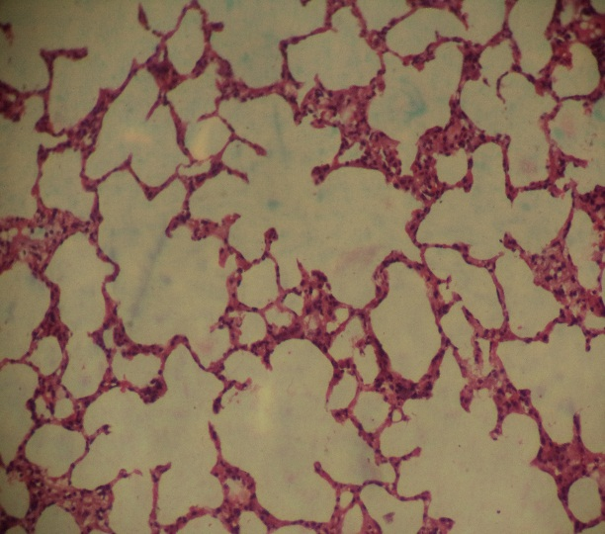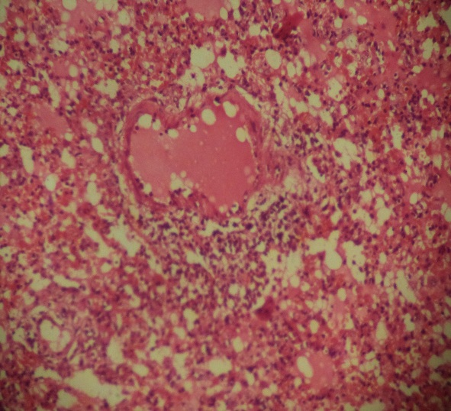
Group 2

Group 1

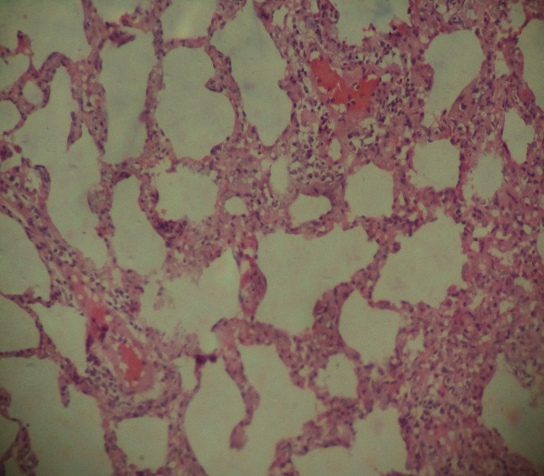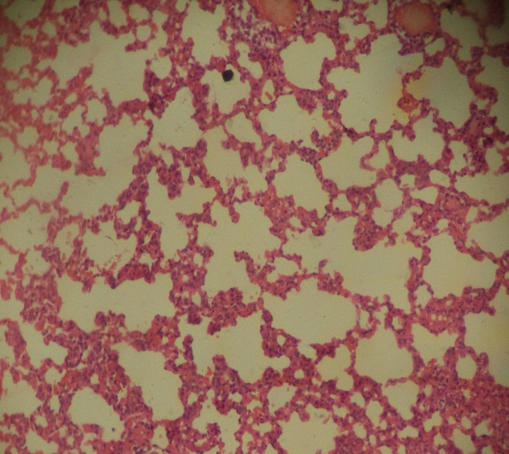
Group 4
vv
vv
vv
Group 3

Plate 1: Lung of Wistar rat from the four groups on day 7. Group 1, 3 and 4 show normal morphology with the presentation of normal alveolar epithelium with normal septa: The alveoli (black stars) and alveolar ducts (white lines) are clear and surrounded by intact pneumocytes (white arrows). Group 3 shows slightly enlarged pneumocytes and mild interstitial haemorrhage (black arrows) with tissue architecture well preserved. Group 2 lung shows diffuse interstitial oedema (white stars) and vacuolation (black arrowheads), complete alveolar collapse, dilation and congestion of blood vessels, interalveolar septal haemorrhages (black arrows) and prominent infiltration of inflammatory cells (white arrowheads) in perivascular area. H&E X100

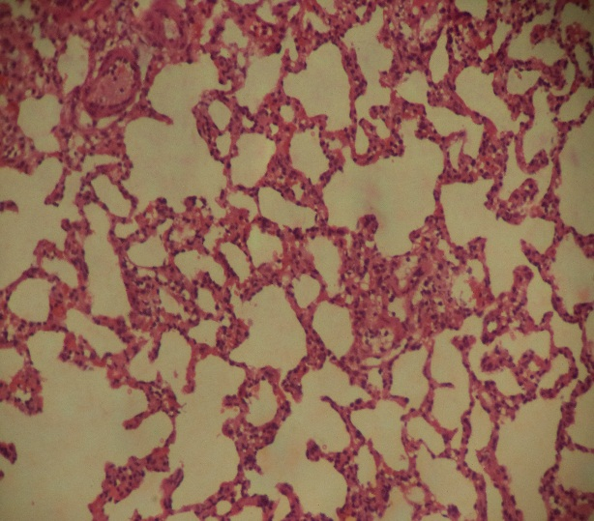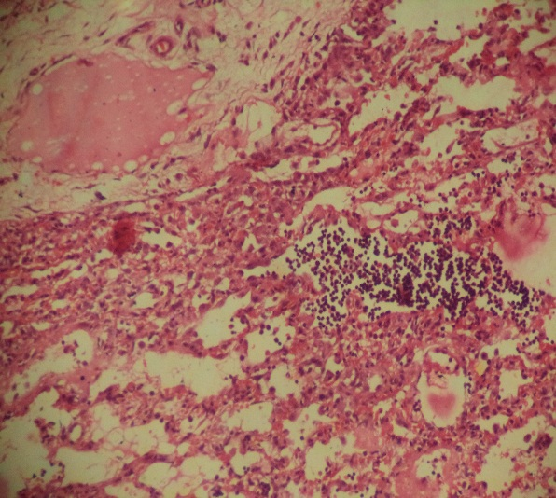
Group 2

Group 5

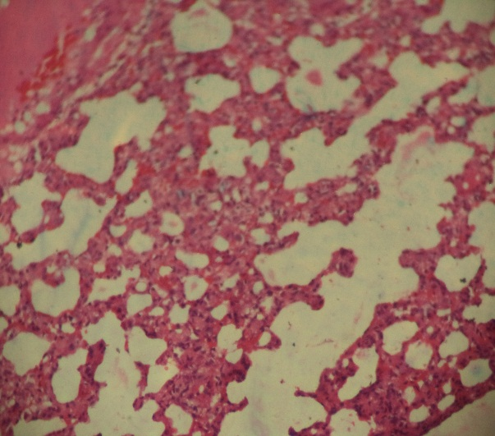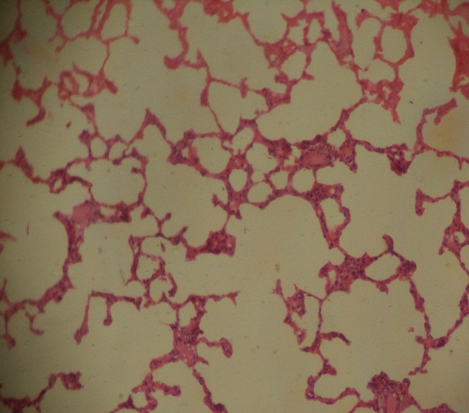
Group 4
Group 3

Plate 2: Lung of Wistar rat from the four groups on day 14. Group 1, 3 and 4 show normal morphology with the presentation of normal alveolar epithelium with normal septa: The alveoli (black stars) and alveolar ducts (white lines) are clear and surrounded by intact pneumocytes (white arrows). Group 3 shows slightly enlarged pneumocytes and mild interstitial haemorrhage (black arrows) with tissue architecture well preserved with mild tissue oedema (white star). Group 2 lung shows diffuse interstitial oedema (white stars) and vacuolation (black arrowheads), complete alveolar collapse, dilation and congestion of blood vessels, and prominent infiltration of inflammatory cells (white arrowheads) within the tissue. H&E X100

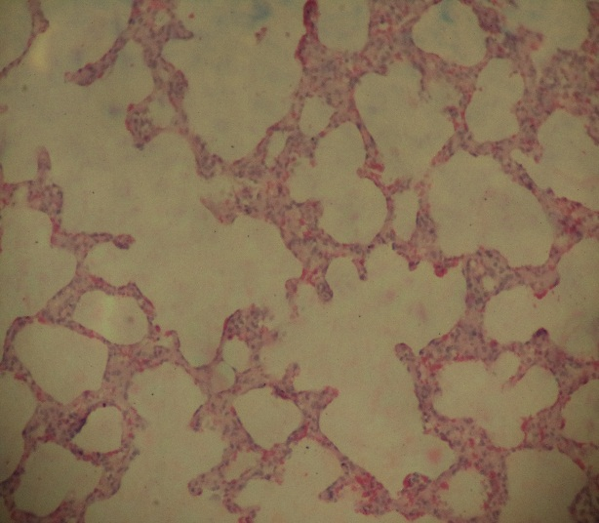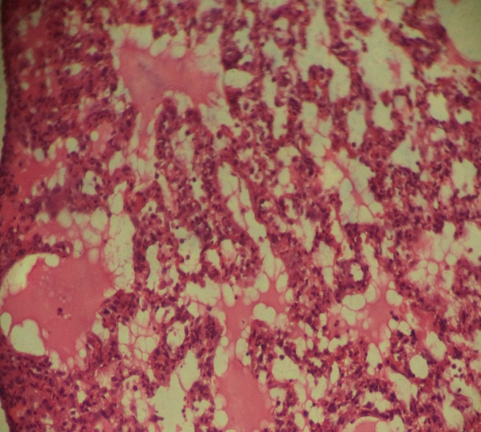
Group 2

Group 1

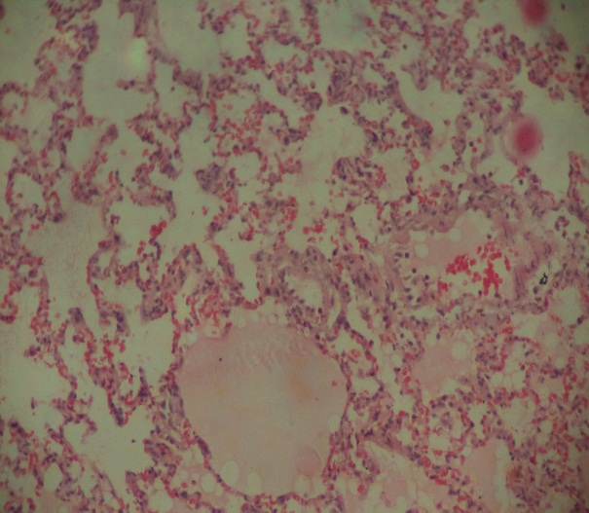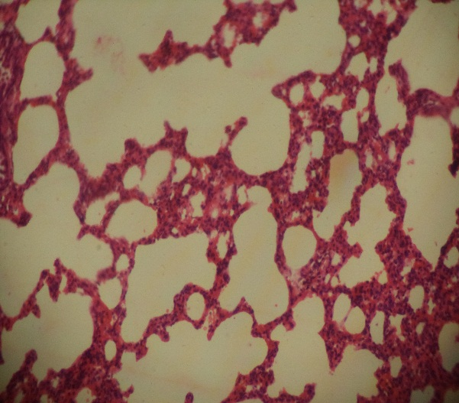
Group 4
Group 3

Plate 3: Lung of Wistar rat from the four groups on day 21. Group 1, and 4 show normal morphology with the presentation of normal alveolar epithelium with normal septa: The alveoli (black stars) and alveolar ducts (white lines) are clear and surrounded by intact pneumocytes (white arrows). Group 3 shows mild interstitial haemorrhage (black arrows) with tissue architecture well preserved and mild tissue oedema (white star). Mild interstitial inflammation is seen by the presence of inflammatory cells (white arrowheads) within the tissue. Group 2 lung shows diffuse interstitial oedema (white stars) and vacuolation (black arrowheads), partial alveolar collapse, dilation and congestion of blood vessels, and prominent infiltration by inflammatory cells (white arrowheads) within the tissue. H&E X100

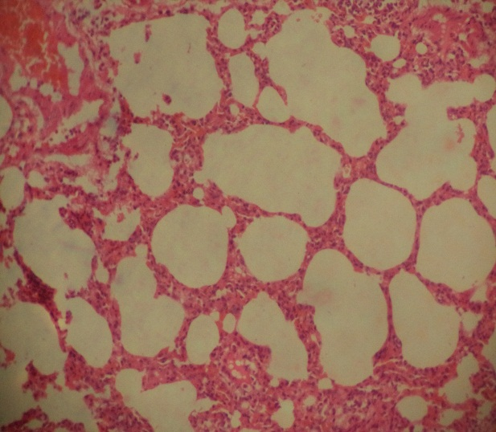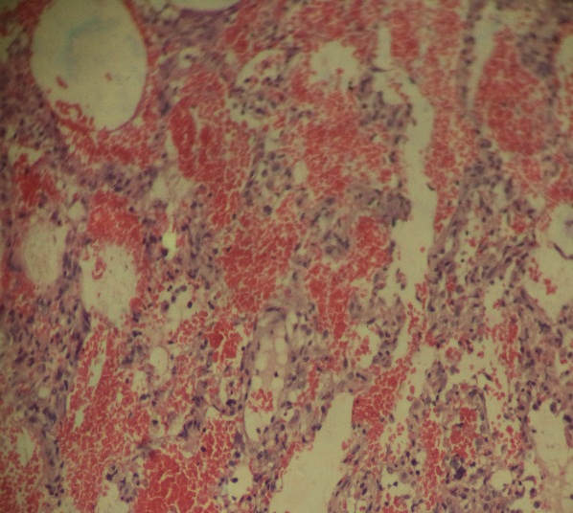
Group 2

Group 1

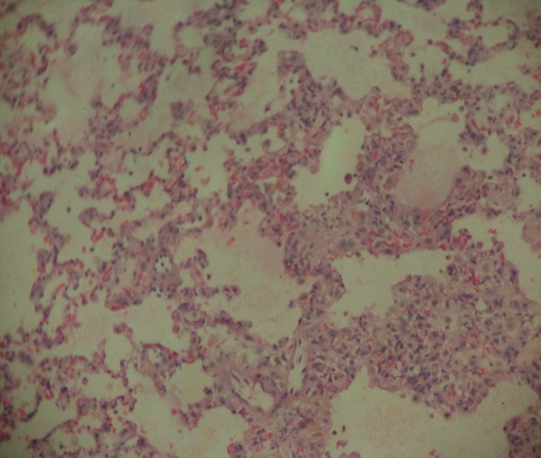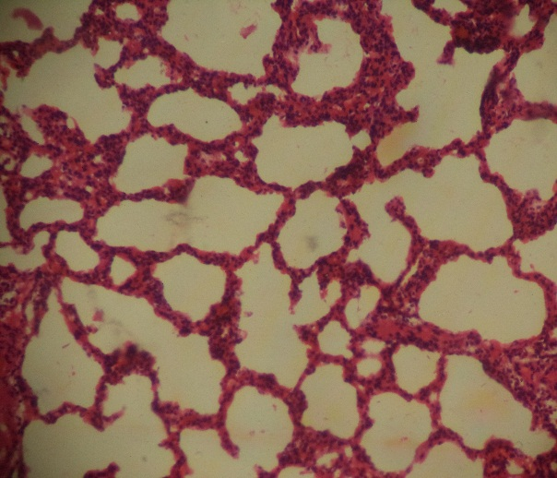
Group 4
Group 3

Plate 4: Lung of Wistar rat from the four groups on day 28. Group 1, and 4 show normal morphology with the presentation of normal alveolar epithelium with normal septa: The alveoli (black stars) and alveolar ducts (white lines) are clear and surrounded by intact pneumocytes (white arrows). Group 3 shows mild tissue oedema (white star) with significantly normal alveoli (black stars) and thickened Pneumocytes (white arrows). Group 2 lung shows diffuse complete alveolar collapse and massive congestion/ interstitial haemorrhage (black arrows) with prominent infiltration by inflammatory cells (white arrowheads) within the tissue. H&E X100

4. Conclusion
This research has shown that a combination of vitamin C and activated charcoal has ameliorative effect on paraquat-induced toxicity by presenting a synergistic effect of the oxidative properties of vitamin C and the adsorbent properties of activated charcoal. The research is novel in that there is no research that used this combination in an effort to ameliorate the toxicity of paraquat on long histopathology. Further work is recommended where graded concentrations of the combination would be used, and the duration of experiment extended. The work has also shown that duration of exposure to paraquat increases the toxicity on the lungs of Wistar rats.

Ethical approval

Ethical approval, with ethical number AEC/02/173/24 was obtained from the National veterinary research Institute Vom, Animal Ethics committee. There were unannounced visits by members of the Animal ethics committee, in the course of the experiment.

References
Adefola, E.T., John, A.A., Sunday, E.S., & Ugochukwu, U. (2024). Histological and Biochemical Effects of Lutein on Paraquat-induced Renal Toxicity in Wistar Rats. Asian Journal of Medicine and Health, 22(11), 56-67. https://doi.org/10.9734/ajmah/2024/v22i111117
Amin, F., Basirat, H., Parvaz, N., Khademalhosseini, M., Hakimizadeh, E., & Fatemi, I. (2025). Protective effects of myrtenol against paraquat-induced toxicity in rats. BMC Pulmonary Medicine. https://doi.org/10.1186/s12890-025-03484-5
Awadalla, E. A. (2012). Efficacy of vitamin C against liver and kidney damage induced by paraquat toxicity. Experimental and Toxicologic Pathology, 64(5), 431-434. https://doi.org/10.1016/j.etp.2010.10.009
Avwioro, O. G. (2011). Staining reactions of microwave processed tissues compared with conventional paraffin wax processed tissues. European Journal of Experimental Biology, 1(1), 57-62. https://www.primescholars.com/articles/staining-reactions-of-microwave-processed-tissues-compared-w-90613.html
Baradaran Rahimi, V., Rakhshandeh, H., Raucci, F., Buono, B., Shirazinia, R., Samzadeh Kermani, A., Maione, F., Mascolo, N., & Askari, V. R. (2019). Anti-inflammatory and anti-oxidant activity of Portulaca oleracea extract on LPS-induced rat lung injury. Molecules, 24(1), 139. https://doi.org/10.3390/molecules24010139
Chada, N., Romanos, J., Hilton, R., Suppes, G., Burress, J., & Pfeifer, P. (2012). Activated carbon monoliths for methane storage. Bulletin of the American Physical Society, 57(1), W33.012. https://meetings.aps.org/Meeting/MAR12/Bulletin
Cheng, J., Su, Y., Lin, F., Iqbal, M., Mehmood, K., Zhang, H., et al. (2021). Effect of paraquat on cytotoxicity involved in oxidative stress and inflammatory reaction: A review of mechanisms and ecological implications. Ecotoxicology and Environmental Safety, 224, 112711. https://doi.org/10.1016/j.ecoenv.2021.112711
Choji, T. P. P., Ngokere, A. A., Ogenyi, S. I., & Kumbish, P. R. (2015). Histo-architechtural Evaluation of Conventional Versus Two Rapid Microwave Processing Techniques. British Biotechnology Journal, 8(3), 1-19. https://doi.org/10.9734/BBJ/2015/18948
Cope, R. B., Bildfell, R. J., Valentine, B. A., White, K. S., Cooper, B. J., & Oncken, A. (2004). Fatal paraquat poisoning in seven Portland, Oregon, dogs. Veterinary and Human Toxicology, 46(5), 258-264. https://pubmed.ncbi.nlm.nih.gov/15487649/
Debnath, A., Ali, M. A., Newmai, K., Madhuri, P., Azyu, R. Z., & Malsawmsangi. (2024). Effective management of wistar rats in laboratory research: A Brief Review. International Journal of Advanced Biochemistry Research. https://doi.org/10.33545/26174693.2024.v8.i12Si.3182
Dinis-Oliveira, R. J., Duarte, J. A., Sánchez-Navarro, A., Remião, F., Bastos, M. L., & Carvalho, F. (2008). Paraquat Poisonings: Mechanisms of Lung Toxicity, Clinical Features, and Treatment. Critical Reviews in Toxicology, 38(1), 13–71. https://doi.org/10.1080/10408440701669959
Dinis-Oliveira, R. J., Duarte, J. A., Remião, F., Sánchez-Navarro, A., Bastos, M. L., & Carvalho, F. (2006). Single high dose dexamethasone treatment decreases the pathological score and increases the survival rate of paraquat-intoxicated rats. Toxicology, 227(1), 73-85. https://doi.org/10.1016/j.tox.2006.07.025
Edo, G. I. (2022). Effects of paraquat dichloride on adult male wistar rat. An approach in the toxicity of body weights and hematological tissues. Journal of Analytical & Pharmaceutical Research, 11(1), 1–7. https://doi.org/10.15406/japlr.2022.11.00394
Fenech, M., Amaya, I., Valpuesta, V., & Botella, M. A. (2019). Vitamin C Content in Fruits: Biosynthesis and Regulation. Frontiers in Plant Science. https://doi.org/10.3389/fpls.2018.02006
Gawarammana, I. B., & Buckley, N. A. (2011). Medical management of paraquat ingestion. British Journal of Clinical Pharmacology, 72(5), 745-755. https://doi.org/10.1111/j.1365-2125.2011.04026.x
Guo, H., Li, L., & Gao, L. (2023). Paraquat and Diquat: Recent Updates on Their Pretreatment and Analysis Methods since 2010 in Biological Samples. Molecules. https://doi.org/10.3390/molecules28020684
Gupta, P.K. (2018). Toxicity of Herbicides. In R. C. Gupta (Ed.), *Veterinary Toxicology, Basic and Clinical Principles* (3rd ed., pp. 553–567). Elsevier. https://doi.org/10.1016/C2016-0-01687-X
Haripriya, B., Lakshman, M., & Sudha, V. (2017). Influence of Paraquat (PQ) Induced Acute Toxicity On Body Weights And Haemotobiochemical Parameters In Experimental Rats. International Journal of Scientific Research, 6(7), 396–398. https://doi.org/10.36106/ijsr.
Hernandez-Baixauli, J., Chomiciute, G., Tracey, H., Mora, I., Cortés-Espinar, A. J., Ávila-Román, J., Abasolo, N., Palacios-Jordan, H., Foguet-Romero, E., Suñol, D., Galofré, M., Alcaide-Hidalgo, J. M., Baselga-Escudero, L., Del Bas, J. M., & Mulero, M. (2024). Exploring Metabolic and Gut Microbiome Responses to Paraquat Administration in Male Wistar Rats: Implications for Oxidative Stress. Antioxidants, 13(1), 67. https://doi.org/10.3390/antiox13010067
Hossain, M. M. (2015). Recent perspective of herbicide: Review of demand and adoption in world agriculture. Journal of the Bangladesh Agricultural University, 13(1), 19–30. https://doi.org/10.3329/jbau.v13i1.28707
Huang, Y., Zhan, H., Bhatt, P., & Chen, S. (2019). Paraquat Degradation From Contaminated Environments: Current Achievements and Perspectives. Frontiers in Microbiology, 10, 1754. https://doi.org/10.3389/fmicb.2019.01754
Ijaz, M.U., Qamer, M., Hamza, A. Ahmed, H., Sfsar, T., Abulmeaty, M., Ayub, A., & Razak, S. (2023). Sciadopitysin mitigates spermatological and testicular damage instigated by paraquat administration in male albino rats. Sci Rep 13, 19753.
Jain, R., Bhalla, A. S., Naranje, P., Vyas, S., Rewari, V., Banday, I. A., & Jana, M. (2022). Ingestion poisoning related lung injury- a pictorial review. Emergency Radiology, 29(4), 757-767. https://doi.org/10.1007/s10140-022-02044-2
Khruengsai, S., Pripdeevech, P., Pongnailert, S., Chanlek, N., Thumanu, K., Muangmora, R., Rojviroon, T., & Pongpiachan, S. (2024). Chemical characterization of activated carbon derived from Napier grass, rubber wood, bamboo, and hemp. International Journal of Renewable Energy Development, 13(6), 1115-1124. https://doi.org/10.61435/ijred.2024.60502
Khodayar, M. J., Kiani, M., Hemmati, A. A., Rezaie, A., Zerafatfard, M. R., & Nooshabadi, M. R. R. (2014). The preventive effect of atorvastatin on paraquat-induced pulmonary fibrosis in the rats. Advanced Pharmaceutical Bulletin, 4(4), 345-349. https://doi.org/10.5681/apb.2014.050
Koo, J. R., Kim, J. C., Yoon, J. W., Kim, G. H., Jeon, R. W., Kim, H. J., Chae, D. W., & Noh, J. W. (2002). Failure of continuous venovenous hemofiltration to prevent death in paraquat poisoning. American Journal of Kidney Diseases, 39(1), 55–59. https://doi.org/10.1053/ajkd.2002.29880
Lee, K. H., Gil, H. W., Kim, Y. T., Yang, J. O., Lee, E. Y., & Hong, S. Y. (2009). Marked recovery from paraquat-induced lung injury during long-term follow-up. The Korean Journal of Internal Medicine, 24(2), 95–100 https://doi.org/10.3904/kjim.2009.24.2.95
Lewis, S. M., Ullrey, D. E., Barnard, D. E., & Knapka, J. J. (2006). Nutrition. In M. A. Suckow, S. H. Weisbroth, & C. L. Franklin (Eds.), The laboratory rat (pp. 219-301). Elsevier Academic Press. https://doi.org/10.1016/B978-012074903-4/50012-1
Liu, Z., Wang, X., Wang, Y., & Zhao, M. (2017). NLRP3 inflammasome activation regulated by NF-κB and DAPK contributed to paraquat-induced acute kidney injury. Immunologic Research, 65, 687–698. https://doi.org/10.1007/s12026-017-8901-7
Mehta, P., Annam, R.S., & Hadiyel, I. (2025). Catastrophic Outcomes: Rapid Multi-Organ Failure from Paraquat Poisoning- A Case Report. Nigerian Medical Journal, 66(2), 811–817. https://doi.org/10.71480/nmj.v66i2.730
Min, J., Jiaqi, H., Lihua, L., Qianqian, C., Shujuan, W., Xiang, L., Liang, L., Liang, R., Yiwu, Z., & Qian, L. (2024). Proteomics of severe SARS-COV-2 infection and paraquat poisoning in human lung tissue samples: comparison of microbial infected and toxic pulmonary fibrosis. Frontiers in Cellular and Infection Microbiology, 14, 1446305. https://doi.org/10.3389/fcimb.2024.1446305
Mondal, H., Mondal, S., Saha, K., & Roul, B. (2019). Development of a Low-cost Smartphone-connected Digital Microscope. Journal of Microscopy and Ultrastructure, 8(2), 51–54. https://doi.org/10.4103/JMAU.JMAU_35_19
Narayanan, S., Kumar, S. S., Manguvo, A., & Friedman, E. (2021). Current Estimates of Serum Vitamin C and Vitamin C Deficiency in the United States. Current Developments in Nutrition. https://doi.org/10.1093/cdn/nzab053_060
National Population Commission (2006). 2006 Population and Housing Census, Priority Table IV. National Population Commission, Nigeria. http://www.population.gov.ng
Nuwongsa, I., Markmee, T., Pholpo, N., Chockjamsai, M., Monum, T., Amornlertwatana, Y., & Tajai, P. (2024). Paraquat Poisoning: Insights from Autopsy, Histology, and Liquid Chromatography with Tandem Mass Spectrometry in Multidisciplinary Forensic Toxicology Practice. Toxics, 12(9), 675. https://doi.org/10.3390/toxics12090675
Nwafor, J., Umudu, J., Oviosun, A., & Uchewa, O. (2020). Effect of virgin coconut oil on the kidney of wistar rats exposed to toxic dose of paraquat. International Journal of Medical Reviews and Case Reports, 4(5), 136-140. https://doi.org/10.5455/IJMRCR.virgin-coconut-oil-the-kidney-wistar-rats
Okolonkwo, B. N., Brisibe, N., & George-Opuda, I. M. (2023). Ameliorative Effect of Vitamin E and C on Paraquat Induced Nephrotoxicity in Rat. Healthcare Studies, 1(1), 1–6. https://doi.org/10.58612/hs111
Okolonkwo, B. N. (2022). The effect of combined vitamin treatment on paraquat-inflicted liver damage. Asian Journal of Biochemistry, Genetics and Molecular Biology, 12(4), 132-138. https://doi.org/10.9734/ajbgmb/2022/v12i4278
Ostadi, A., & Paeezi, M. (2018). Hemoperfusion Efficiency in Paraquat Toxicity. International Journal of Medical Toxicology and Forensic Medicine, 8(4), 151-156. https://doi.org/10.22037/ijmtfm.v8i4(Autumn).23089
Pedroso, A. L., Canal, R., Gehrke, S. A., da Costa, E. M., Scarano, A., Zanelatto, F. B., & Pelegrine, A. A. (2025). The Validation of an Experimental Model in Wistar Female Rats to Study Osteopenia and Osteoporosis. Bioengineering, 12(7), 702. https://doi.org/10.3390/bioengineering12070702
Reed, D. R., Duke, F. F., Ellis, H. K., Rosazza, M. R., Lawler, M. P., Alarcon, L. K., & Tordoff, M. G. (2011). Body fat distribution and organ weights of 14 common strains and a 22-strain consomic panel of rats. Physiology & Behavior, 103(5), 523–529. https://doi.org/10.1016/j.physbeh.2011.04.006
Reddy, K. B. A. K., Jeevanalatha, M., Lakshman, M., & Rani, M. U. (2019). The toxic effects of Paraquat on body weights and haematological parameters in male albino wistar rats and its amelioration with vitamin C. International Journal of Current Microbiology and Applied Sciences, 8(11), 314–320. https://doi.org/10.20546/ijcmas.2019.811.039
Roberts, T. R., Dyson, J. S., & Lane, M. C. G. (2002). Deactivation of the biological activity of paraquat in the soil environment: A review of long-term environmental fate. Journal of Agricultural and Food Chemistry, 50(13), 3623-3631. https://doi.org/10.1021/jf011323x
Turner, P. V., Pekow, C., Vasbinder, M. A., & Brabb, T. (2011). Administration of substances to laboratory animals: Equipment considerations, vehicle selection, and solute preparation. Journal of the American Association for Laboratory Animal Science, 50(5), 614–627. https://www.ncbi.nlm.nih.gov/pmc/articles/PMC3189663/
Wesseling, C., Corriols, M., & Bravo, V. (2005). Acute pesticide poisoning and pesticide registration in Central America. Toxicology and Applied Pharmacology, 207(2 Suppl), 697–705. https://doi.org/10.1016/j.taap.2005.03.033
Xiao, Q., Wang, W., Qi, H., Gao, X., Zhu, B., Li, J., & Wang, P. (2020). Continuous hemoperfusion relieves pulmonary fibrosis in patients with acute mild and moderate paraquat poisoning. Journal of Toxicological Sciences, 45(10), 611–617. https://doi.org/10.2131/jts.45.611
Zhou, Q., Kan, B., Jian, X., Zhang, W., Liu, H., & Zhang, Z. (2013). Paraquat poisoning by skin absorption: Two case reports and a literature review. Experimental and Therapeutic Medicine, 6, 1504–1506. https://doi.org/10.3892/etm.2013.1320

