Review Article
Resilient Techniques for Heat Stress Tolerance in Seed Production of Field Crops

Abstract
Heat stress is one of the most important stresses that need to be addressed for better crop performance and to boost crop yield. A rise in temperature due to global warming affected plant growth and development and also reduces the quality and yield. Most of the field crops are sensitive to heat stress at the reproductive stage, which results in shortening the duration of seed filling and maturity, reducing the pollen fertility and stigma receptivity; thereby reducing the seed setting and seed yield. So, there is a need to mitigate the impact of heat stress in seed production for gaining better quality seeds. Even though plants have some morphological, physiological and biochemical adaptations to tolerate heat stress, additional practices are required for improving the quality and yield of seed crops (Hassan et al., 2021). Breeding and biotechnological approaches can be used to identify the genes that are tolerant to high temperatures and to develop new varieties with heat stress tolerance. To mitigate the adverse effect of climate change and also to further boost the quality of hybrid seed availability in the country, alternative areas for hybrid seed production among major crops have been identified under AICRP-National Seed Project (crops), and this will help to maintain the adequate production and supply of quality seeds. Changing planting dates, nutrient management and irrigation management also can be practiced for improving crop growth under heat stress conditions. Seed priming with various chemical agents improves crop performances under abiotic stresses including high-temperature stress, low-temperature stress, drought stress, etc. Singh et al., 2018; Ganesh et al., 2017). Seed inoculation with bacteria like plant growth-promoting rhizobacteria Bacillus spp. and Azospirillum spp. Abd El-Daim, et al., 2014 improve the tolerance against heat stress by reducing the production of reactive oxygen species. Osmo-protectants have been recently identified as important molecules that have beneficial effects on plants subjected to heat stress, as osmoprotectant spray substantially improves plant growth and the activity of anti-oxidants under heat stress conditions. All these will surely help to mitigate the negative effects of heat stress, and thus, contribute to improved plant productivity and food security under the current scenarios of climate change and global warming.
Keywords: Heat stress, reproductive stage, climate change, global warming,seed quality
Introduction
Abiotic and biotic stress management for sustainable yield is a wild wide area of research. Abiotic stress, such as drought, heat, floods, etc., causes a substantial amount of loss in agricultural products, particularly in nations like India that rely heavily on agriculture. Despite the fact that heat is the second biggest cause of production loss after drought, the quality of the products also declined.
The foundation of global food security is seed commerce, and seed security depends on food security. The development of multinational seed firms, the increased accessibility of F1 hybrids, the protection of intellectual property, and the rising usage of counter-season production have all contributed to the expansion of the global seed market over the past three decades. Due to genetic gains acquired through plant breeding, better agronomic inputs, and unique management techniques, the seed yield for the world's primary crops has increased by 1-3% every year for the past 50 years (Hampton et al., 2016).
Can this seed production continue to increase in light of the current climatic change? This climatic change will undoubtedly have an impact on agricultural activities. Since seeds are the foundational element of agriculture, the seed industry must be able to consistently produce and transport adequate amounts of high-quality seeds. However, the manufacturing of high-quality seeds will have greater opportunities to overcome climate change conditions. Stress is used to describe environmental factors that have a negative impact on a plant's ability to grow, develop, or produce. The two main types of stress that plants experience are biotic stress and abiotic stress.

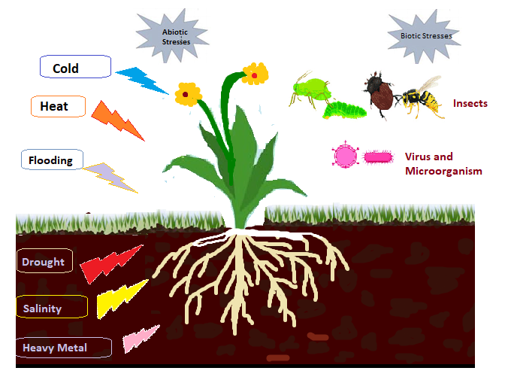
Fig 1: Classification of different plant stresses
Biotic stress is brought on by pests, nematodes, and disease infections. Abiotic stress, on the other hand, can be caused by low light intensity, high light intensity, low temperature, high temperature, low water (drought), high water (flooding), chemicals like salt, pesticides, mineral toxicity, etc.
As the world's temperature rises year after year, high-temperature stress needs to be addressed. Carbon dioxide and methane concentrations in the atmosphere have increased by 30% and 150%, respectively, over the previous 250 years (Friedlingstein et al. 2010). They raise the temperature since they are greenhouse gases. The plant will experience heat stress as a result of the temperature rise, which will reduce crop production. Heat stress is defined as an increase in temperature that persists for a length of time long enough to permanently harm normal plant growth and development. Most crops are susceptible to heat stress.
The germination of seeds is the beginning of plant life. Low germination percentage, shorter roots, and poor stand establishment brought on by heat stress led to low plant population and hence low output. By interfering with the function of enzymes necessary for the digestion of starch and activating the synthesis of ABA, heat stress inhibits germination. Additionally, it will reduce protein synthesis in seed embryos, which significantly reduced maize seed germination above 37 degrees Celsius (Rilkey, 1981).
Crops | Stages sensitive to Heat stress
Rice | Flowering
Wheat | Floret formation and anthesis
Maize | Tasseling and seed set
Sorghum | Panicle initiation and anthesis
Kidney bean | 6–15 days before anthesis and anthesis
Common bean | 6–8 days before anthesis and anthesis
Cowpea | 6–12 days before anthesis
Chickpea | 10 days before flowering, anthesis and pod development
Soybean | Flowering and pod set
Groundnut | 3 days before anthesis and 15 days after anthesis

Table 1: Sensitive stages of different crops for heat stress
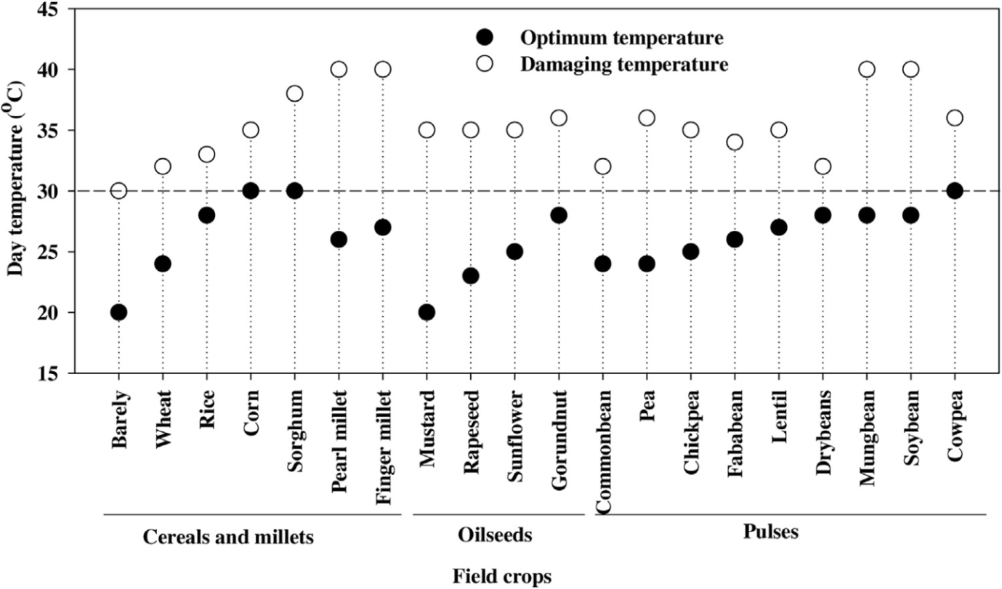
Fig 2: Optimum and damaging temperature at the reproductive stage of various field crops
Discussion:
Effect of heat stress on plant growth and development
By lowering plant height, tillering, and dry matter production, heat stress slows down plant growth. Additionally, it causes morphological signs such as leaf scorching, fruit discolourations, ageing of the leaves, rolling of the leaves, damage to the tips of the leaves, drying of the leaves, and necrosis (Omae et al. 2012). Later heat stress promotes pollen sterility and reduces the number, size, and weight of wheat kernels (Farooq et al., 2011). An increase in temperature (1-2ºC) above the optimum range shortened the grain filling phase in cereals, which reduced ultimate production. Heat stress also impacted plant phenology, shortening the plant.
In plants, photosynthesis is a crucial process that produces a variety of bioproducts, including lipids, proteins, carbohydrates, and proteins. Heat stress results in significant changes in chloroplasts, including thylakoid disarray, grana swelling, and photosystem II reduction, which reduces the number of pigments involved in photosynthetic activity. Low yield is the result of insufficient photosynthesis. Heat stress increases ROS generation, lowers ATP synthesis and increases respiratory carbon loss. Under heat stress, wheat flag leaf respiration considerably increased, which significantly reduced photosynthesis and grain output (Almeselmani et al. 2012). High-temperature stress also inhibits the uptake of nutrients and water, which significantly slows plant growth. High temperatures also change the source-sink relationships in plants, the number of hormones produced in roots, and the concentration of nutrients in plants. Similar to other abiotic stresses, heat stress causes an accumulation of undesirable and dangerous ROS species, such as hydrogen peroxide, hydroxyl radicals, and superoxide, which are in charge of causing oxidative stress in plants. Plants, that are exposed to ROS can develop a variety of physiological problems. Proteins, lipids, DNA, and even all components of the cell undergo reactions with hydroxyl radicals during the photosynthetic process (Moller et al. 2007). Proteins, unsaturated fats, and plant DNA are all oxidized by superoxide (Karuppanapandian et al. 2011). Additionally, ROS denatures plant proteins, lowers membrane permeability, and increases lipid peroxidation.
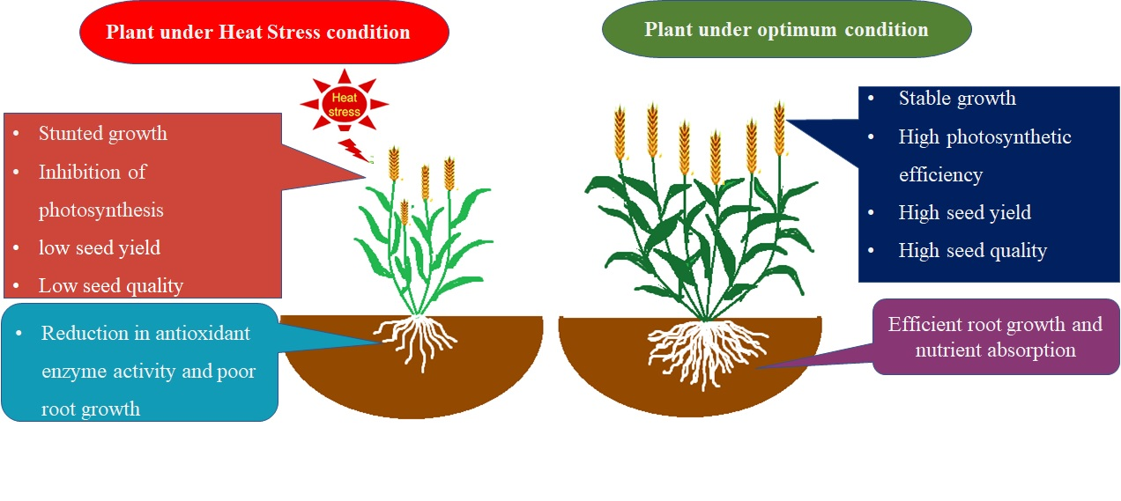
Fig.3. Plant responses to optimum and heat stress condition
Even under mild heat stress, there has been a considerable decrease in photosynthetic light responses, which has been attributed to an increase in electron leakage from thylakoid membranes as a result of ROS buildup. Additionally, heat stress raises leaf temperature, which decreases the activities of enzyme antioxidants and significantly raises the levels of malondialdehyde (MDA) in plant leaves (Hurkman et al., 2009). Heat stress affects every plant tissue and stage of growth. Although reproduction is particularly sensitive to heat stress, even little increases in temperature during flowering can have a major impact on the eventual crop's output. When the reproductive stage first begins, a brief period of heat stress might diminish the floral buds and result in flower abortion.
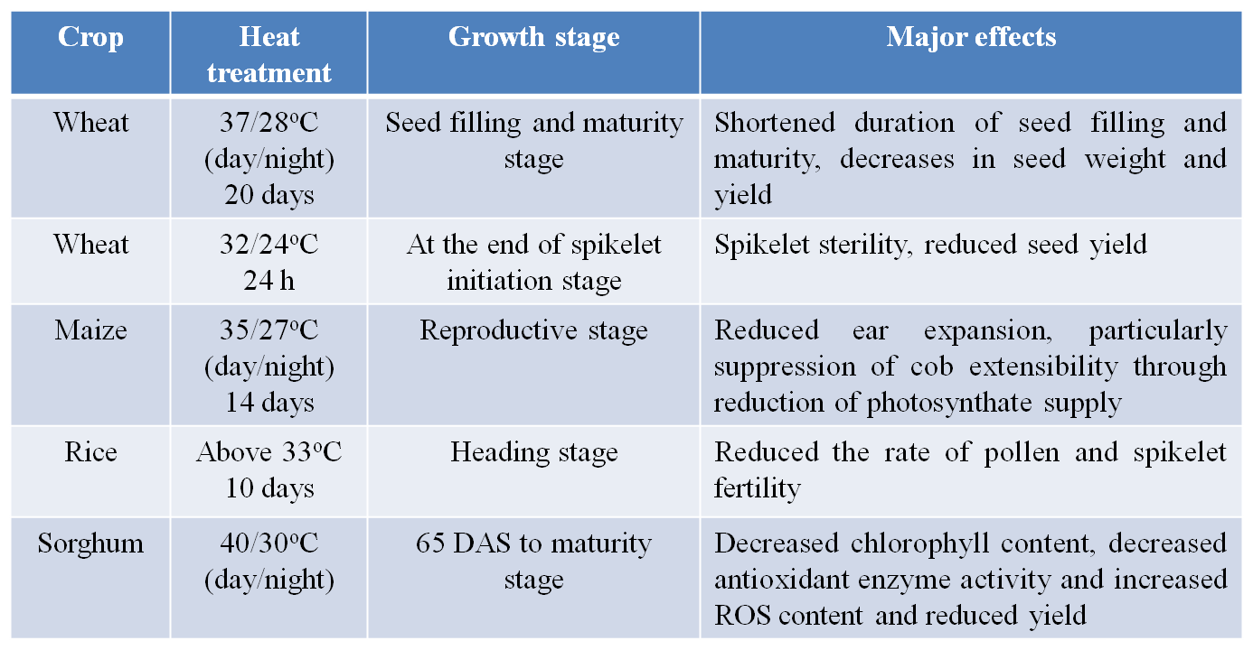Table 2: Effects of high-temperature stress in cereals
Early reproductive heat stress prevents the formation of flowers, which prevents the setting of seeds or fruit. Additionally, the endosperm and pro-embryo development, as well as the number of pollen grains retained by the stigma, are all reduced by the greater temperature during the reproductive stage. Increased sterility and a resulting decrease in final yield are caused by all of these factors working together. When wheat was subjected to heat stress at the plant heading, it experienced reduced anther dehiscence and pollen fertility which resulted in a considerable drop in seed production (Ahamed et al. 2010). In fact, higher temperatures (over 35ºC) made pollen more sterile, which decreased its germination and, as a result, the yield of seeds in maize (Suwa et al. 2010).
A considerable rise in ethylene synthesis is another effect of high temperature that renders pollen male-sterile. Ethylene production weakens the sink strength, which restricts grain filling and ultimately leads to grain sterility. This is done by inhibiting the enzymes involved in sugar-starch metabolism. The production of seeds and fruits is decreased by heat stress because it causes flower and fruit abortion and abscission. There have been reports of yield reductions of 31% in wheat, 45% in maize, 50% in rice, 46% in soybeans, 31% in peanuts, 44% in sorghum, and 10% in sunflower as a result of high temperature stress (Nadeem et al., 2018). Heat stress impacts plant growth and development and lowers the yield and quality of the finished grain.
Effect of Heat stress on seed development and seed quality
In accordance with the species and other environmental factors, heat stress can also cause either early or delayed flowering. Accelerated flowering may cause reproductive development before the plant has acquired enough biomass resources to supply growing seeds (Zinn et al. 2010). Asynchronous male and female reproductive development brought on by heat stress can also pose a challenge for the formation of hybrid seeds, which depend on the male parent line's pollen being available when the female parent line's stigmas are open to receiving it.
Heat stress can shorten the period of time that floral organs are open to pollen and pollen tubes, as well as lower the quantity, size, and shape of those organs. It can also speed up the development of the stigma and ovule (Hedhly et al. 2009). Heat can have a deleterious impact on the amount and morphology of pollen, anther dehiscence and pollen wall construction, pollen chemical composition and metabolism, pollen viability, germination, and pollen tube growth. Because heat stress has a negative impact on pollen viability, pollen germination, and pollen tube growth rate, which reduces seed set, it will have a greater impact on seed production (Prasad et al. 2002).
The ability of the plant to supply the nutrients required to synthesize the storage compounds required for germination can be inhibited by high temperature stress before seeds reach physiological maturity, which can reduce germination. Additionally, the seeds may experience physiological damage to the point where they lose their ability to germinate. Increased temperature may result in decreased seed mass due to rapid seed growth and shorter seed filling times, although decreased seed mass does not always mean decreased germination or vigour. Short-term exposure to high temperatures at critical stages of seed development might diminish seed vigour by inducing or speeding up the physiological deterioration of seeds (Hampton et al. 2013).
The possible loss of genetic quality in open-pollinated, and F1 hybrid cultivars is a crucial effect of climate change on seed production. Elevated temperatures can cause changes in a plant's sexuality, such as the breakdown of male sterility or self-incompatibility processes. These breeding techniques are used in seed production to ensure the production of F1 hybrid seeds or to encourage outcrossing in order to maintain a high level of heterozygosity in many open-pollinated crops.
Self-pollination is the result of these genetic mechanisms breaking down. As a result, the cultivar's genetic integrity is lost, and any seed produced will no longer be true to type. Many forage plants, including clovers and perennial ryegrass, rely on self-incompatibility to maintain outcrossing and heterozygosity within open pollinated open-pollinated populations. Inbreeding could occur quickly in a few generations of seed production if self-incompatibility breaks down. As a result, there would be a considerable decline in the frequency of heterozygosity at many loci, which would lead to inbreeding depression and much lower crop productivity. A significant source of pollen contamination for the formation of hybrid seeds is the breakdown of self-incompatibility or male sterility caused by heat stress. The use of a single dominant herbicide resistance gene in the homozygous form in the desired pollen parent is one potential remedy. Any true hybrid seed that is collected from the female parent is thus heterozygous for herbicide resistance, and any harvested seed resulting from the self-pollination of the female parent can be destroyed by sensitivity to the herbicide (Hampton et al. 2016).
Plant mechanism to tolerate Heat stress
The ability of a plant to develop and grow to generate an acceptable yield under heat stress is known as thermo-tolerance. Under heat stress, plants can modify their morphology and phenology over a lengthy period of time, but they can also use short-term acclimation or avoidance strategies such as transpirational cooling, shifting the direction of their leaves, or altering the lipid contents of their membranes. Following are some of the adaption strategies plants use to withstand heat stress:
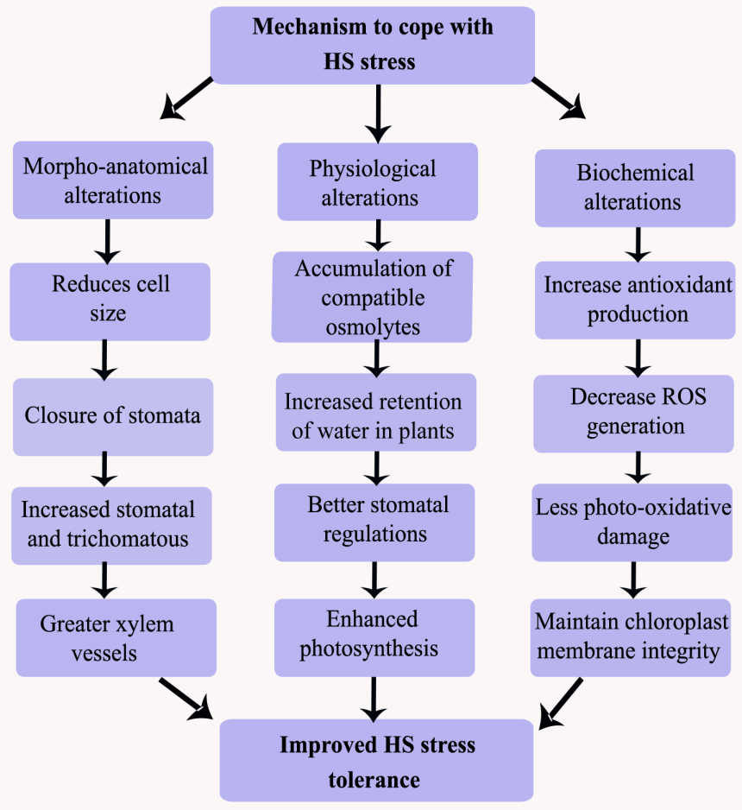
Fig 4: Physiological, biochemical, and morphological adaptations of plants to deal with HS
Resilient Techniques for heat stress tolerance
Even though plants have some morphological, physiological and biochemical adaptations to tolerate heat stress, additional practices are required for improving the quality and yield of seed crops. The following mitigation strategies can be practiced for reducing the effect of heat stress and increasing plant performance under heat stress (Hassan et al. 2021).

- Breeding strategies
- Molecular and biotechnological approaches
- Moving sites for seed production
- Sowing date
- Seed priming
- Bacterial seed treatment
- Spray of osmoprotectants
- Nutrient management
- Water management
Breeding strategies
The genetic heterogeneity in wild and farmed plant species needs to be sorted out in order to improve crop performance under stressful circumstances. The polygenic regulation and extreme sensitivity to environmental factors of the genetic features linked to abiotic stress tolerance make them extraordinarily complex. To increase heat stress tolerance in plants, it is also necessary to investigate heat stress resistant genes and quantitative trait loci (QTLs) in wild landraces and non-adapted genotypes.
The genetic heterogeneity in wild and farmed plant species needs to be sorted out in order to improve crop performance under stressful circumstances. The polygenic regulation and extreme sensitivity to environmental factors of the genetic features linked to abiotic stress tolerance make them extraordinarily complex. To increase heat stress tolerance in plants, it is also necessary to investigate heat stress resistant genes and quantitative trait loci (QTLs) in wild landraces and non-adapted genotypes.
These genotypes can be crossed with superior cultivar cultivars that currently exist to give the superior cultivar the ability to withstand heat stress. This can be accomplished through a variety of breeding techniques, which leads to the creation of new heat-tolerant varieties. For good production, these types can be grown under heat stress.
Table 3: Heat tolerant varieties of some field crops
Crops | Heat tolerant varieties
Wheat | HD 2932, HD 2864, HD 3095, HI 8703, HUW 234
Maize | DTPYC9F119
Chick pea | Pusa 1103, Pusa 1003, KWR 108, BGM 408, BG, 240, PG 95333, JG 14, ICCV 07110, ICCV 92944, ICC 1205
Lentil | IG 2507, IG 3263, IG 3745, IG 4258, FLIP 2009
Mung bean | EC 693357, EC 693358, EC 693369, Harsha, ML 1299
Indian mustard | BPR-538-10, NRCDR-2, RH-0216
Molecular and biotechnological approaches
Identification of heat stress-related QTLs requires expertise in both molecular biology and molecular markers, respectively. Variations in the activities of transcription and translation can influence a plant's tolerance to heat stress. The requisite translational actions during the stressful period require transcription to be supported. Typically, such activities in plants alter swiftly during seed germination, and similarly, amid heat and drought stress (Gallie et al. 1998).
Genetic engineering and marker-assisted selection are the two main biotechnological methods used to increase plants' ability to withstand heat stress (MAS). Both methods have significantly contributed to our understanding of the genetic and metabolic underpinnings of plant heat stress tolerance, which forms the basis for the creation of heat stress tolerant genotypes. Given the complexity of heat stress and the challenges associated with phenotypic selection for heat stress tolerance, MAS is a vital strategy for enhancing plant tolerance to heat stress. Use This method has been used to significantly identify and define a number of QTLs with great effects on heat stress at various plant growth stages (Foolad 2005).
In order to breed genotypes with a higher tolerance to heat stress, more contemporary techniques, including gene expression and genetic transformation, have promoted a better understanding of plant heat stress tolerance's biochemical and genetic roots. With the aid of transgenic technology, changes in gene expression and the synthesis of targeted genes, proteins, and enzymes have increased the tolerance of several plant species to heat stress. In conclusion, biotechnology methods have promise for creating cultivars that can withstand heat stress. However, further study in this area is needed to comprehend the physiological, molecular, and genetic underpinnings and create cultivars with enhanced heat stress resistance. Omics are the newly developed techniques providing an opportunity to identify translational, transcriptional and post-translational mechanisms and the signaling pathways that appreciably regulate plants’ responses to heat stress. Omics also help in systematically examining and determining the correlations between the variations in the genomes, micromes, and proteomes of different plants in response to high temperatures.
Moving sites for seed production
A crop variety must be adapted to the local photoperiod and temperature circumstances if it is to be produced there for seed production. Large amounts of sunshine, relatively light rain, and the lack of strong winds are all favourable conditions for the creation of fruitful, high-quality seeds. Heat stress, however, will degrade seed quality and produce unfavourable conditions for seed formation. Alternative places for hybrid seed production among important crops have been found under the AICRP-National Seed Project in order to reduce the negative effects of climate change and to further improve the quality of hybrid seed availability in the nation (crops)
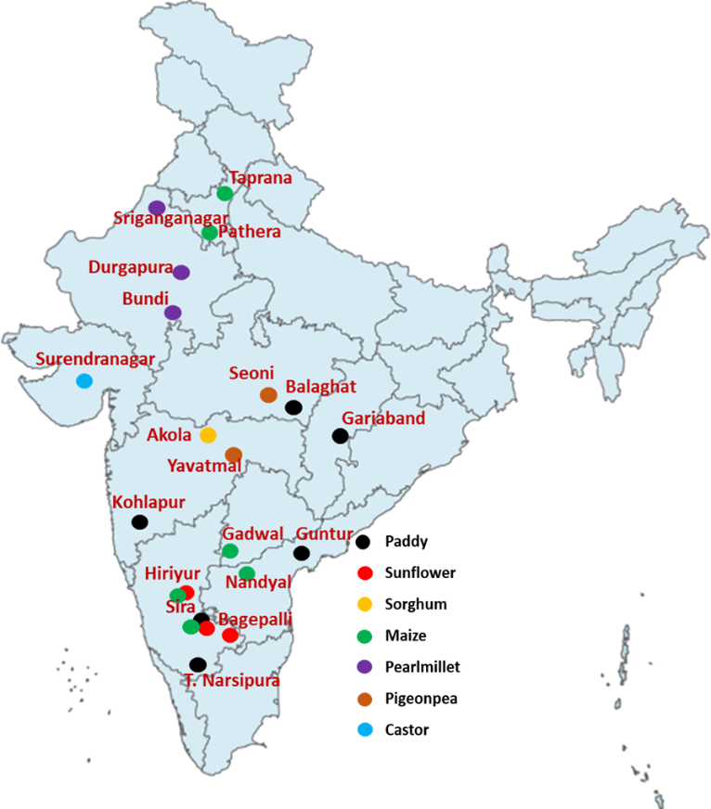
Fig. 5. Map showing alternative areas for hybrid seed production of major crops in India
Crops | Alternative seed production site
Paddy | Kolhapur (Maharashtra); Balaghat (Madhya Pradesh); Sira (Tumkur), T. Narsipura (Mysore) in Karnataka; Dhamtari, Mahasamund & Gariaband in Chhatisgarh; Chilakalurpet (Guntur) in Andhra Pradesh
Sorghum | Akola region (Maharashtra)
Sunflower | Bagepalli, Gudibande, Gowribidanur in Chikkaballapura district; Challakere, Hiriyur in Chitradurga district & Sira in Tumkur District of Karnataka
Maize | Nandyal (Kurnool) in Andhra Pradesh; Gadwal (Mehaboobnagar) in Telangana; Pathera & Taprana in Haryana; Hiriyur in Chitradurga district & Sira in Tumkur District of Karnataka
Pearlmillet | Sriganganagar, Bundi, Durgapura & Bharathpur in Rajasthan
Pigeon pea | Seoni in Madhya Pradesh and Yeotmal in Maharashtra
Castor | Surendranagar in Gujarat
Table 4: Alternative seed production areas to mitigate heat stress effects
Sowing date
To achieve the best yields under various heat stress circumstances, sowing timing is a non-financial management strategy. Anthesis and grain filling are later growth stages that are avoided by choosing an appropriate planting or sowing period, which increases crop production under heat stress. The choice of appropriate sowing timings is a crucial strategy to acquire the highest yield under such challenging circumstances because crop growth and development vary with the planting time. Increase Different effects on seed quality and vigour result from an increase in temperature during late stages. For instance, seeds from late-sown soybeans had lower protein and oil concentrations and less vigour than seeds from the crop sown at the ideal time.
Reverse effects on agricultural yield components caused by delayed seeding lower crop yield. In fact, postponing the sowing of wheat results in the generation of less productive tillers and kernels with lower grain weights per thousand grains (Radmehr et al. 2005). When plants are sown at the right moment, they can take advantage of ideal weather conditions for the highest possible yield. The growth and productivity of a crop can be severely hampered by either early or late seeding. Because of this, crops should be planted at the right time to avoid high temperatures during later growth stages in order to attain their greatest yield potential. This approach would considerably increase crop yield in the event of rising temperatures.
Seed priming
Globally, seed priming is a promising and cost-effective strategy being employed to enhance crop stand establishment. Seed priming significantly enhances crop stand, emergence, germination, and growth. Crop performance under abiotic conditions, such as heat stress, drought, and low temperate stress, is improved by seed priming with a variety of substances, including water, salicylic acid, KNO₃, CaCl₂, and KCl (Farooq et al. 2008).
In the same way, seed priming improved maize, rice, and chickpea production in semi-arid settings by promoting greater growth, earlier flowering, and optimum germination (Harris et al. 2001). It has been demonstrated that seed priming of normal and low-vigor seeds increases root length and root and shoot growth. Wahid and Shabbir (2005) discovered that barley seeds primed with glycine-betaine (GB) under heat stress exhibited decreased membrane damage and greater photosynthetic rate, osmotic adjustment, root and shoot dry biomass as compared to unprimed seeds
Seed priming with various chemicals protects the photosynthetic system from heat stress-related damages by enhancing the antioxidant system's activity. For instance, seed priming with Calpurnia aurea leaf extract reduced the number of free radicals present when the seeds were exposed to heat stress while also boosting the number of pigments that are involved in photosynthesis (Adedapo et al. 2008). As a result of seed priming, plants are able to preserve their water potential even in high-temperature environments by maintaining higher levels of cell membrane integrity.
Furthermore, seed priming significantly raises sugar concentration while under heat stress. By maintaining the water balance and osmotic adjustment as well as by defending the cellular structures, the increased buildup of sugars reduces the harmful effects of heat stress (Wahid, 2007). As phenolics can act as hydrogen donors by detoxifying ROS in the stability of membranes, seed priming also encourages their biosynthesis.
Bacterial seed treatment
Increased heat stress tolerance in crops may be determined through the application of biological agents like bacteria and fungi. Under heat stress conditions, growth is benefited by plant growth-promoting rhizobacteria (PGPR). The wheat crop's ability to withstand heat stress was greatly improved by rhizobacteria seed inoculation (Yang et al. 2009). According to Abd-El-Daim et al. (2014), seed treatments with Bacillus species and Azospirillum species increase the ability of plants to withstand heat stress by lowering the formation of reactive oxygen species (ROS).
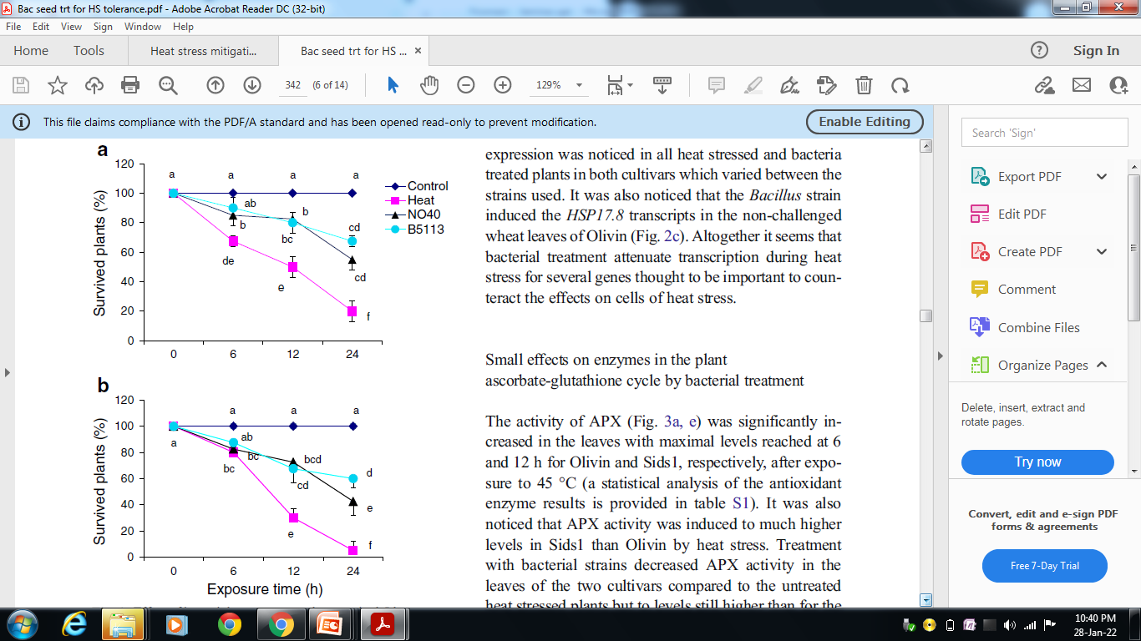
Fig. 6. Effect of bacterial treatment on plant survival.

Plants were pretreated with Bacillus amyloliquefaciens 5113 (B5513) or Azospirillum brasilense NO₄₀ (NO₄₀) or untreated (Heat) and plant survival (%) of heat stressed wheat seedlings were recorded at different time points (0, 6, 12 and 24 h) and compared to untreated and unchallenged plants (Control)
Spray of osmo-protectants
Osmo-protectants, which significantly boost plant growth and antioxidant activity in heat-stressed circumstances, have lately been recognized as significant chemicals that benefit plants. Rasheed et al. (2011) discovered in a study on sugarcane that exogenously applied glycine-betaine (20 mM) and proline (20 mM) improved a variety of physiological processes and morphological aspects in heat stressed plants.
As a result of the application of GB and proline, the concentration of K⁺, Ca ²⁺, proline, and sugar increased. This improved membrane stability and anti-oxidant system activity helped to mitigate the harmful effects of heat stress. Another study by Kaushal et al. (2011) found that the protection provided by exogenously administered proline extends to a number of enzymes involved in carbon metabolism and antioxidant systems, which form the basis of chickpea heat stress tolerance. Additionally, they discovered that exogenous proline results in lessened heat stress-induced membrane damage, enhanced water potential, and increased chlorophyll content.
The effect of ABA on the growth of chickpea seedlings under heat stress was investigated by Kumar et al. in 2012. They discovered that by raising the level of endogenous ABA, exogenously administered ABA enhances plant development. Similar to how they evaluated the impact of different 24-epibrassinolide (24-EBL) concentrations on mustard behaviour under heat stress, these authors found that exogenously given 24-EBL increased mustard's tolerance to heat stress by enhancing the anti-oxidant system's activity.
Nitric oxide (NO) is an important compound involved in various plant physiological processes, and improves crop performance against heat stress. The exogenously applied NO significantly alleviated the heat stress by decreasing ion leakage, and improving the activities of different anti-oxidant enzymes (Song et al. 2006). Selenium is not considered an essential element for plants. However, it has proved his role as relevant osmo-protectant under various stress conditions including heat stress.
Nutrient management
Mineral nutrients play a significant role in final production. However, poor soil fertility and an inadequate and erratic delivery of essential nutrients reduce crop yield worldwide. Over 60% of soils are said to be nutrient-deficient worldwide. Therefore, good yields require appropriate nutrition availability. Optimum by supporting a number of physiological processes, optimal nutrient availability upholds plant integrity. N and Mg are essential nutrients for the process of photosynthesis, while P and K are needed to regulate stomata and activate enzymes. P is a crucial component of nucleic acids and is needed to produce energy.
N is crucial for the metabolism of carbon and the use of light energy that has been absorbed. N-deficient plants, however, have a surplus of useless energy that causes oxidative damage. Furthermore, under heat-stress situations, N shortage results in lipid peroxidation (Huang et al. 2004). Lack of K affects the partitioning and use of assimilates as well as CO2 fixation. Such alterations result in an abundance of photosynthetic electrons, which in turn promotes the generation of ROS (Waraich et al. 2012).
Boron is a crucial micronutrient that significantly boosts the anti-oxidant system's activity and lessens the damaging effects of ROS created by heat stress. Mn also lessens the negative effects of high temperatures by enhancing plant photosynthesis and nitrogen metabolism. Similar to how zinc (Zn) aids in the structural formation of GPX, selenium (Se) shields plants against the harmful effects of ROS.
Zn plays a significant role in maintaining membrane permeability and safeguards plants from the damaging effects of heat stress (Peck et al. 2010). When temperatures are high, Ca is also necessary for the anti-oxidant enzymes to function, and it is also much more necessary to counteract the harmful effects of heat stress.
Water management
Water scarcity and heat stress are typically related. So, to increase crop output while under heat stress, water management is essential. It has been noticed that plants can easily withstand heat stress as long as they can quickly perspire. In addition, many field crops can easily endure extreme temperatures (up to 40°C) with adequate water delivery, whereas insufficient water supply dehydrates plant leaves and significantly lowers the yield. The reason for the lower production at high temperatures is because water-stressed plants try to conserve water by closing their stomata; as a result, evaporative cooling significantly declines, and without cooling, leaf temperature rises to as much as 50°C.
Plant physiological processes are significantly slowed down at such high temperatures, and all of these changes result in poorer production. As a result, it may be inferred that scheduling irrigation and applying water using the proper irrigation techniques are good water management practices. By lessening the effects of heat stress, irrigation scheduling based on important growth stages, effective irrigation methods, provision of extra water (depending on water availability), and application of irrigation based on soil moisture boost crop output.
Conclusion
Heat stress has a potentially devastating impact on plant growth and development. However, reproductive growth is the major phase affected by heat stress. Thus, the occurrence of heat stress during the reproductive stages (anthesis - seed filling) determines the most serious losses in final seed yield. High temperatures at critical times during seed development will reduce seed quality. The genetic quality of cultivars in open pollinated and F1 hybrid crops is also likely to be reduced. So, there is a need to mitigate the negative effect of high-temperature stress to seed crops. Even though plants have such mechanism to tolerate the heat stress, additional practices are required to improve the performance of plants to give more seed quality and yield. Seed priming, osmoprotectants spray, water and nutrient management can improve the performance of plants under heat stress. All these will surely help to mitigate the negative effects of heat stress and contribute to improved plant productivity and food security under the current scenarios of climate change and global warming.

COMPETING INTERESTS DISCLAIMER:
Authors have declared that they have no known competing financial interests OR non-financial interests OR personal relationships that could have appeared to influence the work reported in this paper.
References
Abd-El-Daim, A., Islam, A., Bejai, S. and Meijer, J., 2014. Improved heat stress tolerance of wheat seedlings by bacterial seed treatment. Plant and Soil, 379(1), pp.337-350. https://doi.org/10.1007/s11104-014-2063-3
Adedapo, A.A., Jimoh, F.O., Koduru, S., Afolayan, A.J. and Masika, P.J., 2008. Antibacterial and antioxidant properties of the methanol extracts of the leaves and stems of Calpurnia aurea. BMC Complementary and alternative medicine, 8(1), pp.1-8. https://doi.org/10.1186/1472-6882-8-53
Ahamed, K.U., Nahar, K., Fujita, M. and Hasanuzzaman, M., 2010. Variation in plant growth, tiller dynamics and yield components of wheat (Triticum aestivum L.) due to high temperature stress. Advances in Agriculture &Botanics, 2(3), pp.213-224.https://www.aab.bioflux.com.ro/docs/2010.213-224.pdf
Almeselmani, M. and Deshmukh, P.S., 2012. Effect of high temperature stress on physiological and yield parameters of some wheat genotypes recommended for irrigated and rainfed condition. Jordan Journal of Agricultural Science, 8, pp.66-78.
Bhardwaj, A., Sita, K., Sehgal, A., Bhandari, K., Kumar, S., Prasad, P.V., Jha, U., Kumar, J., Siddique, K.H. and Nayyar, H., 2021. Heat Priming of Lentil (Lens culinarisMedik.) seeds and foliar treatment with γ-aminobutyric acid (GABA), confers protection to reproductive function and yield traits under high-temperature stress environments. International Journal of Molecular Sciences, 22(11), p.5825.https://doi.org/10.3390/ijms22115825
Djanaguiraman, M., Prasad, P.V. and Seppanen, M., 2010. Selenium protects sorghum leaves from oxidative damage under high temperature stress by enhancing antioxidant defense system. Plant Physiology and Biochemistry, 48(12), pp.999-1007.https://doi.org/10.1016/j.plaphy.2010.09.009
Farooq, M., Basra, S.M.A., Rehman, H. and Saleem, B.A., 2008. Seed priming enhances the performance of late sown wheat (Triticum aestivum L.) by improving chilling tolerance. Journal of Agronomy and Crop Science, 194(1), pp.55-60.https://doi.org/10.1111/j.1439-037X.2007.00287.x
Farooq, M., Bramley, H., Palta, J.A. and Siddique, K.H., 2011. Heat stress in wheat during reproductive and grain-filling phases. Critical Reviews in Plant Sciences, 30(6), pp.491-507.https://doi.org/10.1080/07352689.2011.615687
Foolad, M.R., 2005. Breeding for abiotic stress tolerance in tomato (No. BOOK). Food Products Press.
Friedlingstein, P., Houghton, R.A., Marland, G., Hackler, J., Boden, T.A., Conway, T.J., Canadell, J.G., Raupach, M.R., Ciais, P. and Le Quéré, C., 2010. Update on CO2 emissions. Nature geoscience, 3(12), pp.811-812.https://doi.org/10.1038/ngeo1022
Gallie, D.R., Le, H., Caldwell, C. and Browning, K.S., 1998. Analysis of translation elongation factors from wheat during development and following heat shock. Biochemical and biophysical research communications, 245(2), pp.295-300.https://doi.org/10.1006/bbrc.1998.8427
Gupta, P.K., Balyan, H.S., Gahlaut, V. and Kulwal, P.L., 2012. Phenotyping, genetic dissection, and breeding for drought and heat tolerance in common wheat: status and prospects. Plant breeding reviews, 36, pp.85-168.https://doi.org/10.1002/9781118358566.ch2
Hampton, J.G., Boelt, B., Rolston, M.P. and Chastain, T.G., 2013. Effects of elevated CO2 and temperature on seed quality. The Journal of agricultural science, 151(2), pp.154-162.https://doi.org/10.1017/S0021859612000263
Hampton, J.G., Conner, A.J., Boelt, B., Chastain, T.G. and Rolston, P., 2016. Climate change: seed production and options for adaptation. Agriculture, 6(3), p.33.https://doi.org/10.3390/agriculture6030033
Harris, D.B.S.R., Raghuwanshi, B.S., Gangwar, J.S., Singh, S.C., Joshi, K.D., Rashid, A. and Hollington, P.A., 2001. Participatory evaluation by farmers of on-farm seed priming in wheat in India, Nepal and Pakistan. Experimental Agriculture, 37(3), pp.403-415https://doi.org/10.1017/S001447970100307X.
Hassan, M.U., Chattha, M.U., Khan, I., Chattha, M.B., Barbanti, L., Aamer, M., Iqbal, M.M., Nawaz, M., Mahmood, A., Ali, A. and Aslam, M.T., 2021. Heat stress in cultivated plants: Nature, impact, mechanisms, and mitigation strategies—A review. Plant Biosystems-An International Journal Dealing with all Aspects of Plant Biology, 155(2), pp.211-234.https://doi.org/10.1080/11263504.2020.1727987
Hedhly, A., Hormaza, J.I. and Herrero, M., 2009. Global warming and sexual plant reproduction. Trends in plant science, 14(1), pp.30-36.https://doi.org/10.1016/j.tplants.2008.11.001
Huang, Z.A., Jiang, D.A., Yang, Y., Sun, J.W. and Jin, S.H., 2004. Effects of nitrogen deficiency on gas exchange, chlorophyll fluorescence, and antioxidant enzymes in leaves of rice plants. Photosynthetica, 42(3), pp.357-364https://doi.org/10.1023/B:PHOT.0000046153.08935.4c.
Hurkman, W.J., Vensel, W.H., Tanaka, C.K., White hand, L. and Altenbach, S.B., 2009. Effect of high temperature on albumin and globulin accumulation in the endosperm proteome of the developing wheat grain. Journal of Cereal Science, 49(1), pp.12-23.https://doi.org/10.1016/j.jcs.2008.06.014
Karuppanapandian, T., Moon, J.C., Kim, C., Manoharan, K. and Kim, W., 2011. Reactive oxygen species in plants: their generation, signal transduction, and scavenging mechanisms. Australian Journal of Crop Science, 5(6), pp.709-725.https://www.informit.org/library/browse;res=IELAPA;issn=1835-2693
Kaushal, N., Gupta, K., Bhandhari, K., Kumar, S., Thakur, P. and Nayyar, H., 2011. Proline induces heat tolerance in chickpea (Cicer arietinum L.) plants by protecting vital enzymes of carbon and antioxidative metabolism. Physiology and Molecular Biology of Plants, 17(3), pp.203-213.https://doi.org/10.1007/s12298-011-0078-2
Kumar, S., Kaushal, N., Nayyar, H. and Gaur, P., 2012. Abscisic acid induces heat tolerance in chickpea (Cicer arietinum L.) seedlings by facilitated accumulation of osmoprotectants. Acta Physiologiae Plantarum, 34(5), pp.1651-1658.https://doi.org/10.1007/s11738-012-0959-1
Møller, I.M., Jensen, P.E. and Hansson, A., 2007. Oxidative modifications to cellular components in plants. Annu. Rev. Plant Biol., 58, pp.459-481. https://doi.org/10.1146/annurev.arplant.58.032806.103946
Nadeem, M., Li, J., Wang, M., Shah, L., Lu, S., Wang, X. and Ma, C., 2018. Unraveling field crops sensitivity to heat stress: Mechanisms, approaches, and future prospects. Agronomy, 8(7), p.128.https://doi.org/10.3390/agronomy8070128
Omae, H., Kumar, A. and Shono, M., 2012. Adaptation to high temperature and water deficit in the common bean (Phaseolus vulgaris L.) during the reproductive period. Journal of Botany, 2012.https://doi.org/10.1155/2012/803413
Peck, A.W. and McDonald, G.K., 2010. Adequate zinc nutrition alleviates the adverse effects of heat stress in bread wheat. Plant and soil, 337(1), pp.355-374.https://doi.org/10.1007/s11104-010-0532-x
Prasad, P.V., Boote, K.J., Allen Jr, L.H. and Thomas, J.M., 2002. Effects of elevated temperature and carbon dioxide on seed‐set and yield of kidney bean (Phaseolus vulgaris L.). Global Change Biology, 8(8), pp.710-721.https://doi.org/10.1046/j.1365-2486.2002.00508.x
Radmehr, M., Lotf, A.A.G.A. and Mamghani, R., 2005. Responses of late, medium and early maturity bread wheat genotypes to different sowing dates. 1. Effect of sowing date on phenological, morphological and grain yield of four bread wheat genotypes. Iran J Seed Sampling21,pp.175-189.https://sid.ir/paper/20289/en
Rasheed, R., Wahid, A., Farooq, M., Hussain, I. and Basra, S., 2011. Role of proline and glycinebetaine pretreatments in improving heat tolerance of sprouting sugarcane (Saccharum sp.) buds. Plant growth regulation, 65(1), pp.35-45.https://doi.org/10.1007/s10725-011-9572-3
Rilkey, G.J., 1981. Effects of high temperature on protein synthesis during germination of maize (Zea mays L.). Planta, 151(1), pp.75-80.https://doi.org/10.1007/BF00384240
Song, L., Ding, W., Zhao, M., Sun, B. and Zhang, L., 2006. Nitric oxide protects against oxidative stress under heat stress in the calluses from two ecotypes of reed. Plant Science, 171(4), pp.449-458.https://doi.org/10.1016/j.plantsci.2006.05.002
Suwa, R., Hakata, H., Hara, H., El-Shemy, H.A., Adu-Gyamfi, J.J., Nguyen, N.T., Kanai, S., Lightfoot, D.A., Mohapatra, P.K. and Fujita, K., 2010. High temperature effects on photosynthate partitioning and sugar metabolism during ear expansion in maize (Zea mays L.) genotypes. Plant Physiology and Biochemistry, 48(2-3), pp.124-130.https://doi.org/10.1016/j.plaphy.2009.12.010
Wahid, A., 2007. Physiological implications of metabolite biosynthesis for net assimilation and heat-stress tolerance of sugarcane (Saccharum officinarum) sprouts. Journal of plant Research, 120(2), pp.219-228.https://doi.org/10.1007/s10265-006-0040-5
Wahid, A. and Shabbir, A., 2005. Induction of heat stress tolerance in barley seedlings by pre-sowing seed treatment with glycine betaine. Plant Growth Regulation, 46(2), pp.133-141.https://doi.org/10.1007/s10725-005-8379-5
Waraich, E.A., Ahmad, R., Halim, A. and Aziz, T., 2012. Alleviation of temperature stress by nutrient management in crop plants: a review. Journal of soil science and plant nutrition, 12(2), pp.221-244.https://doi.org/10.4067/S0718-95162012000200003
Yang, J., Kloepper, J.W. and Ryu, C.M., 2009. Rhizosphere bacteria help plants tolerate abiotic stress. Trends in plant science, 14(1), pp.1-4.https://doi.org/10.1016/j.tplants.2008.10.004
Zinn, K.E., Tunc-Ozdemir, M. and Harper, J.F., 2010. Temperature stress and plant sexual reproduction: uncovering the weakest links. Journal of experimental botany, 61(7), pp.1959-1968..https://doi.org/10.1093/jxb/erq053

