Review Article

Nutritional Significance of Sulphur in Pulse Crops

Abstract
Sulphur (S) is required to support the growth of plants along with nitrogen, phosphorus, and potassium. For leguminous crops, it is important for growth, metabolism, and productivity. Sulphur, is required for biosynthesis of methionine, cysteine, cystine, and other proteins, vitamins, and coenzymes. In legumes, Sulphur plays an important role in the development of root nodules. Sulphur is not a constituent of chlorophyll, but its deficiency brings about chlorosis which is silvery whitening of the tissues that significantly undercuts yield potential especially in yield potential in semi-arid tropics. A lot of countries in Asia including India suffer from over 40% of agricultural soils lacking sufficient sulphur. These regions are declining, impacting crop yield and nitrogen efficiency. sulphur is important in the metabolism of Glutathione (GSH) thus, help in the detoxification of plants and formation of various protective substances. Sulphur has many forms, both organic and inorganic, within the soil. Most of the soil sulphur is bound in the soil organic matter. It is in the forms of sulphate (SO₄²⁻) and sulphate or SO₄²⁻, which is the main form available and easily leached. Thus, consistent replenishment through fertilizers or organic matter is critical. Different types of pulses have different requirements as well as different agro- climates areas. For example, black gram and soybeans are able to utilize 40 kilograms of sulphur per hectare; however, mung beans are able to use 45 kilograms per hectare. Plants take up sulphate using their roots. Later, they transport it to the growing seeds through the phloem. Within the seeds, sulphur is allocated for both protein construction and protective metabolites. A deficiency, however, can result in stunted growth, immature aging, reduced protein production, impaired photosynthesis, and increased susceptibility to pests and illnesses. Chlorosis and a reduced flower, pod, and seed size in pulses may also be noted.
Key word

Introduction
Pulses play an important role in ensuring environmental sustainability by fixing the soil nitrogen and grow as a secondary crop in marginal lands with less care. Pulses have the potential to address food and nutritional security apart from ensuring environmental sustainability (Tiwari and Shivhare, 2016). It is considered one of the important protein sources for the vegetarian population in the country (Suresh and Reddy, 2016; Singh et al., 2022; Sah et al., 2021). India is the largest producer, consumer, and importer of pulses in the World (Jadhav et al., 2018). India produced 25.75 million tonnes of pulses during 2021-22, which constituted 9 per cent of total food grain production in the country (Government of India, 2022-23). Chickpea (Gram/Chana), pigeon pea (Tur/ Arhar), black gram (urd bean), mung bean (Green gram), and Lentil (Masur) are the major pulses contributing to 89.45 per cent of the total pulses production in the country during 2021-22. Madhya Pradesh, Rajasthan, Maharashtra, Uttar Pradesh, Karnataka, Gujarat and Andhra Pradesh are the top pulses-producing states, which contributed 84 per cent to the total pulses production in the country during 2021-22. Pulse productivity in India is 889 kg ha^{-1,} which is far less than the global average of 964 kg ha-¹. Pulses are largely grown under rainfed conditions, hence suffer high instability in yield (Kumar et al., 2023). As the pulses are short duration crops, proper nutrient management techniques are highly needed to increase productivity.
Among the major nutrients, sulphur is said to be the fourth important nutrient, which is mostly required for leguminous crop. Sulphur is treated as a mandatory nutrient for its role in the development and metabolism of crop plants (Vidyalakshmi et al., 2009). Sulphur plays a crucial role in forming sulphur-containing amino acids, viz., methionine, cystine and cysteine, protein synthesis, and root nodule formation. It is present in the topmost layers of the soil and shows a decreasing trend with an increase in depth. Sulphur has an important place in growth, production, development and yield attributes in legumes. There exists a greater variation in distribution of total sulphur present in the soil, due to the difference in soil characteristics. It is now recognized that sulphur, being a limiting factor, affecting the production of crops in semi-arid tropical regions, covering around 73 million hectares of vertisols and other associated soils in India (Rao and Ganeshamurthy, 1994). Pulse production can be drastically increased to a greater extent by the application of this nutrient. Though sulphur is not an integral part of chlorophyll yet its deficiency leads to chlorosis. Higher sulphur fertilizer requirement is seen in different regions of Asia. In soils, sulphur is obtained from sulphur-containing minerals and from plant and animal residues.
It has been observed that, without the presence of adequate sulfur (S) in soil, plants/crops cannot complete their life cycle adequately in terms of yield, quality or protein content in seeds, nor can they make optimum utilization of supplied N, required for protein and enzyme synthesis (Zenda et al., 2021). Sulfur compounds like tripeptide glutathione (GSH) are involved in detoxification of reactive oxygen species (ROS) in response to various abiotic and biotic stresses; it also acts as a substrate for the biosynthesis of phytochelatins and/or glucosinolates (GSLs) in response to defense against herbivores and other pathogens (Davidian et al., 2010). Similarly, Honse et al. (2012) reported that sulfur deficiency leads to a reduction in sulfate as well as S-containing compounds like cysteine (Cys), methionine (Met) and GSH; protein synthesis was suppressed, and the pools of soluble N, such as nitrate and amides, were also increased. During the time of seed maturation, the GSH/GSSG (glutathione disulfide) ratio was increased, whereas glutathione reductase (GR) activity decreased. Moreover, the glutathione level became very low while imbibing, resembling ROS production during radicle protrusion. At the time of maturation, GSH accumulation signifies a protective role of GSH as an antioxidant during the storage of seeds. Along with this, the storage pool of S is remobilized, and the amount of S-rich seed storage proteins (SSP) is decreased, whereas to compensate for the deduction of total seed proteins, the S-poor SSP is enhanced (Nikiforova et al, 2004).
Crop yield and seed quality assessment are closely related to their sulfur content (Fuentes-Lara et al.,2019a). As mentioned ahead, sulfur insufficiency reduces the proportion of sulfur-containing amino acids in grains, while its operation also increases their content. In addition, it increases the nutritive value of grains (Blake-Kalff et al.,2000). In the case of legumes fodder, it also affects the seed yield and quality of seed, and by applying them with an optimum quantity, these traits can be improved, as well as the nutritional status of herbivorous livestock, and as a result, it increases the yield and quality of wool, produces more milk and improves the quality of milk of dairy cows (Shi-Ping et al.,2002).From scientific reports and literature, it is clear that sulfur (S) is a growth-limiting macronutrient in plants, necessary for their various growth phases. From an agricultural perspective, seed germination, crop growth, quality and yield are important traits regulated by sulfur, whether in cereals, legumes, oilseeds, or many other crops.
Fate of Sulphur in Soil Ecosystem
Sulfur deficiency in soil is a widespread issue globally, including in India, significantly impacting crop yields and quality. In India, approximately 40% of agricultural land is sulfur deficient, with an additional 35% potentially deficient. This deficiency is prevalent in various regions and soil types, including alluvial and laterite soils. According to Shukla et al. (2021), over 615 districts in India are deficient in sulphur, with approximately 58.6% of the soils being low in sulphur. In Pakistan, around 15% of the soils suffer from sulphur deficiency. In Bangladesh, about 7 million hectares (about 52%) of agricultural land are reported to have sulphur-deficient soils. A study by indicated that 30 ​% of Sri Lanka's soils are sulphur-deficient. Although Nepal and Bhutan have a limited area, they too face sulphur deficiency.
TABLE 1. Requirement of Sulphur in Pulses under Different Agro-Climatic Conditions.
S. No | Crop | Sulphur  requirement | Agro-climatic conditions  and location | Soil | Reference
1 | Black gram | 40 kg ha⁻¹ | Humid subtropical | Sandy loam | Niraj and Ved Prakash, 2014
2 | Soybean | 40 kg ha⁻¹ | Humid subtropical | Sandy loam | Paliwal et al., 2009
3 | Mung bean | 45 kg ha⁻¹ | Humid subtropical | Sandy clay loam (Inceptisol) | Tripathi et al., 2012
4 | Pigeon pea | 20 kg ha⁻¹ | Subtropical | Dark clay | Deshbhratar et al., 2010
5 | Sun hemp | 40 kg ha⁻¹ | Subtropical | Sandy loam | Saha et al., 2013
6 | Soybean | 40 kg ha⁻¹ | Tropical wet and dry | Vertisol | Hosmath et al.,2014

Sulphur in soil
Soil sulphur exists as organic sulphur compounds, sulphide (S²⁻), elemental sulphur (S⁰), and sulphate (SO₄²⁻) (Fuentes-Lara et al.,2019b). It is transformed between these forms via processes of mobilization, mineralization, immobilization, oxidation, and reduction. Up to 98% of the total soil sulphur occurs in form of organic sulphur compounds, and comprises a heterogeneous mixture of plant residues, animal manures, and soil microbes. It is not directly accessible to plants until it undergoes mineralisation by micro-organisms to release SO₄²⁻ for plant uptake (Scherer, H.W., 2001).
The rates of mineralisation and immobilisation are determined by the factors that govern micro-organisms growth, including soil water, temperature, pH, and availability of other nutrients. As such, the available soil sulphur varies throughout the year. Studies suggest that the soil microbiological biomass S generally accounts for 1.5–5% of total soil organic S, with proteins and amino acids being the major S form in microbial cells. Meanwhile, microbiological biomass is relatively labile and believed to be the most active pool for S turnover in the soil. Generally, the application of soil organic matter (SOM) increases the microbiological biomass, including microbial S. Meanwhile, in acid-sulphate soils, S²⁻ can predominate, and significant SO₄²⁻ can be present in arid soils or soils where large additions of gypsum have been made. However, plants cannot absorb or utilize organic S or S²⁻, until it is transformed to the SO₄²⁻ form (Zhao et al,.2008).
Sulphate is the most popular form of inorganic S, categorized into soil SO₄²⁻, adsorbed SO₄²⁻ and mineral S. Inorganic S is usually much less (10% or less of total soil S) abundant in most of the agricultural soils than is organically bound S (Landers et al.,1983). In soil solution, SO₄²⁻ is highly mobile and only weakly held on colloidal particles; it is easily leached out of the crop rhizospheres, and huge losses of up to 100 kg S ha⁻¹ per year have been recorded in Southern England. Sulphur may precipitate in the form of SO₄²⁻ as CaSO₄²⁻, MgSO₄²⁻, or Na₂SO₄. Sulphur can also be present in waterlogged soils as S²⁻ which is transformed to plant available SO₄²⁻ when the soils dry out. Wetlands may accumulate huge amounts of sulphide metals such as pyrite (FeS₂), and upon draining these areas, the S compounds are oxidized to SO₄²⁻, accompanied by a decrease in pH. If adsorbed SO₄²⁻ in the soil is not readily available to plants, any treatment causing a decrease in retention and a corresponding increase of SO₄²⁻ in soil solution should increase SO₄²⁻ availability to plants. The higher concentration of SO₄²⁻ in the soil solution of the uppermost soil layer may also be caused by the application of S containing fertilizers and other S inputs. It is also believed that subsoil plant residues adsorb more SO₄²⁻ as compared to surface soil material since SO₄²⁻ adsorption sites tend to be blocked by SOM and phosphate accumulations (Eriksen 2009a).

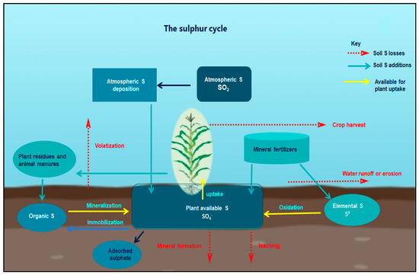
FIG 1. The sulphur cycle
A simplified systematic representation of the sulphur (S) cycle . Atmospheric S (SO₂) arises from burning S containing fossils, volcanic emissions and other natural processes. SO₄²⁻ and sulphuric acid are deposited back on the earth through precipitation. Atmospheric deposition exists as dust settling on plants, emanating from mineral mining and rock erosion. Organic S becomes available when SOM is mineralized to SO₄²⁻. Addition of mineral S fertilizers ((NH₄)₂ SO₄, CaSO₄²⁻, K₂SO₄, ZnSO₄, MgSO₄, S⁰, SSP, etc) to the soil improves the readily available soil S pool for plant uptake. The unharvested plant material and reused plant/agricultural residues return S back into the soil in an organic form. Animal manure and other biosolids also provide organic S into the soil, with the S quantity in such materials depending on the animal species, age and diet fed upon. Organic S must be mineralized to provide SO₄²⁻ to the plants. Plant residual derived S becomes available only when residues are decomposed by soil microbes. S⁰ needs biological oxidation, by means of several S oxidizing bacteria, to be transformed into plant available SO₄²⁻. Sulphur losses can be encountered through several processes. The loss of S through volatilization is quite small (<0.05 percent of total soil S). SO₄²⁻ may be leached out of the root zone due to excess rainfall or may accumulate at the soil surface in dry conditions. Under certain specific conditions, mineral formation processes may cause S to form relatively insoluble mineral complexes (CaSO₄²⁻, feSO₄²⁻, etc.). Surface losses of S can occur via runoff when SO₄²⁻ is localized near the soil surface during high intensity rainfall events or via erosion when soil sediment is lost through erosion. The plant metabolic SO₄²⁻ is harvested in seeds and other plants products. Detailed explanations to S cycle can be obtained from Till (2010) and Eriksen (2009) b.
Source to Sink Relationship
Sulfur is taken up from the rhizospheric region by plant roots as sulfate and distributed within the tissues in this form. Moreover, Tabe and Droux (2001) depicted that the dominant form of sulfur is sulfate and it is translocated via phloem, supplied in pods during the time of lupin seed development, then the seed is able to reduce and assimilate sulfate. Within the plant tissue, including the developing phase of seeds, if sulfate is not in a reduced form, then the excess amount of sulfate is stored in the vacuole (Martinoia et al.,). In developing seeds of M. truncatula, a transcriptomic analysis revealed that within the seed tissues sulfur assimilation takes place by following two distinct pathways (figure no. 2). In most of cases, sulfate enters the embryo and is utilized for the biosynthesis of cysteine (Cys) and gets incorporated into proteins, while in another pathway sulfate enters the seed coat and endosperm. The latter is preferentially involved in the biosynthesis of defense-related sulfur compounds (Gallardo et al., 2007). This kind of partitioning of sulfur in between the seed compartment implies an active exchange of sulfate.

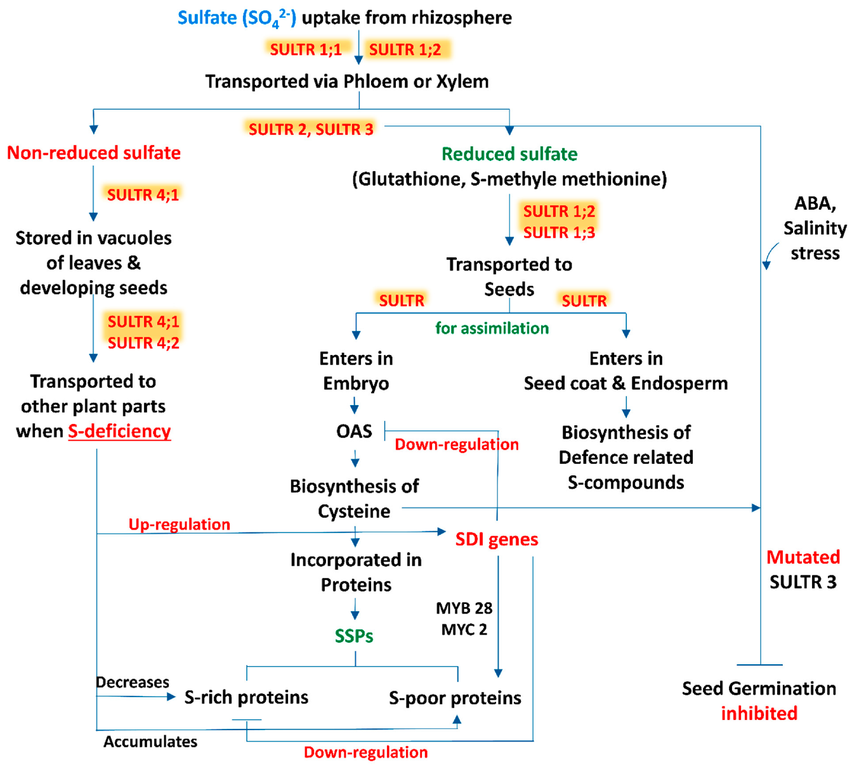
Fig 2. Pathways of sulfur assimilation
In the above figure show a schematic representation of source-sink relationship of sulfur (S) in plants: an insight in uptake and transportation of sulfate (SO₄²⁻) in different plant parts by various transporters (SULTRs) and its assimilation, accumulation of S-containing seed storage proteins (SSPs) and regulation of S-mediated seed germination. (Abbreviations: OAS, O-acetylserine; SDI genes, sulfur deficiency induced genes; MYB28, myeloblastosis28; MYC2, master regulator of cell cycle entry and proliferative metabolism2; ABA, abscisic acid).
Role of Sulphur in Plants
Sulphur is present in all living cells and is a significant component of two out of the twenty amino acids found in plants, specifically cysteine and methionine, which are essential for protein formation. Sulphur also plays a crucial role in aiding nitrogen fixation in leguminous plants like peas and beans. When nitrogen levels are elevated, sulfur becomes vital in enhancing the efficiency and utilization of nitrogen by plants, ultimately leading to increased yields of both grass and crops (Dawar et al.,2023)

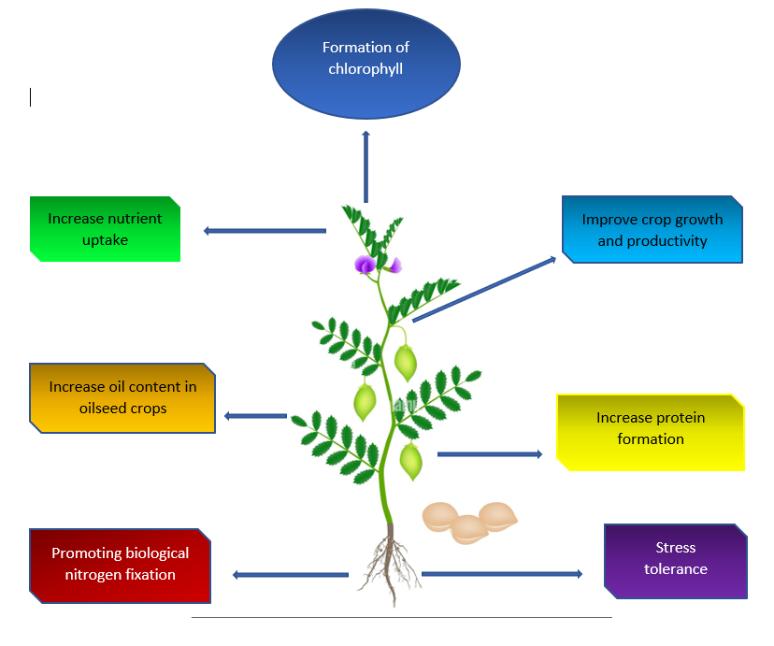

Fig 3. Sulphur Deficiency in Plants
Sulphur deficiency in plants refers to a condition in which plants do not receive an adequate supply of sulphur, which is an essential nutrient for their growth and development. When plants lack sufficient sulphur, they can exhibit various symptoms and physiological problems that can negatively impact their overall health and productivity.
Common signs and symptoms of sulphur deficiency in plants may include:
- Chlorosis: The most common symptom of sulphur deficiency is the yellowing of the leaves, known as chlorosis. This typically starts with the younger leaves and can progress to older leaves as the deficiency worsens (Hawkesford et al., 2016).
- Stunted Growth: Sulphur-deficient plants often show reduced growth, resulting in smaller overall plant size (Narayan et al.,2023).
- Delayed Maturity: Sulphur deficiency can cause a delay in flowering and fruiting, which can lead to reduced yields in crop plants (Dobermann et al.,2000).
- Reduced Protein Synthesis: Sulphur is a critical component of amino acids, which are the building blocks of proteins. Inadequate sulphur can result in reduced protein synthesis, leading to poor plant structure and function (Yu et al.,2018).
- Impaired Photosynthesis: Sulphur is necessary for the formation of chlorophyll, the green pigment responsible for photosynthesis. Sulphur deficiency can hinder photosynthesis, reducing a plant's ability to produce energy and carbohydrates (Terry 1976).
- Increased Susceptibility to Pests and Diseases: Sulphur deficiency can weaken a plant's natural defences, making it more susceptible to pests and diseases (Criollo-Arteaga et al.,2021).
- Altered Nutrient Uptake: Sulphur deficiency can disrupt the uptake of other essential nutrients, such as nitrogen and phosphorus, leading to further nutrient imbalances (Mehmood et al.,2021).
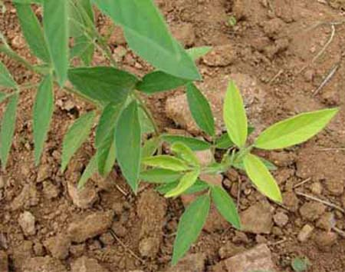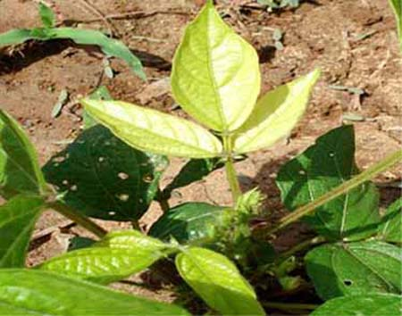
S Deficiency in Pigeon Pea S Deficiency in Moongbean
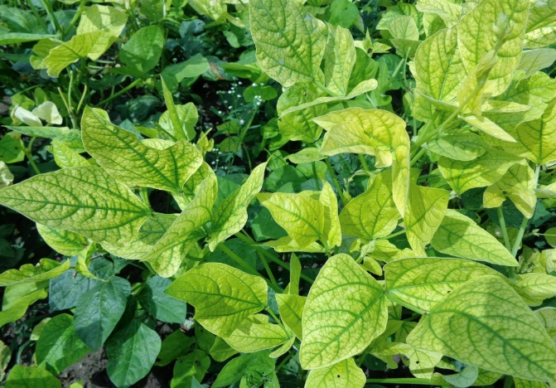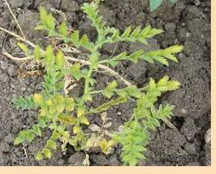
S Deficiency Cowpea S Deficiency Chickpea

Fig 4. Symptoms of sulphur deficiency in different plants

The severity of sulphur deficiency symptoms can vary depending on the plant species, soil conditions, and environmental factors. To address sulphur deficiency in plants, it is important to conduct soil tests to assess sulphur levels and consider sulphur fertilisation if necessary. Proper nutrient management practices can help ensure that plants receive the sulphur they need for optimal growth and development. Sulphur deficiency symptoms in pulses and oilseeds crops are summarized in Table 2.

Table 2. Sulphur deficiency symptoms in pulse crops
Crops | Deficiency Symptoms
Chickpea | Plants appear erect, with premature drying and withering of young leaves.
Pea | Chlorosis in young leaves. Flowering and yield are reduced.
Green gram | Chlorosis in young leaves. Flowering and yield are reduced.
Soybean | Foliage becomes pale green to yellow with non-prominent veins, growth and maturity is delayed, and protein formation is reduced
Pigeon pea | Young and middle leaves turn yellow, branching; leaf size and flowering are suppressed. Flowers lack normal yellow colour and shed early. Pod formation and seed development is retarded.
French bean | Plants have short internodes, fewer and smaller leaves. The entire foliage appears pale green. Growth is poor and yield is low

Conclusion
The performance of pulses is highly dependent upon Sulphur, a vital macronutrient, which not only impacts the yield but also the qualitative and quantitative aspects. Sulphur is essential to a number of processes, including the synthesis of protein and amino acids, the formation of nodules, nitrogen fixation, and maintaining an adaptive response. Its presence is crucial to ensuring that the legume-based systems function properly. Despite its importance, the deficiency of Sulphur across Indian lands affects the overall productivity of these lands, leading to undernourishment. Proper Sulphur management, through the proper control of its application, the coordinated use of organic amendments, and the use of Sulphur intensives can improve pulses productivity and its protein content, its nitrogen efficient usage, as well as biotic and abiotic stresses. The strategic concentration on sulphur use, with human and animal health-friendly nutrition, certainly brings a breath of fresh air not only in terms of sustainable food production but also in food and nutritional security of India and the world. In light of the above, the following needs to be emphasised: implementation of precision nutrient applications, continuous monitoring of soil’s health status, and analysis to fine-tune the use of sulphur in different regions, thus prompting agriculture to shift from pulses to a more sustainable approach.

Reference
Blake-Kalff, M. M. A., Hawkesford, M. J., Zhao, F-J., & McGrath, S. P. (2000). Diagnosing sulphur deficiency in field-grown oilseed rape (Brassica napus L.) and wheat (Triticum aestivum L.). Plant and Soil, 225(1), 95-107. https://doi.org/10.1023/A:1026503812267
Criollo-Arteaga, S., Moya-Jimenez, S., Jimenez-Meza, M., Gonzalez-Vera, V., Gordon-Nunez, J., Llerena-Llerena, S., Ramirez-Villacis, D.X., van 't Hof, P., & Leon-Reyes, A. (2021). Sulfur deprivation modulates salicylic acid responses via nonexpressor of pathogenesis-related gene 1 in Arabidopsis thaliana. Plants, 10(6), 1065. https://doi.org/10.3390/plants10061065
Davidian, J. C., & Kopriva, S. (2010). Regulation of sulfate uptake and assimilation—the same or not the same. Molecular Plant, 3(2), 314-325. https://doi.org/10.1093/mp/ssq001
Dawar, R., Karan, S., Bhardwaj, S., Meena, D. K., Padhan, S. R., Reddy, K. S., & Bana, R. S. (2023). Role of Sulphur Fertilization in Legume Crops: A Comprehensive Review. International Journal of Plant & Soil Science, 35, 718-727. https://doi.org/10.9734/IJPSS/2023/v35i214033
Deshbhratar, P. B., Singh, P. K., Jambhulkar, A. P., & Ramteke, D. S. (2010). Effect of sulphur and phosphorus on yield, quality and nutrient status of pigeonpea (Cajanus cajan). *Journal of Environmental Biology*, *31*(6), 933–937. https://pubmed.ncbi.nlm.nih.gov/21506478/
Dobermann, A., & Fairhurst, T. H. (2000). Rice: Nutrient disorders and nutrient management. Potash and Phosphate Institute; Potash and Phosphate Institute of Canada; International Rice Research Institute. https://www.nlb.gov.sg/biblio/11900007
Eriksen, J. (2009). Soil sulfur cycling in temperate agricultural systems. Advances in Agronomy, 102, 55-89. https://doi.org/10.1016/S0065-2113(09)01002-5
Eriksen, J. (2009). Soil sulfur cycling in temperate agricultural systems. Advances in Agronomy, 102, 55-89. https://doi.org/10.1016/S0065-2113(09)01002-5
Fuentes-Lara, L. O., Medrano-Macías, J., Pérez-Labrada, F., Rivas-Martínez, E. N., García-Enciso, E. L., González-Morales, S., Juárez-Maldonado, A., Rincón-Sánchez, F., & Benavides-Mendoza, A. (2019). From elemental sulfur to hydrogen sulfide in agricultural soils and plants. Molecules, 24(12), 2282. https://doi.org/10.3390/molecules24122282
Fuentes-Lara, L. O., Medrano-Macías, J., Pérez-Labrada, F., Rivas-Martínez, E. N., García-Enciso, E. L., González-Morales, S., Juárez-Maldonado, A., Rincón-Sánchez, F., & Benavides-Mendoza, A. (2019). From elemental sulfur to hydrogen sulfide in agricultural soils and plants. Molecules, 24(12), 2282. https://doi.org/10.3390/molecules24122282
Gallardo, K., Firnhaber, C., Zuber, H., Hericher, D., Belghazi, M., Henry, C., Kuester, H., & Thompson, R. (2007). A combined proteome and transcriptome analysis of developing Medicago truncatula seeds: evidence for metabolic specialization of maternal and filial tissues. Molecular & Cellular Proteomics, 6(12), 2165–2179. https://doi.org/10.1074/mcp.M700208-MCP200
Government of India, Directorate of Pulses Development. (2022-23). *Annual Progress Report*. Ministry of Agriculture & Farmers Welfare, Department of Agriculture and Farmers Welfare, Directorate of Pulses Development. https://dpd.nic.in/images/Annual_Progress_Report_2022-23.pdf
Hawkesford, M. J., Kopriva, S., & De Kok, L. J. (Eds.). (2014). Nutrient Use Efficiency in Plants: Concepts and Approaches. Springer. https://doi.org/10.1007/978-3-319-10635-9
Hosmath, J.A., Babalad, H.B., Basavaraj, G.T., Jahagirdar, S., Patil, R.H., Athoni, B.K., & Agasimani, S.C. (2014). Sulphur nutrition in soybean [Glycine max (L.) Merril] in India. In International Conference on Biological, Civil and Environmental Engineering (BCEE-2014) (pp. 17-18). https://doi.org/10.15242/IICBE.C0314071
Jadhav, V., Swamy, N. M., & Gracy, C. P. (2018). Supply-demand gap analysis and projection for major pulses in India. Economic Affairs, 63(1), 277-285. https://doi.org/10.30954/0424-2513.2018.00150.34
Kumar, S., Gopinath, K.A., Sheoran, S., Meena, R.S., Srinivasarao, C., Bedwal, S., Jangir, C.K., Mrunalini, K., Jat, R., & Praharaj, C.S. (2023). Pulse-based cropping systems for soil health restoration, resources conservation, and nutritional and environmental security in rainfed agroecosystems. Frontiers in Microbiology, 13, 1041124. https://doi.org/10.3389/fmicb.2022.1041124
Landers, D. H., David, M. B., & Mitchell, M. J. (1983). Analysis of organic and inorganic sulfur constituents in sediments, soils and water. International Journal of Environmental Analytical Chemistry, 14(4), 245-256. https://doi.org/10.1080/03067318308071623
Martinoia, E., Maeshima, M., & Neuhaus, H. E. (2007). Vacuolar transporters and their essential role in plant metabolism. Journal of Experimental Botany, 58(1), 83–102. https://doi.org/10.1093/jxb/erl183
Mehmood, M. Z., Afzal, O., Ahmed, M., Qadir, G., Kheir, A. M. S., Aslam, M. A., Din, A. M. U., Khan, I., Hassan, M. J., Meraj, T. A., Raza, M. A., & Ahmad, S. (2021). Can sulphur improve the nutrient uptake, partitioning, and seed yield of sesame?. Arabian Journal of Geosciences, 14(10), 865. https://doi.org/10.1007/s12517-021-07229-6
Narayan, O. P., Kumar, P., Yadav, B., Dua, M., & Johri, A. K. (2023). Sulfur nutrition and its role in plant growth and development. Plant Signaling & Behavior, 18(1), 2030082. https://doi.org/10.1080/15592324.2022.2030082
Nikiforova, V. J., Gakière, B., Kempa, S., Adamik, M., Willmitzer, L., Hesse, H., & Hoefgen, R. (2004). Towards dissecting nutrient metabolism in plants: a systems biology case study on sulphur metabolism. Journal of Experimental Botany, 55(404), 1861–1870. https://doi.org/10.1093/jxb/erh177
Niraj, V.P.S. and Ved Prakash, V.P., 2014. Effect of phosphorus and sulphur on growth, yield and quality of blackgram (Phaseolus mungo L.).
Paliwal, A.K., VajpaI, S.K. and Kiran Vajpai, K.V., 2009. Interaction effect of sulphur and phosphorus application on yield and major nutrient composition of soybean (Glycine max L. Merrill) grown on alfisol.
Rao, A.S. and Ganeshamurthy, A.N., 1994. Soybean responses to applied phosphorus and sulphur on Vertic Ustochrepts in relation to available phosphorus and sulphur. Journal of the Indian Society of Soil Science, 42(4), pp.606-610.
Sah, U., Verma, P., Pal, J., Singh, V., Katiyar, M., Dubey, S.K., & Singh, N.P. (2024). Pulse Value Chains in India- Challenges and Prospects: A Review. Legume Research: An International Journal, 47(7), 1065-1072. https://doi.org/10.18805/LR-4632
Saha, S., Saha, M., Saha, A.R., Mitra, S., Sarkar, S.K., Ghorai, A.K., & Tripathi, M.K. (2013). Interaction effect of potassium and sulfur fertilization on productivity and mineral nutrition of sunnhemp. Journal of Plant Nutrition, 36(8), 1191-1200. https://doi.org/10.1080/01904167.2013.779705
Scherer, H. W. (2001). Sulphur in crop production. European Journal of Agronomy, 14(2), 81-111. https://doi.org/10.1016/s1161-0301(00)00082-4
Shi-Ping, W.A.N.G., Yan-Fen, W.A.N.G., Xiao-Yong, C.U.I., Zuo-Zhong, C.H.E.N., Hong-Kang, C.H.I., Schnug, E., Haneklaus, S. and Fleckenstein, J., 2002. Influence of sulphur fertilizer on sulphur cycling and its implications on sulphur fertilizer requirement of grazed pasture in warm seasonal rangeland of Nei Monggol steppe of China. Journal of Integrative Plant Biology, 44(2), p.204.
Singh, J. M., Kaur, A., Chopra, S., Kumar, R., Sidhu, M. S., & Kataria, P. (2022). Dynamics of Production Profile of Pulses in India. Legume Research - An International Journal, 45(5), 565-572. https://doi.org/10.18805/LR-4274
Suresh, A., & Reddy, A.A. (2016). Total factor productivity of major pulse crops in India: implications for technology policy and nutritional security. Agricultural Economics Research Review, 29, 87-98. https://doi.org/10.5958/0974-0279.2016.00036.7
Tabe, L. M., & Droux, M. (2001). Sulfur assimilation in developing lupin cotyledons could contribute significantly to the accumulation of organic sulfur reserves in the seed. Plant Physiology. https://doi.org/10.1104/pp.126.1.176
Terry, N. (1976). Effects of sulfur on the photosynthesis of intact leaves and isolated chloroplasts of sugar beets. Plant Physiology, 57(4), 477-479. https://doi.org/10.1104/pp.57.4.477
Till, A. R. (2010). Sulphur and sustainable agriculture. International Fertiliser Industry Association. https://www.fertilizer.org/resource/sulphur-and-sustainable-agriculture/
Tiwari, A.K. and Shivhare, A.K., 2016. Pulses in India: retrospect and prospects. Published by Director, Govt. of India, Ministry of Agri. & Farmers Welfare (DAC&FW), Directorate of Pulses Development, VindhyachalBhavan, Bhopal, MP.
Tripathi, P. K., Singh, M. K., Singh, J. P., & Singh, O. N. (2012). Effect of rhizobial strains and sulphur nutrition on mungbean (Vigna radiata (l.) wilczek) cultivars under dryland agro-ecosystem of Indo-Gangetic plain. African Journal of Agricultural Research, 7(1), 34-42. https://doi.org/10.5897/AJAR11.868
Vidyalakshmi, R., Paranthaman, R. and Bhakyaraj, R., 2009. Sulphur Oxidizing Bacteria and Pulse Nutrition- A Review. World Journal of Agricultural Sciences, 5(3), pp.270-278.
Yu, Z., Juhasz, A., Islam, S., Diepeveen, D., Zhang, J., Wang, P., & Ma, W. (2018). Impact of mid-season sulphur deficiency on wheat nitrogen metabolism and biosynthesis of grain protein. Scientific Reports, 8(1), 2499. https://doi.org/10.1038/s41598-018-20935-8
Zenda, T., Liu, S., Dong, A., & Duan, H. (2021). Revisiting sulphur—The once neglected nutrient: It’s roles in plant growth, metabolism, stress tolerance and crop production. Agriculture, 11(7), 626. https://doi.org/10.3390/agriculture11070626
Zhao, F. J., Tausz, M., & De Kok, L. J. (2008). Role of sulfur for plant production in agricultural and natural ecosystems. In R. Hell, C. Dahl, D. B. Knaff, & T. Leustek (Eds.), Sulfur metabolism in phototrophic organisms (pp. 417-435). Springer. https://doi.org/10.1007/978-1-4020-6863-8_21

