Management and control strategies for the Corn Leafhopper (Dalbulus maidis): A systematic literature review

ABSTRACT

The corn leafhopper (Dalbulus maidis), vector of the corn stunt complex (Spiroplasma kunkelii, Phytoplasma, and MRFV) in corn (Zea mays L.), causes losses of up to 100% in the crop. This review aimed to analyze the limitations of current control methods and the potential of integrated strategies. A systematic review covering the period from 2021 to 2025 was conducted to evaluate the effectiveness of chemical and biological control tactics against D. maidis. The review reveals that chemical control, such as seed treatment, has limited effectiveness (persisting up to stage V2) and fails to prevent transmission by already infected insects. Strategies focused only on vector mortality are proven insufficient. In contrast, biocontrol with entomopathogenic fungi (e.g., Cordyceps javanica) has proven to be more effective, disrupting the feeding behavior of D. maidis and directly interrupting pathogen transmission. In the field, the combination of these fungi with resistant hybrid seeds has achieved efficacy equivalent to that of insecticides. It is concluded that effective management requires a paradigm shift: from population control to interruption of transmission. Integrated Pest Management (IPM), integrating resistant hybrids, monitoring, and behavioral biocontrol, is consolidating itself as the most sustainable and resilient strategy.

Keywords: Zea mays L.; Corn leafhopper; Corn stunt complex; Entomopathogenic fungi; Resistant hybrids; Sustainable mamagement.
1. INTRODUCTION
Corn (Zea mays L.) holds a prominent position in global agriculture, being the most consumed food worldwide (Pinto et al., 2023). However, corn cultivation has a limiting factor that affects its yields: the corn leafhopper (Dalbulus maidis), the main vector of three phytopathogens that cause corn stunting (Jones & Medina, 2020; da Costa et al., 2023; Toloy et al., 2024). This complex is composed of two Mollicute bacteria, Spiroplasma kunkelii (corn stunt spiroplasma/CSS) (Whitcomb et al., 1986), phytoplasma (maize bushy stunt phytoplasma/MBSP) (Nault, 1980, 1990), both known for causing pale stunting and red stunting, respectively; in addition to the Maize Rayado Fino Virus (MRFV) (Oliveira et al., 2018). The magnitude of the damage can lead to productivity losses of up to 100% (Maia et al., 2025).
These pathogens, spiroplasma and phytoplasmas, establish systemically in corn plants and are transmitted persistently and propagatively by D. maidis (Haas et al., 2023). In field conditions, it is common for a single corn plant or a single vector individual to be simultaneously infected by one or more pathogens, resulting in symptomatic overlap that hinders differential diagnosis (Gorayeb et al., 2025; Oliveira et al., 2023). This difficulty justifies the collective designation of the three infections as the "corn stunt complex" (CSC). Currently, CSC management faces a significant challenge because there are no chemical or biological control strategies directly effective against phytopathogen. The emphasis, therefore, falls on controlling the vector D. maidis (Oliveira et al., 2022; Dalaisón-Fuentes et al., 2022). However, a limited understanding of the ecological and physiological strategies the vector employs to survive and disperse in the field compromises the effectiveness of implemented management tactics, perpetuating the disease cycle and production losses (Oliveira et al., 2020).
Historically, management strategies for D. maidis control have been heavily centralized on chemical intervention tactics, notably through seed treatment (ST) with systemic insecticides (Oliveira et al., 2020). However, the vector's high infectivity rate, combined with the systemic, persistent, and propagative nature of phytopathogen transmission (Haas et al., 2023), makes the isolated use of these tactics insufficient, especially in the face of recent evidence of reduced control efficacy in the field (Machado et al., 2024). This complex epidemiological dynamic alters the management paradigm: the economic injury level (EIL) for D. maidis is exceptionally low, as the presence of the infected vector can result in irreversible damage, disassociating control success from total population density reduction (Gorayeb et al., 2025; Oliveira et al., 2023).
Instead, efficacy must be measured by the ability to prevent initial infection and reduce disease incidence (Feinberg & Keeshin, 2022). Therefore, a critical and systematic reassessment of available control approaches is necessary to underpin integrated strategies capable of ensuring vector suppression at levels that prevent its propagation and disease establishment. The objective of this systematic review is to analyze and synthesize scientific evidence on management strategies focused on interrupting the transmission of corn stunt complex phytopathogens by D. maidis. With particular emphasis on biological control agents, including entomopathogenic fungi and natural predators, aiming at the optimization of Integrated Pest Management (IPM).

2. METHODOLOGY

This systematic review was designed and conducted following the guidelines of the Preferred Reporting Items for Systematic Reviews and Meta-Analyses (PRISMA 2020). The review protocol was registered on the Open Science Framework (OSF) platform under the registration [https://osf.io/be4n2/overview?view_only=e114590fe3a44a1283c9098837d1700e].

2.1 Research Question and PICO Structure

The formulation of the guiding question and the definition of eligibility criteria were based on the PICO (population, intervention, comparison, outcome) strategy. This structure was adopted to ensure the specificity of the search and the relevance of the retrieved studies in relation to the objective of interrupting the transmission of the stunt complex. The research question was defined as: "Which management techniques show the best efficacy for controlling Dalbulus maidis (corn leafhopper) in corn plantations?" The details of the PICO strategy components are presented in Table 1.
Table 1. Structure of the research question based on the PICO strategy and delimitation of the review's scope.
P (Population) | I (Intervention) | C (Comparison) | O (Outcome)
Dalbulus maidis (corn leafhopper) in corn (Zea mays L.) crops | Management and control techniques (e.g., Chemical Control, Biological Control, Area Management, Genetic Management, Integrated Management) | Absence of Control, Placebo Control (when applicable), or direct comparison between different management techniques | Effectiveness of population control (e.g., mortality, infestation reduction, population suppression) and/or reduction of damage and disease incidence (stunting)

2.2 Data Sources and Search Strategies

A systematic search was conducted in the electronic databases Web of Science (WoS), Scopus, and SciELO (Scientific Electronic Library Online) between September and October 2025.
The search strategy was constructed by combining keywords and synonyms related to the PICO concepts, using the Boolean operators "AND" and "OR". The central concepts of the search were: (1) the pest ("Dalbulus maidis" OR "Corn leafhopper") and (2) the intervention ("Integrated Pest Management" OR "Biological control" OR "Control").

2.3 Eligibility Criteria

The study selection process followed rigorously defined inclusion criteria to ensure the inclusion of only high-quality primary research data relevant to the review's objectives. The following categories of publications were systematically included: Primary studies (experimental, quasi-experimental, observational), which involved management techniques (chemical, biological, area management, genetic, or integrated) for D. maidis that reported the outcome on population change. The study selection process followed rigorously defined exclusion criteria to ensure the inclusion of only high-quality primary research data relevant to the review's objectives. The following categories of publications were systematically excluded: narrative reviews, editorials, letters to the editor, technical notes, and conference abstracts; studies that did not present original efficacy data related to the management or control of the target pathogen or vector were discarded; or studies with a temporal misalignment outside the specified research period of 2021 to 2025.
The application of these criteria allowed for the definition of a refined set of studies, constituting a robust documentary basis for subsequent systematic analysis and data extraction.

2.4 Study Selection and Data Extraction

Bibliographic management and the selection process were carried out on the intelligent platform Rayyan (rayyan.ai) (Ouzzani et al., 2016). Initially, automatic and manual duplicate removal was performed. The subsequent selection was executed by two independent reviewers in blinded screening mode, rigorously following the PRISMA flow in two distinct stages: (i) screening based on reading titles and abstracts; and (ii) eligibility assessment by reading full texts. In both phases, any discrepancies between the evaluators were discussed and resolved by consensus, ensuring consistency in the application of inclusion criteria. After eligibility definition, data from the included studies were independently extracted by the two reviewers, using a standardized and pre-tested data collection instrument, developed in an electronic spreadsheet. The information was systematized into four main domains: (i) bibliometric characterization (author, publication year, and geographical location of the study); (ii) methodological attributes (experimental design and conduction environment: field, greenhouse, or laboratory); (iii) intervention details (type of management, biological or chemical control agent, and application method); and (iv) outcomes and results (main efficacy indicators, metrics of population reduction/transmission, and authors' conclusions).

2.5 Methodological Quality Assessment (Risk of Bias)
The methodological integrity and risk of bias of the included studies were examined using the critical appraisal tools of the Joanna Briggs Institute (JBI). Given the heterogeneity of the experimental designs retrieved, specific checklists compatible with the architecture of each study were applied (Checklist for Randomized Controlled Trials for field trials; Checklist for Quasi-Experimental Studies for non-randomized trials). Discrepancies in scores were resolved by consensus. Critical appraisal was not used as an exclusion criterion but rather to weigh the reliability of the evidence synthesis presented in the results section.
2.6 Data Synthesis
Given the expected heterogeneity in study designs, intervention types, and outcome metrics, a qualitative data synthesis was planned. Results were grouped and summarized in evidence tables, organized by intervention category (biological, chemical, area management, monitoring strategies, and use of predatory insects). Comparative analysis sought to identify patterns, knowledge gaps, and strategies that demonstrated greater efficacy in D. maidis population control.

3. RESULTS

3.1 Article Selection

The initial systematic search in the databases (Web of Science, Scopus, and SciELO) yielded 44 records. After the removal of 6 duplicates, 38 unique articles were retained for title and abstract screening. In this phase, 17 articles were excluded for not meeting the preliminary scope criteria. Full-text evaluation of the 21 pre-selected articles resulted in the exclusion of 13 studies that did not meet the detailed eligibility criteria in Table 2. The main reasons for exclusion were: divergent population (n = 4), intervention not pertinent to the objective (n = 4), and absence of outcome data (n = 5). At the end of the selection process, 8 articles were retained to compose the bibliographic portfolio for qualitative synthesis.
Figure 1 - PRISMA flowchart illustrating the process of identification, screening, eligibility, and inclusion of studies in the systematic review.
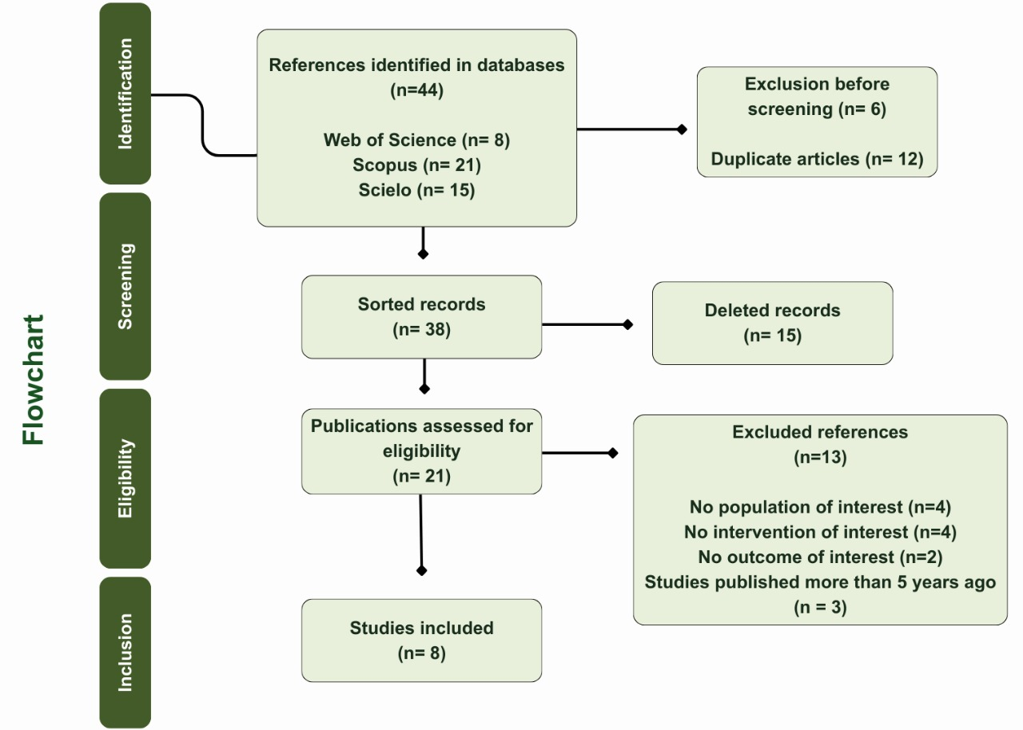

3.2 Characterization of Studies

Eight studies were included, covering field trials, laboratory bioassays, and observational analyses, spanning different scales of agroecosystem complexity. The studies evaluated different management and control techniques for the corn leafhopper (Dalbulus maidis), conducted under distinct experimental conditions and environments, considering both biological and chemical approaches, as well as cultural and integrated management practices. This variety of experimental contexts highlights the growing interest in sustainable strategies adapted to local growing conditions for the control of this insect.
The studies showed methodological and experimental diversity, with samples ranging from D. maidis eggs and nymphs to corn plants of hybrid seeds. Among the identified designs, laboratory experiments predominated (5), followed by field trials (2) and one descriptive observational study (1). The main variables analyzed included: parasitism and predation rates (n=2), efficiency of entomopathogenic fungi (n=3), oviposition behavior (n=1), mortality of nymphs and adults (n=1), and physiological responses of plants (n=1). It was observed that 5 of the studies emphasized sustainable control strategies, such as the use of entomopathogenic organisms, natural predators, and resistant hybrids, while another 3 explored ecological and behavioral factors influencing pest population dynamics.
3.3 Area Management
Regarding the evaluation technique, direct insect counting was selected as the most appropriate, surpassing plastic tray shaking and beat cloth techniques. The superiority of this method was proven by being the only one to maintain consistently low relative variances (below 25%) across all phenological stages and biomes evaluated, indicating greater stability in precision. Furthermore, direct counting showed the highest operational efficiency, with an average execution time of up to 3.25 seconds per sampling, less than half the time required by the beat cloth method. Another decisive factor was crop integrity: while the use of the beat cloth resulted in torn leaves and stem injuries, direct counting proved to be a completely non-destructive method (Pinto et al., 2023).
3.4 Monitoring Strategy
The study conducted by Moya-Raygoza (2024) investigated the temporal continuity and winter survival of Dalbulus maidis egg parasitoids in Mexico, comparing irrigated corn and adjacent border grasses. The study identified Paracentrobia subflava as the dominant biological control agent, registering the highest levels of parasitism (53%) in asynchronously planted irrigated corn, in contrast to synchronous planting (37%). Crucially, although D. maidis was absent from the border grasses, P. subflava was found persisting in these areas (<2% parasitism) by utilizing alternative hosts (such as Graminella sonora). These findings demonstrate that borders function as essential winter refuges, ensuring the survival of P. subflava between seasons and allowing its subsequent migration to corn. The study conducted by Maluta et al. evaluated the effect of the entomopathogenic fungus Cordyceps javanica on the probing behavior of Dalbulus maidis in corn, using electropenetrography (DC-EPG). Forty-eight hours after fungal application, a significant disturbance in stylet activities was observed in both phloem and non-phloem phases. The results demonstrated that the treatment substantially reduced the duration of the Dm5 wave, which corresponds to passive ingestion of phloem sap. This alteration in feeding behavior suggests a potential for reducing the acquisition and inoculation of phloem-restricted pathogens, such as Spiroplasma kunkelii, transmitted by this vector.

Table 2. Summary of Biological, Behavioural, and Integrated Pest Management Studies on Dalbulus maidis in Maize
Author | Title | Objective | Study Type | Sample Size | Intervention Protocol | Outcome 1 | Outcome 2 | Conclusion
Albarracin et al., (2021) | Influence of the oviposition site on the parasitism level of eggs in the corn leafhopper. | Influence of Oviposition Site on Parasitism | Laboratory experimental study | 600 eggs on 60 leaves | Adult female D. maidis conditioned in cages (30 x 30 x 50cm) containing healthy corn plants (V3-V4) | 187 D. maidis eggs found on V3 plants; 20 (10.7%) located in leaf sheaths, 53 (28.3%) in the midrib, and 114 (61.0%) in leaf blades. A total of 495 eggs were found on V4 plants; 46 (9.3%) located in the sheath, 198 (40.0%) in the midrib, and 251 (50.7%) in the leaf blade. | Mymaridae Anagrus virlai (144 = 74.2%), A. flaveolus Waterhouse (24 = 12.4%) and A. nigriventris Girault (4 = 2.1%), and Trichogrammatidae Paracentrobia tapajosae Viggiani (15 = 7.7%) and Pseudoligosita longifrangiata (Viggiani) (7 = 3.6%) | The leafhopper's preference for laying its eggs in the midrib (where 95% of eggs are laid) ends up exposing its offspring to a significantly higher parasitism risk (28.3%) compared to other locations.
Bortolotto et al., (2024) | First report of Doru luteipes earwig (Dermaptera: Forficulidae) attacking corn leafhopper nymphs Dalbulus maidis (Hemiptera: Cicadellidae) | First Report of Predation by Doru luteipes | Observational and Experimental Study (First Report) | Insects collected in Ponta Grossa, Paraná, Brazil. 10 replicates for 1 female D. luteipes and 10 D. maidis nymphs | 1 adult female D. luteipes and 10 D. maidis nymphs per petri dish. Predation activity was monitored at 12h intervals | First documented record of the earwig Doru luteipes preying on corn leafhopper nymphs (Dalbulus maidis). | Each adult earwig consumed approximately 4.6 D. maidis nymphs (4th instar) within a 12-hour period. | The study demonstrated that adult Doru luteipes have predation capacity on D. maidis nymphs.
G Moya-Raygoza (2024) | Temporal overlap between maize susceptibility to Dalbulus maidis and transmission efficiency of Spiroplasma kunkelli explains timing of yield losses | Continuity of Resources for Parasitoids in Winter | Experimental Study | Corn bait leaves: Asynchronous (2022): 35, 34, and 37 leaves. Borders (2023): 66 leaves in March and 66 leaves in April. Synchronous Corn (2023): 53 leaves in May and 57 leaves in June. | Use of bait plants with D. maidis eggs exposed for 5 days. Year 1 (2022): Corn planted on different dates, in three development stages. Year 2 (2023): Wild grasses on borders and corn planted on the same date in two stages. | The highest total parasitism percentage reached 53% in corn at early reproductive stage. Three species were identified: (Hymenoptera: Paracentrobia subflava, Anagrus virlai, and Pseudoligosita sp.). The parasitoid Paracentrobia subflava was the most abundant and dominant species in all corn treatments. | Asynchronous planting is more effective in maintaining high levels of parasitism and greater diversity of parasitoids than synchronous planting. Wild grasses on crop borders act as a vital winter survival habitat for the key parasitoid (P. subflava). | P. subflava is an efficient biological control agent against D. maidis in irrigated winter corn, achieving high field parasitism. Asynchronous planting of corn in winter is more effective in maintaining high levels and diversity of parasitoids than synchronous planting.
Maia et al., (2025) | Sustainable control of Dalbulus maidis: field study with entomopathogenic fungi | Sustainable Control with Fungi and Hybrids | Field experimental study | Sample size not specified | Hybrids with different resistance levels were planted (BM 3066 PRO3, SHS 7970 PRO3, and BT 83 MQK1). 6 types of treatment (T1 to T6). T1 – Methomyl: high reduction; T2 – M. anisopliae: significant mortality; T3 – B. bassiana: moderate reduction; T4 – C. fumosorosea: minor reduction; T5 – M. anisopliae + B. bassiana: higher mortality and control; T6 – M. anisopliae + C. fumosorosea: high mortality, slightly lower than T5. | No specific outcome | No specific outcome | The combination of resistant hybrids with the application of entomopathogenic fungi (isolated or combined) resulted in higher productivity and sustainable control of D. maidis.
Maluta et al., (2023) | DC-electrical penetration graph waveforms for Dalbulus maidis (Hemiptera: Cicadellidae) and the effects of entomopathogenic fungi on its probing behavior | Effect of Fungi on Feeding Behavior | Laboratory experimental study | D. maidis colony and corn plants (H. LP2020) conditioned in a temperature-controlled room (25 ± 1°C). 20 treatments performed. | Adult leafhoppers (7-15 days old) were sprayed with Octane (Cordyceps javanica, strain ESALQ 1296). Monitored for 10h in a DC-EPG system at different times (0, 15, 30, 48, 72, and 120h). | Confirmed that the waveforms recorded by the DC-EPG system are similar in appearance to previously published AC and AC-DC EPG waveforms. | The fungus's effect was most pronounced 48 hours after spraying. | The microbiological product with Cordyceps javanica demonstrated the ability to alter D. maidis probing behavior.
Pinto et al., (2023) | Key Pest Sampling Methodology: Sampling Technique and Unit for Assessing Dalbulus maidis population in Corn Crops | Dalbulus maidis Sampling Methodology | Experimental study | 16 commercial corn crops (2022 and 2023) in two biomes (Atlantic Forest and Cerrado). | Leaves in different canopy positions (whorl leaves, 1st apical leaf, 2nd, 3rd, etc.). Direct counting on plants at stages V4, V6, V8, and V10. | The article provides a concrete guideline for any agronomist or producer needing to monitor the leafhopper through Relative Variance and Negative Binomial Distribution. | It was determined that the plan requires 81 samples (plants) to ensure that the sampling error is at most 15%. This guarantees the reliability of the population estimate. | The study established the first conventional and robust sampling plan for D. maidis, recommending Direct Counting on the Whorl Leaf due to its precision, speed, and low cost, being essential for IPM programs.
Redoan et al, (2025) | What is the relationship between the effectiveness of seed treatment with insecticides against healthy Dalbulus maidis and those infected with Spiroplasma? | Relationship between Seed Treatment and Infected Vectors | Field experimental study | 250 healthy D. maidis adults and 250 infected adults. 80 plants (40 exposed to healthy D. maidis and 40 to unhealthy) | 6 insecticide treatments (Control – untreated seeds; 2- Imidacloprid + Thiodicarb; 3- Thiamethoxam; 4- Clothianidin; 5- Fipronil; 6- Thiamethoxam + Fipronil.) | Insecticide treatment affected D. maidis mortality compared to the control group (GLM: χ² = 72.98, df = 6, p < 0.001). Leafhoppers with spiroplasma showed higher mortality compared to healthy ones (GLM: χ² = 61.98, df = 6, p < 0.001). | Imidacloprid/thiodicarb (χ² = 12.89, df = 1, p < 0.001) and (χ² = 20.80, df = 1, p < 0.001) | Seed treatment with imidacloprid + thiodicarb showed high efficacy against D. maidis (healthy and Spiroplasma-infected), protection is most effective up to V2 stage.
Souza et al., (2021) | First report on the natural occurrence of entomopathogenic fungi in populations of the leafhopper Dalbulus maidis (Hemiptera: Cicadellidae): Pathogen identifications and their incidence in maize crops | First Occurrence of Entomopathogenic Fungi against Dalbulus maidis | Observational study | 120 to 200 leaves per region (Field 1: Barreiras/BA; Field 2: Campo Verde/MT). 18 individual plants; 15 spores for morphological analysis. | No controlled treatments (spraying or management) were applied; only observed and recorded the natural occurrence of entomopathogenic fungi such as Metarhizium brasiliense and Batkoa (gen. sp.) | In Field 1, the fungus Metarhizium was able to kill adult leafhoppers at 0.22 ± 0.02 (%) in the 1st area and 0.53 ± 0.15 (%) in the 2nd area. | In Field 2, the fungus Batkoa sp. (Entomophthorales) was able to kill 1.88 ± 0.26 (%) cadavers per corn leaf. | This study reported for the first time the natural presence of fungi (Metarhizium brasiliense and Batkoa sp.) infecting Dalbulus maidis populations in corn fields in Brazil.

3.5 Chemical Control

The study by Redoan et al. (2025) evaluated the efficacy of insecticide seed treatments against Dalbulus maidis (corn leafhopper), comparing healthy individuals with those infected by Spiroplasma kunkelii. Maximum efficacy occurred at the V2 plant stage. The mixture of imidacloprid + thiodicarb proved to be the most effective, causing 100% mortality in healthy insects and 85.7% in infected ones, which completely prevented spiroplasma transmission. Pathogen-infected leafhoppers showed significantly higher mortality, indicating that S. kunkelii infection increases vector susceptibility to the tested insecticides.
3.6 Biological Control: Fungal Intervention

The field study by Maia et al. (2025) validated the efficacy of integrated Dalbulus maidis management, evaluating the synergy between different levels of resistance of experimental hybrids and entomopathogenic fungi. The results confirmed that experimental hybrids with low resistance (BT 8303) showed higher vector infestation and stunting severity. Significantly, the application of Metarhizium anisopliae (ME), as well as the combination of M. anisopliae + Beauveria bassiana (ME+BE), reduced the vector's population density. From these results, the authors confirm that the use of these entomopathogenic fungal formulations achieved control levels statistically similar to those of chemical treatment (Methomyl), proving that integration with hybrids of different resistance levels is a sustainable and efficient strategy. The study by Souza et al. 2021 reported, for the first time, the natural occurrence of entomopathogenic fungi in Dalbulus maidis populations in Brazil. Morphological and molecular analyses identified Metarhizium brasiliense and Batkoa sp.. M. brasiliense was found in crops in the Northeast (incidence of 0.22 to 0.53 adults/leaf) and Central-West (0.04 adults/leaf). Notably, in the Central-West, the study also recorded an unprecedented epizootic caused by Batkoa sp., which infected 86.42% of the sampled adults, reaching an average of 1.88 infected individuals per leaf.
3.7 Biological Control: Predatory Insects

Albarracín et al. (2021) demonstrated that Dalbulus maidis uses spatial oviposition selection as an adaptive strategy to mitigate egg parasitism. The study revealed that, although most eggs (50-60%) were laid on unfolded leaf blades, the exact location varied with plant stage (leaf apex in V3; midrib base in V4). Crucially, egg parasitism, predominantly by Anagrus virlai and less frequently by Polynema, Paracentrobia, Oligosita, and Pseudoligosita complexes, was significantly reduced in eggs allocated to the apical midrib, indicating lower detection by natural enemies. These results confirm the "spatial escape" hypothesis, where D. maidis selects micro-habitats that confer protection, a relevant finding for biological control strategies. Bortolotto et al. (2024) provided the first documented record of Doru luteipes preying on Dalbulus maidis nymphs, demonstrating its potential as a biological control agent. In controlled laboratory assays, the study quantified effective predation, where adult D. luteipes females consumed, on average, 4.6 D. maidis nymphs within a 12-hour period. This pioneering finding confirms the predator-prey interaction and highlights the importance of conservative management strategies, such as the use of selective pesticides, to protect this natural enemy in corn crops.
3.8 Risk of Bias

Regarding methodological quality, articles were segregated into "Experimental" and "Observational" designs, using the JBI (Joanna Briggs Institute) tool. Although some studies demonstrated rigorous implementation of methods, ensuring the minimization of potential biases, others presented significant methodological flaws, such as insufficient detail regarding control and differential exposure between specimens, which may compromise the reliability of the results.

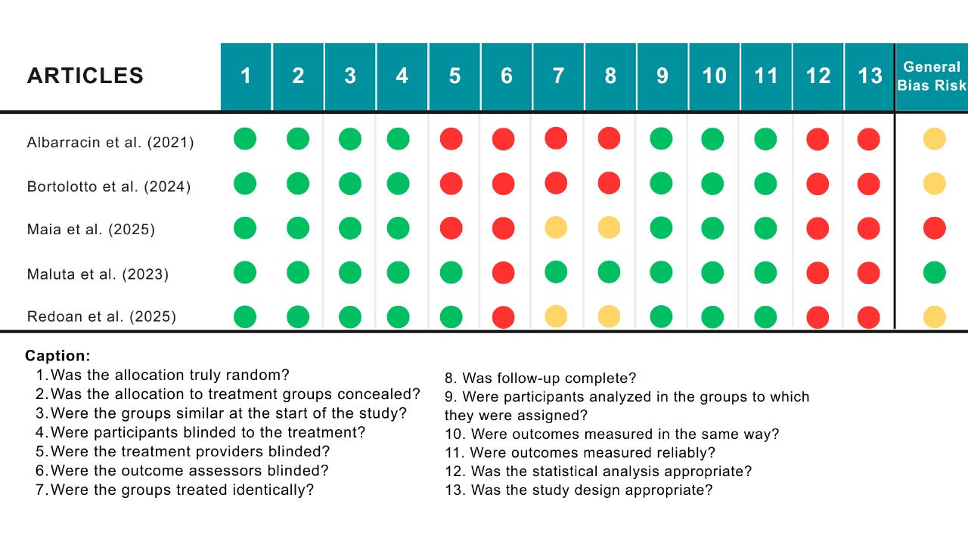
Figure 2 – Risk of Bias Assessment of Experimental Studies using the Joanna Briggs Institute (JBI) tool. Information regarding the following parameters (1 to 13) was judged: (Red) indicates High Risk of Bias, (Green) indicates Low Risk of Bias, and (Yellow) indicates Uncertain Answers or Moderate Risk. The result in the Overall column reflects the global risk of each study. (1) Was allocation truly random? (2) Was allocation to treatment groups concealed?; (3) Were groups similar at baseline?; (4) Were participants blinded to treatment?; (5) Were treatment appliers blinded? (6) Were outcome assessors blinded? (7) Were groups treated identically? (8) Was follow-up complete?; (9) Were participants analyzed in the groups to which they were allocated?; (10) Were outcomes measured in the same way?; (11) Were outcomes measured reliably?; (12) Was statistical analysis appropriate?; (13) Was the study design appropriate?.
The overall analysis revealed that three articles presented Low overall risk of bias (Maluta et al. 2023, G Moya-Raygoza 2024, and Pinto et al. 2023), while three were classified with Moderate overall risk and one with High overall risk (Maia et al. 2025). Of the five Experimental Studies evaluated by the JBI checklist, the main source of methodological fragility was the High Risk of Bias (red), concentrated on blinding criteria (items 4, 5, and 6). This risk, notably present in articles with Moderate overall risk (Albarracin et al., 2021; Bortolotto et al., 2024; Redoan et al., 2025) and High (Maia et al., 2025), indicates that the failure to "blind" participants, appliers, and assessors may have introduced performance or detection bias, overestimating the results. Additionally, the Maia et al. (2025) article, classified with High overall risk, presented critical flaws in statistical analysis (item 12) and design (item 13), requiring extreme caution in interpreting its findings. In contrast, Maluta et al. (2023) stood out for presenting a Low overall risk, ensuring greater confidence in its results, as most studies demonstrated success in preventing selection bias (items 1 and 2).
The variation in the applicability of bias risk criteria is intrinsic to the study design. In Experimental Studies (Figure 2), the evaluation focuses on mechanisms that ensure comparability and prevent distortion of results, with failure in criteria such as random allocation or its blinding (items 1, 2, 4, 5, and 6) being the main source of selection bias. On the other hand, in Observational Studies (Figure 3), the main threat to validity lies in confounding bias. Of the three Observational Studies, two presented a Low overall risk (G Moya-Raygoza, 2024, and Pinto et al., 2023). However, the Souza et al. (2021) study was classified with Moderate overall risk due to High Risk of Bias (red) in essential criteria for the validity of observed associations: exposure measurement/valid criteria (item 4) and identification of confounding factors (item 5). The classification of High Risk in these domains implies that the result is vulnerable to information bias and confounding bias, respectively. Therefore, the association found should be interpreted with reservation due to the possibility that uncontrolled variables may have influenced the outcome.

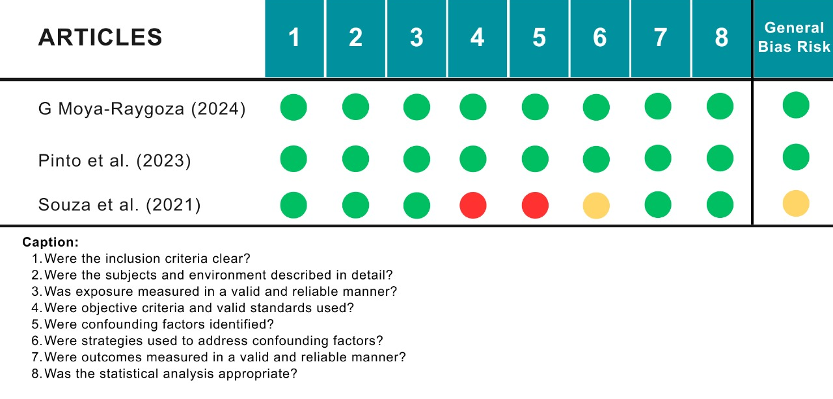
Figure 3 – Risk of Bias Assessment of Observational Studies, using the adapted Joanna Briggs Institute (JBI) tool. Information regarding the following parameters (1 to 8) was judged: (Red) indicates High Risk of Bias, (Green) indicates Low Risk of Bias, and (Yellow) indicates Uncertain Answers or Moderate Risk. The result in the Overall column reflects the global risk of each study. (1) Were inclusion criteria clear?; (2) Were subjects and environment described in detail?; (3) Was exposure measured validly and reliably?; (4) Were objective and valid standard criteria used?; (5) Were confounding factors identified?; (6) Were strategies used to deal with confounding factors?; (7) Were outcomes measured validly and reliably?; (8) Was statistical analysis appropriate?.
Thus, methodological limitations vary; while clinical trials may face insurmountable blinding challenges, observational studies face the persistent challenge of controlling all relevant confounding variables. Despite these specific risks, the study findings were considered in conjunction, recognizing that bias factors vary according to the types of interventions studied and the methodological designs used.

4. DISCUSSION

The synthesis of the eight studies in this review highlights the necessary transition to integrated pest management (IPM) for Dalbulus maidis control. The control model should no longer be a binary choice, whether chemical or biological, but rather a synergistic system that manages vectorial risk through multiple mechanisms of action. Chemical seed treatment (ST) fulfills the role of protecting corn seeds in the early stages. However, the study by Redoan et al. (2025) demonstrates that this protection is limited (maximum up to V2) and has reduced efficacy against infected vectors. While mortality in healthy insects was maximal, the survival of 14.3% of infected vectors creates a high risk in the crop after the chemical residual breaks down.
Therefore, sampling surveillance becomes the crucial link for the later phase of the crop. The data from Pinto et al. (2023) validate the Direct Counting on the Whorl Leaf methodology as the most robust technique for monitoring, being essential to determine the intervention threshold before the transmission risk consolidates in the field. IPM thus requires that the residual efficacy of ST be complemented by a rigorous sampling protocol (Pinto et al., 2023) and the use of long-term strategies. The main gap left by chemical control (the risk of residual transmission) is filled by biocontrol mechanisms. While chemicals aim for population mortality, entomopathogenic fungi (Souza et al., 2021) have the unique ability to disrupt vectorial function.
The study by Maluta et al. (2023) proved that the fungus Cordyceps javanica caused a significant disturbance in phloem ingestion within 48 hours, leading to a reduction in the Dm5 wave (passive phloem sap ingestion). This is fundamental evidence: biocontrol does not depend on immediate death but acts by altering the vector's feeding behavior, preventing pathogen acquisition or transmission. This rapid action directly contrasts with the limitation of vector selection by chemicals (Redoan et al., 2025). The validation of this tactic in the field by Maia et al. (2025) confirmed that the synergy between entomopathogenic fungi (M. anisopliae + B. bassiana) and hybrids of different resistance levels achieved control levels statistically equivalent to chemical control, adding the strategic benefit of mitigating insecticide resistance selection pressure. Consequently, the long-term viability of this approach requires a transition to landscape-scale management, ensuring essential ecological refuges for the persistence of natural enemies.

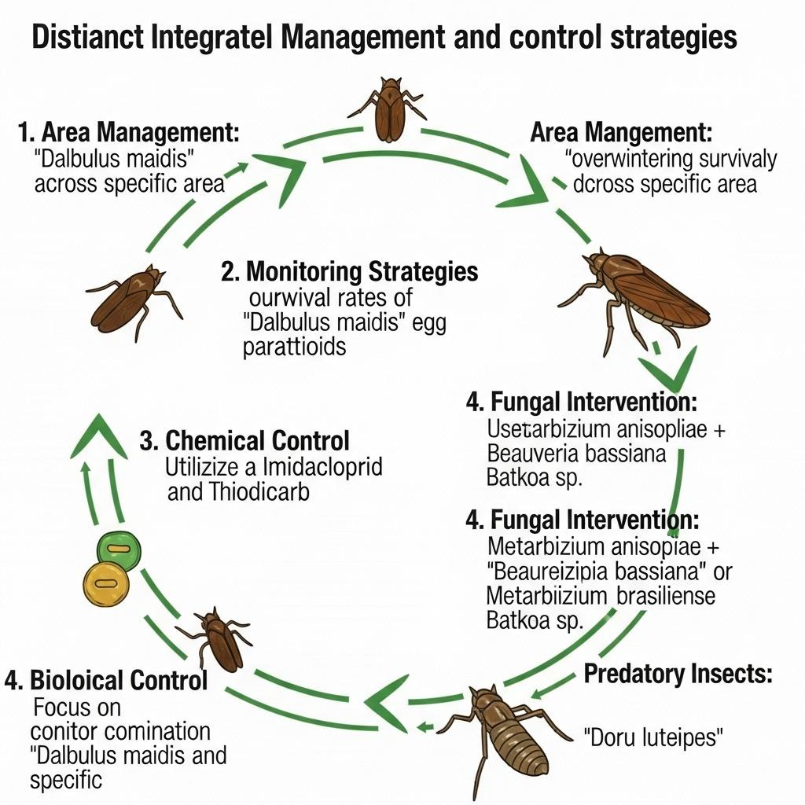

Figure 4 – Integrated Control Strategies. Conceptual model of multimodal strategies for the management of Dalbulus maidis. The diagram illustrates the functional synergy between chemical control and biological agents, highlighting the complementarity between predation by Doru luteipes and infection by entomopathogenic fungi (Metarhizium anisopliae and Beauveria bassiana). Arrows indicate combined suppression mechanisms aimed at reducing vector population density.
The data from Moya-Raygoza (2024) are crucial for regional management. The author demonstrated that asynchronous planting and, more importantly, the presence of border grasses are vital for the winter survival of parasitoids, such as P. subflava. Borders function as natural enemy refuges, allowing their subsequent migration to crops. The conservation of these micro-habitats, combined with the protection of predators like Doru luteipes (Bortolotto et al., 2024), underpins conservative biological control tactics. These practices are essential to counteract behavioral defense mechanisms, such as 'spatial escape' via oviposition site selection (Albarracín et al., 2021); by ensuring a diversity of enemies acting at different life stages of the leafhopper.
The results of the Penetration Graph (DC-EPG) technique (Maluta et al., 2023) show the success of biological behavioral disruption. For chemical control, future research should focus on new active ingredients or combinations that cause immediate behavioral disruption (reduction in phloem feeding time) and not just mortality (Silveira, 2019). There is an urgent need to develop insecticides that act during the initial feeding phase of infected D. maidis directly in the phloem (Dm4/Dm5 waves), neutralizing the vectors' inoculation capacity before insect death occurs, to equate the efficacy of biological control agents. Advancing studies on IPM for D. maidis requires the union of surveillance, ecological conservation, and, fundamentally, the synergy between resistant hybrids and biocontrol focused on vectorial interruption.
- CONCLUSION
This systematic review demonstrates that effective control of Dalbulus maidis and mitigation of corn stunting is greater with the use of various management techniques, surpassing the efficacy of isolated strategies. The results indicate that, although chemical seed treatment provides initial protection, its efficacy is temporarily limited. The sustainability of management is conditioned by the integration of biological control (microbial and conservative) and monitoring. Notably, biological agents demonstrated potential not only to induce mortality but to disrupt the vector's feeding and probing behavior, thereby reducing pathogen acquisition and inoculation. Future advancement in D. maidis management depends on IPM strategies that exploit this behavioral disruption, combining chemical selectivity, biological agents, and plant resistance.

REFERENCES

- Albarracin, E. L., Virla, E. G., & Ordano, M. (2021). Influence of the site of oviposition on the level of egg parasitism in the corn leafhopper, Dalbulus maidis (Hemiptera: Cicadellidae). Anais da Academia Brasileira de Ciências, 93, e20190686. https://doi.org/10.1590/0001-3765202120190686

- Bortolotto, O. C., Santos, J. V. C., & Ochonski, A. G. (2024). First report of earwig Doru luteipes (Dermaptera: Forficulidae) preying on corn leafhopper Dalbulus maidis (Hemiptera: Cicadellidae) nymphs. Brazilian Journal of Biology, 84, e285975. https://doi.org/10.1590/1519-6984.e285975

- Gorayeb, E. S., et al. (2025). Genetic Variability of Dalbulus maidis Populations from Brazil and Their Infectivity with Pathogens of Corn Stunt Complex. Neotropical Entomology, 54(1), 1-12. https://doi.org/10.1007/s13744-025-01257-7

- Haas, I. C. R., Canale, M. C., Lopes, J. R. S., et al. (2023). Biochemical modifications and corn stunt progression is dependent on maize susceptibility to Spiroplasma kunkelii infection. Tropical Plant Pathology, 48, 556–563. https://doi.org/10.1007/s40858-023-00598-1

- Machado, E. P., Souza, E. V., Dias, G. S., Sacilotto, M. G., & Omoto, C. (2024). Is insecticide resistance a factor contributing to the increase in problems with Dalbulus maidis (Hemiptera: Cicadellidae) in Brazil? Pest Management Science, 80(12). https://doi.org/10.1002/ps.8237.

- Maia, P. T. N., et al. (2025). Sustainable control of Dalbulus maidis: A field study with entomopathogenic fungi. Entomologia Experimentalis et Applicata.

- Maluta, N., Castro, T., & Lopes, J. R. S. (2023). DC-electrical penetration graph waveforms for Dalbulus maidis (Hemiptera: Cicadellidae) and the effects of entomopathogenic fungi on its probing behavior. Scientific Reports, 13(1), 22033. https://doi.org/10.1038/s41598-023-48779-x

- Moya-Raygoza, G. (2024). Temporal resource continuity for egg parasitoids of Dalbulus maidis (Hemiptera: Cicadellidae) during winter on irrigated maize crops and edge grasses. Journal of Insect Science, 24(4), 14. https://doi.org/10.1093/jisesa/ieae079

- Nault, L. R. (1990). Evolution of an insect pest: maize and the corn leafhopper, a case study. Maydica, 35, 165–175. https://maydica.com/

- Nault, L. R., & DeLong, D. M. (1980). Evidence for co-evolution of leafhoppers in the genus Dalbulus (Cicadellidae: Homoptera) with maize and its ancestors. Annals of the Entomological Society of America, 73, 349-353. https://doi.org/10.1093/aesa/73.4.349

- Oliveira, C. M., & Sabato, E. O. (2018). Estratégias de manejo de Dalbulus maidis, para o controle de enfezamentos e virose na cultura do milho. In M. C. D. Paes, R. G. V. Pinho, & S. G. Moreira (Eds.), Soluções integradas para os sistemas de produção de milho e sorgo no Brasil (pp. 748–777). Sete Lagoas: Embrapa Milho e Sorgo. https://www.infoteca.cnptia.embrapa.br/infoteca/bitstream/doc/1099999/1/Cap25Estrategiasdemanejo.pdf

- Oliveira, C. M., & Sabato, E. O. (2018). Estratégias de manejo de Dalbulus maidis, para o controle de enfezamentos e virose na cultura do milho. In M. C. D. Paes, R. G. V. Pinho, & S. G. Moreira (Eds.), Soluções integradas para os sistemas de produção de milho e sorgo no Brasil (pp. 748–777). Sete Lagoas: Embrapa Milho e Sorgo. https://www.embrapa.br/busca-de-publicacoes/-/publicacao/1090900/estrategias-de-manejo-de-dalbulus-maidis-para-controle-de-enfezamentos-e-virose-na-cultura-do-milho

- Oliveira, C. M., Frizzas, M. R., & Oliveira, E. (2020). Overwintering plants for Dalbulus maidis (DeLong and Wolcott) (Hemiptera: Cicadellidae) adults during the maize off-season in central Brazil. International Journal of Tropical Insect Science, 40, 1105–1111. https://doi.org/10.1007/s42690-020-00165-0

- Ouzzani, M., Hammady, H., Fedorowicz, Z., & Elmagarmid, A. (2016). Rayyan — a web and mobile app for systematic reviews. Systematic Reviews, 5, 210. https://doi.org/10.1186/s13643-016-0384-4

- Pinto, C. B., et al. (2023). Sampling Methodology of a Key Pest: Technique and Sampling Unit for Evaluation of Leafhopper Dalbulus maidis Populations in Maize Crops. Agriculture, 13(7), 1391. https://doi.org/10.3390/agriculture13071391

- Redoan, A. C. M., et al. (2025). What is the relationship between efficacy of seed treatment with insecticides against Dalbulus maidis (Delong and Wolcott) (Hemiptera: Cicadellidae) healthy and infected with spiroplasm in the corn stunt control? Insects, 16(7), 713. https://doi.org/10.3390/insects16070713

- Silveira, C. H. (2019). Eficácia de inseticidas no controle de Dalbulus maidis (DeLong & Wolcott) (Hemiptera: Cicadellidae) e da transmissão de espiroplasma do milho (Dissertação de Mestrado). Escola Superior de Agricultura “Luiz de Queiroz”, Universidade de São Paulo, Piracicaba. https://www.teses.usp.br/teses/disponiveis/11/11136/tde-16102019-104000/pt-br.php

- Whitcomb, R. F., et al. (1986). Spiroplasma kunkelii sp. nov.: characterization of the etiological agent of corn stunt disease. International Journal of Systematic and Evolutionary Microbiology, 36(2), 170-178. https://doi.org/10.1099/00207713-36-2-170

- Jones, T.-k. L., & Medina, R. F. (2020). Corn Stunt Disease: An Ideal Insect–Microbial–Plant Pathosystem for Comprehensive Studies of Vector-Borne Plant Diseases of Corn. Plants, 9(6), 747. https://doi.org/10.3390/plants9060747

- da Costa, R.V., de Almeida, R.E.M., Cota, L.V. et al. Corn stunt disease complex increases charcoal rot (Macrophomina phaseolina) under field conditions. Trop. plant pathol. 48, 283–292 (2023). https://doi.org/10.1007/s40858-023-00570-z

- Toloy, R. S., Nose, N. P., Giongo, M. V., Cangussu, A. S. R., Campos, F. S., Ootani, M. A., Ribeiro, J. M., Aguiar, R. W. S., Viteri Jumbo, L. O., Oliveira, E. E., & Santos, G. R. (2024). Exploring Natural Infection in Alternative Hosts of Corn Stunt Spiroplasma and Tracking the Temporal Dynamics of Corn Stunt Disease in the Brazilian Cerrado Biome. Agronomy, 14(10), 2341. https://doi.org/10.3390/agronomy14102341

- Oliveira, C.M., Frizzas, M.R. Eight Decades of Dalbulus maidis (DeLong & Wolcott) (Hemiptera, Cicadellidae) in Brazil: What We Know and What We Need to Know. Neotrop Entomol 51, 1–17 (2022). https://doi.org/10.1007/s13744-021-00932-9

- Dalaisón-Fuentes, L. I., Pascual, A., Gazza, E., Welchen, E., Rivera-Pomar, R., & Catalano, M. I. (2022). Development of efficient RNAi methods in the corn leafhopper Dalbulus maidis, a promising application for pest control. Pest Management Science, 78(7), 3108–3116. https://doi.org/10.1002/ps.6937

- Feinberg, J., & Keeshin, S. (2022). Prevention and initial management of HIV infection. Annals of Internal Medicine, 175, ITC81–ITC96. Advance online publication. https://doi.org/10.7326/AITC202206210

