Assessment of suitable extractant for estimating soil available potassium in acidic soils of rice- lentil cropping system

Abstract
The productivity and sustainability of rice–lentil cropping systems in acidic soils are severely constrained by potassium deficiencies, exacerbated by intensive cropping and imbalanced fertilization. Potassium plays a crucial role in plant growth, yield, stress tolerance, and nutrient use efficiency. However, the relationship between soil K dynamics, its availability to crops, and the impact on yield attributes remains inadequately explored in acidic soils. Therefore, a pot experiment was conducted under the Central Agricultural University, Imphal, Manipur to determine the K application response and the most suitable extractant in acidic soils of rice-lentil cropping system. A total number of 25 bulk soil sample (0–15 cm) were collected from rice–lentil fields of Thoubal District, Manipur, India using simple random sampling method. The soils were analysed for available potassium estimated by five extractants. The available K extracted using different extractants varies, with the strong positive correlation with potassium extracted by 1N NH₄OAc (r = 0.924, p-value < 0.001) followed by Morgan’s Reagent (r = 0.802, p-value < 0.001), while others either overestimated or underestimated available K. This study suggests that the available potassium extracted with 1N NH₄OAc is closely linked to higher yields, making it the most effective extractant for predicting plant response and yield. Further, also provides valuable diagnostic thresholds for guiding potassium fertilization in similar agro-ecological zones.
Keywords: Potassium, Rice–Lentil cropping system, Acidic soil, Extractants, Critical limit

Introduction
Potassium is an essential nutrient for plant growth, and one of the three main macronutrients together with N and P (Barbagelata, 2006). It plays a crucial role in crop growth and development. Its influence extends beyond basic nutrition, significantly affecting various physiological and biochemical processes that enhance overall crop yield and quality. Among the essential plant nutrients, potassium assumes greater significance because it is needed in comparatively larger amounts by plants and besides increasing the yield and immensely enhances the crop produce quality (Srinivasrao et al., 2011). But potassium is a neglected nutrient in an intensive agricultural production because of the general conception that Indian soils are rich in native-K resulted from the exclusion of potassium in balanced nutrition led to the mining of soil reserve K. In a balanced nutrition the exclusion of K leads to the mining of soil reserve K. Rice-lentil cropping system represent a crucial agricultural strategy, particularly in areas like the Indo-Gangetic Plains of India. There is some concern now that the increased crop yields and nutrient withdrawal, in combination with unbalanced fertilization, lead to depletion of the soil potassium and to K deficiency. Assessing potassium availability in soil is essential for optimizing plant nutrition. A variety of extractants have been tested for their efficacy in estimating plant-available K, each employing distinct methodologies and yielding different results. The neutral normal ammonium acetate, which extracts both solution and exchangeable K (surface and edge sites), has been used as the most widely accepted extractant for evaluating plant-available soil K in most soil testing laboratories (Bedi et al., 2002; Aramrak et al., 2007). Many researchers alternatively suggested the non-exchangeable K as the index of long-term K supplying ability of many soils (Laxminarayana et al., 2011; Tafaroji et al., 2005) and boiling 1 N HNO₃ method, has been advocated (Bhatt and Meisheri, 2007; Tiwari et al., 1996). The greatest research challenge lies with selecting a suitable chemical extractant for determining the K availability under a particular set of soil, crop, and climatic condition (Jones, 1998) and the suitability of the method needs to be further evaluated by comparing the soil test results with some universally accepted standard values. Therefore, it is necessary to assess the ability of potassium extractants to assess plant-available K in a wide range of soils and plants. Keeping this in view, a study was carried out to assess the relative suitability of extractants for predicting the available potassium status of rice - lentil cropping system soil in acidic condition.
Materials and Methods
A total of twenty- five bulk soil samples (0-15 cm) depth were collected from different fields of rice-lentil cropping system of Thoubal district, Manipur, India with proper geo referenced using simple random sampling method. The collected soil samples were air dried in shade, processed and passed through a 2mm sieve and subjected to routine chemical analysis. The available potassium of the soil samples was determined using different chemical extractants as shown in Table 1.
Table 1. Extractants for estimation of soil available potassium
Sl. No. | Extractant | Soil: Extractant ratio | Shaking time | References
1. | 1N NH₄OAc | 1.5 | 30 min | Muhr et al. (1965)
2. | 0.01 M CaCl₂ | 1:2 | 30 min | Woodruff and Mcintosh (1960)
3. | 1N HNO₃ | 1:10 | 10 min boiling | Wood and DeTurk (1941)
4. | 6N H₂SO₄ | 1:10 | Keep for 30 min followed by leaching | Hunter and Pratt (1957)
5. | Morgan’s reagent (P^{H} 7.0) | 1:2 | 1 min | Morgan (1941)
6. | Distilled water | 1:10 | 30 min | Mac Lean (1960)

Pot experiment
A pot experiment was conducted under Central Agricultural University, Imphal, Manipur to determine the K application response and the most suitable extractant. Five kgs each of air-dried soils were filled in polyethylene pots, and arranged in a Completely Randomized Design (CRD) with seven different levels of potassium (0, 10, 20, 30, 40, 50 and 60 kg K₂O ha⁻¹) through Muriate of Potash and replicated thrice. The recommended dose of nitrogen @ 60 kg ha⁻¹ and phosphorus @ 40 kg ha⁻¹ were applied as basal through urea and SSP. Rice variety (RC Maniphou- 13) seedling of 25 day old was transplanted in each pot following the lowland rice water management practices. The rice plants from each pot were harvested at 45 days after transplanting, washed and dried in hot air oven at 65ºC for 24 hours. The dry matter yield of rice was recorded. Bray’s percent yield was calculated using the formula-
Yield of dry matter in control pots
Bray’s percent yield = --------------------------------------------------------------- x 100
Maximum dry matter yield of the treated pots

Statistical analysis
The Pearson correlation coefficient was calculated to assess the linear relationships among related variables. Prior to the application of parametric tests, a normality test was conducted to verify the distributional assumptions of the data. Only after confirming the assumption of normality were appropriate parametric tests applied. All statistical analyses and custom functions were implemented using the R programming language. Graphical illustrations, including plots and visual summaries, were developed using both R and Python to ensure clarity and precision in data presentation.
Results
Soil properties
Analysis of 25 soil samples from the rice-lentil cropping system of Thoubal District, Manipur varied in their properties (Table 2). They were clay in texture with acidic soil P^{H} ranging from 5.32 to 5.99, moderate to high organic carbon (1.09 - 1.86 %), bulk density (1.09 - 1.75 g cm⁻³), low levels of EC (0.15 – 0.65 dsm⁻¹), CEC ranges from 16.50 to 37.94 cmol (+) kg⁻¹ . Nutrient availability assessments showed mean available soil nitrogen (359.64 kgha⁻¹), phosphorus (13.01 kgha⁻¹), and potassium (274.13 kgha⁻¹) respectively.
Table 2. Selected properties of rice-lentil cropping system soils (n=25)
Soil properties | Minimum | Maximum | Mean ± SD | CV
¹Bulk density (g cm⁻³) | 1.09 | 1.75 | 1.41 ± 0.19 | 0.13
²P^{H} (1:2.5 soil water) | 5.32 | 5.99 | 5.60 ± 0.19 | 0.03
³ EC (dsm⁻¹) | 0.15 | 0.65 | 0.40 ± 0.16 | 0.40
⁴CEC (cmol P⁺ kg⁻¹) | 16.50 | 37.94 | 28.55 ± 5.92 | 0.21
⁵OC (%) | 1.09 | 1.86 | 1.45 ± 0.23 | 0.16
⁶Available N (kg ha⁻¹) | 256.23 | 482.46 | 359.63 ± 65.46 | 0.18
⁷Available P₂O₅ (kg ha⁻¹) | 7.67 | 18.60 | 13.01 ± 3.37 | 0.26
⁸Avail. K₂O (kg ha⁻¹) | 168.15 | 369.28 | 274.13 ± 72.52 | 0.26
⁹Texture | Clay
¹Keen-Rackzowski Box method (Baruah and Borthakur,1997), ²P^{H} meter (soil: water, 1:2.5) (Jackson,1973), ³Electrical conductometer (Jackson,1973), ⁴Ammonium acetate saturation method (Borah et al., 1987),⁵Walkley and Black’s rapid titration method (Jackson,1973), ⁶Alkaline potassium permanganate method (Subbiah and Asija,1956),⁷Bray’s method (Bray and Kurtz,1945), ⁸1N NH₄OAc (Muhr et al., 1965), ⁹Hydrometer method (Bouyoucos, 1962)
Potassium extraction by various methods
Significant variation existed in available K content of twenty-five georeferenced soil extracted by six different extractants (Table 3).
Table 3. Mean and ranges of available K (kg ha⁻¹) extracted by different extractants (n=25)
Extractant | Mean ± SD | Range
0.01M CaCl₂ | 50.04 ± 11.50 | 30.17-74.35
1N HNO₃ (boiling) | 469.51± 74.64 | 309.39 - 628.80
1N NH₄OAc | 274.13 ± 72.52 | 168.15 - 369.28
6N H₂SO₄ | 1086.76 ± 237.24 | 698.77-1563.43
Morgan’s reagent | 401.34 ± 86.43 | 262.86 - 552.83
Distilled water | 39.79 ± 11.34 | 20.07- 63.93

Bray’s Yield (%)
Bray's Yield (%), which represents the ratio of yield under control (no added potassium) to the optimum yield (with potassium application), reflects the potassium sufficiency of the soil in supporting plant growth. The overall Bray's yield ranged from 67.76% to 96.71%, with a mean of 80.48% and a standard deviation of 8.53, showing moderate variability in potassium responsiveness across the sampled soils.as shown in Table 4. This range indicates that some soils had nearly optimal yields even without potassium addition, suggesting sufficient native soil K. In contrast, other soils had a significant yield response to potassium fertilization, highlighting potassium deficiency.

Table 4. Effect of potassium on dry matter yield and Bray’s percent yield of rice
Sample | Soil K (kg ha⁻¹)  1N NH₄OAc | Plant K% (Control) | Dry matter (g pot⁻¹) |  | Bray’s yield (%)
Sample | Soil K (kg ha⁻¹)  1N NH₄OAc | Plant K% (Control) | Yield  (Control) | Optimum Yield | Bray’s yield (%)
1 | 345 | 1.37 | 9.20 | 10.59 | 86.86
2 | 334.62 | 1.62 | 8.31 | 10.07 | 82.57
3 | 364.25 | 1.65 | 9.63 | 10.17 | 94.63
4 | 339.85 | 1.4 | 8.67 | 10.12 | 85.67
5 | 215.97 | 1.46 | 8.23 | 10.85 | 75.92
6 | 207.17 | 1.38 | 9.56 | 11.09 | 86.19
7 | 333.64 | 1.67 | 9.47 | 11.67 | 81.15
8 | 358.5 | 1.39 | 9.86 | 11.93 | 82.61
9 | 365.76 | 1.52 | 11.94 | 12.88 | 92.66
10 | 328.3 | 1.66 | 7.98 | 8.35 | 95.59
11 | 168.15 | 1.45 | 9.60 | 13.43 | 71.47
12 | 192.82 | 1.7 | 10.16 | 12.59 | 80.71
13 | 204.43 | 1.37 | 7.68 | 11.33 | 67.76
14 | 194.85 | 1.63 | 9.98 | 13.56 | 73.57
15 | 188.53 | 1.47 | 6.82 | 9.58 | 71.17
16 | 342.9 | 1.53 | 8.02 | 10.83 | 74.05
17 | 369.28 | 1.46 | 8.45 | 12.24 | 69.04
18 | 211.25 | 1.62 | 9.15 | 10.68 | 85.71
19 | 328.66 | 1.66 | 11.53 | 11.92 | 96.71
20 | 192.02 | 1.46 | 8.37 | 11.28 | 74.2
21 | 213.71 | 1.62 | 8.79 | 10.96 | 80.15
22 | 204.41 | 1.6 | 8.84 | 12.31 | 71.79
23 | 323.94 | 1.59 | 10.86 | 13.37 | 81.29
24 | 252.2 | 1.44 | 8.28 | 11.56 | 71.62
25 | 273.15 | 1.66 | 8.56 | 10.85 | 78.89
Mean | 274.13 | 1.54 | 9.12 | 11.37 | 80.48
S D (±) | 72.52 | 0.11 | 1.19 | 1.26 | 8.53
CV | 0.26 | 0.07 | 0.13 | 0.11 | 0.11

Relationships between extractable K and plant response
The correlation matrix shows the relationship between Bray’s yield and available potassium extracted using different extractants in acid soil. Bray’s yield (%) showed a strong positive correlation with potassium extracted by 1N NH₄OAc (r = 0.924, p-value < 0.001) as shown in Fig. 2. This suggests that the available potassium extracted with 1N NH₄OAc is closely linked to higher yields, making it the most effective extractant for predicting plant response and yield. Bray’s yield also showed a significant positive correlation with 6N H₂SO₄ (r = 0.474, p-value < 0.001), 1N HNO₃ (r = 0.415, p-value < 0.001), and Morgan’s solution (r = 0.802, p-value < 0.001). These extractants also have strong correlations with yield, but the correlation is not as high as with 1N NH₄OAc. The 0.01 M CaCl₂ extractant shows a moderate positive correlation with Bray’s yield (r = 0.335, p-value = 0.003) as observed in Fig. 5. While significant, this correlation is weaker than the others, indicating that calcium chloride may be a less effective indicator of available potassium for predicting yield. 1N NH₄OAc shows the strongest correlations across the board with the other extractants, particularly with Morgan’s solution (r = 0.879, p-value < 0.001), 6N H₂SO₄ (r = 0.441, p-value < 0.001), and 1N HNO₃ (r = 0.450, p-value < 0.001) as observed in Fig.1, indicating that it is a robust method for extracting potassium in this soil context. 0.01 M CaCl₂ has the weakest direct correlation with Bray’s yield (r = 0.335, p-value = 0.003). This suggests that CaCl₂ may not be as efficient in reflecting the available potassium that influences yield in acidic soils.

The best extractant for potassium, in terms of its ability to predict Bray’s yield in acidic soil, appears to be 1N NH₄OAc, as it showed the strongest correlation with both available potassium and yield (r = 0.924, p-value < 0.001). Morgan’s solution also performed well, especially for predicting yield (r = 0.802, p-value < 0.001) shown in Fig. 4, and could be considered good alternatives, depending on specific needs and laboratory availability. 0.01 M CaCl₂, although commonly used in some contexts, has a weaker correlation with Bray’s yield and may not be the most effective extractant for potassium in these soils. Therefore, 1N NH₄OAc stands out as the most reliable extractant for predicting potassium availability and its relationship with crop yield in acidic soils. It should be prioritized in future potassium extraction and soil fertility studies in this region.
Discussion
The observed correlations between extractable K and crop response highlight the critical role of selecting an appropriate extractant for accurate assessment of K availability in acidic soils. The high correlation observed with 1 N NH₄OAc (0.92) suggests its suitability for estimating plant-available K in these soils, potentially due to its effectiveness in replacing K⁺ ions from the exchange sites of clay minerals and organic matter. This was in conformity with the findings of Amorim et al. (2021). This was also supported by the understanding that ammonium ions (NH₄⁺) have a similar ionic radius and charge density to K⁺, facilitating the displacement of K⁺ from soil colloids into the solution (Simonis,1996). Conversely, the relatively low correlations obtained with distilled water and 0.01 M CaCl₂ indicate their limited ability to extract K⁺ from the soil matrix in these acidic conditions. Distilled water primarily extracts readily soluble K, which may not represent the K pool accessible to plants over the growing season. Similarly, 0.01 M CaCl₂, while useful for flocculating soil particles and estimating ionic strength, does not efficiently displace adsorbed K⁺ ions, resulting in an underestimation of available K. Similar observations have also been obtained by Gianello and Amorim (2015). The moderate correlations observed with 1 N HNO₃ and 6 N H₂SO₄ suggest that these strong acids can release K⁺ from non-exchangeable forms through mineral dissolution. This was in conformity with the findings reported by Sardi and Csitari (1998). However, their use as routine extractants is limited due to their potential to overestimate K availability by extracting K from structural components of soil minerals that are not readily accessible to plants (Rezk and Amer, 1969).
The correlation observed with Morgan's reagent, which is an acidic buffer solution commonly used in soil testing, indicates its potential to estimate plant-available K in these acidic soils. The choice of extractant should consider the specific soil characteristics and the K dynamics in the soil-plant system to provide a reliable estimate of K availability for optimal crop nutrition (Mc Lean and Watson, 1985). It is also important to acknowledge that extractants like 1 N NH₄OAc may not always be indicative of K uptake by plants (Charbonnier et al., 2020). The selection of the most appropriate extractant is important for managing soil fertility and optimizing crop production.
Conclusion
The significant correlation between 1 N NH₄OAc extractable K and crop response underscores its reliability in predicting K availability to plants in the studied soils. The ability of ammonium acetate to effectively estimate K availability can be attributed to its capacity to mimic the K uptake process by plants, where K⁺ ions are exchanged with other cations at the root surface. This exchange process is particularly relevant in soils with a high cation exchange capacity, where K⁺ ions are predominantly held on exchange sites. The lower correlations observed with other extractants highlight the limitations of relying solely on readily soluble K or K released by strong acids for assessing plant-available K.
The results emphasize the need for a more comprehensive approach that considers the dynamic equilibrium between different K forms in the soil and the specific mechanisms of K uptake by plants. The use of strong acids like 1 N HNO₃ and 6 N H₂SO₄ may overestimate available potassium by extracting K from structural components of soil minerals that are not readily accessible to plants. This can lead to an inaccurate assessment of K availability and potentially result in over-fertilization or sub-optimal crop nutrition management. This study suggests that the available potassium extracted with 1N NH₄OAc is closely linked to higher yields, making it the most effective extractant for predicting plant response and yield. Further, also provides valuable diagnostic thresholds for guiding potassium fertilization in similar agro-ecological zones.

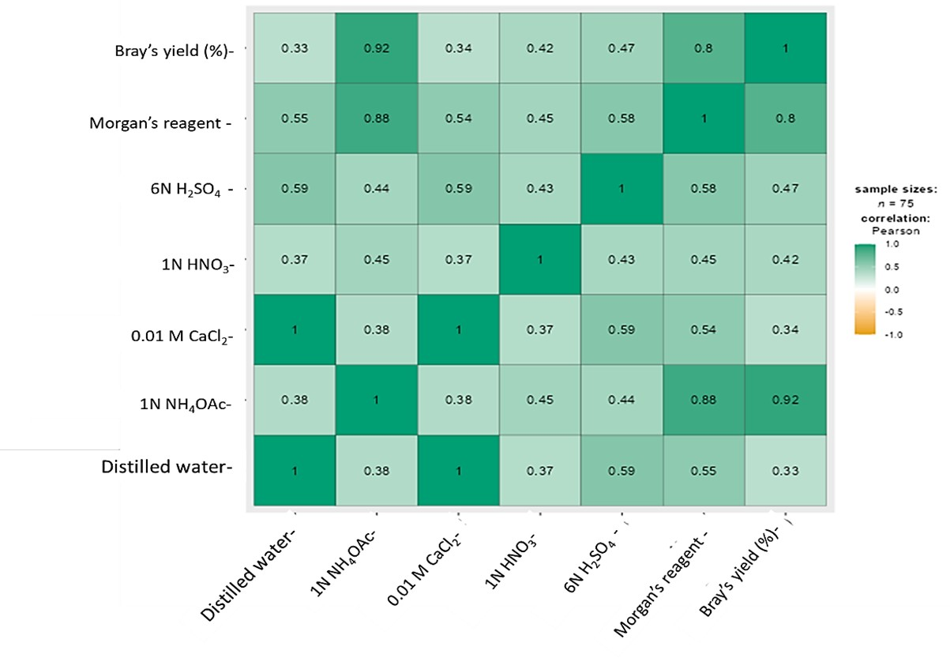

Figure 1. Correlation of different extractants of available potassium (K) with Bray’s yield (%)

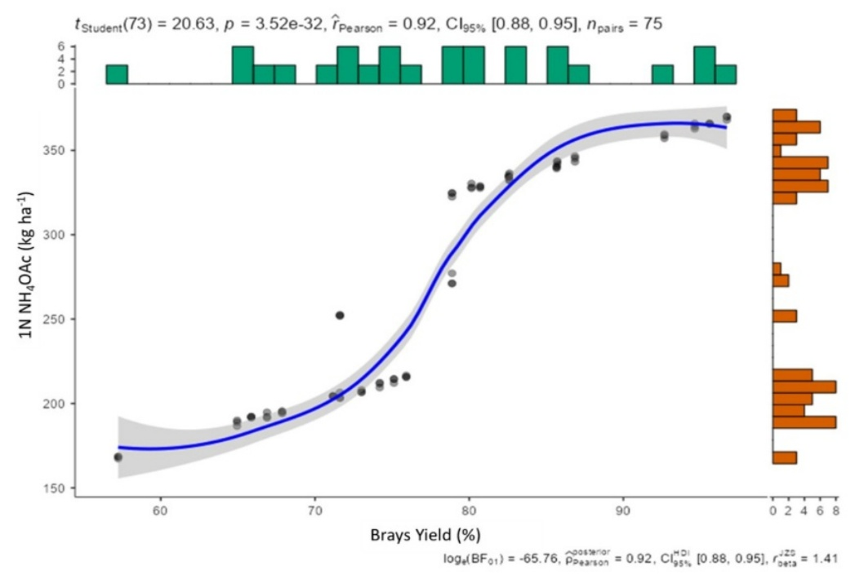
Figure 2. Correlation of potassium (kg ha⁻¹) determine by 1N NH₄OAc extractant with Bray’ s yield (%)

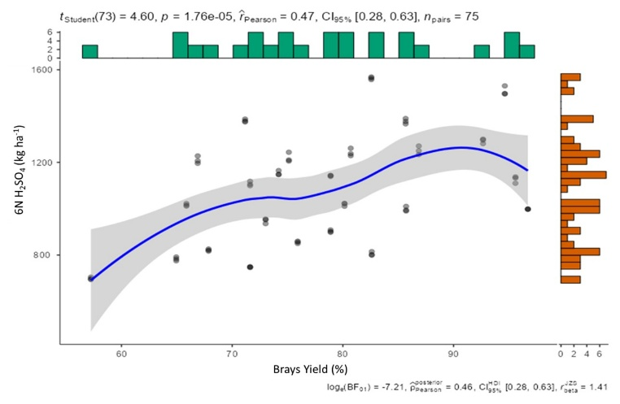
Figure 3. Correlation of potassium (kg ha⁻¹) determine by 6N H₂SO₄ extractant with Bray’ s yield (%)

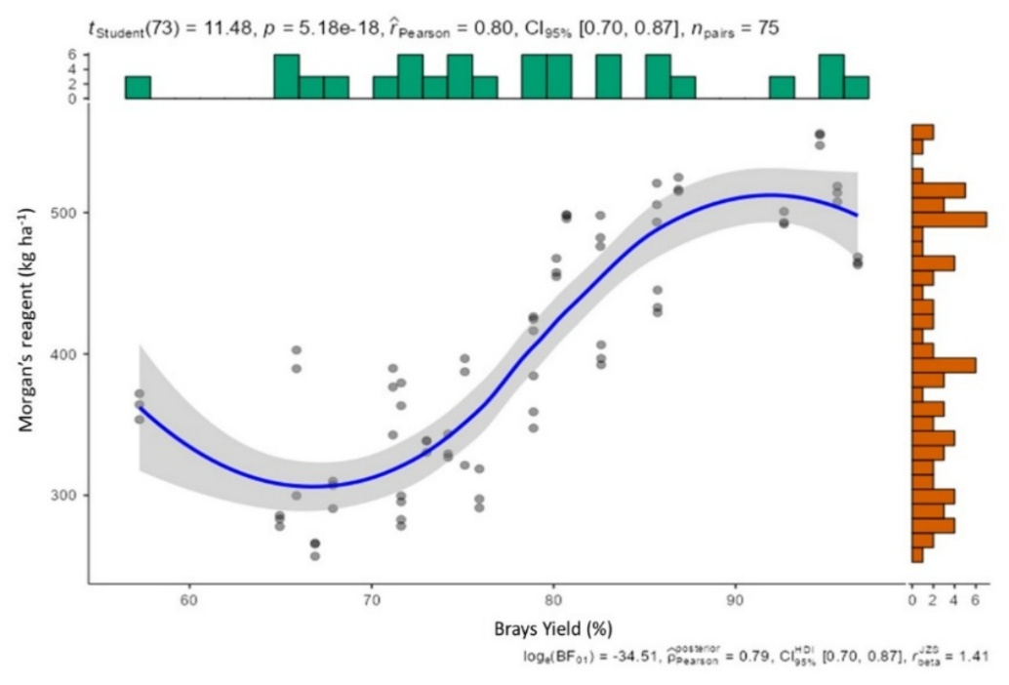
Figure 4. Correlation of potassium (kg ha⁻¹) determine by Morgan’s reagent extractant with Bray’ s yield (%)
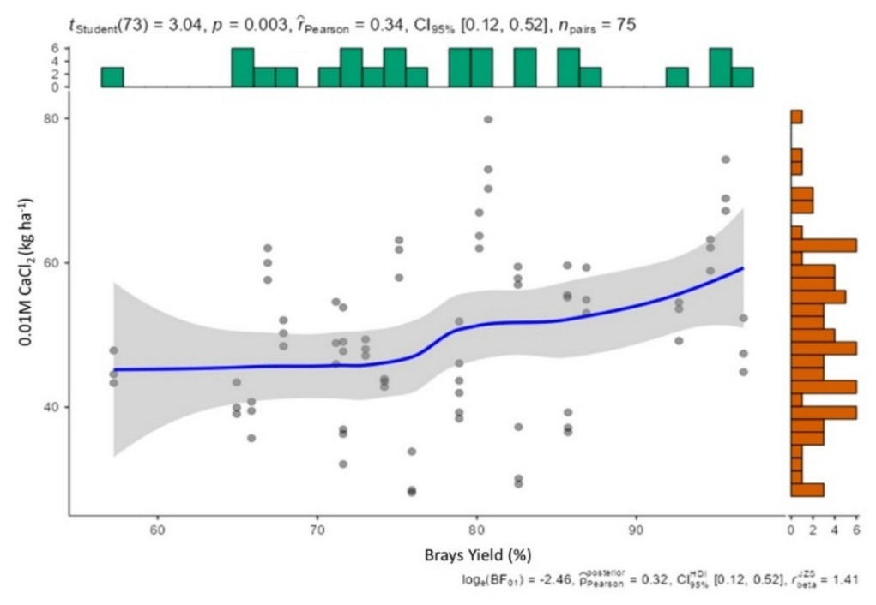
Figure 5. Correlation of potassium (kg ha⁻¹) determine by 0.01M CaCl₂ extractant with Bray’ s yield (%)

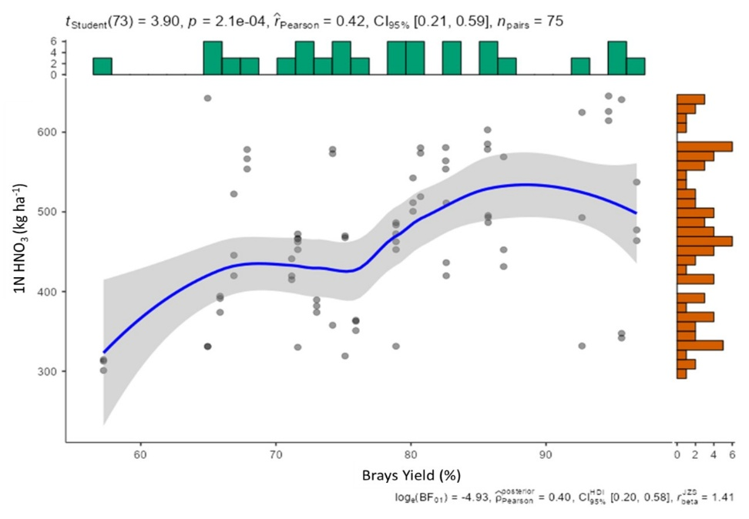
Figure 6. Correlation of potassium (kg ha⁻¹) determine by 1N HNO₃ extractant with Bray’ s yield (%)
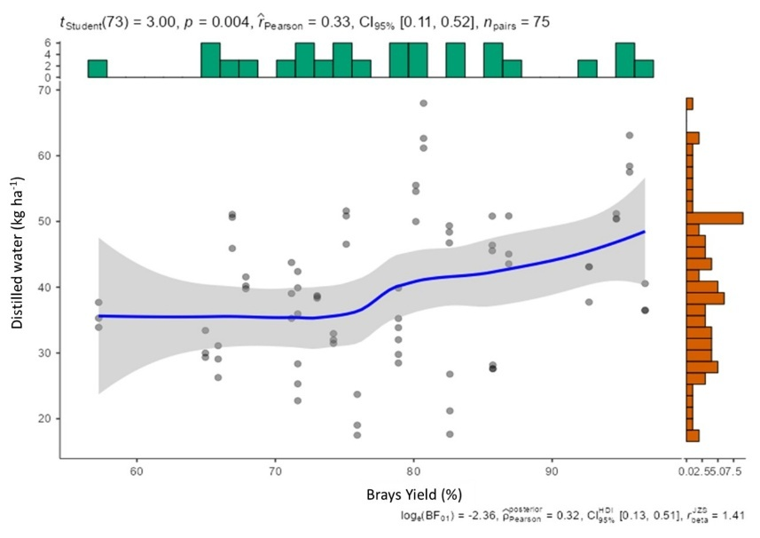
Figure 7. Correlation of potassium (kg ha⁻¹) determine by distilled water extractant with Bray’ s yield (%)

References
Amorim, M. B., Rogeri, D. A., & Gianello, C. (2021). Potassium available to corn plants extracted by ammonium acetate, ammonium chloride, Mehlich-1 and Mehlich-3 solutions in Southern Brazilian soils. Communications in Soil Science and Plant Analysis, 52(15), 1790–1797. https://doi.org/10.1080/00103624.2021.1892736 .
Aramrak, S., Chanchareonsook, J., Suwannarat, C., & Sarobol, E. (2007). Assessment of multielement extractants for prediction of available potassium in Thai soils. Agriculture and Natural Resources, 41(3), 461-466. https://li01.tci-thaijo.org/index.php/anres/article/view/244266 .
Barbagelata, P. A. (2006). *Evaluation of potassium soil tests and methods for mapping soil fertility properties in Iowa corn and soybean fields* (Doctoral dissertation, Iowa State University). https://lib.dr.iastate.edu/rtd/1797 .
Baruah, T. C. and Borthakur, H. P. (1997). Soil Physics. In: A textbook of Soil Analysis, Vikas Publishing House Pvt. Ltd., New Delhi.
Bedi, A.S., Wali, P., Verma, M.K. (2002). Evaluation of extractants and critical levels for potassium in wheat. Journal of the Indian Society of Soil Science, 50(3):268-271.
Bhatt, V.R. and Meisheri, M.B. (2007). Relative efficacy of soil test methods to measure changes in K status due to uptake, addition and release of potassium in calcareous soil under continuous cropping. The Asian Journal of Soil Science, 2(1):28-32.
Borah, D. K., Bordoloi, P. K., Karmakar, R.M., Baruah, N. G. and Das, M. (1987). Practical manual of Fundamental of Soil Science (Part-III). Assam Agricultural University, Jorhat, Assam.
Bouyoucos, G. J. (1962). Hydrometer method improved for making particle size analyses of soils. Agronomy Journal, 54, 464–465. https://doi.org/10.2134/agronj1962.00021962005400050028x .
Bray, R. H., & Kurtz, L. T. (1945). Determination of total, organic, and available forms of phosphorus in soils. Soil Science, 59(1), 39–46. https://doi.org/10.1097/00010694-194501000-00006 .
Charbonnier, D. A., Coelho, M. J., & Ruiz Diaz, D. A. (2020). Cation exchange resins as indicator of in-season potassium supply for Soybean in Kansas. Kansas Agricultural Experiment Station Research Reports, 6(9):12. https://doi.org/10.4148/2378-5977.7980 .
Gianello, C., & Amorim, M. B. (2015). Ammonium chloride solution as an alternative laboratory procedure for exchangeable cations in Southern Brazilian Soils. Communications in Soil Science and Plant Analysis, 46(1), 94–103. https://doi.org/10.1080/00103624.2014.999020 .
Hunter, A. H., & Pratt, P. F. (1957). Extraction of potassium from soils by sulfuric acid. Soil Science Society of America Journal, 21, 595–598. https://doi.org/10.2136/sssaj1957.03615995002100060007x .
Jackson ML. Soil chemical analysis. Prentice Hall of India Private Ltd., New Delhi, 1973, 56-70.

Jones Jr, J. B. (1998). Soil test methods: past, present, and future use of soil extractants. Communications in Soil Science and Plant Analysis, 29(11-14), 1543-1552. https://doi.org/10.1080/00103629809370048 .
Laxminarayana, K., Bharali, S., & Patiram. (2011). Evaluation of chemical extraction methods for available potassium in rice soils of Meghalaya. Journal of the Indian Society of Soil Science, 59(3), 295-299..
MacLean, A.J. (1960). Water soluble potassium, percent K-saturation and pK-1/2p (Ca+Mg) as indices of management effects on K status of soils. Transactions 7th International Congress on Soil Science, Madison III: 86-91.
Mc Lean, E. O., & Watson, M. E. (1985). Soil measurements of plant-available potassium. In R. D. Munson (Ed.), *Potassium in Agriculture* (pp. 277–308). American Society of Agronomy, Crop Science Society of America, Soil Science Society of America. https://www.echocommunity.org/resources/a0e2111e-121e-411e-821e-1e121e121e12 .
Morgan, M. F. (1941). Chemical soil diagnosis by the universal soil testing system. Connecticut Agricultural Experiment Station Bulletin, (450)..
Muhr, G. R., Datta, N. P., Sankarasubramoney, H., Leley, V. K., & Donahue, R. L. (1965). *Soil testing in India*. U.S. Agency for International Development, Mission to India..
Rezk, A. I. and Amer, F. (1969). Exchangeable potassium and its selectivity by soils as quantity‐intensity parameters for soil potassium. Soil Science Society of America Journal, 33(6): 876–880.
Sardi, K., & Csitari, G. (1998). Potassium fixation of different soil types and nutrient levels. Communications in Soil Science and Plant Analysis, 29(11–14), 1843–1850. https://doi.org/10.1080/00103629809370074 .
Simonis, A. D. (1996). Effects of pH and solvent/soil ratio on extraction of potassium by various extracting solutions compared to neutral molar ammonium acetate. Communications in Soil Science and Plant Analysis, 27(5–8), 919–934. https://doi.org/10.1080/00103629609369629 .
Srinivasarao, C., Satyanarayana, T. and Venkateswarlu, B. (2011). Potassium mining in Indian agriculture: Input and output balance. Karnataka Journal of Agricultural Sciences, 24(1): 20-28.
Subbiah, B. V., & Asija, G. L. (1956). A rapid procedure for the estimation of available nitrogen in soils. Current Science, 25, 259-260. https://www.cabidigitallibrary.org/doi/10.1079/PA20063060001 .
Tafaroji, S.H., Haghparast-Tanha, M.R. and Vasse-Mosalla, S. (2005). Evaluation of different extraction methods to extract available potassium in soils of Guilan province. Journal of Agricultural Sciences, 1(6):27-40.
Tiwari, A., Misra, S.G., Tiwari, R. (1996). Calibration of soil test methods and assessment of critical limits of potassium in soils and plants of chickpea. Indian Journal of Pulses Research, 9(1):43-46.
Wood, L. K., & DeTurk, E. E. (1941). The absorption of potassium in soils in non-replaceable forms. Soil Science Society of America Journal, 5, 152–161. https://doi.org/10.2136/sssaj1941.036159950005000C0026x .
Woodruff, C. M. and Mcintosh, J. L. (1960). Testing soil for potassium. Transactions 7th International Congress of Soil Science: 80–85.

