A Hybrid Feature-Based SVM Approach for Image-Based Fabric Type Classification

Abstract
Accurately identifying fabric types is a complex and important issue in the textile industry, as materials such as cotton, denim, linen, polyester, and silk often have similar characteristics. Traditional manual methods of separating fabrics are time-consuming, expensive, and susceptible to human error. Recently, image-based fabric classification using computer vision and machine learning technologies has emerged as a promising solution. However, many conventional studies have focused only on texture- or color-based features, which limits the ability to accurately distinguish between all types of fabrics. This study proposes a hybrid feature-based approach that integrates color features, shape features, and local binary pattern (LBP) texture features. By combining these hybrid features, we can represent the physical properties of each fabric in a multidimensional way, resulting in more accurate classification than achieved with a single feature type. The support vector machine (SVM) algorithm is used for classification and its performance is evaluated using different kernel functions, including radial basis function (RBF), linear and polynomial kernels. Experimental results show that the proposed method achieves very high performance, with an overall accuracy of 99.9%, precision of 0.9991, recall of 0.9991 and F1-score of 0.9991 in fabric classification, where the linear kernel exhibits superior performance in most cases. This study contributes to an automated image-based fabric recognition method that can be applied in quality control, inventory management and automated production processes within the textile industry.
Keywords: Support Vector Machine (SVM), Fabric Types, Local Binary Pattern (LBP), Radial Basis Functions (RBF), Hybrid Features (HF).
- Introduction
Accurate identification of fabrics presents a complex, important and challenging problem in the textile industry. Different types of fabrics such as cotton, denim, linen, polyester and silk often have similar colors, textures and shapes. As a result, it can be difficult for individuals to identify fabrics by sight or touch alone. Traditional manual identification methods are not only time-consuming and laborious, but also expensive. In addition, these methods are susceptible to human error, which leads to potential problems in production, quality control and inventory management. Therefore, there is a need for advanced technologies that enable automated, fast and accurate fabric identification. In addition, Darl et al. [1] in 1997 offered an automated machine vision-based method for fabric pilling detection and classification, reducing human subjectivity but potentially having limitations due to illumination and threshold values. Wang Xet al.[2] in 2011 proposed a deep learning-based approach for fabric defect classification using Convolutional Neural Network (CNN), achieving higher accuracy than conventional algorithm. Moreover, Shady et al.[3] in 2012 developed a digital image processing method for fabric texture and weave pattern identification, dividing images into sub-images using Wiener filters. The method accurately identified structure in uni-color fabrics and determined cover factor and spacing. Zhang et al.[4] in 2013 highlight the advancement of image analysis technology in fabric identification, highlighting its efficiency and potential for future advancements. The scheme of [5] in 2016 proposed an automated machine vision-based method for fabric defect detection and classification, using thermal camera temperature difference measurement and wavelet transform, thresholding, and morphological operations. Similarly, Mohanty et al.[6] in 2017 proposed an automated method for fabric defect detection and classification using image mining and association rule miner. It achieves an average accuracy of 92%, but faces limitations like image quality dependence, limited datasets, and complexity. Mishra et al. [7] in 2019 compared machine learning algorithms for fabric defect detection using DFT features, revealing Random Forest as the most accurate, but its applicability in real industrial environments is limited. Hussain et al.[8] in 2020 developed a deep convolutional neural network-based model for woven fabric pattern recognition and classification. Rasheed et al.[9] in 2020 review computer vision and digital image processing techniques for fabric defect detection in the textile industry, highlighting the efficiency and accuracy of automated vision systems over human-based inspection methods. Liu et al.[10] in 2024 developed a lightweight, efficient convolutional neural network (CNN) model for fabric image classification, achieving 99.5% accuracy. The model, optimized using global average pooling, outperformed classic models and is suitable for vision-based textile applications like fabric retrieval and defect detection. Nugroho et al.[11] in 2024 developed a low-cost prototype system for defect detection in fabric production using Google Teachable Machine and. Finally, the scheme of [12] in 2024 developed a LabVIEW-based automated system for fabric defect detection and classification. This study proposes a hybrid feature-based approach that combines color, shape, and local binary pattern (LBP) texture features to identify visual features of fabrics. Color features help identify light or dark colors, distributions, and distinct elements. Shape features analyze silhouettes, fiber patterns, and irregular shapes. LBP texture features identify subtle textural patterns, which are essential for distinguishing fabric types such as cotton, linen, or denim. Combining these features improves accuracy compared to single-feature classification by representing physical and aesthetic features within a multidimensional feature space. This study uses the Support Vector Machine (SVM) algorithm for fabric classification, a powerful machine learning model that distinguishes fabric classes within a high-dimensional feature space. The performance of the model is evaluated using kernel functions such as RBF, linear, and polynomial kernels. The combination of hybrid features and RBF kernel improves accuracy, precision, recall, and F1-score in most scenarios. The research introduces an automatic image-based fabric recognition method for the textile industry, increasing labor efficiency, reducing human errors, and improving overall production quality. It also suggests the potential for broad application in complex fabric classification and large-scale textile databases. The primary contributions of the research are:
- This study proposes an integrated hybrid feature set that combines color, shape, and LBP texture features to accurately represent the multidimensional characteristics of each fabric.
- This study also involves analyzing the performance of various kernel functions in SVM classification, comparing their effectiveness, and identifying the optimal kernel.
- Developing a high-precision automatic fabric classification system that can be applied to quality control, rapid classification, and smart production systems in the textile industry in the future.
The rest of the paper is organized as follows: Section 2 demonstrates the methodology and dataset, Section 3 provides the experimental results and analysis, and Section 4 concludes the paper.
- Methodology and Dataset
In this section, we have discussed the proposed methodology, dataset, and method evaluation metrics. This study presents a hybrid approach for classifying fabrics using images, utilizing a Support Vector Machine (SVM) classifier to integrate color, shape, and texture features. Figure 1 demonstrates the proposed methodology. The proposed method is organized into several key steps (3.1-3.6).
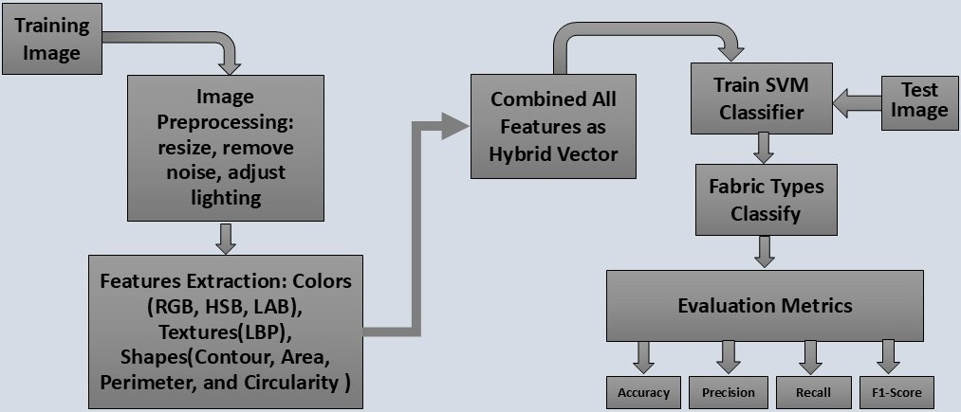

Figure 1. Workflow of the proposed hybrid feature-based fabric classification methodology.
2.1 Dataset collection and preparation
Images of five types of fabrics—cotton, denim, linen, polyester, and silk—were collected from local markets and from the Internet and textile mills. These images were taken using a Samsung smartphone, which was held at a certain distance. To ensure balance in the classification, a total of 75 images were collected for each category. The images were taken under different lighting conditions and from different angles to accurately reflect real-world situations. Figure 2 illustrates the image data of the five types of fabrics. Table 1 in Section 3.1 provides details about the fabric types in the image dataset and will be discussed.
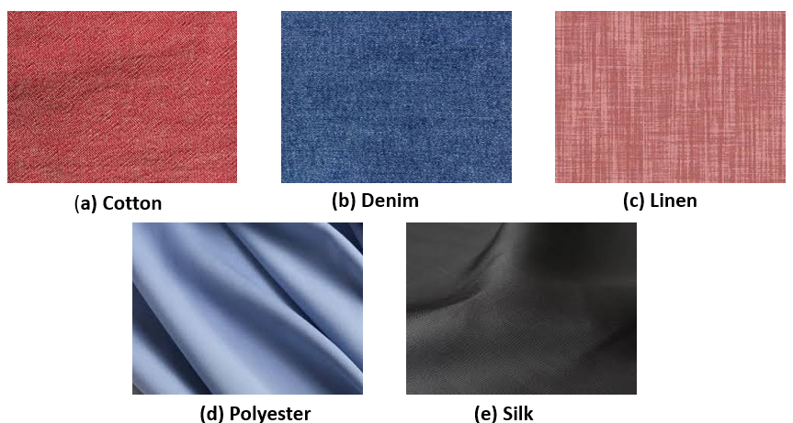

Figure 2. Depiction of five fabric samples.
2.2 Image Pre-processing
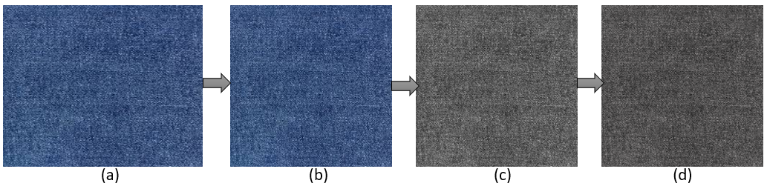
To ensure reliable feature extraction and reduce unwanted variations, we implemented a systematic preprocessing pipeline for all collected images. The first step involved resizing each original image to a standardized resolution of 250×250 pixels (see Figure 3b), which helped eliminate inconsistencies due to varying image dimensions. Next, the resized images were converted from RGB to grayscale (refer to Figure 3c). This conversion was crucial because it reduced computational complexity and minimized the effects of color variations while preserving essential texture and structural information on the fabric surface. In the final stage, contrast enhancement was applied to the grayscale images (illustrated in Figure 2d). This step highlighted fine details, improved the visibility of subtle patterns, and made the features more robust for subsequent analysis and classification tasks. Figure 3 (a–d) illustrates the overall sequence of preprocessing steps: (a) original image, (b) resized image, (c) grayscale conversion, and (d) contrast-enhanced image.
Figure 3. Image preprocessing steps: (a) Original image, (b) Resized (250×250), (c) Grayscale conversion, and (d) Contrast enhancement.
2.3. Feature Extraction
A hybrid feature set is created from each image, which includes three types of features: color features, shape features, and texture features. Color features consist of histograms and percentage color distributions calculated based on the RGB, HSV, and LAB color spaces of the images, revealing the color differences present in the fabric [13]. Shape features include shape-based attributes such as contour, area, perimeter, and circularity determined from the image[13], [14]. Texture features utilize Local Binary Pattern (LBP) techniques to capture the fine texture of the fabric, with LBP histograms collected from each image to highlight subtle changes in texture[15], [16].
2.4. Feature Vector
A hybrid feature vector is created by combining the three types of features discussed earlier. As a result, the multidimensional characteristics of each image are converted into a single, unified representation. Equation 1 presents the hybrid feature vector.
$$HybridFeatures=F_{1}+F_{2}+F_{3}……..+F_{n}…......Equation\left(1\right)$$
2.5. SVM-Based Fabric Classification
Support Vector Machine (SVM) is a powerful and widely used machine learning technique for classifying fabric images. Originally developed for binary classification, SVM has now been successfully applied to multiclass problems [17]. The primary goal of the SVM algorithm is to identify a hyperplane that separates data from different classes with the maximum margin. In binary classification, the decision function can be expressed as follows:
$$f(x) = w^{T}x +b ... ... ...Equation(2).$$
The weight vector is represented by (w), the bias by (b), and the feature vector by (x). Therefore, the final output is determined by:
$$y= sign(w^{T}x +b) ... ... ...Equation(3).$$
Real-world data, particularly the texture and color features present in fabric images, often cannot be linearly separated. To overcome this challenge, kernel functions are employed in Support Vector Machines (SVM). These functions allow the data to be projected into a high-dimensional feature space, making it easier to separate nonlinear data. The most common kernel functions include linear kernels, polynomial kernels, and radial basis function (RBF) kernels. While linear kernels are relatively fast. Polynomial kernels can capture intricate patterns, whereas RBF kernels are frequently used for nonlinear data[18]. Fabric classification typically involves multiple categories, such as cotton, silk, denim, and wool. As a result, SVM must be adapted for multiclass classification. Two common techniques for this adaptation are One-vs-One (OvO) and One-vs-Rest (OvR), where each class is compared either in pairs or against all other classes. In this study, a hybrid feature vector is created by combining color, texture, and shape features from fabric images, which is then input into an SVM classifier. After training and testing with various kernel functions—linear, polynomial, and RBF—it was found that the linear kernel provides the highest classification performance, demonstrating its superior ability to detect complex features in fabric images.

2.6. Performance Evaluation
Different standard evaluation metrics are employed to determine the performance of the proposed fabric types classification model[19], [20]
$$Accuracy = \frac{TP+TN}{TP+TN+FP+FN}.... ... ... Equation(4)$$
Where, TP denotes the true positive,
TN denotes the true negative,
FP denotes the false positive,
FN denotes the false negative.
$$Precision = \frac{TP}{TP+FP}.... ... ... Equation(5)$$
$$Recall =\frac{TP}{TP+FN}.... ... ... Equation(6)$$
$$F1-Score = \frac{2×(Precision ×Recall )}{(Precision +Recall )}.... ... ... Equation(7)$$
Additionally, the confusion matrix is utilized to compare the effectiveness of each kernel function. In this study, we created a hybrid feature vector by integrating color, shape, and texture features extracted from fabric images. We then performed a comparative analysis using different kernels of the SVM classifier. The experimental results indicated that the combination of hybrid features and the careful selection of kernel functions significantly improved the accuracy of fabric classification.
- Result Analysis
The study presents experimental results for a proposed system designed to classify fabric types. This system utilizes SVM classifiers with different kernel functions, including radial basis functions (RBF), linear, and polynomial kernels. The performance of the SVM classifier has been assessed using a custom-built dataset comprising five classes. Four evaluation metrics—accuracy, precision, recall, and F1-score—are employed to evaluate the effectiveness of the proposed SVM model.
3.1 Dataset Representation
Earlier, Section 2.1 outlined the procedure for collecting images of various fabric types. Figure 2 in Section 2.1 presents five sample fabric images: cotton, denim, linen, polyester, and silk respectively. This section addresses the methods employed to enhance the fabric image dataset.
Table 1 details the finalized image augmentation techniques applied to the dataset.
SN | fabric | Original Image | Rotation (angles  0 to180 | Scaling(up-down) | Reflection  (Horizontal-Vertical) | (Total Original + Augmentation Image)
1 | cotton | 75 | 2×75 | 2×75 | 2×75 | 525
2 | linen, | 75 | 2×75 | 2×75 | 2×75 | 525
3 | polyester, | 75 | 2×75 | 2×75 | 2×75 | 525
4 | silk | 75 | 2×75 | 2×75 | 2×75 | 525
5 | denim | 75 | 2×75 | 2×75 | 2×75 | 525
The dataset comprises the total number of images |  |  |  |  |  | 2625

Table 1 illustrates the final image augmentation techniques applied to primary the dataset. Initially, 75 original images were collected for each fabric class. Subsequently, various augmentation techniques were applied to increase the size of the dataset and improve the generalization ability of the proposed method. First, each image was rotated by two angles (0° and 180°) using rotation, which resulted in 150 additional images from each category. Then, each image was downscaled and upscaled once using Scaling, which resulted in 150 new images. In addition, each image was reflected once horizontally and once vertically using Reflection, which resulted in 150 additional images for each category. As a result of these augmentations, 450 additional images were added to the 75 original images in each class, for a total of 525 images. Since the study included five fabric categories (Cotton, Denim, Linen, Polyester, and Silk), the total size of the entire dataset is 2625 images. Initially, the dataset had only 375 images, but through the augmentation process, it was increased to 2625. These augmentation techniques not only increased the size of the dataset, but also increased the diversity of the images, which is essential for improving the performance and stability of the model.
3.2 Experimental Setup
Table 2 provides a comparison of the performance of various kernel functions—linear, RBF, and polynomial—across different feature sets and support vector machine (SVM) models. Each experiment was conducted using 80% of the data for training and 20% for random testing. For each experiment, four standard performance metrics were used: accuracy, precision, recall, and F1-score.

Table 2 Performance scores under varying settings and evaluation metrics using augmented fabric image dataset.
Exp  No | Features Name | SVM Model with different Kernel function | Accuracy | Precision | Recall |  | F1-score
1 | RGB, HSB, and LAB colors features | Linear | 0.836 | 0.8588 | 0.8357 |  | 0.8188
1 | RGB, HSB, and LAB colors features | RBF | 0.9823 | 0.9827 | 0.9822 |  | 0.9822
1 | RGB, HSB, and LAB colors features | Polynomial | 0.9756 | 0.9764 | 0.9756 |  | 0.9756
2 | LBP texture features | Linear | 0.801 | 0.8003 | 0.8004 |  | 0.7783
2 | LBP texture features | RBF | 0.9761 | 0.9769 | 0.976 |  | 0.976
2 | LBP texture features | Polynomial | 0.9818 | 0.9828 | 0.9818 |  | 0.9817
3 | Colors and LBP texture features | Linear | 0.9982 | 0.9983 | 0.9982 |  | 0.9982
3 | Colors and LBP texture features | RBF | 0.9961 | 0.9941 | 0.9491 |  | 0.9491
3 | Colors and LBP texture features | Polynomial | 0.9996 | 0.9996 | 0.9996 |  | 0.9996
4 | Shapes features | Linear | 0.5093 | 0.4673 | 0.5081 |  | 0.4684
4 | Shapes features | RBF | 0.6543 | 0.6354 | 0.6534 |  | 0.6179
4 | Shapes features | Polynomial | 0.7172 | 0.7181 | 0.7168 |  | 0.7152
5 | All Color namely RGB, HSB, and LAB, LBP texture, and Shapes | Linear | 0.9991 | 0.9991 | 0.9991 |  | 0.9991
5 | All Color namely RGB, HSB, and LAB, LBP texture, and Shapes | RBF | 0.9982 | 0.9983 | 0.9982 |  | 0.9982
5 | All Color namely RGB, HSB, and LAB, LBP texture, and Shapes | Polynomial | 0.9965 | 0.9965 | 0.9965 | 0.9965
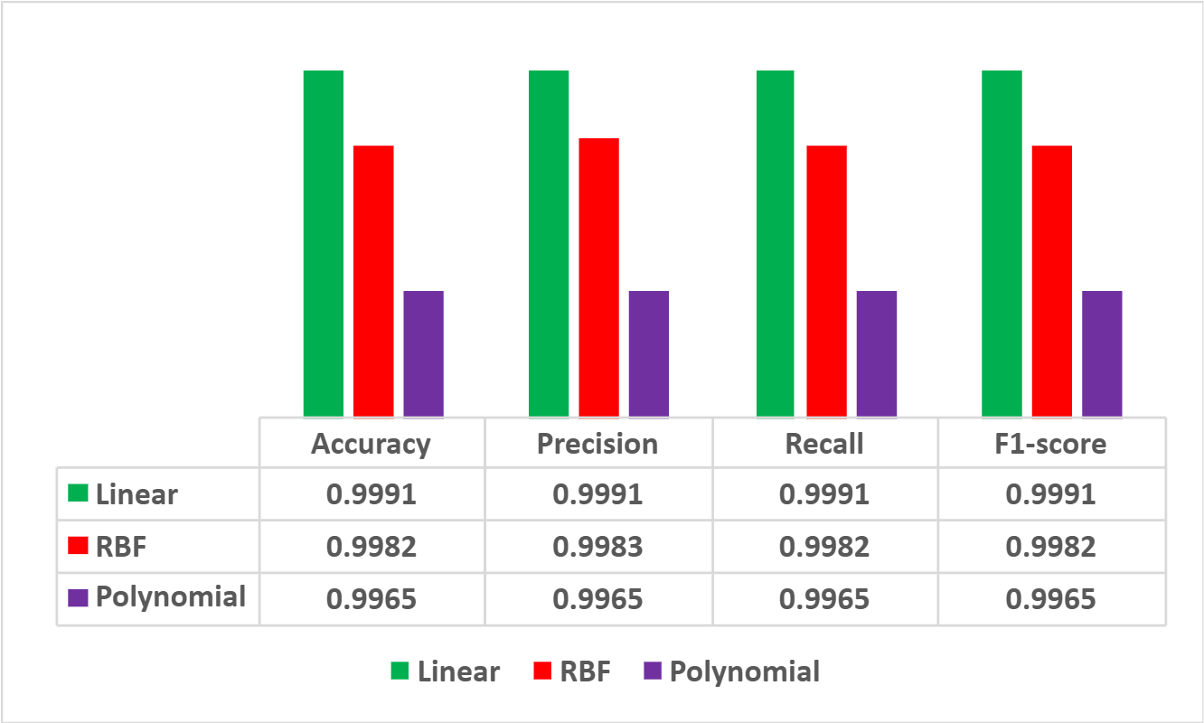
In the first experiment, the analysis was conducted using color-based features. The linear kernel yielded relatively poor results, with an accuracy of 0.836. In contrast, the RBF kernel achieved an accuracy of 0.9823, while the polynomial kernel reached 0.9756, demonstrating significantly better performance. This indicates that when dealing with color features, nonlinear kernels such as RBF and polynomial are more effective at identifying complex patterns within the data. In the 2nd experiment, using only LBP texture features, the linear kernel achieved an accuracy of only 0.801, which is relatively low. In contrast, the RBF kernel produced an accuracy of 0.9761, and the polynomial kernel reached 0.9818, both demonstrating significantly better performance.
Figure 4. Comparison of linear, RBF, and polynomial kernels across different feature sets using accuracy, precision, recall, and F1-score.

These results indicate that texture features exhibit a high degree of nonlinearity, necessitating the use of complex kernels for accurate classification. In the 3rd experiment, combination of color and texture features yielded impressive results. The linear kernel achieved an accuracy of 0.9982, while the polynomial kernel reached the highest accuracy of 0.9996. These results indicate that the combination of color and texture features created a robust discriminating feature set, effectively classified by any SVM kernel. In 4th experiments, the results were relatively weak when using only shape features. The accuracy of the linear kernel was 0.5093, the RBF kernel achieved 0.6543, and the polynomial kernel reached 0.7172. These findings indicate that shape features alone are insufficient and ineffective for data classification. In 5th experiments, the highest performance was achieved when all features were utilized together. The linear kernel attained an accuracy of 0.9991, the RBF kernel reached an accuracy of 0.9982, and the polynomial kernel achieved an accuracy of 0.9965. Notably, the linear kernel performed exceptionally well, suggesting that the data was linearly separable when combining multiple features. Figure 4 demonstrates a comparison of the classification performance of Support Vector Machine (SVM) using three kernel functions: linear, radial basis function (RBF), and polynomial. The results indicate that the linear kernel achieved the highest performance, with accuracy, precision, recall, and F1-score values each around 0.9991. In contrast, the RBF kernel showed slightly lower performance, with values ranging from 0.9982 to 0.9983, yet it still demonstrated strong results. The polynomial kernel exhibited the lowest performance, with a value of 0.9965, suggesting it was less effective than the other two kernels. This analysis implies that the linear kernel is the most suitable and reliable option for the given dataset, while the RBF kernel serves as a viable alternative; however, the polynomial kernel is comparatively less effective. The feature importance is addressed in Figure 5, which is vital for identifying the features that influence the classification result. This figure displays the average weight magnitude of the features obtained from the linear SVM model because linear kernel SVM model indicates the highest result among three kernels.
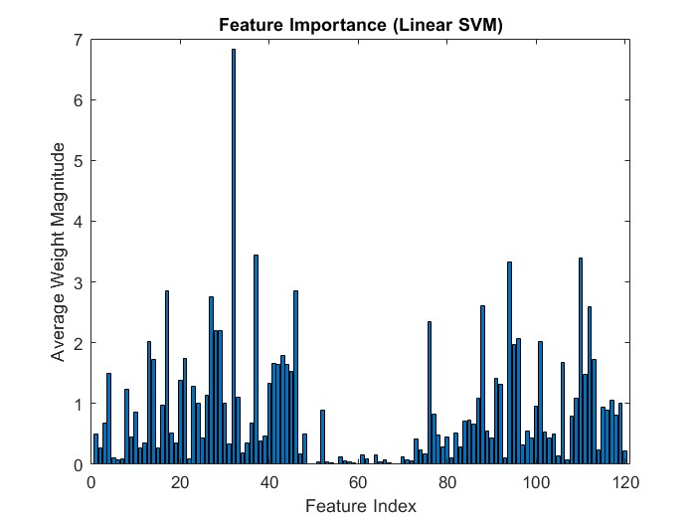
Figure 5. Feature importance ranking based on the linear SVM model.
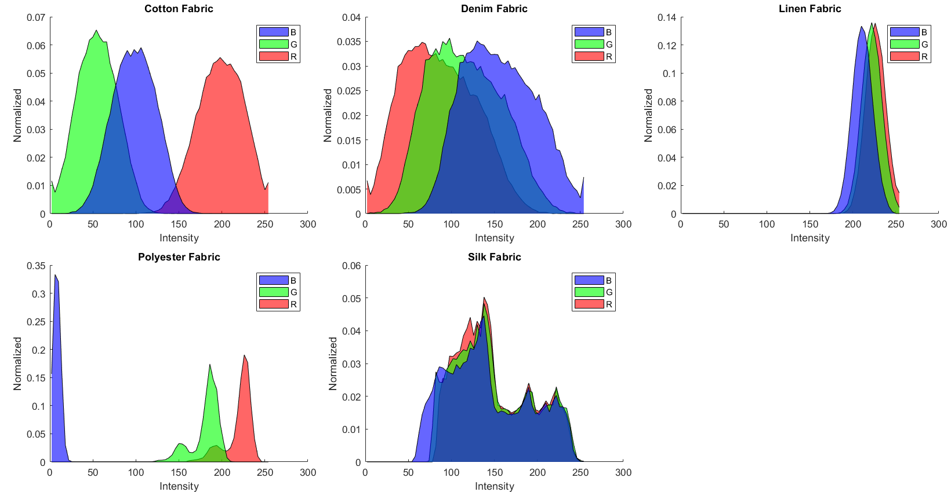
The contribution of the features varies significantly; certain features show higher values that greatly influence the classification results. Specifically, features 30–40 and 90–110 are identified as the most important, while some features have weights that are nearly zero, indicating minimal impact on the classification. This analysis highlights the importance of an effective feature selection process in improving the efficiency of the classification model. The figure 6 demonstrates the analysis of RGB intensity distribution of different types of fabrics (Cotton, Denim, Linen, Polyester and Silk). In Cotton fabric, there is a clear separation between each color channel, which indicates its unique color characteristics. In Denim fabric, there is a partial overlap of the three channels, which indicates its relatively dense and mixed color characteristics. In Linen fabric, all channels are concentrated in the high intensity region, which reflects the bright or light color characteristics. In Polyester fabric, the blue channel is strong at low intensities, while the red and green channels show distinct peaks in the high intensity region, which is consistent with its glossy and reflective nature.

Figure 6. Comparative RGB intensity distributions of different fabric types.

On the other hand, the intensity distribution of Silk fabric is broad and multi-peaked, indicating the complexity of light reflection and color diversity. Overall, this analysis shows that each fabric has its own color response characteristics, which can play an effective role in the automatic fabric identification and classification process. Moreover, Overall testing and analysis illustrate that the linear kernel of SVM consistently demonstrated the highest and most stable performance across the different features, confusion matrices, and feature importance evaluations used. Therefore, the linear SVM model can be identified as the most effective and reliable method for the proposed fabric image classification.

Comparison with Recent Study
In this section, we evaluated the effectiveness of the proposed model by comparing it with findings from three recent, well-regarded studies. This comparative analysis highlighted both the strengths and weaknesses of existing methods while underscoring the efficacy of the proposed model. The evaluation metrics included accuracy, precision, recall, and F1-score, which are standard indicators of model performance. The discussion emphasizes that the proposed method outperforms the existing studies in terms of accuracy, effectiveness, and reliability. Table 3 and Figure 7 present a consolidated overview of the comparative outcomes from the three most recent studies, providing a benchmark for evaluating the proposed model.

Table 3. Comparative analysis of the proposed method with three recent state-of-the-art studies.
Schemes | Used Method | Claim Accuracy | Contribution | Limitation
Hussain et al. [8] | CNN | 95–98% | Able to recognize complex patterns | High computation GPU is required.
Liu et al.[10] | CNN | 99.5% | High accuracy- lightweight model. Usable in embedded systems. | Deep learning expertise and hardware are required for training
Meeradevi et al. [12] | LabVIEW | 95% | Suitable for industrial deployment and Real-time system | Accuracy is relatively low.
Proposed Method | SVM | 99.9% | Extremely high accuracy through handcrafted features. | Difficult to scale to new datasets.

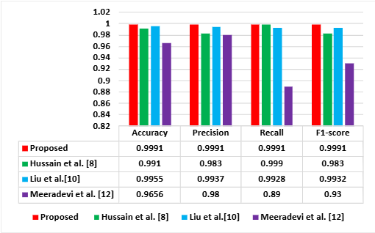
The proposed model achieved a 99.991% accuracy on fabric types classification using hybrid features (color, shape, LBP texture) and a linear SVM kernel, demonstrating high accuracy and low computational cost with handcrafted features, though it presents challenges in new dataset application and feature creation time. In comparison, Hussain et al. [8] (2020) utilized Deep CNN
Figure 7. Performance comparison Recent Study with our Proposed model.

for knitted fabric patterns, reaching 95–98% accuracy but requiring significant computational resources (GPU) and offering lower accuracy. Liu et al.[10] (2024) developed a lightweight CNN with global average pooling, achieving 99.5% accuracy suitable for embedded systems but necessitating deep learning expertise and training hardware. Meeradevi et al. [12] (2024) presented a real-time industrial fabric defect detection system using LabVIEW and a multiclass classifier with over 95% accuracy, though this accuracy level is considered relatively low. Figure 7 presents the comparison of recent study with proposed model. The proposed model demonstrates superior performance compared to existing studies by Hussain et al. [8], Liu et al. [10], and Meeradevi et al. [12] across Accuracy, Precision, Recall, and F1-score metrics. Achieving an Accuracy, Precision, Recall, and F1-score of 0.9991, the model surpasses its counterparts, particularly in reducing false positives and false negatives, indicating a balanced and robust performance.

- Conclusion
This research classifies fabric successfully applying combined features of color, shape, and texture in a Support Vector Machine (SVM). Experimental setup with SVM demonstrates better results from hybridizing features than applying individual features, significantly, and specially for its kernel with linear and Radial Basis Function. The accuracy level convinces us with a great hope of its usability in market and commercially. It would advance the automated quality control systems within the textile industry, facilitating intelligent detection in garment production, and supporting applications in fashion technology. The efficacy of this approach may be improved by integrating advanced deep learning models and utilizing large-scale datasets in future works.

Dataset availability: Data will be made available on request.
ACKNOWLEDGEMENT: We would like to extend our sincere gratitude for the guidance and assistance provided throughout this study
COMPETINGINTERESTS: Authors have declared that no competing interests exist.
References
[1] I. M. Darl, W. Mahmoodb, and G. Vachtsevanosb, “Automated Pilling Detection and Fuzzy Classification of Textile Fabrics.” [Online]. Available: http://www.ece.gatech.edu/users/gjv;
[2] Wang, X., Georganas, N. D., & Petriu, E. M. (2011). Fabric texture analysis using computer vision techniques. IEEE Transactions on Instrumentation and Measurement, 60(1), 44–56. https://doi.org/10.1109/TIM.2010.2069850 .
[3] E. Shady, K. Qashqary, M. Hassan, and J. Militky, “Image Processing Based Method Evaluating Fabric Structure Characteristics. FIBRES & TEXTILES in Eastern,” 2012. https://bibliotekanauki.pl/articles/2012/6A(95)
[4] J. Zhang, B. Xin, and X. Wu, “A Review of Fabric Identification Based on Image Analysis Technology,” 2013. [Online]. Available: http://www.tlist-journal.org/
[5] Yıldız, K., Buldu, A., & Demetgul, M. (2016). A thermal-based defect classification method in textile fabrics with K-nearest neighbor algorithm. Journal of Industrial Textiles, 45(5), 780–795. https://doi.org/10.1177/1528083714555777
[6] A. Kumar Mohanty and A. Bag, “Detection and Classification of Fabric Defects in Textile using Image Mining and Association Rule Miner,” International Journal of Electrical, Electronics and Computers (EEC Journal), vol. 2, no. 3, https://dx.doi.org/10.24001/eec.2.3.5
[7] Loonkar, S., & Mishra, D. S. (2019). Analysis of Defect Classification Approaches for Fabric Images based on Four DFT Sector Features. In 2019 6th IEEE International Conference on Advances in Computing, Communication and Control, ICAC3 2019 https://doi.org/10.1109/ICAC347590.2019.9036775
[8] Hussain, M. A. I., Khan, B., Wang, Z., & Ding, S. (2020). Woven fabric pattern recognition and classification based on deep convolutional neural networks. Electronics (Switzerland), 9(6), 1048. https://doi.org/10.3390/electronics9061048

[9] Rasheed, A., Zafar, B., Rasheed, A., Ali, N., Sajid, M., Dar, S. H., Habib, U., Shehryar, T., & Mahmood, M. T. (2020). Fabric Defect Detection Using Computer Vision Techniques: A Comprehensive Review. Mathematical Problems in Engineering https://doi.org/10.1155/2020/8189403
[10] Liu, R., Yu, Z., Fan, Q., Sun, Q., & Jiang, Z. (2024). The improved method in fabric image classification using convolutional neural network. Multimedia Tools and Applications, 83(3), 6909–6924. https://doi.org/10.1007/s11042-023-15573-w
[11] Nugroho, E. A., Setiawan, J. D., Munadi, & Diki. (2024). Design of image classification system for fabric inspection process using Raspberry Pi. Journal of Mechatronics, Electrical Power, and Vehicular Technology, 15(1), 57–67. https://doi.org/10.55981/j.mev.2024.863
[12] Meeradevi, T., & Sasikala, S. (2024). Automatic fabric defect detection in textile images using a labview based multiclass classification approach. Multimedia Tools and Applications. https://doi.org/10.1007/s11042-023-18087-7

[13] S. R. Dubey and A. S. Jalal, “Apple disease classification using color, texture and shape features from images,” Signal Image Video Process, vol. 10, no. 5, pp. 819–826, Jul. 2016, https://doi.org/10.1007/s11760-015-0821-1
[14] S. Kothari, J. H. Phan, A. N. Young, and M. D. Wang, “Histological image classification using biologically interpretable shape-based features,” BMC Med Imaging, vol. 13, no. 1, Mar. 2013, https://doi.org/10.1186/1471-2342-13-9
[15] L. Nanni, A. Lumini, and S. Brahnam, “Survey on LBP based texture descriptors for image classification,” Expert Syst Appl, vol. 39, no. 3, pp. 3634–3641, Feb. 2012, https://doi.org/10.1016/j.eswa.2011.09.054
[16] B. Xiao, K. Wang, X. Bi, W. Li, and J. Han, “2D-LBP: An Enhanced Local Binary Feature for Texture Image Classification,” IEEE Transactions on Circuits and Systems for Video Technology, vol. 29, no. 9, pp. 2796–2808, Sep. 2019, https://doi.org/10.1109/TCSVT.2018.2869841
[17] C. Cortes, V. Vapnik, “Support-Vector Networks Editor,” Kluwer Academic Publishers, 1995. https://doi.org/10.1007/BF00994018
[18] H. Abdellah, R. Ahmed, and O. Slimane, “Defect Detection and Identification in Textile Fabric by SVM Method,” 2014. [Online]. Available: https://doi.org/10.9790/3021-041246977
[19] S. M. A. Al Shuaeb, Md. R. Hassan, and M. Uddin, “Soil Wetness Classification in Agriculture Using Machine Learning Models,” Asian Journal of Soil Science and Plant Nutrition, vol. 10, no. 4, pp. 803–815, Dec. 2024, https://doi.org/10.9734/ajsspn/2024/v10i4451
[20] B. Hossain, U. K. Roy, Shamsunnaher, Md. S. A. A. Kawser, and S. M. A. Al Shuaeb, “Image-based Pest Identification Using Support Vector Machine for Agricultural Crop Protection,” Asian J Res Crop Sci, vol. 10, no. 3, pp. 13–22, Jun. 2025, https://doi.org/10.9734/ajrcs/2025/v10i3368

