Case report
Infectious Bovine Keratoconjunctivitis in a Calf: A Case Report on Successful Therapeutic Management

Abstract
This case report details the successful management of Infectious Bovine Keratoconjunctivitis (IBK) in an 8 month-old calf, characterized by conjunctival inflammation, blepharospasm, excessive tearing, and corneal clouding. Following bacteriological examination and antibiotic sensitivity testing, Moraxella bovis was identified as the causative agent, showing sensitivity to oxytetracycline. Treatment with a combination of to Ayural tetracycline eye drops and parenteral oxytetracycline injection led to significant improvement within 5 days.The condition completely resolve by the 15th day post treatment. This case underscores the importance of prompt intervention and effective treatment strategies in managing IBK, a disease with significant economic and welfare implications in cattle production.
Key words
Infectious Bovine Keratoconjunctivitis (IBK), Moraxella bovis, Oxytetracycline, Cattle, Therapeutic management
Introduction
Infectious Bovine Keratoconjunctivitis (IBK), or pinkeye, is a significant ocular disease affecting cattle globally, posing both welfare and economic concerns (Dennis & Kneipp, 2021; Kneipp, 2021). It's a painful condition characterized by lacrimation, blepharospasm, photophobia, and conjunctivitis (Dewell et al., 2014; Kneipp, 2021). If left untreated, IBK can lead to corneal scarring and permanent blindness (Irby & Angelos, 2018; Kneipp, 2021), resulting in substantial economic losses due to reduced weaning weights (Dennis & Kneipp, 2021).
The disease is primarily associated with Moraxella bovis and other bacteria (Dickey et al., 2016; Dickey et al., 2018; Gupta et al., 2023), with additional pathogens potentially contributing to its development (Loy et al., 2021). The face fly (Musca autumnalis) plays a significant role in transmitting M. bovis. Additionally, ocular and nasal discharges from infected animals can harbor the pathogens, facilitating direct transmission through animal-to-animal contact, contaminated equipment, and animal handlers (Jeyabal et al., 2013).
Infectious Bovine Keratoconjunctivitis (IBK) may not be fatal, but it has substantial economic consequences, including reduced weight gain, lower milk production, increased treatment costs, and market penalties due to eye damage and blindness (Postma et al., 2008; O’Connor et al., 2012). The annual economic burden of IBK is estimated to be $150 million in the United States (Hansen, 2001) and $22 million in Australia (Kizilkaya et al., 2013). Notably, calves and immunologically naïve cattle are particularly susceptible to the infection (Takele and Zerihun, 2000; Postma et al., 2008; Kizilkaya et al., 2013; ).
Given the significant economic and welfare implications of IBK, effective diagnosis, treatment, and management strategies are crucial for cattle producers. To contribute to the existing knowledge and inform best practices, this case report aims to provide further insight into the disease's clinical presentation, diagnosis, and management, with a focus on a confirmed case that highlights the importance of effective prevention and treatment strategies.
Case presentation
Case History
On August 13, 2025, the University of Maiduguri Veterinary Teaching Hospital's (UMVTH) Large Animal Unit received a call for an ambulatory service at a farm in Old Maiduguri, with a chief complaint of a calf with watery discharge from the eye and loss of appetite.
Clinical examination
Clinical Examination: Ocular examination revealed characteristic signs of Infectious Bovine Keratoconjunctivitis, such as conjunctival inflammation, blepharospasm, excessive tearing, corneal clouding, and conjunctival redness (Figure 1 & 2). Systemic parameters, such as temperature, pulse, and respiratory rates, were within normal ranges, indicating a localized infection. Further investigation revealed that the animal had been previously treated by the herdsman with unsatisfactory results, and the owner was unable to provide details about the treatment protocol. Given the poor response to previous treatment and the patient's condition, it was decided to conduct bacteriological examination and antibiotic sensitivity testing to identify the most effective antibiotic and optimize treatment.
Sample Collection:
After restraining the animal, a sterile microbiological swab was used to collect samples from the cornea and conjunctiva regions via impression smear. The collected samples were then submitted for bacteriological examination and antibiotic sensitivity testing at the university of Maiduguri, Veterinary Microbiology Laboratory to guide targeted treatment.
Laboratory Examination
Samples collected were inoculated onto 5% sheep blood agar and incubated aerobically at 37°C for 24 hours. The plates were then examined for characteristic growth patterns of Moraxella spp., following established protocols (Juni & Bøvre, 2015)
The isolated bacteria formed characteristic haemolytic colonies on blood agar, exhibiting a clear zone of haemolysis, with a distinctive pattern of agar corrosion at the edges of the colonies, and some colonies displayed surface-spreading growth. Gram staining revealed Gram-negative bacteria, appearing as diplococci or paired rods. The organism was non-motile and tested positive for catalase and oxidase, consistent with the properties of Moraxella bovis.
The isolate were then access for antibiotic sensitivity using the Kirby-Bauer disc diffusion method, in accordance with Clinical and Laboratory Standards Institute (CLSI) guidelines (2023). After incubation at 37°C for 18-24 hours, the zones of inhibition were measured and interpreted according to CLSI M100 guidelines (2023). The results indicated that the organism was highly sensitive to chloramphenicol, nalidixic acid, oxytetracycline (OTC), ampicillin, and linezolid, but exhibited resistance to streptomycin. Oxytetracycline was selected in this case based on its availability, cost and broad spectrum of activity.
Treatment
In this case, a combination of topical and parenteral therapy was used, consisting of topical tetracycline eye drops administered thrice daily for 5 days and a 5% oxytetracycline injection given intramuscularly at 10 mg/kg body weight for 3 days, alongside an 8 mL multivitamin supplement (Vitaminolyte). The animal responded favourably to the antibiotic therapy, demonstrating significant improvement within 5 days of treatment. Notably, epiphora (excessive tearing) resolved, corneal opacity decreased, and scar tissue formation was observed in the central region of the eye, indicating a healing process (Figure 4). The condition completely resolves by the 15th day post treatment as seen in Figure 5.
Discussion
Effective disease management relies on surveillance and early detection, particularly for contagious diseases like Infectious Bovine Keratoconjunctivitis (IBK), where vaccine options are limited. IBK is an economically important disease of cattle, capable of infecting up to 80% of a herd within three weeks, highlighting the need for prompt intervention (Jeyabal et al., 2013). Prompt treatment of IBK, is crucial for a favourable outcome in affected animals, reducing bacterial shedding and the risk of transmission to other cattle, thereby promoting overall herd health.
Treatment approaches for IBK typically involve topical, systemic, and subconjunctival routes. In this case report, a combination of topical and systemic treatments with oxytetracycline injection and tetracycline eye drops yielded a successful outcome. Systemic therapy using oxytetracycline can penetrate the lacrimal glands and nasal passages, achieving therapeutic concentrations in the cornea and intraocular tissues due to its lipophilic nature (Slatter et al., 1982). Previous studies have demonstrated the efficacy of parenteral oxytetracycline administration in eliminating M. bovis in calves with IBK (Smith et al., 1985; Starke et al., 2007). Additionally, topical ointments can achieve increased 'contact' time due to increased viscosity and sustained release of the drug. This treatment approach aligns with existing research, highlighting the importance of combined systemic and topical therapies in managing IBK effectively.
Following treatment, the corneal opacity regressed, with favourable improvement in lacrimation and vascularization within 5 days and complete healing by day 15. This outbreak of IBK occurred during the rainy season, coinciding with an increased fly population, which likely contributed to the transmission and spread of the disease. Face flies (Musca autumnalis) are known vectors of M. bovis, the bacterium that causes IBK. Proper hygiene, effective manure management, and fly control measures are essential components of IBK prevention strategies, as flies breeding in accumulated manure and dung can significantly increase the fly burden and facilitate disease transmission.

References
CLSI. (2023). Performance standards for antimicrobial susceptibility testing. Clinical and Laboratory Standards Institute.
Dennis, E. J. & Kneipp, M. (2021). A review of global prevalence and economic impacts of infectious bovine keratoconjunctivitis. Veterinary Clinics of North America: Food Animal Practice, 37, 355-369.
Dewell, R. D., Millman, S. T., Gould, S. A., Tofflemire, K. L., Whitley, R. D., Parsons, R. L., Rowe, E. W., Liu, F., Wang, C. & O’Connor, A. M. (2014). Evaluating approaches to measuring ocular pain in bovine calves with corneal scarification and infectious bovine keratoconjunctivitis-associated corneal ulcerations. Journal of Animal Science, 92, 1161-1172.
Dickey, A. M., Loy, J. D., Bono, J. L., Smith, T. P., Apley, M. D., Lubbers, B. V., DeDonder, K. D., Capik, S. F., Larson, R. L., White, B. J., Blom, J., Chitko-McKown, C. G. & Clawson, M. L. (2016). Large genomic differences between Moraxella bovoculi isolates acquired from the eyes of cattle with infectious bovine keratoconjunctivitis versus the deep nasopharynx of asymptomatic cattle. Veterinary Research, 47, 31.
Dickey, A. M., Schuller, G., Loy, J. D. & Clawson, M. L. (2018). Whole genome sequencing of Moraxella bovoculi reveals high genetic diversity and evidence for interspecies recombination at multiple loci. PLOS ONE, 13, e0209113.
Gupta, S., Kuehn, L. A. & Clawson, M. L. (2023). Early detection of infectious bovine keratoconjunctivitis with artificial intelligence. Veterinary Research, 54, 122.
Hansen, R. (2001). New tools in the battle against pinkeye. In Nevada Livestock Production Annual Update (pp. 5-8).
Hansen, R. (2001). New tools in the battle against pinkeye. Nevada Livestock Production Annual Update, 5-8.
Irby, N. L. & Angelos, J. A. (2018). Ocular diseases. In Rebhun’s Diseases of Dairy Cattle (3rd ed.).
Kizilkaya, K., Tait, R. G., Garrick, D. J., Fernando, R. L. & Reecy, J. M. (2013). Genome-wide association study of infectious bovine keratoconjunctivitis in Angus cattle. BMC Genetics, 14, 23.
Kneipp, M. (2021). Defining and diagnosing infectious bovine keratoconjunctivitis. Veterinary Clinics of North America: Food Animal Practice, 37, 237-252.
Loy, J. D., Clothier, K. A. & Maier, G. (2021). Component causes of infectious bovine keratoconjunctivitis-non-Moraxella organisms in the epidemiology of infectious bovine keratoconjunctivitis. Veterinary Clinics of North America: Food Animal Practice, 37, 295-308.
O'Connor, A., Shen, H., Wang, C. & Opriessnig, T. (2012). Descriptive epidemiology of Moraxella bovis, Moraxella bovoculi and Moraxella ovis in beef calves with naturally occurring infectious bovine keratoconjunctivitis (Pinkeye). Veterinary Microbiology, 155(3-4), 374-380.
Postma, G. C., Carfagnini, J. C. & Minatel, L. (2008). Moraxella bovis pathogenicity: An update. Comparative Immunology, Microbiology and Infectious Diseases, 31(5), 449-458.
Takele, G. & Zerihun, A. (2000). Epidemiology of infectious keratoconjunctivitis in cattle in South-east Ethiopia. Journal of Veterinary Medicine, Series B, 47(7), 509-517
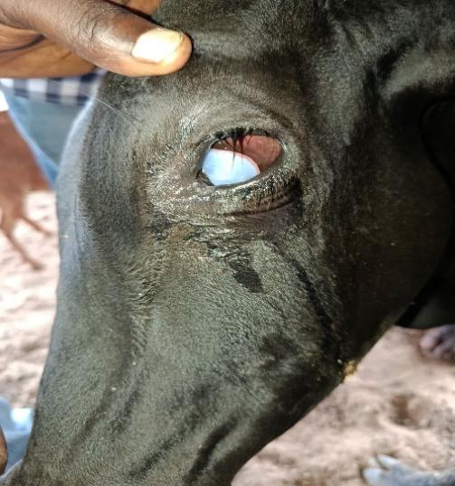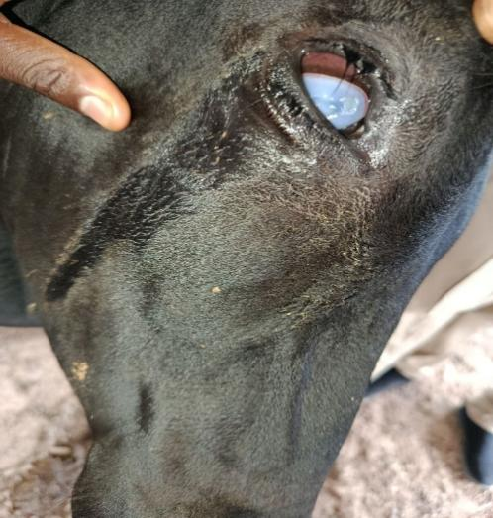
Figure 1 Figure. 2
Figure 1 and 2 showing the left and right eye affected respectively on the day of presentation

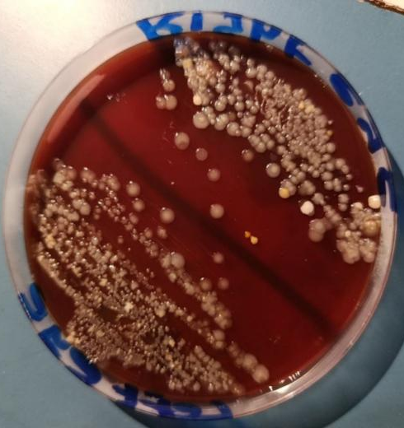
Figure 3. Showing bacterial growth on blood agar plate
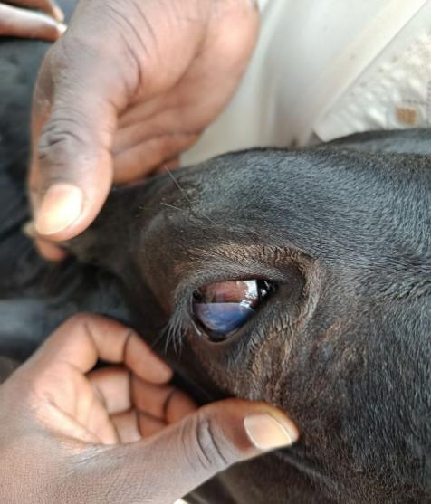
Figure 4. Animal on day 5 post treatment
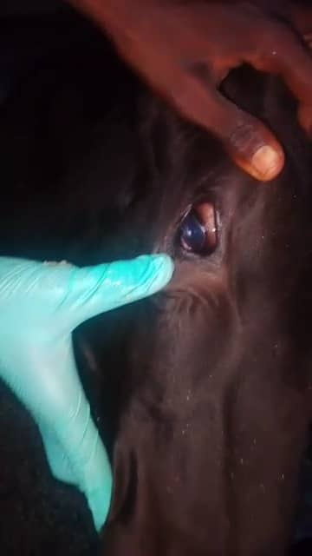
Figure 5. Animal after complete recovery on day 15 post treatment

