Original Research Article
STRATEGIC TRANSFORMATION IN LAND USE: THE DECLINE OF FALLOW LANDS AND AGRICULTURAL INTENSIFICATION

ABSTRACT
This study provides a comprehensive analysis of the strategic transformation in agricultural land use in Turkey, focusing on the rapid decline of traditional fallow practice between 2015 and 2024. Utilizing official data from the Turkish Statistical Institute (TurkStat), the research quantifies a dramatic nationwide reduction of 35.5% in fallow area, from 41.1 million to 26.6 million decares. Spatial analysis reveals that this decline is markedly non-uniform, being concentrated in the arid and semi-arid interior regions where fallow is most critical for risk management. The most pronounced regional contraction occurred in Eastern Anatolia (TRB), with a decline of 30.9%, followed by significant losses in Central Anatolia (TR7). The investigation further identifies the primary land-use shifts driving this transformation. The analysis demonstrates that abandoned fallow lands are predominantly being converted to continuous cereal cultivation, indicating an intensification of the traditional crop rotation system, and to a lesser extent, to irrigated perennial crops such as orchards. While this shift signifies a move towards agricultural intensification with potential short-term gains in land productivity and output, the study critically examines its sustainability trade-offs. The concurrent expansion of water-intensive agriculture and the loss of a vital soil moisture-replenishment mechanism create a "dual threat," exacerbating pressures on already over-exploited groundwater resources and increasing risks of soil organic matter depletion, erosion, and long-term degradation. Concluding that the unchecked continuation of this trend poses significant risks to the resilience of Turkey's agricultural systems, particularly under climate change scenarios, the study advocates for an urgent policy reorientation. It recommends an integrated strategy based on: (1) promoting "smart fallow" systems using cover crops, (2) facilitating a transition to conservation agriculture principles, (3) accelerating the dissemination of drought-resistant crop varieties, and (4) implementing strict, basin-based water management alongside advanced irrigation technologies. The findings underscore that managing this land-use transformation is imperative for balancing productivity goals with the ecological limits of water and soil resources to ensure long-term food security and agricultural sustainability.

KEYWORDS: Fallow, agricultural intensification, land use change, sustainable agriculture, water resources management, Turkish agriculture.

- INTRODUCTION

1.1 The Agro-Ecological Significance and Evolution of Fallow Practice
Fallow, defined as the deliberate resting of arable land from cultivation for one or more growing seasons, constitutes a foundational agricultural strategy in semi-arid and arid regions worldwide. Its primary functions are agro-ecological: to conserve and accumulate soil moisture, suppress weed cycles, and enhance the bioavailability of nutrients through natural biogeochemical processes (Gül et al., 2020). In rainfed farming systems characterized by low and variable precipitation, such as those prevalent across much of Turkey, fallow serves as a critical risk-mitigation mechanism. It buffers crop production against hydrological uncertainty by stabilizing soil water reserves, thereby ensuring a more reliable yield in subsequent cultivation seasons (Yıldırım, 2025; Koç et al., 2024). Historically, this practice has been integral to the sustainability of dryland agroecosystems.
1.2 Drivers of Change: The Global and National Shift Towards Intensification
The latter half of the 20th century witnessed the global ascendancy of "Agricultural Intensification" as the dominant paradigm for meeting escalating food demand. This model prioritizes maximizing output per unit area through increased inputs—including irrigation, synthetic fertilizers, and pesticides-and the reduction or elimination of non-productive phases in crop rotations, such as fallow (Pretty, 2018). While successful in boosting short-term productivity, this paradigm often overlooks critical ecological thresholds, leading to widespread land degradation, depletion of freshwater resources, and loss of biodiversity, particularly in vulnerable dryland regions (Rockström et al., 2017).
Turkey’s agricultural sector has undergone a profound transformation aligned with this global trend. Driving forces include demographic pressures, market integration, state-led modernization policies, and significant public investment in irrigation infrastructure, notably large-scale projects like the Southeastern Anatolia Project (GAP) (Demiralay, 2010; Koç et al., 2024). These drivers have collectively incentivized the conversion of fallow lands to continuous cultivation or more profitable, water-intensive crops like fruits and vegetables. Consequently, the traditional fallow-cereal rotation system is being rapidly dismantled, signaling a fundamental shift in land-use strategy with potentially significant consequences for ecosystem resilience.
1.3 Research Objectives and Significance
Despite the scale of this transition, a detailed, spatially explicit analysis of its magnitude, regional patterns, and proximate land-use outcomes within the Turkish context remains crucial for informed policy-making. This study aims to fill this gap by providing a comprehensive empirical investigation of the strategic transformation in fallow land use in Turkey between 2015 and 2024. Specifically, it seeks to:
- Quantify the national and sub-national (NUTS-1 level) trends in fallow area decline over the past decade.
- Analyze the geographical disparities in this decline, identifying regions experiencing the most rapid contraction.
- Investigate the primary land-use conversions replacing fallow, with a focus on shifts towards continuous cereal monocultures and irrigated perennial crops.
- Discuss the implications of these changes for soil health, water resource sustainability, and long-term agricultural viability in Turkey’s water-stressed regions.
By linking quantitative spatial analysis with a discussion of sustainability trade-offs, this research aims to move beyond descriptive statistics and contribute to the critical debate on managing agricultural intensification within ecological limits. The findings are intended to provide an evidence base for developing policies that reconcile productivity goals with the imperative of sustaining the natural resource foundations of Turkish agriculture.

- MATERIALS AND METHODS

This research examines the change in fallow areas in Turkey using quantitative data and spatial analysis techniques.

  - Data Sources
The primary data source for the study is the annual "Crop Production Statistics" published by the Turkish Statistical Institute (TurkStat). Annual datasets covering the 2015-2024 period were used in the analyses. The data were taken at the level of 12 NUTS-1 Regions (Statistical Region Units), with fallow area (decare) as the key variable. Additionally, data on cereal and fruit cultivation areas for the same period and regions were utilized to analyze the crop patterns replacing fallow. State Hydraulic Works reports were used for supporting policy and investment information.

2.2. Analytical Methods and Calculations
- Temporal Trend Analysis: Absolute and relative (percentage) changes in fallow areas at the national and regional levels were calculated. Annual reduction rates and total percentage decreases for the period were determined.
- Regional Comparative Analysis: Change rates between regions were compared to understand the geographical distribution of the fallow decline, investigating whether the decrease was concentrated in regions with high drought risk.
- Land Use Shift Analysis: The relationship between the decrease in fallow area and concurrent changes in cereal and fruit areas in selected pilot regions (especially TR7 Central Anatolia) was analyzed to determine what replaced fallow.

  - Visualization and Software
All data cleaning, calculation, and table creation processes were performed using Microsoft Excel. The Python programming language and pandas, matplotlib, seaborn libraries were employed for dynamic data processing and effective visual presentation.

- FINDINGS AND DISCUSSION

3.1. The Panorama of Fallow Areas in Turkey: A Striking Decline
Analysis of TurkStat data reveals that fallow practice in Turkey has declined dramatically over the last decade. The total fallow area, which was 41.14 million decares in 2015, decreased to 26.55 million decares by 2024. This represents an approximate 35.5% reduction. Examination of the trend shows that the most pronounced decline occurred between 2015 and 2019, and although the pace slowed somewhat after 2020, the decreasing trend continued.

Table 1. Change in Total Fallow Area in Turkey (2015-2024)
Year | Total Fallow Area (Decare) | Year-on-Year Change (%)
2015 | 41,139,762 | –
2016 | 39,982,957 | -2.8
2017 | 36,974,137 | -7.5
2018 | 35,127,733 | -5.0
2019 | 33,873,817 | -3.6
2020 | 31,732,521 | -6.3
2021 | 30,591,619 | -3.6
2022 | 29,595,607 | -3.3
2023 | 28,143,070 | -4.9
2024 | 26,554,335 | -5.6
Source: TurkStat Crop Production Statistics (2024)

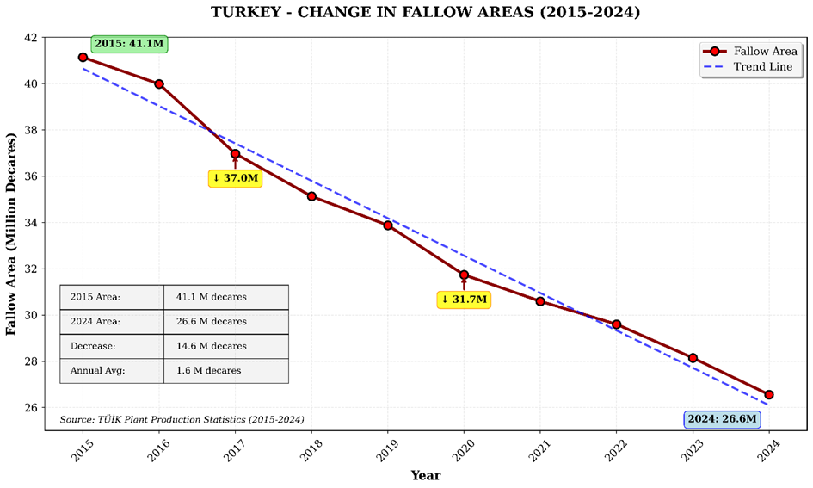
Figure 1. Change in Total Fallow Area in Turkey (2015-2024)
Note: Figure 1 would show a line graph depicting the steady decline from 41.1 million to 26.6 million decares.
The data for the 2015-2024 period, as shown in Figure 1, reveal that fallow areas in Turkey decreased dramatically by 35.5%, from 41.1 million to 26.6 million decares. This consistent downward trend (average annual loss of 1.6 million decares) reflects the transition of farming systems from the traditional fallow-cereal rotation to more intensive production models. Notably, the acceleration of the decline in 2017 and 2020 is particularly striking. While this transformation carries the potential to increase land use efficiency, it simultaneously poses the risk of intensifying pressure on water resources and negatively affecting soil health in arid regions, underscoring the critical importance of transitioning to smart fallow practices and conservation agriculture systems for sustainability (Göçmez & İşçioğlu, 2004).

This macro-level decline is a clear indicator of Turkish agriculture's shift from the traditional "fallow-cereal" rotation system towards more intensive and continuous production models. This transition carries the potential to increase land use efficiency and short-term production volume, while also bringing the risk of creating serious pressures on soil health and water resources, particularly in arid regions.

3.2. Regional Disparity: Intensive Decline in Arid Interior Regions
The decrease in fallow areas is not homogeneously distributed across Turkey's geography. The decline in arid and semi-arid regions where fallow is traditionally most widespread and critical for agricultural production—such as Central Anatolia (TR7), Southeastern Anatolia (TRC), and Eastern Anatolia (TRB)—has been well above the national average.

Table 2. Fallow Areas in Selected Regions and Change during the 2020-2024 Period
Region Code | Region Name | 2020 Fallow Area (da) | 2024 Fallow Area (da) | Absolute Decrease (da) | Change (%)
TR7 | Central Anatolia | 9,086,031 | 7,507,572 | -1,578,459 | -17.4
TR5 | Western Anatolia | 6,039,170 | 5,232,307 | -806,863 | -13.4
TRB | Eastern Anatolia | 2,451,420 | 1,694,317 | -757,103 | -30.9
TR8 | Western Black Sea | 3,326,842 | 3,003,620 | -323,222 | -9.7
TR9 | Eastern Black Sea | 562,077 | 569,290 | +7,213 | +1.3
Source: TurkStat Crop Production Statistics (2020, 2024)

As can be seen from Table 2, the TRB (Eastern Anatolia) region experienced the most significant proportional decline at 30.9%. In contrast, fallow areas have remained marginal in regions with relatively sufficient and regular rainfall, such as TR9 (Eastern Black Sea), showing no statistically significant change. This distribution demonstrates that the fallow decline is concentrated primarily in regions with pronounced water constraints, and this situation risks further increasing pressure on existing water resources.

Figure 2. Regional Change in Fallow Areas in Turkey (2020-2024)
Note: Figure 2 would be a bar chart comparing the percentage changes in Table 2 across the five regions.

Figure 2 illustrates the change in fallow areas between 2020 and 2024 in five different regions of Turkey. The most notable decrease occurred in the Eastern Anatolia (TRB) region, where the fallow area fell by 30.9%, recording the highest relative decline. The highest absolute decrease, however, was observed in the Central Anatolia (TR7) region (-1,578,459 da). While the general trend is a decline in fallow areas across all regions—attributable to factors such as the widespread adoption of modern irrigation techniques, crop rotation practices, and changes in agricultural policies—the Eastern Black Sea (TR9) region shows a slight increase (+1.3%), contrary to the overall trend. This may be due to the region's specific ecological conditions or agricultural structure.
3.3. What Replaced Fallow? The Cereal-Fruit Nexus and Emerging Risks
With the decrease in fallow land, the question of which crop patterns these lands have shifted to becomes important. The Central Anatolia (TR7) region serves as a significant case for analyzing this transformation. Between 2020 and 2024, while the fallow area in TR7 decreased by 1.58 million decares, the cereal area increased by 1.91 million decares. This indicates that fallow lands have largely been converted to continuous cereal cultivation, signifying an intensification within the fallow-cereal rotation. Such intensification can lead to increased fertilizer and pesticide use, a decline in soil organic matter, and heightened erosion risk (Sirat, 2016).
Another notable development in the same period is the expansion of fruit cultivation areas. Fruit area in TR7 expanded by approximately 93 thousand decares. Compared to cereals, orchards require significantly higher amounts of irrigation water. The simultaneous expansion of irrigated agriculture (especially fruit growing) alongside the decline of fallow in an arid region creates a "dual threat" on groundwater and surface water resources already under threat of overuse.

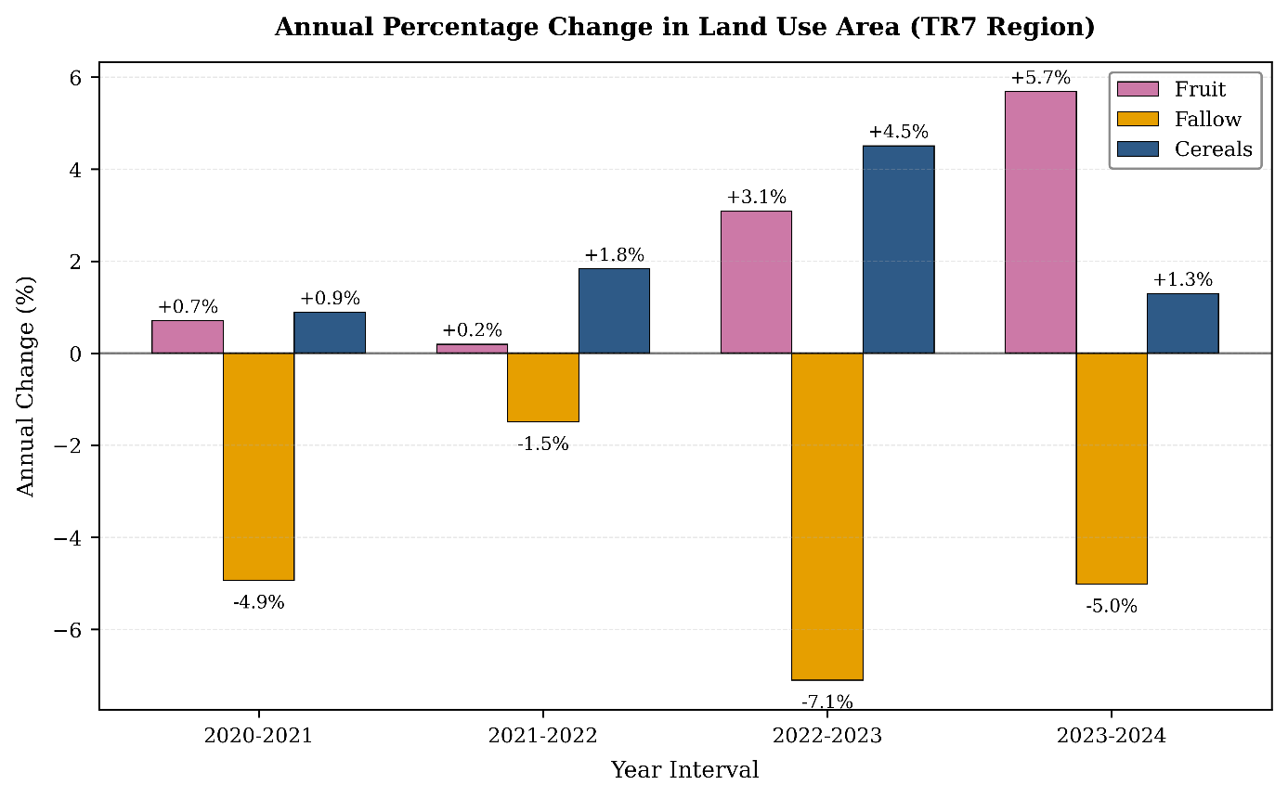
Figure 3. Land Use Change in the TR7 (Central Anatolia) Region (2020-2024)
Note: Figure 3 would be a line or grouped bar chart showing trends for fallow, cereal, and fruit areas over the years.

The chart in Figure 3 indicates a clear product-based transformation in the annual percentage changes in land use in the TR7 Region during the 2020-2024 period. While fruit areas generally show growth, with a particularly notable expansion between 2022-2023 and 2023-2024, pointing towards a focus on permanent horticultural production. Cereal areas show fluctuating changes, suggesting that production levels from previous seasons are being maintained in some form. In contrast, the strong and continuous decline observed in fallow across the board demonstrates the more intensive and continuous use of agricultural land.

3.4. The Transformative Role of Support Policies and Irrigation Investments
One of the fundamental structural drivers behind the reduction in fallow areas is the evolution of agricultural support policies. Production-independent, area-based direct income support creates a strong economic incentive for farmers to maximize their cultivable land, potentially leading to the conversion of marginal, ecologically fragile lands to agriculture. Research indicates that targeted subsidy mechanisms in Turkey, such as crop-specific premiums and diesel-fertilizer supports, directly shape farmers' crop pattern preferences. These policies accelerate the shift away from traditional, less water-demanding dryland farming systems by increasing the orientation towards crops with high water demand and market value but lower drought resilience, such as corn, sugar beet, alfalfa, and certain fruit varieties (Ekiz & Demiray, 2025).
In addition to these policies, the completion of large-scale dam and irrigation networks (such as GAP) and irrigation infrastructure investments at central and local levels (including the drilling of groundwater wells, grants, and loans for pressurized irrigation systems) constitute the other critical pillar of this transformation. These investments have paved the way for the physical feasibility of irrigated agriculture on vast lands that were previously entirely rain-fed (dry farming). Thus, the economic attractiveness created by support policies, combined with the technical opportunities provided by irrigation access, has become the fundamental "enabler" of the observed land-use transformation from "fallow-cereal" to "continuous cultivation" or "cereal-fruit" systems (Özgür, 2025). This dual effect has initiated a vicious cycle in critical regions like the Konya Closed Basin, causing significant declines in groundwater levels and threatening long-term production potential and ecosystem balance.

3.5. The Impact of Declining Fallow on System Resilience in the Context of Climate Change and Water Scarcity
A significant portion of Turkey's land lies within the Mediterranean and semi-arid climate zones, which are highly vulnerable to the effects of climate change. Current climate projections forecast increased variability in precipitation regimes, reduced snowfall, and a marked rise in the frequency, duration, and severity of drought events alongside heatwaves (Türkeş et al., 2019). In this context, the rapid abandonment of fallow practice has the potential to weaken the natural resilience and adaptive capacity of farming systems against these increasing hydro-climatic risks.
Fallow is not merely a passive reservoir that stores accumulated soil moisture for the next crop; it is also an active soil health management tool that contributes to the preservation of soil organic matter, structural stability, and improved water infiltration capacity. This practice serves as critical "water insurance" and a "productivity buffer" for unpredictable dry periods. Abandoning this traditional risk management tool means crops become more vulnerable to water stress, especially in vast dryland areas with limited irrigation opportunities, leading to intensified year-to-year fluctuations in production. Therefore, while climate change adaptation strategies typically aim to use water efficiently, conserve soil moisture, and strengthen ecosystem resilience, the decline in fallow areas creates a trend that directly contradicts these goals (Cayci et al., 2009). This situation serves as a serious warning that short-term yield increases could lead to more fragile and unsustainable production systems in the face of climate shocks in the medium to long term, and must be evaluated as a strategic risk factor for the future security of agricultural production.

- CONCLUSION

The dramatic 35.5% decline in fallow areas in Turkey during the 2015-2024 period is one of the clearest indicators that the agricultural sector is rapidly moving away from its traditional structure and transitioning to a more intensive production model. This transformation carries the potential to respond to increasing food demand and enhance land use efficiency. However, as analyses reveal, this decline is not geographically balanced; it has been most severe in arid regions with the highest water stress, such as Central Anatolia (TR7) and Eastern Anatolia (TRB). In these regions, fallow has been largely replaced by continuous cereal production and, to a lesser extent, irrigated fruit cultivation.

This situation creates a "dual threat" on these already fragile ecosystems: (1) The loss of opportunity for soil resting and moisture accumulation poses risks of decreased soil organic matter, increased erosion risk, and long-term productivity loss. (2) The growing shift towards water-demanding crops risks causing a rapid decline in groundwater levels and a deepening water scarcity problem. Therefore, the uncontrolled continuation of the current trend harbors the danger that short-term production gains could result in difficult-to-reverse environmental degradation and the collapse of production systems in the medium to long term.

REFERENCES
Benek, S. (2009). The Southeastern Anatolia Project (GAP) in terms of its emergence, development, and effects on the region. Ankara University Faculty of Political Sciences Journal, 64(03), 45-71.
Cayci, G., Heng, L. K., Öztürk, H. S., Sürek, D., Kütük, C., & Sağlam, M. (2009). Crop yield and water use efficiency in semi-arid region of Turkey. Soil and Tillage Research, 103(1), 65-72.
Çelik, A. (2016). Steps to be taken for the adoption and dissemination of conservation tillage and direct seeding in Türkiye. Journal of Agricultural Machinery Science, 12(4), 243-253.
Demiralay, İ. (2010). OPPORTUNITIES FOR UTILIZING FALLOW LANDS IN Türkiye. Atatürk University Faculty of Agriculture Journal, 12(2-3).
Ekiz, M., & Demiray, O. Ç. (2025). THE IMPACT OF AGRICULTURAL SUPPORT POLICIES ON AGRICULTURAL PRODUCTION IN TURKEY. Çukurova University Institute of Social Sciences Journal, 34(2), 1135-1148.
Göçmez, G., & İşçioğlu, A. (2004). Groundwater level changes in the Konya closed basin. National Symposium on Groundwater, 23-24.
Gül, E. N., Özgüven, M. M., & Özgöz, E. (2020). Soil Compaction Measurement Systems and Recent Technological Developments. Gaziosmanpaşa Scientific Research Journal, 9(3), 75-89.
Sirat, A. (2016). Organic grain farming. Yüzüncü Yıl University Journal of Agricultural Sciences.
TURKSTAT. (2024). Crop Production Statistics Methodology. Turkish Statistical Institute. Retrieved from https://data.tuik.gov.tr/Bulten/Index?p=Bitkisel-Uretim-Istatistikleri-2023-49393
Türkeş, M., Turp, M. T., An, N., Ozturk, T., & Kurnaz, M. L. (2019). Impacts of climate change on precipitation climatology and variability in Turkey. In Water resources of Turkey (pp. 467-491). Cham: Springer International Publishing.
Özgür, B. (2025). The Water-Food-Energy Nexus Approach to Planning and Governance: The Case of Konya Closed Basin (Doctoral dissertation, Middle East Technical University (Turkey)).
Koç, A. A., Bayaner, A., & Koç, G. (2024). Agri-food policy trends and state of sustainable food system in Türkiye. New Medit, 23(3).
Pretty, J. (2018). Intensification for redesigned and sustainable agricultural systems. Science, 362(6417), eaav0294.
DOI: https://doi.org/10.1126/science.aav0294
Rockström, J., Williams, J., Daily, G., Noble, A., Matthews, N., Gordon, L., ... & Smith, J. (2017). Sustainable intensification of agriculture for human prosperity and global sustainability. Ambio, 46(1), 4-17.
DOI: https://doi.org/10.1007/s13280-016-0793-6
Yıldırım, M. (2025). Sustainable Land and Water Resources Use in the Agricultural Sector. Şura Academy, (8 ENVIRONMENT), 23-36.

