Case Report
Infantile hemangioma “in beard”: A case study at the Albert Royer Children's University Hospital Center

Abstract
Infantile hemangiomas (IH) are neoplastic proliferations of endothelial cells. Most IH are small and disappear spontaneously, requiring no treatment. However, depending on their size or location, some IH can cause problems, particularly segmental cervicofacial IH, hepatic IH, and subglottic IH. Infants with segmental facial IH are at risk of developing PHACES syndrome (20 to 30% of cases). The diagnosis of PHACES syndrome is based on the presence of a segmental infantile hemangioma larger than 5 cm associated with one major criterion or two minor criteria (Table 1). Ulceration is the most common complication, affecting approximately 16% of patients. It can cause pain, bleeding, secondary infection, functional impairment, and unsightly scarring. The discovery of propranolol has revolutionized treatment over the last decade. Propranolol can be administered on an outpatient basis in most infants, with the most commonly used dosage being 1 mg/kg in two doses.
Other more selective beta-blockers such as atenolol may be offered. Laser therapy may also be used for residual hemangiomas with fibro-adipose tissue remnants. Surgery is indicated for disfiguring hemangiomas or those resistant to multiple treatments. The overall prognosis is good and rapid with the use of oral propranolol, but treatment for at least 6 months is recommended.
We report the case of a 3-month-old infant admitted to the neonatal unit of the Albert Royer Children's Hospital for ulceration of the mandibular region extending to the peri-auricular region, measuring 10 cm in length, with a fibrinous and necrotic base in places, bordered by an angiomatous plaque with almost complete destruction of the lower lip and right earlobe. This ulceration was associated with sternal agenesis, suggesting PHACES syndrome. She was treated with 2 mg/kg of propanolol for 6 months. Complications such as ulceration, secondary infection, and disfigurement were noted.
This clinical case highlights the importance of early diagnosis of IH to avoid complications. Spontaneous regression is possible, but for high-risk forms, oral propanolol remains the first-line treatment.

Introduction
Infantile hemangiomas (IH) are the most common benign tumors in infants, with a prevalence of 5 to 10%. (1). Segmental HI accounts for approximately 13% of HI cases (2,3). Most are generally small, resolve spontaneously, and do not require treatment. However, some are considered high risk and will require more specific treatment (hemangiomas larger than 5 cm regardless of location, or larger than 2 cm on the face or scalp) (4). Infants with segmental facial HI are at risk of developing PHACES syndrome (20 to 30% of cases), hence the need for systematic screening (cerebral vascular anomaly, posterior fossa anomaly, coarctation of the aorta or other cardiac malformations, sternal malformations, eye damage) (5). The diagnosis of PHACES syndrome is based on the presence of an infantile segmental hemangioma larger than 5 cm associated with one major criterion or two minor criteria (Table1) (6). The lower cervicofacial location or beard-shaped hemangioma is particularly dangerous because it is associated with an increased risk of subglottic hemangioma, which must be detected and treated early as it can cause acute respiratory distress that is life-threatening (4). Ulceration is the most common complication of infantile hemangiomas and can lead to significant morbidity, including pain, bleeding, secondary infection, functional impairment, and unsightly scarring (5).
Through this observation, we report the case of a 3-month-old infant who was seen late for consultation for a large HI at the stage of ulceration, necrosis, superinfection, and malnutrition, thus emphasizing the importance of early screening for HI to optimize management.

Case Présentation
We report the case of a 3-month-old female infant hospitalized in the neonatal unit of the Albert Royer Children's Hospital for cervicofacial ulceration. She was born to second-degree consanguineous parents and is the youngest of two siblings aged 2 years. The 22-year-old mother reported no particular family history.
The first clinical manifestations appeared at 2 weeks of age, beginning with confluent erythematous plaques that gradually spread (Figure 1).
The clinical examination had found:
- An ulceration of the mandibular region extending to the peri-auricular region, measuring 10 cm in length, with a fibrinous and necrotic base in places, with almost complete destruction of the lower lip and right earlobe (Figure 2). This ulceration was bordered by a ring-shaped angiomatous plaque.
- sternal agenesis (Figure 3).
- an infectious syndrome and malnutrition
Vital signs and the rest of the clinical examination were normal (neurological, cardiovascular, pulmonary, and ENT examination).
Laboratory tests showed a biological inflammatory syndrome with hyperleukocytosis at 24,410/mm3, predominantly neutrophils, thrombocytosis at 1,055,000/mm3, and hypochromic microcytic anemia, probably inflammatory, at 7.9 g/dl. C-reactive protein was 96 mg/L.
Fasting blood glucose, blood ionogram, and renal function were normal.
Swabbing of the ulcerations isolated Staphylococcus aureus, which was sensitive to vancomycin and resistant to amoxicillin clavulanic acid.
Nasofibroscopy (to look for a subglottic hemangioma), an ophthalmological examination (to look for eye abnormalities), a cardiac and vascular Doppler ultrasound (to look for cardiac or vascular malformations), a brain CT scan in the absence of a brain MRI (to look for malformations of the posterior cranial fossa), and an abdominal ultrasound were performed and found no abnormalities.
The diagnosis of PHACES syndrome was made based on the combination of a large segmental hemangioma and sternal agenesis.
She received antibiotic therapy with Vancomycin at a dose of 60 mg/kg/day for 7 days, enteral nutrition via nasogastric tube, and daily local care with Chlorhexidine. Beta-blockers were administered after 7 days of antibiotics at a dose of 2 mg/kg for 6 months.
The outcome was favorable after just 2 months of treatment, marked by complete healing of the ulceration (Figure 4) and good weight gain.

Discussion :
Infantile hemangiomas affect approximately 5% of full-term newborns and must be distinguished from congenital hemangiomas (CH), which they resemble clinically but differ from in terms of their immunohistochemical characteristics (CH are negative for GLUT1, a marker characteristic of IH) (7). The risk factors for HI include placental abnormalities, prematurity, and low birth weight. Segmental hemangiomas account for approximately 13% of infantile hemangiomas. The topographical classification of cervicofacial hemangiomas is divided into four segments (S1 to S4) : segment S1 (frontotemporal), segment S2 (maxillary), segment S3 (mandibular), and segment S4 (frontonasal) (4,8). In our patient, the facial hemangioma extended over the mandibular region (segment S3), hence its name “beard hemangioma.” Ulceration is the most common complication, affecting approximately 16% of patients (9). Ulcerated lower cervical-facial HI with localized necrosis should prompt consideration of other causes of tropical ulceration, particularly noma cancrum oris. The early presence of vascular abnormalities (erythematous plaque) at 2 weeks of age and the absence of signs of immunodeficiency allowed the diagnosis to be established. Ulceration can lead to secondary infection, as seen in our patient (Staphylococcus aureus infection), pain, bleeding, and cosmetic sequelae (10).
PHACES syndrome is defined by the presence of an infantile segmental hemangioma larger than 5 cm associated with one major criterion or two minor criteria (Table 1) (6). The latter was chosen for our patient due to the combination of a large lower cervicofacial hemangioma and sternal agenesis. Beard hemangioma is associated with a risk of subglottic hemangioma in 30% of cases, hence the importance of early detection through a clinical ENT examination supplemented by nasofibroscopy, as performed in our patient, who returned to normal (4). A complete assessment, including cardiac ultrasound, brain imaging, abdominal Doppler ultrasound, and ophthalmological examination, was performed on our patient in accordance with recommendations to rule out other organ involvement present in PHACES syndrome.
Most HI can be treated conservatively, but for those requiring active treatment, the discovery of propranolol has revolutionized treatment over the past decade. Propranolol can be administered on an outpatient basis in most infants, with the most commonly used dosage being 1 mg/kg in two doses. Looking ahead, beta-blockers with a more selective mechanism of action, such as atenolol, show promise. For persistent lesions, systemic corticosteroids or sirolimus may be considered (11). Other treatment options for small, superficial, uncomplicated infantile hemangiomas include imiquimod or laser therapy.
Both therapies can cause side effects such as unsightly scarring and ulceration. Laser therapy can also be used for residual hemangiomas with fibro-adipose tissue remnants. Surgery is indicated for disfiguring hemangiomas or those that are resistant to multiple treatments (7,12,13). Overall, progress is good and rapid with the use of oral propranolol, but treatment for at least 6 months is recommended (7).

Conclusion :
This clinical case highlights the importance of early diagnosis and a multidisciplinary approach in the management of high-risk HI. Spontaneous involution is possible, especially for small HI, which only requires monitoring. However, large HI or those located in the face, subglottic region, or liver can have serious complications and result in significant functional sequelae. The use of propranolol has revolutionized management, and other beta-blockers such as atenolol are also promising. The overall prognosis is good, with healing of the lesions.

Références
1. Pr N. Dupin (Paris), Pr B. Cribier (Strasb ourg), P. Vabres (Dijon) PLM (Angers), Groupe. Referentiels des collèges de dermatologie. 7 eme. elsevier Masson, éditeur. 2017. 35 p.
2. Barreau M, Dompmartin A. Hémangiomes infantiles cutanés. Archives de Pediatrie. 2017;24(6):592‑6.
3. Enjolras O. Anomalies vasculaires superficielles (« angiomes »). EMC - Pediatrie. 2004;1(2):129‑51.
4. Krowchuk DP, Frieden IJ, Mancini AJ, Darrow DH, Blei F, Greene AK, et al. Clinical Practice Guideline for the Management of Infantile Hemangiomas. Pediatrics. janv 2019;143(1):e20183475.
5. Enjolras O. Anomalies vasculaires superficielles (« angiomes »). EMC - Pédiatrie. 1 mai 2004;1(2):129‑51.
6. Hicks ED, Hameed M, Shahare H, Jones-Brooks P, Wong K, Filipek J, et al. A Multimodal Approach to a Complex PHACES Patient With Progressive Infantile Hemangioma: A Case Report and Review of Literature. Cureus. 17(3):e80261.
7. Léauté-Labrèze C, Harper JI, Hoeger PH. Infantile haemangioma. Lancet. 1 juill 2017;390(10089):85‑94.
8. Barreau M, Dompmartin A. [Cutaneous infantile hemangiomas]. Arch Pediatr. juin 2017;24(6):592‑6.
9. Açikgöz A, Sakallioglu U, Ozdamar S, Uysal A. Rare benign tumours of oral cavity--capillary haemangioma of palatal mucosa: a case report. Int J Paediatr Dent. juin 2000;10(2):161‑5.
10. Chamlin SL, Haggstrom AN, Drolet BA, Baselga E, Frieden IJ, Garzon MC, et al. Multicenter prospective study of ulcerated hemangiomas. J Pediatr. déc 2007;151(6):684‑9, 689.e1.
11. Sebaratnam DF, Rodríguez Bandera AL, Wong LCF, Wargon O. Infantile hemangioma. Part 2: Management. J Am Acad Dermatol. déc 2021;85(6):1395‑404.
12. Callahan AB, Yoon MK. Infantile hemangiomas: A review. Saudi J Ophthalmol. juill 2012;26(3):283‑91.
13. Alcántara-González J, Boixeda P, Truchuelo-Díez MT, Pérez-García B, Alonso-Castro L, Jaén Olasolo P. Infantile hemangiomas treated by sequential application of pulsed dye laser and Nd:YAG laser radiation: a retrospective study. Actas Dermosifiliogr. 2013;104(6):504‑11.

Table 1 : Diagnostic criteria for phaces syndrome
Major criteria | Minor criteria
Arterial: anomalies of major cerebral or cervical, stenosis, occlusion, dysplasia. hypoplasia, persistent carotid-vertebrobasilar anastomosis | Arterial: aneurysm of cerebral arteries arteries
Structural brain: posterior fossa anomalies:  Dandy-Walker complex, unilateral or bilateral cerebral dysplasia or hypoplasia | Structural brain: midline anomaly, malformation of cortical development, neuronal migration disorder
Cardiovascular: aortic arch anomalies.  aneurysm, an aberrant origin of the subclavian artery | Cardiovascular: ventricular septal defect, right aortic arch
Ocular: posterior segment anomaly, retinal vascular anomalies | Ocular: anterior segment anomalies, cataracts, sclerocornea, microphthalmia
Ventral or midline: sternal defect, sternal cleft | Ventral or midline: hypopituitarism, ectopic thyroid, midline sternal papule

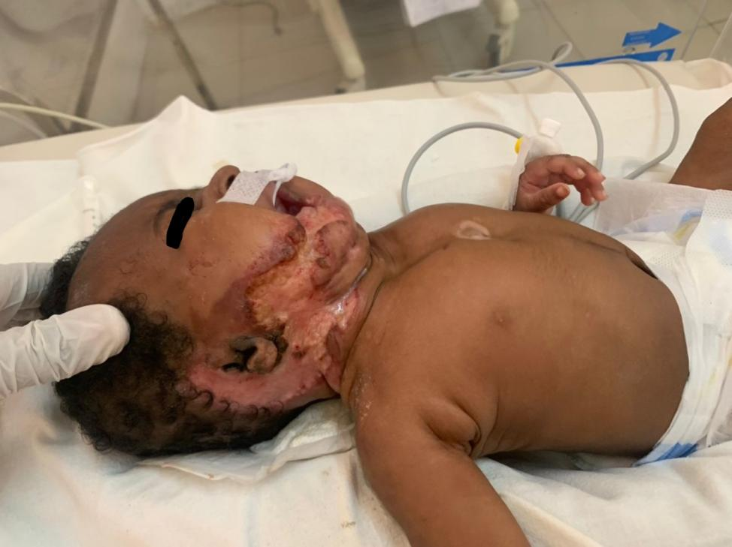
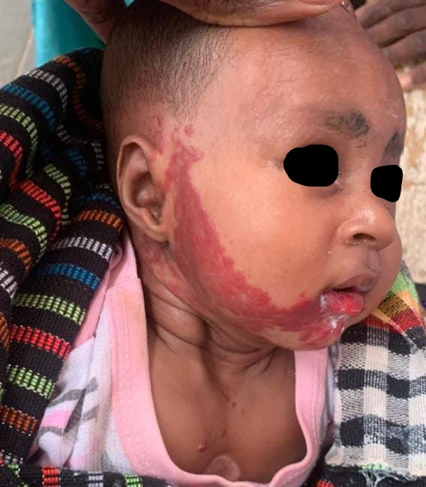

Figure 1 : Annular erythematous plaque Figure 2 : Ulceration with necrosis

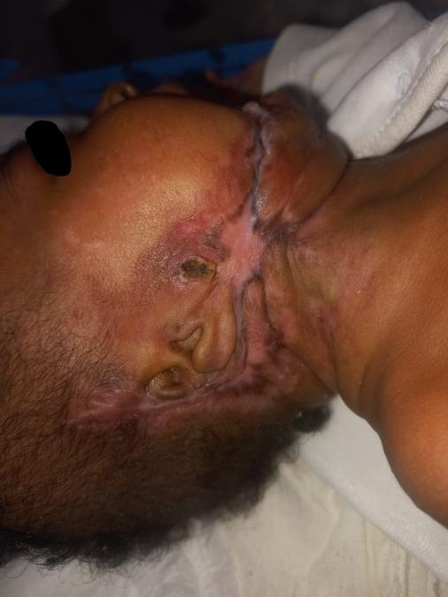
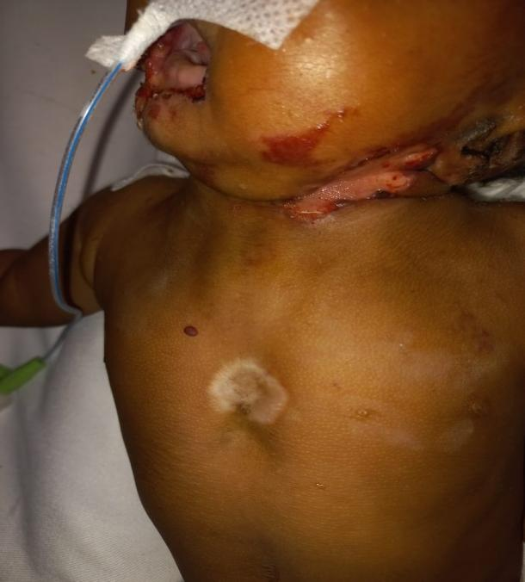

Figure 3 : Sternal agenesis Figure 4: évolution après 2 mois de traitement

