Eco-Friendly Synthesis and Adsorptive Performance of ZnO/CuO and MnO/CuO Bimetallic Nanoparticles for Heavy Metal Removal from Aqueous Solutions

Abstract
This study reports the green synthesis, characterization, and adsorptive performance of ZnO/CuO and MnO/CuO bimetallic nanoparticles for the removal of heavy metals from aqueous solutions. The nanoparticles were synthesized using Anacardium occidentale (cashew leaf) extract as a natural reducing and stabilizing agent, providing an eco-friendly alternative to conventional chemical synthesis. UV–Vis spectroscopy confirmed nanoparticle formation with surface plasmon resonance peaks at 400 nm for ZnO/CuO and 500 nm for MnO/CuO. The materials were further characterized by FTIR, SEM, XRD, and XRF, which revealed functional groups responsible for reduction, crystalline face-centered cubic structures, and nanosized morphologies with high metal oxide composition. The adsorption efficiency of the nanoparticles toward Cd²⁺, Fe³⁺, and Cr³⁺ ions was systematically investigated under varying parameters such as pH, contact time, dosage, temperature, and concentration. Optimum adsorption occurred at pH 6, 0.4 g dosage, and 45 °C, with removal efficiencies exceeding 95% for all metal ions. Adsorption equilibrium data fitted both Freundlich and Langmuir isotherm models, suggesting the coexistence of multilayer and monolayer adsorption processes. Kinetic analysis indicated that the adsorption followed a pseudo-second-order model, implying chemisorption mechanisms. Thermodynamic parameters (ΔG < 0, ΔH > 0, ΔS > 0) confirmed that the adsorption process was spontaneous, feasible, and endothermic, with increased randomness at the solid–solution interface. These results demonstrate the potential of A. occidentale-derived ZnO/CuO and MnO/CuO nanoparticles as sustainable and highly efficient adsorbents for heavy metal remediation in wastewater treatment.
Keywords: Heavy metals, bimetallic nanoparticles, adsorption, green synthesis, isotherm models.

Introduction
Water pollution, driven by industrial and human activities, has become a pressing global issue especially in developing nations where waste management systems are often inadequate. The discharge of pollutants into water bodies not only threatens human health but also disrupts ecological balance. Conventional treatment methods are often ineffective against persistent contaminants, thus highlighting the need for innovative approaches. Nanotechnology presents a cutting-edge solution for water purification. Nanoscience focuses on the manipulation of matter at the nanoscale (1–100 nm), producing materials with novel and enhanced properties (Bayda et al., 2020). Monometallic nanoparticles (e.g., Cu, Zn, Mn, Ti, Ag, Au, Pt and so on) have been extensively studied for their ability to remove both organic and inorganic contaminants. The development of bimetallic nanoparticles, which integrate two different metals, results in enhanced efficiency through synergistic effects, leading to superior catalytic, antimicrobial, and sensing properties compared to single-metal nanoparticles. This synergy arises from the unique combination of physicochemical characteristics and electronic interactions between the two metals, which increases active sites, optimizes electronic structures, and lowers activation energies for catalytic reactions. As a result, bimetallic nanoparticles demonstrate improved catalytic activity for pollutant reduction. These materials offer large surface areas and reactive sites, making them highly effective in pollutant breakdown. Green synthesis of nanoparticles using plant or microorganism-based extracts has gained popularity as an eco-friendly alternative to traditional chemical methods. This approach leverages phytochemicals like flavonoids, alkaloids, and phenolic acids found in plants to reduce metal ions into nanoparticles (Patil et al., 2022; Ejidike et al., 2023). Although, there have been reported studies on the synthesis of Copper Oxide nanoparticles using Anacardium occidentale leave extract. However, no report has been found on the synthesis of its bimetallic (CuO/ZnO, CuO/ MnO) bimetallic nanoparticles using the aforesaid plant extract.
Therefore, this study aims to synthesize ZnO/CuO and MnO/CuO bimetallic nanoparticles using Anacardium occidentale leaf extract and evaluate their structural, morphological, and adsorptive characteristics. Specifically, the study investigates their efficiency in removing Cd²⁺, Fe³⁺, and Cr³⁺ ions from aqueous solutions under varying physicochemical conditions, analyzes the adsorption mechanisms through isotherm and kinetic models, and determines the thermodynamic feasibility of the adsorption process. The findings are expected to contribute to the development of sustainable nanomaterial-based technologies for wastewater remediation and environmental protection.Therefore, this study seeks to explore more on the use of metal oxide nanoparticles particularly the bimetallic from Anacardium occidentale leave extract and deduce its efficiency towards heavy remediation.

- Materials and Methods
Fresh Anacardium occidentale leaves were collected from the botanical garden of Gombe State University, Nigeria, washed, air-dried, and ground into powder. Ten grams of the powder was boiled in 200 mL of distilled water at 80 °C for one hour, cooled, and filtered. The filtrate served as a natural reducing and stabilizing agent.
ZnO/CuO nanoparticles were synthesized by adding 20 mL of the leaf extract to 80 mL of mixed metal salt solution containing zinc nitrate and copper sulfate (2:8 molar ratio). The mixture was heated at 80 °C under continuous stirring for one hour, and NaOH (0.1 M) was added dropwise until precipitation occurred. The mixture was aged for 24 hours, washed with distilled water, and oven-dried at 80°C to obtain nanopowder. MnO/CuO nanoparticles were synthesized similarly, substituting manganese sulfate for zinc nitrate.
The synthesized nanoparticles were characterized using UV–Visible Spectroscopy (UV–Vis), Fourier Transform Infrared Spectroscopy (FTIR), X-Ray Diffraction (XRD), Scanning Electron Microscopy (SEM), and X-Ray Fluorescence (XRF).
Batch adsorption experiments were conducted using 100 mL of metal ion solutions (Cd²⁺, Fe³⁺, and Cr³⁺) with concentrations of 10–30 mg/L. Variables such as pH (2–10), contact time (10–50 min), adsorbent dose (0.1–0.5 g), and temperature (25–60°C) were optimized. Metal ion concentrations were determined using Atomic Absorption Spectrophotometry (AAS). Adsorption capacity and percentage removal were calculatd from equilibrium concentrations. Isotherm models (Langmuir and Freundlich), kinetic models (pseudo-first and pseudo-second-order), and thermodynamic parameters (ΔG°, ΔH°, ΔS°) were applied to elucidate the adsorption mechanism.

3. Results and Discussion

3.1. Biosynthesis Zinc/Copper (ZnO/CuO) and Manganese/Copper Oxide (MnO/CuO) nanoparticles.
The reduction of Zinc/Copper ions and Maganese/Copper ions into ZnO/CuONPs and MnO/CuONPs by the Anacardium occidentale leave extract acting as a stabilizing and reducing agent was confirmed by a gradual change in color from light brown to dark green and dark brown to black precipitates indicating the formation of both the bimetallic nanoparticles ZnO/CuO and MnO/CuO
3.2. UV–vis analysis of synthesized ZnO/CuO and MnO/CuO NPs
The UV-Visible spectrophometric analysis was used to determine the optical property of the extract and the synthesized adsorbents. The UV-Visible spectrophometric analysis of Anacardium occidentale leave extract showed in fig.1 recorded highest absorbance at peak 300nm. This is considered to be due to the surface Plasmon vibration and excitation of the bio reduction and capping agent (phytochemicals) present in the leaf extract.

Fig.1 UV-Visible spectra for Extract
The synthesized ZnO/CuO and MnO/CuO nanoparticles are shown in fig 2 and 3

Fig. 2. UV-Visible spectra for ZnO/CuONPs
The Zinc-Copper oxides bimetallic (ZnO/CuONPs) nanoparticles showed in fig. 2 gave the highest absorbance at 400nm which is due to the surface Plasmon vibration and excitation of the bio reduction and capping agent present in the leaf extract. This corresponds to that obtained by Naranjan et al., (2015), Emmanuel et al., (2018) and Orshiso et al., 2023 which showed the highest absorbance peaks at 350, 315, and 380nm. The slight variations observed may be due to the reducing agent and the type of metal salt used as a precursor.

Fig.3 UV-Visible spectra for MnO/CuO NPs

The Manganese/Copper oxides bimetallic nanoparticles (MnO/CuONPs) showed in fig.3 recorded absorbance at 500nm, this is attributed to the surface plasmon vibration and the excitation of bio-reduction and capping or stabilizing agent present in the leaf extract. This corresponds with the literature of Vijay et al. (2015) and Kiranmai et al. (2017), which reported the highest absorbance peaks at 300 nm and 650 nm. Similar research carried out by Alafaleq et al. (2023) reported the synthesis of bimetallic Cu-Mn NPs with surface plasmon resonance band maxima of 270 and 340 nm; this variation observed may be due to the reducing agent and the type of metal salt used as a precursor.
3.3. FTIR Spectroscopy
FTIR Spectroscopy was conducted in order to ascertain the functional groups present in the plant extract responsible for the reduction, stabilization, capping and the formation of the nanoparticles. The IR spectra of the plant extract and the synthesized nanoparticles were presented in Fig. 4, 5 and 6 respectively.
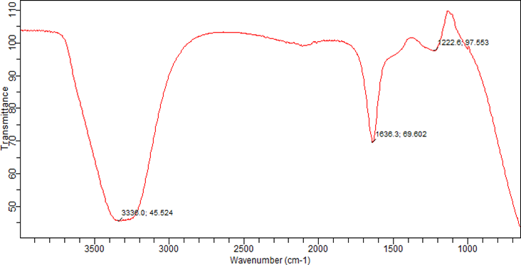
Fig. 4 FTIR spectra of plant extract
The FTIR results for the prepared extract show several peaks at 3330 cm⁻¹, 1636 cm⁻¹, and 1222 cm⁻¹. The peak at 3330 cm⁻¹ represents an OH stretching vibration due to alcohol, 1636 cm⁻¹ indicates C=C weak vibration alkenes due to the secondary metabolites' aromatic ring, and 1222 cm⁻¹ is for the C-N aliphatic amines and C-O-C strong stretching vibration. Titus et al. (2021) and Yangma et al. (2020).
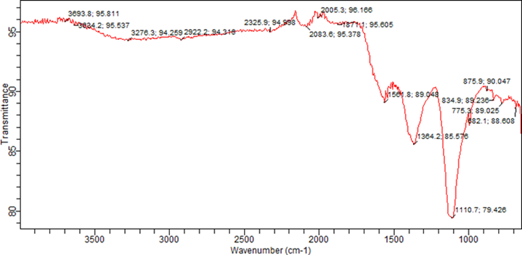
Fig. 5 FTIR spectra of ZnO/CuO
The FTIR results for synthesized zinc/copper oxide (ZnO/CuO) nanoparticles displayed several peaks at 3893 cm⁻¹, 3424 cm⁻¹, 2726 cm⁻¹, 2326 cm⁻¹, 1871 cm⁻¹, 1560 cm⁻¹, 1364, 1110 cm⁻¹, and 872 cm⁻¹.. The peaks at 3893 cm⁻¹ and 3424 cm⁻¹ represent O-H stretches due to free hydroxyl alcohol and phenols; 2726 cm⁻¹ and 2326 cm⁻¹ are due to H-C=O aldehydes; 1871 cm⁻¹ is due to C=C triple bond alkynes in the secondary metabolites; 1560 cm⁻¹ and 1364 cm⁻¹ indicate C-H bends and C-H rocks in aliphatic alkanes; 1110 cm⁻¹ is due to C-H alkanes; and 872 cm⁻¹ is due to C-Br alkyl halides. (Dastafkan and Obedavi, 2020) (Ali et al., 2020).
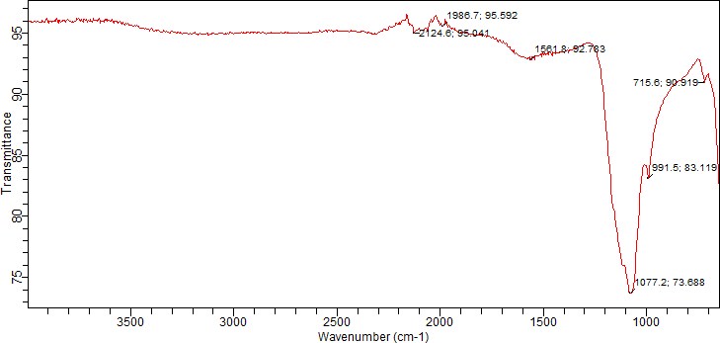
Fig. 6 FTIR spectra of MnO/CuO
The FTIR results for manganese/copper oxide (MnO/CuO) nanoparticles in Fig. 6 displayed several peaks at 2124 cm⁻¹, 1946 cm⁻¹, 1561 cm⁻¹, 1077 cm⁻¹, 991 cm⁻¹, and 7715 cm⁻¹.. The peaks at 2124 cm⁻¹ and 1946 cm⁻¹ represent C=C alkenes; 1561 cm⁻¹ and 1077 cm⁻¹ are due to C-H alkanes and –C=C aromatic bends; and 991 cm⁻¹ and 715 cm⁻¹ are also due to C-Br alkyl halides. Atheofeona et al. (2020) and Dastafkan and Obedal (2020).
3.4. X-ray Diffraction (XRD) Pattern of the synthesized Nanoparticles
XRD pattern was used to describe the crystalline structures of synthesized ZnO/CuO and MnO and CuO bimetallicnanoparticle as shown in Fig 7-8.
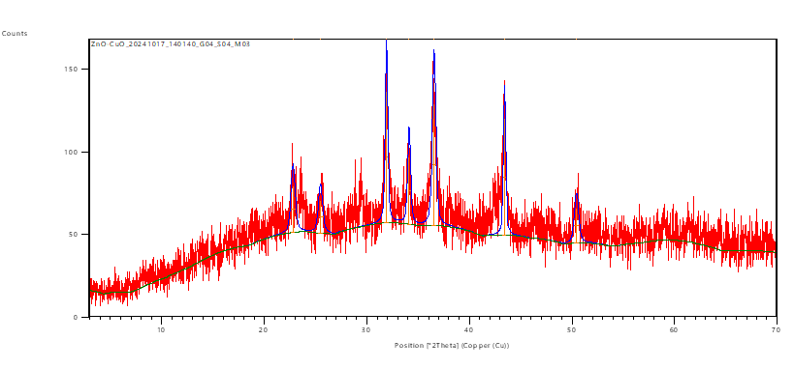
Fig. 7 XRD result for synthesized Zinc/Copper oxide nanoprticles (ZnO/CuO)
The result obtained from the XRD analysis of the synthesized zinc/copper oxide nanoparticles with the Braggs angle of 23.79-50.40º observed along with the weak peaks. It was found that four prominent peaks were observed at 2θ =22.79º, 31.58º, 36.53 º and 50.40º with respect to the plane of (111), (211), (321) and (310). It shows Face Centered Cubic [FCC] structure and the average crystalline size 39.60nm according to the Scherer equation calculated. The diffraction peaks were indexed based on JCPDS file number 89-0599, and it corresponds to the literature reported by Alice et al. (2016).
The XRD analysis of the synthesized manganese/copper oxide nanoparticles with the Bragg's angle of 36.29-54.23° was observed along with the weak peaks. It was found that two prominent peaks were observed at 2θ = 36.29° and 54.23° with respect to the plane of (201) and (301). It shows a face-centered cubic [FCC] structure and the average crystalline size is 60.14 nm according to the Scherer equation calculated. This result corresponds to that reported by Khan et al. (2018).
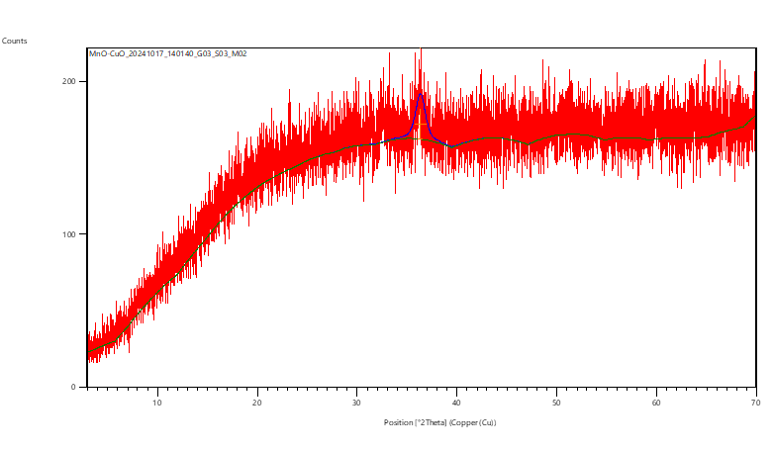
Fig. 8 XRD result for synthesized Manganese/Copper oxide nanoprticles (MnO/CuO)

3.5. Scanning Electron Microscopy (SEM)
The bimetallic nanoparticles surface morphology was examined using scanning electron microscopy.
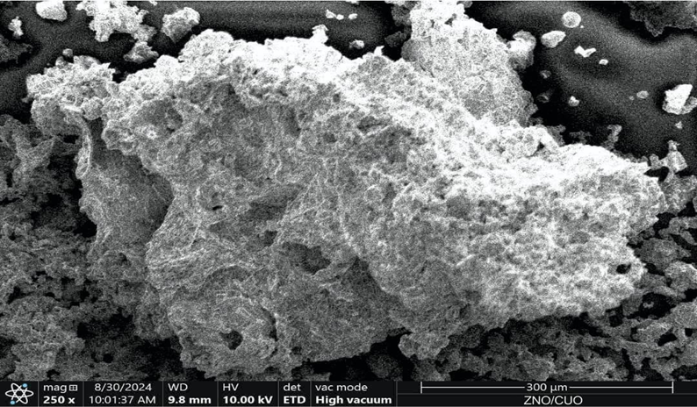
Fig. 9 SEM results for the synthesized Zinc/ Copper oxide nanoparticles (ZnO/CuO)

The SEM result for the synthesized zinc/copper oxide nanoparticles (ZnO/CuO) (Fig. 9) shows that the zinc/copper oxides have sponge-like, irregular, granular-shaped morphology that is partially spherical with a well-compacted arrangement. The result obtained is nearly in agreement with the literature reported by Alice et al. (2016).
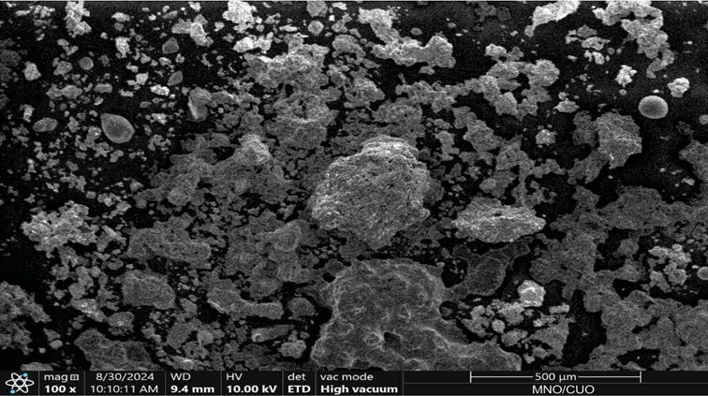

Fig.10 SEM results for the synthesized Manganese/copper oxide nanoparticles (MnO/CuO)

3.6. The X-Ray Fluorescence (XRF) Analysis
The X-ray fluorescence (XRF) analysis was conducted to show the elemental compositions and the different metal oxides present in the synthesized bimetallic nanoparticles. Table.1 and 2 gives the XRF result showing the elemental composition in the synthesized nanoparticle.

TABLE 1: Determination of the Chemical Composition of Zinc/Copper Oxides Nanoparticles Using XRF analysis
Composition | ZnO | SiO₂ | Nb₂O₃ | SO₃ | Al₂O₃ | ZrO₂ | Fe₂O₃ | CuO
Weight percentage | 18.04 | 2.54 | 1.68 | 1.15 | 3.09 | 1.36 | 0.07 | 36.98

TABLE 2: Determination of the Chemical Composition of Manganese/Copper Oxides Nanoparticles Using XRF analysis
Composition | MnO | SiO₂ | Nb₂O₃ | SO₃ | Al₂O₃ | ZrO₂ | Fe₂O₃ | CuO
Weight percentage | 59.72 | 1.18 | 0.55 | 2.48 | 5.49 | 0.19 | 0.25 | 28.14

3.7. Evaluation of Adsorption Studies
The result below shows the adsorption effect
The effect of initial concentration on Cd²⁺, Fe³⁺ and Cr³⁺ removal
Effect of initial concentration of cadmium, iron and chromium concentration on the removal efficiency of ZnO/CuO and MnO/CuO NPs was investigated at a pH =7.0, contact time = 30 min temperature of 25 ºC, adsorbent dose of 0.3g/100ml solution with a concentration of 10, 15, 20, 25 and 30 mg/L of metals ions (Cd²⁺, Fe³⁺ and Cr³⁺). The results are shown in Fig.11 and 12 for ZnO/CuO and MnO/ CuO respectively. Fig.11 shows ZnO/CuO NPs adsorption efficiencies for Cd2+, Fe3+ and Cr3+ indicating a decrease with increase in concentration of the adsorbent (10 to 30 ppm) from 99.08% to 96.30%, 97.77% to 95.39% and 98.90% to 95.03% with highest adsorption efficiency at 99.08% (10ppm), 97.77% (10ppm) and 98.90% (10ppm) for Cd2+, Fe3+ and Cr3+ metal ions respectively. This may be due to the increased surface area-to-volume ratio of the adsorbent and reduced competition for adsorption sites Fig 11, thereby allowing for more efficient adsorption and higher removal efficiency, as observed in similar research carried out by Titus et al. (2021) and Kambire et al. (2021).

Fig: 11 effect of initial concentration on the percentage removal of Cd²⁺, Fe³⁺ and Cr³⁺ by the synthesized ZnO/CuO NPs.

Fig: 12 effect of initial concentration on the percentage removal of Cd²⁺, Fe³⁺ and Cr³⁺ by MnO/CuO NPs.

Fig.12 above indicates the MnO/CuO NPs adsorption efficiencies for Cd²⁺, Fe³⁺ and Cr³⁺ showing a decrease with increase in concentration of the adsorbent from 10 to 30 ppm with observable percentage decrease from 98.72% to 96.64% , 97.52% to 95.75% and 97.05% to 94.91% with highest adsorption efficiency at 98.72% (10ppm), 97.52% (10ppm) and 97.05% (10ppm) for Cd²⁺, Fe³⁺ and Cr³⁺ metal ions respectively, the observable higher adsorption at lower concentration may be due to increased surface area to volume ratio of the adsorbent which increases the available surface area for adsorption and the reduced competition for the adsorption sites thereby giving higher removal efficiency at lower concentration as observed in similar reaction by Titus et al. (2021) and Kambire et al.(2021).
The effect of adsorbent dosage on Cd²⁺, Fe³⁺ and Cr³⁺ removal

Fig.13 effect of adsorbent dosage on the percentage removal of Cd²⁺, Fe³⁺ and Cr³⁺ by ZnO /CuO NPs
Adsorption efficiencies of ZnO/CuO NPs on Cd²⁺, Fe³⁺, and Cr³⁺ were investigated by varying the adsorbent dosage of 0.1, 0.2, 0.3, 0.4, and 0.5 g at pH=6, Conc.=10 ppm, time=30 min, and temp.=25°C. Optimum percentage removal for Cd²⁺, Fe³⁺, and Cr³⁺ was observed at an adsorbent dose of 0.4 g, showing that the percentage removal increased with an increase in the amount of adsorbent dosages. The percentage adsorption increases from 95.23% to 98.98% at the optimum dose of 0.4 g for Cd²⁺ and from 96.54% to 99.06% at the optimum dose of 0.4 g for Fe³⁺ and also from 94.34% to 97.68% for Cr³⁺ at a dosage of 0.4 g, at optimum degradation efficiencies of 98.98%, 99.06%, and 97.68% for both the Cd²⁺, Fe³⁺, and Cr³⁺. The increase in the adsorption efficiency may be attributed to the increasing number of binding sites, which increases with the amount of adsorbent (Rehab et al., 2024; Ibrahim et al., 2012; Ghaedi et al., 2015; Kambire et al., 2021).

Fig.14: effect of adsorbent dosage on the percentage removal of Cd²⁺, Fe³⁺ and Cr³⁺ by MnO/CuO NPs
Adsorption efficiencies of ZnO/CuO NPs on Cd²⁺, Fe³⁺, and Cr³⁺ were investigated by varying the adsorbent dosage of 0.1, 0.2, 0.3, 0.4, and 0.5 g at pH=6, Conc.=10 ppm, time=30 min, and temp.=25°C. The optimum percentage removal for Cd²⁺, Fe³⁺, and Cr³⁺ was observed at an adsorbent dose of 0.4 g, showing that the percentage removal increased with an increase in the amount of adsorbent dosages. The percentage adsorption increases from 95.23% to 98.98% at the optimum dose of 0.4 g for Cd²⁺ and from 96.54% to 99.06% at the optimum dose of 0.4 g for Fe³⁺ and also from 94.34% to 97.68% for Cr³⁺ at a dosage of 0.4 g, at optimum degradation efficiencies of 98.98%, 99.06%, and 97.68% for both the Cd²⁺, Fe³⁺, and Cr³⁺. The increase in the adsorption efficiency may be attributed to the increasing number of binding sites, which increases with the amount of adsorbent (Rehab et al., 2024; Ibrahim et al., 2012; Ghaedi et al., 2015; Kambire et al., 2021).
The effect of contact time on Cd²⁺, Fe³⁺ and Cr³⁺ removal
The effect of agitation time on adsorption capacity of the adsorbent on Cd²⁺, Fe³⁺ and Cr³⁺ solutions at different contact time of 10, 20, 30, 40 and 50min at optimum condition of metal ions concentrations at 10ppm for Cd²⁺, Fe³⁺ and Cr^{3+,} pH of 6 adsorbent of doses of 0.4g respectively at temperature of 25ºC.

Fig.14: effect of contact time on the percentage removal of Cd²⁺, Fe³⁺ and Cr³⁺by ZnO/CuO NPs

The effect of contact time as shown in Fig. 14 above shows the percentage removal increases with an increase in contact time until it reaches equilibrium contact time. In the increase in adsorption that was observed, the percentage adsorption increased from 94.53% to 98.92%, 94.92% to 97.97%, and 92.79% to 96.92% for Cd²⁺, Fe³⁺, and Cr³⁺, with the highest percentage adsorption of 98.92% (40 mins), 97.97% (50 mins), and 96.92% (40 mins), respectively. In the early stage of adsorption, a greater number of vacant sites are available for adsorption to proceed. As constant time increases, the adsorption capacity increases until it reaches optimum; the maximum number of sites that got adsorbed to the ZnO/CuO NPs increases, which makes it difficult for it to search for the very few remaining sites; thus, the rate of adsorption remains constant as agitation. Taman et al. (2015) and Nyoni et al. (2017). See Fig. 15: The effect of agitation time on adsorption capacity of the synthesized MnO/CuO NPs on Cd²⁺, Fe³⁺, and Cr³⁺.

Fig.15: effect of contact time on the percentage removal of Cd²⁺, Fe³⁺ and Cr³⁺by MnO/CuO NPs
The result shows the increase in percentage adsorption with an increase in contact time until it reaches equilibrium contact time. In the increase in adsorption that was observed, the percentage adsorption increased from 95.92% to 98.91%, 94.83% to 97.96%, and 95.54% to 97.35% for Cd²⁺, Fe³⁺, and Cr³⁺, with the highest percentage adsorption of 98.91% (40 mins), 97.96% (40 mins), and 97.35% (40 mins), respectively. In the early stage of adsorption, a greater number of vacant sites are available for adsorption to proceed. As constant time increases, the adsorption capacity increases until it reaches optimum; the maximum number of sites that got adsorbed to the MnO/CuO NPs increases, which makes it difficult for it to search for the very few remaining sites; thus, the rate of adsorption remains constant as agitation Taman et al. (2015) and Nyoni et al. (2017).

The effect of temperature on Cd²⁺, Fe³⁺ and Cr³⁺ removal
The percentage removal of Cd²⁺, Fe³⁺ and Cr³⁺ ions by the synthesized nanoparticles as determined at different temperatures of 25ºC -60ºC. Fig. 16 shows the percentage removal of Cd²⁺, Fe³⁺ and Cr³⁺ ions by the synthesized ZnO/CuO NPs as determined at different temperatures of 25ºC -60ºC.

Fig.16: effect of temperature on the percentage removal of Cd²⁺, Fe³⁺ and Cr³⁺ by ZnO /CuO NPs
The percentage removal increases with an increase in temperature from 94.06% to 97.18%, 93.87% to 96.83%, and 93.38% to 96.28% for Cd²⁺, Fe³⁺, and Cr³⁺, respectively, with an optimum at 45°C for Cd²⁺ and Cr³⁺, while the optimum is observed at 55°C for Fe³⁺, showing that adsorption is endothermic up to the optimum temperature because adsorption increased with an increase in temperature. However, desorption of metal ions occurs after the optimum, reducing the percentage removal of metal ions. Elsamra et al. (2024) (Ghaedi et al. 2015; Kambire et al. 2021; Ali et al., 2024).
The percentage removal increases with an increase in temperature for MnO/CuO, as shown in Fig. 17 below, from 95.73% to 98.27%, 95.07% to 97.43%, and 93.03% to 97.17% for Cd²⁺, Fe³⁺, and Cr³⁺, respectively, with optimum temperatures at 45°C for Cd²⁺ and Fe³⁺ and 55°C for Cr³⁺. This shows that the adsorption is endothermic up to the optimum temperature because adsorption increased with an increase in temperature. However, desorption of metal ions occurs after the optimum, reducing the percentage removal of metal ions. Elsamra et al. (2024) (Ghaedi et al. 2015; Kambire et al. 2021; Ali et al., 2024).

Fig. 17 effect of temperature on the percentage removal of Cd²⁺, Fe³⁺ and Cr³⁺ by MnO /CuO NPs

Fig. 18 shows the effect of pH on the percentage removal of ZnO/CuO NPs investigated on Cd²⁺, Fe³⁺ and Cr³⁺ at different pH values of 2, 4, 6, 8 and 10.

Fig. 18 effect of percentage removal against pH on adsorption of Cd²⁺, Fe³⁺ and Cr³⁺ by ZnO/CuO NPs
The percentage removal increases with an increase in pH up to the optimum; this may be due to the deprotonation at the surface enhancing the uptake of the metal ions in solution (Preeja and Leema (2019), (Ghaedi et al., 2015; Kambire et al., 2021).

Fig. 19 shows the effect of pH on the percentage removal of MnO /CuONPs investigated on Cd²⁺, Fe³⁺ and Cr³⁺ at different pH values of 2, 4, 6, 8 and 10.

Fig. 19: effect of percentage removal against pH on adsorption of Cd²⁺, Fe³⁺ and Cr³⁺ MnO/CuO NPs

The percentage removal increases with an increase in pH up to the optimum; this may be due to the deprotonation at the surface enhancing the uptake of the metal ions in solution (Preeja and A. Leema, 2019; Ghaedi et al., 2015; Kambire et al., 2021).
3.8 Adsorption Modelling
The equilibrium adsorption of Cd²⁺, Fe³⁺, and Cr³⁺ onto ZnO/CuO and MnO/CuO nanoparticles is established when the concentration of metal ions in bulk solution is in dynamic balance with that on the liquid-adsorbent interface. The Freundlich and Langmuir isotherm models were used to describe the equilibrium data. The model equations with the definition of each parameter with the calculated parameters of the isotherm models are given in Tables 3 and 4. As described by Sharifpour et al. (2018), the Langmuir adsorption isotherm assumes that monolayer adsorption occurs at the binding sites of the uniform surface of the adsorbent, while the Freundlich isotherm model is empirical in nature and describes the adsorption characteristics for a heterogeneous adsorbent surface.

Table 3: Isotherm parameters for adsorption of Cd²⁺, Fe³⁺ and Cr³⁺ions by ZnO/CuO NP^{S}
Metal ion | Langmuir Model |  |  |  | Freundlich Model
 | q_{max} | K_{L} | R_{L} | R² | K_{F} | I/n | R²
Cd²⁺ | 3.4566 | 5.8209 | 0.0034 | 0.9479 | 3.2908 | 0.4206 | 0.9925
Fe³⁺ | 4.6382 | 1.5646 | 0.0126 | 0.9775 | 2.8563 | 0.5713 | 0.9889
Cr³⁺ | 3.3738 | 5.0667 | 0.0039 | 0.9456 | 2.9587 | 0.4047 | 0.9968
Table 4 given below shows the adsorption isotherm for MnO/CuO NPs. The Langmuir isotherm fitted the experimental data very well for the adsorption of Cd²⁺ and Fe³⁺ onto MnO/CuO NPs with R² values of 0.9973 and 0.9926, respectively, which are greater than the Freundlich isotherm, confirming the monolayer coverage of Cd²⁺ and Fe³⁺ onto ZnO NPs and its homogeneous distribution of active sites on the adsorbent, while the Freundlich isotherm best fit the experimental data for the adsorption of Cr³⁺, describing the multilayer coverage and heterogeneous surfaces. The RL and 1/n values less than 1 also confirm favorable adsorption of the metal ions onto MnO/CuO NPs (Kambire et al., 2021). The maximum adsorption capacity for adsorption for Cd²⁺, Fe³⁺, and Cr³⁺ onto MnO/CuO NPs was observed to be 6.830 mg/g, 3.659 mg/g, and 5.022 mg/g, respectively.
Table 4: Isotherm parameters for adsorption of Cd²⁺, Fe³⁺ and Cr³⁺ions by MnO/CuO NP^{S}
Metal ion | Langmuir Model |  |  |  | Freundlich Model
 | q_{max} | K_{L} | R_{L} | R² | K_{F} | I/n | R²
Cd²⁺ | 6.8306 | 0.6259 | 0.0301 | 0.9973 | 2.9580 | 0.5165 | 0.9912
Fe³⁺ | 3.6590 | 2.8768 | 0.0069 | 0.9926 | 1.9431 | 0.5743 | 0.9923
Cr³⁺ | 5.0226 | 0.5694 | 0.0339 | 0.9944 | 2.1130 | 0.6471 | 0.9975

3.9 Kinetics of adsorption
The results of the batch adsorption experiments were fitted to pseudo-first-order and second-order kinetic models. The parameters for each model are summarized in Table 5. The linear graph of pseudo-first order was plotted from ln (qe-qt) against t (mins), and the graph of pseudo-second order was plotted from t/qt against t (min). The qcal, K1, K2, and R2 were obtained from the plots and are presented with qexp in Tables 5 and 6. The pseudo-second-order model assumes that the rate is proportional to the square of the number of remaining free surface sites (Pindiga et al., 2022; Kumar et al., 2024; Ali et al., 2024). Table 5 summarizes the experimental data processed using the pseudo-first-order and second-order kinetics of Cd²⁺, Fe³⁺, and Cr³⁺ ion adsorption by ZnO/CuO NPs.
Table 5: Kinetics of Cd²⁺, Fe³⁺ and Cr³⁺ ions adsorption by ZnO/CuO NP^{s}
 |  | Pseudo First Order |  |  | Pseudo Second Order
Metal ion | qe _{exp} | K₁ | q_{e} | R² | K₂ | q_{e} | R²
Cd²⁺ | 1.2688 | 0.0209 | 0.0044 | 0.8390 | 1.9212 | 1.2511 | 1
Fe³⁺ | 1.2385 | 0.0287 | 0.0016 | 0.8578 | 2.6261 | 1.2352 | 1
Cr³⁺ | 1.2363 | 0.0240 | 0.0038 | 0.7964 | 1.8508 | 1.2252 | 0.9999

Table 6. below summarizes the experimental data processed using the pseudo-first-order and second order kinetics of Cd²⁺, Fe³⁺ and Cr³⁺ ions adsorption by MnO/CuO NPs
Table 6: Kinetics of Cd²⁺, Fe³⁺ and Cr³⁺ ions adsorption by MnO/CuO NP^{s}
 |  | Pseudo First Order |  |  | Pseudo Second Order
Metal ion | qe _{exp} | K₁ | q_{e} | R² | K₂ | q_{e} | R²
Cd²⁺ | 1.2688 | 0.0159 | 0.0017 | 0.8197 | 4.1580 | 1.2441 | 0.9999
Fe³⁺ | 1.2477 | 0.0210 | 0.0022 | 0.8549 | 2.5233 | 1.1148 | 0.9994
Cr³⁺ | 1.2833 | 0.0058 | 0.0039 | 0.6907 | 5.0531 | 1.2214 | 1

3.10 Adsorption thermodynamics
The calculated thermodynamic parameters such as ΔG°, ΔH° and ΔS° for the adsorption of Cd^{2+,} Fe³⁺ and Cr³⁺ by ZnO/C uO NPs is given in Table 7

Table 7: Thermodynamic parameters for adsorption of Cd^{2+,} Fe³⁺ and Cr³⁺ ions by ZnO/CuO NP^{s}
Metal ion | ΔG° at 25° C  (kJ.mol⁻¹) | ΔH°  (kJ.mol⁻¹) | ΔS°  (kJ.mol⁻¹.K⁻¹)
Cd²⁺ | -1.6768 | 23.6017 | 0.0848
Fe³⁺ | -1.5553 | 17.4976 | 0.0639
Cr³⁺ | -1.4249 | 14.7831 | 0.0543

The results above showed that the adsorptions are an endothermic process. The ΔH° values obtained were positive and a possible bond occurred between the metal ion and the adsorbent. The positive values of ΔS° suggested the increasing randomness at the solid/liquid interface during the adsorption of Cd²⁺, Fe³⁺, and Cr³⁺ on ZnO/CuO NPs. The negative values of ΔG° indicated that the adsorption was feasible and spontaneous (Nwabosi et al., 2020) and (Nyoni et al., 2016).
The calculated thermodynamic parameters such as ΔG°, ΔH° and ΔS° for the adsorption of Cd^{2+,} Fe³⁺ and Cr³⁺ by MnO /CuO NPs is given in Table 8

Table 8 : Thermodynamic parameters for adsorption of Cd^{2+,} Fe³⁺ and Cr³⁺ ions by MnO/CuO NP^{s}
Metal ion | ΔG° at 25° C  (kJ.mol⁻¹) | ΔH°  (kJ.mol⁻¹) | ΔS°  (kJ.mol⁻¹.K⁻¹)
Cd²⁺ | -3.2343 | 14.3291 | 0.0589
Fe³⁺ | -2.2343 | 13.9733 | 0.0548
Cr³⁺ | -1.5830 | 19.9062 | 0.0721

The results above showed that the adsorptions are an endothermic process. The ΔH° values obtained were positive, and a possible bond occurred between the metal ion and the adsorbent. The positive values of ΔS° suggested the increasing randomness at the solid/liquid interface during the adsorption of Cd²⁺, Fe³⁺, and Cr³⁺ on MnO/CuO NPs. The negative values of ΔG° indicated that the adsorption was feasible and spontaneous (Nwabosi et al., 2020) and (Nyoni et al., 2016).

4. Discussion
The successful green synthesis of ZnO/CuO and MnO/CuO bimetallic nanoparticles using Anacardium occidentale (cashew leaf) extract demonstrates the efficiency of plant-based routes as viable alternatives to conventional chemical synthesis. The observable color change from dark brown to greenish precipitates signified the reduction of metal ions to their corresponding nanoparticles, a transformation driven by the phytochemicals (flavonoids, phenolics, and alkaloids) present in the leaf extract, which acted as reducing and stabilizing agents. Similar reports have been made by Patil et al. (2022) and Ejidike et al. (2023), who highlighted that plant metabolites effectively reduce metal ions through redox reactions involving hydroxyl and carbonyl groups.
The UV–Vis spectral peaks at 400 nm and 500 nm for ZnO/CuO and MnO/CuO confirmed nanoparticle formation via surface plasmon resonance (SPR) excitation, consistent with previous studies by Orshiso et al. (2023) and Niranjan et al. (2015). The slight shift in absorption peaks compared to monometallic systems can be attributed to electronic interactions between the two metal oxides, leading to modified band structures and synergistic effects typical of bimetallic systems (Bayda et al., 2020). Such shifts indicate strong coupling between Cu and Zn (or Mn) ions, which enhances the optical and catalytic activity of the resulting nanoparticles.
The FTIR spectra revealed functional groups such as O–H, C=O, and C–N, which correspond to alcohols, carbonyls, and amines involved in reduction and capping processes. The broad O–H stretching vibrations observed between 3300–3400 cm⁻¹ are typical signatures of polyphenolic compounds found in plant extracts, confirming their role in nanoparticle stabilization (Yangma & Jinhou, 2020; Titus et al., 2021). These biomolecules prevent agglomeration and improve nanoparticle dispersity, which in turn increases the effective surface area available for adsorption.
XRD analyses confirmed that both ZnO/CuO and MnO/CuO nanoparticles exhibited a face-centered cubic (FCC) crystalline structure, with average crystallite sizes of 39.60 nm and 60.14 nm respectively, as calculated using the Scherrer equation. The appearance of distinct diffraction peaks at corresponding Bragg angles matched standard JCPDS reference files for ZnO and CuO structures, in agreement with Alice et al. (2016) and Khan et al. (2018). The relatively smaller crystallite size of ZnO/CuO suggests higher surface reactivity, which may partly explain its superior adsorption performance compared to MnO/CuO at equivalent conditions.
SEM micrographs showed that the synthesized nanoparticles possessed compact, sponge-like, and partially spherical morphologies, providing a large number of active sites favorable for adsorption. This is consistent with earlier findings by Taman et al. (2015) and Elsamra et al. (2024), who demonstrated that surface roughness and irregular nanostructures promote enhanced sorption of heavy metal ions through increased contact area and electrostatic attraction.
The XRF results further confirmed the predominance of CuO and ZnO (or MnO) components, alongside trace elements such as SiO₂, Al₂O₃, and Fe₂O₃. The relatively high proportions of CuO (≈37% in ZnO/CuO and ≈28% in MnO/CuO) and ZnO/MnO (≈18% and ≈60%, respectively) indicate successful integration of both oxides, which likely contributed to the observed synergistic adsorption behavior. Similar compositional trends were observed by Alafaleq et al. (2023) during the biosynthesis of Cu–Mn nanoparticles.
The adsorption experiments revealed that both bimetallic nanoparticles exhibited high removal efficiencies (>95%) for Cd²⁺, Fe³⁺, and Cr³⁺ ions under optimized conditions (pH 6, 0.4 g dosage, 40–50 min contact time, and 45 °C). The high uptake capacity at lower metal concentrations (10 ppm) is attributable to the abundance of available adsorption sites on the nanoparticle surfaces. This trend agrees with the observations of Ghaedi et al. (2015) and Kambiré et al. (2021), who noted that adsorption efficiency typically decreases with increasing solute concentration due to site saturation.
The dependence of adsorption on pH showed that metal ion removal increased with increasing pH up to the optimum, beyond which a slight decline occurred. This behavior can be explained by reduced competition between H⁺ ions and metal ions for active sites and by deprotonation of surface functional groups at higher pH levels, leading to enhanced metal binding (Preeja & Leema, 2019; Elsamra et al., 2024). The observed endothermic nature of the adsorption process is evident from the increasing adsorption capacity with rising temperature, which facilitates ion mobility and pore diffusion.
The equilibrium data fitted both Langmuir and Freundlich isotherm models, indicating the coexistence of monolayer and multilayer adsorption mechanisms on heterogeneous surfaces. ZnO/CuO nanoparticles followed the Freundlich model more closely (R² ≈ 0.99), suggesting multilayer chemisorption, while MnO/CuO showed stronger correlation with the Langmuir model (R² ≈ 0.99) for Cd²⁺ and Fe³⁺, implying uniform surface binding and monolayer adsorption. Similar dual-behavior adsorption mechanisms have been reported by Sharifpour et al. (2018) and Rehab et al. (2024) for bimetallic nanoadsorbents.
Kinetic modeling revealed that the pseudo-second-order model best described the adsorption process (R² ≈ 1.0), suggesting that chemisorption governed the rate-limiting step involving electron exchange or covalent bonding between metal ions and surface functional groups (Kumar et al., 2024; Pindiga et al., 2022). This result is consistent with other biosynthesized oxide nanoparticle systems where adsorption is controlled by valence interactions rather than mass transfer diffusion (Nyoni et al., 2017; Nwabosi et al., 2020).
Thermodynamic analysis confirmed that all adsorption processes were spontaneous and feasible, as indicated by negative Gibbs free energy (ΔG°) values. The positive enthalpy (ΔH°) values signified endothermic reactions, implying that the adsorption process requires energy input to overcome the electrostatic repulsion between the positively charged metal ions and adsorbent surfaces. The positive entropy (ΔS°) values reflect increased randomness at the solid–liquid interface, possibly due to the displacement of water molecules from hydrated metal ions upon adsorption (Nwabosi et al., 2020; Nyoni et al., 2016). The superior performance of the green-synthesized ZnO/CuO and MnO/CuO nanoparticles demonstrates the potential of Anacardium occidentale-derived phytochemicals in producing efficient, low-cost, and environmentally friendly adsorbents. The integration of CuO with ZnO or MnO significantly improved the adsorptive efficiency through synergistic effects, enhanced electron mobility, and higher surface reactivity. These findings align with the growing body of literature emphasizing bimetallic nanocomposites as next-generation materials for sustainable wastewater remediation (Bayda et al., 2020; Alafaleq et al., 2023; Ali et al., 2024).

5. Conclusion
This study successfully demonstrated the eco-friendly synthesis of ZnO/CuO and MnO/CuO bimetallic nanoparticles using Anacardium occidentale (cashew) leaf extract as a natural reducing and stabilizing agent. The green synthesis route proved to be simple, sustainable, and effective, avoiding the use of toxic chemicals typically associated with conventional nanoparticle production. Spectroscopic and microscopic analyses confirmed the formation of stable, crystalline, and nanosized particles with distinct morphological and elemental characteristics. The presence of phytochemicals such as phenolics and flavonoids in the leaf extract played a vital role in the reduction of metal ions and the stabilization of the nanoparticles.
Both ZnO/CuO and MnO/CuO nanoparticles exhibited excellent adsorption efficiency for Cd²⁺, Fe³⁺, and Cr³⁺ ions from aqueous solutions. The adsorption process was strongly influenced by pH, temperature, contact time, and adsorbent dosage, with optimal conditions achieved at pH 6, 0.4 g dosage, 45 °C, and a contact time of 40–50 minutes. The adsorption equilibrium data fitted both the Langmuir and Freundlich isotherm models, indicating the coexistence of monolayer and multilayer adsorption mechanisms. Kinetic modeling revealed that the pseudo-second-order model best described the experimental data, implying chemisorption as the dominant mechanism. Thermodynamic analysis further confirmed that the adsorption process was spontaneous, feasible, and endothermic in nature.
The superior performance of the synthesized nanoparticles can be attributed to the synergistic interactions between their metal oxide components and the functionalization provided by plant-derived organic molecules. These properties enhance surface reactivity and adsorption potential, making them promising candidates for practical applications in wastewater treatment and environmental remediation. Compared to many conventional adsorbents, these green-synthesized nanomaterials offer the advantages of low cost, environmental compatibility, and high efficiency. The study provides a valuable contribution to the field of green nanotechnology and environmental chemistry. It demonstrates that Anacardium occidentale-derived bimetallic oxide nanoparticles represent a sustainable, efficient, and eco-friendly solution for the removal of heavy metals from contaminated water systems, aligning with the global pursuit of clean water and a greener environment.
REFERENCES
Alafaleq, N. O., Zughaibi, T. A., Jabir, N. R., Khan, A. U., Khan, M. S., & Tabrez, S. (2023). Biogenic Synthesis of Cu-Mn Bimetallic Nanoparticles Using Pumpkin Seeds Extract and Their Characterization and Anticancer Efficacy. Nanomaterials, 13(7), 1201.
Ali .R., Abdul .N.,Ijaz .A.,Fozia .F.,Mikhlid .H.,Madeeha .A.,Muhammad .I.,Bader O. Zia .U. (2024). Synthesis of Plant-Mediated Iron Oxide Nanoparticles and Optimization of Chemically Modified Activated Carbon Adsorbents for Removal of As, Pb, and Cd Ions from Wastewate. ACS Omega , 9, 1, 317–329.
Ali, M .S., Craig, W. and Polla, K. A.(2020). Synthesis of Zeolite A from Iraqi Natural Kaolin Using a Conventional Hydrothermal Synthesis Technique. Kurdistan research article Available online: 31-12-2020.
Athifeona, T., Sabeena, G., Pushpalaksmi, E. Jenson, S. and Annadurai, G. (2020)”Synthesis and Characterization of ZnO-MMT Nanocomposites for Antibacterial Activity Studies. Journal of Applied Science and Environmental Management. 24(6):1079-1089.
Alice, L., Macedo, J. D. F., Manoel, J. M., Pires, W. L., Oliveira, J. D. A., Rodinei, A. H., Aragon, R., Santos, C. A. O. and Marcio, C. P. (2016). A Mesoporous SiO₂/Y-Fe₂O₃/KI Heterogeneous Magnetic Catalyst for the Green Synthesis of Biodiesel” Journal of Brazilian Chemical Society 27(12):2290-2209.
Bayda, S., Adeel, M., Tuccinardi, T., Cordani, M., & Rizzolio, F. (2020). The History of Nanoscience and Nanotechnology: From Chemical–Physical Applications to Nanomedicine. Molecules, 25(1), 112.
Dastafkan, M. S and Obedavi, S. (2020) Manganese Dioxide Nanoparticles-Y Zeolite as Nanocomposite Catalyst for the Decontamination Reactions of S-diethyl phosphonothiolate. International Journal of Environmental Science Technology. 12:905- 918.
Ejidike, I. P., Ijimdiya, R., Emmanuel-Akerele, H., Emmanuel, G., Ejidike, O., Bamigboye, M., Seyinde, D., Olaleru, A., Tanimowo, W., & Awolope, R. (2023). Biosynthesis, Characterization, and Antimicrobial Assessment of Metal Nanoparticles from Dryopteris manniana (Hook.) C. Chr Leaf Extract. Bulletin of Pharmaceutical Sciences Assiut, 46(1), 225-238.
Emmanuel, M., Nwufo, B.T., and Ekwenchi, M.M. (2018). Inhibiting effect of dioctyPythalate on the corrosion of mild steel in 1.0M Hydrochloric acid solution. Open Access Library Journal, 5: 4927.
Elsamra, R. M. I., Masoud, M. S., Zidan, A. A., El Zokm, G. M., & Okbah, M. A. (2024). Green synthesis of nanostructured zinc oxide by Ocimum tenuiflorum extract: Characterization, adsorption modeling, cytotoxic screening, and metal ions adsorption applications. Biomass Conversion and Biorefinery, 14, 16843–16856.
Ghaedi, M. A., Hajjati, S.A. Z. Mahmudi, A.. Tyagi, B., Shilpi, A. B. A., Maity, V.K. G. (2015) Modeling of Competitive Ultrasonic Assisted Removal of the Dyes – Methylene Blue and Safranin-O using Fe₃O₄ Nanoparticles. Chemical Engineering, Journal 268: 28–37.
Ibrahim E., Laszlo, E, Jong-Ho, K and Ho Kyong, S. (2012) Adsorption and photocatalytic degradation of Methylene Blue over Hydrogen-Titanate 1 nanofibres produced by a peroxide method. Faculty of Engineering and Information Technology, University of Technology, Sydney 6 (UTS), PO Box 123, Broadway, 2007 Australia
Kambiré, O., Kouakou, Y.U., Kouyaté, A., Sadia, S.P., Kouadio, K. E., Kimou, K.J. and Koné, S. (2021) Removal of Rhodamine B from Aqueous Solution by Adsorption on Corn Cobs Activated Carbon. Mediterranean Journal of Chemistry 11(3), 271-281
Khan, M. Z. K., Tarek, F. K., Hossen, M. N. and Roki, A. M. (2018) Green Synthesis and Characterization of Silver Nanoparticles Using Coriandrum Sativum Leaf Extract. Journal of Engineering Science and Technology.13 (1):158-166.
Kiranmai, M., Keethi, K., Charla, N., Keesara, S., Fatima, P. B. and Umar, B. (2017). Green synthesis of stable copper nanoparticles and synergistic activity with antibiotics” Indian journal of pharmaceutical science, 79(5): 695-700.
Kumar, N., Jyoti, J., Aggarwal, N. et al. (2024). Adsorption of Pb2+ using biosynthesized ZnO nanoparticles derived using Azadirachta indica (neem) leaf extract. Biomass Conv. Bioref. 14, 30601–30611.
Niranjan,B, Saha,S, Chaaraborty, M, Maiti, M, Das,S, Basu, S and Nandy, P.(2015) Green synthesis of Zinc oxides nanoparticles using hibiscus subdariffa leaf extract, effect of tempreture on synthesis, anti bacterial activity and anti diabetic activity. Royalsociety of chemistry. 3(8),1-9
Nwabosi, V. N., Igbokiwe, R. K, and Once, E. J. E.(2020) Removal of Methylene Blue Dye from Aqueous Solution Using Modified Igbo Clay. Journal of Materials Science Research and Reviews.5 (2):32-46.
Nyoni, S. S. E., Mukaratiwa M. N. and Shumba, M. (2017) Comparative Biosorption of Pd Ions from Solution Using Moringa Oleifera Plant Part Equilibrium Kinetics and Thermodynamic Studies. African Journal of Biotecchnology. 16(48) 2215-2231
Orshiso TA, Zereffa EA, Murthy HCA, Demissie TB, Pardeshi O, Avhad LS, Ghotekar S. (2023). Biosynthesis of Artemisia abyssinica Leaf Extract-Mediated Bimetallic ZnO-CuO Nanoparticles: Antioxidant, Anticancer, and Molecular Docking Studies. ACS Omega. 8(44):41039-41053.
Patil, S., Sastry, M., & Bharde, A. (2022). Size and shape directed novel green synthesis of plasmonic nanoparticles using bacterial metabolites and their anticancer effects. Frontiers in Microbiology, 13, 866849.
Pindiga, N. Y., Khadija A. Y., Adamu A. and David Y. M. (2022 B). Green Synthesis and Characterization of Cobalt, Iron and Cop-per Nanoparticles Derived from the Stem-Bark Extract of Khaya Senegalensis (Mahogany) and Its Antimicrobial Activity. Online Journal of Chemistry, 1:1-13.
Preeja P. T and A. Leema, R (2019) Photodegradation of Congo Red Dye Via Simple and Effective Air Oxidation Using Copper (II) Chloride and Sunlight. Nature Environment and Pollution Technology, An International Quarterly Scientific Journal, 2019 18(4) pp. 1243-1248.
Rehab.M., Abdel-Megeed (2024). Biogenic nanoparticles as a promising drug delivery system. Toxicology Reports, 14, 101887. https://doi.org/10.1016/j.toxrep.2024.101887
Sharifpour E, Ghaedi M, Nasiri Azad F, Dashtian K, Hadadi H, Purkait MK (2018). Zinc oxide nanorod-loaded activated carbon for ultrasound-assisted adsorption of safranin O: central composite design and genetic algorithm optimization. Appl Organomet Chem 32(2):e4099.
Taman, R., Ossman, M. E., Mansour, M. S., & Farag, H. A. (2015). Metal oxide nano-particles as an adsorbent for removal of heavy metals. Journal of Advanced Chemical Engineering, 5(3), Article 1000125.
Titus, C. E, Ambali, S, Abdulsalami, S. K, Eyitayo, A , Jimoh, O, Mercy,T. B, Shufeng, B & Wiets, D R.(2021) Adsorption of Cr(VI), Ni(II), Fe(II) and Cd(II) ions by KIAgNPs decorated MWCNTs in a batch and fxed bed process. Scientifc Reports | (2021) 11:75
Vijay, K.P.P.N, Shamreen, U.P, alvini, R.H and Pammi, S.V.N. (2015). Green synthesis of copper oxide nanoparticles using aloe vera leaf extract and its antibacterial activity against fish bacterial pathogen. Bio nano science, 5(2), 135-139.
Yangma, Y. and Jinhou, J. (2020) Preparation and Antibacterial Activity of Nano Copper Oxides Loaded Zeolite 10X” International Journal of Molecular Science, 23(8421):1-10.

