Ethnobotanical Study of the African Yam Bean (Sphenostylis stenocarpa (Hochst. ex A. Rich.) Harms) in some yYoruba localities of Benin Republic

ABSTRACT
Aims: To document production constraints, uses, and farmers' selection criteria for the African yam bean (Sphenostylis stenocarpa) in some yYoruba localities of Benin Republic, identify production areas, prioritize constraints, evaluate genetic diversity, determine varietal selection criteria, and gather endogenous knowledge on cultivation practices, use, conservation, and seeds.
Study design: Participatory ethnobotanical survey involving group investigations and individual surveys.
Place and Duration of Study: Ten villages in the Yoruba cultural zone of southern Benin (Plateau and Collines departments).
Methodology: Surveys were conducted using participatory methodologies, including group discussions with comparison matrix for constraints and preferences, and structured questionnaires for individual data (n=21 households). The percentages of constraints and preference criteria were calculated based on the number of villages mentioning these elements relative to the total number of villages surveyed. The percentages of producers’ response have been also calculated.
Results: Eleven local varieties identified, differentiated by seed color (41.7%), cooking time (25.0%), and ritual/symbolic functions (20.8%). Varieties per village: 2-7. Main constraints: pod rot (17.24%), lack of trees for intercropping (17.24%), market outlets (12.06%). Diversity loss: high erosion (up to 100% in some villages). Uses: domestic consumption (100%), rituals (50%). Preference: seed availability (61.9%). Production decline: 81% of producers. Solutions: upright varieties (42.9%), improved practices (37.1%).
Conclusion: Local knowledge is crucial for AYB conservation despite erosion; revitalization needs farmer-led selection, adapted varieties, and institutional support. Biochemical/molecular characterization recommended for true diversity assessment.
Keywords: Sphenostylis stenocarpa; varietal diversity; traditional knowledge; neglected crops; Benin

1. INTRODUCTION
Food security and poverty reduction are major concerns in developing countries. These objectives cannot be achieved without agricultural intensification and crop diversification (Osei-Bonsu et al., 2022). Unfortunately, current climatic conditions are increasingly unfavorable to the main cultivated species. The intensive use of chemical fertilizers and pesticides harms the environment as well as the health of producers and consumers. In this context, research focuses on identifying and promoting neglected and underutilized species, often rich in vitamins and better adapted to difficult soil and climate conditions (Padulosi et al., 2019
; Dansi et al., 2013).
Sphenostylis Stenocarpa, commonly known as African yYam bBean (AYB), is one such species. It is cultivated locally for its seeds and tubers. The tubers contain twice as much protein as sweet potato and more than yam or cassava (Amoatey et al., 2000). The amino acid content of the seeds is comparable to that of chicken eggs and higher than that of cowpea or pigeon pea (Uguru et al., 2001). Its nutritional value meets WHO standards (Ekpo, 2006).
Promoting its cultivation would therefore be a major asset in the fight against malnutrition in Benin. However, the species remains marginalized: production areas are poorly understood, varieties are unidentified, and farmers' knowledge is poorly documented. Farmers' preference criteria, agronomic performance, uses, and seed systems are still largely unexplored.
This study aims to:
Identify the AYB production areas in Benin;
Identify and prioritize the constraints related to one's culture;
Determine the farmers' criteria for varietal selection;
Gathering endogenous knowledge related to cultivation practices, use, conservation and seeds.

2. MATERIAL AND METHODS
2.1 Study Area and Site Selection
The Republic of Benin is in West Africa, between latitudes 6°10′ N and 12°25′ N and longitudes 0°45′ E and 3°55′ E. It covers an area of 112,622 km² and has a population of over 14 million. A rapid field survey, conducted with decentralized services of the Ministry of Agriculture and in local markets, identified the Yoruba (or Nago) cultural zone as the main production region for African yam beans (AYA B) in southern Benin. To cover this area, ten villages were randomly selected. These ten villages are located in two departments in the south of the country: Plateau and Collines. This region belongs to the Guinean agro-ecological zone, characterized by a sub-humid climate, two rainy seasons, annual rainfall between 1100 and 1400 mm, and average temperatures ranging between 25 and 30 °C.
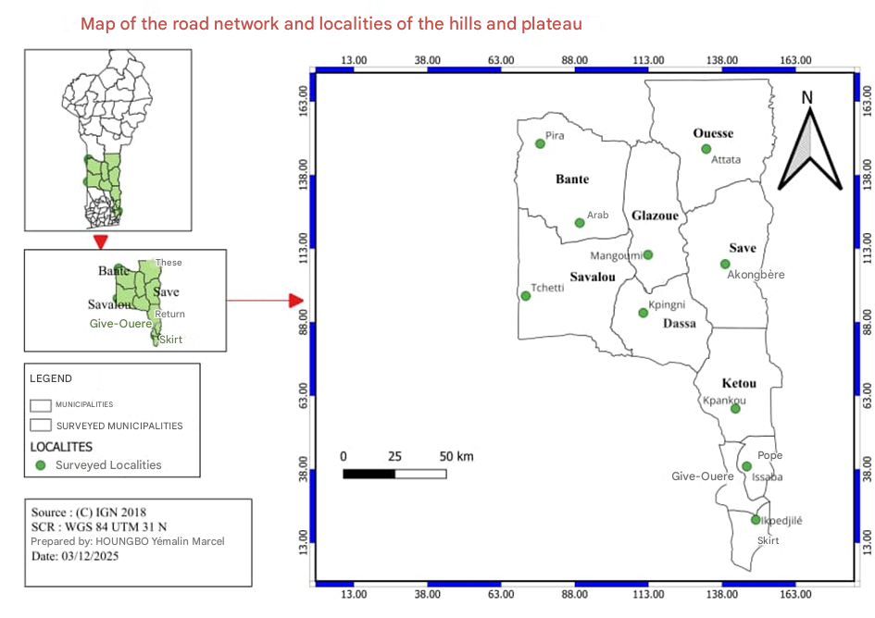
Fig. 1. Map of the study area
2. 2 Data Collection
In each village, two types of surveys were conducted according to the participatory methodology described by Dansi et al. (2010):
Group investigation, including direct observations and field visits
Individual survey, based on a structured questionnaire.
The assessment of production constraints was based on the participatory comparison matrix method (Kamara et al., 1996; Defoer et al., 1997; Dansi et al., 2010). Producers first freely listed the constraints, then ranked them in order of importance using a progressive elimination process: the constraint deemed most urgent to resolve was selected, removed from the list, and then the process was repeated until a complete ranking was obtained. The same approach was used to identify and classify farmers' varietal preference criteria.
The information obtained in groups was used to construct a structured questionnaire for individual surveys. In each village, all reported AYB farming households were interviewed. The respondent was designated by the host couple, according to Dansi et al. (2000).
The variables collected was: sex, age, marital status, education level, ethnicity, household size, number of cultivated varieties, planted area, years of experience, and available labor force. Direct observations in the field (cultivated plots, seed storage facilities, agricultural tools) helped to corroborate the producers' statements.
The percentages of constraints and preference criteria were calculated based on the number of villages mentioning these elements relative to the total number of villages surveyed. These percentages allowed for the assessment of respondents' perceptions regarding the classification of AYB (Avocado-Flavored Wheat), the evolution of its production, proposed solutions to strengthen this production, as well as seed supply sources, storage time, AYB cooking time, and field pests and diseases.
3. Results
3.1 Socio-Demographic Characteristics of the Households Surveyed
Men (90.5%) headed the majority of households surveyed (n = 21), compared to only 9.5% women, all located in Aroba. The level of education was largely dominated by illiteracy: 81.0% of household heads had received no formal education, 9.5% had a primary education, and 4.8% a secondary education. The producers were on average 55.2 ± 2.8 years old, ranging from 30 to 75 years. Their agricultural experience varied considerably (2 to 65 years), with an average of 30.3 ± 4.0 years. The areas cultivated under intensive agricultural management (IAM) ranged from a few plants to 0.5 ha, with an estimated average of 0.37 ± 0.05.
Table 1: Sociodemographic and agricultural characteristics of the surveyed household heads
Variable | Category / Statistics | Value
Gender of the head of household | Men | 90.5% (n = 19)
 | Women | 9.5% (n = 2)
Education level | Illiterate | 81.0% (n = 17)
 | Primary | 9.5% (n = 2)
 | Secondary | 4.8% (n = 1)
 | Not specified | 4.8% (n = 1)
Age (years) | Mean ± standard deviation | 55.2 ± 2.8
 | Observed interval | 30 to 75
Agricultural experience (years) | Mean ± standard deviation | 30.3 ± 4.0
 | Observed interval | 2 to 65
Cultivated area in AYB (ha) | Mean ± standard deviation (estimate) | 0.37 ± 0.05
 | Designated beach | A few plants at 0.5 ha

3.2 Production Constraints
The surveyed producers identified ten major constraints affecting African yam bean (AYA) production (Fig. 2). Two constraints stand out clearly, with a citation frequency of 17.24: pod rot on the ground and a lack of trees in the fields to allow for intensive intercropping. These two factors constitute the main agronomic obstacles to productivity and crop intensification. They are followed, at an intermediate level (12.06), by a group of four constraints that are also very frequently mentioned: a lack of market outlets, the absence of processed products, storage insects, and preparation in the bush. These reveal major difficulties in terms of commercialization, post-harvest storage, and working conditions. Finally, three constraints are cited much less frequently but remain significant in certain areas: constipation after consumption and fear of consumption due to taboos (3.44 each), as well as the long cooking time (6.9), reflecting barriers related to culinary acceptability and cultural beliefs. This ranking clearly shows that the most critical constraints are technical and economic, while culinary and sociocultural aspects, although real, appear secondarily.
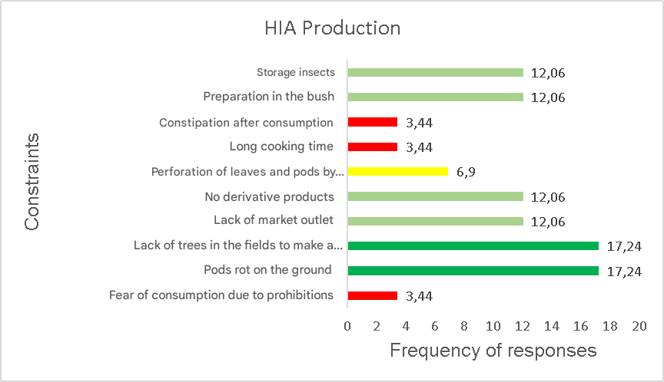
Fig 2: Figure on production constraints
3.3 Uses of AYB
Analysis of the uses of the African yam bean reveals a plurality of functions—nutritional, ritual, and symbolic—within the villages studied. Domestic consumption is the most widespread use: it is reported in all ten localities, confirming the central role of the species as a food source. The Tchango ceremonies, linked to rain-invoking rites, are observed in five villages (Akon gbèré, Kpankou, Attata, Tchetti, and Ikpedjilé), demonstrating the continued strong cultural and ritual dimension surrounding the seed. Its use as rain seed, perceived as a symbolic trigger for the first rains, appears in four villages (Kpingni, Magoumi, Aroba, and Pira), reflecting a particular agronomic and mystical value. Finally, spiritual protection is mentioned in only one village (Issaba), where the seeds are used as a protective talisman, testifying to a rarer but socially significant symbolic function.
Table 2: Uses of AYB seeds reported by village
Village | Domestic consumption | Tchango ceremonies (rain) | Rain seed | Spiritual protection
Akon gbèré | + | + | - | -
Kpankou | + | + | - | -
Kpingni | + | - | + | -
Magoumi | + | - | + | -
Attata | + | + | - | -
Tchetti | + | + | - | -
Issaba | + | - | - | +
Aroba | + | - | + | -
Pira | + | - | + | -
Ikpedjilé | + | + | - | -

+: use declared by the producers of the corresponding village.
- : No usage declared by the village producers corresponds
Noticed: Some villages combine several functions for AYB seeds, highlighting their ritual and food versatility.

3.4 AYB ranking
When asked to rank all the crops grown on their farms, 33.3% of producers placed agroforestry in sixth position, indicating a marginal status within their production system. This was followed by fourth (23.8%) and second (19.1%), showing that a minority consider it a priority. These data reflect a contrasting perception of the importance of agroforestry, influenced by both technical constraints and cultural considerations (Fig. 3).

Fig 3: AYB Classification
3.5 Preference criteria
Producers place primary importance on seed availability (61.9%), the dominant practical criterion. Other selection factors include the white color of the seed coat (14.3%) and quick cooking time (9.5%), indicators of culinary quality and domestic acceptability (Table 3).
Table 3: Main producer preference criteria for AYB varieties
Preference criteria | Percentage of responses (%)
Seed availability | 61.90
Quick cooking | 9.52
Very soft seeds | 4.76
Cooking does not require changing the water | 4.76
Medicinal Use | 4.76
White color of the integument | 14.29

3.6 Production evolution
A clear downward trend is observed: 81% of producers (17/21) report a reduction in the area or frequency of cultivation of the AYB, while 19% (4/21) report a recovery or local increase in production (Table 4). This widespread decline raises questions about the resilience of the sector.
Table 4: Perceived evolution of AYB production by producers
Production trend | Effective | Proportion (%) | Comment
In decline | 17 | 81.0 | Reduction in surface area, frequency, or yield
Increasing | 4 | 19.0 | Local revitalization, improved promotion, curiosity

3.7 Solutions proposed by producers to strengthen AYB production
The main approaches suggested by producers to strengthen the cultivation of AYB (High Impact Algae) are the adoption of upright varieties (42.9%) and the improvement of cultivation practices (37.1%). Other proposals include the development of market outlets (11.4%) and, less frequently, the selection of short-cooking varieties, community awareness-raising, and the creation of derivative products (each at 2.9%) (Fig. 4).
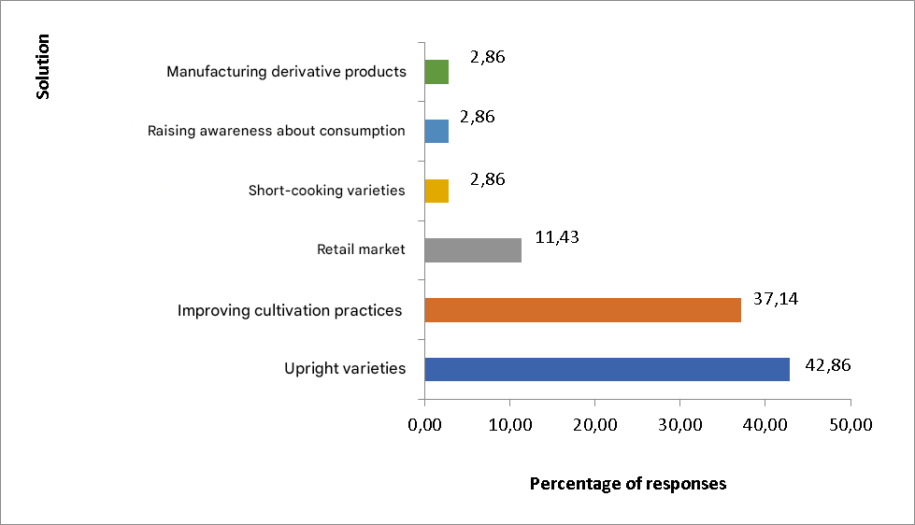
Fig 4: Solutions proposed by producers to strengthen AYB production
3.8 Seed supply sources and storage duration
Self-production remains the main source of seeds (56.76%), ahead of local purchase (29.73%) and donations or inter-community exchanges (13.51%) (Fig. 5), reflecting a relative seed autonomy but also an absence of formal circuits.
Regarding seed viability, 57.1% of producers store them for 2 years, while 19.1% mention storage for 1 or 3 years. A small group reports storage for up to 5 years (4.8%) (Table 5), demonstrating varying levels of expertise in storage.

Fig: 5 (Figure on seed supply sources)

Table 5: Producer-reported storage duration of AYB seeds
Storage duration | Proportion (%)
2 years | 57.1
1 year | 19.1
3 years | 19.1
5 years | 4.8

3.9 AYB cooking time
Perceived cooking times vary: 3 hours is cited by 42.86% of respondents, followed by 4 hours (23.81%) and 3.5 hours (14.29%), while a final group mentions cooking times of 2.5 hours or less (Fig. 6). These data confirm that cooking time remains a significant obstacle.

Fig 6: Cooking time according to producers

3.10 Symptoms after AYB consumption
Adverse effects related to consumption are widely reported: post-consumption "measles" is mentioned by 62.1% of producers, stomach aches by 20.7%, dizziness by 10.3% and headaches by 6.9% (Fig.7), highlighting a need for physiological or culinary clarification.
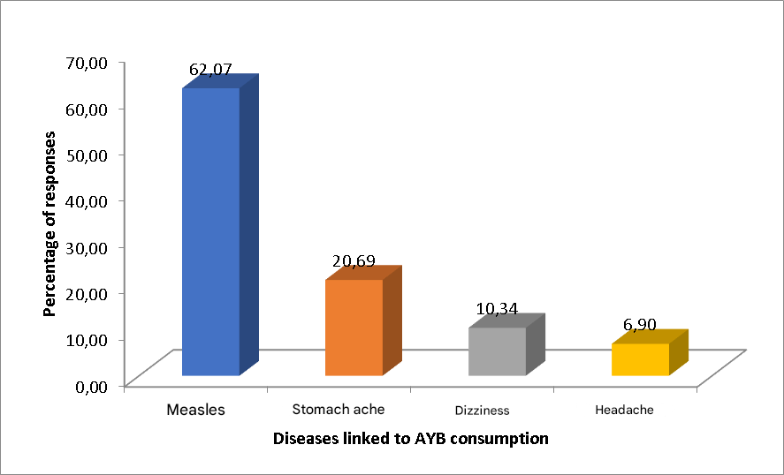
Fig 7: Symptoms after AYB consumption
3.11 Field Pests and Diseases
More than half of the producers (61.9%) reported leaf and pod perforations caused by insects. However, only 14.3% were able to name or precisely identify these pests. No phytosanitary treatments were applied, mainly due to cost and the perceived low impact on yield (Table 6).
Table 6: Phytosanitary problems reported in AYB fields
Presence of diseases in the plant | Types of diseases observed | Measures taken to deal with diseased plants | Knowledge of pests | Phytosanitary treatment applied against pests and diseases |  | Part of the plant consumed
Yes (61.90%) No (38.10%) | Insects perforate the leaves and pods | Nothing | Yes (14.28%), meaning 3 out of the 8 who said there was an illness | Lack of financial resources and also because the damage is not significant | Seeds

3.12 Seed Preparation and Storage
Producers select only healthy and visibly disease-free seeds, without resorting to any preventative treatment. The seeds are then stored in airtight bags or containers (Table 7), according to empirical practices passed down orally.
Table 7: Preparation and storage of AYB seeds
Part used as seeds |  | Criteria for seed selection | Treatments before seed storage | Storage containers
 | Seeds | Healthy plants, healthy pods, and healthy seeds | None | Bags and jerrycans

4. Discussion
The study revealed a socio-demographic profile of the surveyed households characterized by a male predominance, a low level of education, and significant agricultural experience. The areas cultivated with African yam bean (AYB) are relatively small, which is characteristic of subsistence farming systems in sub-Saharan Africa (Jayne et al., 2014). AYB producers face significant constraints, including pod rot and lack of trees in the fields, which affect the productivity and marketing of their production. These results are consistent with those of other studies that have shown that post-harvest losses and crop management are major challenges for legume producers in sub-Saharan Africa (Affognon et al., 2015; Ajeigbe et al., 2024).
The analysis of AYB uses showed a plurality of functions - nutritional, ritual, and symbolic - within the studied villages. Domestic consumption is the most widespread use, confirming the central role of the species as a food source (Bhattarai et al., 2025; Oboh et al., 2015). The study also showed that AYB producers face significant challenges in improving the marketing of their production, including a lack of commercial outlets and the absence of processed products (Mabberley et al., 2015).
The contrasting perception of the importance of agroforestry can be attributed to several factors, including a lack of knowledge about the benefits of this practice, labor constraints, and economic priorities (Franzel et al., 2001). However, producers who have a better understanding of the benefits of agroforestry are more likely to adopt it and consider it a priority (Ajayi et al., 2007).
Regarding varietal preference criteria, producers gave primary importance to seed availability, which is consistent with the results of other studies that have shown that access to seeds is a key factor in crop variety selection (Almekinders et al., 1994; Sperling et al., 2001).
The downward trend in AYB cultivation is concerning and raises questions about the resilience of the sector. This situation can be attributed to several factors, including biodiversity loss, soil degradation, climate change, low crop profitability, and lack of support for producers (Bhattarai et al., 2025; Ajeigbe et al., 2024).
Producers mainly suggested the adoption of upright varieties and improved cultural practices to strengthen AYB cultivation. These results are consistent with those of other studies that have shown that the adoption of improved varieties and improved cultural practices are effective strategies for improving crop productivity and profitability (Bhattarai et al., 2025; Ajeigbe et al., 2024).
Personal production remains the main source of seeds, which is consistent with other studies that have shown that food crop producers in sub-Saharan Africa often rely on their own seeds (Almekinders et al., 1994; Sperling et al., 2001). However, this may also indicate an absence of formal seed distribution channels, which can limit access to improved varieties and quality seeds (Garrity et al., 2010).
Cooking time is a significant obstacle, with 42.86% of respondents citing 3 hours. Adverse effects related to consumption are widely reported, including post-consumption "measles" and stomach pains, suggesting that producers may not be aware of appropriate preparation and cooking methods (Ajeigbe et al., 2024).
Insect damage is common, but phytosanitary treatments are not applied due to cost and perceived low impact on yield (Mercer, 2004).
5. Conclusion
The study on African yam bean production, highlights the importance of this species in improving food security and reducing malnutrition in Benin. The results of the study underscore the constraints faced by producers, but also the opportunities for promoting AYB cultivation. It is therefore essential to develop breeding and dissemination programs for improved AYB varieties, as well as to strengthen the capacities of producers to improve productivity and quality of production. This will contribute to promoting this alternative crop and improving the living conditions of rural populations in Benin.
References:
1. Affognon, H., Mutungi, C., Sanginga, P., & Borgemeister, C. (2015). Unpacking Postharvest Losses in Sub-Saharan Africa: A Meta-Analysis. World Development, 66, 49-68. https://doi.org/10.1016/j.worlddev.2014.08.002 .
2. Ajeigbe, H. A., Akinwale, R. O., Ayuba, L. K., & Jonah, J. (2018). Agronomic evaluation of cowpea cultivars developed for the West African Savannas. Legume Research, 41(6), 875-882.
3. Ajayi, O. C., Place, F., Kwesiga, F., & Mafongoya, P. (2007). Impacts of improved tree fallow technology in Zambia. In H. Waibel & D. Zilberman (Eds.), *International research on natural resource management: Advances in impact assessment* (pp. 147–168). CABI. https://doi.org/10.1079/9781845932831.0147 .
4. Almekinders, C. J. M., Louwaars, N. P., & de Bruijn, G. H. (1994). Local seed systems and their importance for an improved seed supply in developing countries. Euphytica, 78(3), 207-216. https://doi.org/10.1007/bf00027519
5. Amoatey, H. M., Klu, G. Y. P., Bansa, D., Kumaga, F. K., Aboagye, L. M., Bennett-Lartey, S. O., & Gamedoagbao, D. K. (2000). The African yam bean (Sphenostylis stenocarpa): A neglected crop in Ghana. West African Journal of Applied Ecology, 1(1), 53-60. https://doi.org/10.4314/wajae.v1i1.40570 .
6. Bhattarai, R. R., Sulochana, G., Maheta, R. G., Severn-Ellis, A., Pati, K., Sruthi, N. U., Samson, A., & Johnson, S. (2025). Comparative analysis of bioactives and protein characteristics in six genotypes of yam bean tubers. Sustainable Food Technology. https://doi.org/10.1039/D5FB00398A
7. Dansi, A., Dantsey-Barry, H., Dossou-Aminon, I., N'Kpenu, E. K., Agré, A. P., Sunu, Y. D., Kombaté, K., Loko, Y. L., Dansi, M., Assogba, P., & Vodouhè, R. (2013). Varietal diversity and genetic erosion of cultivated yams (Dioscorea cayenensis Poir - D. rotundata Lam complex and D. alata L.) in Togo. International Journal of Biodiversity and Conservation, 5(4), 223-239. https://doi.org/10.5897/IJBC12.124 .
8. Dansi, A., Adoukonou-Sagbadja, H., Vodouhè, R., & Akpagana, K. (2010). Diversity, conservation and related wild species of Fonio millet (Digitaria spp.) in the northwest of Benin. Genetic Resources and Crop Evolution, 57, 827-839. https://doi.org/10.1007/s10722-009-9522-3 .
9. Dansi, A., Mignouna, H. D., Zoundjihekpon, J., Sangare, A., Asiedu, R., & Quin, F. M. (1999). Morphological diversity, cultivar groups and possible descent in the cultivated yams (Dioscorea cayenensis/D. rotundata) complex in Benin Republic. Genetic Resources and Crop Evolution, 46(4), 371–388. https://doi.org/10.1023/A:1008698123887 .
10. Defoer, T., Kamara, A., & De Groote, H. (1997). Gender and variety selection: Farmers' assessment of local maize varieties in southern Mali. African Crop Science Journal, 5(1), 65-76. https://doi.org/10.4314/acsj.v5i1.27872 .
11. Ekpo, A. S. (2006). Determination of amino acid composition of pigeon pea (Cajanus cajan) seeds. Journal of Applied Sciences and Environmental Management, 10(2), 97-99.
12. Franzel, S., Coe, R., Cooper, P., Place, F., & Scherr, S. J. (2001). Assessing the adoption potential of agroforestry practices in sub-Saharan Africa. Agricultural Systems, 69(1-2), 37-62. https://doi.org/10.1016/S0308-521X(01)00017-8 .
13. Garrity, D. P., Akinnifesi, F. K., Ajayi, O. C., Weldesemayat, S. G., Mowo, J. G., Kalinganire, A., Larwanou, M., & Bayala, J. (2010). Evergreen Agriculture: A robust approach to sustainable food security in Africa. Food Security, 2(3), 197-214. https://doi.org/10.1007/s12571-010-0070-7 .
14. Headey, D. D., & Jayne, T. S. (2014). Adaptation to land constraints: Is Africa different? Food Policy. https://doi.org/10.1016/j.foodpol.2014.05.005 .
15. Defoer, T., Kamara, A., & De Groote, H. (1997). Gender and variety selection: Farmers' assessment of local maize varieties in Southern Mali. African Crop Science Journal, 5(1), 65-76. https://doi.org/10.4314/acsj.v5i1.27872 .
16. Mabberley, D. J. (2017). Mabberley's Plant-book: A portable dictionary of plants, their classification and uses (4th ed.). Cambridge University Press. https://www.cambridge.org/core/books/mabberleys-plantbook/9781107115026 .
17. Mercer, D. E. (2004). Adoption of agroforestry innovations in the tropics: A review. Agroforestry Systems, 61(1), 311-328. https://doi.org/10.1023/B:AGFO.0000029007.85754.70 .
18. Oboh, G. (2006). Nutrient and antinutrient composition of condiments produced from some fermented underutilized legumes. Journal of Food Biochemistry, 30, 579–588. https://doi.org/10.1111/j.1745-4514.2006.00083.x .
19. Osei-Bonsu, I., Osei, M. K., Agyeman, A., Bonsu, K. O., & Berchie, J. N. (2022). Sustainable agriculture and food security in Sub-Saharan Africa: Challenges and opportunities. Food Security, 14(5), 1123-1140.
20. Padulosi, S., Thompson, J., & Rudebjer, P. (2013). Fighting poverty, hunger and malnutrition with neglected and underutilized species: Needs, challenges and the way forward. Bioversity International. https://www.bioversityinternational.org/e-library/publications/detail/fighting-poverty-hunger-and-malnutrition-with-neglected-and-underutilized-species/ .
21. Sperling, L., Osborn, T., & Cooper, H. D. (2001). Recognizing and enhancing local seed systems: The role of informal seed sources in maintaining crop genetic diversity. In L. Sperling (Ed.), Targeting seed aid and seed systems interventions: Strengthening small-farmer seed systems in East and Central Africa (pp. 11-22). https://hdl.handle.net/10568/56552 .
22. Uguru, M. I., & Madukaife, S. O. (2001). Studies on the variability in agronomic and nutritive characteristics of African yam bean (Sphenostylis stenocarpa Hochst ex. A. Rich) Harms. Plant Production and Research Journal, 6, 10-19.

