Case Report

Uterine Rupture in a Didelphic Uterus: A Rare Case Report of Intrauterine Foetal Demise in a Primigravida

Abstract
Uterus didelphys is an uncommon developmental Müllerian malformation caused by a lack of complete fusion between the paramesonephric ducts, making the foetus have two uterine cavities, making pregnancy outcomes difficult. Though a large proportion of women with this anomaly successfully deliver, spontaneous rupture of an unscarred uterus is extremely rare. We describe a case of a 27-year-old primigravida who presented with vaginal bleeding, labour-like pain, and no foetal movement after 48 hours. Intrauterine foetal demise (IUFD) was identified by ultrasound. The exam revealed severe abdominal tenderness and palpable foetal parts, which raised the suspicion of uterine rupture. An exploratory laparotomy showed there is hemoperitoneum, and the foetus is floating freely in the peritoneal cavity. The uterus had two cavities (uterus didelphys), and one of the hemi-uteri had been ruptured at the base of the uterus. The surgery was successfully completed, and the patient healed without problems. The case suggests the critical role of antenatal diagnosis of uterine anomaly early in pregnancy and monitoring of rupture in an unscarred uterus. The awareness of such unusual manifestations can positively influence the maternal outcomes by providing timely surgical intervention and multidisciplinary care.
Keywords: uterus didelphys, uterine rupture, intrauterine foetal demise, Müllerian anomalies, obstetric emergency
Introduction
Congenital uterine malformations are uncommon structural defects that occur because of the malfunctioning fusion or resorption of the Müllerian ducts during embryonic development. The prevalence is estimated at 4–7% in the general population and approximately 0.2–0.3% for uterus didelphys specifically (Hosseinirad et al., 2021). In uterus didelphys, there are two entirely distinct uterine spaces, which can have two cervices, and sometimes a longitudinal vaginal barrier (Acien & Acien, 2022). The majority of women do not have symptoms, although these anomalies are linked with poor reproductive outcomes, incidences of miscarriage, preterm birth, malpresentation, and the incidence of uterine rupture (Ćwiertnia et al., 2022; Kebede et al., 2025).
Uterine rupture is a disastrous obstetric crisis which normally happens in scarred uteri after a caesarean section or excessive use of uterotonics. However, spontaneous rupture in an unscarred, abnormal uterus is extremely rare and has a high probability of maternal and foetal morbidity (Kebede et al., 2025). The given case is about a 27-year-old primigravida with undiagnosed uterus didelphys who presented with IUFD and intraoperative rupture in one of the hemi-uteruses.
Case Presentation
The patient is a 27-year-old primigravida who presented with 48 hours of vaginal bleeding, lower abdominal pain suggesting labour, and no foetal movements that began on presentation to the maternity unit. She negated the use of uterotonic agents. On overall analysis, she appeared pale and hemodynamically stable. Abdominal scan indicated severe tenderness, patella of 38 weeks and palpable foetal parts with no foetal heart sounds.
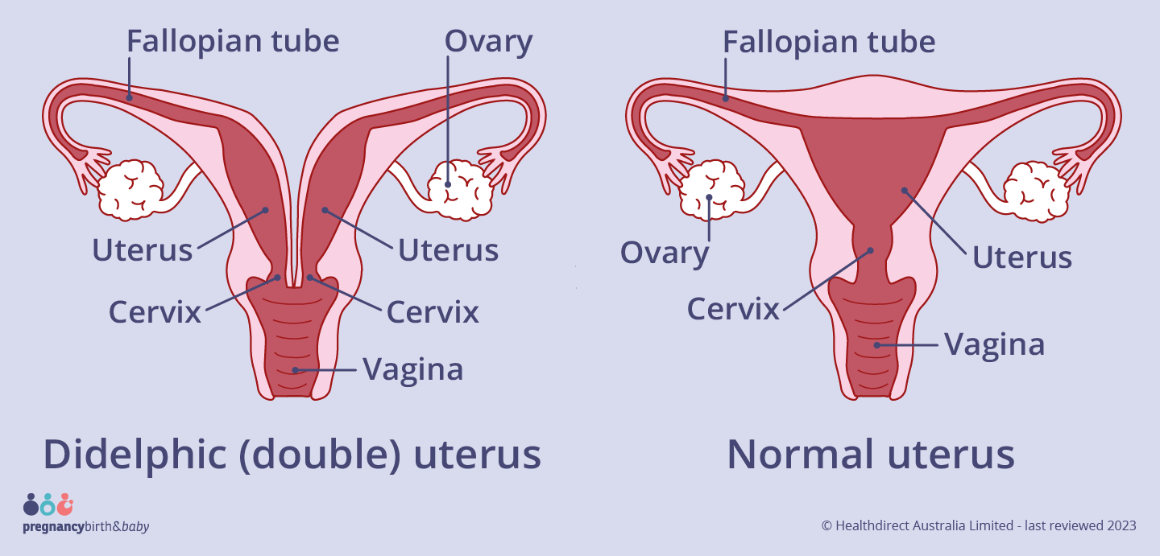
Figure 1: Comparison between a normal uterus and a didelphic (double) uterus.
The illustration shows the structural difference between a normal uterus (right) and a uterus didelphys (left), characterized by complete duplication of the uterine cavities, cervices, and often a longitudinal vaginal septum. In uterus didelphys, failure of Müllerian duct fusion during embryogenesis results in two distinct uterine horns and cervices. Source: Healthdirect Australia Limited, 2023 (https://www.pregnancybirthbaby.org.au/double-uterus). Reproduced under fair use for educational and illustrative purposes.
Pelvic examination: Cervix completely effaced, no presenting part, 4 cm dilated. As there is an incongruency between the degree of dilation, the severity of pain, and palpable foetal parts, the severity of a rupture or the imminent rupture of the uterus was suspected. A bedside ultrasound revealed intrauterine foetal death and a lack of uterine contour integrity that is indicative of rupture.
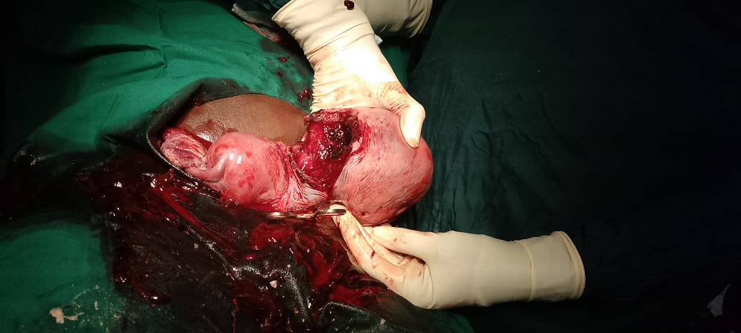
Figure 2: Intraoperative findings demonstrating uterine didelphys with rupture of one horn.
Intraoperative photograph showing two distinct uterine bodies consistent with a didelphic uterus. One uterine horn is ruptured with visible fetal parts and significant hemorrhage, while the second uterine horn remains intact. This presentation confirms complete duplication of the uterus with separate cavities and cervices, consistent with Müllerian duct fusion failure. Image obtained intraoperatively at Dokolo Health Centre with patient consent for academic publication.
An exploratory laparotomy was done urgently. On admission, about 1.2 litres of hemoperitoneum were removed. The foetus (3.6 kg) itself was freely floating in the peritoneal cavity (Figure 1). There was a full placental delivery. Intraoperative examination showed two different uterine cavities, which were in line with uterus didelphys, and a laceration at the base of one hemi-uterus that went laterally (Figures 2–4).
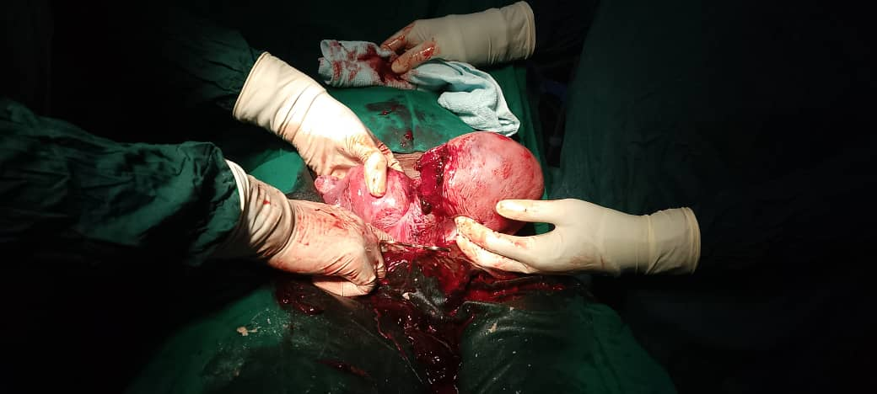
Figure 3:Intraoperative image showing a ruptured uterine horn containing a nonviable fetus in a case of uterine didelphys.
The photograph illustrates a ruptured left uterine horn with expulsion of a macerated fetus, confirming uterine rupture associated with Müllerian duct anomaly (uterus didelphys). The right uterine horn remains intact. The finding highlights the obstetric complications that can occur in women with congenital uterine malformations. Image captured intraoperatively with appropriate patient consent for academic and publication purposes.
The torn part was joined back together in layers using absorbable sutures, the rectus walls stitched, and the skin stapled. The patient was administered two units of packed red blood cells and broad-spectrum antibiotics. Her recovery was uneventful, and she was discharged on day six and given advice on contraception and follow-up regarding future fertility counselling.
Discussion
Uterus didelphys is a malformation caused by the total non-fusion of the Müllerian ducts in the 12th- 16th week of gestation (Cwiertnia et al., 2022). This anomaly is estimated to be found in 1 in 3,000 women, with an approximation of 10 per cent of all the Müllerian malformations (Hosseinirad et al., 2021). Uterus didelphys is a Class III anomaly defined by the American Society of Reproductive Medicine (ASRM) and the European Society of Human Reproduction and Embryology (ESHRE) and is typically accompanied by two cervices and, in 75% of cases, a longitudinal vaginal septum (Acien & Acien, 2022).
Even though the majority of patients are able to become pregnant, uterus didelphys has greater obstetric risks, such as termination of pregnancy (up to 32%), premature birth ss(17-33%), foetal growth retardation, and malpresentation (Ćwiertnia et al., 2022; Crowley et al., 2021). This structural weakness and poor vascularity of the abnormal uterine wall create a predisposition to preterm labour and, in rare cases, rupture (Kebede et al., 2025).
Rupture of a didelphic uterus spontaneously, as occurred in this patient, is extremely rare. Similar results were reported by Kebede et al. (2025), who reported a case of a 19-year-old primigravida, whose unscarred hemi-uterus ruptured early in the third trimester, along with IUFD and massive hemoperitoneum, thus highlighting the importance of antenatal anomaly screening.
Crowley et al. (2021) reported two instances of didelphic uterus with a good prognosis after the caesarean delivery; both women gave healthy births despite the structural defects. Likewise, Cwietnia et al. (2022) have also described a primigravida with didelphys uterus and carried to term through careful observation, which highlights that successful pregnancies are possible as long as they are closely observed. On the other hand, Yayna et al. (2023) described the case of an Ethiopian woman who has only one full-term uterus but the other one prolapsed, which demonstrates the mechanical instability of these malformations. This spectrum is further broadened by the current case, as it is evident that rupture is possible even in the absence of external factors that cause it, like oxytocic induction or previous caesarean.
Uterus didelphys is a preoperative diagnosis that is not easy to detect, especially in low-resource countries where sophisticated imaging (3D ultrasound or MRI) is not a regular procedure. Potential complications that could be fatal can be avoided through early identification in the process of antenatal care by planning elective delivery (Hosseinirad et al., 2021). In case of rupture, the primary approach to management consists of exploratory laparotomy and uterine repair, provided the patient is hemodynamically stable and would like to have fertility again (Kebede et al., 2025).
The success of the postoperative fertility relies on how much the unaffected hemi-uterus is preserved and repaired. Research shows that up to 45-60 per cent of second pregnancies in the case of uterus didelphys can be brought to term with close monitoring (Ćwiertnia et al., 2022). Here, close follow-up and early imaging are required prior to making a future conception attempt. The caesarean section must be scheduled to reduce the chances of recurrence.
Conclusion and Learning Points
This case provides a means to remember the need to have a high index of suspicion concerning congenital uterine anomalies in obstetric emergencies, especially where clinical results are incompatible with the labour course. Even spontaneous rupture of a didelphic uterus, which is rare, may happen in primigravidae with no scarring and is catastrophic (intra-abdominal foetal expulsion and hemoperitoneum). Prioritised intervention should be the use of early antenatal screening using ultrasound or MRI to detect cases of Müllerian anomalies in all primigravidas with non-characteristic symptoms or malpresentation. Multidisciplinary and timely surgical intervention can save lives. Subsequent pregnancies must be treated as high-risk and delivered with follow-up imaging.

References
Acién, M., & Acién, P. (2022). Classification of Müllerian anomalies: Is a consensus possible?. Case Reports in Women's Health, 34, 1-2. https://doi.org/10.1016/j.crwh.2022.e00413
Crowley, C. M., Botros, K., Hegazy, I. F., & O'Donnell, E. (2021). Uterine didelphys: diagnosis, management and pregnancy outcome. BMJ Case Reports CP, 14(3), 1-4. https://doi.org/10.1136/bcr-2021-242233
Ćwiertnia, A., Borzyszkowska, D., Golara, A., Tuczyńska, N., Kozłowski, M., Kwiatkowski, S., & Cymbaluk-Płoska, A. (2022). The impact of uterus didelphys on fertility and pregnancy. International journal of environmental research and public health, 19(17), 1-10. https://doi.org/10.3390/ijerph191710571
Hosseinirad, H., Yadegari, P., Falahieh, F. M., Shahrestanaki, J. K., Karimi, B., Afsharzadeh, N., & Sadeghi, Y. (2021). The impact of congenital uterine abnormalities on pregnancy and fertility: a literature review. JBRA assisted reproduction, 25(4), 1-9. https://doi.org/10.5935/1518-0557.20210021
Kebede, T. N., Tiche, G. D., Kitaw, T. M., Taye, B. T., Chekole, M. S., Lema, T., ... & Taye, Z. (2025). Early-third-trimester uterine rupture in an unscarred primigravida with a didelphic uterus: a case report. Journal of Medical Case Reports, 19(1), 1-6. https://doi.org/10.1186/s13256-025-05461-2
Yayna, A. A., Ayza, A., Dana, W. W., Desalegn, A., Kassaye, G., Yemaneh, A., ... & Tesfaye, A. (2023). A rare case report of uterine didelphys, in which one uterus carried a pregnancy while the other prolapsed, with a successful pregnancy outcome resulting in an alive-term delivery. SAGE Open Medical Case Reports, 11, 1-5. https://doi.org/10.1177/2050313X231159505

