Original Research Article

Ecological Distribution and Trophic Dynamics of Carnivorous Fishes Across Salinity Gradient in Ashtamudi Lake, Southwest India

Abstract
Ashtamudi Lake is a Ramsar-designated protected estuarine ecosystem where salinity levels strongly influence which species live in different areas. This study investigated the distribution and feeding ecology of 20 carnivorous fish species out of 97 total fish species found across three sites with different salinity levels. Fish diversity was highest at the Kidapram site, a freshwater transition zone, highlighting its importance as a diverse habitat. Indicator Species Analysis identified key species like Dussumieria acuta and Liza parsia that showed strong preferences for specific transition zone habitats, indicating good habitat quality. Food web analysis revealed complex feeding relationships connecting bottom-dwelling organisms with surface water species. Large carnivorous fish such as Sphyraena jello and Caranx ignobilis play important roles in controlling the food web. Energy flow through the system varies seasonally, with zooplankton populations peaking during the monsoon season at Kidapram, providing a major seasonal food source. Additionally, planktivorous fish selectively feed on certain zooplankton sizes, which changes the zooplankton community structure. These results show that carnivorous fish communities are shaped primarily by habitat variety, salinity gradients, and food availability. This information is essential for monitoring and managing this important tropical coastal ecosystem sustainably. The conceptual framework and spatial setting of the study described in the abstract are visually illustrated in Graphical Abstract.
Keywords: Carnivorous fishes, Salinity gradient, Trophic dynamics, Indicator Species Analysis, Estuarine biodiversity, Ashtamudi Lake.

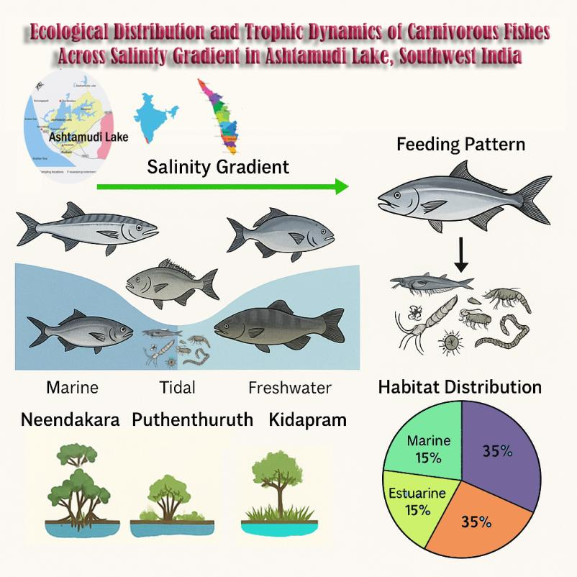
Graphical abstract
1. Introduction
Estuaries are ecotonal habitats of remarkable biological productivity and ecological diversity, within which the interactions between freshwater input and marine tidal action generate dynamic salinity gradients that have a profound impact on habitat features and species composition (Whitfield & Elliott, 2002; Biju Kumar & Deepthi, 2006). Among estuarine organisms, carnivorous fishes are of specific ecological significance, serving as top-down controllers of aquatic food chains by feeding on zooplankton, bottom-dwelling invertebrates, and minor fish species (Blaber, 2000; Whitfield & Elliott, 2002). They are highly sensitive to salinity variation, prey abundance, and substrate complexity, with their distribution, diversity, and feeding patterns being tightly constrained by these aspects (Griffith, 1974; Rahman et al., 2015).
Ashtamudi Lake, situated along the southwest coast of India and identified under the Ramsar Convention, is a tropical estuarine system characterised by high biodiversity and ecological productivity (Kumar et al., 2007). It comprises a mosaic of marine, brackish, and freshwater areas with seasonal changes in monsoon-driven river discharge and tidal exchange with the Arabian Sea (Qasim & Gopinathan, 1969). This hydrological variation causes potential salinity gradients that naturally filter species adaptation and community structure.
This study examines how different salinity levels shape where carnivorous fish live and what they eat in Ashtamudi Lake. Three zones - Neendakara (mainly marine), Puthenthuruth (a mix of tidal and brackish), and Kidapram (where brackish meets freshwater) - to represent the range of salinity found in the estuary and to observe changes in fish communities and their feeding habits. Previous research in the lake has documented the presence of several euryhaline species such as Channa striata, Etroplus suratensis, and Mugil cephalus, which exhibit physiological adaptations to salinity fluctuations and play important roles in connecting trophic levels (Jayaram, 2010; Rahman et al., 2015; Sangita & Mohapatra, 2013). By looking at the types of carnivorous fish and their prey, such as zooplankton and bottom-dwelling organisms, this research helps explain the role of predators in the estuary and offers important information for managing fisheries and habitats in coastal wetlands.
2. Materials and methods
The present study conducted during February 2022 to April 2023 along the three ecologically distinct ecosites within the Ashtamudi Lake wetland system, situated on the southwest coast of India. The first site, Neendakara (N 08°56′7.2″, E 76°32′24.0″), located at the marine-dominated southern region of the lake with salinity 35.69%, having strong tidal exchange with the Arabian Sea results in high salinity influence. The second site, Puthenthuruth (N 08°55′55.6″, E 76°33′10.1″), represents a transitional zone characterized by intermediate salinity levels with 26.70%, semi-enclosed water flow higher organic productivity. The third site, Kidapram (N 08°59′57.7″, E 76°36′7.3″), is located in the upper ranges of the estuary having frequent freshwater inflows, creating a low-salinity with 5.86%. This nutrient-rich area favourable to benthic accumulation and macrophyte growth.
These three selected stations collectively capture the spatial heterogeneity of the Ashtamudi estuary, making them suitable for examining habitat-linked variation in population of the fishes and trophic dynamics. A georeferenced map of the study area indicating the exact locations of Neendakara, Puthenthuruth, and Kidapram is presented in Figure 1, offering a visual overview of the lake’s ecological zonation and sampling framework. This spatial representation highlights the gradient from marine to freshwater influence and serves as a foundational reference for interpreting the ecological data collected during the study.
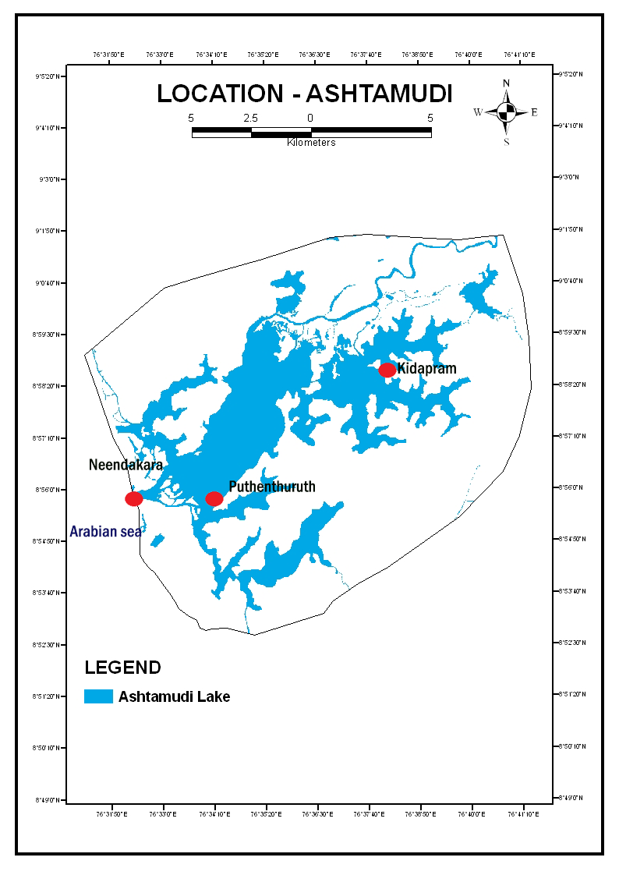
Figure 1. Study Location in the Ashtamudi Wetland
Fish samples were collected seasonally using traditional and standardized fishing techniques such as gill nets, cast nets, and drag nets, with the support of local fishermen to ensure representative coverage (Talwar & Jhingran, 1991). Collected specimens were identified using standard taxonomic keys (Day, 1878; Jayaram, 2010), and total length was measured. Identified carnivorous fishes were classified into two size groups such as small-bodied (<50 cm Total Length, TL) and large-bodied (≥50 TL). This classification method was adopted to reflect a critical ontogenetic shift in the functional role of the fish, and also separating species based on their diets. The species are restricted by gape size (planktivorous) from those capable of exploiting larger fish and crustaceans (apex piscivores) in the estuarine food web (Villéger et al., 2017). Along with fish collection, field observations and in-situ environmental measurements were recorded during each seasonal event to determine habitat preference of species and salinity tolerance. Water quality parameters such as pH, Temperature and Salinity were measured at each sampling point using a calibrated multiparameter probe. The microhabitat of the members was characterized by dominant substrate type like muddy, sandy, intermediate, and the habitat associated vegetation such as mangroves or submerged aquatic vegetation. Habitat preference was assigned by substantiating the capture location data with existing ecological literature (Subramanian et al., 2020).
Planktonic samples were collected using a 60 µm mesh plankton net, the samples were preserved in 4% buffered formalin and transported to the laboratory for microscopic examination. Zooplankton and phytoplankton were identified in lowest taxonomic level using standard references (Newell & Newell, 1977; APHA, 2005). Benthic macroinvertebrates were collected using a Van Veen grab (0.1 m²) from a depth range of 1 to 3 meters. The retained material sieved through a 500 µm mesh and preserved in 5% formalin. Identification and classification were made using standard taxonomic guides (Pennak, 1989).
Key ecological indices were computed, including species richness (S), Shannon-Wiener index (H′), Simpson’s index (1-D), Pielou’s evenness (J′), and Margalef’s richness index (d) to illustrate fish diversity and community structure (Shannon & Weaver, 1963; Krebs, 1989). Indicator Species Analysis (ISA) was conducted to determine habitat specific taxa using the Dufrêne-Legendre method. Trophic interaction models were constructed based on field observations, dietary literature, and compiled trophic preferences, and visualized using Sankey and network diagrams using SankeyMATIC (a free web-based tool). Predator-prey dynamics were further explored through trait-based assessment of prey behavior, size selectivity, and feeding guilds. All statistical and graphical analyses were performed using PAST 4.3 and Python libraries including NetworkX and Matplotlib. Sankey diagram construction was based on observed dietary preferences, prey occurrence, and field-based trophic groupings.
3. Results and discussions
3.1. Composition and Trophic Roles of Fish Assemblages
A total of 97 fish species representing 41 families were recorded from the study area, surrounding a wide range of freshwater, estuarine, and marine habitats. Habitat distribution analysis revealed that 29 species were exclusive to freshwater, 39 were restricted to marine environments and 29 exhibited euryhaline behaviour, thriving across varying salinity zones. Among these, 20 species were identified as carnivorous, including both small-bodied and large-bodied predators distributed across all habitat types (Fig. 2). Notable carnivorous taxa such as Channa striata, Caranx ignobilis, Sphyraena jello, and Epinephelus tauvina were occupying distinct ecological niches, indicating strong habitat partitioning influenced by salinity gradients and prey availability. Families such as Mugilidae, Gobiidae, and Clupeidae demonstrated high ecological plasticity, with species like Mugil cephalus, Tachysurus maculatus, Leiognathus equulus, and Lutjanus fulviflamma occurring across all three habitat types. This overlap reflects the transitional and dynamic nature of Ashtamudi Lake, designed by strong estuarine influence coupled with seasonal freshwater intrusion, which collectively support a diverse and complex fish community of different trophic status.
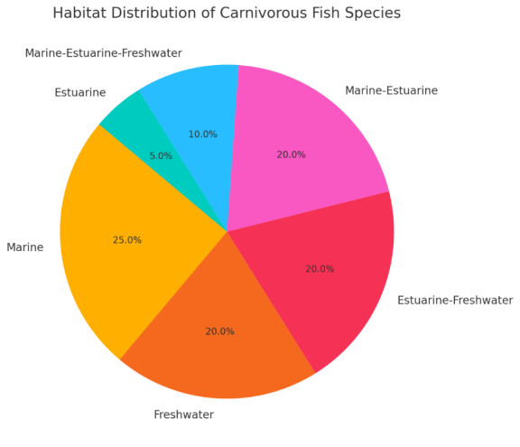
Figure 2. Pie chart showing the habitat distribution of carnivorous fish species
The dominance of marine and estuarine adapted species reflects the salinity gradient, particularly in sites with higher tidal exchange, while the presence of freshwater species such as Anabas testudineus, Channa striata, and Puntius filamentosus. emphasizes the freshwater connectivity of upper zones. Overall, this diverse habitat representation underscores the ecological heterogeneity and complexity of fish assemblages in the Lake.
Trophically, planktivorous and carnivorous fishes constituted over 65% of the total species, indicating strong top-down regulatory potential. Carnivorous species were classified into small-bodied forms like Etroplus suratensis and Channa punctata, and large-bodied predators such as Sphyraena jello, Caranx ignobilis, and Epinephelus tauvina. This division reflects a functional grouping that accounts for the well-documented ontogenetic diet pattern in predatory fish. Stomach content analysis of fishes (including juveniles of the large-bodied species) reflected a dominance of benthic and planktonic invertebrates, confirming their functional role as trophic link between herbivory and secondary carnivores. Large carnivores exhibited broad spatial distribution, especially in marine influenced zones, whereas small carnivores were more localized and abundant in brackish and freshwater transitional areas, indicating size and habitat-mediated niche partitioning within the trophic hierarchy.
3.2. Species Richness and Diversity Indices
Fish diversity varied across the ecosites, with Kidapram recording the highest species richness (S = 28), followed by Puthenthuruth (S = 21) and Neendakara (S = 16). Corresponding diversity indices showed similar trends: Shannon-Wiener index (H′) ranged from 2.773 (Neendakara) to 3.332 (Kidapram); Simpson's index (1-D) ranged from 0.938 to 0.964; and Margalef's index (d) peaked at Kidapram (8.103), indicating a richer and more heterogeneous fish assemblage (Table 1). Although evenness (J′ = 1.0) was uniformly high across sites, suggesting equitable distribution, an ANOVA on Shannon-Wiener and Simpson’s indices revealed statistically significant differences (p < 0.05) between sites, particularly between Neendakara and Kidapram.
Table 1. Species Richness and Diversity Indices of fishes in selected sites
Study Sites | Species Richness (S) | Shannon-Wiener Index (H') | Simpson's index (1–D) | Pielou’s evenness (J′) | Margalef's index (d)
Neendakara | 16 | 2.773 | 0.938 | 0.996 | 5.41
Puthenthuruth | 21 | 3.045 | 0.952 | 0.998 | 6.569
Kidapram | 28 | 3.332 | 0.964 | 0.995 | 8.103

3.3. Indicator Species Analysis
Indicator Species Analysis (ISA) identified several taxa with strong site fidelity and significant indicator values. Notably, Dussumieria acuta (IndVal = 0.81), Sardinella fimbriata (0.79), Ehirava fluviatilis (0.75), and Liza parsia (0.69) showed high associations with specific ecosites, underscoring their potential as bioindicators for environmental monitoring. These species were predominantly found in estuarine to brackish habitats and were sensitive to fluctuations in salinity and organic matter availability (Fig. 3).
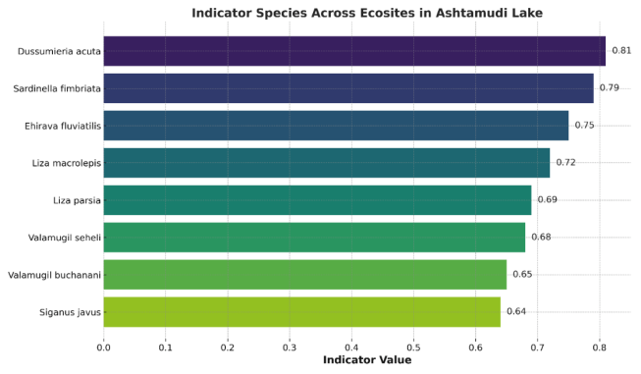
Figure 3. Indicator values computed for habitat-specific taxa across salinity zones
3.4. Trophic Interactions and Energy Flow
A Sankey diagram analysis quantified the biomass transfer pathways among prey groups (phytoplankton, zooplankton, detritus, benthos, small fish) and dominant fish guilds. Planktivorous species such as Valamugil seheli and Liza macrolepis showed strong linkages with phytoplankton and detritus, while carnivorous species like Sphyraena jello and Lutjanus johni were derived the majority of their energy biomass from the consumption of lower trophic levels, namely crustaceans and smaller fish. The analysis underscores the dominance of benthic-pelagic coupling as the primary mode of energy transfer, with zooplankton and small fish serving as critical intermediate trophic levels for higher-order carnivores (Fig. 4).
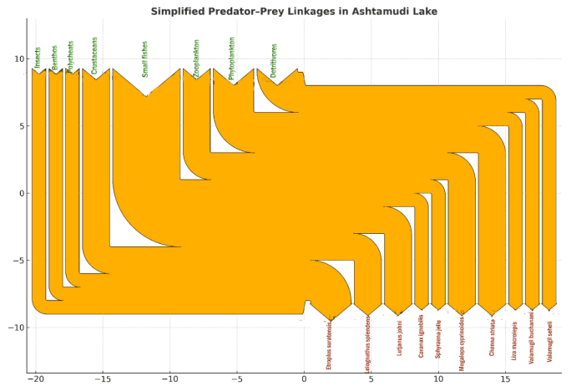
Figure 4. Sankey diagram illustrating biomass transfer and trophic level interaction
A detailed trophic interaction diagram (Fig. 5) illustrates specific predator-prey linkages among the recorded fish species, zooplankton, benthos and phytoplankton. This visual representation provides a clearer understanding of the ecological roles and feeding connectivity pattern among functional groups within the Ashtamudi wetland ecosystems.
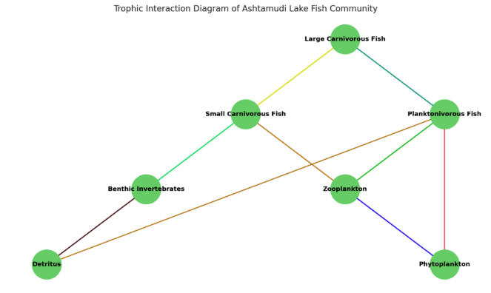
Figure 5. Trophic interaction diagram of predator-prey linkages
3.5. Prey Size Selection and Zooplankton Response
Field data and trait-based inference revealed that planktivorous fishes such as Dussumieria acuta, Sardinella fimbriata, Sardinella longiceps, Anodontostoma chacunda, Stolephorus indicus, S. commersonii, Thryssa malabarica, T. mystax, T. hamiltonii, Rasbora daniconius, Danio aequipinnatus, Puntius filamentosus, Liza macrolepis and Valamugil seheli were preferentially consumed small bodied zooplankton such as Bosmina, Ceriodaphnia, and rotifers, altering zooplankton community structure. In zones with higher plankton predation, large bodied zooplankton like Daphnia were rare. The dominance of fishes with narrow gill rakers suggested selective pressure on zooplankton size distribution.
Behavioural traits also influenced prey capture in such a way that, cladocerans with steady, slow swimming patterns were more vulnerable, while copepods, with rapid escape responses, were less frequently predated. This predator prey dynamic led to trophic reformation, particularly in Puthenthuruth and Kidapram, where zooplankton community shifted towards smaller and evasive taxa.
3.6. Zooplankton and Benthic Community Composition
The study found that zooplankton density changed noticeably over time at different sites. Kidapram had the highest density during the Monsoon season, with 4250 individuals per liter, mainly due to an increase in freshwater-tolerant rotifers and cladocerans in this low-salinity area. This seasonal peak at Kidapram provides an important energy boost to the food web. Neendakara, which is more influenced by the sea, had lower overall densities, reaching a smaller peak of 2300 individuals per liter during the Monsoon. Microscopic examination showed that microcrustaceans and rotifers were the most common benthic taxa. At Neendakara, copepods, especially cyclopoids, made up 45% of the total, showing the marine influence. In contrast, rotifers and cladocerans made up over 60% of the total at Puthenthuruth and Kidapram, which matches the high levels of planktivory seen there. The benthic macrofauna included oligochaetes, polychaetes, and molluscs, with Kidapram showing the greatest variety. Analysis of frequency distribution showed that each habitat had its own unique community, shaped by sediment type and organic content (Table 2).
Table 2. Frequency distribution analysis of habitat-specific assemblages across the three ecosites
Ecosite | Type of Sediment | Organic Content | Dominant Zooplankton | Dominant Benthos | Community Feature
Neendakara | Sandy | Low | Copepods | Polychaetes, Crustaceans | Sperce distribution and  low productivity
Puthenthuruth | Intermediate (Sandy-Muddy) | Moderate | Rotifers, Cladocerans | Moderate diversity | High density due to tidal retention and productivity
Kidapram | Muddy | High | Cladocerans, Rotifers | Oligochaetes, Molluscs | Rich benthic assemblage and detritus-based productivity

4. Discussions
The ecological assessment of fish diversity and trophic interactions in Ashtamudi Lake shows that the estuarine ecosystem is both structured and dynamic. This complexity results from a mix of habitats, changing salinity, and human activities. The study found a wide range of fish species in marine, estuarine, and freshwater areas, with planktivorous and carnivorous fish being the most common. This pattern highlights the estuary’s high productivity and complex food web. Estuarine ecosystems are known worldwide for their biological productivity, as changing salinity strongly shapes habitats and the types of species found there (Whitfield & Elliott, 2002).
The results show clear differences in habitat conditions across the lake. The transitional zone at Kidapram supports a mix of species and higher ecological diversity. This matches findings from other tropical estuaries, including those in southwest India, where overlapping habitats and complex environments often lead to the highest diversity (Subramanian et al., 2020). In contrast, the marine-influenced Neendakara site has lower diversity, which is typical for high-energy inlets that are less stable and support fewer resident species (Talwar & Jhingran, 1991). These diversity patterns highlight how the salinity gradient shapes the fish community in Ashtamudi Lake.
Indicator Species Analysis (ISA) helped to identify which fish species are most closely associated with specific habitats. Four key species showed strong habitat preferences: Dussumieria acuta, Sardinella fimbriata, Ehirava fluviatilis, and Liza parsia. Dussumieria acuta had the highest score, showing it is strongly linked to the estuarine zone and serves as the best indicator of site conditions. These high scores indicate that the transitional zones (Puthenthuruth and Kidapram) have unique fish communities. Such specialized habitat preferences have been observed in other tropical estuaries (Zale & Merrifield, 1989; Pandit et al., 2022). These species are often sensitive to changes in salinity and organic productivity, making them reliable markers of ecosystem health.
The Sankey diagram and food web analysis revealed important feeding relationships in the estuary. The main energy sources supporting the fish community were small fish and zooplankton. Species like Valamugil seheli, Etroplus suratensis, and Siganus javus fed primarily on detritus and phytoplankton, reflecting their feeding habits as bottom-feeders and small-particle eaters. In contrast, top predators like Sphyraena jello, Caranx ignobilis, and Lutjanus johni fed mainly on small fish and crustaceans. These feeding patterns are essential for energy transfer in the estuary and show the system has multiple pathways for energy flow, making it more resilient (Odum & Heald, 1975; Anand & Vasudevan, 2016).
Planktivorous fish such as Valamugil seheli and Liza macrolepis fed heavily on phytoplankton and detritus, which is typical behaviour for Mugilidae in tropical estuaries (Subramanian et al., 2020). Top predators obtained most of their energy from eating lower-level prey, which controlling food web structure through top-down regulation. This feeding structure matches what is found in productive tropical estuaries, where detritus-based pathways and the connection between bottom and surface waters contribute significantly to fish production (Talwar & Jhingran, 1991).
During the monsoon season, zooplankton density peaked at the Kidapram site, providing a massive food source for planktivorous fish. This seasonal increase in prey is common in monsoon-influenced estuaries (Sangita & Mohapatra, 2013). The selective predation by these planktivorous fish also modulates the zooplankton community structure, reinforcing a community shift toward smaller, more evasive taxa, a mechanism governed by predator morphology and prey behavior (Titelman & Kiørboe, 2003; Santer & Lampert, 1995).
Planktivorous fish actively shape zooplankton communities through selective feeding. Fish with closely spaced gill rakers preferentially catch larger zooplankton, pushing communities toward smaller species like Bosmina and rotifers. This pattern evident in Ashtamudi as well, where increased abundance of planktivorous Cyprinidae and Mugilidae corresponded with simplified zooplankton communities dominated by smaller, evasive species (Jeppesen et al., 2007; Lampert, 1987). Such shifts reduce the system’s grazing pressure on phytoplankton, potentially increasing susceptibility to algal blooms, a pattern well documented in temperate and tropical aquatic systems (Jeppesen et al., 2007; Lampert, 1987).
Zooplankton behaviour also affects their vulnerability to predation. Copepods, with their quick, unpredictable movements, are harder to catch than cladocerans, which move more predictably. The presence of both visual hunters and touch-based predators increases selection based on size and behavior, reshaping prey communities (Titelman & Kiørboe, 2003). Additionally, invertebrate predators like Chaoborus larvae, found in transitional habitats, prefer larger prey, adding to this pressure. This combined predation effect reinforces the shift toward smaller zooplankton and highlights how predator traits and prey behaviour together shape aquatic food webs (Santer & Lampert, 1995; Mattila & Bonsdorff, 1988).
The findings also support the hypothesis of estuarine systems functioning as critical nurseries and feeding grounds, particularly for juvenile fish that rely on planktonic and benthic prey, a key ecological function widely recognized across global systems (Whitfield & Elliott, 2002; Talwar & Jhingran, 1991). The food web models show that detritus-based pathways and the coupling between bottom and surface waters are major contributors to fish production, which is typical of tropical estuaries (Blaber, 2000; Subramanian et al., 2020).
5. Summary and conclusions
This study examined fish diversity and feeding relationships in Ashtamudi Lake, is a protected tropical estuary recognized under the Ramsar Convention. Out of 97 fish species recorded, 20 were carnivorous species, distributed across marine, estuarine, and freshwater zones. The analysis revealed clear patterns in how fish communities are organized based on environmental conditions, particularly salinity levels. Among the three selected location, Kidapram is a low-salinity transition zone, consistently showed the highest fish diversity, followed by Puthenthuruth. This confirms that transitional areas with mixed conditions support the most diverse fish communities. Indicator Species Analysis identified key species that are closely tied to specific habitats. Dussumieria acuta and Liza parsia showed strong preferences for estuarine and transitional zones with low-to-intermediate salinity levels. These findings demonstrate that habitat variety and salinity gradients are the main factors controlling where different fish species live in Ashtamudi Lake.
The food web analysis revealed how energy flows through the ecosystem. The estuary has a complex food web where energy from bottom-dwelling organisms and surface waters supports the fish community. Small fish and zooplankton are the primary food sources. Zooplankton numbers peaked during the monsoon season at Kidapram, providing a major seasonal food boost. Top predators like Sphyraena jello, Channa striata, and Caranx ignobilis play important roles in controlling the food web from the top down. Planktivorous fish selectively feed on larger zooplankton, which shifts communities toward smaller species. This research provides important baseline information about carnivorous fish and their ecological roles in Ashtamudi Lake. These findings are essential for developing sustainable fishery management practices and effective restoration plans for this important Ramsar wetland.
Data Availability Statement: The datasets generated and/or analysed during the current study are available from the corresponding author upon reasonable request.

Ethical Approval: This study involved no experiments on humans or animals. Field sampling of fishes and Microorganisms were carried out in accordance with institutional and national guidelines for research and biodiversity conservation.

References
- Anand, M. & Vasudevan, N. (2016). Ecological roles of fish in tropical estuarine food webs: insights from network analysis. Environmental Monitoring and Assessment, 188, 154. DOI: 10.1007/ s10661- 016- 5226-0
- American Public Health Association, American Water Works Association, & Water Environment Federation. (2005). Standard Methods for the Examination of Water and Wastewater (21st ed.). Washington, D.C. https://www.standardmethods.org/
- Biju Kumar, A., & Deepthi, G. R. (2006). Management of wetlands in Kerala with special reference to fish and fisheries. Ecological Economics, 59 (1): 157-163. DOI:10.1016/j.ecolecon.2005.07.037
- Blaber, S. J. M. (2000). Tropical estuarine fishes: Ecology, exploitation and conservation. Blackwell Science. https://doi.org/10.1002/9780470694985
- Day, F. (1878). The fishes of India: Being a natural history of the fishes known to inhabit the seas and fresh waters of India, Burma, and Ceylon. B. Quaritch. https://doi.org/10.5962/bhl.title.55567
- Griffith, R. W. (1974). Environment and salinity tolerance in the genus Fundulus. Copeia, 1974(2), 319-331. https://doi.org/10.2307/1442526
- Jayaram, K. C. (2012). The Freshwater Fishes of the Indian Region (2nd ed.). Narendra Publishing House. https://www.nphindia.com/product/the-freshwater-fishes-of-the-indian-region-2ed/
- Jeppesen, E., Meerhoff, M., Jacobsen, B. A., Hansen, R. S., Søndergaard, M., Jensen, J. P., Lauridsen, T. L., Mazzeo, N., & Branco, C. W. C. (2007). Restoration of shallow lakes by nutrient control and biomanipulation—the successful strategy varies with lake size and climate. Hydrobiologia, 581, 269–285. https://doi.org/10.1007/s10750-006-0507-3
- Krebs, C. J. (1989). Ecological Methodology. Harper and Row Publishers, New York.
- Kumar, B. S., Nair, R. J., & Soman, K. (2007). Fish diversity in Ashtamudi estuary, Kerala. Journal of Aquatic Biology, 22(1): 1-6. DOI: 10.5146/J.AQUAT.BIOL.2007.034
- Lampert, W. (1987). Predictability in lake ecosystems: The role of biotic interactions. In W. Lampert & U. Sommer (Eds.), *Predictability in aquatic ecosystems* (Ecological Studies, Vol. 61, pp. 323-346). Springer. https://doi.org/10.1007/978-3-642-82857-0_23
- Mattila, J., & Bonsdorff, E. (1989). The impact of fish predation on shallow soft bottoms in brackish waters (SW Finland); an experimental study. Netherlands Journal of Sea Research, 23(1). https://doi.org/10.1016/0077-7579(89)90044-6
- Newell, G. E. & Newell, R. C. (1977). Marine Plankton: A Practical Guide. Hutchinson Education Ltd., London.
- Odum, W. E., & Heald, E. J. (1975). The detritus-based food web of an estuarine mangrove community. In L. E. Cronin (Ed.), *Estuarine Research, Volume I* (pp. 265-286). Academic Press. https://books.google.com/books/about/Estuarine_Research.html?id=2_4_AQAAIAAJ
- Pandit, P. S., Suryavanshi, U., & Inamdar, A. B. (2022). Indicator fish species and habitat associations in tropical estuarine systems of western India. Marine Ecology Progress Series, 697, 15-30.
- Pennak, R. W. (1989). Fresh-Water Invertebrates of the United States (3rd ed.). John Wiley and Sons, New York.
- Qasim, S. Z., & Gopinathan, C. K. (1969). Tidal cycle and the environmental features of Cochin Backwater (a tropical estuary). Proceedings of the Indian Academy of Sciences, Section B, 69(6), 336–348. https://doi.org/10.1007/BF03051729
- Rahman, M. A., Kadowaki, S., Hossain, M. A. R., & Ishikawa, M. (2015). Osmoregulatory Adaptations of Freshwater Air-Breathing Snakehead Fish (Channa Striata) After Exposure to Brackish Water. Journal of Comparative Physiology B: Biochemical, Systemic, and Environmental Physiology https://doi.org/10.1007/s10695-015-0060-0
- Sangita, M., & Mohapatra, B. C. (2013). Adaptive distribution of freshwater fish in brackish water environments of Chilika Lake, Odisha. Journal of Inland Fisheries Society of India, 45(2): 1-7. DOI: 10.6087/jifsi.2013.2.031
- Santer, B. & Lampert, W. (1995). Summer vertical migration and predation risk in juvenile Chaoborus flavicans. Journal of Plankton Research, 17 (8): 1559-1570. DOI:10.1093/plankt/17.8.1559
- Shannon, C. E., & Weaver, W. (1963). The mathematical theory of communication. University of Illinois Press. https://www.press.uillinois.edu/books/?id=p02527254847
- Subramanian, R., Deepak, S. V., & Menon, M. (2020). Fish trophic guilds and their spatial distribution in a tropical estuary of southwest India. Regional Studies in Marine Science, 35, 101210. DOI: 10.1016/j.rsma.2020.101210
- Talwar, P. K., & Jhingran, A. G. (1991). Inland Fishes of India and Adjacent Countries (Vols. 1-2). Oxford & IBH Publishing Co. https://books.google.com/books/about/Inland_Fishes_of_India_and_Adjacent_Coun.html?id=2_4bAAAAYAAJ
- Titelman, J., & Kiørboe, T. (2003). Predator avoidance by nauplii. Marine Ecology Progress Series. https://doi.org/10.3354/meps247137
- Whitfield, A. K., & Elliott, M. (2002). Fishes as indicators of environmental and ecological changes within estuaries: A review of progress and some suggestions for the future. Journal of Fish Biology, 61(A): 229-250. https://doi.org/10.1111/j.1095-8649.2002.tb01773.x
- Villéger, S., Miranda, J. R., & Salles, L. O. (2017). A trait-based approach for functional ecology of fish in Amazonian aquatic systems. Ecology of Freshwater Fish, 26(2), 253-264.
- Zale, A. V. & Merrifield, S. G. (1989). Life history and ecological relationships of Ehirava fluviatilis in the Cochin backwaters. Estuarine, Coastal and Shelf Science, 28 (4): 475-488. DOI: 10.1016/0272−7714(89)90098−9
- Vijayan, S. Community Composition of Freshwater Fishes from Aquatic Streams and Rivers in the Western Ghats of South India. Journal of Materials and Environmental Science, 15(8); 1185-1200.

