Original Research Article

Crown Architecture as an Indicator of Competition and Site Quality in Taxus baccata in Deoban Forest, Chakrata (Uttarakhand), India

Abstract
Crown architecture regulates light interception, competition, and growth in forest trees and can serve as a non-destructive indicator of stand condition and site quality. We assessed crown width and stem diameter relationships in natural stands of Taxus baccata in Deoban Forest, Chakrata (Uttarakhand). A quadrat-based survey sampled 223 trees; girth at breast height (GBH) was measured at 1.37 m and converted to DBH, and crown width was measured along two perpendicular axes. The crown width–DBH ratio (CW/DBH) was used as an index of competition. Mean DBH was 50.23 cm (SD 19.55); mean crown width was 595.29 cm (SD 244.50); mean CW/DBH = 11.80 (SD 2.41). The linear regression between DBH and crown width was highly significant: Crown width = 12.38 × DBH − 26.82 (R² = 0.98, p < 0.001). DBH class distribution was concentrated in the 40–60 cm classes, with limited representation of smaller classes, indicating weak recruitment. Quadrat-wise variation in CW/DBH revealed heterogeneous competition environments. We conclude that crown-based indices (especially CW/DBH) provide an effective, non-destructive measure of competition and site quality for T. baccata in Deoban Forest and can inform targeted conservation and silvicultural interventions.
Keywords:Taxus baccata, crown width, DBH, competition index, Deoban Forest, Chakrata, Uttarakhand
1. Introduction
Tree crown form and size influence photosynthetic capacity, resource capture and competitive interactions inside stands (Assmann, 1970; Pretzsch, 2009). Crown width is commonly used as a practical, non-destructive metric to infer growing space, dominance status and competitive stress (Hasenauer, 1997; Hemery et al., 2005). Analysing please check it crown–stem allometry and derived indices (e.g., crown width–DBH ratio) helps quantify how resource availability and neighbourhood please check it competition shape tree architecture (West, 2009).
Taxus baccata it should be in latin is a slow-growing & shade-tolerant conifer with high ecological and medicinal significance within the western Himalaya (Kala, 2005). Because destructive sampling is undesirable for threatened taxa, crown-based measures are particularly useful to assess stand condition and guide management. Prior studies have examined crown allometry in conifers and broadleaves under different stand conditions (Pretzsch, 2009; Sharma et al., 2017). Poor natural regeneration of Taxus baccata it should be in latin has been observed in numerous studies as a result of low seed viability, inferior growth rates and rising levels of human pressure on these trees. Other studies within the western and central Himalaya identify the role of disturbance and forest structure within the Himalaya in the regeneration sequence of Taxus baccata; the study conducted by Rikhari et al. (2000) and Lanker et al. (2010) clearly demonstrates that the intensity of disturbance has a substantial influence on the tree regeneration of the species within the region. The implication of such pressures is an increased need for the identification of non-destructive indicators of competition and site quality to assist in conserving existing populations.
This study examines whether crown architecture — specifically crown width and the CW/DBH ratio — can serve as reliable indicators of competition and site quality in T. baccata stands of Deoban Forest, Chakrata. Objectives were:
- Quantify DBH and crown width distribution of T. baccata in the study area.
- Evaluate the DBH–crown width allometry and report the regression model.
- Derive and assess CW/DBH as an index of competition and examine its spatial (quadrat) variation.
- Discuss implications for conservation and management of T. baccata in Deoban Forest.

2. Materials and Methods
2.1 Study area
The study was conducted in Deoban Forest, Chakrata, Dehradun Division, Uttarakhand, India — a western Himalayan montane zone characterized by coniferous forest stands and altitudinal variability. Climatic conditions are cool temperate to cold temperate with winter snowfall and monsoon precipitation, favoring slow-growing, shade-tolerant conifers including Taxus baccata.
2.2 Sampling design
A quadrat-based sampling design was adopted to capture local variability in stand structure. Fifteen quadrats were established across representative microsites within Deoban Forest (details of quadrat size and exact coordinates may be appended in supplementary material if required). Within each quadrat, all T. baccata individuals were measured. The sample comprised 223 trees in total.
2.3 Field measurements and derived variables
Girth at breast height (GBH) was measured for each tree at 1.37 m above ground using a tape (standard forestry practice). DBH (cm) was computed as:
$$DBH= \frac{GBH}{π}$$
Crown width (cm) was measured along two perpendicular axes (north–south and east–west) and the average was used as mean crown width for each tree. The crown width–DBH ratio (CW/DBH) was calculated as:
$$\frac{CW}{DBH}= \frac{Crown Width (cm)}{DBH (cm)}$$
Lower CW/DBH values were interpreted as indicators of restricted lateral crown expansion (higher competition or suppression), and higher values as indicators of relatively open conditions or improved site quality.
2.4 Data analysis
Descriptive statistics (mean, standard deviation, minimum, maximum) were computed for DBH, crown width and CW/DBH. DBH was grouped into 10-cm classes for population structure analysis.An correct it ordinary least squares (OLS) linear regression analysis was used to establish the relationship of diameter at breast height (DBH) = independent variable to crown width (CW) = dependent variable. The statistical outputs of the analysis were slope, intercept, R² value &p-value. Quadrats were assessed for spatial variability of CW/DBH through the mean and coefficient of variation (CV). All analyses were performed using standard statistical software.
3. Results
3.1 Descriptive statistics
Descriptive statistics of diameter at breast height (DBH), crown width and crown width–DBH ratio of Taxus baccata are presented in Table 1.DBH and crown width exhibited wide variability among individuals, indicating heterogeneous growth conditions within the study area.
Table 1. Descriptive statistics of DBH, crown width and CW/DBH ratio for Taxus baccata
Parameter | Mean | Std. deviation | Minimum | Maximum
DBH (cm) | 50.23 | 19.55 | 6.37 | 101.27
Crown width (cm) | 595.29 | 244.50 | 43.00 | 1235.00
CW/DBH ratio | 11.80 | 2.41 | 6.28 | 46.33

3.2 DBH class distribution
DBH class distribution (10 cm class interval) is shown in Figure 1 and Table 2. The distribution is concentrated in the 40–60 cm classes. The population was dominated by middle diameter classes (40–60 cm), with comparatively fewer individuals in lower diameter classes. The diameter class frequency curve showed a pronounced peak in the 40–60 cm DBH classes, indicating dominance of mature individuals (Figure 1). Lower diameter classes were poorly represented, suggesting weak recruitment in the study area.
Table 2. DBH class distribution (number of trees)
DBH class (cm) | Frequency | DBH class (cm) | Frequency
0–10 | 1 | 50–60 | 48
10–20 | 11 | 60–70 | 25
20–30 | 21 | 70–80 | 18
30–40 | 35 | 80–90 | 8
40–50 | 47 | 90–100 | 4
 |  | 100–110 | 5

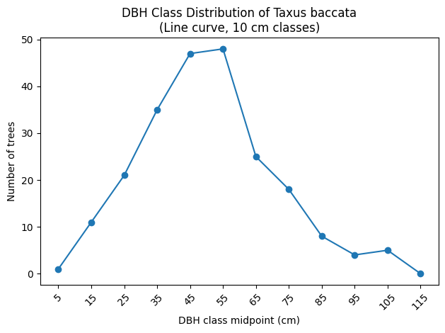
Figure 1. Diameter class distribution of Taxus baccata in Deoban Forest, Chakrata (Uttarakhand) represented as a frequency curve based on 10 cm DBH classes. The curve shows a distinct concentration of individuals in the 40–60 cm diameter range, indicating a mature stand structure with limited representation of lower diameter classes.
Interpretation: The population shows a bell-shaped / mature distribution, with very limited representation in lower (<20 cm) DBH classes suggesting weak recruitment.
3.3 DBH–crown width relationship
Linear regression between DBH and crown width produced the following model:
$$Crown Equation=12.38 \left(cm\right)×DBH\left(cm\right) -26.82$$
Statistics: R² = 0.98, slope = 12.38, intercept = −26.82, significance p < 0.001. Figure 2 (scatter with fitted line) illustrates the very strong positive association; residual scatter around the line indicates local competition and microsite variability.
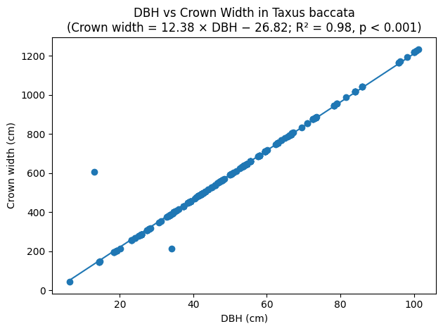
Figure 2. Scatter plot showing the relationship between diameter at breast height (DBH) and crown width of Taxus baccata in Deoban Forest, Chakrata (Uttarakhand). The fitted regression line indicates a strong positive linear relationship (Crown width = 12.38 × DBH − 26.82; R² = 0.98, p < 0.001).
3.4 CW/DBH ratio and quadrat variation
The mean CW/DBH ratio was 11.80 (SD 2.41). Quadrat-wise means of CW/DBH varied across the 15 sampled quadrats, with observed quadrat means ranging approximately from 11.49 to 15.91 and CV of CW/DBH ranging from ~2% to >70% (extremes; see Table 3). Boxplot analysis (Figure 2) highlighted that most quadrats had median CW/DBH ~11–12, while a few quadrats showed wider dispersion and outliers (one extreme outlier CW/DBH ≈ 46), indicating heterogeneous competition regimes and occasional open-grown individuals.Quadrat please give the space between-wise variation in competition intensity, as reflected by the crown width–DBH (CW/DBH) ratio, is illustrated in Figure 3.While most quadrats exhibited narrow interquartile ranges, one quadrat showed exceptionally high variability due to an extreme outlier.
Table 3. Quadrat-wise variation in crown architecture and competition indices of Taxus baccata in Deoban Forest
Quadrat | No. of trees | Mean DBH (cm) | Mean crown width (cm) | Mean CW/DBH | SD (CW/DBH) | CV (CW/DBH) %
1 | 13 | 61.64 | 737.15 | 11.49 | 1.46 | 12.70
2 | 8 | 40.84 | 476.00 | 11.59 | 0.24 | 2.07
3 | 11 | 53.73 | 637.91 | 11.80 | 0.26 | 2.22
4 | 8 | 38.02 | 500.25 | 15.91 | 12.30 | 77.33
5 | 17 | 51.22 | 606.29 | 11.72 | 0.47 | 4.03
6 | 20 | 50.37 | 595.60 | 11.70 | 0.37 | 3.17
7 | 6 | 41.30 | 481.67 | 11.59 | 0.31 | 2.63
8 | 9 | 58.00 | 691.44 | 11.84 | 0.33 | 2.82
9 | 24 | 50.42 | 596.33 | 11.71 | 0.37 | 3.18
10 | 20 | 57.32 | 683.00 | 11.86 | 0.23 | 1.92
11 | 14 | 46.95 | 552.71 | 11.59 | 0.57 | 4.90
12 | 22 | 50.10 | 592.27 | 11.71 | 0.35 | 3.01
13 | 14 | 47.57 | 560.43 | 11.60 | 0.57 | 4.93
14 | 15 | 47.71 | 562.20 | 11.59 | 0.50 | 4.28
15 | 22 | 46.97 | 544.95 | 11.35 | 1.25 | 11.02

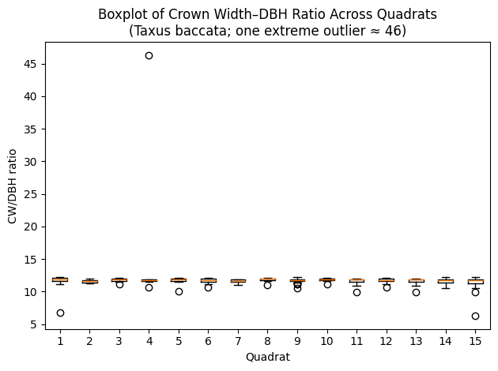
Figure 3. Boxplot of crown width–DBH (CW/DBH) ratio across 15 quadrats of Taxus baccata in Deoban Forest, Chakrata (Uttarakhand). Boxes represent the interquartile range with median values, whiskers indicate data spread, and points denote outliers. One quadrat shows an extreme CW/DBH outlier (~46), indicating highly uneven competition and localized canopy openness.
4. Discussion
4.1 Crown–stem allometry and implications
The strong positive linear relationship between DBH and crown width (R² = 0.98) indicates that crown expansion in T. baccata in Deoban Forest scales closely with stem diameter, a pattern consistent with allometric expectations for many temperate and montane tree species (Assmann, 1970; Pretzsch, 2009). The relatively high R² indicates that DBH explains most of the variation in crown width at stand scale; however, the observed residual scatter shows that local factors (neighbourhood competition, microsite quality) modulate crown expression.
4.2 CW/DBH as an indicator of competition and site quality
The CW/DBH ratio effectively distinguished trees experiencing suppression from relatively dominant trees. Limiting horizontally within densely populated quadrats, thus restricting horizontal growth, while promoting a greater percentage of quadrats showing local habitats or conditions conducive to growth (Hasenauer, 1997; Hemery et al., 2005). The substantial quadrat-wise heterogeneity (CV range) suggests competition operates at fine spatial scales in Deoban stands; such heterogeneity is important when planning selective management interventions.
4.3 Population structure and regeneration concerns
Limited recruitment of trees less than 20 cm DBH was found in sampled stands with a large number of trees falling within the mid-diameter classes of 40 - 60 cm; this indicates a long term trend of accretion (and therefore a stable or relatively stable) within the sampled stands of T. baccata (i.e., slow-growing, shade tolerant). This limitation is likely a result of herbivory and competition for light caused by canopy closure as well as disturbances introduced by humans (Kala, 2005). The lack of a pronounced inverse-J distribution signals a need for conservation attention and possible management to promote regeneration (Rikhari et al., 2000; Lanker et al., 2010; Pretzsch, 2009).
4.4 Management and conservation implications
Given the conservation importance and slow growth of T. baccata, non-destructive crown-based indices can be deployed for rapid monitoring. The practical uses of CW/DBH data will allow:
- Mapping and identifying competition hotspots and suppressed subpopulations for possible future interventions.
- Encouraging selective thinning or gap creation to enhance the light environment for regeneration.
- Assisting management in identifying quadrats exhibiting low recruitment rates when designing protection measures.
4.5 Limitations and further research
This study used static, one-time measurements. Longitudinal monitoring would better capture growth dynamics and crown plasticity in relation to disturbance and management. Additionally, inclusion of environmental covariates (soil depth, moisture, canopy openness, herbivory pressure) will sharpen the interpretation of CW/DBH variation. Nevertheless, the present results demonstrate the value of crown metrics as first-order indicators for stand assessment.

5. Conclusion
Crown width and the crown width–DBH ratio are effective, non-destructive indicators of competition and site quality for Taxus baccata in Deoban Forest, Chakrata (Uttarakhand). The high DBH–crown width allometry and quadrat-wise variation in CW/DBH reveal both general scaling of crown with stem size and localized competition effects. The observed DBH structure indicates a mature stand with weak recruitment, pointing to a need for targeted conservation actions. Crown-based assessment should be incorporated into monitoring and management plans for T. baccata populations in the western Himalaya.

References
Assmann, E. (1970). The principles of forest yield study: Studies in the organic production, structure, increment, and yield of forest stands. Pergamon Press. https://books.google.com/books/about/The_Principles_of_Forest_Yield_Study.html?id=2_4oAAAAYAAJ
Hasenauer, H. (1997). Dimensional relationships of open-grown trees in Austria. Forest Ecology and Management. https://doi.org/10.1016/S0378-1127(97)00057-1
Hemery, G. E., Savill, P. S., & Pryor, S. N. (2005). Applications of the crown diameter–stem diameter relationship for different species of broadleaved trees. Forest Ecology and Management, 215, 285–294. https://doi.org/10.1016/j.foreco.2005.05.016
Kala, C. P. (2005). Indigenous uses, population density and conservation of threatened medicinal plants in protected areas of the Indian Himalaya. Conservation Biology https://doi.org/10.1111/j.1523-1739.2005.00602.x
Pretzsch, H. (2009). Forest dynamics, growth and yield: From measurement to model. Springer. https://doi.org/10.1007/978-3-540-88307-4-1
Sharma, R. P., Vacek, Z., & Vacek, S. (2017). Modelling tree crown-to-bole diameter ratio for Norway spruce and European beech. Silva Fennica, 51(5), article id1740. https://doi.org/10.14214/sf.1740
Rikhari, HC & Sharma, Subrat & Mohammad, Nadeem & Palni, L.. (2000). The effect of disturbance levels, forest types and associations on the regeneration of Taxus baccata: Lessons from the Central Himalaya. CURRENT SCIENCE-BANGALORE-. 79. 88-89. https://d1wqtxts1xzle7.cloudfront.net/68654450/research_20commun2-libre.pdf?1628414535=&response-content-disposition=inline%3B+filename%3DThe_effect_of_disturbance_levels_forest.pdf&Expires=1767416052&Signature=GAPVN8fBTVjob9tLczQzp-P~E029zPcKKaJ5EZnqPbGJhu9R0x8kSyHhfqD8fO~V20LW2AMdNuFxd7B53KOK4C5Wk55-h~4vqagIT5BvIAItk9J2cbp8BZ66SpbvmIjhXVd7kVdZR-ThRB~6IrhFZJdloRRpslDIPBS2BWUtYwbm-7b-IFZzl2ybGn5fq~THYLKI9ZOuAj6m53zOHdcgCBdhFz77CpzReDUhx5GMJ5lkExSjD2a2troPs~CxgFPc7Z5FUI3MdXtG3I4MUmOFYybMC406u~zJc8-o2uOJuxVmOi0I-rDm8DW~v2ua5EPg~ow-7LzDFyiRT0-XB1vb6A__&Key-Pair-Id=APKAJLOHF5GGSLRBV4ZA
Lanker, U., Malik, A. R., Gupta, N. K., & Butola, J. S. (2010). Natural regeneration status of the endangered medicinal plant, Taxus baccata Hook. F. syn. T. wallichiana, in northwest Himalaya. International Journal of Biodiversity Science, Ecosystem Services & Management. https://doi.org/10.1080/21513732.2010.527302
West, Philip. (2015). Tree and Forest Measurement. Springer, Berlin.10.1007/978-3-662-05436-9.

