Original Research Article

Comparative Study of Biomass and Soil Organic Carbon Fractions in Buffer and Multiple-Use Zones of Ruecheyna Range, JDNP, Bhutan

Abstract
Forest serves as critical carbon sinks, and their management significantly influences carbon stock capacity. Despite Bhutan’s national commitment to environmental conservation, empirical data on the impact of park management on carbon stock, particularly soil organic carbon fraction,remain unstudied. This study assessed the impact of forest management practices on carbon stock by analyzing the soil organic carbon fractions such as particulate organic matter (> 53μm) andmineral-associated organic matter (< 53μm) along with biomass stock in Ruecheyna Park Range of Jigme Dorji National Park in Bhutan. A study was carried out using a random sampling design with 30 plots each in the Buffer Zone (BZ) and Multiple Use Zone (MUZ). Aboveground biomass was quantified using species-specific allometric equations, soil organic carbon fraction through physical fractionation, and the loss on ignition method. Results revealed considerably higher carbon stock in BZ (293±90.05 t ha⁻¹) compared to MUZ (210.65±89.75 t ha⁻¹, p<.001), with biomass carbon accounting for 49.75% in BZ and 44.3% in MUZ of the total stock. Soil organic carbon stock varied significantly with an estimated 147.58 t ha⁻¹ ± 47.94 in BZ and 117.31 t ha⁻¹ ± 45.81 in MUZ. Both POM and MAOM showed greater stability in BZ than MUZ with lower CV. These findings underscore the importance of zone-specific forest management in enhancing stable carbon pools. Moreover, results inform researchers on the importance of separately studying soil organic carbon fractions for more accurate and reliable carbon stock estimation.
Maintain space
Mention ‘Zone’
Keywords: Allometric equation, carbon stock, mineral-associated organic matter (MAOM), particulate organic matter (POM), soil organic carbon
Introduction
Forest is known to play a vital role in the global carbon cycle, acting as both carbon source and sink depending on land use and management practices (Jandl et al., 2007). Globally, forest ecosystem covers about 4.1 billion hectares and store about 80% of terrestrial above-ground carbon and about 40% of below-ground carbon, contributing to global climate change mitigation efforts (Food and Agriculture Organization [FAO], 2020; Tshering & Rinzin, 2022). This significant carbon storage is brought about by different carbon pools in forest ecosystems such as the above-ground biomass (AGB), below-ground biomass (BGB), litter, deadwood, and soil organic carbon (SOC) (FAO, 2020). Forest carbon stock assessment is said to play an important role in climate change mitigation, land management, and ecosystem service valuation (Intergovernmental Panel on Climate Change [IPCC], 2021). However, the capacity of forests for carbon storage is said to vary significantly with forest type, management practices, and climatic conditions (Bhatta et al., 2021).
The amount of carbon dioxide in the atmosphere has significantly increased due to anthropogenic activities such as deforestation, land-use changes, and the burning of fossil fuels(Bisht et al., 2022). Forests in Bhutan and the Himalayan region play a crucial role in carbon sequestration and climate change mitigation. Bhutan remains a unique case, being the first carbon-negative country globally and the only carbon-negative country within Asia (Tshering & Rinzin, 2022). Moreover, Bhutan pledges to maintain 60% of forest cover for all time to come under the constitutional mandate, with the current status of 69.71% of forest cover (Forest Monitoring and Information Division [FMID], 2023; Tshering & Rinzin, 2022). Bhutan’s forest carbon stock is estimated at 523.87 million tons, comprising both biomass and soil organic carbon (SOC) (FMID, 2023).
The soil organic carbon,whichis derived from the decomposition and mineralization of dead woods and forest litter, plays and significant role in global climate change mitigation (Cotrufo et al., 2019). As stated by Du et al. (2014) and Manojlović et al. (2011), mountainforest soil organic carbon (SOC) is mainly regulated by land use, altitude, and environmental factors. SOC stocks generally increase with increasing altitude due to the fact that decomposition rates are slower at higher elevations (Du et al., 2014; Manojlović et al., 2011). The SOC variability is controlled by temperature, precipitation, clay content, and slope, among other environmental conditions(Gerke, 2022; Homann et al., 1995).The soil organic carbon also acts as a carbon pool that helps in carbon sequestration to reduce greenhouse gas emissions (Gerke, 2022).
SOC sequestration in forest ecosystems is said to be more stable compared to other land uses like agricultural soil (Sommer & Bossio, 2014).In climate change mitigation, MAOM stability makes it a cornerstone of carbon sequestration initiatives. MAOM has been established to account for 60-80% of total SOC in mineral soils, and its persistence is due to mineral surface saturation and microbial efficiency (Cotrufo et al., 2019).On the other hand, the fast turnover rate of POM sustains soil respiration and nutrient cycling, but its degradation loss releases CO₂ quickly, increasing the climate effect (Lavallee et al., 2020).

Materials and Methods
Study Area
Thestudy was carried out in Ruecheyna Park Range Office (RPRO) within the JDNP. JDNP is Bhutan's second-largest national park and covers around 4,316 square kilometers. Park is situated in the northwestern part of the country and shares a border with the Tibetan Autonomous Region of China. According to Dendup and Dorji (2021), the elevation changes from 1,400 m in the southern part of the park to above 7,300 m in the north. The park is home to a rich variety of wildlife, including 36 mammal species, 328 bird species, 5 reptiles, 300 medicinal plants, and 39 types of butterflies (Dendup & Dorji, 2021).RPRO with a coverage of 233.40 km² is the smallest range in JDNP, and its boundary encompasses part of Goenshari and Kabjisa gewogs (Punakha).

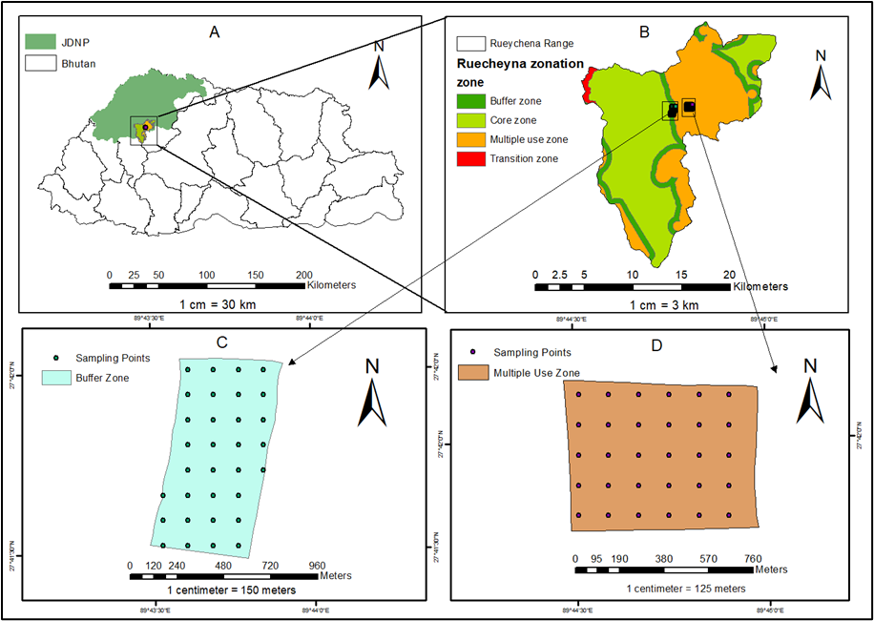
Figure 1: Study Area Map showing A: Bhutan Map; B: Rueychena Park Range; C: Study Area in Buffer zone and D: Study Area in multiple use zones.

JDNP is divided into four management zones with different levels of enforcement, such as the core zone with strict policy tailored towards conservation and complete restriction of human activities. Similarly, a transition zone where traditional and legal rights for sustainable resource use are allowed for a specific duration. Multiple-usezone encompasses settlements, developed areas, privately owned lands, and regions allocated for resource use by park residents(Dendup & Dorji, 2021).The buffer zone is primarily established to protect the core and transition zones from human disturbances, whether from inside or outside the protected areas(Dendup & Dorji, 2021).
Sampling Design
The studyemployed a random sampling design to assess forest biomass and soil organic carbon (SOC) across the Buffer and Multiple-use zone of the Ruecheyna Park Range of JDNP. The two study areas each represent a distinct management regime. These zones differed in their degree of human intervention and ecological conservation as stated by Dendup and Dorji (2021). The Buffer zone is the least disturbed, while the multiple-use zone likely experienced the highest human influence. From each zone, a 50-hectareevergreen oak forest was selected,and the area was divided into grids or plots using GIS tools to facilitate the random selection of sampling locations within that 50-hectare. The studytook30 numbers of circular plots each in buffer and multiple use zone with sampling intensity of 3% which is similar to the study conducted by Bhatta et al. (2021). A total of 60 sampling plots (30 each in BZ and MUZ) with circular plots of 12.62m radius were laid randomly using ArcGIS, which is an adaptation fromthe National Forest Inventory (FMID, 2023).
Data Collection
To measure the tree biomass, the tree DBH and height measurements are required for a nondestructive method. During data collection, all trees having DBH ≥ 10 cm were considered, and DBH (1.37 m above the ground) along with the height of the tree were measured for all the trees within the circular plot size of 12.62 m radius (FMID, 2023; Suberi et al., 2018; Tshering, 2019). Similarly, tree species with DBH equal to and above 5 cm and below 10 cm are consideredsaplings, as stated by (FMID, 2023), and were sampled for the estimation of sapling biomass. The DBH of the tree and sapling wasmeasured using a diameter tape, and clinometers were used to measure the tree and sapling height (FMID, 2023b; Tshering, 2019). These two inputs (tree height and DBH) were used to calculate biomass accumulation and carbon stock using the allometric equation(FMID, 2023).
Similarly, soil Samples were collected from the center of the circular plot at a depth of 30 cm using a soil auger (FMID, 2023; Poeplau et al.,2017). Five samples were collected from each soil plot to make a composite sample, and were taken as a single composite sample. Along with the composite soil sample, one soil core was collected from each plot with the help of a metal corer of 30 cm length and 5cm diameter, to determine the bulk density for carbon stock quantification. All the samples were labeled with site name and plot number and transported to the CNR laboratory for analysis. Further leaflitter and herbs, and grass samples were collected from each sampling plot at the center of the circular plot with a subplot of 30cm² for the determination of their carbon(FMID, 2023).

Above Ground Biomass of Trees and Saplings
The AGB of trees (DBH => 10cm) and saplings (10 > DBH >= 5cm) were estimated using six species-specific and one general allometric biomass equations available with the Department of Forest and Park Services.The general form of allometric equations is described inEquation 1below. As stated by FMID (2023), it is a linear interpolation of the cubic spline function of basal area (ba) as a predictor variable for biomass.
Center align all the equations.
AGB = β₀ + β₁ ba + β₂ X_{2………………………………………………………}(Equation 1)
Where, AGB = aboveground biomass(kg); ba = basal area (m²); β₀, β₁, β₂ = coefficients; and X₂ = g(ba).
$X_{2}= g(ba) = {(ba-t1​)}_{+}^{3}​-{(ba-t2​)}_{+}^{3}\frac{(t3​-t1​)}{(t3 ​- t2)} +{(ba - t3​)}_{+}^{3}\frac{​(t2 ​- t1​)}{(t3​ - t2)​}$………(Equation 2)
The value of each component of equation 2 were computed using the knot values with equations3, 4, and 5.
${(ba - t1)}_{+}^{3}$​=${ (X - t1)}_{+}^{3}$​, if ba>t1 and ${(ba - t1)}_{+}^{3}$=0, if ba<t1…………..(Equation 3)
${(ba - t2)}_{+}^{3 }$=${ (X - t2)}_{+}^{3}$, if ba>t2 and${(ba - t2)}_{+}^{3}$​=0, if ba<t2 ………….(Equation 4)
${(ba - t3)}_{+}^{3}$​=${(X - t3)}_{+}^{3}$, if ba>t3 and ${(ba - t3)}_{+}^{3}$=0, if ba<t3………….(Equation 5)

Table 1: Table showing six species-specific and one general biomass model used for the calculation of tree and sapling biomass
Species | Biomass equations | t1 | t2 | t3
Castanopsis tribuloides | (1.39+5303*ba+2722*X2+4129*X3) | 0.00738 | 0.13404 | 0.40222
Quercus griffithii | (-9.38+5438*ba+15835*X2) | 0.00731 | 0.13214 | 0.365
Quercus lanata | (-0.774+4499.805*ba+25308.290 *X2) | 0.01333 | 0.14188 | 0.39396
Quercus lamellosa | (-5.92+5100.42*ba+35818.84*  X2) | 0.00613 | 0.1234 | 0.40978
Rhododendron arboreum | (-0.19+1636.54*ba+43190.03*  X2) | 0.00683 | 0.09186 | 0.20734
Daphnephyllum  Himalaynse | (0.635+3953.1*ba+12659.447* X2) | 0.0065 | 0.1182 | 0.3794
General broadleaf | (-1.06+4341*ba+30173*  X2+4013*X3) | 0.00664761 | 0.1194591 | 0.3689771
Note: The biomass is calculated in kg. In equation: ba: tree basal area; X1 =ba; X2 =g(X1); X3 =1/0, indicator variable for forked trees; t1, t2, t3 = knot values at 10th, 50th and 90th quantile. Source: FMID (2023).
Below-Ground Biomass of Trees and Saplings
BGB for the treesand saplingswas calculated only at the plot level, similar to the method used by (FMID, 2023). The following equation 6 was used to estimate the BGB at the plot level and not for individual trees.
BGB_{p} =0.489 × (AGB_{p})^{0.89} ………………………………………………………………………(Equation 6)
Where, BGB_{p} = Below Ground Biomass at plot level and AGB_{p} = Above Ground Biomass at plot level.
Biomass of Herbs-Grasses and Litter
Herbs and grasses were destructively sampled from each sampling plot with a subplot of 30 cm². Similarly, the entire volume of the litter within the sampling frame up to the mineral soil layer was carefully collected. The biomass of herbs-grasses and litter was estimated using the formula described in equation 7 as stated by the Department of Forest and Park Services (FMID, 2023). Samples were dried at 65 degrees Celsius in a hot air oven until the constant weight was achieved (FMID, 2023).
AGB_{hg}​= $\frac{W_{f}}{A​​}$ × $\frac{W_{sub-dry}}{W_{subwet }}$× $\frac{1}{1,000,000 }$ ……………………..(Equation 7)
Where, A = Area in ha, W_{f} = Fresh Weight in the Field, W_{sub-dry} = Oven-dried Weight of the sub-sample taken to the laboratory, and W_{subwet} = Wet weight of the sample taken to the laboratory.
Carbon stock
All the biomasswas converted to carbonstock using the IPCC (2006) default fraction of0.47. C = 0.47 × total dry biomass

Soil Organic Carbon (SOC)
Total SOC was divided into Particulate Organic Matter (POM) and Mineral-Associated Organic Matter (MAOM) by the physical separation technique as described by Six et al. (2002) and Liu et al. (2023). Air-dried soil (<2 mm) was suspended in deionized water along with dispersing solution, sieved in a 53 µm mesh for the separation between POM (>53 µm) and the (<53 µm) fraction of MAOM. These fractions were air-dried in a hot air oven at a temperature of 60°C until constant weight was achieved,and the loss on ignition method was used to determine the carbon content (Liu et al., 2023). Then the SOC stock was calculated as: SOC = δ × d × %C, with δ being the bulk density (g cm⁻³), d being the depth (30 cm), and %C being the carbon content. Bulk density was calculated by dividing the dry weight of the soil bythe volume of the core.

Total Carbon Stock Calculation
The total carbon stock (TCS) was calculated as suggested by Pearson et al. (2005) and as cited in Bhatta et al. (2021) by summing up carbon stock in the Biomass (AGB, BGB, Litter, Herbs, and Grasses) and (SOC).
Soil Texture
Soil texture was determined using the hydrometer method to quantify the percentages of sand (0.05–2 mm), silt (0.002–0.05 mm), and clay (<0.002 mm) in soil samples as suggested by (Ashworth et al., 2001).
Data Analysis
For the analysis purpose, the statistical analysis software R version 4.3.3 (R Core Team, 2023), software package was employed to test the research objectives. Mann-Whitney U Test and t-test were employed to compare the biomass and carbon stock across two management zones. To achieve the second objective, which is to analyze the distribution and stability of SOC fractions (POM and MAOM), a Chi-squared test was performed to compare the proportion of samples where POM exceeded MAOM in each zone. The coefficient of Variance (CV) was also tested to understand the variability of POM and MAOM in two zones. Multiple Linear Regression was used to assess the impact of soil texture on SOC stabilization and accumulation.

Results and Discussion
Overview of Forest Biomass
Forest biomass assessment is important for the evaluation of the productivity and sustainability of the forest ecosystem. Forests are essential for carbon storage, water cycle regulation, and biodiversity conservation (Reichstein & Carvalhais, 2019). In the current study evergreen oak forest of Ruecheyna Park Range, JDNP, Bhutan, was studied for biomass and soil organic carbon quantification to inform forest management for better carbon sequestration in response to climate change. In total, 11 species belonging to six families were recorded in BZ, and 10 species belonging to 5 families were recorded in MUZ. In MUZ, 271 trees and 123 saplings were enumerated as compared to 392 trees and 129 saplings recorded in BZ (Table 1). The diameter distribution class of the two zones indicated that both tree density and DBH were higher in BZ, compared to MUZ.
Table 2: Table showing the Diameter distribution across the study area
Dia Class | Buffer Zone |  |  |  | Multiple Use Zone
Dia Class | Frequency (n) | Percent (%) | CumulativePercent (%) | Frequency (n) |  | Percent (%) | Cumulative Percent (%)
<10 | 129 | 24.86 | 24.86 | 123 |  | 31.78 | 31.78
10-19.9 | 79 | 15.22 | 40.08 | 66 |  | 17.05 | 48.83
20-29.9 | 73 | 14.07 | 54.15 | 59 |  | 15.25 | 64.08
30-39.9 | 83 | 15.99 | 70.14 | 47 |  | 12.14 | 76.22
40-49.9 | 59 | 11.37 | 81.51 | 28 |  | 7.24 | 83.46
50-59.9 | 41 | 7.9 | 89.41 | 26 |  | 6.72 | 90.18
60-69.9 | 20 | 3.85 | 93.26 | 15 |  | 3.88 | 94.06
70-79.9 | 9 | 1.73 | 94.99 | 12 |  | 3.1 | 97.16
80-89.9 | 9 | 1.73 | 96.72 | 5 |  | 1.29 | 98.45
90-99.9 | 6 | 1.16 | 97.88 | 3 |  | 0.78 | 99.23
<100 | 11 | 2.12 | 100 | 3 |  | 0.78 | 100
Total | 519 | 100 | 100 | 387 |  | 100 | 100

These could be attributed to anthropogenic activities in MUZ, because of which the larger trees with greater diameter were already harvested, resulting in a lesser number of standing trees (Suberi 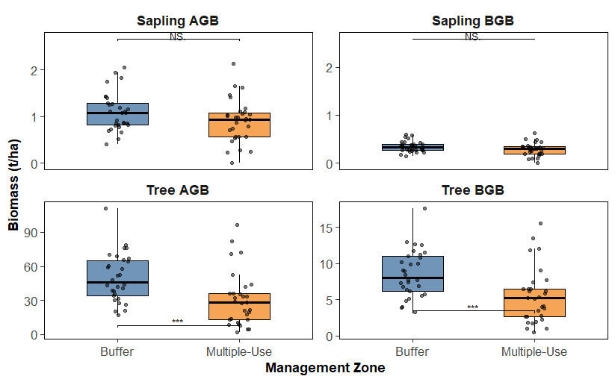et al., 2018). The DBH distribution (Table 1) shows that both zones still have the presence of older trees with higher DBH, indicating lesser harvesting compared to the government reserved forest, which could be due to strict regulation from the park authority(Dendup & Dorji, 2021). Similarly, in terms of sapling distribution, both zones had a similar number of saplings which indicates the same level of natural regeneration.
Incomplete??
Figure 2: Figure showing the biomass of tree and sapling in two zones (* indicates the significance level at p < .05 and NS = Not Significant)
Quercus species showed higher biomass stock compared to the Castanopsis tribuloides, which could be due to the presence of a greater number of Quercus species as compared to Castanopsis tribuloides. Total tree biomass in BZ was estimated at 292.16 t ha⁻¹ and 180.34 t ha⁻¹ in MUZ. More amount of biomass in the buffer zone in the current study could be due to relatively undisturbed ecological conditions in BZ that have favored the greater biomass accumulation, given that both zones had similar species composition (Suberi et al., 2018).
Comparison of Carbon Stock
The total carbon stock in the buffer zone was estimated at 293.31 t ha⁻¹ (90.05 SD), while the multiple use zone had 210.65 t ha⁻¹ (89.75 SD) (p < .001). Since MUZ is allowed for timber extraction and human activities, a lower carbon stock was found. While the results indicated higher stock in BZ, where resource extractions are limited. This finding is similar to Suberi et al. (2018), where total mean carbon stock in harvested forest was reported to be 257.4 t ha⁻¹ and 357 t ha⁻¹ in non-harvested forest in Khotokha, Bhutan.
Table 3: Comparison of carbon stock between buffer and multiple-use zone
Remove bracket, add a comma.
Carbon Pool |  | Buffer Zone  Average ±SD | Multiple Use Zone  Average ±SD | p-value | t-value or U-value
AGTC |  | 117.18 ± 50.3 | 71. 96 ± 56.33 | 0.001** | 675
BGTC |  | 20.13 ± 7.72 | 12.80 ± 9.00 | 0.0009*** | 675
AGSC |  | 0.515 ± 0.192 | 0.424 ± 0.218 | 0.092 | 1.71
BGSC |  | 0.16 ± 0.05 | 0.13 ± 0.06 | 0.082 | 1.76
HGC |  | 0.87 ± 1.1 | 0.586 ± 0.93 | 0.248 | 517
LC |  | 6.86 ± 1.7 | 7.43 ± 2.25 | 0.275 | -1.102
SOC | POM | 59.99 ± 28.08 | 46.3 ± 25.62 | 0.0351* | 593
SOC | MAOM | 87.59 ± 28.57 | 71.01 ± 34.68 | 0.0292* | 598
Total |  | 293.31 ± 90.05 | 210.65 ± 89.75 | 0.0003*** | 698
Note: Significance: ***p<0.001, **p<0.01, *p<0.05
The total biomass carbon varied across zones significantly, with a mean total biomass carbon of 145.73 t ha⁻¹ (58.24 SD) in BZ and 93.34 t ha⁻¹ (65.68 SD) in MUZ, respectively (p <.001).A small difference was observed in MAOM carbon (p < .05) and POM carbon (p < .05) between the two zones. The total SOC exhibited a significant difference (p< .001) with mean total SOC of 147.58 t ha⁻¹ (47.94 SD) and 117.31 t ha⁻¹ (45.81 SD), respectively, for BZ and MUZ, suggesting a strong influence of management or environmental factors on soil carbon stock. However, Herbs & Grasses Carbon (p> .05) and Litter Carbon (p > .05) did not show such a difference across two zones, with mean HGC stock of 0.87 t ha⁻¹ (1.11 SD) and 0.58 t ha⁻¹ (0.98 SD) in BZ and MUZ, respectively. While mean litter carbon in BZ was estimated at 6.86 t ha⁻¹ (1.7 SD) and 7.43 t ha⁻¹ (2.25 SD) in MUZ (Table 2). The slightly higher litter carbon stock as seen in MUZ could be due to felling of trees and resource extraction that increase litter input, unlike BZ where litter input is only through natural litter fall. While similar amount of HGC stock in two zones could be due to the fact that in MUZ the felling of tree results in better sunlight for under story herbs and grasses leading to better growth unlike in BZ where dense canopy could reduce the amount of sunlight in the ground despite having no human disturbance ultimately reducing the amount and quality of herbs and grasses (Bhatta et al, 2021).
The greater carbon stock in BZ potentially reflects the lower disturbance in BZ than MUZ, which likely inhibits biomass accumulation through grazing and forest wood harvesting (Delma et al., 2024). Similarly, Tashi et al. (2017) measured a biomass carbon stock of 179.8 t ha⁻¹ in undisturbed forests, which is very close to the BZ value and confirms the hypothesis of maximum carbon storage under strict protection, whereas MUZ's lower stock agrees with disturbance-mediated reductions in biomass carbon (Tashi et al., 2017).
Suberi et al. (2018) also reported total biomass carbon stock of 155.9 t ha⁻¹ in harvested forest and 267.4 t ha⁻¹ in non-harvested forest in Khotokha, Bhutan, indicating the implication of forest harvesting in biomass carbon stock accumulation. A study by Cruz-Amo et al.(2020) also highlighted more carbon stock in undisturbed Andean tropical montane forest with a total mean carbon stock of 312.7 t ha⁻¹. Delma et al. (2024) estimated an average total carbon stock of 287.5 t ha⁻¹ in Bhutan’s less disturbed forests, pointing out more carbon stock accumulation in protected ecosystems. The significant inter-zone difference aligns with Cruz-Amo et al.(2020), who asserted that management gradients are critical determinants of carbon stock variability.
Spelling
Soil Organic Carbon
Soil organic carbon (SOC) in BZ was 147.58 t ha⁻¹ (SD = 47.94) versus 117.31 t ha⁻¹ (SD = 45.81) in MUZ (p = 0.0069), MAOM-SOC was 87.59 t ha⁻¹ (SD = 28.57) in BZ versus 71.05 t ha⁻¹ (SD = 34.68) in MUZ (p < .05), and POM-SOC at 59.99 t ha⁻¹ (SD = 28.07) in BZ versus 46.3 t ha⁻¹ (SD = 25.62) in MUZ (p < .05).Nidup (2020), documented SOC in Bhutan’s undisturbed forests at 142.3 t ha⁻¹, which is similar to BZ, and 108.9 t ha⁻¹ in disturbed forests, which is further close to 117.31 t ha⁻¹ recorded in MUZ, supporting the observed differences as a function of management intensity (Nidup, 2020). However, different finding was reported by Suberi et al. (2018), where total SOC in the harvested forest was reported to be higher than that of the non-harvesting forest. This could be due to differences in the management practices between the two study areas and the vegetation difference, as the most significant species in Suberi et al. (2018) were conifers, and the current study was conducted in an evergreen oak forest dominated by oak species.
across
Table 4: Soil Organic Carbon (SOC) Pools and Related Metrics Across Buffer and Multiple-Use Zones
Parameter | Buffer Zone (Mean ± SD) | Multiple-Use Zone (Mean ± SD) | Test Statistic | P-value | Effect Size
Total SOC (t ha⁻¹) | 147.58 ± 47.94 | 117.31 ± 45.81 | t =2.786 | 0.0070** | 0.349 (Cohen's d)
POM-SOC (t ha⁻¹) | 60.00 ± 28.10 | 46.30 ± 25.60 | U =593 | 0.0351* | 0.273 (Rank-biserial)
MAOM-SOC (t ha⁻¹) | 87.60 ± 28.60 | 71.00 ± 34.70 | U =598 | 0.0292* | 0.282 (Rank-biserial)
POM Proportion Dominant (%) | 13.3 ± NA | 23.3 ± NA | χ² = 0.445 | 0.5046 | NA
Note: Total SOC, POM-SOC, and MAOM-SOC represent carbon stocks (t ha⁻¹); POM proportion tested with Chi-squared test; stability of POM and MAOM tested with Mann-Whitney U; NA indicates not applicable. P-values rounded to 4 decimal places; * denotes significance at p < 0.05.* *
Notably, the MAOM and POM in the present study surpass typical temperate forest estimates, such as 62.4 t ha⁻¹ for MAOM reported byBeillouin et al. (2023), possibly due to Bhutan’s climatic or pedological differences.Relative SOC fraction distribution, calculated as the proportion of samples in which POM was larger than MAOM, was not significantly different across zones, at 13.3% in BZ and 23.3% in MUZ (χ² = 0.445, p = 0.5046) as indicated in Table 3. This shows that while absolute POM and MAOM stocks vary, their relative contribution to total SOC is comparable for both management types. Stability parameters also underscored these trends. POM had a lower coefficient of variation (CV) in BZ (0.468) compared to MUZ (0.553), showing greater stability, whereas MAOM had a CV of 0.326 in BZ and 0.488 in MUZ, which indicated its greater stability in the buffer zone. Stability indices (1/SD) were marginally higher for POM in MUZ (0.0390) than BZ (0.0356), whereas stability of MAOM was greater in BZ (0.0350) than in MUZ (0.0288), validating BZ management's conservation impact on stable carbon pools.
Impacts of Soil Texture on SOC
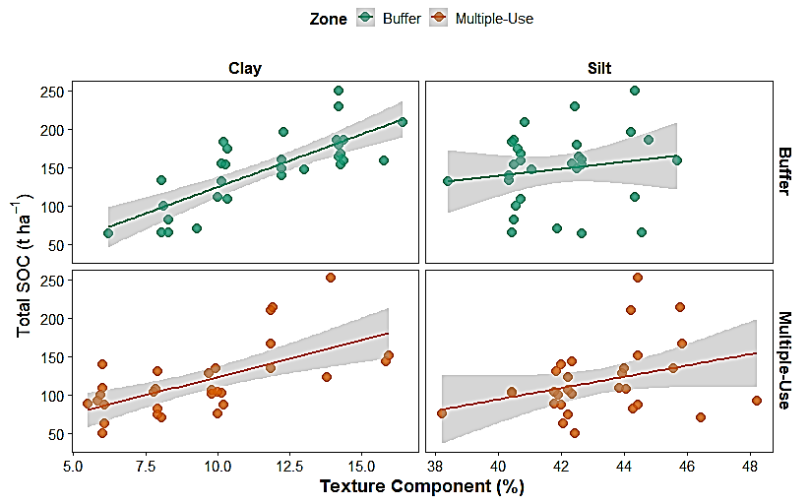
Figure 3: MLR analysis between soil texture and Soil Organic Carbon

Soil texture is said to play an important role in soil organic carbon storage. Multiple linear regression analysis results revealed a highly positive and significant correlation between clay percent and SOC content in BZ(p < 0.001, t = 6.35) and MUZ (p < 0.001, t = 4.25) (Figure 3). This result highlights the premier importance of clay for SOC accumulation, in agreement with recent research underscoring the ability of clay to stabilize organic carbon via physical and chemical mechanisms (Cotrufo et al., 2019; Lehmann & Kleber, 2015). This stabilization probably regulates the noted increment in SOC with increasing clay content across the two zones since clay-rich soils have been shown to promote carbon sequestration through limiting access to decomposers(Cotrufo et al., 2019).
percentage
On the other hand, silt content had no effect on SOC in BZ (p = 0.7127, t = -0.37) or MUZ (p = 0.0738, t = 1.86), although there was a weak trend in MUZ. This lack of significance is consistent with research by Bailey et al. (2018), where it was stated that silt fractions, while contributing to soil water retention, do not contribute significantly to SOC stabilization in relation to clay due to their lower surface area and binding capacity. The borderline significance in MUZ (p = 0.0738) reflects a potential minor effect under certain conditions, attributable to land use, but not statistically significant. It supportsWiesmeier et al. (2019), who stated that silt plays an important role in SOC as a secondary SOC storage factor alongside clay.
Conclusion and Recommendations
This study demonstrates that the forest conservation-based management significantly improves carbon sequestration in Bhutan’s protected areas. The buffer zone under strong policy enforcement showed a higher total carbon stock (293.31 t ha⁻¹) compared to multiple-use zone (210.65 t ha⁻¹). In terms of SOC, both POM and MAOM showed greater variability in BZ as compared to MUZ,which indicated how a conserved ecosystem can promote more stable SOC. Vegetation, litter, and herbaceous carbon were also higher in the buffer zone, emphasizing the role of protection in maintaining resilient carbon pools.
While the study provides valuable evidence on the influence of management zones to the carbon dynamics, it is limited by spatial scope, seasonal timing, and soil depth coverage. Future research should expand sampling beyond 50 hectares per zone and consider a deeper soil layer (up to 100 cm) to capture the full range of carbon variability, especially MAOM at depth. Future studiesshould explore the spatiotemporal distributionof carbon stock across other management zones within National Parks in Bhutan.
In the ‘Reference’, mention only those cited in your paper.

References
Ashworth, J., Keyes, D., Kirk, R., & Lessard, R. (2001). Standard procedure in the hydrometer method for particle size analysis. Communications in Soil Science and Plant Analysis, 32(5–6), 633–642.
Bailey, V. L., Pries, C. H., & Lajtha, K. (2018). What do we know about soil carbon destabilization? Environmental Research Letters, 14, 083002. https://doi.org/10.1088/1748-9326/ab2c11
Beillouin, D., Corbeels, M., Demenois, J., Berre, D., Boyer, A., Fallot, A., Feder, F., & Cardinael, R. (2023). A global meta-analysis of soil organic carbon in the Anthropocene. Nature Communications, 14(1), 3700. https://doi.org/10.1038/s41467-023-39338-z
Bhatta, S., Poudel, A., & Kc, Y. B. (2021). A comparative study of carbon stocks in the Sal forest (Shorea robusta) in core and buffer zones of Shuklaphanta National Park, Nepal. Forestry: Journal of Institute of Forestry, Nepal, 18(1), 1–14. https://doi.org/10.3126/forestry.v18i01.41757
Bisht, S., Bargali, S. S., Bargali, K., Rawat, G. S., Rawat, Y. S., & Fartyal, A. (2022). Influence of anthropogenic activities on forest carbon stocks—A case study from Gori Valley, Western Himalaya. Sustainability, 14(24), 16918. https://doi.org/10.3390/su142416918
Cotrufo, M. F., Ranalli, M. G., Haddix, M. L., Six, J., & Lugato, E. (2019). Soil carbon storage informed by particulate and mineral-associated organic matter. Nature Geoscience, 12(12), 989–994. https://doi.org/10.1038/s41561-019-0484-6
Cruz-Amo, L. de la, Bañares-de-Dios, G., Cala, V., Granzow-de la Cerda, Í., Espinosa, C. I., Ledo, A., Salinas, N., Macía, M. J., & Cayuela, L. (2020). Trade-offs among aboveground, belowground, and soil organic carbon stocks along altitudinal gradients in Andean tropical montane forests. Frontiers in Plant Science, 11, 106. https://doi.org/10.3389/fpls.2020.00106
Delma, S., Gilmour, D., Ota, L. S., Warner, K., Temphel, K. J., & Herbohn, J. (2024). Carbon stocks and sequestration potential of community forests in Bhutan. Trees, Forests and People, 16, 100530. https://doi.org/10.1016/j.tfp.2024.100530
Dendup, P., & Dorji, R. (2021). Conservation management zones of Jigme Dorji National Park. Department of Forests and Park Services. https://doi.org/10.13140/RG.2.2.21000.29444
Du, B., Kang, H., Pumpanen, J., Zhu, P., Yin, S., Zou, Q., Wang, Z., Kong, F., & Liu, C. (2014). Soil organic carbon stock and chemical composition along an altitude gradient in the Lushan Mountain, subtropical China. Ecological Research, 29(3), 433–439. https://doi.org/10.1007/s11284-014-1135-4
FAO. (2020). Global Forest Resources Assessment: Main report. Rome: FAO. https://www.fao.org/forest-resources-assessment
FMID. (2023). National Forest Inventory Report. Forest Monitoring and Information Division, Department of Forests and Park Services, Bhutan.
FMID. (2023b). Bhutan’s Forest Reference Emission Level. Forest Monitoring and Information Division, Department of Forests and Park Services.
Gerke, H. H. (2022). Stabilization mechanisms of soil organic matter: A synthesis. Geoderma, 426, 116111.
Homann, P. S., Sollins, P., Chappell, H. N., & Stangenberger, A. G. (1995). Soil organic carbon in a mountainous, forested region: Relation to site characteristics. Soil Science Society of America Journal, 59(5), 1468–1475. https://doi.org/10.2136/sssaj1995.03615995005900050037x
IPCC. (2021). Climate Change 2021: The Physical Science Basis. Intergovernmental Panel on Climate Change. https://www.ipcc.ch/report/ar6/wg1
Jandl, R., Vesterdal, L., Olsson, M., Bens, O., Badeck, F.-W., & Rock, J. (2007). Carbon sequestration and forest management. CAB Reviews, 2(17), 1–16. https://doi.org/10.1079/PAVSNNR20072017
Lavallee, J. M., Soong, J. L., & Cotrufo, M. F. (2020). Conceptualizing soil organic matter into particulate and mineral-associated forms to address global change in the 21st century. Global Change Biology, 26(1), 261–273. https://doi.org/10.1111/gcb.14859
Lehmann, J., & Kleber, M. (2015). The contentious nature of soil organic matter. Nature, 528(7580), 60–68. https://doi.org/10.1038/nature16069
Liu, B., Xu, M., Zhang, S., & Zhu, Y. (2023). Soil carbon dynamics under afforestation and reforestation in degraded lands. Science of The Total Environment, 857, 159630.
Manojlović, M., Galić, M., & Cvijanović, G. (2011). Organic carbon in mountain soils under different land uses. Journal of Agricultural Sciences, 56(2), 99–109.
Nidup, K. (2020). Carbon stock in forest ecosystems of Bhutan. Bhutanese Journal of Natural Resources and Development, 6(1), 1–9.
Pearson, T. R. H., Brown, S., & Birdsey, R. A. (2005). Measurement guidelines for the sequestration of forest carbon. General Technical Report NE-343, USDA Forest Service.
Poeplau, C., Don, A., Vesterdal, L., Leifeld, J., van Wesemael, B., Schumacher, J., & Gensior, A. (2017). Temporal dynamics of soil organic carbon after land-use change in the temperate zone–carbon response functions as a model approach. Biogeosciences, 8(1), 3041–3051.
R Core Team. (2023). R: A language and environment for statistical computing. R Foundation for Statistical Computing. https://www.r-project.org/
Reichstein, M., & Carvalhais, N. (2019). Aspects of forest carbon dynamics: Global patterns and processes. Nature, 568, 1–10.
Six, J., Conant, R. T., Paul, E. A., & Paustian, K. (2002). Stabilization mechanisms of soil organic matter: Implications for C-saturation of soils. Plant and Soil, 241(2), 155–176. https://doi.org/10.1023/A:1016125726789
Sommer, R., & Bossio, D. (2014). Dynamics and climate change mitigation potential of soil organic carbon sequestration. Journal of Environmental Management, 144, 83–87. https://doi.org/10.1016/j.jenvman.2014.05.017
Suberi, B., Tiwari, K., Gurung, D., Bajracharya, R., & Sitaula, B. (2018). Effect of harvesting and non-harvested forest management on carbon stocks. International Journal of Environment, Agriculture and Biotechnology, 3(4), 1265–1274.
Tashi, S., Keitel, C., Singh, B., & Adams, M. (2017). Allometric equations for biomass and carbon stocks of forests along an altitudinal gradient in the eastern Himalayas. Forestry, 90(3), 445–454. https://doi.org/10.1093/forestry/cpx003
Tshering, S. (2019). Importance value index and assessment of carbon stocks in Western Bhutan Himalaya (Thimphu). Current Journal of Applied Science and Technology, 32, 1–8. https://doi.org/10.9734/CJAST/2019/46398
Tshering, S., & Rinzin, P. (2022). Terrestrial biomass and carbon stock in broad-leaved forests of Punakha District, western Bhutan. Nature Environment and Pollution Technology, 21(1), 175–181. https://doi.org/10.46488/NEPT.2022.v21i01.019
Wiesmeier, M., Urbanski, L., Hobley, E., Lang, B., von Lützow, M., Marin-Spiotta, E., van Wesemael, B., Rabot, E., Ließ, M., & Garcia-Franco, N. (2019). Soil organic carbon storage as a key function of soils–A review of drivers and indicators at various scales. Geoderma, 333, 149–162. https://doi.org/10.1016/j.geoderma.2018.07.026

