Case report
A case of obstructed ventral hernia with intraoperative findings of multiple colonic diverticulitis with faecal evisceration

.
ABSTRACT

Ventral hernia refers to any protrusion of intestine or other tissue through a weakness or gap in the abdominal wall. We report a rare case of a 75 years old female presented with features of obstructed infraumbilical hernia without signs of peritonitis. USG abdomen was suggestive of infraumbilical defect with omentum and bowel loop as contents. Patient was taken for emergency open ventral hernioplasty. On exploration, surprisingly we found sigmoid diverticulitis with faecal evisceration. On table decision was taken to proceed with Hartamann's procedure and primary closure of ventral hernia defect without mesh placement. This case emphasizes the need for preoperative investigations, adaptability, timely action during surgical intervention and intricate surgical strategies employed to address the unique combinations of pathologies.

Keywords: Obstructed hernia, bowel ischemia, hernioplasty, surgical strategies

1. INTRODUCTION

Ventral hernia is most common in elderly age groups due to weakness in abdominal wall muscles. Obstruction of the hernia happens when the contents of the hernia cannot go back to its original position, which presents as irreducibility of the contents, sharp pain, vomiting and constipation. which left untreated may later lead to strangulation (vascular compromise). Association of ventral hernia with diverticulitis is a rare presentation. perforated diverticula with faecal evisceration cause faecal peritonitis (Hinchey 4, summarized in table.1).

Table 1. Hinchey classification

Particulars | Value
Pericolonic phlegmon and inflammation, no fluid collection | 1a
Pericolonic abscess <4cm | 1b
Pelvic or inter-loop abscess OR abscess >4cm | 2
Purulent peritonitis | 3
Feculent peritonitis | 4

2. CASE PRESENTATION

A 75-year-old female came to the emergency department with complaints of swelling below the umbilicus (Fig.1) for approximately two years, initially small in size, which became prominent on coughing and straining and reduced on its own on relaxation. The patient consulted no doctor as it was asymptomatic. Now, the patient complains of pain in the lower abdomen for one week, constipation for two days and 2 to 3 episodes of vomiting on the day of admission. Known case of hypertension on medication, no other known comorbidities. No previous surgical history. No history of fever, loose stools, bloating or loss of appetite.
On examination, vitals were stable (Blood pressure – 130/86 mmHg, Pulse rate-84 b/m, Respiratory rate- 16 cycles/min, SpO2- 99% in room air).
Per abdominal examination: 8x5 cm swelling in infraumbilical region, tender, irreducible, no warmth or signs of strangulation seen.

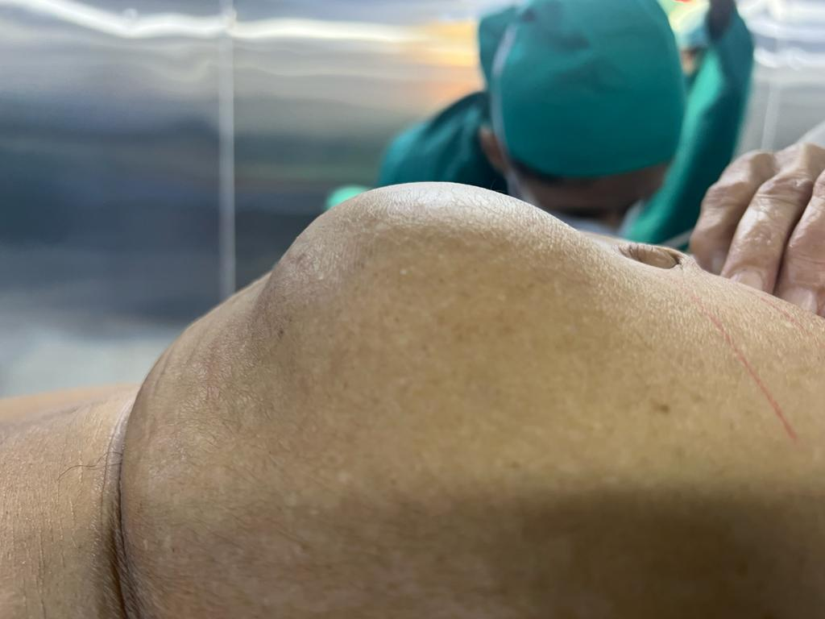

Figure 1. Infraumbilical hernia

2.1. INVESTIGATIONS

X-ray of the abdomen was normal without air under the diaphragm. USG abdomen was suggestive of 5 x 3 cm defect in the infraumbilical region with omentum and bowel loops as contents, with obstruction.
CT abdomen was not done as patient was in severe pain and clinical diagnosis of obstructed ventral hernia was made in emergency department.
Patient was posted for emergency surgery on the same day.

2.2. TREATMENT

The following surgical procedure was followed: Transverse skin incision took over the swelling, and the incision deepened in layers (Fig.2). The Hernia sac opened, and the omentum and sigmoid colon were seen as contents (Fig.3). Foul faecal smell was experienced by us which made us to further explore the bowel. On exploration, to our surprise, sigmoid diverticulitis with faecal evisceration was seen as shown in the picture (Fig.4,5). On table discission was made to carry out Hartmann's procedure (sigmoidectomy and proximal stump colostomy). A thorough bowel wash was given, and the hernia defect was closed using PDS No.1 without mesh placement.

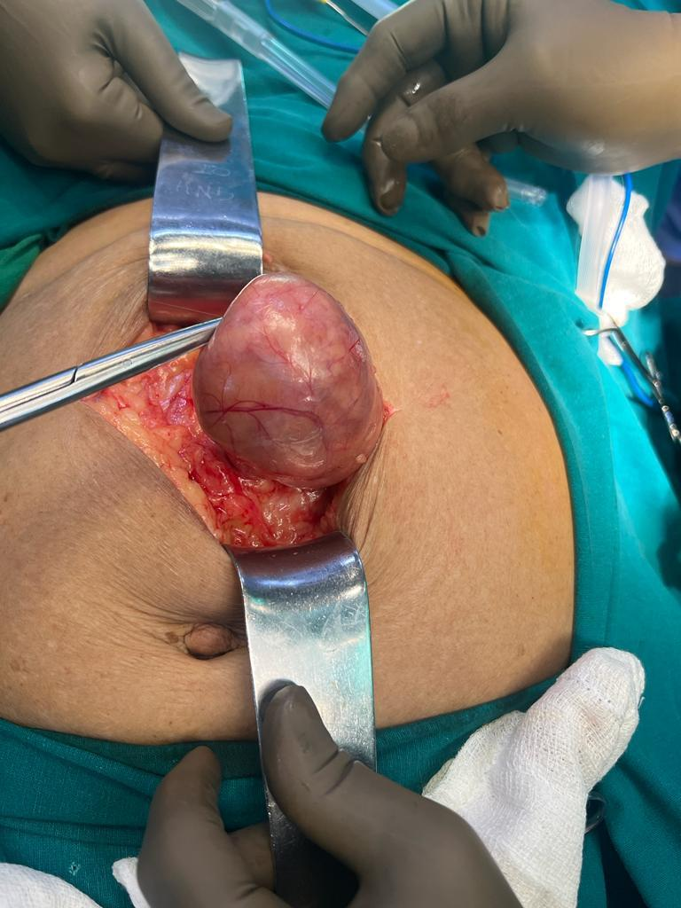
Figure 2. Hernia sac

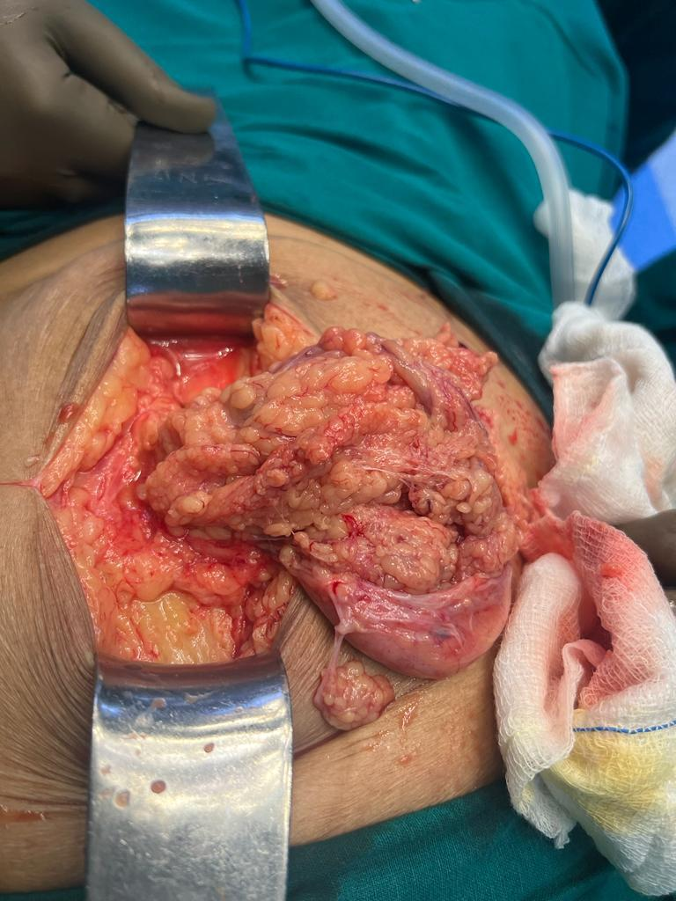
Figure 3. Omentum and bowel as contents

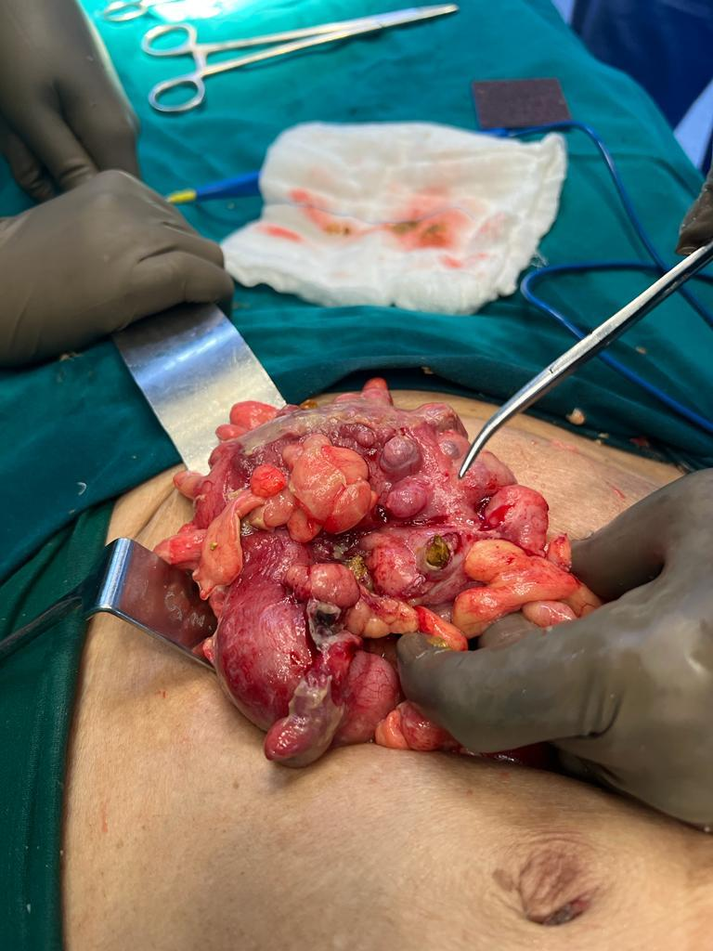
Figure 4. Sigmoid diverticulitis with faecal evisceration

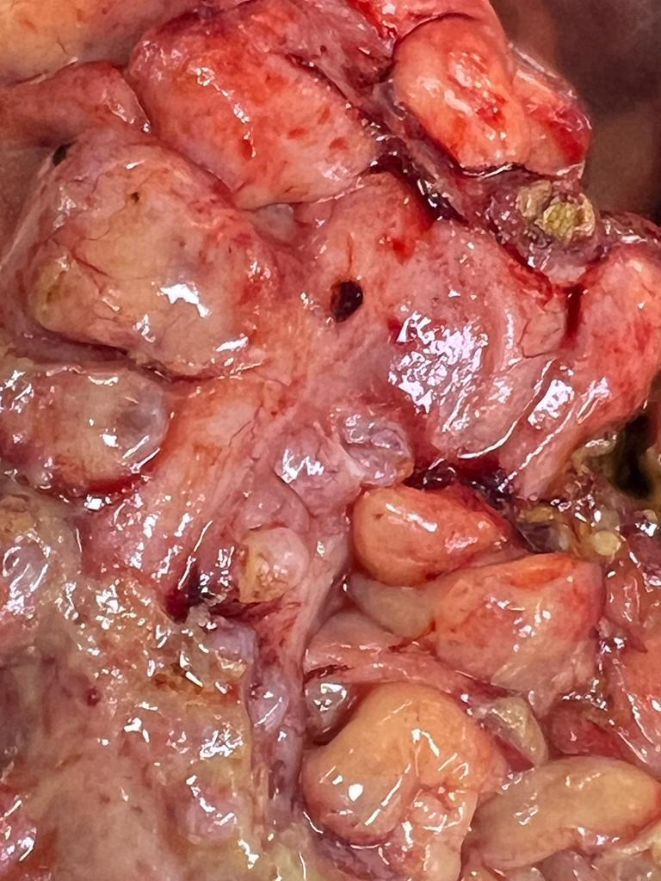
Figure 5. Sigmoid diverticular perforation

2.3. OUTCOME AND FOLLOW-UP

Patient recovered well after surgery. Postoperatively, colostomy was patent and functioning well. We discharged patient on postoperative day 5.
After two months, a reversal of colostomy (colorectal anastomosis) was done.

3. discussion

Diverticulosis is defined by the presence of diverticula, which are sac like protrusions of colonic mucosa through weak points in the muscular wall. Diverticular disease is defined as clinically significant and symptomatic diverticulosis due to diverticulitis or its complications, diverticular bleeding, segmental colitis associated with diverticula or symptomatic complicated diverticular disease
Risk factors: old age, white race (1), male sex, smoking, elevated body mass index has been identified as risk factor for diverticulosis (2,3). Corticosteroid use is associated with threefold increased risk of diverticular perforation (4).
Pathogenesis of diverticulitis and its complications have not been clearly elucidated. Genetics, Gut microbiome, points of weakness which corresponds to the point where vasa recta penetrate the circular muscle layer of the colon (5), abnormal colonic motility, structural changes of connective tissue (collagen) may also be responsible for the appearance of diverticulitis at an early age in connective tissue disorders such as Ehlers-Danlos, Marfan’s syndrome and autosomal dominant polycystic kidney disease (6,7).
In the west, most colonic diverticula are acquired and are " False" or pulsion diverticulum, in which mucosa and submucosa herniate through the muscle layer, covered only by serosa. In Asia, congenital diverticula are common, tend to be in the right colon and include all layers of the colon wall.
Management: Most patients with uncomplicated diverticulitis are managed with IV or oral antibiotics for 3-5 days.
Complicated diverticulitis:
- Abscess (common).
- Perforation.
- Obstruction (rare).
- Fistula formation (rare).
Micro perforation, also called as contained perforation, is the presence of a small amount of air bubbles but no oral contrast outside of the colon on Abdo pelvic CT with contrast. Patients with peri colonic air bubbles only, can be managed the same way as those with uncomplicated diverticulitis. Success rate of nonoperative management is from 85-99% (8,9).
Acute diverticulitis with free (frank) perforation (Hinchey 3 or 4) is a life-threatening condition that mandates emergency surgery (10). The primary goal of the surgery is to obtain source control by removing perforated colonic segment, Secondary goal is to restore intestinal continuity, the feasibility of which is predicted upon the patient's hemodynamic stability and the degree of peritoneal contamination (11).
In unstable patients; Damage control surgery should be expedited to obtain source control of the sepsis, peritoneal lavage and temporary abdominal closure till the patient is stable and well resuscitated. In stable patients; Hartmann's procedure is suggested (12), Some European authors have advocated primary anastomosis with proximal diversion (PAPD) in select patients with Hinchey 3 perforated diverticulitis.

4. Conclusion

Early detection of obstructed hernia signs can prevent bowel ischemia caused by strangulation and avoid further complications. This case emphasizes thorough history taking, pre-operative investigations, and surgical preparedness in managing intraoperative surprises. This also highlights the diagnostic challenges, intricate surgical strategies employed to address the unique combinations of pathologies and optimal patient outcome.

References

1. Peery AF, Keku TO, Galanko JA, Sandler RS. Sex and race disparities in diverticulosis prevalence. Clinical gastroenterology and hepatology. 2020 Aug 1;18(9):1980-6.

2. Peery, A. F., Keku, T. O., Martin, C. F., Eluri, S., Runge, T., Galanko, J. A., & Sandler, R. S. (2016). Distribution and Characteristics of Colonic Diverticula in a United States Screening Population. Clinical Gastroenterology and Hepatology, 14(7), 980–985.e1. https://doi.org/10.1016/j.cgh.2016.01.020.
3. Peery, A. F., Sandler, R. S., Ahnen, D. J., Galanko, J. A., Holm, A. N., Shaukat, A., Mott, L. A., Barry, E. L., Fried, D. A., & Baron, J. A. (2013). Constipation and a low-fiber diet are not associated with diverticulosis. Clinical Gastroenterology and Hepatology, 11(12), 1622–1627. https://doi.org/10.1016/j.cgh.2013.06.033
4. Humes, D. J., Fleming, K. M., Spiller, R. C., & West, J. (2011). Concurrent drug use and the risk of perforated colonic diverticular disease: a population-based case-control study. Gut, 60(2), 219–224. https://doi.org/10.1136/gut.2010.217281.
5. Meyers, M. A., Alonso, D. R., Gray, G. F., & Baer, J. W. (1976). Pathogenesis of bleeding colonic diverticulosis. Gastroenterology, 71(4), 577–583. https://www.sciencedirect.com/science/article/pii/S001650857650100X
6. Wess, L., Eastwood, M. A., Wess, T. J., Busuttil, A., & Miller, A. (1995). Cross linking of collagen is increased in colonic diverticulosis. Gut, 37(1), 91–94. https://doi.org/10.1136/gut.37.1.91
7. S Scheff, R. T., Zuckerman, G., Harter, H., Delmez, J., & Koehler, R. (1980). Diverticular disease in patients with chronic renal failure due to polycystic kidney disease. Annals of Internal Medicine, 92(2 Pt 1), 202–204. https://doi.org/10.7326/0003-4819-92-2-202.
8. Sallinen, V. J., Mentula, P. J., & Leppäniemi, A. K. (2014). Nonoperative management of perforated diverticulitis with extraluminal air is safe and effective in selected patients. Diseases of the Colon & Rectum, 57(7), 875–881. https://doi.org/10.1097/DCR.0000000000000083.
9. Vogels, S., Frouws, M., Morks, A. N., Roos, D., van den Bremer, J., Koch, S. M. P., Smithuis, R. H. M., Hoencamp, R., & van der Wilden, G. M. (2021). Treating acute colonic diverticulitis with extraluminal pericolic air: An Acute Care Surgery in the Netherlands (ACCSENT) multicenter retrospective cohort study. *Surgery*, *169*(5), 1182–1187. https://doi.org/10.1016/j.surg.2020.10.032.
10. Regenbogen, S. E., Hardiman, K. M., Hendren, S., & Morris, A. M. (2014). Surgery for diverticulitis in the 21st century: a systematic review. JAMA Surgery, 149(3), 292–303. https://doi.org/10.1001/jamasurg.2013.5477.
11. S Salem, L., & Flum, D. R. (2004). Primary anastomosis or Hartmann’s procedure for patients with diverticular peritonitis? A systematic review. Diseases of the Colon & Rectum, 47(11), 1953–1964. https://doi.org/10.1007/s10350-004-0701-1.
12. Constantinides, V. A., Tekkis, P. P., Athanasiou, T., Aziz, O., Purkayastha, S., Remzi, F. H., Fazio, V. W., Aydin, N., Darzi, A., & Senapati, A. (2006). Primary resection with anastomosis vs. Hartmann's procedure in nonelective surgery for acute colonic diverticulitis: A systematic review. Diseases of the Colon and Rectum, 49(7), 966-981. https://doi.org/10.1007/s10350-006-0547-9.

