Neuroprotective effect of the hydro-ethanolic extract of khaya grandifoliola in a model of Alzheimer’s-like pathology induced in rats by lipopolysaccharides

Abstract:
Neuroinflammation plays a crucial role in Alzheimer's disease (AD) pathology. AD is a neurodegenerative disorder characterized by progressive memory loss, cognitive decline and loss of autonomy. Present in our living environment, lipopolysaccharides (LPS) are known as potent neurotoxins causing progressive neurodegeneration in the brain. So far, available treatments for the disease only limit its symptoms. Fortunately, Khaya grandifoliola (KG) is used in Cameroonian traditional medicine for the treatment of brain disorders. In this study, we evaluated the neuroprotective effect of KG against LPS-induced neuroinflammation in rats. LPS intoxication was assayed in 25 rats divided into 5 groups of 5 rats each for 6 days at 1 mg/kg and behavioral tests (FST and ECM) were performed on the 4th and 6th days during induction. Thereafter, the rats were treated with reference drug (Baicalin 10 mg/kg) and KG at two doses (75 mg/kg and 225 mg/kg) for 15 days. The FST and ECM tests were performed for 4 days: 3; 7; 10 and 15. On day 22, after 24 hours of fasting, the rats were sacrificed and blood was collected in order to measure ASAT, ALAT, total protein levels, creatinine, markers of oxidative stress (CAT, MDA, GSH, and NO), acetylcholinesterase and pro-inflammatory cytokines (IL1-β and TNF-α). Overall, we observed that LPS-induced anxiety and depression were improved by the administration of KG-75 and KG-225. Treatment with the plant extract led to an improvement of oxidative stress parameters including catalase, lipid peroxidation, glutathione, and nitric oxide. Moreover, acetylcholinesterase activity showed a significant increase in group II (control LPS) and a significant decrease (P<0.05) in the drug treated groups. Evaluation of inflammatory cytokines showed low levels of IL1-β and TNF-α in the groups treated with KG in comparison to the LPS-treated group. Altogether, KG-75 and KG-225 extracts effectively protected the rat’s brain from the toxic effects of LPS.
Keywords: Alzheimer's disease, Khaya grandifoliola, Lipopolysaccharides, anxiety, neuroinflammation.

Introduction
Neurodegenerative diseases currently affect 47 to 50 million people worldwide, including nearly 10% of people over 65 and more than 30% of people over 85 (Erkkinen et al., 2018). Epidemiological studies have indicated that the number of people suffering from Alzheimer’s disease (AD) will increase from 57.4 million to 152.8 million by 2050. The exact cause of the disease is not very well described until now, but neuroinflammation is believed to be a crucial factor for its initiation and progression.
Lipopolysaccharides (LPS) are found on bacteria outer membranes and are endotoxins released by bacterial lysis. Unfortunately, LPS can cross the brain barrier and initiate neuroinflammation in the brain, leading to AD (Peng et al., 2021). Several plant compounds like flavonoids have proven to be efficient in protecting the blood-brain-barrier (BBB) against the toxicity induced by LPS in rats. For instance, rutin pretreatment mitigated LPS-induced BBB disruption and inflammatory pathways in rats (Meng et al., 2025). It is well reported that AD is caused by the accumulation of amyloid-β and tau proteins in the brain. Unfortunately, those two hallmarks do not explain the full pathology seen with AD, suggesting that other mechanisms may be involved. Therefore, some reports have mentioned the endotoxin hypothesis of AD stating that LPS may contribute to the pathophysiology of AD via peripheral infections or gut dysfunction, elevating LPS levels in blood and brain, and promoting amyloid pathology, tau pathology and microglial activation (Brown & Heneka, 2024). It has been reported that BBB levels of LPS were elevated in AD patients (Kesika et al., 2021). Moreover, LPS is known to induce Aβ aggregation, inflammation and neurotoxicity (Zhu et al., 2024). As far as the biochemical mechanism is concerned, LPS are known to bind to Tol-like receptors/4 on cell surface and induce the release of critical pro-inflammatory cytokines such as IL1β and TNF α and nitrites (Wiger et al., 2025). Excess nitrites can react with reactive oxygen species (ROS) to form peroxynitrite, which is toxic to DNA.
Oxidative stress and inflammation are deeply interconnected in neurodegenerative diseases. Therefore, managing oxidative stress is crucial for the treatment of AD. The imbalance between the production of ROS and the antioxidants in the case of AD is mainly produced by microglia, following TLR4 activation by PAMPs and DAMPs (pathogen associated molecular patterns and danger activated molecular patterns). As consequence, ROS can damage DNA, proteins and lipids, cause cellular dysfunction and accelerate aging (Ionescu-Tucker & Cotman, 2021). Furthermore, excess ROS is known to activate inflammatory pathways (NFkB and NLRP3 inflammasome) (Zhou et al., 2011). In the other hand, inflammation amplifies ROS production, with persistent oxidative stress and inflammation reinforcing each other, leading to tissue damage and disease progression.
In AD, ROS damage neurons and promotes Amyloid-β aggregation (Butterfield, 2002). Many enzymes are involved in the cell antioxidant system including catalase, which prevents accumulation of hydrogen peroxide which can damage DNA and proteins. Moreover, reduced catalase activity is linked to AD (Nandi et al., 2019). Malondialdehyde can also form adducts with proteins and DNA, thereby altering their structure and function. Indeed, elevated MDA is linked to neurodegenerative diseases such as AD and PD (Dib et al., 2002). Low glutathione levels are linked to increased oxidative stress and neuronal damage (Akingbade et al., 2023). Another important enzyme is acetyl choline esterase (ACE) which plays an important role in memory and learning by regulating acetylcholine levels in the brain. AD patients often show reduced activity of ACHE due to neuronal loss (Rosengarten et al., 2009). Therefore, ACHE inhibitors appear to be important targets for AD treatment.
The therapeutic options currently available for AD on the market are of limited effectiveness and purely symptomatic (Chakkittukandiyil et al., 2024). For instance, donepezil, galantamine and rivastigmine are cholinesterase inhibitors that are prescribed in the less advanced phases of the disease (moderate AD). Moreover, some of these drugs, in addition to being expensive, are associated with numerous adverse effects (dizziness, somnolence muscle cramps as well as a loss of effectiveness over time). Hence, the need to seek new, more effective and less expensive treatments that can protect the brain from damage is urgent.
Khaya grandifoliola (KG) is a plant used in traditional medicine in Cameroon and West Africa in the treatment of various liver conditions. Previous work done on this plant has shown promising results for the treatment of malaria, arthritis, anemia and fever (Galani et al., 2016; Kouam et al., 2017; Njayou et al., 2015). In addition, it also has antioxidant properties and contains polyphenols and flavonoids as the main bioactive compounds (Mediesse et al., 2018).
The aim of this research was to study the healing effect of KG following LPS intoxication in rats.

MATERIAL AND METHODS

Plant material

The barks of the trunk of KG were harvested in Foumban in the western region of Cameroon; identified at the National Herbarium (Voucher number: 52661 YA) and preserved under appropriate laboratory conditions.

Animals

Wistar albinos’ rats (n = 25), aged between 8-10 weeks at the beginning of the experiment were housed in the animal facility of the Laboratory of Pharmacology and Toxicology, University of Yaoundé 1. All rats used in this study were kept on a 12/12/ dark light cycle and a constant ambient temperature of 25 ° C. All animals were subjected to a standard rat diet and water at will. All the experiments carried out in this study were approved by the Ethics Committee of the National Veterinary Laboratory.

Preparation of the hydro-ethanolic extract

After harvesting, the barks of KG were washed with distilled water, air-dried and crushed into powder. At room temperature, for 200 g of the powder, we carried out two extractions with 2 L of ethanol/ water 65/35 (V / V) with regular agitation for 48 hours. The filtered solutions obtained were pooled and dried evaporated using a rotary evaporator before drying in an oven (HP-AD070, Memmert; Germany) at 50 ° C.

Behavioral tests

To evaluate the impact of KG on mobility, anxiety and memory, different tests were carried out using the ANY-MAZE software.
In vivo studies: induction of neuroinflammation
Prior to experiments, rats have been conditioned in their new living environment for 7 days and have subsequently been randomly divided into 5 groups: Group 1 (control) received distilled water for 6 days, Group 2 received LPS (1 mg / kg, I.P.) for 6 days. Group 3 received LPS (1 mg/kg, I.P.) for 6 days added to Baicalin (10 mg/kg) for 15days; groups (4) and (5) received the LPS (1 mg / kg, I.P.) for 6 days added to KG extract at 75 and 225 mg / kg, respectively for 15 days.
LPS intoxication (1 mg/kg) of the groups (2,3,4 and 5) occurred in the first 6 days. The FST and the ECM tests were carried out on days 3;7;10 and 15. On day 22, after fasting for 24 hours, the rats were sacrificed. The blood was collected and centrifuged. In the serum obtained, liver biochemical markers (ASAT and ALAT), total protein level, creatinine and proinflammatory cytokines levels were measured. Finally, the brains were collected and crushed. In the homogenates obtained, oxidative stress markers (MDA, GSH, and NO), oxidative stress enzyme (CAT) and acetylcholinesterase activity were determined.

The Elevated Cross Maze (ECM)

The ECM is one of the most widely used anxiety tests in rodents. The device consists of a raised four-edged labyrinth with two opened and two closed branches. Open branches are spontaneously anxiogenic for the rat, which therefore prefers to spend its time in closed branches. The variables measured were the number of entries in the open branches and closed branches as well as the time spent in the open branches, closed branches and the neutral central zone. The number of feces and the presence or absence of urine were also recorded. From these variables, the total number of entries in the branches provides information on the locomotor activity of the animal as well as the percentage of entries in open branches [% open branch entries = (number of open branch entries/ total number of entries) x 100] reflecting the degree of anxiety of the rat were calculated.
The Forced Swimming Test (FST)
The FST is a behavioral model that allows predicting the effectiveness of an antidepressant treatment. This animal model, used in both rats and mice, however, has differences in procedure depending on the species used. The test consists of individually placing the rat in an aquarium 40 cm high by 30 cm wide. These dimensions ensure that the rat cannot escape by gripping the edges of the device. The aquarium is filled with water at 25 C. The swimming capacity of each animal was recorded and data analyzed.
Analysis of oxidative and hepatorenal stress parameters
Glutathione assay
Twenty (20) microliters of homogenate of each organ and 20 μL of KCl were added respectively in test tubes: assay and blanc and then, 3 mL of the Ellman reagent (5,5dithiobis-2-nitrobenzoic acid (DTNB) in phosphate buffer (0,1M pH 6,5) were added. After homogenization, the tubes were incubated at room temperature for 1h, and the absorbance was read at 412 nm against the blank.
Catalase assay
The protocol involved mixing precise volumes of distilled water, homogenate, phosphate buffer, hydrogen peroxide and potassium dichromate/glacial acetic acid in test tubes. The tubes were then incubated for 1 minute at room temperature before adding potassium dichromate/glacial acetic acid. The tubes were then capped with glass beads and the solutions heated to 100°C for 10 minutes. After cooling, the absorbance of the samples was read at 570 nm using an Urit-810 spectrophotometer.
Malondialdehyde assay
The protocol consisted of mixing precise volumes of Tris-HCl buffer, homogenate, trichloroacetic acid (TCA) and thiobarbituric acid (TBA) in test tubes. The tubes were then capped using glass beads, heated at 90°C for 10 minutes in a water bath, then cooled with tap water and centrifuged at 3000 rpm/min at room temperature for 15 minutes. The supernatant was then sampled, and its absorbance was read at 530 nm using a spectrophotometer.
Nitrites quantification
The determination of nitric oxide (NO) was carried out by the Griess colorimetric method, based on the reaction of nitrite with Griess reagent to form a colored product. The protocol consisted of preparing a series of standards sodium nitrite (NaNO2) at known concentrations, as well as samples to be analyzed. Griess reagent was then added to each tube, followed by incubation for 10 minutes at room temperature. The absorbance of the solutions was then read at 546 nm using a spectrophotometer. A calibration curve was established by plotting the absorbance of the reference tubes as a function of NaNO2 concentration. The nitrite concentration in each sample was then determined from this calibration curve.
Protein quantification
The determination of total proteins was carried out using the Biuret method. A series of tubes containing solutions of bovine serum albumin (BSA) at known concentrations has been prepared, as well as the samples to be analyzed. Biuret reagent was then added to each tube, followed by a 30-minute incubation at room temperature, protected from light. The absorbance of the solutions was then read at 540 nm using a spectrophotometer. A calibration curve was established by plotting the absorbance of the reference tubes as a function of the amount of protein.

Alanine amino transferase assessment
In two groups of tubes marked blanc and test, we introduced 360 μL of ALAT substrate (Alanine 0.2 M, α-ketoglutarate 2 mM in phosphate buffer 0.1 M, pH 7.4) that we pre-incubated for 5 min at 37°C in a water bath. Then, 40 μL of serum or 40 μL of physiological water were added respectively in the test and blanc tubes. The whole was mixed by agitation with a vortex, then incubated for 30 min at 37°C in a water bath. Two hundred (200) μL of 2,4-DNPH was added in all tubes. The solutions were mixed and incubated at room temperature for 20 min, then 2 mL of 0.4 M NaOH solution was added. The tubes were once again mixed and incubated at room temperature for 30 min. Finally, the absorbance of the brown solution formed was read against the blanc at 505 nm with the spectrophotometer.
Evaluation of Aspartate Amino Transferase
In test tubes, we have introduced 100 μL of distilled water and 100 μL of sample and then 1000 μL of working reagent. The mixture was homogenized, incubated for 1 minute at 37 ° C and the absorbance was read at 340 nm against every minute for 3 minutes.
Creatinine assay
The working reagent was prepared according to the kit instructions (Bio lab) by mixing equal volumes of R1 reagent (picric acid) with R2 reagent (NAQH). The mixture was homogenized and used 30 minutes later. One ml of this solution was mixed with 100 μL of serum, distilled water or calibrator in the test tubes. The mixture was incubated for 10 seconds at 37 ° C and the first absorbance (A1) was read after 30 seconds and the second absorbance (A2) after 90 seconds. The level of creatinine was obtained using the following formula: Creatinine (mg/dL) = ((Δ a) serum)/ ((Δ a) calibrator) x calibrator concentration. Δ a Represents the change in absorbance between 30 and 90 seconds. The calibrator concentration was 2 mg dl.
Acetylcholinesterase assay
Fifty (50) μL of brain homogenate were introduced into a tube containing 950 μL of Tris-HCl buffer (50 mM, pH 8). Subsequently, 100 μL of 5,5'-dithiobis-(2-nitrobenzoic acid) (DTNB) was added, followed by 20 μL of acetylthiocholine iodide (ATCI). The thio-choline produced by enzymatic catalysis reacts with DTNB to produce a product of yellow color, which was monitored by spectrophotometry at 412 nm for 3 minutes, with readings taken at 1-minute intervals. The enzyme activity was calculated using the following formula:
Activity (μmoles ATCI of hydrolyzed ATCI /min/protein) = (A/min) X 50μL/QP.
Measurement of pro-inflammatory cytokines production
We have used ELISA test to quantify the production of pro-inflammatory cytokines in serum homogenates. A 96 well plate was coated with a capture antibody solution which was diluted to the working concentration (1:200) in PBS. Fifty (50)µL per well of the diluted capture antibody was added into the wells and the plate was incubated overnight at 4^{oC}. Rat Ilβ (R&D systems Cat#DY312-04) and TNFα (R&D systems Cat#DY306) were used. After several washing and blocking steps, 50µL of samples or standard were added into the wells. After another series of washing, 50µL of the detection antibody, diluted in reagent diluent was added to each well and incubated for 2hrs at RT. Thereafter, 50µL of the working solution in streptavidin HRP was added to each well and incubated for 20mins. To stop the reaction, 25µL of stop solution (2N sulfuric acid) was used and the optical density of the plate was measured at 450 nm using an ELISA plate reader.
Statistical analysis
The assays were carried out in triplicate; the data were entered into an Excel 2016 spreadsheet and analyzed using the GraphPad Prism software version 8.0.1. The results are expressed as a mean +/- standard deviation. The statistical analysis was carried out by using the one-way ANOVA test for a significance threshold at P<0.05.

RESULTS
Effects of Khaya grandifoliola on anxiety and depressive behaviour of intoxicated rats
Figure 1 illustrates the effect of KG on anxiety and depression in rats following treatment with LPS. From the results, at the beginning of the treatment, rats showed a high level of anxiety in all groups as shown in Fig 1 A. However, when treated with KG at 75 and 225 mg/kg, at the end of the treatment, the level of anxiety decreased as was also observed with Baicalin, the reference drug used. Moreover, as far as depression is concerned, we observed a significant reduction in depressive behaviour in all treated groups, in comparison with G2 (LPS only) (Fig 1D). However, KG-F225 fraction demonstrated a better effect than the KG-75 fraction.
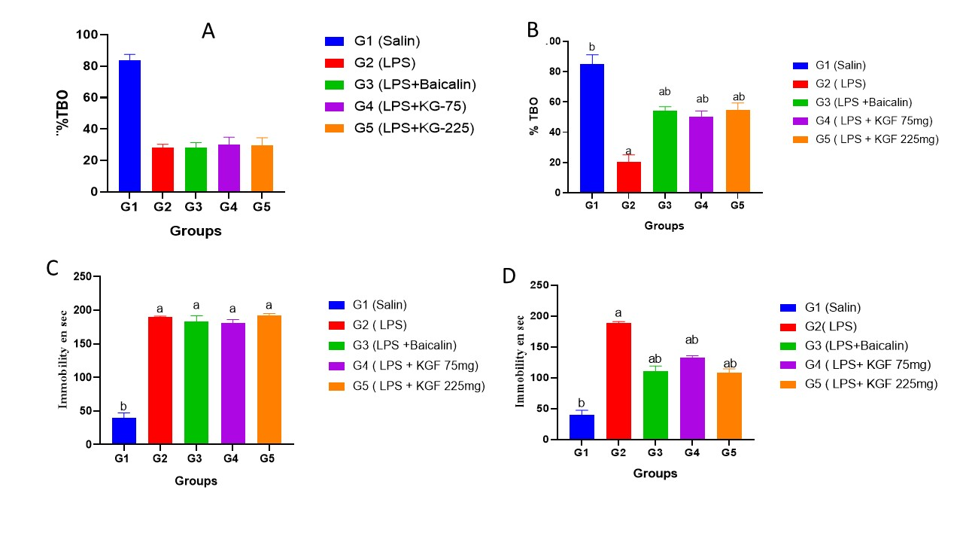

Figure 1: Effects of Khaya grandifoliola on anxiety and depressive behaviour of rats intoxicated with LPS. (A): effects of LPS on rats on early treatment, (B): effects of K. grandifoliola on rats treated with LPS. G1: rats treated only with food and water; G2: rats treated with LPS (1mg/kg); G3: rats treated with LPS (1mg/kg) + Baicalin; G4: LPS (1mg/kg) KGF 75mg; G5: LPS(1mg/kg) + KGF225mg; a= significant difference from G1 p< 0.05; b= significant difference from G2. The data for each bar is represented as a mean ± standard deviation, n = 5. (C): effects of LPS on rats on early treatment, (D): effects of K. grandifoliola on rats treated with LPS G1: rats treated only with food and water; G2: rats treated with LPS (1mg/kg); G3: rats treated with LPS (1mg/kg) + Baicalin; G4: LPS (1mg/kg) KGF 75mg; G5: LPS(1mg/kg) + KGF225mg; a= significant difference from G1 p< 0.05; b= significant difference from G2.
Effects of Khaya grandifoliola on the activity of ALAT, ASAT and serum creatinine levels

Analysis of liver enzymes showed that rats treated with KG exhibited reduced ALAT and ASAT activities compared to that of the positive control (LPS only/G2). However, the KG-F225 fraction has a better hepato-protective effect than the KG-75 fraction. Moreover, rats treated with KG also showed reduced activity in the creatinine level compared to that of the positive control (LPS treatment only).
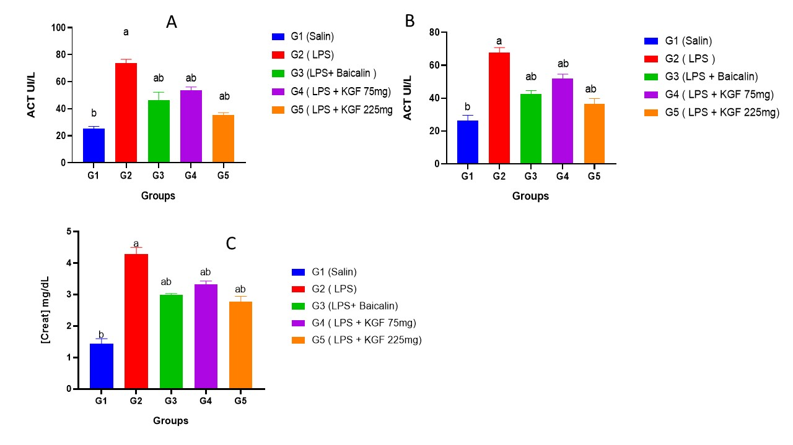

Figure 2: Effects of Khaya grandifoliola on the activity of ALT, AST and serum creatinine level.
(A and B): G1: rats treated only with food and water; G2: rats treated with LPS (1mg/kg); G3: rats treated with LPS (1mg/kg) + Baicalin; G4: LPS (1mg/kg) + KGF 75mg; G5: LPS+KGF225mg. (C) G1: rats treated only with food and water; G2: rats treated with LPS (1mg/kg); G3: rats treated with LPS (1mg/kg) + Baicalin; G4: LPS (1mg/kg) + KGF 75mg; G5: LPS+KGF225mg. (D) G1: rats treated only with food and water; G2: rats treated with LPS. a= significant difference from G1, p< 0.05; b= significant difference from G2. The data for each bar is represented as a mean ± standard deviation, n = 5.

Effects of Khaya grandifoliola on catalase activity and lipid peroxidation
Figure 3 shows that treatment with KG at both doses led to an increase in catalase activity compared to that of the positive control (Fig 3A). In addition, rats treated with KG showed a reduction in the concentration of MDA compared to that of the positive control (Fig 3B).

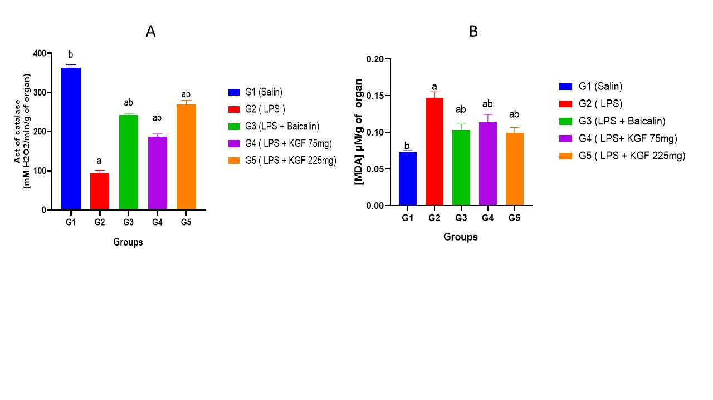

Figure 3: Effects of Khaya grandifoliola on catalase activity and lipid peroxidation

(A):G1: rats treated only with food and water; G2: rats treated with LPS (1mg/kg); G3: rats treated with LPS (1mg/kg) + Baicalin; G4: LPS (1mg/kg) + KGF 75mg; G5: LPS+KGF225mg. (B): (G1: rats treated only with water and food; G2: rats treated with LPS (1mg/kg); G3: rats treated with LPS (1mg/kg) + Baicalin; G4: LPS (1mg/kg) + KGF 75mg; G5: LPS+KGF225mg. a= significant difference from G1 p< 0.05; b= significant difference from G2.

Effects of Khaya grandifoliola on total protein and (GSH) levels
The amount of total protein was significantly reduced in the KG treated groups in comparison to the intoxicated group. However, the concentration of GSH increased significantly in the KG-treated groups in comparison to the LPS-intoxicated group.

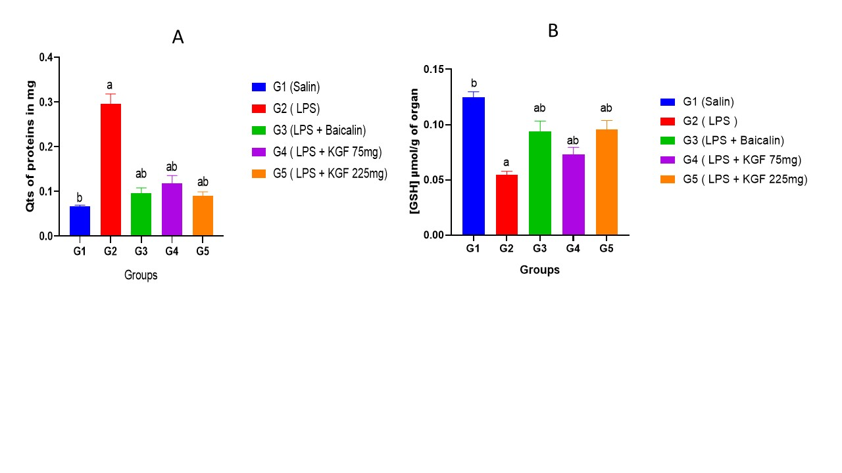

Figure 4: Effects of Khaya grandifoliola on total protein level and the amount of (GSH).
(A): (G1: rats treated only with water and food; G2: rats treated with LPS (1mg/kg); G3: rats treated with LPS (1mg/kg) + Baicalin; G4: LPS (1mg/kg) + KGF 75mg; G5: LPS+KGF225mg. (B): (G1: rats treated only with water and food; G2: rats treated with LPS (1mg/kg); G3: rats treated with LPS (1mg/kg) + Baicalin; G4: LPS (1mg/kg) + KGF 75mg; G5: LPS+KGF225mg.a= significant difference from G1 p< 0.05; b= significant difference from G2.
Effects of Khaya grandifoliola on nitric oxide concentration and acetylcholinesterase activity.
Figure 5A shows that the nitrite concentration decreased significantly in the KG-treated groups in comparison to the LPS-intoxicated group (Fig 5A). The activity of acetylcholinesterase was significantly reduced in the KG-treated groups in contrast to the intoxicated group (Fig 5B).
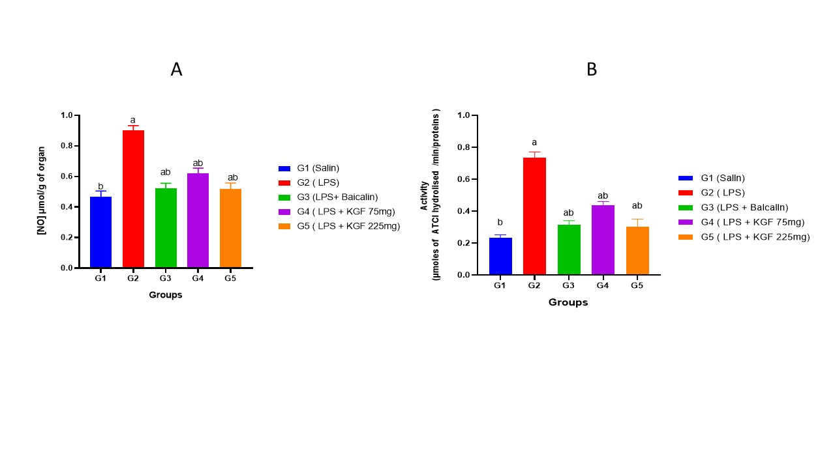

Figure 5: Effects of Khaya grandifoliola on nitric oxide concentration and on acetylcholinesterase activity.
(A):(G1: rats treated only with water and food; G2: rats treated with LPS (1mg/kg); G3: rats treated with LPS (1mg/kg) + Baicalin; G4: LPS (1mg/kg) + KGF 75mg; G5: (B): (G1: rats treated only with water and food; G2: rats treated with LPS (1mg/kg); G3: rats treated with LPS (1mg/kg) + Baicalin; G4: LPS (1mg/kg) + KGF 75mg; G5: LPS+KGF225mg. a= significant difference from G1 p< 0.05; b= significant difference from G2. The data for each bar is represented as a mean ± standard deviation, n = 5.
Effect of K grandifoliola on pro-inflammatory cytokines production
The production of pro-inflammatory cytokines IL1β and TNFα was quantified in all treatment groups. As shown in Fig 6A and B, cytokines levels in sera were significantly reduced in rats treated with KG at both concentrations (Group 4 and Group5) compared to LPS treated group (Group 2).

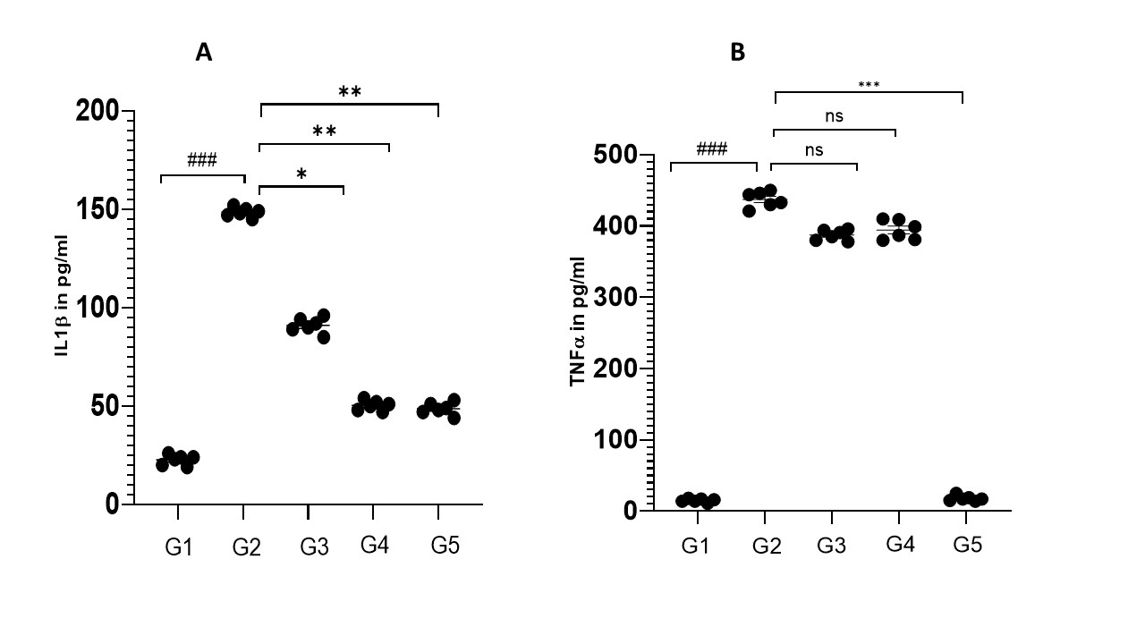

Figure 6:
Figure 6: Effect of KG on the production of pro-inflammatory cytokines. Different rat groups were treated as described in material and methods. Sera was prepared from rats and used for ELISA assay. (A) IL1β, (B) TNFα. Each dot represents the values for each animal of a group (n=5). *p<0.05, **p<0.05, ***p<0.05. ### comparison between control and LPS-treated group.

DISCUSSION
Exposure to infectious bacteria has been linked to the pathogenesis of neurodegenerative disorders, notably AD (Parra-Torres et al., 2023). LPS are known to be potent pro-inflammatory agents that can cross the BBB and initiate neuroinflammation in the brain (Skrzypczak-Wiercioch & Salat, 2022). Indeed, once in the body, they can trigger inflammatory processes that generate oxidative stress, known to be harmful to biological molecules such as DNA and proteins (Zhou et al., 2021). In this research work, our aim was to find new drugs from medicinal plants that can be used to prevent the toxicity induced by LPS on the brain. Several compounds from plants, notably for their wealth of bioactive compounds, have shown potential effects against AD, such as Baicalin, polyphenols, flavonoids, tannins and coumarins thanks to their antioxidant, anti-inflammatory, antidepressant properties and their potential of inhibition of acetylcholinesterase (Calderaro et al., 2022; Song et al., 2025; Zhao et al., 2019).
Khaya grandifoliola is a plant from the Meliaceae family containing bioactive compounds such as polyphenols, flavonoids, tannins and coumarins (Atangana Nkene et al., 2025). Recent scientific studies have highlighted their antioxidant and anti-inflammatory properties, two key mechanisms involved in the development of AD (Mukaila et al., 2021), confirming the antioxidant properties of KG and suggesting that it may help to scavenge harmful free radicals that can damage brain cells. (Owona et al., 2025) have highlighted the anti-inflammatory and antioxidant effects of KG which could help reduce chronic inflammation by inflammasome components inhibition in THP-1 cells. In order to measure the effect of the plant extract in vivo, we have explored the neuroprotective potential of its KG-75 mg/kg and KG-225 mg/kg fractions.
Firstly, we administered LPS at a dose of 1mg/kg for 6 days to mimic the symptoms of AD pathogenesis. Then, we conducted behavioral tests using the ANY- MAZE software. The effect of KG-75 mg and KG-225 mg fractions on anxiety and depression following exposure to LPS were assayed. Depression is a risk factor as well as a common symptom in AD. It is caused by overactive immune response in the brain, oxidative stress, reduced serotonin and acetylcholine activity. As far as anxiety is concerned, it is extremely common in AD, affecting up to 75% of patients. In our study, we observed that anxiety and depression were improved following treatment with KG at the two doses, a result that could be explained by the anti-inflammatory and antioxidant properties of the plant as it was the case with other plant extracts which have demonstrated antioxidant and anti-inflammatory effects with promising effects against AD.
Next, we analyzed the effect of these fractions (KG-F75 and KG-F225) on key biochemical markers of oxidative stress and inflammation. The fractions KG-75 and KG-225 have also shown modulation of the activity of catalase, glutathione, nitric oxide and Malondialdehyde, therefore conferring a protection against oxidative stress, a crucial factor in Alzheimer’s disease pathogenesis (Bai et al., 2022). Regarding liver and kidney toxicities, the fractions restored the ALAT, ASAT and creatinine levels in treated rats, suggesting that they were not toxic to the animals at the doses used. Indeed, many research papers from our laboratory have demonstrated the hepatoprotective effect of KG, which is in line with the results obtained in this study (Galani et al., 2016; Kouam et al., 2021).
The exposure of rats to 1 mg/kg LPS for 6 days induced significant neurotoxicity, evaluated by the reduction of their mobility and the impairment of their short-term memory. These results are consistent with previous studies that have demonstrated the neurotoxic effects of LPS on rats (Chen et al., 2020; Mosalam et al., 2024). The administration of KG-75 mg and KG-225 mg for 15 days after 6 days of LPS intoxication attenuated the neurotoxicity induced by LPS, confirming their neuroprotective properties.
Examination of the enzymatic activity of antioxidant enzymes showed that the KG-75 mg and KG-225 mg fractions significantly influenced enzyme activity. These fractions led to a notable increase in the activity of catalase and nitric oxide (NO) synthase. These observations indicate that the bioactive compounds in the plant could strengthen the antioxidant defense mechanisms of cells, thus offering protection against oxidative damage. Furthermore, the KG-75 mg and KG-225 mg fractions resulted in a substantial reduction in Malondialdehyde (MDA) levels, a key indicator of oxidative stress, while reducing total protein levels, suggesting beneficial effects on cell and tissue health. Furthermore, the decrease in nitrite levels, a metabolite of nitric oxide, indicates that bioactive compounds in plants could reduce the production of nitric oxide, a crucial aspect for neuroprotection and the regulation of vasodilation which is in line with the work of (Hagiwara & Matsushita, 2014; Jin et al., 2021; Moore et al., 2019).

Conclusion
In conclusion, the results of this study provide preliminary evidence for the neuroprotective effect of the KG-75 mg and KG-225 mg fractions of Khaya grandifoliola, which showed a neuroprotective effect against key enzymes of the antioxidant system and modulated their activities, improving the antioxidant defenses. In addition, they attenuated the LPS-induced neurotoxicity, improving cognitive performance in rats. These results suggest that these fractions could constitute promising candidates for the development of treatments against AD. Further research is needed to confirm the efficacy and safety of these in other animal models and investigate the molecular pathways involved.

Consent: It is not applicable.
Ethical approval: All experimental procedures were conducted in accordance with the guidelines of the National veterinary board rules for animal and human bioethics (BTC-JIRB2024-97).
Competing interests: Authors declare that no competing interest exists.
REFERENCES
Akingbade, G. T., Ijomone, O. M., Imam, A., Aschner, M., & Ajao, M. S. (2023). Correction to: D-Ribose-L-Cysteine Improves Glutathione Levels, Neuronal and Mitochondrial Ultrastructural Damage, Caspase-3 and GFAP Expressions Following Manganese-Induced Neurotoxicity. Neurotox Res, 41(6), 752-753. https://doi.org/10.1007/s12640-023-00665-0
Atangana Nkene, E. R., Kamsi, R. A. Y., Adjia, H. Z., Abe, M. T. O., Ngoupo, A. T., & Ndjaka, J. M. B. (2025). Comparative study of physico-chemical properties of some molecules from Khaya Grandifoliola plant. Sci Rep, 15(1), 10430. https://doi.org/10.1038/s41598-025-88302-y
Bai, R., Guo, J., Ye, X. Y., Xie, Y., & Xie, T. (2022). Oxidative stress: The core pathogenesis and mechanism of Alzheimer's disease. Ageing Res Rev, 77, 101619. https://doi.org/10.1016/j.arr.2022.101619
Brown, G. C., & Heneka, M. T. (2024). The endotoxin hypothesis of Alzheimer's disease. Mol Neurodegener, 19(1), 30. https://doi.org/10.1186/s13024-024-00722-y
Butterfield, D. A. (2002). Amyloid beta-peptide (1-42)-induced oxidative stress and neurotoxicity: implications for neurodegeneration in Alzheimer's disease brain. A review. Free Radic Res, 36(12), 1307-1313. https://doi.org/10.1080/1071576021000049890
Calderaro, A., Patane, G. T., Tellone, E., Barreca, D., Ficarra, S., Misiti, F., & Lagana, G. (2022). The Neuroprotective Potentiality of Flavonoids on Alzheimer's Disease. Int J Mol Sci, 23(23). https://doi.org/10.3390/ijms232314835
Chakkittukandiyil, A., Chakraborty, S., Kothandan, R., Rymbai, E., Muthu, S. K., Vasu, S., Sajini, D. V., Sugumar, D., Mohammad, Z. B., Jayaram, S., Rajagopal, K., Ramachandran, V., & Selvaraj, D. (2024). Side effects based network construction and drug repositioning of ropinirole as a potential molecule for Alzheimer's disease: an in-silico, in-vitro, and in-vivo study. J Biomol Struct Dyn, 42(20), 10785-10799. https://doi.org/10.1080/07391102.2023.2258968
Chen, C., Zhang, B. B., Hu, A. L., Li, H., Liu, J., & Zhang, F. (2020). Protective role of cinnabar and realgar in Hua-Feng-Dan against LPS plus rotenone-induced neurotoxicity and disturbance of gut microbiota in rats. J Ethnopharmacol, 247, 112299. https://doi.org/10.1016/j.jep.2019.112299
Dib, M., Garrel, C., Favier, A., Robin, V., & Desnuelle, C. (2002). Can malondialdehyde be used as a biological marker of progression in neurodegenerative disease? J Neurol, 249(4), 367-374. https://doi.org/10.1007/s004150200025
Erkkinen, M. G., Kim, M. O., & Geschwind, M. D. (2018). Clinical Neurology and Epidemiology of the Major Neurodegenerative Diseases. Cold Spring Harb Perspect Biol, 10(4). https://doi.org/10.1101/cshperspect.a033118
Galani, B. R., Sahuc, M. E., Sass, G., Njayou, F. N., Loscher, C., Mkounga, P., Deloison, G., Brodin, P., Rouille, Y., Tiegs, G., Seron, K., & Moundipa, P. F. (2016). Khaya grandifoliola C.DC: a potential source of active ingredients against hepatitis C virus in vitro. Arch Virol, 161(5), 1169-1181. https://doi.org/10.1007/s00705-016-2771-5
Hagiwara, M., & Matsushita, K. (2014). Epigallocatechin gallate suppresses LPS endocytosis and nitric oxide production by reducing Rab5-caveolin-1 interaction. Biomed Res, 35(2), 145-151. https://doi.org/10.2220/biomedres.35.145
Ionescu-Tucker, A., & Cotman, C. W. (2021). Emerging roles of oxidative stress in brain aging and Alzheimer's disease. Neurobiol Aging, 107, 86-95. https://doi.org/10.1016/j.neurobiolaging.2021.07.014
Jin, M. H., Chen, D. Q., Jin, Y. H., Han, Y. H., Sun, H. N., & Kwon, T. (2021). Hispidin inhibits LPS-induced nitric oxide production in BV-2 microglial cells via ROS-dependent MAPK signaling. Exp Ther Med, 22(3), 970. https://doi.org/10.3892/etm.2021.10402
Kesika, P., Suganthy, N., Sivamaruthi, B. S., & Chaiyasut, C. (2021). Role of gut-brain axis, gut microbial composition, and probiotic intervention in Alzheimer's disease. Life Sci, 264, 118627. https://doi.org/10.1016/j.lfs.2020.118627
Kouam, A. F., Njayou, F. N., Yuan, F., Oladejo, B. O., Hongtao, H., Mkounga, P., & Moundipa, P. F. (2021). Inhibitory activity of limonoids from Khaya grandifoliola C.DC (Meliaceae) against hepatitis C virus infection in vitro. Avicenna J Phytomed, 11(4), 353-366. https://doi.org/10.22038/AJP.2020.17215
Kouam, A. F., Yuan, F., Njayou, F. N., He, H., Tsayem, R. F., Oladejo, B. O., Song, F., Moundipa, P. F., & Gao, G. F. (2017). Induction of Mkp-1 and Nuclear Translocation of Nrf2 by Limonoids from Khaya grandifoliola C.DC Protect L-02 Hepatocytes against Acetaminophen-Induced Hepatotoxicity. Front Pharmacol, 8, 653. https://doi.org/10.3389/fphar.2017.00653
Mediesse, F. K., Boudjeko, T., Hasitha, A., Gangadhar, M., Mbacham, W. F., & Yogeeswari, P. (2018). Inhibition of lipopolysaccharide (LPS)-induced neuroinflammatory response by polysaccharide fractions of Khaya grandifoliola (C.D.C.) stem bark, Cryptolepis sanguinolenta (Lindl.) Schltr and Cymbopogon citratus Stapf leaves in raw 264.7 macrophages and U87 glioblastoma cells. BMC Complement Altern Med, 18(1), 86. https://doi.org/10.1186/s12906-018-2156-2
Meng, Y., Liu, X., Ding, D., Wang, J., Mao, J., Kang, L., & Cao, L. (2025). Rutin alleviates lipopolysaccharide-induced neuroinflammation and blood brain barrier dysfunction. Brain Res, 1866, 149941. https://doi.org/10.1016/j.brainres.2025.149941
Moore, K., Howard, L., Brownmiller, C., Gu, I., Lee, S. O., & Mauromoustakos, A. (2019). Inhibitory effects of cranberry polyphenol and volatile extracts on nitric oxide production in LPS activated RAW 264.7 macrophages. Food Funct, 10(11), 7091-7102. https://doi.org/10.1039/c9fo01500k
Mosalam, E. M., Elberri, A. I., Abdallah, M. S., Abdel-Bar, H. M., Zidan, A. A., Batakoushy, H. A., & Abo Mansour, H. E. (2024). Mechanistic Insights of Neuroprotective Efficacy of Verapamil-Loaded Carbon Quantum Dots against LPS-Induced Neurotoxicity in Rats. Int J Mol Sci, 25(14). https://doi.org/10.3390/ijms25147790
Mukaila, Y. O., Ajao, A. A., & Moteetee, A. N. (2021). Khaya grandifoliola C. DC. (Meliaceae: Sapindales): Ethnobotany, phytochemistry, pharmacological properties, and toxicology. J Ethnopharmacol, 278, 114253. https://doi.org/10.1016/j.jep.2021.114253
Nandi, A., Yan, L. J., Jana, C. K., & Das, N. (2019). Role of Catalase in Oxidative Stress- and Age-Associated Degenerative Diseases. Oxid Med Cell Longev, 2019, 9613090. https://doi.org/10.1155/2019/9613090
Njayou, F. N., Amougou, A. M., Fouemene Tsayem, R., Njikam Manjia, J., Rudraiah, S., Bradley, B., Manautou, J. E., & Fewou Moundipa, P. (2015). Antioxidant fractions of Khaya grandifoliola C.DC. and Entada africana Guill. et Perr. induce nuclear translocation of Nrf2 in HC-04 cells. Cell Stress Chaperones, 20(6), 991-1000. https://doi.org/10.1007/s12192-015-0628-6
Owona, B. A., Mary, A., Messi, A. N., Ravichandran, K. A., Mbing, J. N., Pegnyemb, E., Moundipa, P. F., & Heneka, M. T. (2025). Biflavonoid Methylchamaejasmin and Khaya grandifoliola Extract Inhibit NLRP3 Inflammasome in THP-1 Cell Model of Neuroinflammation. Mol Neurobiol, 62(2), 1605-1619. https://doi.org/10.1007/s12035-024-04365-4
Parra-Torres, V., Melgar-Rodriguez, S., Munoz-Manriquez, C., Sanhueza, B., Cafferata, E. A., Paula-Lima, A. C., & Diaz-Zuniga, J. (2023). Periodontal bacteria in the brain-Implication for Alzheimer's disease: A systematic review. Oral Dis, 29(1), 21-28. https://doi.org/10.1111/odi.14054
Peng, X., Luo, Z., He, S., Zhang, L., & Li, Y. (2021). Blood-Brain Barrier Disruption by Lipopolysaccharide and Sepsis-Associated Encephalopathy. Front Cell Infect Microbiol, 11, 768108. https://doi.org/10.3389/fcimb.2021.768108
Rosengarten, B., Paulsen, S., Burr, O., & Kaps, M. (2009). Neurovascular coupling in Alzheimer patients: effect of acetylcholine-esterase inhibitors. Neurobiol Aging, 30(12), 1918-1923. https://doi.org/10.1016/j.neurobiolaging.2008.02.017
Skrzypczak-Wiercioch, A., & Salat, K. (2022). Lipopolysaccharide-Induced Model of Neuroinflammation: Mechanisms of Action, Research Application and Future Directions for Its Use. Molecules, 27(17). https://doi.org/10.3390/molecules27175481
Song, Z. Y., Yu, W. J., Jin, Y. J., Zhou, M. F., He, C. X., Li, Z., He, J. W., Chen, Q., Li, P., Yi, Y., & Cheng, S. W. (2025). Baicalin alleviates pathological changes in Alzheimer's disease comorbid with type 2 diabetes: Targeting metabolic dysregulation and neuroinflammation. J Ethnopharmacol, 353(Pt A), 120352. https://doi.org/10.1016/j.jep.2025.120352
Wiger, C. W., Ranheim, T., Arnesen, H., Vaage, J., Pischke, S. E., Yndestad, A., Stenslokken, K. O., & Torp, M. K. (2025). TLR4 Inhibition Attenuated LPS-Induced Proinflammatory Signaling and Cytokine Release in Mouse Hearts and Cardiomyocytes. Immun Inflamm Dis, 13(1), e70133. https://doi.org/10.1002/iid3.70133
Zhao, S., Zhang, L., Yang, C., Li, Z., & Rong, S. (2019). Procyanidins and Alzheimer's Disease. Mol Neurobiol, 56(8), 5556-5567. https://doi.org/10.1007/s12035-019-1469-6
Zhou, L., Zhang, Y. F., Yang, F. H., Mao, H. Q., Chen, Z., & Zhang, L. (2021). Mitochondrial DNA leakage induces odontoblast inflammation via the cGAS-STING pathway. Cell Commun Signal, 19(1), 58. https://doi.org/10.1186/s12964-021-00738-7
Zhou, R., Yazdi, A. S., Menu, P., & Tschopp, J. (2011). A role for mitochondria in NLRP3 inflammasome activation. Nature, 469(7329), 221-225. https://doi.org/10.1038/nature09663
Zhu, Y., Guo, X., Li, S., Wu, Y., Zhu, F., Qin, C., Zhang, Q., & Yang, Y. (2024). Naringenin ameliorates amyloid-beta pathology and neuroinflammation in Alzheimer's disease. Commun Biol, 7(1), 912. https://doi.org/10.1038/s42003-024-06615-6

