Antagonistic activities of Trichoderma against pathogenic fungi of tomato in Senegal

ABSTRACT:
Soil-borne pathogens are a significant agent in the developing world's important losses of agricultural resources. Trichoderma spp. is biocontrol agents extensively used in the management of fungal diseases of crop plants exhibiting mycoparasitism against a wide range of plant pathogens. This work aims to assess the antagonistic potential of Trichoderma strains on two tomato pathogens: Fusarium oxysporum and Sclerotium rolfsii. Seven Trichoderma asperellum strains and one Trichoderma virens strains collected from Niayes zone of tomato ecosystem in Senegal were characterized for their antagonistic activity against Fusarium oxysporum and Sclerotium rolfsii. Dual culture technique and the sealing agar plate method were used to evaluate the inhibition percentage of pathogens by Trichoderma strains. All the antagonistic Trichoderma have shown the potential of parasitizing in vitro the growth of Sclerotium rolfsii and Fusarium oxysporum. For direct confrontation, Trichoderma strain TM1 showed the highest inhibition capacity of Fusarium (73,49 %) when the strain TN1 exhibited the highest performance (59,26%). For the indirect confrontation test, TG4 showed the maximum inhibition rate for Sclerotium (31,37 %) and TM1 for Fusarium (39,11%). The percentage of inhibition obtained in the confrontation test is greater than that of the indirect confrontation test. The strain of Fusarium oxysporum is more sensitive to different strains of Trichoderma than Sclerotium rolfsii.

Key Word: Trichoderma, biocontrol, Fusarium oxyporum, Sclerotium rolfsii, tomato

INTRODUCTION
Tomato occupies the second position of vegetables consumed in Senegal after onion (ANSD, 2015; Camara et al., 2013). It also plays an important socio-economic role for farmers in Senegal. Its production is important for providing currencies and job opportunities. Despite its significance, this sector is today very threatened. Local production does not cover the entire demand. The main constraints to increasing the tomato production including the poor quality of the seeds used, the low soil organic matter, and the inaccessibility of producers to organic fertilizers (PADEN, 2013), lack of storage warehouses isolation of several production areas (Ndiaye, 2021). In addition, the numerous problems linked to parasite pressure (Camara et al., 2013; Tendeng et al., 2022) and particularly the increase of fungal diseases which negatively impact yields.
Tomatoes are prone to two Fusarium diseases: classic Fusarium wilt caused by Fusarium oxysporum f. sp. lycopersici (Snyder and Hansen) and root and crown rot (Fusarium crown and root rot) caused by Fusarium oxysporum f. sp. radicis-lycopersici Jarvis and Shoemaker (Katan et al., 1997) which are among the most devastating tomato diseases in the world (Hanaa et al., 2011). Sclerotiniosis of tomatoes due to Sclerotium rolfsii Sacc. (Athela rolfsii) can cause damping-off of seedlings root and crown rot (Abada, 2003, Bolou et al., 2015) with very significant economic losses of up to 50% in some cases (Fidah, 1995).
These diseases are complex and difficult to combat because they are often initiated by injuries that facilitate the entry and progression of pathogenic fungi (Caron et al., 2006) and are preserved on soil in form as sclerotia (Bolou et al.,2015). This situation leads to an excessive use of synthetic pesticides by farmers with harmful effects on the environment, human health and useful microorganisms.
Thus, in a context where societal expectations on sustainable agriculture intended to reduce the use of pesticides, it is necessary to find new effective and respectful methods of the environment relies on the interactions between soil and microbiota. Biological control techniques based on the exploitation of the antagonistic potential of microorganisms could become a real and environmentally friendly alternative against fungal plant diseases (Karimi et al., 2016; Rabbee et al., 2019). To improve the biological control potential, Trichoderma spp. has shown promising results against antagonistic fungi (Hassan et al., 2017; Liu et al., 2022). Trichoderma species have been used in the biological control of various pathogenic fungi which cause significant damage in fruit, vegetables, greenhouse and ornamental crops (Hu et al., 2024; Sanchez et al., 2019). Although several bio fungicides based on Trichoderma formulations have been marketed over the decades, there is still an immense need to discover Trichoderma species with potential antimicrobial activities against a wide range of pathogens (Martinez et al., 2023). Our study is part of this framework and therefore sets out to assess the antagonistic potential of Trichoderma strains isolated from different sites in the Niayes area on two tomato pathogens: Fusarium oxysporum and Sclerotium rolfsii.

MATERIALS AND METHODS
2.1. Isolation of Trichoderma
Trichoderma strains used in this study was isolated from rhizosphere soil samples collected from the tomato fields of five different areas of Niaye zone, main area of horticulture production in Senegal: UCAD, Sangalkam, Gorome, Notto Gouye Diama and Mboro. Identification of Trichoderma isolates was based on culture characters as well as microscopic parameters (conidiophores branching, phialides shape and position, spore size and shape) (Nagamani et al., 2006). The pure cultures were stored in the refrigerator at 4°C for further studies. The best producers of enzyme were identified by 18S rRNA sequencing (MACROGEN, SOUTH KOREA). These sequences were deposited in gene bank (NCBI).
2.2 Isolation of Fusarium oxyporum and Sclerotium rolfsii
Fusarium and Sclerotium strains were isolated from samples of infected plants from the Sangalkam, experimental station of ISRA / CDH on tomato culture. The infected parts were cut into pieces about 0.5 cm. The fragments were washed with tap water and then disinfected superficially by soaking in a sodium hypochlorite solution (10%) for 3 minutes. Then they were rinsed with sterile distilled water (3 times) and dried on sterile filter paper. Once dried, the fragments are deposited in a PDA medium (Potato Dextrose Agar) at the rate of 4 fragments per Petri dish (Davet and Rouxel, 1997). The PDA medium is amended with streptomycin sulfate (200 mg / l) in order to prevent the proliferation of bacteria. The dishes were then incubated in the dark at 25 ° C for 2 to 4 days. Successive subcultures were carried out after the appearance of the mycelium in order to obtain pure isolates of Fusarium sp. and Sclerotium sp. The identification of the Fusarium and Sclerotium strains obtained was carried out by observation of the macroscopic and microscopic characteristics with the help of the determination key of Nagamani et al., (2006).
2.3. In vitro antagonistic activities of Trichoderma on Fusarium oxysporum and Sclerotium rolfsii
Two techniques were used. Dual culture technique and sealing agar plate method. The eight Trichoderma isolates used are: Trichoderma asperellum: TS1-KF737410.1, TS2-KU896306.1, TB2-KU896306.1, TN1-KY225658.1, TU1-KF737411.1, TG4-JN108925.1 and TM1-KX620957 .1 and the strain of Trichoderma virens TG1-KY225664.1. (Gueye, 2019).

2.3.1. Direct confrontation tests
Two explants of 8 mm diameter from the cultures of the two fungi were placed in Petri dishes containing 15 ml of PDA. Both pathogen and antagonists were grown on sterilized PDA plates separately for 5 days. Mycelial disk of 5 mm in diameter of antagonist was excised from the edge of an actively growing 5 days old culture plate and inoculated opposite to the pathogenic fungi in the same plate 1cm away from the edge inoculated similarly. In the control plates, PDA plugs were used against the pathogen instead of the antagonist. Three repetitions were selected for each test. The dishes were incubated at 28 °C for 6 days.
2.3.2. Indirect confrontation tests
An explant of 8mm in diameter taken from the colonies of Trichoderma and strains of pathogens (Fusarium or Sclerotium) was deposited in the center of each Petri dish containing the PDA medium following the method described by Dennis and Webster (1971). Trichoderma was inoculated in the center of the petri plates containing solidified sterilized PDA medium by placing 6 mm disc (5 days old culture) cut from the margin of the actively growing region of Trichoderma sp. and incubated for 2 days at 28 °C. After that the top lid of each petri plate was replaced with bottom part of another petri plate with same size containing PDA medium, duly inoculated with a 6mm mycelial disc of the test pathogen. The pairs of each plate were sealed with parafilm (adhesive tape) and incubated at 28 °C. The PDA medium without Trichoderma isolate in the bottom part of petri plate with respective test pathogen on the upper lid of plate served as control. Three replicates were maintained for each treatment and incubated at 28 °C. This assemble was opened after 7 days and the observations were recorded.

2.2.3. Measured parameters
The mycelial growth of pathogens was determined after 6 days of incubation by measuring the diameter of the mycelium of the pathogenic fungus using a graduated ruler.
Then, in the two antagonism tests, inhibition exerted by Trichoderma was calculated by the percentage inhibition of mycelial growth using the following formula (Hmouni et al., 1996):
I (%) = (1- Dn / Do) x 100
Dn: mean diameter of pathogen colonies in the presence of the antagonist
Do: mean diameter of the control colonies.
2.3.4. Statistical analysis
Statistical procedures were conducted using Xlstat 2016 version 4.07 addinsoft. Data were submitted to an analysis of variance (ANOVA). Significantly different means were noted using the Newman Keuls test at 5% probability level.
- RESULTS
  - Morphological aspects of Fusarium oxysporum and Sclerotium rolfsii
Fusarium oxysporum isolates have a white aerial mycelium colored purple, the reverse being intense purple (Figure 1a). They produce spindle-shaped to kidney-shaped macroconidia and microconidia with 0 to 2 septa. The macroconidia are slightly arched, presenting 3 septa, basal pedicelled cell, apical hooked cell, produced by phialides on branched conidiophores or in sporodochia.
Sclerotium rolfsii isolates have a dense whitish mycelium. Sclerotia of smooth, rather spherical structures (1 to 3 mm in diameter) first white, then light brown to red brown with an appearance comparable to that of mustard seeds form within the mycelium 5 to 7 days after transplanting (Figure 1b). Microscopically, hyphae of 5 to 9 microns in diameter are observed. These hyphae of the main branch are hyaline (colorless) and thin-walled with transverse walls and infrequent connections.
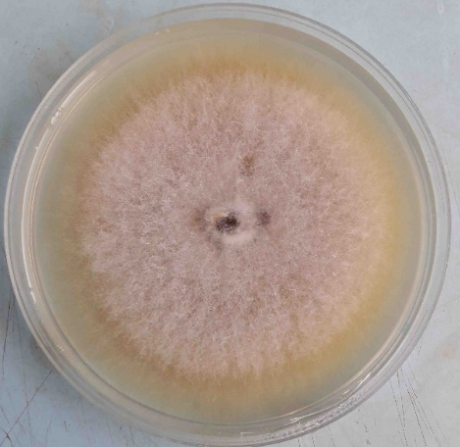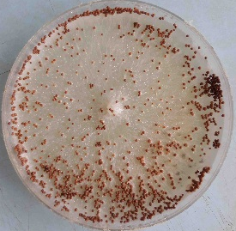
b
a
Figure 1: Aspect of Fusarium oxyporum (a) and Sclerotium rolfsii (b) on PDA medium

  - Direct confrontation tests
The results exhibited that the mycelial growth of the strains witnesses are more important than that obtained with the different confrontations (Table 1). After 6 days of incubation, an inhibitory action significantly exerted by the different strains of Trichoderma toward the mycelial growth of pathogens.
- Direct confrontation between Trichoderma-Sclerotium
The direct confrontation test between the isolates of S. rolfsii (SR1) and Trichoderma revealed the significant mycelial growth between treatments. The control (SR1 alone) showed twice as much mycelial growth as the treatments combining Trichoderma and SR1. The direct confrontation with the Trichoderma TB2 strain that the isolate SR1 showed a greater mycelial growth (4.13 cm). The lowest growth of SR1 was obtained with the TN1 strain (3.43 cm). The percentage inhibition ranging from 51.07% to 59.26%. The highest inhibition (59.26%) was observed in the isolates TU1, followed by TG4 and TM1 respectively (Table 1). The TG1, TB2 and TS2 strains have the lowest inhibition percentages not exceeding 55% with values ​​of 52.63%, 51.07% and 53.80% respectively.
- Direct confrontation between Trichoderma-Fusarium
The test of direct confrontation between Trichoderma and F. oxysporum (FO1), also reveals a greater mycelial growth in the control (7.67 cm) twice higher than that of the other treatments. When confronted directly with TS2, the isolate FO1 exhibited the greatest mycelial growth (3.00 cm). TM1 strain has a higher inhibition capacity (73.49%) followed respectively by the isolates TS1 (70.45%) and TN1 (70.01%). These three isolates more than 70% inhibited the FO1 strain. The TS2 and TB2 strains have the weakest inhibitory capacities. It should be noted that all Trichoderma isolates inhibited more than 60% of FO1.
Table 1: Direct confrontation between Trichoderma strains and pathogenic strains (Fusarium oxyporum and Sclerotium rolfsii)
Trichoderma strains | Pathogens
Trichoderma strains | Sclerotium rolfsii (SR1) |  | Fusarium oxysporum (FO1)
Trichoderma strains | Mycelial growth (cm) | Inhibition (%) | Mycelial growth (cm) | Inhibition (%)
TB2 | 4,13b | 51,07c | 2,97b | 61,32b
TG1 | 4,00bc | 52,63bc | 2,73bc | 64,36ab
TS2 | 3,90bc | 53,80abc | 3,00b | 60,89b
TS1 | 3,83cd | 54,58abc | 2,27bc | 70,45ab
TM1 | 3,60de | 57,31ab | 2,03c | 73,49a
TG4 | 3,57de | 57,70ab | 2,47bc | 67,84ab
TU1 | 3,53e | 58,09ab | 2,53bc | 66,97ab
TN1 | 3,43e | 59,26a | 2,30bc | 70,01ab
Control | 8,50a | - | 7,67a | -
The means that share the same letters within a group in each column are not significantly by Fischer LSD test (P=.05).

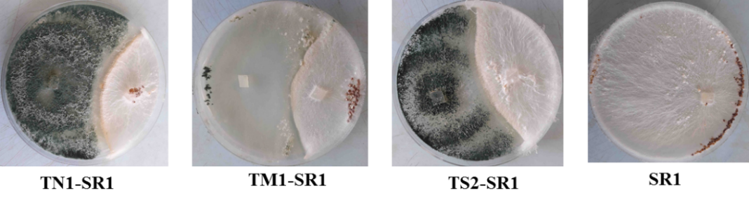
Plate 1 : direct confrontation test Trichoderma-Sclerotium rolfsii (SR1)

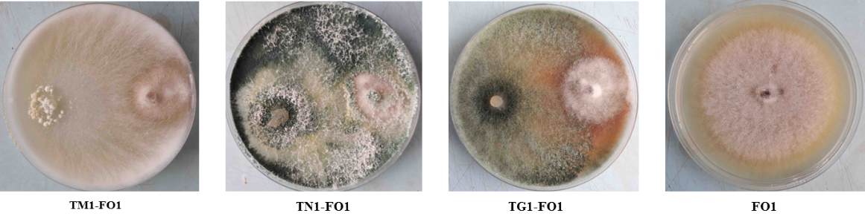
Plate 2: direct confrontation test Trichoderma-Fusarium oxysporum (FO1)

  - Indirect confrontation tests (distance)
Indirect confrontation test (Table 2) shows a slowdown in the growth of the Fusarium and Sclerotium strains exerted by Trichoderma compared to the control. Unlike the direct confrontation test, the inhibition of the mycelial growth of pathogens is less important than for the remote confrontation test.
- Indirect confrontation Trichoderma-Sclerotium
Mycelial growth of the control strains is greater than that in the presence of Trichoderma. With the TM1 strain, the isolate FO1 showed the weakest growth (4.57 cm) in indirect confrontation. Regarding the calculation of the percentage inhibition, a significant difference was noted between the different treatments. The TM1 strain (39.11%) with the highest percentage of inhibition is followed respectively by the TN1 (30.67%) and TU1 (30.22%) strains with a percentage of inhibition which revolves around 30 % (Table 2). None of the Trichoderma strains inhibited the FO1 strain by more than 50% during the indirect confrontation test.
- Indirect confrontation Trichoderma-Fusarium
In an indirect comparison between the isolates of Trichoderma and Fusarium oxysporum (FO1), the results obtained show that the mycelial growth of the control strains is greater than that in the presence of Trichoderma. With the TM1 strain, the isolate FO1 shows the weakest growth (4.57 cm) in indirect confrontation. Regarding the calculation of the percentage inhibition, a significant difference was noted between the different treatments. The TM1 strain (39.11%) with the highest percentage of inhibition is followed respectively by the TN1 (30.67%) and TU1 (30.22%) strains with a percentage of inhibition which revolves around 30 % (Table 2). None of the Trichoderma strains inhibited the FO1 strain by more than 50% during the indirect confrontation test.

Table 2: Distance comparison between Trichoderma strain and pathogens
Trichoderma strains | Pathogènes
Trichoderma strains | Sclerotium rolfsii (SR1) |  | Fusarium oxysporum (FO1)
Trichoderma strains | Mycelial growth (cm) | Inhibition (%) | Mycelial growth (cm) | Inhibition (%)
TN1 | 7,33b | 13,73c | 5,20cd | 30,67b
TG1 | 7,07b | 16,86bc | 5,93b | 20,89d
TS1 | 7,00b | 17,65bc | 5,50bc | 26,67bc
TB2 | 6,80b | 20,00bc | 5,77bc | 23,11cd
TS2 | 6,67b | 21,57b | 5,67bc | 24,44cd
TU1 | 6,63b | 21,96b | 5,23cd | 30,22b
TM1 | 5,97c | 29,80a | 4,57d | 39,11a
TG4 | 5,83c | 31,37a | 5,40bc | 28,00bc
Témoin | 8,50a | - | 7,50a | -
The means that share the same letters within a group in each column are not significantly by Fischer LSD test (P=.05).
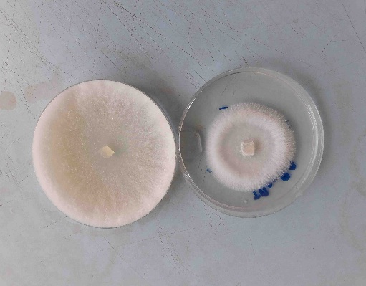
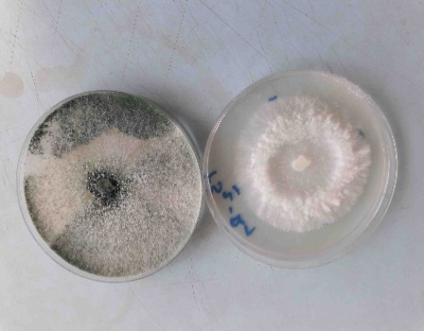
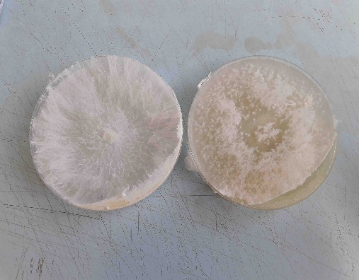
TM1-SR1
TS2-SR1
SR1

Plate 3 : indirect confrontation test Trichoderma sp. - S. rolfsii (SR1)
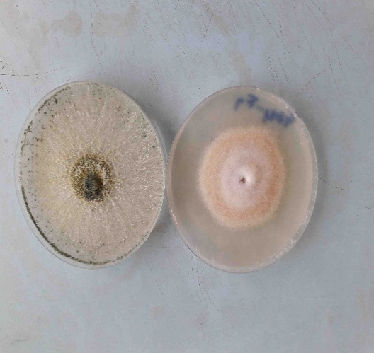
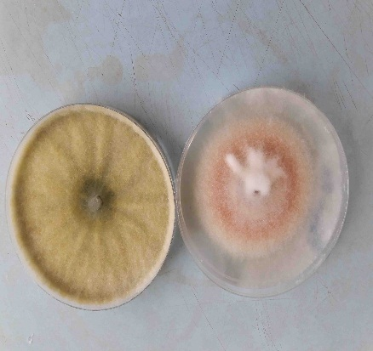
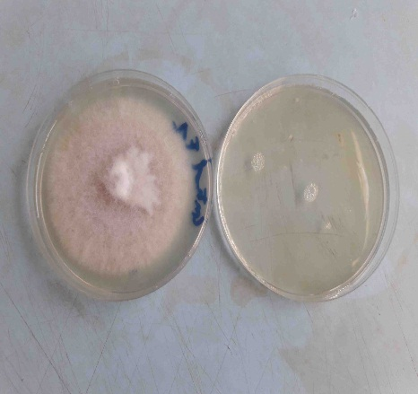
TN1-FO1
TG1-FO1
FO1

Plate 4 : indirecte confrontation test Trichoderma sp.-F. oxysporum (FO1)
Direct confrontation test allowed a greater inhibition of the mycelial growth of pathogens than the remote confrontation test. Trichoderma TM1, TN1, TS1, TG4 and TU1 strains performed best for both antagonist tests.
- DISCUSSION
The morphological characteristics (macroscopic and microscopic) observed confirm the characteristics of the Fusarium oxysporum (Roquebert, 1998) and Sclerotium rolfsii (Nagamani et al.,2006).
Direct and indirect confrontation tests have shown the ability of Trichoderma to inhibit the development of Fusarium oxyporum (FO1) and Sclerotium rolfsii (SR1). This inhibition capacity varies depending on the strains of Trichoderma and the pathogen present. The results showed that greater inhibition capacity on Fusarium oxysporum than on Sclerotium rolfsii during the various antagonism tests.
Many previous studies have shown the antagonistic effect of Trichoderma species against several pathogens with percentages of inhibition varying from one strain to another (Sanchez et al. 2019; Zhang et al., 2022; Chen et al., 2021).
In accordance with our results, Pakkala and Harison, (2018) showed a percentage of inhibition that varies between 45 and 70% during direct confrontation tests and 30 to 50% for the indirect confrontation test between Trichoderma viride and Fusarium oxysporum. Hasan and Nada (2016) showed mycelial growth inhibition of Alternaria alternata and Fusarium semitectum with averages of up to 69.23 and 64% respectively by Trichoderma asperellum strains. The results of Amin et al., (2010) showed volatile activity of the isolates of Trichoderma spp. against different fungal phytopathogens and obtained similar results with an mycelial growth inhibition of 41.8% for Fusarium oxysporum, 40.68% for Sclerotium rolfsii and 30.58% for Rhizoctonia solani. Using different isolates of Trichoderma harzanium and Trichoderma viride, Rehman et al., (2013) and Cherkupally et al., (2017) obtained higher percentages of inhibition which hover around 80% in direct confrontation with different species. of Fusarium oxyporum. In contrast other studies obtained lower inhibition percentages of Trichoderma against Fusarium oxyporum isolates (less than 60%) (Bardia and Rai, (2007).
This inhibition observed during antagonism tests that highlight several mechanisms including: mycoparasitism (Howell, 2003), competition for space and nutrients (Elad et al., 1999), antibiosis (Howell, 1998), inactivation of the pathogen's enzymes (Roco and Perez, 2001), secretion of certain non-volatile antibiotics diffusible by the Trichoderma species (Hajieghrari et al., 2008) and / or the secretion of the cell wall of the enzymes degrading (Harman et al., 2004)
For mycoparasitism, Trichoderma directly attacks the phytopathogen by excreting lytic enzymes, such as chitinases, β-1,3 glucanases and proteases (Haran et al., 1996). The skeletons of the cell walls of fungal pathogens contain chitin, glucan and proteins. Interestingly the enzymes that hydrolyze these components must be present in an effective antagonist so that they play an important role in the lysis of the cell wall of the pathogen (Carsolio et al., 1999).
The phenomenon of competition is manifested by a significant and very rapid growth of Trichoderma which allows them to quickly colonize the culture medium and to mobilize all the nutrients for their benefit (Davet, 1996). This phenomenon considerably reduces the growth of the pathogen. This finding supports the ability of Trichoderma to produce antibiotics preventing the growth of pathogens. This explains the presence of inhibition zones and the stopping of the growth of Fusarium and Sclerotium strains.
This confirm earlier results that the inhibitory action observed with distance confrontation tests is due to substances of a chemical nature released by the strains of Trichoderma (antibiotic phenomenon) (Davet 1983a and 1983b). The ability to produce such substances varies according to isolates of the same or different species. As emphasized Vey et al., (2001) and Bhagat et al., (2014) who reported that large varieties of volatile secondary metabolites produced by Trichoderma, such as ethylene, hydrogen cyanide, aldehydes and ketones, play an important role in the control of phytopathogenic agents.
- CONCLUSION
The antagonistic effect of the isolates of Trichoderma against Fusarium oxysporum and Sclerotium rolfsii has been shown. Indeed, direct and indirect confrontation tests revealed an inhibition of the mycelial growth of the two pathogens. For the direct confrontation test, significant growth inhibition ranging from 60.89% to 73.49% for Fusarium and 51.07% to 59.26% for Sclerotium was obtained. A decrease in the percentage of inhibition was noted during the indirect confrontation test with lower inhibition values between 20.89 and 39.11% for Fusarium and 13.73 to 31.37% for Sclerotium. Field trials are required to confirm these results and to propose these strains as biological control agents against fungal pathogens in vegetable crops in Senegal.

REFERENCES
Abada, K. A. (1994). Fungi causing damping-off and root-rot on sugar-beet and their biological control with Trichoderma harzianum. Agriculture, Ecosystems & Environment. https://doi.org/10.1016/0167-8809(94)90144-9
Amin, F., Razdan, V. K., Mohiddin, F. A., Bhatt, K. A., & Sheikh, P. A. (2010). Effect of volatile metabolites of Trichoderma species against seven fungal plant pathogens in-vitro. Journal of Phytology, 2(10), 34–37. https://updatepublishing.com/journal/index.php/jp/article/view/2178/2156
Agence Nationale de la Statistique et de la Démographie. (2015). *Bulletin Mensuel des Statistiques Economiques et Financières – Avril 2015*. Dakar, Senegal: Agence Nationale de la Statistique et de la Démographie. https://www.ansd.sn/publications/
Hassan AA, Kalboush ZA, Saleh MM. (2017). Efficacy of Trichoderma spp as Biocontrol Agents against Rice Brown Spot Disease and Biochemical Approaches. J. PlantProt. and Path 8(12), 677–686. DOI : 10.21608/jppp.2017.46961
Bardia, P. K., & Rai, P. K. (2007). In vitro and field evaluation of biocontrol agents and fungicides against wilt of cumin caused by Fusarium oxysporum f. sp. cumini. Journal of Spices and Aromatic Crops, 16(2), 88-92. https://updatepublishing.com/journal/index.php/josac/article/view/4877
Bhagat, S. B. A., Kumar, R., Yadav, M. S., & Chattopadhyay, C. (2014). Plant disease management: Prospects of pesticides of plant origin. In D. Singh (Ed.), Advances in Plant Biopesticides (pp. 119-129). Springer India. https://doi.org/10.1007/978-81-322-2006-0_7
Antoine, B. B. B., Hilaire, K. T., Koffi, K. G., Fernand, K., Seydou, T., Mamadou, C., Bomisso, L., & Daouda, K. (2015). Inhibition of Sclerotium rolfsii Sacc. (Corticiaceae), the causal agent of tomato (Solanaceae) stem collar rot, by Xylopia aethiopica (Dunal) A. Rich (Annonaceae) and Trichoderma sp. European Scientific Journal, 11(12), 61–85. https://eujournal.org/index.php/esj/article/view/5464
Camara, M., Mbaye, A. A., Samba, S. A. N., Gueye, T., Noba, K., Diao, S., & Cilas, C. (2013). Etude de la productivité et de la sensibilité de diverses variétés de tomate (Lycopersicon esculentum Mill) à la virose du jaunissement et de l'enroulement en cuillère des feuilles au Sénégal. International Journal of Biological and Chemical Sciences, 7(6), 2504-2512. https://doi.org/10.4314/ijbcs.v7i6.25
Caron J, Laverdière J, Venne J, Bélanger RR. (2006). Research and development of biopesticides and natural pesticides with low toxicity for non-target organisms and environmentally friendly – Final report – Phytopathology section. Québec, Canada : Ministère du Développement durable, de l’Environnement et des Parcs (MDDEP), Université Laval. 143 pages.
Carsolio, C., Benhamou, N., Haran, S., Cortés, C., Gutiérrez, A., Chet, I., & Herrera-Estrella, A. (1999). Role of the Trichoderma harzianum endochitinase gene, ech42, in mycoparasitism. Applied and Environmental Microbiology, 65(3), 929-935. https://doi.org/10.1128/AEM.65.3.929-935.1999
Chen, J., Zhou, L., Din, I. U., Arafat, Y., Li, Q., Wang, J., Wu, T., Wu, L., Wu, H., Qin, X., Pokhrel, G. R., Lin, S., & Lin, W. (2021). Antagonistic Activity of Trichoderma spp. Against Fusarium oxysporum in Rhizosphere of Radix pseudostellariae Triggers the Expression of Host Defense Genes and Improves Its Growth Under Long-Term Monoculture System. Frontiers in Microbiology, 12, 579920. https://doi.org/10.3389/fmicb.2021.579920
Cherkupally, R., Amballa, H., & Reddy, B. N. (2017). In vitro antagonistic activity of Trichoderma species against Fusarium oxysporum f. sp. Melongenae. International Journal of Applied Agricultural Research, 12(1), 87-95. https://www.ripublication.com/ijaar17/ijaarv12n1_10.pdf
Davet P. (1983a). Introduction and Persistence of Trichoderma in Soil. In : Microbial Antagonists – Mode of Action and Application in the Biological Control of Plant Diseases, ACTA, INRA-ENSAM Montpellier (France). 159–168
Davet P. (1983b). Trichoderma as an example of fungal antagonists of pathogenic agents. In Faune et flore auxiliaire en agriculture. ACTA, INRA-ENSAM Montpellier (France). 193–204.
Davet, P. (1996). Vie microbienne du sol et production végétale. INRA Editions. https://hal.inrae.fr/hal-02841361
Davet, P., & Rouxel, F. (2000). Detection and Isolation of Soil Fungi. INRA Science Publishers.
Dennis, C., & Webster, J. (1971). Antagonistic properties of species-groups of Trichoderma: I. Production of non-volatile antibiotics. Transactions of The British Mycological Society, 57, 25-30. https://doi.org/10.1016/S0007-1536(71)80077-3
Elad Y, David DR, Levi T, Kapat A, Kirshner B. (1999). Trichoderma harzianum T-39-mechanisms of biocontrol of foliar pathogens. In: Modern fungicides and antifungal compounds II. Eds. H. Lyr, P.E. Russell, H.W. Dehne, and H.D. Sisler). Andover, Hants, UK: Intercept. pp. 459-467.
Fidah A. (1995). Sugar Beet Rot Caused by Sclerotium rolfsii in the Doukkala Region: Epidemiology and Control Trials. Third Cycle Thesis, Faculty of Sciences Semlalia, Marrakech, Morocco, p123.
Guèye N. (2020). Characterization of indigenous Trichoderma spp. and evaluation of their antagonistic potential against two tomato (Solanum lycopersicum L.) pathogens in Senegal : Fusarium oxysporum and Sclerotium rolfsii. PhD Thesis, Cheikh Anta DIOP University, Faculty of Sciences, Dakar, p183.
Hajieghrari, B., Torabi-Giglou, M., Mohammadi, M. R., & Davari, M. (2008). Biological potantial of some Iranian Trichoderma isolates in the control of soil borne plant pathogenic fungi. African Journal of Biotechnology, 7(8), 967-972. https://doi.org/10.5897/AJB07.709
Hanaa, R. M. F., Abdou, Z. A., Salama, D. A., Ibrahim, M. A. R., & Sror, H. A. M. (2011). Effect of neem and willow aqueous extracts on fusarium wilt disease in tomato seedlings: Induction of antioxidant defensive enzymes. Annals of Agricultural Sciences, 56(1), 1–7. https://doi.org/10.1016/j.aoas.2011.05.007
Haran, S., Schickler, H., & Chet, I. (1996). Molecular mechanisms of lytic enzymes involved in the biocontrol activity of Trichoderma harzianum. *Microbiology*, *142*(9), 2321-2331. https://doi.org/10.1099/00221287-142-9-2321
Hassan GM, Nada HF. (2016). In vitro Assessment of Trichoderma asperellum Isolated from plant rhizosphere and evaluation of their potential activity against some pathogenic fungi. Egypt. J. Genet. Cytol., 45 : 113-128. DOI : 10.21608/ejgc.2016.9701
Hassan, A. A., Kalboush, Z. A., & Saleh, M. S. (2017). Efficacy of Trichoderma spp as Biocontrol Agents against Rice Brown Spot Disease and Biochemical Approaches. Journal of Plant Protection and Pathology, Mansoura University, 8(12), 677–686. https://jppp.journals.ekb.eg/article_46961_b59b381b450bef1b407f98445ceacf02.pdf
Hmouni, A., Hajlaoui, M. R., & Mlaiki, A. (1996). Résistance de Botrytis cinerea aux benzimidazoles et aux dicarboximides dans les cultures abritées de tomate en Tunisie. OEPP/EPPO Bulletin, 26, 697-705. https://doi.org/10.1111/j.1365-2338.1996.tb01513.x
Howell, C. R. (2003). Mechanisms employed by Trichoderma species in the biological control of plant diseases: The history and evolution of current concepts. Plant Disease, 87(1), 4–10. https://doi.org/10.1094/PDIS.2003.87.1.4
Howell, C. R. (1998). The role of antibiosis in biocontrol. In G. E. Harman & C. P. Kubicek (Eds.), *Trichoderma and Gliocladium: Enzymes, Biological Control and Commercial Applications* (Vol. 2, pp. 173–183). Taylor and Francis Ltd. https://www.routledge.com/Trichoderma-And-Gliocladium-Volume-2-Enzymes-Biological-Control-and/Harman-Kubicek/p/book/9781482267945
Hu, X., Shi, H., Zhang, Z., & Bai, C. (2024). Antifungal effects of volatile organic compounds produced by Trichoderma hamatum against Neocosmospora solani. Letters in Applied Microbiology, 77(7). https://doi.org/10.1093/lambio/ovae063
Karimi, E., Safaie, N., Shams-Baksh, M., & Mahmoudi, B. (2016). Bacillus amyloliquefaciens SB14 from rhizosphere alleviates Rhizoctonia damping-off disease on sugar beet. Microbiological Research, 192, 221-230. https://doi.org/10.1016/j.micres.2016.06.011
Katan, T., Shlevin, E., & Katan, J. (1997). Sporulation of Fusarium oxysporum f. sp. lycopersici on stem surfaces of tomato plants and aerial dissemination of inoculum. Phytopathology, 87(7), 712-719. https://doi.org/10.1094/PHYTO.1997.87.7.712
Liu, Y., He, P., He, P., Munir, S., Ahmed, A., Wu, Y., Yang, Y., Lu, J., Wang, J., Yang, J., Pan, X., Tian, Y., & He, Y. (2022). Potential biocontrol efficiency of Trichoderma species against oomycete pathogens. Frontiers in Microbiology, 13. https://doi.org/10.3389/fmicb.2022.974024
Lorito, M., Hayes, C. K., Di Pietro, A., Woo, S. L., & Harman, G. E. (1994). Purification, characterization, and synergistic activity of a glucan 1,3-beta-glucosidase and an N-acetyl-beta-glucosaminidase from Trichoderma harzianum. Phytopathology, 84, 398–405. https://doi.org/10.1094/Phyto-84-398
Martínez, Y., Ribera, J., Schwarze, F. W. M. R., & De France, K. (2023). Biotechnological development of Trichoderma-based formulations for biological control. Applied Microbiology and Biotechnology, 107, 5595–5612. https://doi.org/10.1007/s00253-023-12687-x
Nagamani, A., Kunwar, I. K., & Manoharachary, C. (2006). Handbook of soil fungi. I. K. International Private Limited. https://catalog.cnr.edu.bt/cgi-bin/koha/opac-detail.pl?biblionumber=4404
Ndiaye, P. Y. (2021). *Diagnostic des contraintes du maraîchage dans la zone humide des Niayes : cas de la commune de Ndiébéne Gandiol* [Master's thesis, Université Assane Seck de Ziguinchor]. https://rivieresdusud.uasz.sn/handle/123456789/1366
PADEN. (2013). Studies of Horticultural Value Chains, Final Report, Ministry of Agriculture and Rural Equipment, Niayes Economic Development and Planning Program, Soned-Afrique Report. 54 pages.
Pakkala, A., & Harison, M. (2018). In vitro Antagonism of Trichoderma viride against Fusarium oxysporum strains. Journal of Pharmacognosy and Phytochemistry, 7(2), 2816-2819. https://www.phytojournal.com/archives/2018/vol7issue2/PartAN/7-2-407-792.pdf
Rabbee, M. F., Ali, M. S., Choi, J., Hwang, B. S., Jeong, S. C., & Baek, K. H. (2019). Bacillus velezensis: A valuable member of bioactive molecules within plant microbiomes. Molecules, 24(6), 1046. https://doi.org/10.3390/molecules24061046
Rehman, S. U., Dar, W. A., Ganie, S. A., Bhat, J. A., Mir, G. H., Lawrence, R., Narayan, S., & Singh, P. K. (2013). Comparative efficacy of Trichoderma viride and Trichoderma harzianum against Fusarium oxysporum f sp. ciceris causing wilt of chickpea. African Journal of Microbiology Research, 7(50), 5731-5736. https://doi.org/10.5897/AJMR2013.6442
Roco, A., & Pérez, L. M. (2001). In vitro biocontrol activity of Trichoderma harzianum on Alternaria alternata in the presence of growth regulators. Electronic Journal of Biotechnology. https://doi.org/10.2225/vol4-issue2-fulltext-1
Roquebert MF. (1998). Taxonomy of Molds : Culture Methods and Observation Techniques ; Identification. In : Molds in Low-Moisture Foods. Tec & Doc Edition. pp. 39–95.
Sanchez, A. D., Ousset, M. J., & Sosa, M. C. (2019). Biological control of Phytophthora collar rot of pear using regional Trichoderma strains with multiple mechanisms. Biological Control. https://doi.org/10.1016/j.biocontrol.2019.05.012
Tendeng, E., Labou, B., Sylla, E. H. S., Baldé, A., Diatte, M., Seydi, O., Ndiaye, I. A., Diop, P., Sène, S. O., Diarra, K., & Djiba, S. (2022). Diversité et Occurrence des Ravageurs dans les Agroécosystèmes Maraîchers en Basse Casamance, Sénégal. European Scientific Journal, ESJ, 18(27), 104. https://doi.org/10.19044/esj.2022.v18n27p104
Vey, A., Hoagland, R. E., & Butt, T. M. (2001). Toxic metabolites of fungal biocontrol agents. In T. M. Butt, C. Jackson, & N. Magan (Eds.), Fungi as biocontrol agents: Progress, problems and potential (pp. 311-346). CABI. https://doi.org/10.1079/9780851993560.0000
Zhang, S., Xiang, D., Sun, C., Han, K., Li, T., Zhou, J., Xu, B. (2022). Morphological and Molecular Identification of Peach Brown Rot Disease in Tibet and Exploration of the Biocontrol Efficiency of Trichoderma. J. Fungi. https://doi.org/10.3390/jof8111174

