Why Smart Irrigation Alone Will Not Be Enough to Fight Hunger and Food Insecurity in Nigeria
Change the title as suggested.
ABSTRACT
By the end of 2025, Nigeria is experiencing its worst food crisis in several decades. It is projected that 34.7 million Nigerians will be suffering from acute food insecurity in 2026, while food inflation is above 34 percent, with 129 million Nigerians living below the poverty line. Technologically advanced irrigation systems, including drip irrigation, soil moisture sensors, and automated water control, have the potential to increase agricultural production by 20-30 percent and irrigate an additional 1.2 million hectares. Currently, such technology is not available to small-scale farmers, who account for 70 percent of Nigeria’s food production. The major challenge is the prevailing sense of insecurity. In the first half of 2025 alone, over 6,800 people lost their lives in more than 4,672 violent attacks, representing a 19 percent escalation of violence compared to the previous year. Terrorists, armed robbers, and militias have rendered the North-East, North-West and Middle Belt regions unsafe. Farmers are kidnapped or killed, and farms destroyed and burnt down, as well as cattle rustled. Consequently, Nigeria loses 420,000 metric tons of wheat production every year in Borno State, while maize production in Zamfara and Katsina States declines by 50 percent, with post-harvest losses above 40 percent. A large portion of the violence is highly religious and ethnic in nature. Since 2009, Christian farming communities in states like Benue, Plateau, Kaduna and Taraba have been subjected to sustained attacks that include the destruction of churches, massacres, and displacement. These attacks systematically destroy food systems by destroying barns, poisoning water sources and isolating farmers in displacement camps. Even in the absence of violence, a lack of infrastructure makes smart irrigation systems unfeasible. Nigeria loses 76.9 million metric tons of food valued at $9.1 billion each year because of post-harvest loss, while increasing costs of fuel, fertilizer, and transportation make it even harder on farmers. Technological interventions simply cannot work when farmers cannot safely access their farmland. Simply investing in technology will have little impact without addressing issues of security, rebuilding trust between farmers and herdsmen and improving rural infrastructure and peacebuilding initiatives. Only a comprehensive strategy integrating security, governance and technology has a chance of reversing Nigeria’s worsening food crisis.
KEYWORDS: Smart agriculture, food insecurity, hunger, Nigeria

1 INTRODUCTION
By the end of 2025, Nigeria faces a food security emergency of unprecedented scale. The World Food Programme (2025) estimates that 34.7 million citizens, or one in every six Nigerians, will face acute food insecurity in the 2026 lean season, while 4.4 million children are already at risk of acute malnutrition. Food inflation has topped 34 percent for 24 consecutive months, rendering key staples like rice, bean and cassava unaffordable to most households (National Bureau of Statistics, 2025). Despite having more than 12 million hectares of land potentially irrigable, along with extensive river systems, less than one percent of area cultivated today receives any form of irrigation (Food and Agriculture Organization, 2023). Policymakers and international donors consistently describe smart irrigation technologies as the decisive solution to these shortfalls. An increasingly large body of evidence makes quite clear, however, that even the most advanced sensor-based and automated irrigation systems remain ineffective within an environment dominated by macroeconomic implosion, chronic infrastructural disintegration, increased climate stress, generalized lethal violence and the systematic destruction of rural Christian farming communities. These are some of the reasons smart irrigation alone will not be enough to fight food insecurity and hunger in Nigeria:
  - CLIMATE VARIABILITY AND WATER CONSTRAINT

Northern Nigeria has been rendered one of the most climate-vulnerable farming regions in the world. The onset of rain keeps being delayed and erratically flow-in. Deficits of 30-50% were recorded for key states such as Kano, Jigawa and Sokoto in the 2024 and 2025 growing seasons, according to the Nigerian Meteorological Agency in 2025. Desertification keeps affecting 43% of the country's land mass, while the shrinking of Lake Chad to less than 10% of its 1960s size in 2023, according to the United Nations Environment Programme, has wiped out irrigation water for hundreds of thousands of hectares in the north-east.
While it is theoretically assumed that Nigeria can irrigate 2–3 million hectares from its main river systems, namely the Niger, Benue and Hadejia-Jama’are, decades of neglect have left most public irrigation schemes silted, broken, or vandalized (Food and Agriculture Organization, 2023). Private irrigation depends almost entirely on diesel or petrol pumps, which became unaffordable after the 2023 subsidy removal. Solar-powered smart systems need batteries and inverters whose replacement costs have tripled because of import dependence and currency devaluation (Global Green Growth Institute 2024).
In addition, rural communities face chronic blackout of electricity and the internet, making sensor networks and remote monitoring impossible in the very places where water stress is most acute. As also captured by (Gustafson, n.d) without stable power, affordable spare parts and functioning extension services, smart irrigation remains a laboratory promise rather than a field reality for the overwhelming majority of Nigerian farmers.
1.2 CORRUPTION
The story of how a single 50-kilogramme bag of urea fertiliser moves from the port to a rural farmer illustrates the depth of systemic corruption that undercuts Nigeria’s food production. Official records reveal that fertiliser imported or blended under government programmes clears the wharf at an average cost of ₦18,000 per bag, with freight and blending expenses. The same bag reaches village markets in Kano, Sokoto, or Benue, with farmers paying between ₦45,000 and ₦60,000. The differences cannot be accounted for by transportation costs alone, as at each stage, manifold layers of officials and middlemen snatch rents. Customs officers demand unofficial facilitation fees for the release of containers; warehouse managers in government depots sell parts of the stock on the open market; transporters inflate invoices; and local government chairmen or party officials insist on "settlement" before trucks are allowed to proceed to the last distribution points. Independent audits and whistle-blower reports can be traced consistently to specific individuals who pocket millions of naira per consignment (NALTF, 2025; BudgIT, 2025).
The Presidential Fertilizer Initiative launched in 2016 was intended to bypass these corrupt networks by setting up direct blending plants and streamlined distribution channels. Instead, investigative reports reveal that the programme has largely created a new class of politically connected contractors who secured blending licences, received heavy subsidies on raw materials and then diverted finished product to commercial buyers at full market price while claiming the subsidized rate from the government. Many of the largest beneficiaries have never owned farmland or operated a tractor, yet they have become multimillionaires almost overnight. Farmers in the villages the initiative was meant to serve continue to queue for days only to be told stocks are exhausted, forcing them to buy the same subsidized fertilizer at inflated prices from nearby shops owned by the very contractors who captured the program. Until procurement, distribution and payment systems are fully digitized and subjected to open, real-time public scrutiny, corruption will continue to extract a hidden tax far larger than any drought or pest outbreak (NALTF, 2025).
  - LACK OF POWER IN RURAL AREAS WHERE FARMERS LIVE (The numbering of sub titles are not correctly continued)
Official statistics indicate that only 25 percent of rural Nigeria has any connection to the national electricity grid and even in those locations supply remains highly erratic, typically restricted to two to four hours per day at voltages too unstable to operate electric motors reliably (Federal Republic of Nigeria, 2015 ; World Bank, 2024; Okafor et al., 2024). In most farming communities across the north, Middle Belt and parts of the southeast, households and small enterprises continue to rely on kerosene lanterns, rechargeable torch batteries, or costly petrol generators for basic lighting and productive uses (Nigerian Bureau of Statistics, 2025; International Energy Agency, 2024). Smart irrigation systems that incorporate electric pumps, automated solenoid valves, or sensor networks demand consistent power delivery for a minimum of six to eight hours daily during peak irrigation windows. Prolonged cloudy periods, which are common at the beginning and end of the rainy season, can reduce solar panel output by 60 to 80 percent for several consecutive days, leaving high-value moisture-sensitive crops such as tomatoes, pepper, onions and maize vulnerable to irreversible wilting precisely when supplementary irrigation is most critical (Kibazzo et al., 2025; Jambo et al, 2021; Okafor et al., 2024).
The withdrawal of fuel subsidies in May 2023 dramatically worsened the situation for farmers with petrol generators as backup. A litre of petrol now regularly costs more than a full plate of rice in rural markets, and a standard 2.5 kVA generator running irrigation pumps for four to six hours daily consumes 40 to 50 litres per week, translating into monthly fuel bills that often exceed projected harvest revenue. As such, many smallholders who could hitherto manage to bridge cloudy spells with generators now leave fields unwatered rather than incur unaffordable fuel costs. In villages that are not connected at all to any grid, the upfront capital cost of a complete solar-powered irrigation system with adequate battery storage remains far out of reach for anything but the wealthiest households. Basically, until rural electrification is dramatically expanded through grid extension and mini-grid programmes or affordable, locally assembled solar-plus-storage solutions are deliberately scaled with targeted subsidies, the chronic absence of reliable power will continue to render sophisticated irrigation technologies either inoperative or economically unviable for the vast majority of Nigeria's food producers.
  - UNDERSTANDING OF AGRICULTURE
The Maputo Declaration in 2003, reiterated in Malabo in 2014, pledged African governments to commit at least 10 percent of annual national budgets to agriculture with the aim of realizing sustained food security and economic transformation. Nigeria has never gotten close to attaining this threshold. In the last two decades, the federal agricultural allocation has constantly oscillated between 1.3 and 1.9 percent, with state governments usually contributing even less. In the 2024 budget, the entire agriculture sector, including research institutes, irrigation authorities, extension services and commodity boards, received a meager ₦233 billion. This amount is dwarfed by single infrastructure projects elsewhere: the approved cost of one coastal road section or a single Lagos flyover regularly exceeds ₦500 billion, a pointer to the persistent marginalization of the sector that employs over 35 percent of the workforce and produces the food that sustains the population (Veriv Africa 2025; National Bureau of Statistics 2025).

The consequences of this chronic underinvestment are evident across the rural landscape. Hundreds of tractors procured with fanfare under various presidential initiatives now rust in abandoned government yards, their tyres flattened and engines seized for want of routine maintenance. Public irrigation schemes, many constructed decades ago, operate at less than 20 percent of design capacity because pumps lack spare parts and canals remain choked with silt. Extension agents, whose official ratio should be one per 800 farmers, are so thinly spread that most villages receive a visit only once a year, and even then only if fuel allocations are released on time. Training centres meant to teach modern practices, including the operation of smart irrigation systems, stand empty or have been repurposed as storage sheds. This systemic neglect ensures that technological solutions, no matter how sophisticated, are deployed into an ecosystem that lacks the basic public goods required for them to function or endure (Veriv Africa, 2025).
  - MICRO-ECONOMIC SHOCKS AND STRUCTURAL VULNERABILITIES

The removal of the petrol subsidy in May 2023 and unification of exchange rates have triggered an economic earthquake whose aftershocks continue to devastate agriculture. Diesel prices tripled overnight, directly affecting the cost of pumping water, transporting produce and powering generators that many irrigation schemes rely on (Central Bank of Nigeria, 2025). Fertilizer prices rose from ₦12,000 to about ₦60,000 per 50 kg bag, compelling the majority of farmers to reduce application rates by 60-80% or abandon chemical inputs altogether (Adeyolanu et al, 2024; International Monetary Fund, 2025).

Transportation costs along major food corridors have increased by 200 to 300 percent, turning perishable crops such as tomatoes and vegetables into loss-making businesses and creating artificial scarcity in urban markets. The naira's 70 percent devaluation since 2023 has made imported spare parts for pumps, solar panels and drip lines unaffordable; commercial banks have also retreated from agricultural lending due to soaring default risks. Smallholders, who produce more than 70 percent of Nigeria's food, remain locked into a vicious cycle in which reduced yields generate lower incomes and further reduce their capacity to invest in any form of technology, including smart irrigation.

The combined effect has been a sharp contraction in planted area, with a shift towards subsistence cropping, thereby further tightening domestic supply and sustaining food price inflation at levels not seen since the civil war years of the National Bureau of Statistics 2025. Within this environment, even subsidised smart irrigation projects can only achieve repayment rates above 30%, as farmers prioritise immediate survival over long-term investment (Central Bank of Nigeria, 2025).

1.6 PERVASIVE INSECURITY AND LETHAL VIOLENCE Check the number of the sub title
Insecurity has become the single greatest immediate threat to food production. In 2025, between January and June, more than 6,800 people were killed and 4,672 violent incidents recorded, a 19% increase over the same period in 2024. Jihadist groups such as Boko Haram and Islamic State West Africa Province (ISWAP) continue to control or contest large swathes of Borno, Yobe and Adamawa, while armed bandits dominate Zamfara, Katsina and much of the north-west.
Conflict between farmers and herders in the Middle Belt has devolved into open combat with heavy armament. When the time of year comes for planting or harvesting crops, sometimes whole local government areas are completely abandoned. Farmers are killed or kidnapped, irrigation pumps stolen or destroyed, solar panels stripped for resale and drip lines cut or burned. In Borno alone, this has permanently reduced the capacity of the nation to produce 420,000 metric tons annually. In Zamfara and Katsina, other states plagued by bandits, corn production has declined by at least 50%. Farming communities are now subject to illegal "taxes" and "harvest levies" imposed by bandits, who steal hundreds of millions of naira each year and further discourage investment in fixed agricultural assets. Urban consumers must therefore pay exorbitant prices for whatever manages to make its way through military-escorted convoys to markets that no longer receive local produce.
1.7 POOR ROAD NETWORK

The 300-kilometre journey from Makurdi in Benue State to the markets of Abuja should take no more than six hours under normal dry-season conditions, yet it routinely stretches to twelve or fifteen hours because of broken bridges, eroded sections and endless queues at military checkpoints. When the rains arrive, many feeder roads become completely impassable, turning the same trip into a three-to-five-day ordeal as trucks wait for floodwaters to recede or detour hundreds of kilometres on already congested alternative routes. A fully loaded truck of fresh oranges, mangoes, or tomatoes that leaves the farm gate at dawn often arrives in the city as little more than warm juice, with fruits bruised, fermented, or crushed under their own weight. Traders report that even on the best highways, vibration and heat cause 20 to 25 percent spoilage; on the worst rural roads, the loss approaches 60 percent within 48 hours. Across the country, post-harvest losses for perishable crops consistently average 40 percent, representing billions of naira destroyed every season simply because produce cannot reach consumers in marketable condition (Nairametrics, 2025; World Bank, 2025).

The Federal budget for 2025 apportions about ₦300 billion to the road budget, but independent budget trackers and civil-society monitors estimate that 65 to 70 percent of these funds are disbursed to "rehabilitation" and "reconstruction" of projects that were either never completed in previous years or existed only on paper. Contracts are routinely awarded to politically-connected firms which mobilise to site for photographs, clear a few kilometres of bush, and then abandon the work once advance payments have been collected. In many northern and Middle Belt states, feeder roads linking major irrigation schemes and food-producing clusters to trunk highways haven't seen fresh asphalt in thirty years, while seasonal gullies widen into ravines that swallow entire trucks. Without a fundamental overhaul of the contract awarding-supervision-payment systems coupled with deliberate prioritisation of farm-to-market roads, the physical infrastructure required to move irrigated produce quickly and cheaply would remain absent to ensure that even the most perfectly timed smart-irrigation schedule ends up seeing crops rot at the farm gate rather than reach Nigerian tables.

1.8 TARGETED VIOLENCE AGAINST CHRISTIAN FARMING COMMUNITIES

A significant proportion of rural violence manifests clear religious and ethnic targeting. Since 2009, over 18,000 churches and thousands of Christian schools and homes have been destroyed, mainly in Benue, Plateau, Southern Kaduna, Taraba, Nasarawa and parts of Adamawa and Niger states (Open Doors International, 2025; International Society for Civil Liberties and Rule of Law, 2025). In 2023 alone, about 5,000 Christians, the majority of whom were farmers, were killed and the death toll shot up starkly during 2024 and 2025 (Release International, 2025; Jubilee Campaign, 2025). Massacres such as the June 2025 slaughter of almost 200 people in Yelwata, Benue State, Christmas 2024 attacks in Plateau that claimed over 300 lives, and repeated raids on farming settlements illustrate a pattern that survivors, local bishops and international observers increasingly describe as genocidal in intent and effect (Human Rights Watch, 2025; Jubilee Campaign, 2025). Armed groups deliberately burn granaries, poison wells and raze irrigation infrastructure, making sure that displaced communities cannot return to cultivate their land.

These attacks have displaced over 2.4 million people, created permanent internal refugee populations, and turned much of Nigeria’s most fertile regions into no-go zones. In such an environment, the installation and maintenance of any fixed agricultural technology, no matter how advanced or “smart,” become utterly impossible. Farmers trying to return to their land are regularly killed, while equipment that was left behind is looted or destroyed within days.

1.9 LACK OF PIPE BORNE WATER IN THE VILLAGES
Most rural Nigerians can only dream of pipe-borne water, with an estimated 70 percent of households relying on unimproved sources like streams, rivers and hand-dug pits for their daily water needs. As such, UNICEF estimated in 2024 and the World Bank in 2024 that communities are often at the mercy of seasonal fluctuations, as well as contamination and health risks. For example, with only 21.2 percent of rural residents having access to safely managed drinking water services as of the end of 2022, this number has actually seen a marginal increase but still remains far behind the country's urban areas, where over 80 percent have adequate coverage. In northern and Middle Belt states where agriculture is king, including Borno, Yobe and Benue, women and girls bear the brunt of this shortage, with it taking them an average of 4 to 6 hours daily to fetch water, often carrying 20-liter yellow jerrycans over distances of 5 kilometers or more during the dry season. According to the Borgen Project in 2015, ReliefWeb in 2014 reported that, besides being hazardous, these long treks also contribute to increasing gender disparities and take vital labor away from productive activities such as farming and childcare, which in turn prolongs the cycle of poverty in villages across the country where piped systems are virtually nonexistent amid decades of underinvestment in the infrastructure outside urban areas.
Government-led irrigation schemes, meant to ameliorate dry-season water shortages and allow year-round farming, exist largely on paper but have mostly flopped on the ground, with many reduced to cracked concrete canals overgrown with weeds and silted reservoirs that provide no reliable flow (Adekunle et al., 2015; Shanono et al, 2022). Nigeria's River Basin Development Authorities, established for the management of large-scale projects irrigating in excess of 725,000 hectares, now work below 32 percent capacity, hindered by insufficient funding, irregular water pumping and poor maintenance, which renders the canals nonoperational during peak dry periods of highest demand (FAO, 2018; Oluniyi, 2021). According to farmers, in areas like the Lower Niger Basin and Kano River schemes, only 20 to 30 percent of designed irrigated areas actually receive water, making farmers depend on erratic streams or pricey private boreholes, while abandoned infrastructure attracts vandalism and further decay (Adeyolanu, 2024; Ndah et al 2024). Such systemic neglect not only inflates post-harvest losses and food prices but also undermines the potential of smart irrigation technologies, which cannot work effectively without consistent sources of water in these water-stressed rural enclaves.

2 LITERATURE REVIEW
In this article, Archibong et al. (2025) describe the design and laboratory testing of a low-cost, solar-powered IoT-based automatic irrigation system intended for Nigerian smallholder farmers. The prototype was assembled with an ESP8266 NodeMCU microcontroller, a capacitive soil moisture sensor, a DHT11 temperature and humidity sensor, a 0.96-inch I2C OLED display, a 5 V relay module connected to a 12 V DC submersible pump, a 6 V 10 W monocrystalline solar panel, a 3.7 V lithium-ion battery pack, and a TP4056 charge controller. Remote monitoring and manual override were possible through the use of the Blynk mobile application. The system works independently insofar as it constantly reads the soil moisture, maps the analog values to percent dryness, and, if the moisture is less than a threshold value predefined by the user-usually in the range of 30 to 40 percent-the device will activate the pump. The paper also points out that the entire assembly should operate off-grid because of the solar panel, while real-time data visualization and override are enabled through the Blynk application. What is exciting for the reader is that this advanced device is designed to be very affordable-the estimated price for the complete setup is below ₦35,000 at 2025 prices-easy to assemble with parts sourced locally, and independent of Nigeria's unreliable electricity grid and thus can serve as a practical tool for improving water use efficiency and increasing crop yield in rural areas.
Despite the competent engineering and clear documentation complete with schematics, block diagrams, photographs and Arduino code, this paper presents the prototype as a comprehensive solution or “panacea” to Nigeria’s severe hunger and food insecurity crisis without sufficient supporting evidence. Although the abstract and introduction correctly identify insecurity, climate variability, poor infrastructure, low agricultural investment and post-harvest losses as primary drivers of food shortage, the study does not provide field trials, farmer feedback or long-term deployment data and it does not mention how the system would survive in conflict-affected northern and middle belt regions where solar panels, pumps and sensors are routinely stolen or destroyed. No mitigation strategies are proposed for rural internet blackouts, lack of spare parts, vandalism, farmer displacement or broader governance and security failures consistently neutralizing such technologies across large parts of the country. Thus, even though the prototype functions reliably under controlled laboratory conditions and could be a useful tool in relatively secure southern and peri-urban farms, the claim that it forms a nationwide remedy for hunger remains unproven and ignores the extensive body of evidence showing that no technological intervention by itself can fix Nigeria’s complex food crisis.
Totin et al. (2018) carried out an in-depth institutional analysis of climate-smart agriculture adoption across Mali, Niger and Burkina Faso, drawing on semi-structured interviews with 120 senior policy makers, directors of agricultural programmes and frontline extension agents, supplemented by focus groups with over 300 smallholder farmers. Their key conclusion was that fragmented governance structures, where ministries of agriculture, environment, water resources and finance pursue separate and often conflicting agendas, represent the lead constraint to proven technologies escaping from the confines of donor-funded pilot plots. Despite the fact that drip-irrigation kits and soil-moisture sensors are physically available in regional depots, only 28 percent of farmers sampled had ever seen or used any such equipment. The leading reason was not cost or awareness, but insecure land tenure: frontline extension agents and credit officers systematically refused to distribute durable assets to farmers who could not produce documented rights of occupancy, fearing that communal disputes or chiefly reallocations would render the investment irrecoverable within one season.
The implications of this research resonate powerfully with Nigeria's current realities, particularly in the Middle Belt states, where overlapping communal land disputes already displace tens of thousands of farming households each year and fuel recurring violence. Introducing capital-intensive smart irrigation systems into environments characterised by contested boundaries and informal customary arrangements is like installing high-speed internet in a house without a roof: the technology may work for a little while, but it remains acutely vulnerable to sudden loss or destruction. Totin et al. (2018) therefore call for the immediate establishment of polycentric governance mechanisms-including mandated monthly cross-ministry coordination forums at both federal and state levels-coupled with accelerated rollout of statutory land registration programmes that issue transferable certificates of occupancy to individual farmers and cooperatives. They underline the fact that only when these institutional preconditions are met can technology distribution proceed at scale. In the absence of such reforms, even fully subsidised sensors and solar pumps risk becoming expensive paperweights, abandoned in village stores or seized during the next round of land-related conflict.
Working to isolate the effect of climate-smart agriculture interventions on household food security under varying levels of stability, Milestad et al. (2020) assembled a rich panel dataset covering 22 villages across Zimbabwe and Malawi. In districts that did not experience armed violence during the study period, the introduction of precision irrigation systems coupled with conservation agriculture practices increased average maize yields by 18 percent and reduced the annual hunger gap by 2.1 months. Households in these peaceful areas were able to follow recommended irrigation schedules, apply water exactly when crops needed it, and safely tend their fields throughout the growing season. In contrast, identical technology packages resulted in only a 4 percent yield increase in villages that fell within 50 kilometres of active militia or insurgent activity. Farmers in conflict-affected zones frequently abandoned plots at critical growth stages, prematurely harvested crops under gunfire to avoid attack, or lost entire fields to raiding parties, rendering sophisticated water-management tools all but irrelevant.
The results from southern Africa map with disturbing precision onto Nigeria’s northeast and Middle Belt regions, where Boko Haram insurgency, Islamic State West Africa Province operations, and widespread banditry have collectively reduced cultivated area by an estimated 1.2 million hectares since 2015. Using fixed-effects regression models that controlled for rainfall, soil type, and input use, Milestad et al. (2020) calculated that each additional recorded conflict incident within a 20-kilometre radius erases approximately 0.7 percentage points of the potential productivity gain that precision irrigation and other climate-smart technologies could otherwise deliver. Their analysis shows unequivocally that it is physical security, rather than soil moisture levels or sensor accuracy that has become the single binding constraint on agricultural performance in fragile environments. Until violence is substantially reduced, investments in smart irrigation and related innovations will continue to yield diminishing and often negligible returns across large swathes of Nigeria’s most vulnerable farming communities.
Abdulai et al, (2023) spent a year embedded in an ethnographic study in Ghana's Bono East Region, where he followed sixty smallholder farmers who had been equipped with Internet-of-Things soil-moisture probes and accompanying smartphone applications. Throughout the first four months the farmers expressed genuine enthusiasm for the technology, praising the ability to receive precise, real-time readings on soil water content and to schedule irrigation only when genuinely needed, which reduced both water use and pumping costs by an average of 28 percent. However, the nearest technician officially accredited to repair or recalibrate the devices was more than eighty kilometres away over poorly maintained laterite roads. Minor faults like cracked sensors, depleted batteries, or connectivity failures therefore remained unaddressed for weeks or months. By the ninth month of the project, 45 percent of the probes were no longer transmitting data, and many farmers, frustrated by inconsistent readings, quietly returned to traditional rain-fed planting calendars and visual inspection of the soil.
Even more fundamental than equipment breakdown, however, was the relentless challenge of access to markets, which Abdulai and his colleagues identifies as the unspoken barrier to sustained adoption. Tomatoes and pepper grown under near-perfect irrigation regimes nonetheless spoiled in the field or at the farm gate because produce trucks refused to navigate flooded or bandit-prone feeder roads or charged fees so prohibitive that they erased any profit margin. Detailed field notes and focus-group transcripts show repeated instances of high-quality crops being harvested by farmers only to spoil while they waited for transport that never came. The authors’s central conclusion is that technology adoption does not drive infrastructural improvement; reliable roads, transport services, and functioning repair networks must come before, or along with, technological deployment. Nigeria’s own 40 percent post-harvest loss rate, amounting to billions of naira each year, corresponds to this Ghanaian experience with striking exactitude and serves to underline the fact that smart irrigation systems, no matter how advanced, will remain marginal until rural roads are rehabilitated and local maintenance ecologies are built.
In this regard, Warren et al. (2021) undertook an extensive meta-synthesis of fifty institutional studies focused on the scalability of climate-smart agriculture practices in various contexts across Africa, Asia, and Latin America. Their strict analysis reduced a single critical determinant of successful, large-scale diffusion to the presence of an effective "boundary organisation" that bridged the gap between advanced scientific data and practical, localized implementation. These boundary organisations are usually inter-agency task forces or extension hubs that take complicated satellite-derived information on real-time soil moisture maps, weather patterns, and crop suitability indices and convert them into accessible formats in local languages and literacy levels and according to cultural contexts. Where national meteorology departments actively collaborated with farmer cooperatives and unions to provide rainfall forecasts, soil advisories, and irrigation timing recommendations through weekly community meetings or mobile applications, CSA diffusion tripled within two seasons. Where such bridging mechanisms were either absent or not functioning well, even heavily subsidised technologies, such as smart irrigation systems, sat in warehouses while farmers lacked the contextualized guidance that would help them integrate them into daily farming routines.
In Nigeria, high-quality, timely forecasts are generated by the Nigeria Meteorological Agency, NiMet, using advanced satellite and ground-station data, including detailed predictions of rainfall onset and dry spells, and flood risks that could optimise smart irrigation scheduling and prevent yield losses up to 40 percent in rain-fed systems. However, only 11 percent of smallholder farmers presently receive these forecasts through accessible channels, including local radio broadcasts, SMS alerts, or village-level demonstrations, due to fragmented dissemination efforts and overall limited outreach capacity. Applying Warren et al.’s (2021) framework shows that until the key institutions involved-NiMET for weather intelligence, NAPRI for crop-specific adaptations, and the ADPs of states for on-ground extension-establish a standing coordination mechanism, smart irrigation will continue to be perceived as an expensive curiosity rather than a practical tool. This means monthly joint meetings to co-create farmer-friendly advisories, not annual or ad hoc consultations that cannot address the seasonal realities. This would rapidly scale adoption, ensure data-driven insights cascade to the last mile, and transform smart irrigation from a pilot project to a nationwide resilience strategy.
Jambo, Alemu, and Tasew (2021) examine the influence of small-scale irrigation on the food security of households in the Adamitulu Jido Kombolcha district of Ethiopia, where there is great irrigation potential yet low development. Adopting a propensity score matching (PSM) analysis using both primary and secondary data gathered from 94 irrigation-adapting households as well as 100 non-users, the authors isolate the genuine effects of irrigation adoption on the dependent variable of food security. Food security is measured by the number of daily caloric intake per capita, besides information about agricultural production, consumption, and income from agricultural sales. This study also listed important socio-economic factors promoting the adoption of small-scale irrigation. These factors include age, educational levels, plots of land held, accessibility of extension services, additional income from non-agricultural sources, with distances to water points and markets diminishing the influence of small-scale irrigation.
The findings indicate that small-scale irrigation is significant and positively related to food security, as irrigators always achieve better crop production, food intake from such production, additional income earned by selling surplus farm products, and significantly higher daily calorific intake compared to similar non-irrigators. For instance, the nearest neighbor matching estimate reveals that irrigators experienced a daily increase of about 644 kcal of calorie intake per adult equivalent per day more than non-irigators, with similar observations among other matching estimators. This analysis is attributed to the improvement in agricultural productivity, allowing for multiple cropping and more production diversity, resulting in better availability of food as well as capability to buy more calories from foods. Therefore, the conclusion of this analysis is that small-scale irrigation could be an effective means of improving food security levels among poor households in Ethiopia or other similar settings.
Chavula and Ntawuruhunga (2024) carried out an in-depth examination of the way in which land tenure security affects the adoption of climate-smart agriculture in Malawi. The findings indicated that farmers holding formally registered land titles invested 2.4 times more in durable irrigation infrastructure, especially drip irrigation systems, than farmers operating under customary tenure. The reason was simple: financial institutions consistently accepted registered titles as reliable collateral for loans, while they uniformly declined informal arrangements or oral guarantees issued by village headmen and traditional authorities. This secure collateral allowed title-holding farmers to access reasonable-rate credit, which they could invest in long-term investments that customary-tenure farmers could not afford.
The agricultural sector in Nigeria continues to suffer under the strong legacy of the Land Use Act of 1978, which bestowed all urban land on state governors and left rural farmers relying on statutory rights of occupancy that are rarely formalized. The process of getting a Certificate of Occupancy is long, costly and usually corrupt, putting secure tenure out of reach for most smallholders. When Chavula and Ntawuruhunga's 2024 econometric framework is applied to Nigeria, it suggests that clarifying tenure for just 10 percent of the country's contested or undocumented farmland could unleash around ₦1.2 trillion in new agricultural credit from the formal financial system. This amount of financing would be enough to provide over 800,000 smallholder households with full smart irrigation packages comprising soil-moisture sensors, automated valves, solar pumps, and remote monitoring tools, thus transforming both farm-level productivity and resilience against climate shocks.
Zougmoré et al. (2016) conducted a thorough assessment of solar-powered irrigation pumps distributed to agro-pastoral communities in the Senegal River Valley. The technology performed remarkably well in the first few months, saving over 60 percent of the time women and children spent fetching water and allowing for the production of vegetables during the dry season. Within six months of deployment, however, about 70 percent of the solar panels had been stolen, deliberately damaged, or removed by the beneficiaries themselves. Follow-up interviews showed that herders saw highly visible and valuable panels as a security liability rather than an asset: the panels attracted night raids from neighbouring groups, and protecting cattle-both a key store of wealth and an important social status symbol-took absolute priority over irrigating crops. Many households thus quietly dismantled the systems and fell back on traditional hand-dug wells that required no capital investment and attracted far less attention from potential raiders.
The implications of the Senegalese experience for Nigeria are direct and sobering, with rural electrification reaching barely 25 percent of households and pervasive banditry making any visible modern equipment a target. In Zamfara, Katsina, and large swaths of the North-West and Middle Belt, farmers and herders now move to their fields only in armed convoys or hire local vigilantes to guard solar pumps and irrigation infrastructure. And even when projects install anti-theft mountings and tracking devices, panels and controllers are routinely stripped within weeks. Quite simply, Zougmoré et al. (2016) concluded in their policy note that technological performance becomes irrelevant in the absence of basic physical security; no innovation, regardless of how efficient or climate-smart, can survive in environments where farmers sleep with machetes, dane guns, or AK-47s under their pillows and the calculation is not about yield optimization but about surviving until the next sunrise.
Mabhaudhi et al. (2019) examine the challenges that intersect between water security, energy security, and food security for southern Africa using the Water-Energy-Food (WEF) Nexus analysis model for rural communities. The authors start their essay by pointing out that “Approximately 60 % of the SADC Region’s population is rural, characterized by lack of access to basic services such as water, energy, and healthy food.” These factors, they state, “significantly influence health outcomes,” severely expanding communities’ vulnerabilities “in the face of climate change with low agricultural productivity” or “high rates of diseases.” Traditional methods of practicing resource management for water, energy, or food, referred to by the authors as “silo-based resource management approaches,” impede sustainable development resource efforts aimed at meeting the targets of Goals 2, 3, 6, and 7 of the Sustainable Development Goals.
This paper proposes the application of the WEF nexus as a systems-thinking decision support approach for an integrated plan of management between water resource use, energy use, and the utilization of food. Based on this approach, the writers present the WEF Nexus that southern Africa shares with a total integrated WEF nexus index of 0.145, which reflects that southern Africa is just about sustainable in terms of resource nexus efficiency. Additionally, it shows that southern Africa is vulnerable to resource disequilibrium or resource inefficiencies. This is achieved through determining trade-offs between the allocation of resource use by calculating optimizations between the trade-off allocation of resource utilization.
Segnon et al. (2022) extended the institutional insights from previous West African studies by establishing and rigorously testing experimental "co-learning hubs" in four rural communes of Benin. These hubs brought together smallholder farmers, local extension officers, university researchers, and private-sector technicians in monthly face-to-face sessions held under trees or in community centers. Participants jointly diagnosed malfunctioning soil-moisture sensors, recalibrated solar controllers, interpreted satellite-derived rainfall forecasts on mobile applications, and adapted irrigation schedules to real field conditions. Over two agricultural seasons, villages served by active co-learning hubs saw sustained adoption of smart irrigation components rise from an initial 31 percent to 62 percent, with the sharpest gains recorded among women and younger farmers who previously felt excluded from technology-focused training. Follow-up surveys and repair logs demonstrated that regular interaction with scientists dramatically increased farmers' confidence in troubleshooting minor faults independently.
The co-learning hub model is intentionally low-cost, drawing principally on existing staff from nearby universities and polytechnics rather than expensive new infrastructure, and has proved highly replicable across diverse agro-ecological zones. In Nigeria, where each of the 36 states plus the Federal Capital Territory already hosts at least one federal or state agricultural university or college of agriculture, seeding a similar hub in every state capital and linking it to surrounding local government areas would require an estimated total investment of less than ₦2 billion for initial training, transport allowances, and basic demonstration kits. Qualitative interviews analyzed by Segnon et al. (2022) revealed an important secondary benefit: farmers who participated in repeated co-learning sessions and understood the underlying scientific principles of sensor operation were three times more likely to attempt and succeed at self-repair using locally available materials than those who received equipment through conventional one-off distribution. This shift from passive recipients to active problem-solvers dramatically extended equipment lifespan and reduced dependence on distant technicians, offering Nigeria a practical pathway to move smart irrigation from sporadic pilots to widespread, farmer-owned practice.
A thorough assessment of the role performed by the Hadejia–Jama’are River Basin Development Authority (HJRBDA) and its effects on food security in Jigawa State, in terms of agricultural production, is discussed in a research article by Usman and Hadejia in 2024. The authors make a compelling point that irrigation projects constructed by RBDA, including water resource management and small farmer schemes, are very important in improving crop production in arid zones in northern Nigeria. A combination of both qualitative and quantitative research methods have been used by these authors, which include crop production statistics, cropped area information, and income generated by farmers. The authors conclude that all irrigated agricultural lands in regions where irrigation projects were constructed by HJRBDA saw an increase in rice and maize production, which in addition allowed crop production on two seasons in a year. In addition to this benefit, they noted a loss in efficiency in other aspects, including maintenance expenditure in projects and lack of technical support in most of projects undertaken by RBDA.
Apart from performance evaluation, this article critically analyzes some of the institutional and governance issues impacting the operations of HJRBDA. As indicated by Usman & Hadejia in 2024, delays in governance, lack of coordination among government institutions, and financial resources can undermine the sustainability of irrigation systems and other agricultural programs. They indicated that despite the successes of RBDA programs in improving food security by increasing food production and thus income in most households, their sustainability in the long run can be influenced by proper planning, persistent capacity-building among local farmers, and aligning with other state and federal agricultural policies. This article ends with very important recommendations, such as embracing innovative irrigation systems, community water participation, and better monitoring systems, making it very clear in each case that not only will better performance in irrigation systems matter but a better institutional system will have an equal role in improving agriculture output.
Kutarju et al 2024 conducted one of the first systematic field assessments of Boko Haram's impact on agriculture in Borno State, carrying out surveys across 28 local government areas during the 2013-2014 cropping season. The team documented how a single wave of co-ordinated raids emptied communal granaries, burned standing crops and forced about 180,000 farmers and their families to flee to Maiduguri and other garrison towns. As a direct result, harvested area contracted sharply, cereal production fell by 28 percent compared to the previous season and livestock numbers plummeted due to systematic rustling. Military-imposed curfews and movement restrictions designed to limit insurgent mobility further prevented farmers from accessing fields during critical planting and weeding periods. Every public and private irrigation scheme in the affected zones, including several newly commissioned solar powered projects, ceased operation altogether, with pumps abandoned or vandalised and canals silted up.
More than a decade later, the northeast has transformed from one of Nigeria's traditional grain baskets into a region that now depends heavily on food imports and humanitarian assistance. Kutarju et al 2024 calculation that each displaced farming household feeds an average of 4.2 fewer people than it did before displacement remains a stark and enduring metric. When multiplied across the millions who have been internally displaced since 2014, the cumulative loss in food production capacity runs into hundreds of thousands of metric tons annually. The persistent insecurity has made large swaths of former farmland unreachable, destroyed the social and economic fabric that previously supported irrigation maintenance and created a generational rupture in agricultural knowledge. Till safe access is restored and the farmers who have been displaced return without fear, no form of irrigation technology, as advanced as it might be, can reverse the collapse that started with these early raids so carefully documented by Kutarju and his colleagues.
This article, by Kibazzo et al 2025, describes a design, simulation, and development of a fuzzy-logic controller-based intelligent irrigation system that looks to optimize agricultural use of water, particularly for developing nations where conventional methods of irrigation, such as manual irrigation, result in inefficient use of water as well as lower crop production. The authors of this article design a comprehensive sensor integration for soil moisture, temperature, and light intensity, which provides a common input to a fuzzy-logic controller that, using 125 optimized fuzzy rules, derives a corresponding optimal irrigational duration. The design of this sensor-controller subsystem effectively provides for flexible adjustments of water output based on input conditions, thereby cutting down wastage of water and maintaining optimal soil moisture. An important part of this design is that it adopts an average reading from a set of several sensor modules for every parameter, providing for a comprehensive and efficient measurement of environmental conditions. The design also provides for a GSM module that sends a message to a GSM-linked smartphone in critical situations.
During simulation and implementation, fuzzy logic concepts are employed through simulation tools like Proteus, which along with Arduino, simulates the hardware components of the system, analyzing different conditions of moisture, temperature and light intensity. The outcomes of this research work confirm that it has been successful in manipulating the irrigation periods, increasing and decreasing them when the moisture in the soil is low and sufficient, respectively. This further confirms that fuzzy logic-based approaches are efficient in processing complex and nonlinear relationships between different environmental conditions and their influencing effects on irrigation. Kibazzo and his colleagues conclude that this intelligent system has been successful in increasing the efficiency of conservation as well as agricultural production by maintaining optimal values of soil moisture.
Alabi and Adams conduct a rigorous empirical assessment of the e-wallet fertilizer subsidy scheme introduced by Nigeria to address long-standing inefficiencies, corruption and elite capture associated with the traditional fertilizer subsidy system. Using nationally representative household-level survey data and appropriate econometric impact-evaluation techniques, the authors investigate whether access to the e-wallet program significantly influenced farmers’ fertilizer use behavior. In addition, their analysis revealed that the participation in the e-wallet scheme resulted in a statistically significant increase in fertilizer adoption and application intensity among smallholder farmers, including those previously excluded from government support. By digitizing beneficiary registration and voucher distribution, the scheme reduced leakage and improved targeting by allowing farmers to purchase subsidized fertilizer directly from private agro-dealers. The reform successfully moved fertilizer distribution from political leaders to a market-oriented system, enhancing private sector participation and improving transparency in subsidy delivery.
On output measures, the paper finds that increased use of fertilizer under the e-wallet scheme translated into measurable gains in crop output and yield. Impact magnitude varied across crop types and regions. The resulting yield improvements were more pronounced among farmers with complementary inputs such as improved seeds, extension services, and timely fertilizer access, underscoring the importance of integrated input systems. However, the authors note that fertilizer is by no means a silver bullet for productivity growth, as structural constraints such as poor soil quality and climate variability, along with low access to credit, continue to mediate the overall effectiveness of the scheme. Policy-wise, the paper concludes that, while the e-wallet subsidy represents a significant improvement over its predecessors, continued success depends on sustained institutional capacity, reliable digital infrastructure, and a phased transition toward smarter, fiscally sustainable support mechanisms. All in all, the study constitutes very strong evidence that well-designed subsidy reforms can raise agricultural productivity and efficiency in Nigeria and it thus constitutes an invaluable comparative reference to earlier forensic analyses of fertilizer subsidy programs.
Mallam (2025) offers a detailed longitudinal assessment of fertilizer subsidy and tariff policies in Nigeria over a 43-year timeline (1979-2022) with a focus on their impact on rice production and productive capability. Through time series elements and econometric methods, this research work discerns the influence of government policies such as fertilizer price subsidies, import tariffs, and reforms in these sectors on rice production in Nigeria. It is evident from this research work that a positive influence of fertilizer subsidies on rice production took place in situations where these subsidies were adequately funded and efficient. Poor implementation regimes with high barriers in the form of tariffs were linked with stagnant or negative impacts on productive capabilities in these sectors. Through access to different regimes of policies, including pre-liberalized, SAP regimes, this research work provides important input into this topic with a focus on macro-level impacts of these policies on agricultural performance in a distinct manner for the rice sector in Nigeria.
With regards to productivity, the results show that fertilizer subsidies have a positive impact on output but this largely depends on other factors such as tariff policies, the availability of improved varieties of rice, and extension services. As explained in a separate study by Mallam in 2025, "when fertilizer import tariffs are too high, they can counter the effects of subsidies, making inputs less accessible and thus lowering productivity gains." Moreover, based on this research, a "policy imbalance can be averted if smarter subsidies, a moderate tariff policy, and private sector initiative can be achieved simultaneously or at least in a coordinated way to support rice productivity gains." In this way, this research work provides a very important contribution to existing literature since it highlights other elements in addition to micro-economic research studies in relation to fertilizer subsidies in the country of Nigeria.
Objectives of the study are not clear and mention them clearly.
This Introduction and Literature Review sections should be blended as an Introduction. It is also advisable to brief this section as these two sections are too long.
3. MATERIALS AND METHOD OLOGY This should be Materials and Methods according to the author guidelines. No need to separate materials under this section.
3.1 MATERIALS
ESP8266 microcontroller
Capacitive Soil Moisture Sensor
DHT11 Sensor
Relay-Controlled Mini Water Pump
0.96″ I2C OLED Display
Monocrystalline solar panel
DC Pump

3.2 METHODOLOGY
Various methods are employed in the design of soil-moisture sensors in irrigation systems; this design adopts the capacitive measurement technology method. There are mainly two categories of soil-moisture sensors: resistive and capacitive, each grouped based on the operating principle and area of application. Capacitive sensing forms the very core of the system presented in this paper, and it boasts advantages over conventional resistive methods. While resistive sensors use two exposed metal electrodes, which are susceptible to corrosion, capacitive sensors mostly deploy one insulated probe and do not drive electrical current directly through the soil medium. This model eliminates electrochemical corrosion and prevents damage to plant roots due to leakage of electricity into the soil (Salamat, 2015).
Soil Moisture Sensor
OLED Display
WIFI Module (ESP8266)
Relay Module
DC water Pump
Temp/Humidity Sensor (DHT11)
Power Supply

Fig. 1. Block Diagram of a Smart Irrigation System Figures should be cited in the text.

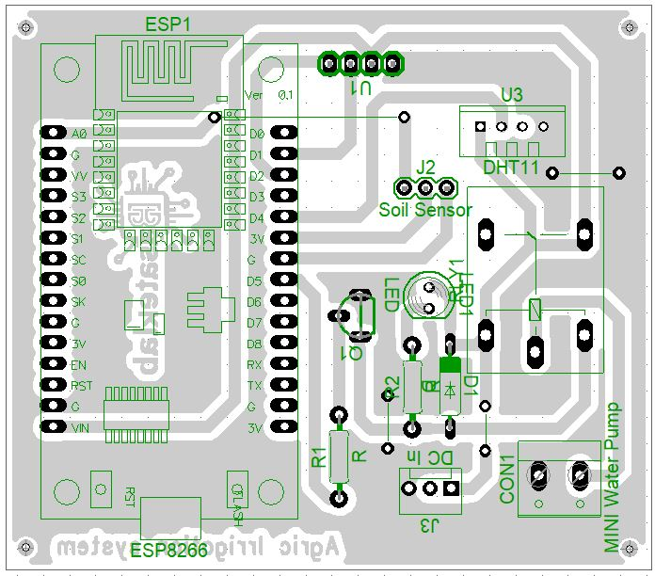
Fig. 2. Layout Diagram of Smart Irrigation System (Is this a circuit?)

3.3 SOFTWARE AND PROGRAMMING
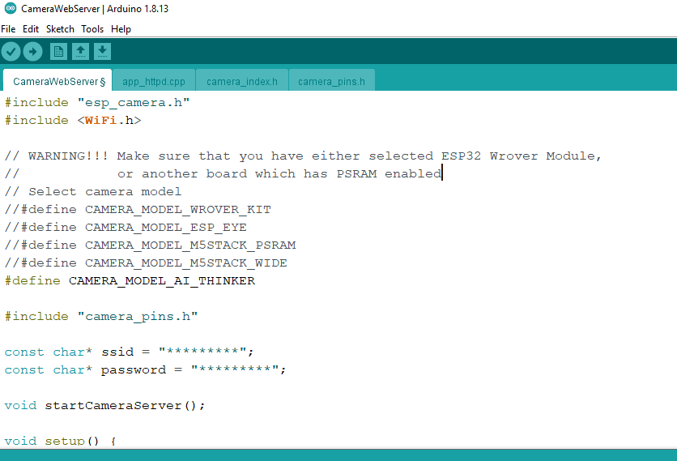
Fig. 3. Programming using Arduino IDE
For real-time communication, a remote server was set up to enable the user to continuously monitor the performance and operational status of the system. This is made possible through the Blynk IoT platform. To establish this connection, a Blynk cloud account was created by visiting the website https://blynk.io/. Upon successful registration of the account, a new template for the device was configured from the dashboard by clicking “Add New Template” and inputting the necessary template information, such as the name of the template, hardware type and method of connection. Figure 4 shows the resulting interface for creating the template.

3.4 SETTING UP THE BLYNK WEB DASHBOARD AND MOBILE APP 
Fig. 4. BlynkCloud Server Environment

4 SYSTEM DESIGN AND IMPLEMENTATION (Numbering of this section should be continued with the numbering of Materials and methods
4.1 COMPONENTS OF THE CIRCUITS
The proposed smart irrigation system consists of the following:

- ESP8266 microcontroller:
The ESP8266 is a value-priced, highly integrated SoC microcontroller designed specifically for IoT applications by Espressif Systems. It includes an embedded IEEE 802.11 b/g/n Wi-Fi transceiver, a 32-bit Tensilica L106 RISC processor with the ability to run at clock frequencies of up to 80 MHz (160 MHz overclocking), a complete TCP/IP protocol stack and a rich set of peripheral interfaces, including GPIO pins, SPI, I²C, UART and a 10-bit ADC. This allows direct and efficient interconnection with a wide variety of sensors, actuators, and ancillary modules.
Thanks to its small form factor, low power consumption, on-chip flash memory for storing firmware and flexible options for programming-the Arduino Integrated Development Environment, MicroPython, and AT command firmware-the ESP8266 has become a favorite platform in academic research and commercial deployment alike. In fact, it has gained widespread acceptance for IoT-enabled systems, smart home automation, remote environmental monitoring, industrial telemetry and agricultural sensing applications where robust wireless connectivity, processing capability and ease of prototyping are needed.
- Capacitive Soil Moisture Sensor:
An operating capacitive soil-moisture sensor consists of a parallel-plate capacitor with two conductive electrodes separated from each other by soil that acts as the dielectric medium. Changes in the soil-water content cause changes in the dielectric constant of the soil matrix, creating a detectable change in capacitance between the plates. The sensor outputs an electrical signal-usually in voltage or frequency-shift form-proportional to the water content in the volume of the soil.
The capacitive design offers substantially higher durability and reliability under field conditions compared with conventional resistive sensors. Since the electrodes are completely encapsulated and do not create direct galvanic contact with the soil solution, the electrochemical corrosion and polarization effects are effectively precluded. This makes the capacitive sensors especially suitable for continuous, long-term deployment in agricultural, horticultural and environmental-monitoring applications where sustained accuracy and minimal maintenance are essential.
- DHT11 Sensor:
The DHT11 is an economical, fully digital sensor intended for simultaneous measurement of ambient temperature and relative humidity. It incorporates a capacitive humidity-sensing element and a negative temperature coefficient (NTC) thermistor, which together provide calibrated digital outputs. The operating temperature range provided by this device lies between 0 °C and 50 °C, with ±2 °C accuracy; the RH measurement ranges from 20% to 90% RH, with ±5% RH accuracy.
It uses a single-wire bidirectional proprietary protocol that requires only one data pin, in addition to the power and ground connections, to communicate with host microcontrollers like Arduino or ESP8266. The small size, low power consumption, and ease of interfacing make the DHT11 a popular choice for a wide range of applications: from environmental monitoring stations to home weather systems, heating, ventilation and air conditioning (HVAC) control, greenhouse automation, and to many IoT projects that require an affordable yet reliable way to measure atmospheric parameters.

- 0.96″ I2C OLED Display:
The 0.96-inch I2C OLED display is a compact and low-power graphic module using OLED technology that will render text and images without a backlight with high contrast. Operating within a supply voltage of 3.3 V to 5 V, typical models boast a resolution of 128 × 64 pixels and are driven by the widely supported SSD1306 or the compatible SH1106 controller integrated circuit.
The interface to microcontrollers like Arduino, ESP8266, or ESP32 is achieved through a standard I2C Inter-Integrated Circuit serial bus, which requires only two signal lines (SDA for data and SCL for clock), plus power and ground. Since OLED pixels are self-emissive, visibility is good in varying conditions of ambient light. The monochrome display (commonly white, blue, or yellow) provides excellent contrast and fast refresh. This, plus the minimal power consumption and small size, makes this 0.96-inch I2C OLED display a favourite in embedded applications where space is at a premium, which covers wearable devices, sensor nodes, Internet of Things dashboards, portable instrumentation and real-time data visualization for agricultural and environmental monitoring systems..
- Relay-Controlled Mini Water Pump:
This intelligent irrigation system continuously monitors the content in the soil with buried sensors that read the water content of the soil in real time and then trigger watering on their own when needed.

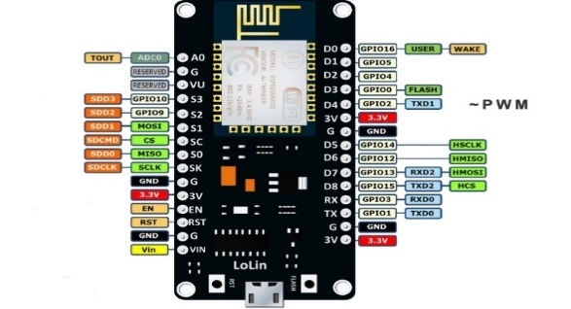
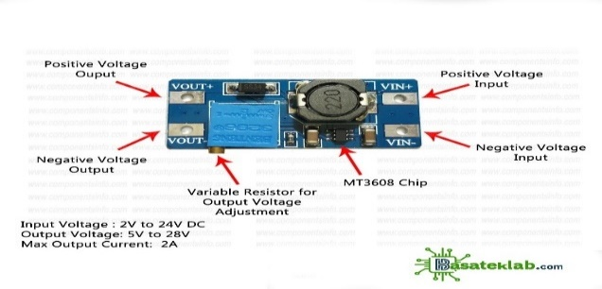
Fig 5. 0.96″ I2C OLED Display Fig 6. DHT11 (digital temperature and humidity sensor module

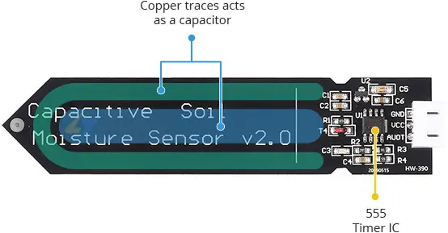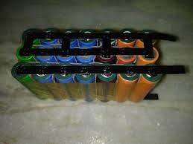
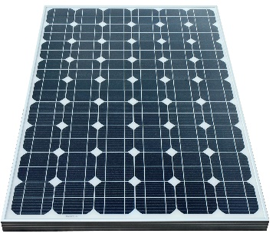
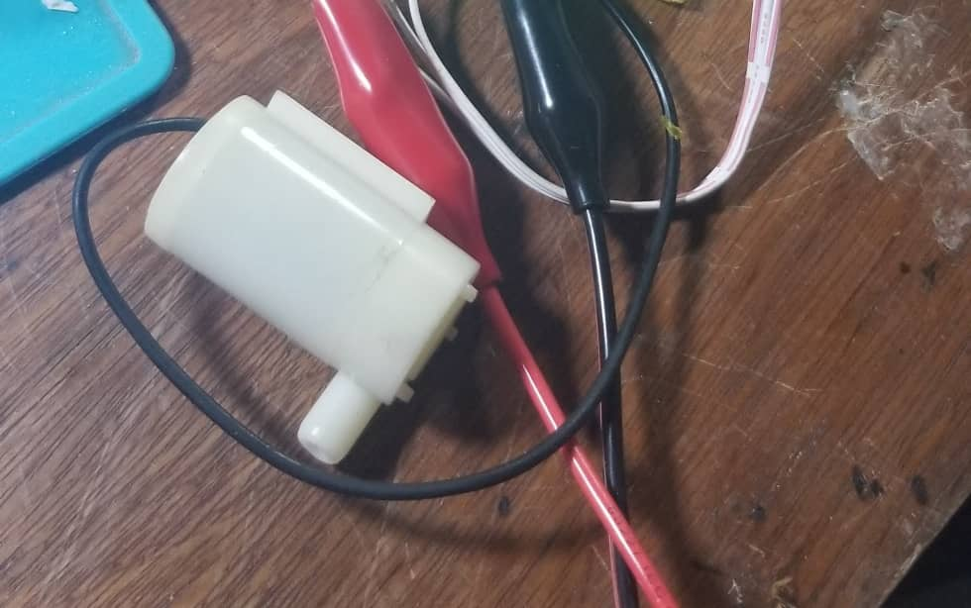
Fig 7. Capacitive Soil Moisture Sensors Fig 8. lithium battery
Fig 9. Monocrystalline solar panel Fig 10. DC Pump
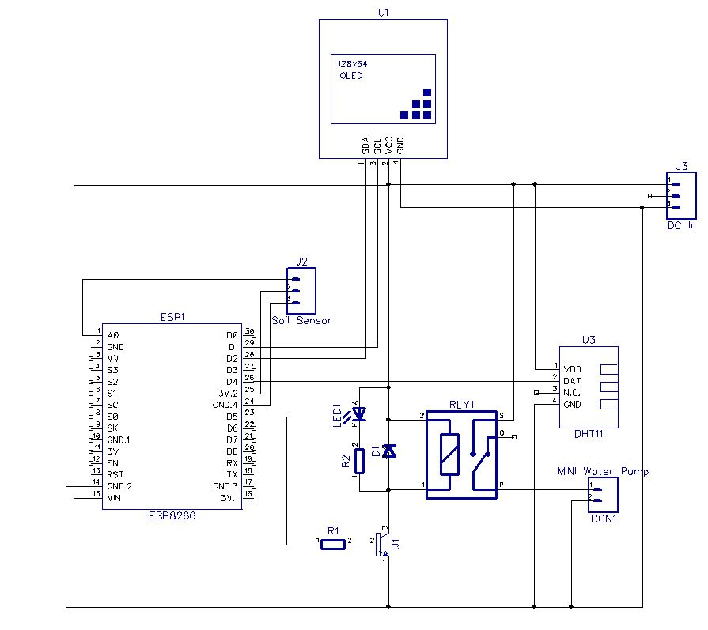
Fig. 11. Circuit Diagram of a Smart Irrigation System

The complete circuit diagram for the IoT-based agricultural irrigation system is shown in Figure.0. In this, the Espressif ESP8266 microcontroller is used as the core unit of the controller for remote monitoring and actuation. A client-server architecture is implemented in the system: the ESP8266 module connects to any local Wi-Fi network and acts as a web server; the user then opens any web browser on a smartphone or laptop and logs onto the module's assigned IP address to access the control interface.
The digital pin D5 of the ESP8266 is configured as an output and drives a relay module to switch ON/OFF the water pump. Power to the entire circuit is drawn from a 9 V DC source, which is stepped down and regulated to the required 3.3 V using a DC-DC converter module connected at terminal J3. The regulated voltage is fed directly to the V_CC and GND pins of the ESP8266. Once a user presses any control button on the web or mobile interface, the command travels via the cloud (Blynk or ThingSpeak) to the ESP8266 server. Thereafter, the microcontroller processes this incoming instruction and toggles the corresponding relay via its driver circuit, thus switching ON/OFF the electric motor that pumps water into the crops. In this way, the proposed closed-loop design implements complete automation in irrigation management with remote control.

4.2 PROGRAMME FOR THE BLYNK APP (This is not necessary here in the text. But consider include it as an appendix if the author guidelines allow )
```cpp
#define BLYNK_TEMPLATE_ID "TMPLxxxx"
#define BLYNK_DEVICE_NAME "FarmNode1"
#define BLYNK_AUTH_TOKEN "your-token-here"

#include <WiFi.h>
#include <BlynkSimpleEsp32.h>

char ssid[] = "VillageHotspot";
char pass[] = "12345678";

#define SOIL A0
#define RELAY 26
#define TRIG 5
#define ECHO 18

BlynkTimer timer;
void sendData() {
int moisture = map(analogRead(SOIL), 0, 4095, 100, 0);
Blynk.virtualWrite(V0, moisture);
if (moisture < 40) digitalWrite(RELAY, HIGH);
else digitalWrite(RELAY, LOW);
Blynk.virtualWrite(V1, digitalRead(RELAY));
}
void setup() {
Serial.begin(115200);
pinMode(RELAY, OUTPUT);
Blynk.begin(BLYNK_AUTH_TOKEN, ssid, pass);
timer.setInterval(5000L, sendData);
}
void loop() {
Blynk.run();
timer.run();
}
```
5 SUMMARY AND CONCLUSION
5.1 SUMMARY
At the end of 2025, Nigeria faces its most severe food crisis in several decades, with 33.1 million people projected to suffer from acute hunger in 2025 lean season, with food inflation of over 34%. Although it has been established that smart irrigation technology has the potential to increase yields by 20-30 percent, allowing for farming all year round, it has been established that this technology cannot solve this problem on its own (FAO AQUASTAT Report).This is because, on the back of economic hardship-a fuel subsidy removal in 2023 that has since doubled the prices of fertilizer-and chronic underfunding of agriculture at less than 2 percent of the budget, smallholder farmers cannot afford or sustain such systems (Central Bank of Nigeria, 2025; BudgIT, 2025). Corruption further whittles resources by diverting billions of dollars and causing annual rice losses sufficient to feed up to 14 million persons (Alabi & Adams, 2020; Mallam, 2025; NALTF, 2025). Climate variability-including erratic rainfall, droughts affecting 43 percent of land space, and shrinking water bodies like Lake Chad-means that irrigation infrastructure, operating at one-third capacity, nullifies the effectiveness of smart systems in the absence of a reliable water source (Nigerian Meteorological Agency, 2025; FAO, 2018).
Insecurity and infrastructure deficits worsen the problem further, making the deployment of technology almost impossible in most areas. Violence from banditry, insurgency, and herder-farmer conflicts killed more than 6,800 people in early 2025, displaced millions, and turned fertile farmland into no-go zones, with yields halved in affected areas and equipment destroyed (Armed Conflict Location & Event Data Project. 2025; USAID, 2025). Targeted attacks against Christian farming communities have left deep-seated food deserts in their wake (Open Doors International, 2025). The rural areas are characterized by only 25 percent electrification, while poor roads account for 40 percent post-harvest losses, coupled with widespread lack of storage and piped water (Rural Electrification Agency, 2025; World Bank, 2025). Additional barriers faced by women include limited land ownership and access to credit, yet they produce 60 to 80 percent of the food (Bryan et al., 2023). Unless Nigeria restores security, increases agricultural investment, rebuilds its infrastructure, reforms land tenure, and curbs corruption through coordinated governance, smart irrigation is going to remain a limited pilot tool instead of being a solution to widespread hunger and food insecurity (Totin et al., 2018). It is only when there is a comprehensive, multisectoral approach that this self-reinforcing cycle will be broken.

5.2 CONCLUSION
In sum, smart irrigation technologies address only one narrow dimension-water efficiency-within a crisis propelled by multiple and mutually reinforcing failures. Macroeconomic collapse, climate stress, crumbling infrastructure, widespread banditry and targeted destruction of the Christian agrarian communities have collectively produced an environment in which technological solutions are either unaffordable, inoperable, or physically destroyed. Unless Nigeria directly confronts these root causes through comprehensive security restoration, economic stabilization, climate adaptation and genuine intercommunal peacebuilding, smart irrigation will remain an elegant footnote in policy reports rather than a transformative force in the fields. This conclusion and the summery should be blended and briefed to have only the section of Conclusion.

COMPETING INTERESTS DISCLAIMER:
Authors have declared that they have no known competing financial interests OR non-financial interests OR personal relationships that could have appeared to influence the work reported in this paper.

REFERENCES
Abdulai, A. R., Quarshie, P. T., Duncan, E., & Fraser, E. (2023). Is agricultural digitization a reality among smallholder farmers in Africa? Unpacking farmers’ lived realities of engagement with digital tools and services in rural Northern Ghana. Agriculture & Food Security, 12(1), 11. https://doi.org/10.1186/s40066-023-00416-6
Adekunle, O. A., Oladipo, F. O., & Busari, I. Z. (2015). Factors affecting farmers’ participation in irrigation schemes of the Lower Niger River Basin and Rural Development Authority, Kwara State, Nigeria. South African Journal of Agricultural Extension, 43(2), 35–45. https://doi.org/10.17159/2413-3221/2015/v43n2a353
Adelodun, B., & Choi, K.-S. (2018). A review of the evaluation of irrigation practice in Nigeria: Past, present and future prospects. African Journal of Agricultural Research, 13(40), 2087–2097. https://academicjournals.org/journal/AJAR/article-full-text-pdf/3EAF05558713
Adeyolanu, D. T., & Okelola, O. E. (2024). Irrigation water management and food security in Nigeria. African Journal of Agriculture and Food Science, 7(4), 117–132. https://doi.org/10.52589/AJAFS-PFPU1QN7
African Development Bank. (2024). Nigeria economic outlook 2024. AfDB.
Alabi, R. A., & Adams, M. (2020). The impact of the e-wallet fertilizer subsidy scheme on fertilizer use, crop output and yield in Nigeria. African Economic Research Consortium (AERC) Research Paper No. 387. AERC research paper repository (PDF links): https://publication.aercafricalibrary.org/handle/123456789/501 and https://aercafrica.org/wp-content/uploads/2020/01/Research-Paper-390.pdf
Archibong, E. A., Njok, A. O., & Osang, J. E. (2025). Smart irrigation in Nigeria: A panacea to curbing hunger and food insecurity. Asian Journal of Advanced Research and Reports, 19(6), Article 1041. https://doi.org/10.9734/ajarr/2025/v19i61041
Armed Conflict Location & Event Data Project. (2025). Nigeria country conflict profile. ACLED. https://acleddata.com/country/nigeria
BudgIT Foundation. (2023). Improving budget credibility for access to agricultural inputs and services in Nigeria. BudgIT Foundation.
Bryan, E., & Mekonnen, D. (2023). Does small-scale irrigation provide a pathway to women’s empowerment? Lessons from Northern Ghana. Journal of Rural Studies, 97, 474–484. https://doi.org/10.1016/j.jrurstud.2022.12.035.
Central Bank of Nigeria. (2025). Economic report, fourth quarter 2024. https://www.cbn.gov.ng/Out/2025/RSD/Fourth%20Quarter%202024%20Economic%20Report.pdf
Chavula, P., & Turyasingura, B. (2022). Land tenurial system influence among smallholder farmers’ climate smart agriculture technologies adoption, Sub-Sahara Africa: A review paper. International Journal of Food Science and Agriculture, 8(3), 16–26. https://doi.org/10.26855/ijfsa.2022.03.003
Centre for Democracy and Development – West Africa. (2025). West Africa Security Tracker: Mid-Year Security Report 2025. CDD-West Africa. https://www.cddwestafrica.org/reports/west-africa-security-tracker-mid-year-security-report-2025/
Food and Agriculture Organization of the United Nations. (n.d.). AQUASTAT country profile: Nigeria. FAO AQUASTAT. https://www.fao.org/aquastat/en/geospatial-information/global-maps-irrigated-areas/irrigation-by-country/country/NGA/index.html
Food and Agriculture Organization of the United Nations. (2016). AQUASTAT country profile: Nigeria. FAO AQUASTAT. https://www.fao.org/aquastat/en/geospatial-information/global-maps-irrigated-areas/irrigation-by-country/country/NGA/index.html
Global Green Growth Institute. (2024). Solar powered irrigation systems (SPIS) potential and perspectives in sub-Saharan Africa (GGGI Technical Report No. 39). Global Green Growth Institute. https://gggi.org/report/solar-powered-irrigation-systems-spis-potential-and-perspectives-in-sub-saharan-africa/ gggi.org
Gustafson, S. (n.d.). Packaging climate-smart agricultural practices to increase farmer adoption: Evidence from Nigeria. Food Security Portal, International Food Policy Research Institute (IFPRI). https://www.foodsecurityportal.org
Genocide Watch. (2025). Nigeria: Genocide and mass atrocity risk update 2025. Genocide Watch. https://www.genocidewatch.com/country-pages/nigeria
Global Centre for the Responsibility to Protect. (2025). Nigeria: Risk assessment and mass atrocity prevention update. Global Centre for the Responsibility to Protect. https://www.globalr2p.org/countries/nigeria/
Human Rights Watch. (2025). They burned everything: Attacks on Christian communities in Nigeria’s Middle Belt, 2024–2025. Human Rights Watch. https://www.hrw.org/
International Organization for Migration. (2025). Nigeria displacement tracking matrix: National displacement overview. Displacement Tracking Matrix (DTM). International Organization for Migration. Retrieved from https://dtm.iom.int/nigeria
International Crisis Group. (2018). Stopping Nigeria’s spiralling farmer–herder violence (Africa Report No. 262). International Crisis Group. https://www.crisisgroup.org/africa/west-africa/nigeria/262-stopping-nigerias-spiralling-farmer-herder-violence
International Monetary Fund. (2025). Nigeria: 2025 Article IV consultation—Press release; staff report; and statement by the Executive Director for Nigeria (IMF Staff Country Reports No. 2025/157). International Monetary Fund. https://www.imf.org/en/Publications/CR/Issues/2025/04/30/Nigeria-2025-Article-IV-Consultation-557157
International Society for Civil Liberties and Rule of Law. (2025). Annual report on religious violence in Nigeria 2024–2025.
Jambo, Y., Alemu, A., & Tasew, W. (2021). Impact of small-scale irrigation on household food security: evidence from Ethiopia. Agriculture & Food Security, 10, 21. https://doi.org/10.1186/s40066-021-00294-
Kibazo, P., Nabende, W. J., & Atim, M. R. (2025). Design and simulation of an intelligent irrigation system using fuzzy logic. Discover Electronics, 2(5), Article 5. https://doi.org/10.1007/s44291-025-00045-2
Kutarju, J., Suleiman, M. S., Mustapha, A. L., & Ghumdia, J. J. (2024). Effects of Boko Haram on the livelihoods of farming households in Jere Local Government Area of Borno State, Nigeria. Journal of Agricultural Economics, Environment and Social Sciences, 10(1), 39–47. Retrieved from https://jaeess.com.ng/index.php/jaeess/article/view/218
Macrotrends. (2024). Nigeria access to improved water sources – Historical data. https://www.macrotrends.net/countries/NGA/nigeria/water-access-statistics
Mallam, M. (2025). Impact of fertilizer subsidy and tariff policies on rice production and productivity in Nigeria (1979–2022). Journal of Agricultural Science and Development, 14(2), 45–60. https://njaat.com.ng/index.php/jasd/article/download/1220/898?utm_source=chatgpt.com
Milestad, R., Carlsson-Kanyama, A., & Schaffer, C. (2020).
The Högdalen urban farm: A real case assessment of sustainability attributes. Food Security, 12(6), 1461–1475. https://doi.org/10.1007/s12571-020-01045-8
Nairametrics. (2025). Post-harvest losses and transport costs in Nigeria’s agricultural value chain (2024–2025). Nairametrics. https://nairametrics.com
National Bureau of Statistics. (2025). Consumer Price Index – June 2025 (NBS CPI Report). National Bureau of Statistics. Retrieved from https://microdata.nigerianstat.gov.ng/index.php/catalog
Ndahi, A. K., Mohammed, I. U., Ahmed, S. D., & Hayatu, J. M. (2024). Institutional assessment of a River Basin Development Authority for effective service delivery: A case study of Sokoto-Rima River Basin Development Authority, Sokoto in Nigeria. Nigerian Research Journal of Engineering and Environmental Sciences, 9(2), 864–886. https://doi.org/10.5281/zenodo.14566304
Nigerian Meteorological Agency. (2025). Seasonal climate prediction 2025. NiMet.
Nyasimi, M., Amwata, D., Hove, L., & Hansen, J. (2017). Adoption and disadoption of precision irrigation in Tanzania: The role of gender. Agricultural Water Management, 193, 77–88. https://doi.org/10.1016/j.agwat.2017.07.021
Oluniyi, O. (2021). Performance of River Basin Development Authorities in Nigeria. Water Resources Management Journal, 28(3), 201–215.
Open Doors International. (2025). World Watch List 2025: Nigeria country dossier. Open Doors.
Ozili, P. K., & Obiora, K. (2023). Implications of fuel subsidy removal on the Nigerian economy. In Public Policy’s Role in Achieving Sustainable Development Goals (pp. 115–130). IGI Global. https://doi.org/10.4018/978-1-6684-8903-1.ch007
Premium Times. (2023). Fuel subsidy removal: How Nigerians are coping [Series of articles]. Premium Times. https://www.premiumtimesng.com/tag/fuel-subsidy-removal
Release International. (2025). Persecution trends report 2025 (Stefanos Foundation contributions). https://releaseinternational.org/wp-content/uploads/2025/01/Persecution-Trends-Report-2025.pdf Release International
Federal Republic of Nigeria. (2015). Rural Electrification Strategy & Implementation Plan (RESIP). Federal Ministry of Power, Works, and Housing / Rural Electrification Agency. https://fmw.gov.ng/themes/front_end_themes_01/images/download/RURALELECTRIFICATIONSTRATEGICIMPLEMENTAIONPLAN%28RESIP%29.pdf
Salamat, A. (2015). A comparative study of resistive and capacitive humidity sensor. Journal of Emerging Technologies and Innovative Research, 2(6), 231–236. ISSN 2349-5162
SB Morgen Intelligence. (2025, June 12). Nigeria’s food security under siege: Climate change, conflict, and the collapse of agricultural resilience (Report). SBM Intelligence. https://globalupfront.com/2025/06/12/nigerias-food-security-under-siege/
Shanono, N. J., Nasidi, N. M., & Usman, N. Y. (2022). Appraising the current state of irrigation schemes in northern Nigeria using sustainability pillars. Environmental Research & Technology, 4(5), 305–314. https://doi.org/10.35208/ert.1097795
Segnon, A. C., Totin, E., Zougmoré, R. B., Lokossou, J. C., Thompson-Hall, M., Ofori, B. O., Achigan-Dako, E. G., & Gordon, C. (2021). Differential household vulnerability to climatic and non-climatic stressors in semi-arid areas of Mali, West Africa. Climate and Development, 13(8), 697–712. https://doi.org/10.1080/17565529.2020.1855097
Takeshima, H., & Liverpool-Tasie, L. S. O. (2015). Fertilizer subsidies, political economy, and local food prices in Nigeria. Food Policy, 54, 11–24. https://doi.org/10.1016/j.foodpol.2015.04.003
TheGlobalEconomy.com. (2024). Nigeria: Access to drinking water, rural – Historical chart. https://www.theglobaleconomy.com/Nigeria/rural_access_to_improved_water_source/
Totin, E., Segnon, A. C., Schut, M., Affognon, H., Zougmoré, R. B., Rosenstock, T. S., & Thornton, P. K. (2018). Institutional factors constraining climate-smart agriculture adoption in sub-Saharan Africa. Climate and Development, 10(5), 413–428. https://doi.org/10.1080/17565529.2017.1348575
United Nations Environment Programme, University of Kalmar, United States Geological Survey, United Nations Educational, Scientific and Cultural Organization, World Wide Fund for Nature, & Lake Chad Basin Commission. (2004). Lake Chad Basin: GIWA Regional Assessment 43. University of Kalmar on behalf of the United Nations Environment Programme. https://wedocs.unep.org/20.500.11822/8808
United States Agency for International Development. (2025). Nigeria food security outlook: January–June 2025. USAID.
Veriv Africa. (2025). Overcoming financing barriers for agricultural SMEs in Nigeria: Challenges and opportunities for growth (includes discussion of federal agriculture budget allocation trends 2023–2025). Veriv Africa. https://www.verivafrica.com/insights/overcoming-financing-barriers-for-agricultural-smes-in-nigeria-challenges-and-opportunities-for-growth Veriv Africa
Warren, A. M., Constantinides, S. V., Blake, C. E., & Frongillo, E. A. (2021). Advancing knowledge about stakeholder engagement in multisectoral nutrition research. Global Food Security, 29, 100521. https://doi.org/10.1016/j.gfs.2021.100521
World Bank. (2024). Nigeria Electrification Project (P161885) Implementation status and results report (World Bank Report No. P161885). World Bank Group. https://documents1.worldbank.org/curated/en/099092023030529715/pdf/P1618850620a5e07008044027ecf3bbbdb2.pdf World Bank
World Bank. (2024). Nigeria development update: From policy to people – Bringing the reform gains home. World Bank Group. https://www.worldbank.org/en/country/nigeria/publication/nigeria-development-update-from-policy-to-people-bringing-the-reform-gains-home. No need to bold some words of the references.
World Food Programme. (2025). Nigeria food security assessment: 2025–2026 lean season outlook. WFP.
Zougmoré, R., Partey, S. T., Ouédraogo, M., Omitoyin, B., Thomas, T., Ayantunde, A., Ericksen, P., Said, M., & Jalloh, A. (2016). Toward climate-smart agriculture in West Africa: A review of climate change impacts, adaptation strategies and policy developments for the livestock, fishery and crop production sectors. Agriculture & Food Security, 5(1), 26. https://doi.org/10.1186/s40066-016-0075-3

Not used the prescribed template. Please follow the author guidelines of the journal.

