Morpho-Molecular Characterization of Antagonistic Bacillus spp. Isolated from Different Brinjal (Solanum melongena L.) Cultivars across Tamil Nadu and Andhra Pradesh, India.
Alternative title :
Survey and characterization of native antagonistic Bacillus spp from rhizosphere zone of brinjal in Tamilnadu and Andhra Pradesh ,India

ABSTRACT
Diseases caused by soil borne pathogen including Fusarium spp. pose a major constraint to brinjal (Solanum melongena L.) production, necessitating eco-friendly disease management strategies. The present study aimed to isolate, characterize, and identify antagonistic Bacillus spp. from the brinjal rhizosphere across Tamil Nadu and Andhra Pradesh, India. A systematic field survey conducted during 2023–2024 resulted in the isolation of twenty Bacillus isolates (AUBI-1 to AUBI-20) from diverse agro-ecological regions. The isolates were characterized based on morphological and biochemical traits. All isolates were Gram-positive and exhibited variable biochemical profiles, with most showing positive reactions for siderophore production, starch hydrolysis, catalase activity, citrate utilization, and nitrate reduction, while all isolates were negative for chitinase production and methyl red test. Based on superior morphological and biochemical characteristics, isolate AUBI-14 was selected for molecular identification. 16S rRNA gene sequencing and BLAST analysis confirmed the identity of AUBI-14 as Bacillus subtilis (GenBank accession number: PX737071.1). The results highlight the diversity of Bacillus populations in brinjal rhizosphere soils and identify B. subtilis AUBI-14 as a promising candidate for further evaluation as a biocontrol agent against soil-borne pathogens.
Keywords: Bacillus subtilis, brinjal, rhizosphere, biocontrol, morphological characterization, molecular identification
1. INTRODUCTION
Brinjal (Solanum melongena L.) is one of the most widely cultivated vegetable crops in India due to its adaptability to diverse agro-climatic conditions, high nutritional value, and year-round cultivation potential. The crop plays a crucial role in food security and income generation for small and marginal farmers, particularly in southern Indian states such as Tamil Nadu and Andhra Pradesh, which contribute significantly to national brinjal production.(Ref )

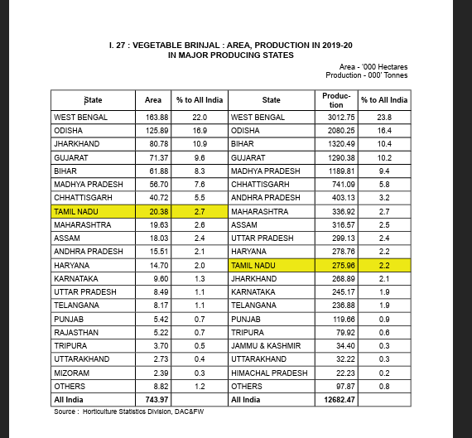
Losses caused by pests and disease :; Ref
Kaniyassery, A., Thorat, S. A., Kiran, K. R., Murali, T. S., & Muthusamy, A. (2023). Fungal diseases of eggplant (Solanum melongena L.) and components of the disease triangle: A review. Journal of Crop Improvement, 37(4), 543–594. https://doi.org/10.1080/15427528.2022.2120145
Laxman Singh Saini, B.L. Jat, Akhter Hussain and M.S. Meena (2024). Estimation of Crop Losses
Due to Insect Pests in Brinjal (Solanum melongena). Biological Forum – An International Journal, 16(7): 141-143.
Sarnaik, R., Shelake, J. & Waghmare, M. Fusarium wilt of brinjal: impact, pathogenicity, and sustainable management strategies. Discov. Plants 2, 244 (2025). https://doi.org/10.1007/s44372-025-00331-
Suggested to include these references.

Sustainable brinjal cultivation increasingly depends on maintaining soil health and beneficial microbial populations within the rhizosphere. (Ghosh, 2022; Sihag, 2021). The rhizosphere is a dynamic ecological zone enriched with diverse microorganisms that influence plant growth, nutrient uptake, and soil fertility. Among rhizosphere-associated bacteria, members of the genus Bacillus have received considerable attention due to their ecological adaptability and multifunctional roles in agricultural systems. Bacillus spp. are Gram-positive, rod-shaped, spore-forming bacteria capable of surviving under adverse environmental conditions such as high temperature, desiccation, and nutrient stress. Their ability to form endospores ensures long-term persistence in soil and enhances their suitability for agricultural applications. (Adal, 2023; Borriss, 2020). Several Bacillus species, including B. subtilis, B. velezensis, B. amyloliquefaciens, and B. thuringiensis, are commonly associated with crop rhizospheres and are known for their metabolic versatility. These bacteria contribute to soil health through nutrient cycling, starch hydrolysis, nitrate reduction, and siderophore production, which enhances iron availability to plants. Such biochemical traits enable Bacillus spp. to establish efficiently in the rhizosphere and interact positively with host plants. Consequently, Bacillus populations represent an important microbial resource for sustainable agriculture. The diversity and functional potential of Bacillus spp. are strongly influenced by agro-ecological factors such as soil type, climate, cropping pattern, and host cultivar. Tamil Nadu and Andhra Pradesh encompass a wide range of agro-climatic zones, making these regions ideal for exploring the diversity of Bacillus populations associated with brinjal cultivation. Despite the recognized importance of Bacillus spp., systematic studies integrating field survey, isolation, and detailed morphological, biochemical, and molecular characterization of Bacillus isolates from brinjal rhizosphere soils across these regions remain limited. Morphological and biochemical characterization provides essential preliminary information on bacterial identity and functional traits, while molecular identification based on 16S rRNA gene sequencing offers accurate taxonomic resolution. Integrating these approaches enables reliable characterization of Bacillus isolates and helps establish a baseline for future studies aimed at their utilization in sustainable crop production and soil health management. (Rocha, et al., 2023). Therefore, the present study was undertaken to conduct a systematic survey of brinjal-growing regions of Tamil Nadu and Andhra Pradesh, isolate Bacillus spp. from rhizosphere soils, characterize the isolates based on morphological and biochemical traits, and identify representative isolates using 16S rRNA gene sequencing. The findings of this study provide valuable insights into the diversity and characteristics of Bacillus spp. associated with brinjal cultivation and lay the foundation for their future application in sustainable agricultural systems. (Sacchi, et al., 2002; Wang, et al., 2007).
2. MATERIALS AND METHODS
2.1 Survey and Sample Collection
A systematic field survey was conducted during 2023–2024 across major brinjal (Solanum melongena L.) growing regions of Tamil Nadu and Andhra Pradesh, India, to collect rhizosphere soil samples for the isolation of antagonistic Bacillus spp. The survey locations were selected to represent diverse agro-climatic conditions, soil types, and brinjal cultivation practices In Tamil Nadu, samples were collected from Cuddalore district (Sivapuri and Parathurchavadi), Salem district (Attur, Thalaivasal and Gangavalli), Dindigul district (Seelapadi, Anaipatti and Siluvathur), and Krishnagiri district (KK Nagar, Hosur and Sundekuppam). In Andhra Pradesh, survey locations included Chittoor district (Kuppam, Madanapalli and Ramakuppam), Kurnool district (Velugodu, Peddapadu and Atmakur), and Guntur district (Tenali, Rompicharala and Ponnur). Rhizosphere soil adhering closely to the roots and root segments were collected using sterile tools. Samples were placed in sterile polyethylene bags, properly labelled, and transported to the laboratory in an insulated ice box for further processing. All samples were processed within 24 hours of collection.
2.2 Isolation of Bacillus spp.
Isolation of Bacillus spp. was carried out using standard serial dilution and plating techniques. Rhizosphere soil samples (10 g) were suspended in 90 mL of sterile distilled water and shaken vigorously for 10 minutes. The suspension was serially diluted up to 10⁻⁶. An aliquot of 0.1 mL from appropriate dilutions was spread plated on Nutrient Agar (NA) plates. (Travers, et al., 1987; Fangio, et al., 2010). To selectively enrich spore-forming Bacillus spp., the soil suspensions were heat-treated at 80 °C for 10 minutes before plating. Plates were incubated at 28 ± 2 °C for 48 hours. Distinct colonies exhibiting typical Bacillus-like morphology were selected and purified by repeated streaking on NA plates. Pure cultures were maintained on NA slants at 4 °C for short-term use and preserved in 50% glycerol at −80 °C for long-term storage (Cornea, et al., 2002; Miljaković, et al., 2020).

2.3 Morphological Characterization
Morphological characterization of antagonistic Bacillus isolates was performed by observing colony characteristics on NA plates after 48 hours of incubation at 28 ± 2 °C. Parameters such as colony size, shape, margin, elevation, surface texture, and pigmentation were recorded. Cell morphology and Gram reaction were determined by Gram staining and microscopic observation under oil immersion (100×). Endospore formation was assessed using the Schaeffer–Fulton spore staining technique, employing malachite green as the primary stain and safranin as the counterstain. (Montanari, et al., 2004; Rocha, et al., 2023; Lu, et al., 2018).
2.4 Biochemical Characterization
Biochemical characterization of the selected antagonistic Bacillus isolates was carried out following standard bacteriological procedures. The tests included Gram staining, Siderophore estimation, starch hydrolysis, citrate utilization, catalase activity, Nitrate reduction, Chitinase Production and methyl red test. All tests were performed in triplicate, and results were recorded based on standard interpretations. (Koni, & Ellar, 1994; Rajashekhar, et al., 2017).
2.5 Molecular Identification of Bacillus Isolates
Genomic DNA was extracted from 24-hour-old Bacillus cultures grown in nutrient broth using a modified cetyltrimethylammonium bromide (CTAB) method. The quality and concentration of the extracted DNA were assessed using a NanoDrop spectrophotometer. The 16S rRNA gene was amplified using universal bacterial primers 27F (5′-AGAGTTTGATCCTGGCTCAG-3′) and 1492R (5′-GGTTACCTTGTTACGACTT-3′). PCR amplification was carried out in a 25 μL reaction mixture containing 12.5 μL of 2× PCR Master Mix, 0.5 μL of each primer (10 μM), 2 μL of template DNA, and nuclease-free water to make up the final volume. The PCR conditions consisted of an initial denaturation at 95 °C for 3 minutes, followed by 35 cycles of denaturation at 95 °C for 30 seconds, annealing at 55 °C for 30 seconds, extension at 72 °C for 90 seconds, and a final extension at 72 °C for 10 minutes. The amplified PCR products were resolved on 1% agarose gel stained with ethidium bromide and visualized under UV illumination. The expected amplicons (~1.5 kb) were purified and sequenced bi-directionally. The obtained sequences were edited and assembled using BioEdit software and compared with reference sequences available in the NCBI GenBank database using BLASTn. Phylogenetic analysis was performed using MEGA software (version X/11) employing the Neighbor-Joining method with 1000 bootstrap replications to assess the reliability of the branching pattern. (Avşar, et al., 2017; Ruiz-Sánchez, et al., 2016, Bhandari, et al., 2013).
3. RESULTS AND DISCUSSION
3.1 Survey and Isolation of Bacillus spp.
A systematic field survey conducted across major brinjal-growing regions of Tamil Nadu and Andhra Pradesh resulted in the isolation of twenty antagonistic Bacillus isolates, designated as AUBI-1 to AUBI-20. The isolates were obtained from diverse agro-ecological locations representing different soil types, climatic conditions, and cultivation practices. In Tamil Nadu, isolates were recovered from Cuddalore (Sivapuri, Parathurchavadi), Salem (Attur, Thalaivasal, Gangavalli), Dindigul (Seelapadi, Anaipatti, Siluvathur), and Krishnagiri (KK Nagar, Hosur, Sundekuppam) districts. In Andhra Pradesh, isolates were collected from Chittoor (Kuppam, Madanapalli, Ramakuppam), Kurnool (Velugodu, Peddapadu, Atmakur), and Guntur (Tenali, Rompicharala, Ponnur) districts (Table 1). Heat treatment followed by serial dilution plating facilitated the selective isolation of spore-forming bacteria, predominantly Bacillus spp. The recovery of Bacillus isolates from all surveyed locations indicates their widespread distribution and ecological adaptability in brinjal rhizosphere environments. Similar observations have been reported earlier, where Bacillus spp. were consistently isolated from diverse agro-climatic regions due to their ability to survive adverse soil conditions through endospore formation and rapid colonization of the rhizosphere. (Wei, et al., 2010; McInroy, & Kloepper, 1995).
3.2 Morphological Characterization of Bacillus Isolates
Morphological characterization of the twenty Bacillus isolates revealed considerable variability in colony characteristics (Table 1). Most isolates produced white to creamy white or milky white colonies on nutrient agar. Colony margins varied from serrated and undulate to slimy, while elevation ranged from flat and slightly raised to convex and umbonate. Such diversity in colony morphology reflects strain-level variation commonly observed among Bacillus populations. With respect to cell morphology, the majority of isolates were rod-shaped, a characteristic feature of the genus Bacillus. Some isolates exhibited irregular rod shapes, which may be associated with differences in growth phase or physiological state. Isolates AUBI-4, AUBI-9, AUBI-11, AUBI-12, AUBI-15, AUBI-17 and AUBI-19 showed well-defined rod morphology with smooth to slimy colony texture, features often associated with metabolically active and antagonistically efficient Bacillus strains. The observed morphological diversity among isolates collected from different locations suggests adaptation to local soil and environmental conditions. Similar variations in colony morphology and cell shape among antagonistic Bacillus spp. isolated from vegetable crops have been reported, emphasizing that morphological traits alone are insufficient for precise identification but provide a useful preliminary characterization. (El-Kersh, et al., 2012; Rocha, et al., 2023).
3.3 Biochemical Characterization of Antagonistic Bacillus Isolates
The biochemical characteristics of the twenty antagonistic Bacillus isolates (AUBI-1 to AUBI-20) are presented in Table 2. All isolates exhibited Gram-positive reaction, confirming their affiliation to the genus Bacillus. Considerable variability was observed among the isolates with respect to biochemical traits. Siderophore production was recorded in 15 out of 20 isolates, while isolates AUBI-1, AUBI-8, AUBI-12, AUBI-16 and AUBI-19 tested negative for siderophore estimation. Starch hydrolysis was positive in the majority of isolates, with negative reactions observed only in AUBI-5, AUBI-9 and AUBI-17. Catalase activity was detected in most isolates, whereas AUBI-3, AUBI-11 and AUBI-17 showed negative reactions. All isolates except AUBI-19 were positive for citrate utilization, indicating broad metabolic versatility among the isolates. Nitrate reduction activity varied among isolates, with positive reactions recorded in twelve isolates, while eight isolates exhibited negative reactions. Notably, chitinase production and methyl red test were negative in all isolates, indicating the absence of chitinolytic activity and mixed acid fermentation. Overall, the biochemical profiling revealed a predominantly uniform Gram-positive Bacillus population with isolate-specific variations in siderophore production, enzymatic activity, and nutrient utilization patterns, providing a functional basis for subsequent antagonistic screening. (Wulff, et al., 2002; Solanki, et al., 2015).
3.4 Molecular Identification of Bacillus Isolates
Based on a comprehensive evaluation of morphological and biochemical characteristics (Table 1 and Table 2), isolate AUBI-14 was selected for molecular identification. This isolate exhibited colony morphology and biochemical reactions that closely matched the typical diagnostic features of the genus Bacillus and showed a biochemical profile consistent with antagonistically efficient strains. Genomic DNA of isolate AUBI-14 was subjected to 16S rRNA gene sequencing for precise taxonomic identification. Sequence analysis using BLASTn against the NCBI GenBank database revealed a high level of sequence similarity with Bacillus subtilis. The nucleotide sequence of isolate AUBI-14 has been deposited in the GenBank database under the accession number PX737071.1, confirming its identity as Bacillus subtilis (Avşar, et al., 2017; Lu, Guo, & Liu, 2018).

Table 1. Survey and Morphological characterization of isolates of Bacillus sp.
Sl. No | State | District | Colour of colony | Margin | Elevation | Shape | Isolate Identification code
1 | Tamil Nadu | Cuddalore | White | Serrated | Slightly raised | Rod | AUBI-1
2 | Tamil Nadu | Cuddalore | White | Serrated | Convex | Rod | AUBI-2
3 | Tamil Nadu | Salem | Pale White | Undulate | Slightly convex | Irregular rod | AUBI-3
4 | Tamil Nadu | Salem | Creamy white | Slimy | Flat | Rod | AUBI-4
5 | Tamil Nadu | Salem | Creamy white | Serrated | Umbonate | Rod | AUBI-5
6 | Tamil Nadu | Dindigul | Pale White | Slimy | Flat | Irregular rod | AUBI-6
7 | Tamil Nadu | Dindigul | Creamy white | Undulate | Convex | Rod | AUBI-7
8 | Tamil Nadu | Dindigul | White | Serrated | Flat | Irregular rod | AUBI-8
9 | Tamil Nadu | Krishnagiri | Milky White | Slimy | Raised | Rod | AUBI-9
10 | Tamil Nadu | Krishnagiri | White | Undulate | Flat | Irregular Rod | AUBI-10
11 | Tamil Nadu | Krishnagiri | White | Slimy | Slightly raised | Rod | AUBI-11
12 | Andhra Pradesh | Chittoor | Milky White | Undulate | Convex | Rod | AUBI-12
13 | Andhra Pradesh | Chittoor | Milky White | Slimy | Slightly convex | Irregular rod | AUBI-13
14 | Andhra Pradesh | Chittoor | Creamy white | Serrated | Flat | Rod | AUBI-14
15 | Andhra Pradesh | Kurnool | Creamy white | Slimy | Umbonate | Rod | AUBI-15
16 | Andhra Pradesh | Kurnool | Pale White | Undulate | Flat | Irregular rod | AUBI-16
17 | Andhra Pradesh | Kurnool | Creamy white | Serrated | Convex | Rod | AUBI-17
18 | Andhra Pradesh | Guntur | White | Slimy | Flat | Irregular rod | AUBI-18
19 | Andhra Pradesh | Guntur | Pale White | Serrated | Raised | Rod | AUBI-19
20 | Andhra Pradesh | Guntur | Milky White | Slimy | Flat | Rod | AUBI-20

Table 2. Biochemical analysis of Bacterial antagonistic Bacillus sp.
Isolate | Gram staining | Siderophore estimation | Starch hydrolysis | Catalase production | Citrate utilization | Nitrate reduction | Chitinase production | Methyal red test
AUBI-1 | + | - | + | + | + | + | - | -
AUBI-2 | + | + | + | + | + | - | - | -
AUBI-3 | + | + | + | - | + | + | - | -
AUBI-4 | + | + | + | + | + | + | - | -
AUBI-5 | + | + | - | + | + | + | - | -
AUBI-6 | + | + | + | + | + | + | - | -
AUBI-7 | + | + | + | + | + | - | - | -
AUBI-8 | + | - | + | + | + | + | - | -
AUBI-9 | + | + | - | + | + | + | - | -
AUBI-10 | + | + | + | + | + | - | - | -
AUBI-11 | + | + | + | - | + | + | - | -
AUBI-12 | + | - | + | + | + | + | - | -
AUBI-13 | + | + | + | + | + | + | - | -
AUBI-14 | + | + | + | + | + | + | - | -
AUBI-15 | + | + | + | + | + | - | - | -
AUBI-16 | + | - | + | + | + | + | - | -
AUBI-17 | + | + | - | - | + | + | - | -
AUBI-18 | + | + | + | + | + | + | - | -
AUBI-19 | + | - | + | + | - | - | - | -
AUBI-20 | + | + | + | + | + | + | - | -

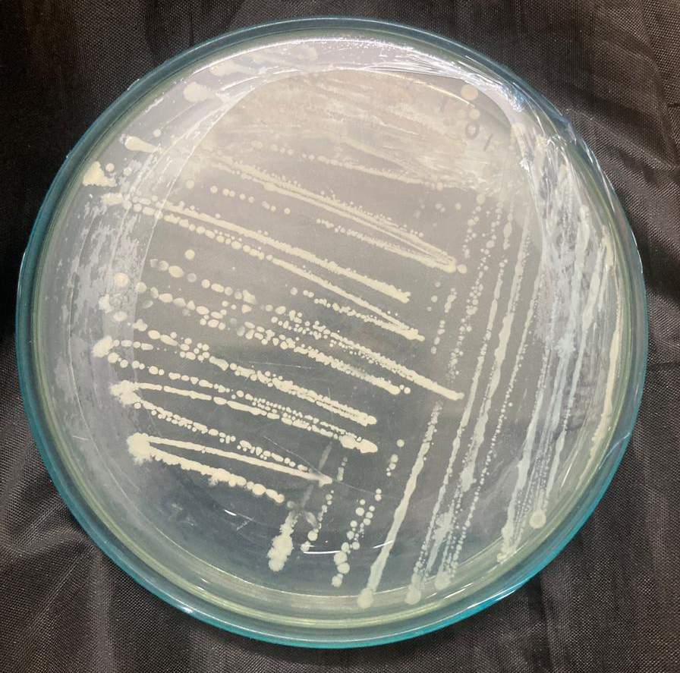  Fig. 1. Axenic culture of Bacillus subtilis (AUBI-14) | 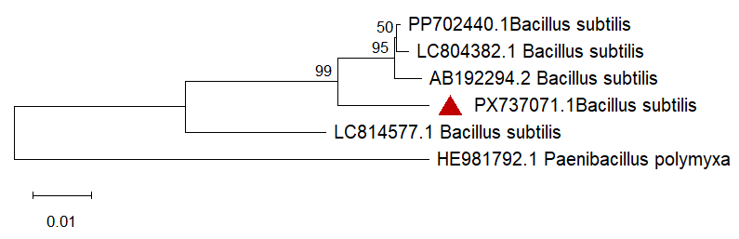  Fig. 2. Phylogenetic tree of Bacillus isolates based on 16S rRNA gene sequences. The tree was constructed using the Neighbor-Joining method with 1,000 bootstrap replications to infer the evolutionary relationships among the isolates.

Conclusion
The present study revealed the widespread occurrence of antagonistic Bacillus spp. in the brinjal rhizosphere across Tamil Nadu and Andhra Pradesh. Twenty isolates exhibited uniform Gram-positive morphology and diverse biochemical traits associated with rhizosphere competence and biocontrol potential. Among them, isolate AUBI-14 was conclusively identified as Bacillus subtilis through 16S rRNA gene sequencing. The absence of chitinase activity suggests that disease suppression may be mediated through siderophore production and other bioactive metabolites rather than direct cell wall degradation. Collectively, the findings highlight AUBI-14 (B. subtilis) as a promising biocontrol candidate for sustainable disease management in brinjal. Future studies should focus on evaluating the field-level efficacy of AUBI-14 under diverse agro-climatic conditions and developing suitable formulations to facilitate its large-scale application in integrated disease management programs.
Reference

Adal, Y. M. (2023). Role of Rhizosphere on the Soil Fertility and Availability Nutrient. Journal of Global Ecology and Environment. https://doi.org/10.56557/jogee/2023/v19i3-48492
Avşar, C., Koyuncu, H., & Aras, E. S. (2016). Isolation and molecular characterization of Bacillus spp. isolated from soil for production of industrial enzymes. Biological and Chemical Research, 3(9), 72-86.
Bhandari, V., Ahmod, N. Z., Shah, H. N., & Gupta, R. S. (2013). Molecular signatures for Bacillus species: demarcation of the Bacillus subtilis and Bacillus cereus clades in molecular terms and proposal to limit the placement of new species into the genus Bacillus. International Journal of Systematic and Evolutionary Microbiology, 63(Pt_7), 2712-2726. https://doi.org/10.1099/ijs.0.048488-0
Borriss, R. (2020). Bacillus. In N. Amaresan, M. S. Kumar, K. Annapurna, K. Kumar, & A. Sankaranarayanan (Eds.), Beneficial microbes in agro-ecology (pp. 107-132). Academic Press. https://doi.org/10.1016/B978-0-12-823414-3.00007-1
Cornea, C. P., Grebenisan, I., Mateescu, R. O. D. I. C. A., Vamanu, E., & Campeanu, G. (2002). Isolation and characterization of new Bacillus spp. strains-useful as biocontrol agents of plant pathogens. Romanian Biotechnological Letters, 8, 1115-1122.
El-kersh, T. A., Al-sheikh, Y. A., Al-akeel, R. A., & Alsayed, A. A. (2012). Isolation and characterization of native Bacillus thuringiensis isolates from Saudi Arabia. African Journal of Biotechnology, 11(8), 1924-1938. https://doi.org/10.5897/AJB11.2717
Fangio, M. F., Roura, S. I., & Fritz, R. (2010). Isolation and identification of Bacillus spp. and related genera from different starchy foods. Journal of Food Science, 75(4), M218-M221. https://doi.org/10.1111/j.1750-3841.2010.01566.x
Ghosh, S. K. (2022). Eggplant (Solanum melongena L.) and climate resilient agricultural practices. In S. R. Choudhury & C. K. Panda (Eds.), Climate Change Dimensions and Mitigation Strategies for Agricultural Sustainability (Vol. II, pp. 33-56). New Delhi Publishers. https://doi.org/10.30954/NDP-climatev2.4
Koni, P. A., & Ellar, D. J. (1994). Biochemical characterization of Bacillus thuringiensis cytolytic δ-endotoxins. Microbiology, 140(8), 1869-1880. https://doi.org/10.1099/13500872-140-8-1869
Lu, Z., Guo, W., & Liu, C. (2018). Isolation, identification and characterization of novel Bacillus subtilis. Journal of Veterinary Medical Science, 80(3), 427-433. https://doi.org/10.1292/jvms.16-0572
McInroy, J. A., & Kloepper, J. W. (1995). Survey of indigenous bacterial endophytes from cotton and sweet corn. Plant and soil, 173(2), 337-342. https://doi.org/10.1007/BF00011472
Miljaković, D., Marinković, J., & Balešević-Tubić, S. (2020). The significance of Bacillus spp. in disease suppression and growth promotion of field and vegetable crops. Microorganisms, 8(7), 1037. https://doi.org/10.3390/microorganisms8071037
Montanari, G., Borsari, A., Chiavari, C., Ferri, G., Zambonelli, C., & Grazia, L. (2004). Morphological and phenotypical characterization of Bacillus sporothermodurans. Journal of Applied Microbiology, 97(4), 802-809. https://doi.org/10.1111/j.1365-2672.2004.02371.x
Rajashekhar, M., Shahanaz, E., & Vinay, K. (2017). Biochemical and molecular characterization of Bacillus spp. isolated from insects. Journal of Entomology and Zoology Studies, 5(5), 581-588. http://www.entomoljournal.com/
Rocha, G. T., Montalvão, S. C. L., Queiroz, P. R. M., Berçot, M. R., Gomes, A. C. M. M., & Monnerat, R. G. (2023). Morphological and biochemical characterization of bacterial species of Bacillus, Lysinibacillus and Brevibacillus. Revista Ceres, 70, 91-104. https://doi.org/10.1590/0034-737x202370030010
Ruiz-Sánchez, E., Mejía-Bautista, M. Á., Serrato-Díaz, A., Reyes-Ramírez, A., Estrada-Girón, Y., & Valencia-Botín, A. J. (2016). Antifungal activity and molecular identification of native strains of Bacillus subtilis. Agrociencia, 50(2), 133-148. https://www.redalyc.org/articulo.oa?id=30244591001
Sacchi, C. T., Whitney, A. M., Mayer, L. W., Morey, R., Steigerwalt, A., Boras, A., Weyant, R. S., & Popovic, T. (2002). Sequencing of 16S rRNA gene: a rapid tool for identification of Bacillus anthracis. Emerging Infectious Diseases, 8(10), 1117–1123. https://doi.org/10.3201/eid0810.020391
Sihag, M. P. (2021). Analysis of agrometeorological Aspects of Brinjal cultivation (Doctoral dissertation, HARYANA AGRICULTURAL UNIVERSITY Hisar).
Solanki, M. K., Singh, R. K., Srivastava, S., Kumar, S., Kashyap, P. L., & Srivastava, A. K. (2015). Characterization of antagonistic-potential of two Bacillus strains and their biocontrol activity against Rhizoctonia solani in tomato. Journal of Basic Microbiology, 55(1), 82-90. https://doi.org/10.1002/jobm.201300528
Travers, R. S., Martin, P. A., & Reichelderfer, C. F. (1987). Selective process for efficient isolation of soil Bacillus spp. Applied and environmental microbiology, 53(6), 1263-1266. https://doi.org/10.1128/aem.53.6.1263-1266.1987
Wang, L. T., Lee, F. L., Tai, C. J., & Kasai, H. (2007). Comparison of gyrB gene sequences, 16S rRNA gene sequences and DNA–DNA hybridization in the Bacillus subtilis group. International Journal of Systematic and Evolutionary Microbiology, 57(8), 1846-1850. https://doi.org/10.1099/ijs.0.64685-0
Wei, Y. H., Wang, L. C., Chen, W. C., & Chen, S. Y. (2010). Production and characterization of fengycin by indigenous Bacillus subtilis F29-3 originating from a potato farm. International Journal of Molecular Sciences, 11(11), 4526-4538. https://doi.org/10.3390/ijms11114526
Wulff, E. G., Mguni, C. M., Mansfeld-Giese, K., Fels, J., Lübeck, M., & Hockenhull, J. (2002). Biochemical and molecular characterization of Bacillus amyloliquefaciens, B. subtilis and B. pumilus isolates with distinct antagonistic potential against Xanthomonas campestris pv. campestris. Plant pathology, 51(5), 574-584. https://doi.org/10.1046/j.1365-3059.2002.00753.x

