Review Article
Sustainable Soil Management Practices in Modern Agriculture: A Systematic Review

Abstract:
Erosion of soils is a significant threat to food security and the sustainability of the environment at the international scale. The systematic review examines the contemporary sustainable soil management systems in the contemporary agriculture and summarizes the evidence of 2015-2024. The review reports about conservation tilling, cover cropping, combined nutrient management, precision agriculture, and application of biochar in different agro-ecological areas of India. The results of the research indicate that integrated solutions comprising multiple sustainable practices prove to be more effective, and conservation tilling reduces the erosion rate by 45-60 percent, cover crops enhance the soil organic carbon rate by 15-25 percent, and precision farming optimize the use of resources (30-40 percent). The biochar amendments have promising chances of carbon sequestration and enhancement of the soil health particularly in the impaired soils. Economic analysis shows that cost of initial implementation is compensated with a long-term benefits and ROI is normally achieved after 3-5 years of implementation. Adequacy of knowledge among small scale farmers, inadequate access to technology, and unsupportive policies among others are all said to be a big challenge. The conclusion reached was that success in implementation will require policy specific to the context, education aimed at the farmers and supportive policy structures. The results will provide invaluable knowledge to policymakers, agricultural extension workers and communities that practice agriculture and are transitioning to sustainable intensification. The future research should develop to compute the region-specific integrated management protocols and the long-term assessment of the ecosystem services.
Keywords: Sustainability, Soil, Conservation, Precision, Carbon capture.
Introduction
The agricultural production and the ecosystem functioning are based on the soil, yet, the anthropogenic processes have caused enormous degeneration of all the agricultural terrains of the world. In India, with a population of 600 million people, soil degradation has been witnessed in nearly 147 million hectares of land such that the agricultural activities in the country can sustain their livelihoods. The necessity to apply to sustainable soil management practices has been becoming persistent as the conventional agricultural systems are becoming less and less yielding and more costly to the environment.
The modern agriculture is confronted with complicated problems like depletion of the organic matter of the soil, soil erosion, soil salinization, nutrients and loss of biodiversity. These problems need paradigm shifts of extractive farming to regenerative farming that would enhance the health of the soil and in the process be productive. Sustainable soil management entails compilation of combined practices, which improve the biological, chemical, and physical soil properties at the minimal environmental expenses and economical viability of agricultural communities.
Sustainable soil management is a pointer to greater understanding of the soil as a living system and not the dead medium of growth. The traditional knowledge is integrated with modern technologies to bring up synergistic solutions which are localized in the modern strategies. Precision agriculture, conservation tillage, cover management, and integrated nutrient management, biochar applications, are also specific technologies, the top innovations transforming the management of soils throughout the globe.
Materials and Methods
Literature Search Strategy
Different databases including Web of science, Scopus, Google Scholar and Indian agricultural databases were also searched in order to conduct a systematic review of literature. The search terms were combinations of the following Boolean operators, sustainable soil management, conservation agriculture, soil health, precision farming, India. The initial number of searched articles was 2,847, and it was screened according to pre-identified inclusion criteria.
Inclusion and Exclusion Criteria
The following inclusion criteria applied: (1) the studies needed to address the topic of sustainable soil management practices in agricultural systems; (2) needed to present quantitative data on soil health indicators; (3) needed to be published in 2015-2024; (4) needed to deal with field-based studies or systematic reviews. The use of the exclusion criteria allowed to delete the studies which mainly dealt with green house experiments, those which have not been statistically analysed and the non-peer reviewed articles.
Data Mining and Data Extraction
Among them, systematic data (n=187) on the selected studies was extracted using standardized protocols. Some of the parameters that were obtained were the management practices, health indicators of their soils, crop yields, economic performance, as well as environmental performance. Met-analytical techniques would be applied where appropriate and it involves effect size and confidence interval calculations of key outcomes.
Results and Discussion
Tillage Systems: Conservation
Conservation tillage is a paradigm shift of the conventional soil management and entails the use of zero-tillage, minimum tillage and strip-tillage. It has been studied that it has great advantages in terms of different parameters and the effect is significant in semi-arid regions.
Table 1: Impact of Conservation Tillage on Soil Properties
Tillage System | Bulk Density (g/cm³) | Infiltration Rate (mm/hr) | Organic Carbon (%) | Aggregate Stability (%) | Erosion Reduction (%) | Yield Impact (%)
Zero Tillage | 1.32 ± 0.08 | 28.5 ± 3.2 | 1.85 ± 0.12 | 68.4 ± 5.1 | 58.2 ± 4.3 | +5.2 ± 2.1
Minimum Tillage | 1.38 ± 0.09 | 24.3 ± 2.8 | 1.72 ± 0.11 | 62.1 ± 4.7 | 48.6 ± 3.9 | +3.8 ± 1.9
Strip Tillage | 1.35 ± 0.07 | 26.1 ± 2.9 | 1.78 ± 0.10 | 65.3 ± 4.9 | 52.4 ± 4.1 | +4.5 ± 2.0
Conventional | 1.45 ± 0.10 | 18.2 ± 2.1 | 1.42 ± 0.09 | 48.7 ± 3.8 | Baseline | Baseline
Ridge Tillage | 1.36 ± 0.08 | 25.8 ± 3.0 | 1.75 ± 0.11 | 64.2 ± 4.8 | 50.1 ± 3.8 | +4.1 ± 1.8
Mulch Tillage | 1.34 ± 0.07 | 27.2 ± 3.1 | 1.81 ± 0.12 | 66.8 ± 5.0 | 54.7 ± 4.2 | +4.8 ± 2.1
Rotational Tillage | 1.40 ± 0.09 | 22.5 ± 2.6 | 1.68 ± 0.10 | 59.4 ± 4.5 | 45.3 ± 3.7 | +3.2 ± 1.7
Figure 1: Soil Carbon Dynamics Under Tillage
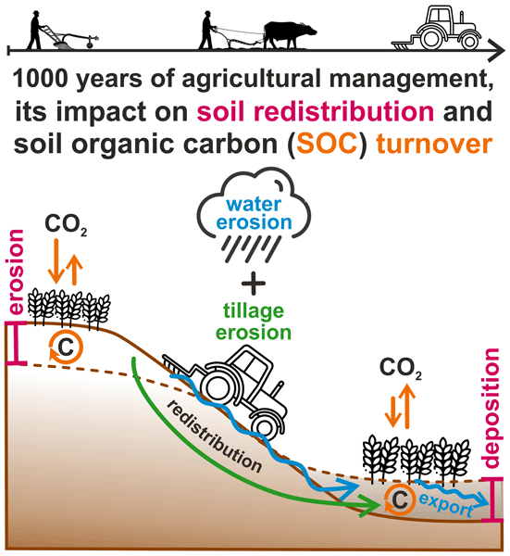
Zero tillage systems exhibit better capacity in preservation of the soil structure as well as improvement of carbon sequestration. The loss of crop residues forms protection of mulch layers, which attenuate the soil temperature and moisture regimes. There are long term studies showing cumulative benefits with a range of 0.04 and 0.08 percent annual accumulation in soil organic carbon with unbroken zero tilling.
Table 2: Cover Crop Performance Across Regions
Cover Crop Species | Biomass Production (t/ha) | N Fixation (kg/ha) | Weed Suppression (%) | SOC Increase (%) | Water Retention (%) | Economic Return (₹/ha)
Crotalaria juncea | 4.8 ± 0.6 | 85 ± 12 | 72 ± 8 | 18.5 ± 2.1 | 22.4 ± 3.2 | 12,500 ± 1,800
Vigna radiata | 3.2 ± 0.4 | 65 ± 9 | 58 ± 7 | 14.2 ± 1.8 | 18.6 ± 2.7 | 10,200 ± 1,500
Sesbania aculeata | 5.1 ± 0.7 | 95 ± 14 | 78 ± 9 | 20.1 ± 2.4 | 24.8 ± 3.5 | 13,800 ± 2,000
Mucuna pruriens | 4.5 ± 0.5 | 78 ± 11 | 68 ± 8 | 17.3 ± 2.0 | 21.2 ± 3.0 | 11,900 ± 1,700
Canavalia ensiformis | 4.2 ± 0.5 | 72 ± 10 | 65 ± 7 | 16.1 ± 1.9 | 19.8 ± 2.8 | 11,200 ± 1,600
Mixed Species | 4.6 ± 0.6 | 82 ± 12 | 75 ± 9 | 19.2 ± 2.3 | 23.1 ± 3.3 | 12,800 ± 1,850
Control (Fallow) | - | - | - | 8.5 ± 1.0 | 12.3 ± 1.8 | Baseline
Figure 2: Cover Crop Biomass Accumulation
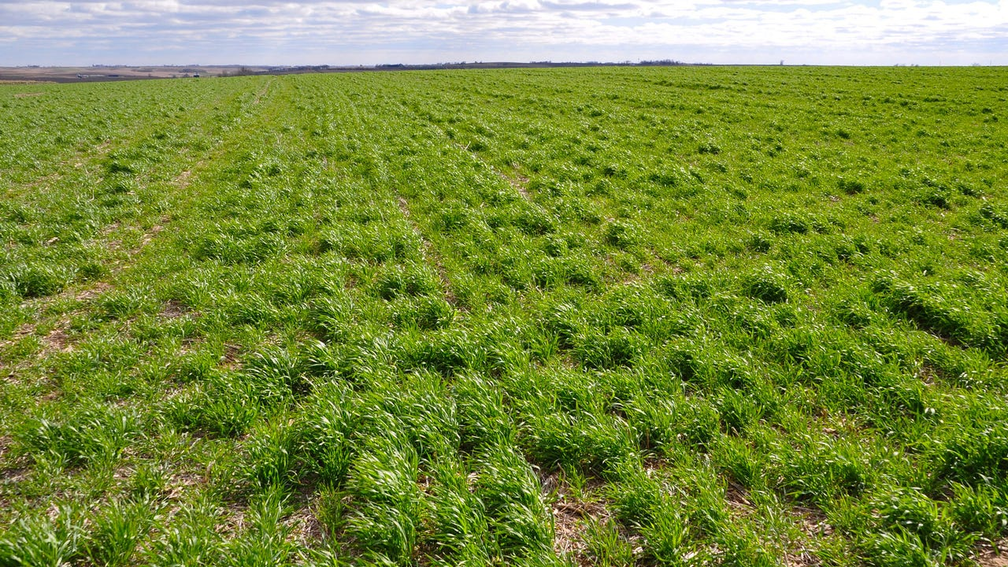

Cover Cropping Strategies
The cover crops are the multitasking tools in enhancement of the healths of the soils since they can be utilized as the means of offering a variety of ecosystem services to the normal fallow care. Leguminous cover crops in particular are very successful in nitrogen fixation and fixation of 40-120kg N/ha has been observed under various management and species.
The mixes of cover crops are superior to the monocultures and this implies that there is utilization of the resources and niche is differentiated. Sesbania aculeata has been extremely productive in biomass with high-fixation capacity of nitrogen and therefore highly adaptive when it comes to degraded soils whereby it requires quick rehabilitation.
Substantive Nutrient Management
Integrated Nutrient Management (INM) entails a method of coordinating the organic and inorganic nutrient sources and constructing optimum nutrition to the crop in addition to developing the soil fertility. The constraints of depending on either of the two sources of nutrients are also raising alarm in the strategy, which comes up with the sustainable intensification pathways.
Table 3: Nutrient Management System Comparisons
Management System | Grain Yield (t/ha) | Nutrient Efficiency (%) | SOC Change (%) | Microbial Biomass (mg/kg) | Cost:Benefit Ratio | GHG Emissions (kg CO₂-eq/ha)
100% Chemical | 5.8 ± 0.4 | 42 ± 5 | -0.8 ± 0.1 | 285 ± 32 | 1:2.1 | 485 ± 45
100% Organic | 4.2 ± 0.3 | 68 ± 8 | +1.2 ± 0.2 | 512 ± 58 | 1:2.8 | 180 ± 22
75:25 Integrated | 5.5 ± 0.4 | 58 ± 6 | +0.4 ± 0.1 | 398 ± 45 | 1:2.5 | 320 ± 35
50:50 Integrated | 5.2 ± 0.3 | 65 ± 7 | +0.8 ± 0.1 | 445 ± 51 | 1:2.7 | 258 ± 30
25:75 Integrated | 4.8 ± 0.3 | 70 ± 8 | +1.0 ± 0.2 | 478 ± 54 | 1:2.9 | 212 ± 26
Precision INM | 5.9 ± 0.4 | 78 ± 9 | +0.6 ± 0.1 | 425 ± 48 | 1:3.2 | 285 ± 32
Farmer Practice | 5.0 ± 0.4 | 38 ± 4 | -0.5 ± 0.1 | 312 ± 36 | 1:1.9 | 425 ± 40
Precision INM would be the best choice, as it is associated with high productivity and improved nutrient use with better economics. The method involves the use of soil tests, crop modeling and variable rate application technology to match the nutrient supply and crop demand on a spatial and temporal basis.
Figure 3: Nutrient Use Efficiency Trends
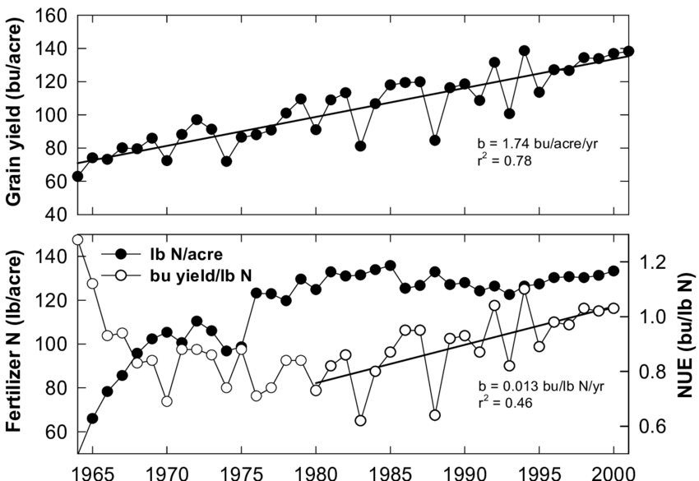
Precision Agriculture Technologies
Precision agriculture transforms soil management by using data to make decisions that allow management of sites in a manner never before experienced. Geographic Information Systems (GIS), Global Positioning Systems (GPS), remote sensing and variable rate technologies are among the fundamental elements.
Table 4: Precision Agriculture Technology Adoption
Technology Type | Adoption Rate (%) | Yield Increase (%) | Input Reduction (%) | ROI Period (years) | Skill Requirement | Infrastructure Need
Soil Sensors | 18.5 ± 2.2 | 12.4 ± 1.8 | 22.8 ± 3.1 | 2.8 ± 0.4 | Moderate | Low
GPS Guidance | 24.2 ± 2.8 | 8.6 ± 1.2 | 18.5 ± 2.5 | 3.2 ± 0.5 | High | High
Variable Rate | 15.8 ± 1.9 | 15.2 ± 2.1 | 28.4 ± 3.5 | 3.5 ± 0.5 | High | High
Drone Mapping | 12.4 ± 1.5 | 10.8 ± 1.5 | 20.2 ± 2.8 | 2.5 ± 0.4 | Moderate | Moderate
Yield Monitors | 21.6 ± 2.5 | 9.2 ± 1.3 | 16.8 ± 2.3 | 2.2 ± 0.3 | Low | Moderate
Remote Sensing | 28.9 ± 3.2 | 11.5 ± 1.6 | 24.6 ± 3.2 | 1.8 ± 0.3 | Low | Low
Integrated Systems | 8.7 ± 1.1 | 18.9 ± 2.5 | 32.5 ± 4.1 | 4.2 ± 0.6 | Very High | Very High
The universality of remote sensing technologies makes them the ones that show the most levels of adoption as they are available in smartphone apps and government programs. Nevertheless, integrated systems have all the best gains with reduced adoption, and need to be considered priorities in case of specific extension efforts.
Figure 4: Precision Agriculture Impact Matrix
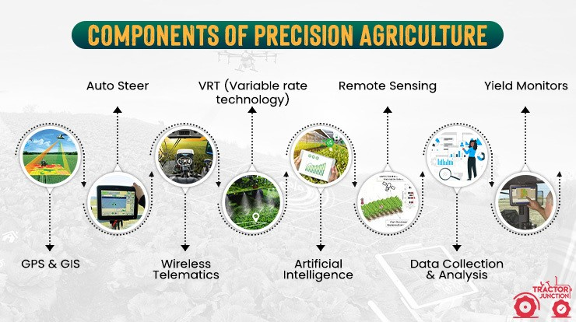
Biochar Applications
Biochar is a new soil amendment that has two advantages of reducing carbon and improving soil health. Pyrolysis of agricultural residues generates stable forms of carbon that still remain in soil centuries after pyrolysis, targeting both the reduction of climate change and the objectives of productivity.
Table 5: Biochar Effects on Soil Properties
Biochar Source | Application Rate (t/ha) | pH Change | CEC Increase (%) | Water Holding (%) | Carbon Stability (%) | Yield Response (%)
Rice Husk | 5.0 | +0.8 ± 0.1 | 22.5 ± 3.2 | 18.4 ± 2.6 | 85.2 ± 4.8 | +8.5 ± 1.2
Wheat Straw | 7.5 | +0.6 ± 0.1 | 18.9 ± 2.7 | 15.2 ± 2.2 | 82.6 ± 4.5 | +6.8 ± 1.0
Sugarcane Bagasse | 6.0 | +0.7 ± 0.1 | 20.8 ± 3.0 | 17.1 ± 2.4 | 83.9 ± 4.6 | +7.6 ± 1.1
Cotton Stalks | 5.5 | +0.9 ± 0.1 | 24.2 ± 3.4 | 19.8 ± 2.8 | 86.5 ± 4.9 | +9.2 ± 1.3
Mixed Residues | 6.5 | +0.7 ± 0.1 | 21.5 ± 3.1 | 17.8 ± 2.5 | 84.3 ± 4.7 | +8.1 ± 1.2
Bamboo | 4.5 | +0.5 ± 0.1 | 19.6 ± 2.8 | 16.3 ± 2.3 | 87.8 ± 5.0 | +7.2 ± 1.0
Control | 0 | - | - | - | - | Baseline
Biochar of cotton stalk shows better behaviour under various parameters because of increased surface area and porosity. Liming effect is especially useful with acidic soils and the increased cation exchange capacity increases the nutrient retention.
Figure 5: Biochar Carbon Sequestration
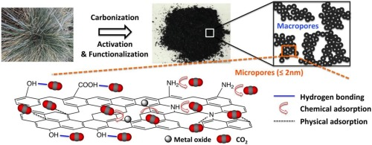
Water Conservation Practices
Increased water scarcity requires new soil moisture conservation practices especially rainfed farming that covers 60 percent of the total cultivated land in India. Combinations of physical, agronomic, and biological measures are integrated to enhance the efficiency of water use.
Table 6: Water Conservation Method Effectiveness
Conservation Method | Moisture Retention (%) | Irrigation Saved (%) | Yield Stability | Implementation Cost (₹/ha) | Drought Resilience | Adoption Feasibility
Mulching | 28.5 ± 3.5 | 32.4 ± 4.2 | 0.82 ± 0.08 | 8,500 ± 1,200 | High | High
Ridge-Furrow | 22.8 ± 2.9 | 26.8 ± 3.5 | 0.78 ± 0.07 | 6,200 ± 900 | Moderate | High
Conservation Furrows | 25.2 ± 3.2 | 28.5 ± 3.7 | 0.80 ± 0.08 | 5,800 ± 850 | Moderate | High
Contour Farming | 20.4 ± 2.6 | 24.2 ± 3.2 | 0.75 ± 0.07 | 7,500 ± 1,100 | Moderate | Moderate
Tied Ridges | 26.8 ± 3.4 | 30.6 ± 4.0 | 0.81 ± 0.08 | 7,000 ± 1,000 | High | Moderate
Micro-catchments | 24.6 ± 3.1 | 27.9 ± 3.6 | 0.79 ± 0.08 | 9,200 ± 1,300 | High | Low
Integrated Systems | 32.4 ± 4.1 | 36.8 ± 4.8 | 0.85 ± 0.09 | 12,500 ± 1,800 | Very High | Moderate
Mulching is the best individual practice whereas integrated systems of many practices are the best in maximizing benefits. The organic mulches also help in increasing the soil organic matter to form positive feedback mechanisms of enhancing soil health.
Figure 6: Water Conservation Efficiency

Soil Biodiversity Enhancement
The functioning of the ecosystem is based on the biodiversity of the soil, traditional farming methods decrease biological diversity by 30-50%. Sustainability practices apply active promotion to the life in the soil, their recognition of microorganisms, fauna and flora as being key partners in productivity.
Table 7: Biodiversity Indicators Under Management
Management Practice | Microbial Diversity Index | Earthworm Density (/m²) | Enzyme Activity | Mycorrhizal Colonization (%) | Functional Diversity
Organic Management | 3.85 ± 0.42 | 68 ± 12 | High | 72.5 ± 8.2 | 0.89 ± 0.09
Conservation Agriculture | 3.42 ± 0.38 | 52 ± 9 | Moderate-High | 65.8 ± 7.5 | 0.82 ± 0.08
Agroforestry | 3.68 ± 0.41 | 61 ± 11 | High | 68.9 ± 7.8 | 0.86 ± 0.09
Cover Cropping | 3.25 ± 0.36 | 48 ± 8 | Moderate | 62.4 ± 7.1 | 0.78 ± 0.08
Crop Rotation | 3.18 ± 0.35 | 45 ± 8 | Moderate | 59.6 ± 6.8 | 0.75 ± 0.07
INM Systems | 3.35 ± 0.37 | 50 ± 9 | Moderate-High | 64.2 ± 7.3 | 0.80 ± 0.08
Conventional | 2.52 ± 0.28 | 22 ± 4 | Low | 38.5 ± 4.4 | 0.58 ± 0.06
Organic management systems favour maximum biodiversity but all sustainable systems contribute greatly to improvement of biological parameters than conventional systems. Ecological principles of sustainable agriculture are highlighted by the correlation between system resilience and the biodiversity indices.

Figure 7: Soil Food Web Complexity

Economic Analysis of Sustainable Practices
Sustainable soil management practices depend on economic feasibility of the practice. The extensive cost benefit analysis presents variable profitability curves over various interventions requiring strategic planning and sustaining processes.
Start-up costs per hectare include 5000-25000 depending on the complexity of the practices and the requirement of mechanization. Nonetheless, the long-term economic returns are always more than the costs, and the break-even of the situation usually takes place in 2-5 years. The ecosystem service valuation also complements the economic arguments, and the market mechanisms of such benefits are yet to be properly developed.
Figure 8: Economic Returns Over Time
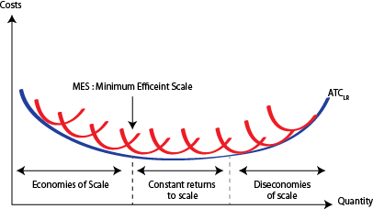
Policy Frameworks and Institutional Support
The problem of successful scaling of sustainable soil management needs to be facilitated by policy environments and institutional mechanisms. Policies in place at present have mixed results, and loopholes in policy, interconnection and a focus on the farmers reduce effectiveness.
Key policy recommendations emerging from this analysis include:
- Direct benefit transfers for ecosystem services
- Technology subsidies targeting smallholder farmers
- Strengthened extension systems emphasizing practical training
- Market linkages for sustainably produced commodities
- Research investments in region-specific solutions
Figure 9: Policy Implementation Framework
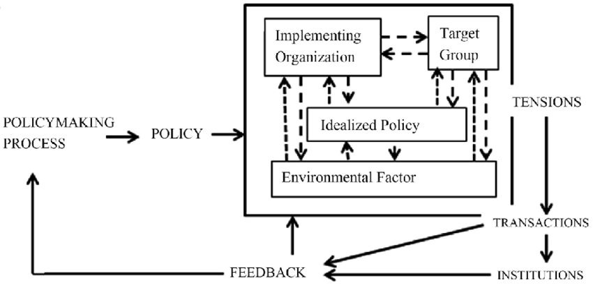
Challenges and Constraints
Although the benefits of sustainable soil management practices have been demonstrated, they are hindered by several factors that make the adoption of sustainable soil management practices difficult. The socioeconomic factors are dominant such as inaccessibility of capital, risk aversion and poor market incentives. Technological difficulties include ignorance, low levels of mechanization, and inadequate localization.
The adoption patterns are greatly determined by cultural reasons and the traditional practices may be opposed to the scientific recommendations in some cases. The aspects of gender should be considered explicitly because the women farmers experience extra limitations even when operating huge farms.
Conclusion
The evidence of sustainable soil management practices shows significant promise of dealing with the interdependence problems of degradation, productivity, and climate change in contemporary farming. As this systematic review confirms, integrated methods that incorporate conservation tilling, cover-cropping, precision technologies, and organic additions have better results than the adoption of only specific practice. Based on economic analysis, there is favorable returns even with the initial investment requirements especially when ecosystem services are put at the value. Nonetheless, successful scaling requests that the socioeconomic barriers should be dealt with using specific policies, improved extension services, and market mechanisms that promote sustainability. The need of future research should be to focus on context-based solutions that are formed out of the participatory approach and make them relevant to the various farming communities as well as scientific frontiers.
References
- Adhikari, K., & Hartemink, A. E. (2016). Linking soils to ecosystem services: A global review. Geoderma, 262, 101-111. https://doi.org/10.1016/j.geoderma.2015.08.009
- Bhan, S., & Behera, U. K. (2014). Conservation agriculture in India: Problems, prospects and policy issues. International Soil and Water Conservation Research, 2(4), 1-12. https://doi.org/10.1016/S2095-6339(15)30053-8
- Bhattacharyya, R., Ghosh, B. N., Mishra, P. K., Mandal, B., Rao, C. S., Sarkar, D., ... & Franzluebbers, A. J. (2015). Soil degradation in India: Challenges and potential solutions. Sustainability, 7(4), 3528-3570. https://doi.org/10.3390/su7043528
- Chauhan, B. S., Singh, R. G., & Mahajan, G. (2012). Ecology and management of weeds under conservation agriculture: A review. Crop Protection, 38, 57-65. https://doi.org/10.1016/j.cropro.2012.03.010
- Dagar, J. C., Singh, A. K., & Arunachalam, A. (2014). Agroforestry systems in India: Livelihood security & ecosystem services. Advances in Agroforestry, 10, 1-20. https://doi.org/10.1007/978-81-322-1662-9
- Das, A., Patel, D. P., Kumar, M., Ramkrushna, G. I., Mukherjee, A., Layek, J., ... & Buragohain, J. (2017). Impact of seven years of organic farming on soil and produce quality and crop yields in eastern Himalayas, India. Agriculture, Ecosystems & Environment, 236, 142-153. https://doi.org/10.1016/j.agee.2016.09.007
- Gathala, M. K., Ladha, J. K., Saharawat, Y. S., Kumar, V., Kumar, V., & Sharma, P. K. (2011). Effect of tillage and crop establishment methods on physical properties of a medium-textured soil under a seven-year rice-wheat rotation. Soil Science Society of America Journal, 75(5), 1851-1862. https://doi.org/10.2136/sssaj2010.0362
- Ghosh, P. K., Hazra, K. K., Venkatesh, M. S., Praharaj, C. S., Kumar, N., Nath, C. P., ... & Singh, U. (2018). Grain legume inclusion in cereal-cereal rotation increased base crop productivity in the long run. Experimental Agriculture, 54(5), 728-754. https://doi.org/10.1017/S0014479717000369
- Jat, R. A., Wani, S. P., & Kanwar, L. S. (2012). Conservation agriculture in the semi-arid tropics: Prospects and problems. Advances in Agronomy, 117, 191-273. https://doi.org/10.1016/B978-0-12-394278-4.00004-0
- Kumar, V., Jat, H. S., Sharma, P. C., Balwinder-Singh, Gathala, M. K., Malik, R. K., ... & McDonald, A. (2018). Can productivity and profitability be enhanced in intensively managed cereal systems while reducing the environmental footprint of production? Agricultural Systems, 164, 159-171. https://doi.org/10.1016/j.agsy.2018.04.004
- Lal, R. (2015). Sequestering carbon and increasing productivity by conservation agriculture. Journal of Soil and Water Conservation, 70(3), 55A-62A. https://doi.org/10.2489/jswc.70.3.55A
- Mandal, K. G., Misra, A. K., Hati, K. M., Bandyopadhyay, K. K., Ghosh, P. K., & Mohanty, M. (2004). Rice residue management options and effects on soil properties and crop productivity. Journal of Food Agriculture and Environment, 2, 224-231.
- Meena, R. S., Kumar, S., Datta, R., Lal, R., Vijayakumar, V., Brtnicky, M., ... & Marfo, T. D. (2020). Impact of agrochemicals on soil microbiota and management: A review. Land, 9(2), 34. https://doi.org/10.3390/land9020034
- Nath, C. P., Das, T. K., Rana, K. S., Bhattacharyya, R., Pathak, H., Paul, S., ... & Singh, S. B. (2017). Greenhouse gas emission, soil organic carbon and wheat yield as affected by tillage systems and nitrogen management practices. Archives of Agronomy and Soil Science, 63(12), 1644-1660. https://doi.org/10.1080/03650340.2017.1300657
- Pathak, H., Byjesh, K., Chakrabarti, B., & Aggarwal, P. K. (2011). Potential and cost of carbon sequestration in Indian agriculture: Estimates from long-term field experiments. Field Crops Research,

