DETERMINING WATER-USE ZONATION BASED ON PREDICTED LAND-COVER CHANGE IN THE BOLON RIVER WATERSHED

Abstract
This study assesses how land-cover change influences water-use zonation in the Bolon River Watershed (DAS Bolon) and predicts future land-cover dynamics to 2033 to inform sustainable water-resource governance. A GIS-based spatial approach was implemented using QGIS and the MOLUSCE plugin, integrating Cellular Automata (CA) and Artificial Neural Networks (ANN) to project land-cover patterns for 2024, 2029, and 2033. Water-use zones were delineated by combining indicators of recharge areas, catchment capacity, and water availability. The results indicate substantial land conversion—particularly from forest and wet agricultural land toward plantations and built-up areas—leading to reduced infiltration potential and diminished catchment effectiveness. The projected continuation of these trends through 2033 suggests increasing exposure to hydrological extremes, including drought and flooding risks in the Bolon watershed. An overlay analysis between derived water-use zones and the regional spatial plan (RTRW) reveals pronounced mismatches, most notably within plantation-designated areas, implying potential conflicts between land-development trajectories and hydrological sustainability. This research provides spatially explicit evidence for improving local water-resource management and strengthening the integration between land-use policy and watershed governance. The study is limited by its reliance on Sentinel-2 imagery for land-cover mapping; future work should incorporate multi-source datasets and more explicit socio-economic impact assessments to better capture the broader implications of land conversion. Overall, this study contributes to understanding land–water interactions and offers a transferable spatial-modelling framework applicable to other watersheds in Indonesia.
Keywords: Watershed; MOLUSCE; land-cover change prediction; GIS; water-use zonation

1. Introduction
Rapid land-cover transformation within watersheds can disrupt hydrological processes and degrade both water quantity and quality. Land conversion—such as deforestation and the replacement of agricultural land with plantations or built-up areas—may increase surface runoff, reduce infiltration, and heighten vulnerability to floods and droughts (Nasrullah et al., 2010). Accordingly, understanding the hydrological implications of land-cover change is essential for designing sustainable watershed management strategies.
Effective water-use zonation requires a sound understanding of the physical and ecological attributes of a landscape. Different zones deliver distinct hydrological functions and should be managed according to environmental priorities and socio-economic needs (Loucks & van Beek, 2017). This calls for systematic spatial assessment of the factors shaping water distribution, storage, and utilization.
Advances in Geographic Information Systems (GIS) enable predictive land-cover modelling using spatial datasets and robust algorithms. The MOLUSCE plugin in QGIS has been widely used to forecast land-use/land-cover change with relatively high performance, supporting evidence-based conservation and natural resource planning (Muhammad et al., 2022). Such modelling is increasingly relevant for watershed-scale governance where land conversion pressures are accelerating.
In the Bolon watershed, ongoing urban expansion and plantation development are likely to reduce recharge and catchment functions. This study employs QGIS–MOLUSCE to predict land-cover change through 2033 and assess its implications for water-use zonation, providing a forward-looking basis for water-resource planning.
Recharge areas play a critical role in replenishing groundwater. Infiltration and recharge capacity are shaped by slope, soil texture, and rainfall (Prahasta, 2014). Landscapes with gentle slopes and coarse-textured soils typically exhibit higher infiltration potential.
In addition to recharge areas, catchment areas regulate how rainfall is collected and routed toward the main river network. Rainfall intensity and land cover strongly influence runoff generation and streamflow responses (Santoso et al., 2025). Therefore, mapping catchment functionality is fundamental for anticipating future water stress.
Water-use zonation should integrate land cover, recharge potential, and water availability in order to guide sustainable utilization while preventing ecological degradation (Muhammad et al., 2022). Such zonation becomes especially valuable when it is aligned with formal spatial planning instruments.
Integrating water-use zonation with regional spatial plans (RTRW) is crucial to ensure that development priorities do not compromise hydrological sustainability. Spatial planning documents that differentiate protected and cultivation zones must reflect hydrological capacity and watershed constraints (Bappeda Prov. Sumatera Utara, 2017).
This study aims to (i) evaluate the impacts of land-cover change on water-use zonation in the Bolon watershed, and (ii) predict land-cover change through 2033 using spatial modelling, thereby supporting policy recommendations for sustainable local water-resource governance (Loucks & van Beek, 2017).

2. Methods
2.1 Study Area
The study was conducted in the Bolon River Watershed, North Sumatra, Indonesia. The watershed delineation covers approximately 1,956 km²; however, after raster alignment, masking, and consistent class coverage across multi-temporal datasets, the effective analysis extent used in land-cover tabulation is 1,950 km². The Bolon watershed is a major water source for agriculture, settlements, and industry across areas including Simalungun and Batu Bara.
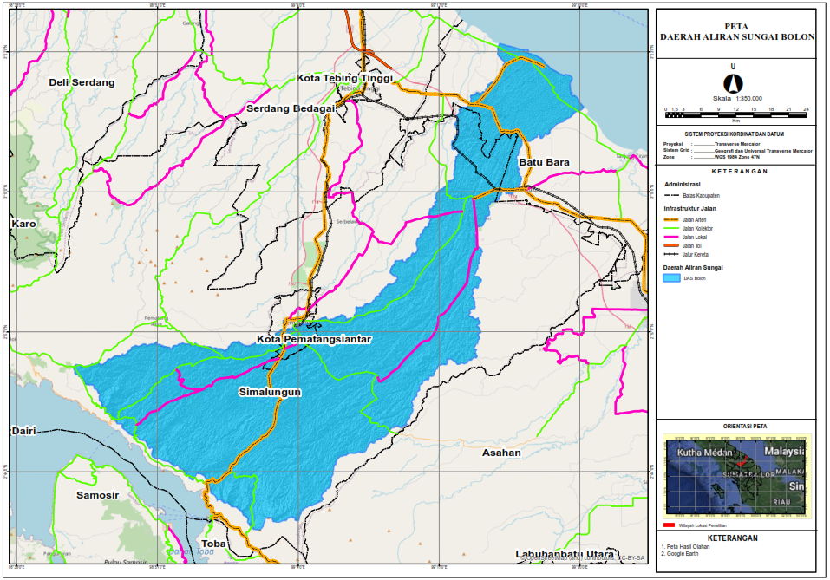
Figure 1. Location map of the Bolon River Watershed (DAS Bolon)
2.2 Data and Data Sources
This study uses both primary and secondary spatial datasets:
- Sentinel-2 imagery for land-cover mapping (2017, 2021, 2024).
- Digital Elevation Model (DEM) for slope derivation.
- Rainfall data from local hydrological stations.
- Supporting soil and hydrological datasets where available (e.g., soil texture).
2.3 Land-Cover Change Prediction (MOLUSCE: CA–ANN)
Land-cover change prediction was performed using QGIS with the MOLUSCE plugin. The model integrates Cellular Automata (CA) and Artificial Neural Networks (ANN) (including MLP in MOLUSCE workflows) to simulate land-cover dynamics and project future patterns for 2024, 2029, and 2033.
A conceptual CA transition formulation can be expressed as:
$$P_{t+1}=f(P_{t},N_{t})$$
where:
- $P_{t}$is the cell state at time $t$,
- $P_{t+1}$is the cell state at time $t+1$,
- $N_{t}$represents neighborhood influence,
- $f$is the transition function/rules governing change (Sugiarto, 2018).
Model performance was assessed using the Kappa Index:
$$κ=\frac{P_{o}-P_{e}}{1-P_{e}}$$
where:
- $P_{o}$is observed agreement,
- $P_{e}$is expected agreement due to chance.
2.4 Water-Use Zonation Analysis
After generating land-cover predictions, water-use zones were delineated by integrating three components: recharge areas, catchment function, and water availability.
(1) Recharge potential was derived from slope, rainfall, and soil texture:
$$I=f(S,T,C)$$
where:
- $I$is recharge/infiltration potential,
- $S$is slope,
- $T$is soil texture,
- $C$is rainfall (Prahasta, 2014).
(2) Catchment function was assessed using rainfall and land-cover characteristics affecting runoff:
$$A=\int_{0}^{T}{R(t)⋅C(t) dt}$$
where:
- $A$denotes catchment contribution (conceptual),
- $R(t)$is rainfall at time $t$,
- $C(t)$is the land-cover coefficient at time $t$.
2.5 Spatial-Plan Consistency (RTRW Overlay)
Zonation outputs were compared against RTRW spatial allocations through overlay analysis to identify mismatches and potential land–water conflicts. A weighted suitability score can be expressed as:
$$S_{t}=\sum_{i=1}^{n}{W_{i}}⋅A_{i}$$
where:
- $S_{t}$is the suitability score at time $t$,
- $W_{i}$is the weight of parameter $i$,
- $A_{i}$is the area meeting parameter $i$.
2.6 Data Analysis
Outputs were evaluated using descriptive statistics and spatial analysis (map-based interpretation, tabulation of class changes, and overlay-based consistency evaluation). The results were synthesized into policy-relevant recommendations for watershed management.

3. Results and Discussion
3.1 Land-Cover Dynamics (2017–2024)
Land-cover mapping using Sentinel-2 imagery indicates significant conversion from forest and wet agricultural land toward plantations, built-up land, and bare/unused land. This pattern reflects intensifying land-use pressure within the watershed and suggests declining hydrological buffering capacity.
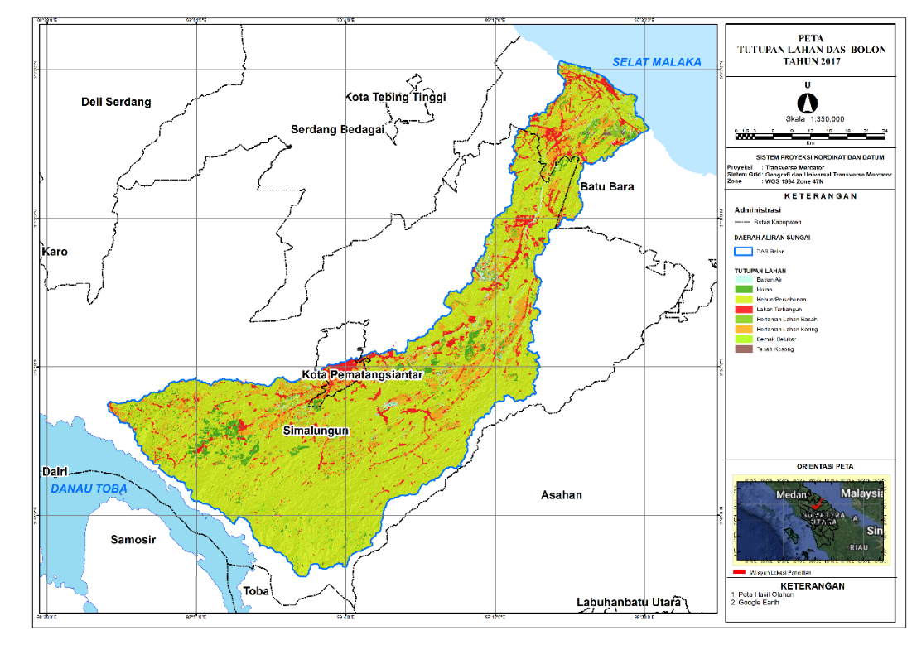
Figure 2. Land cover map (2017)
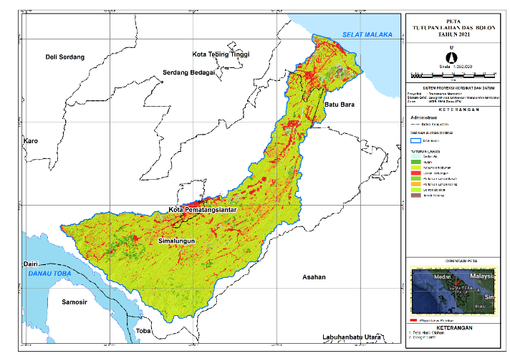
Figure 3. Land cover map (2021)
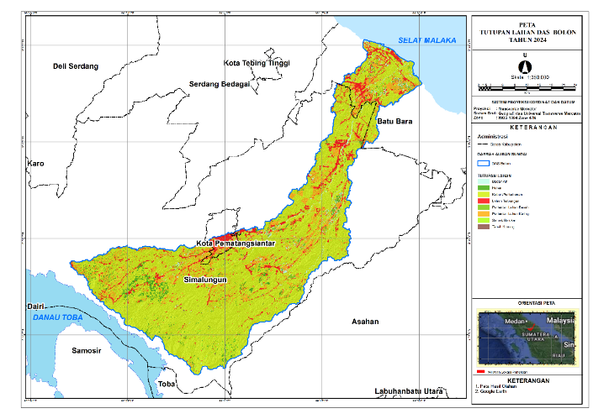
Figure 4. Land cover map (2024)

Table 1. Land-cover distribution in the Bolon watershed (2017, 2021, 2024)
Year | Forest | Wet Agriculture | Dry Agriculture | Plantation | Built-up | Bare Land | Total (km²)
2017 | 800 | 250 | 100 | 300 | 50 | 100 | 1,950
2021 | 750 | 240 | 120 | 330 | 60 | 150 | 1,950
2024 | 700 | 220 | 130 | 350 | 80 | 180 | 1,950
The table shows a consistent decline in forest and wet agriculture, accompanied by rapid expansion of plantations and built-up areas. Such conversion typically reduces infiltration and increases runoff, thereby weakening watershed resilience to hydrological extremes.
3.2 Predicted Land-Cover Change (2029–2033)
Future land-cover simulations suggest continued expansion of plantations and built-up areas through 2033, while forests and wet agriculture are projected to shrink further.
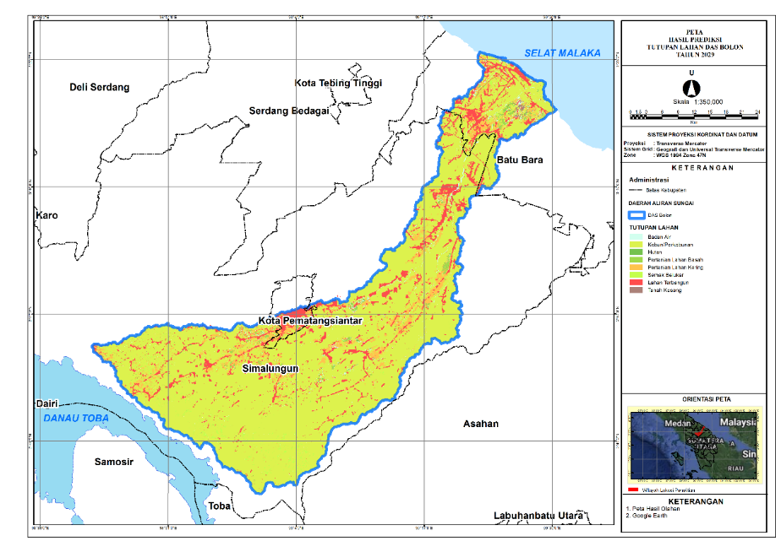
Figure 5. Predicted land cover (2029)
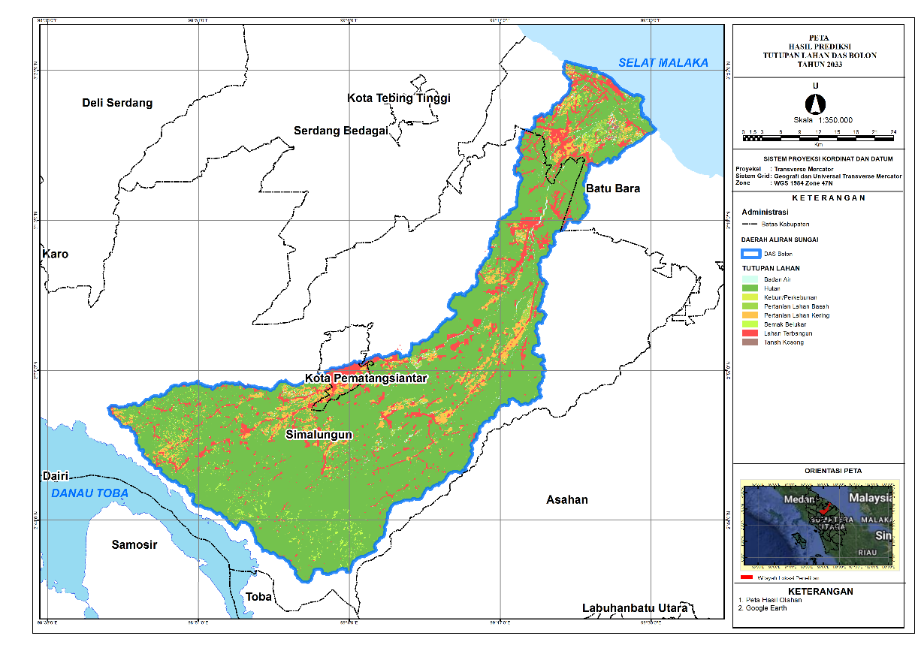
Figure 6. Predicted land cover (2033)
Table 2. Predicted land-cover distribution in the Bolon watershed (2029 and 2033)
Year | Forest | Wet Agriculture | Dry Agriculture | Plantation | Built-up | Bare Land | Total (km²)
2029 | 650 | 200 | 140 | 400 | 100 | 150 | 1,950
2033 | 600 | 180 | 150 | 450 | 130 | 180 | 1,950
The projected decline in forests and wet agriculture is likely to alter key watershed functions. Plantation and built-up expansion typically increases impervious or compacted surfaces, intensifying peak flows while reducing groundwater recharge, particularly when conversion occurs within recharge-sensitive areas.
3.3 Impacts on Recharge Areas
Recharge zones are essential for maintaining groundwater storage and baseflow. The results indicate that conversion of forest to plantations and built-up land reduces recharge capacity, especially in areas characterized by exposed land cover and steeper slopes. Spatial outputs for 2024, 2029, and 2033 suggest an increasing share of low-recharge zones as land conversion progresses, implying heightened drought susceptibility during dry seasons.
3.4 Catchment Function and Water Availability
Catchment areas collect rainfall and route it toward the river system. The simulations indicate a contraction of effective catchment area despite a projected increase in rainfall, highlighting the structural role of land cover in shaping water availability.
Table 3. Catchment conditions and infiltration capacity (2024, 2029, 2033)
Year | Catchment Area (km²) | Rainfall (mm/year) | Infiltration Capacity (mm/year)
2024 | 1,200 | 2,500 | 1,200
2029 | 1,150 | 2,550 | 1,180
2033 | 1,100 | 2,600 | 1,150
Despite increasing rainfall, infiltration capacity declines, consistent with land-cover conversion that favors runoff generation. This divergence implies rising risks of flood peaks during wet periods and reduced groundwater replenishment during dry periods.
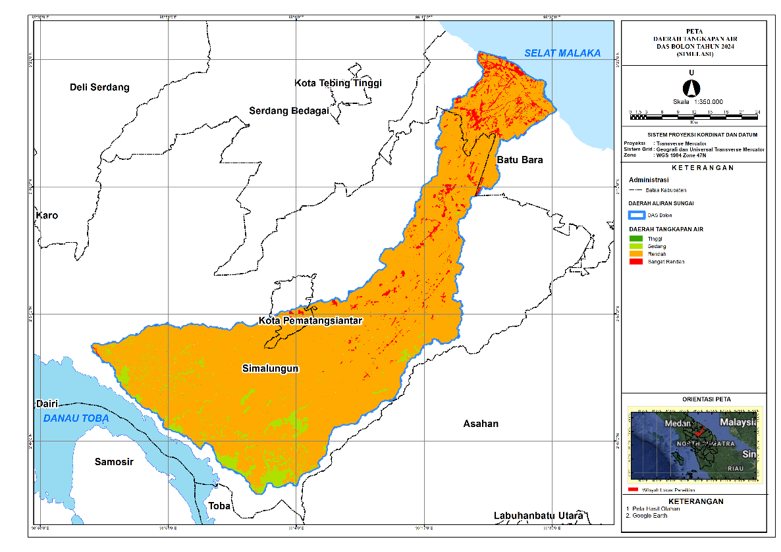
Figure 7. Catchment function map (2024)
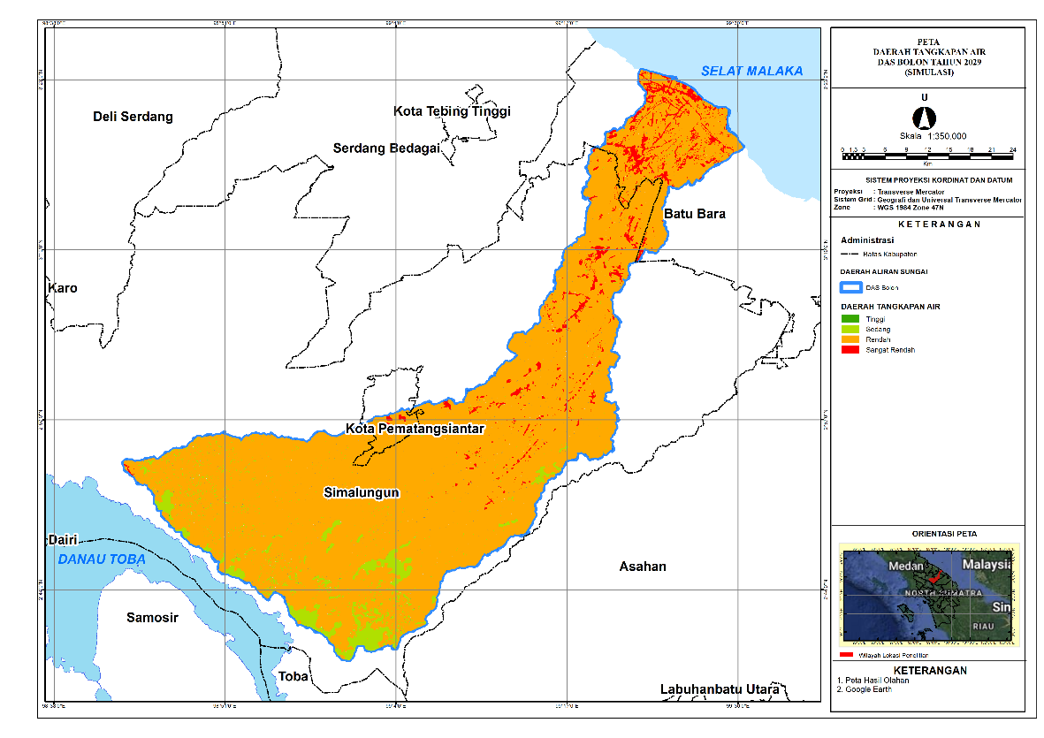
Figure 8. Catchment function map (2029)
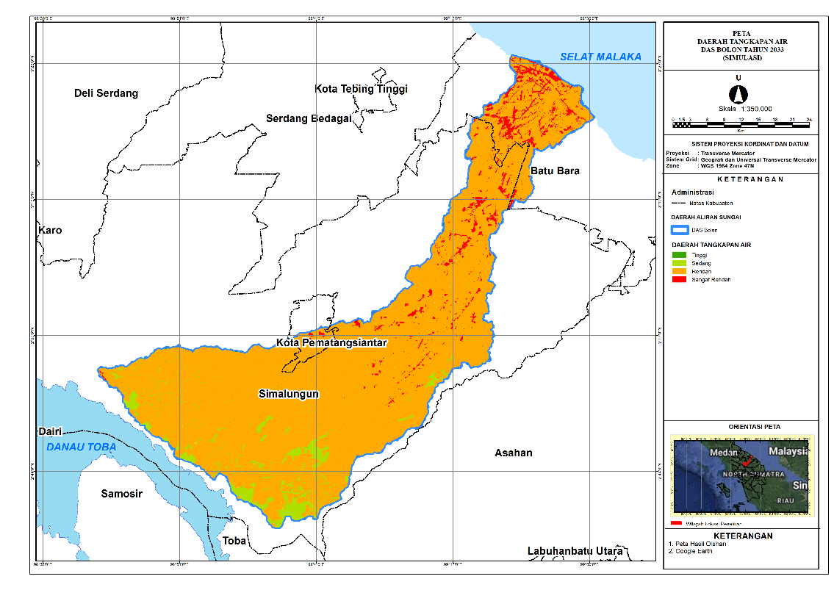
Figure 9. Catchment function map (2033)
3.5 Consistency of Water-Use Zones with RTRW
Overlay analysis shows that several water-use zones are not fully aligned with RTRW allocations, suggesting potential land–water governance conflicts.
Table 4. Overlay results: water-use zones vs. RTRW (2024)
Zone | Area (km²) | Consistency with RTRW (%)
Recharge Zone | 400 | 85%
Catchment Zone | 350 | 75%
Plantation Zone | 500 | 50%
Recharge and catchment zones show relatively high consistency, whereas plantation zones exhibit substantial mismatch. This indicates that plantation expansion may encroach upon areas that are hydrologically strategic for recharge and catchment functions, potentially undermining long-term water security.
3.6 Discussion
The overlay between water-use zones and the RTRW land-use structure provides a spatial diagnostic of alignment and potential conflict between watershed hydrological capacity and planned development directions. By integrating these layers, the analysis identifies where current and future land allocations are likely to support hydrological functions (e.g., recharge and flow regulation) versus where they may erode them through intensification of built-up, industrial, or high-input cultivation uses.
Across 2024, 2029, and 2033, the overlay reveals a consistent pattern. The very-low water-use zone is fully allocated to industrial cultivation areas (≈2.97 km² in 2024 and ≈2.93 km² in 2029–2033), indicating a hydrologically coherent match: areas with minimal capacity to provide/retain surface water are indeed planned for intensive economic use. In contrast, the low and medium zones dominate the watershed and are largely embedded within cultivation space, particularly agriculture (≈824.81 km² in 2024; ≈822.83 km² in 2029; ≈821.39 km² in 2033) and production forest (≈228 km² consistently). While portions of these zones fall within protected designations (e.g., water bodies, mangroves, conservation and local protection), the prevailing allocation to cultivation implies that large areas with limited-to-moderate hydrological function remain exposed to continued land-use pressure, potentially reinforcing low infiltration and elevated runoff if conservation practices are not mainstreamed.
Most critically, the high water-use zone—representing the best hydrological capacity—remains predominantly located within cultivation allocations, especially settlements and agriculture. The settlement footprint in the high zone increases from ≈59.05 km² (2024) to ≈61.46 km² (2029) and ≈62.70 km² (2033), while high-zone agriculture expands from ≈35.59 km² (2024) to ≈38.92 km² (2029) and ≈41.69 km² (2033). This persistent configuration signals a structural planning risk: hydrologically strategic areas are not sufficiently protected within the spatial plan and may experience functional degradation unless development controls, green infrastructure, and water-sensitive land management are strengthened. Consequently, the overlay indicates that the RTRW framework, while partially aligned with hydrological protection in designated protected sub-areas, may still permit cumulative impacts that reduce watershed resilience to flood–drought extremes.
Planning implications (compact)
- Priority protection: High-capacity water-use zones currently assigned to settlement and agriculture should be treated as hydrological priority areas, with stricter controls on impervious expansion and stronger requirements for green open space and drainage performance.
- Prevent “medium → low” degradation: Medium zones heavily used for agriculture and settlements should adopt conservation-oriented practices (e.g., infiltration enhancement, riparian buffers, erosion control) to avoid downward shifts in hydrological function.
- Targeted restoration: Where low-capacity zones intersect protected designations, restoration (vegetation recovery and hydrological rehabilitation) is needed to realign actual function with the protection intent.
- RTRW refinement: The recurring mismatch in high zones suggests the need to update or operationalize RTRW provisions using hydrological zonation as a constraint layer for permitting and zoning enforcement.

4. Conclusions
This study demonstrates that land-cover change has significant implications for water-use zonation in the Bolon River Watershed. GIS-based modelling using QGIS–MOLUSCE indicates that conversion from forests and wet agricultural land to plantations and built-up areas has reduced recharge potential and weakened catchment function. If these trajectories persist through 2033, the watershed will face increasing exposure to hydrological hazards, including flood and drought risks, with potential consequences for water availability and ecosystem stability.
Overlay analysis further reveals notable mismatches between water-use zones and the RTRW spatial plan, particularly within plantation zones. This suggests the need for more adaptive and proactive spatial planning that recognizes hydrological priorities and prevents development patterns from undermining watershed resilience.
Overall, the study offers spatially explicit evidence to support sustainable watershed management in the Bolon basin and provides a transferable modelling approach for other Indonesian watersheds experiencing similar land-conversion pressures.

References
Bappeda Prov. Sumatera Utara. (2017). Rencana Tata Ruang Wilayah Provinsi Sumatera Utara 2017–2037. Badan Perencanaan Pembangunan Daerah Provinsi Sumatera Utara.
DeMers, M. N. (2005). Fundamentals of Geographic Information Systems (3rd ed.). John Wiley & Sons.
Fardani, I., Mohmed, F. A. J., & Chofyan, I. (2020). Pemanfaatan Prediksi Tutupan Lahan Berbasis Cellular Automata-Markov dalam Evaluasi Rencana Tata Ruang (Studi Kasus Kota Cirebon). Majalah Kajian Geografi, 21(2), 157–169. https://doi.org/10.23887/mkg.v21i2.28121
Gao, C., Cheng, D., Iqbal, J., & Yao, S. (2023). Yellow River Region land cover and relationship analysis with mountain hazards. Land, 12(340), 1–24. https://doi.org/10.3390/land12020340
Gregorio, A., & Jansen, L. J. M. (2000). Land Cover Classification System (LCCS): Classification concepts and user manual for software version 1.0. FAO.
Iskandar, B., Saidah, Kurnia, A. A., Jauhari, A., & Zannah, F. (2023). Modeling land cover change using MOLUSCE in Kahayan Tengah Forest Management Unit, Central Kalimantan. Jurnal Sylva Lestari, 11(1), 79–97. https://doi.org/10.23960/jsl.v12i2.734
Kumari, S., & Roy, A. (2025). Simulation of land use and land cover using the MOLUSCE plugin integrated with QGIS for the Western Himalayan Region of India. ISPRS Archives, 48(5), 81–85. https://doi.org/10.5194/isprs-archives-XLVIII-M-5-2024-81-2025
Loucks, D. P., & van Beek, E. (2017). Water resources planning and management: An overview. In Water Resource Systems Planning and Management. Springer. https://doi.org/10.1007/978-3-319-44234-1_1
Muhammad, R., Zhang, W., Abbas, Z., Guo, F., & Gwiazdzinski, L. (2022). Spatiotemporal change analysis and prediction of future land use/land cover changes using QGIS MOLUSCE and remote sensing big data: A case study of Linyi, China. Land, 11(3). https://doi.org/10.3390/land11030419
Nasrullah, & Kartiwa, B. (2010). Landuse change analysis in relation to hydrological characteristic of Krueng Aceh watershed. Indonesian Soil and Climate Journal, (31). https://doi.org/10.2017/jti.v0i31.223
Prahasta, M. (2014). Introduction to GIS and Spatial Data Analysis. PT Elex Media Komputindo.
Ramadan, G. F., & Hidayati, I. N. (2022). Prediction and simulation of land use and land cover changes using open source QGIS: A case study of Purwokerto, Central Java, Indonesia. Indonesian Journal of Geography, 54(3), 344–351. https://doi.org/10.22146/IJG.68702
Santoso, D. H., Algary, T. A., & Hilmi, I. K. (2025). Land use change analysis using plugin MOLUSCE in Yogyakarta Urban Agglomeration Area. INSOLOGI: Jurnal Sains dan Teknologi, 4(2), 160–169. https://doi.org/10.55123/insologi.v4i2.5032
Speich, M. J., Zappa, M., Scherstjanoi, M., & Lischke, H. (2020). FORests and HYdrology under climate change in Switzerland v1.0. Geoscientific Model Development, 13(2), 537–564. https://doi.org/10.5194/gmd-13-537-2020
Sugiarto, I. D. (2018). Pemetaan Tata Guna Lahan Kota Batu dengan Data Penginderaan Jauh (Undergraduate thesis). Universitas Airlangga.

