Original Research Article

Assessment of Mosquito Larval Breeding Sites in Open Habitats within the University of Abuja Main Campus

Abstract:
Introduction: A survey of mosquito larval habitats was conducted at the University of Abuja main campus, Federal Capital Territory (FCT), Nigeria, during the wet season in August 2019. Methods: Larvae were collected using a dropper from various aquatic habitats including ground pools, gutters, stagnant water bodies, and discarded containers. A total of 133 larvae were sampled and identified, representing three genera and five mosquito species.
Result: The species composition was as follows: Aedes aegypti (15%), Culex quinquefasciatus (24%), Culex pipiens (3%), Anopheles gambiae (36.8%), Anopheles species (8.3%), and Aedes albopictus (12.8%). Statistical analysis revealed a non-significant difference (p > 0.05) in the distribution of mosquito species across the identified larval habitats. These findings highlight the ecological diversity of mosquito breeding sites within the study area and underscore the importance of larval habitat characterization in vector control efforts.
Conclusion and Recommendation: Improved understanding of the distribution and habitat preferences of mosquito larvae can inform more effective environmental management strategies to combat mosquito-borne diseases.

Keywords: Aquatic Habitat, Mosquitos species, Larvae, wet season, University of Abuja.

Introduction
Surveys of mosquito larvae are performed to determine the distribution of the various disease-transmitting mosquitoes in a given environment. The collection of data on mosquito larva habitus overtime will notify vector control operations, this will improve public health questions such as what kind of mosquitoes are targeted by vector control operations, when, where and how to target them, can be addressed after an accurate survey of mosquito larval (Aribodor et al., 2013)
Mosquitoes are very important to the health and economic development of humans. They transmit diseases to humans and animals. Mosquitoes are ranked first among the public health and veterinary important arthropods that spread diseases such as malaria, yellow fever, filariasis, dengue fever, encephalitis, and other viral and bacterial diseases (Imbahale et al., 2013).
Apart from the transmission of diseases, mosquitoes can be considered a public enemy because of the noise they make, the way they bite, and the outcome of their bites -sickness. (Oyindo, 2010). According to the World Malaria Report, WHO, 2012, malaria is transmitted by female anopheles mosquitoes and has infected more than 200 million people. It is also the cause of the death of up to 800,000 people all over the world, and 90% of the deaths in sub-Saharan Africa.
Malaria is a very common disease in Nigeria, and over 90% of the population is at risk of getting infected (FMOH, 2011). Almost 50% of the Nigerian population suffers from malaria at least once every year, and 11% of deaths of pregnant women and infants are related to malaria. (FMOH, 2011). About 132 billion naira is spent on the treatment and prevention of malaria. Malaria is the cause of some deformities in some children. For example, our children who suffered cerebral malaria, if they are not properly treated early, will end up not functioning well even after recovery.
Mosquitoes breed in habitats where there are water bodies, because water supports the life cycle of mosquitoes from egg to larva to pupa to adult. The adult mosquitoes lay their egg in different types of water bodies. Which mosquito species have environmental requirements to enable them to lay their eggs? Mosquito habitat type can be divided into open and closed habitats. Open habitats are defined as water bodies that are open to air and light; that is, in the open habitat, light can reach the water surface and plants. One of the problems that is limiting the effective control of mosquitoes and the disease they transmit is that mosquitoes breed in different habitats that occur naturally and are affected by human activities. (Sinka et al., 2011). This study is focused on investigating the open larval habitats of mosquitoes in the University of Abuja, main campus, FCT, Abuja. Nigeria.
Materials and Methods
The chapter consists of a map of the study area and the location, research design and population of the study, sample, and sampling procedures for data collection, method of data collection, and method of data analysis:

Geography of the Study Area
The study was undertaken in the University of Abuja, Gwagwalada, Abuja-Nigeria. The University of Abuja is located about 50km away from the federal capital city. It lies between latitudes 8.9817⁰N and 7.1811⁰E, covering an area of about 11,800 hectares of land.
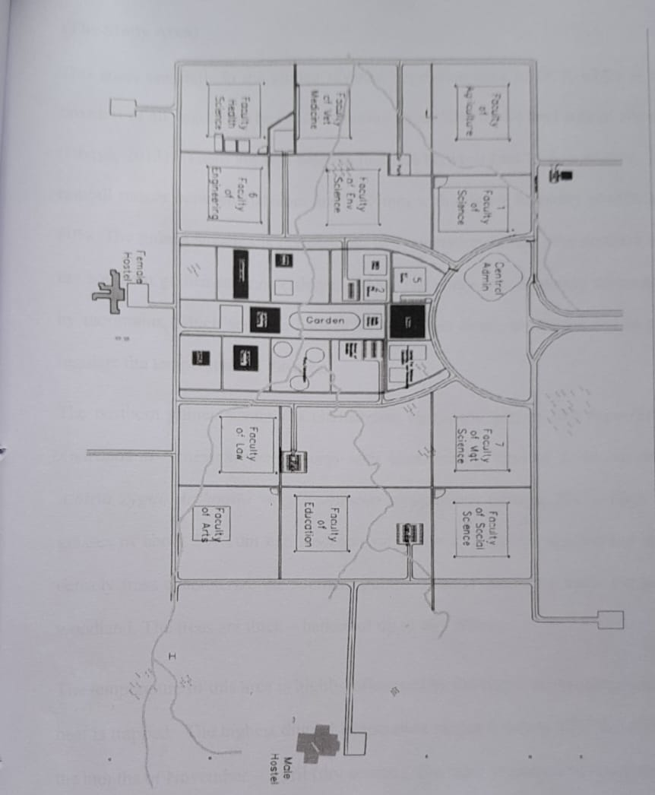
Figure 1. Map of the study area University of Abuja
The study area falls in the Guinea savanna vegetation of FCT, which is the broadest of all vegetation types, constituting about 50% of the land area of Nigeria. Two seasons last between four to five months. The rainfall ranges between 1016 mm and 1524 mm, with relative humidity levels of 60% to 80%. The Guinea savanna is divided into two vegetation zones: the northern and southern Guinea savannas (Ishaya, 2013). The study area is mainly surrounded by mountains, which serve as habitat for numerous living organisms and in turn regulate the temperature of the area.
The northern guinea savanna is characterized mainly by grasses like Hyparrhenia andropogon, Schizachyrium species, with interspersed trees of Isobelina doka, Alhizia Zygai, Anthoesta virgelli, Annona senegalensis. High fall grasses of about 5-10m (e.g., Andropogon gayanus, Tectorum species) and more dense trees characterize the southern guinea savanna. Hence, the name transitioned to woodland. The trees are thick-barked of up to 40 -50 feet.
The temperature of this area is highly influenced by the Niger-Benue trough, where heat is trapped. The highest diurnal temperature ranges between 27⁰C and 37⁰C in the months of November–April (dry season). The rainy season comes between the months of April to October, with the temperature range of 23⁰C and 27⁰C. (Ishaya, 2013).
Selection of Breeding Sites
Three communities (Girls Hostel, Boys Hostel, and Adelabu Market) were randomly selected, and every container with water or water bodies was identified and considered a potential breeding site. The breeding sites were those that had at least one larva in the habitat. The major habitat that was surveyed was open habitats.
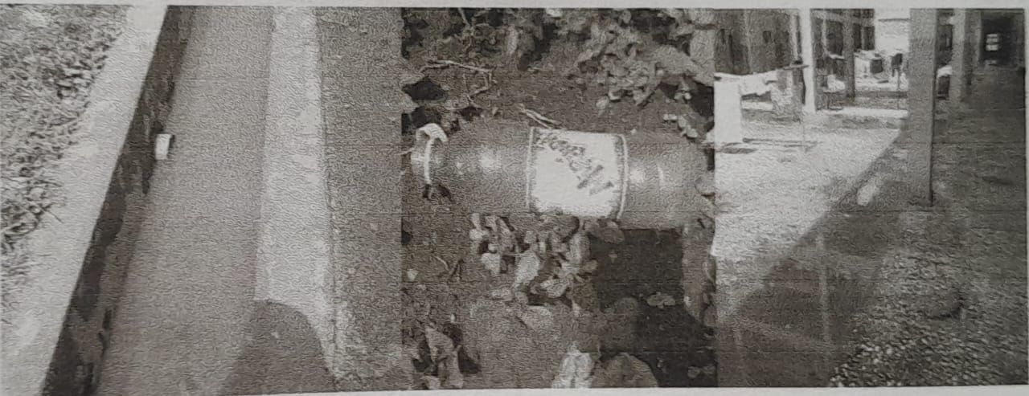
Figure 2, Girls Hostel site

Collection of Mosquito Larvae
Mosquito larvae were collected randomly from three sites within the university. The sites were Adelabu market, the Boys and Girls hostel of the University of Abuja. In each of these sites, mosquito larvae were sampled from three locations, making a total of nine locations. The breeding sites sampled were stagnant water pools, gutters, ground pools, and discarded containers. The vector sampling was concentrated on areas around human dwellings.
Methods of larval collections
Samples were collected during the rainy season, August 2019. Mosquito larvae were collected using dipper and pipettes as described by Adeleke et al. (2010). The larvae in a discarded container were collected with a pipette while those in other breeding sites were collected by using a standard dipper (400mI) recommended by WHO (2010; 2005). Ten dips were collected from each of the breeding sites. The samples collected from each breeding habitat were poured into a plastic container and transported to the Biological Laboratory of the University of Abuja. In the laboratory, the mosquito larvae were transferred into a Specimen bottle containing 75% ethanol and 15% formalin for preservation. Identification of mosquito larvae was done with the aid of a dissecting microscope using the identification keys by Wilke et al. (2016).
Identification of Mosquitoes
Identification of the mosquito larvae was carried out microscopically using morphological keys. The identification was based on gross external morphological features, appearance of the antennae, compound eyes, siphon, tracheal gills, palps, thorax, abdominal segment, etc. (Wilke et al., 2016).
Statistical Analysis
The statistical tools used were chi-square and Simpson's index of diversity (ED).

Results
A total of 133 mosquitoes (Table 1) comprising three genera (Anopheles, Aedesand Culex) and six species were obtained, 18.0% (N=24) were sampled from Ground pools, 28.7% (N=33) from stagnant water pools, 16.5% (N=22) from discarded containers, and 42.6% (N=54) from gutters.
Table 1: Total Mosquito Abundance And Diversity in University Abuja (Permanent Site) Oct, 2019
Mosquito Species | Breeding Sites |  |  |  | Total
Mosquito Species | Ground Pools | Discarded Container | Stagnant Water | Gutter
Aedes Aegypti | 7 | 5 | 3 | 5 | 20 | 15.0%
Aealbopictus | 2 | 3 | 5 | 7 | 17 | 12.8%
Anopheles Gambiae | 11 | 9 | 12 | 17 | 49 | 36.8%
An. Funestus | 4 | 0 | 0 | 0 | 4 | 3.0%
Culex Quinquefasciatus | 0 | 5 | 9 | 18 | 32 | 24.1%
Cx. Pipens | 0 | 0 | 4 | 7 | 11 | 8.3%
Total | 24 | 22 | 33 | 54 | 133
Percentage Total | 18.0% | 16.5% | 28.7% | 42.6%

Mosquito species identified include two species of Anopheles, An. gambiae and An. Funestus two species of Culex, Cx. quinquifasciatus and Cr. pipensand two species of Aedes, Aedesaegvpti and Ae. Albopictus. ln the open larval habitat, 18.0 % (24/133) were collected from the Ground pool, 28.7% (33/133) were collected from stagnant water, 16.5 % (22/133) were collected from discarded containers, and 42.6 % (54/133) were collected from the Gutter. The most abundant species collected from the gutter, stagnant water, Ground pool, and discarded containers were An. Gambiae, Cx. Quinquefasciatus, Ae. Aegvpti, and Ae. Alpobitus respectively. Overall, the most abundant genus of mosquito collected was Anopheles, while the most abundant species collected was An. Gambiae.
The distribution of the genera (Fig. l) shows that Anopheles are the most widely distributed (39.8%) in the area, followed by Culex (32.3%) and Aedes (27.8%).
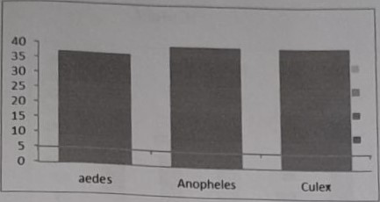
Figure 3: Distribution of Mosquito Genera in the Various Breeding Habitats in University of Abuja (Perm. Site) Source: Field Work 2019
The distribution of mosquito species in the breeding sites indicates that more species were found in the gutter, followed by stagnant water and ground pools. The least population was obtained in the discarded container. Among the mosquito larval species identified, An. gambiae (36.8%) was the most abundant and well distributed in all the breeding sites, this was followed by Culex quinquefacciatus (24.1%), Aedesaegypti(15.0%), and Ae. Albopictus, An. Funestus, An. Funestus, Cx. pipens has (12.8%, 8.3%, and 3.0%) respectively as shown in Figure 2 below.
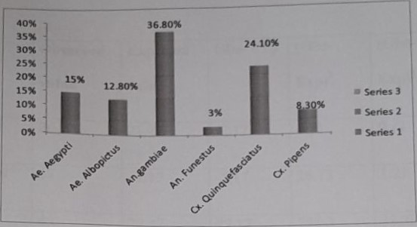

Figure 4, Mosquito Species Distribution in University of Abuja (Permanent Site), Source: Field Work 2019.

Table 2. The calculated X² to determine the difference in the distribution of mosquito species in the study Area.
Category | Observed Value | Expected Value | Obs- Exp | (Obs-Exp)² | (Obs-Exp)²/Exp
Aedes aegypi | 20 | 21.17 | -2.17 | 4.71 | 0.21
Ae. Alpobictus | 17 | 22.17 | -5.17 | 26.73 | 1.21
Anopheles gambiae | 49 | 22.17 | 27.17 | 738.2 | 33.30
An. Funestus | 4 | 22.17 | 10.17 | 103.4 | 4.66
Culex quinquefasciatus | 32 | 22.17 | 10.17 | 103.4 | 4.66
Cx. Pipens | 11 | 22.17 | -11.17 | 124.8 | 5.63
Total | 133 | 60.17

X² = 60
Df = 6-1 = 5
At a 5% significance level = 11.061
P value= 11.061
Decision rule
We reject HO, because the X² calculated is greater than the X² tabulated value at 5% (p < 0.05). Therefore, we accept HI, which says there is a significant difference in the distribution of mosquito species in the University of Abuja.

DISCUSSION
The project was carried out to identify the mosquito species breeding in the University of Abuja Main Campus. The three genera of mosquitoes encountered were well distributed in the study area (ED = 0.22). Larval survey revealed the co-breeding of Aedes, Culex, and Anopheles in a variety of habitats. Generally, the mosquitoes showed a preference for different breeding habitats. The distribution of these genera of mosquitoes in open larval habitats was statistically significant (P < 0.05) in the distribution of mosquito genera in the various breeding sites encountered. It then means that the type of larval habitat obtainable in any place would determine the mosquito genera that would be encountered in such a place.
This shows that the mosquito genera have their preferred choice of larval habitat. The study reveals gutter habitats to be the most favourable and successful habitat for the breeding of mosquitoes, followed closely by stagnant water habitats in the study area. This could be due to the fact that these habitats had the necessary requirements for the growth of mosquito larvae, such as favorable temperature, availability of adequate food, water, and other essential substances for their growth. Discarded container was observed to be a favourable habitat for mosquito breeding in the study area compared to the ground pool. This could have been influenced by the high rate of indiscriminate disposal of waste, especially of tins, plastics in the security village, which could retain enough water for the breeding of mosquitoes. The overall rich population of mosquitoes in the gutter/drains could be a result of the bad drainage system in the university, made of concrete, which makes it favorable for mosquito breeding. In general, the total abundance of mosquitoes in the habitats surveyed was slightly poor. This could be attributed to severe rainfall that characterized the period. Rainfall washes out larvae from their breeding habitats, leading to a reduction in their density. The disparity in the abundance and distribution of the mosquito species in the different locations could be due to different environmental conditions or microclimatic variations, as well as the availability of suitable preferred breeding sites. The most dominant specie observed from the study was Anopheles gambiae. The present result is in partial agreement with that reported elsewhere in Nigeria (Egbuche et al., 2016). The wide geographical distribution of Anopheles gambiae is likely to be associated with variations in its biology, enabling it to survive in a variety of different environmental conditions. However, the distribution of the mosquito species in the study area was not uniform (ED = 0.15%); An. Gambiae and Cx. Quiguefaciatus tend to be more abundant and use almost all the breeding sites encountered than other species. Anopheles mosquitoes in general breed in clean and oxygenated water (WHO, 2012).
The abundance of such habitats on campus creates a favourable environment for the breeding of the mosquito species. This mosquito species shows breeding preferences for domestic water containers. Stored water in the container for a long period, and ambient relative humidity and temperature may favour the breeding of Ae. aegypti and other aedine mosquitoes (Getachew et al., 2015). The types of containers, water quality, and conditions of water containers are important for breeding (Chen et al., 2011). Culex quiquefasciatus was the second dominant species in the studied habitat and was well distributed. Aedes was one of the most frequently encountered genera in the present survey. This mosquito species shows breeding preferences for domestic water containers. Stored water in the container for a long period, and ambient relative humidity and temperature may favour the breeding of Ae. aegvpti and other aedine mosquitoes (Getachew et al., 2015). Larvae belonging to this genus were present in quite high numbers throughout the survey period. The presence of Aedes, Culex, and Anopheles, which are known vectors of urban yellow fever, lymphatic filariasis, and malaria (Service, 2010). Suggest that the residents within the study area are at risk of mosquito-borne diseases. Mosquito-borne diseases infect more than 700 million people around the world each year, and they result in as many as two million deaths annually. Aedes aegypti is the most efficient vector for arboviruses because it is highly anthropophilic, frequently bites, and thrives in proximity to humans. It is the principal vector of dengue and dengue hemorrhagic fever in almost all countries. (WHO, 2012).
Ae. aegypti have also been implicated in large outbreaks of Zika virus disease. This is one mosquito species likely to give rise to an immediate public health problem if the authority fails to act appropriately within the study area. Culex quinquefasciatus is of great concern to public health as diseases such as lymphatic filariasis have been traced to this particular species in various parts of the country. Culex spp. are known to be the most important vectors of West Nile Virus (WNV), of which infections are increasingly occurring in many parts of the world. (Diaz et al., 2011). Mosquitoes of the An. gambiae complex have been reported as important vectors of malaria and lymphatic filariasis (LF), which are major public health diseases in Nigeria. The abundance of the species in this area could be associated with the favorable climatic conditions characteristic of the zone and the abundance of breeding habitats. Anopheles Gambiae is a widespread, efficient vector of Plasmodium parasites in sub-Saharan Africa (Sinka et al., 2012). Anopheles Gambiae is usually responsible for a nuisance to humans in villages along rivers, and its abundance rapidly decreases within a few kilometers of the breeding sites. It is considered a secondary malaria vector in Nigeria (Montoya et al., 2011). The flesh-eating habits of these vectors are a major contributing factor to their public health impact. It is possible that the Anopheles gambiae recorded in the study may be of local importance in disease transmission.
Conclusion
This study has provided important information on the types of mosquito larval breeding habitats in the university community. It has also created awareness about the vectors and the need for the university community to be protected. Furthermore, this study calls for regular spraying of the breeding sites and the residential houses using WHO-approved insecticides. The study recommends proper environmental management, health education, a good drainage system, and proper hygiene within the university community, which will reduce the breeding of these mosquitoes transmission.
Recommendation
The finding that mosquito larval species cohabitate in the different habitats, which are mostly man-made, suggested that larval control in the study area could be targeted to the breeding sites, and source reduction is the most effective. Furthermore, this study calls for regular spraying of the breeding sites using WHO-approved insecticides. The study recommends proper environmental management, health education, a good drainage system, and proper hygiene within the university community, which will reduce the breeding of these mosquitoes. Regular surveillance is also needed to monitor the increase of larval populations in the area in order to reduce disease transmission.

REFERENCES
Adeleke, M. A., Mafiana, C. F., Idowu, A. B., Sam-Wobo, S. O., & Idowu, O. A. (2010). Population dynamics of indoor sampled mosquitoes and their implication in disease transmission in Abeokuta, south-western Nigeria. Journal of Vector Borne Diseases, 47(1), 33–38.
Aribodor, D. N., Aribodor, O. B., Eneanya, C. I., & Onyido, A. E. (2013). Survey of open larval habitats of mosquitoes in four communities in Awka South Local Government Area, Anambra State, Nigeria. The Bioscientist Journal, 1(2), 132–139.
Balarabe M.B. Muhammad, H.R, Idris, H.S, and Emiri, J. (2012). Prevalence of Malaria among Blood Donors at General Hospital Suleja, Niger state, Nigeria. Instasci Journal of Medical Sciences and Clinical research. 2(1):46-49.
Chen, C. D., Lee, H. L., Stella-Wong, S. P., Lau, K. W., & Sofian-Azirun, M. (2011). Container survey of mosquito breeding sites in a university campus in Kuala Lumpur, Malaysia. Tropical Biomedicine, 28(3), 531–539.
Diaz-Badillo, A., Bolling, B. G., Perez-Ramirez, G., Moore, C. G., Martinez-Munoz, J. P., Padilla-Viveros, A. A., & de Lourdes Munoz, M. (2010). The distribution of potential West Nile virus vectors, Culex pipiens pipiens and Culex pipiens quinquefasciatus (Diptera: Culicidae), in Mexico City. Parasites & Vectors, 4(1), 1–12. https://doi.org/10.1186/1756-3305-4-70
Egbuche, C. M., Ejezie, G. C., Obiezue, R. N. N., & Okoye, I. C. (2016). A study on mosquito vector abundance and malaria infection rate in Enugu Metropolis, Enugu State, Nigeria. Nigerian Journal of Parasitology, 37(1), 47–53.
Getachew, D., Tekie, H., Gebre-Michael, T., Balkew, M., & Mesfin, A. (2015). Breeding sites of Aedes aegypti: Potential dengue vectors in Dire Dawa, East Ethiopia. Interdisciplinary Perspectives on Infectious Diseases, 2015, Article ID 706276. https://doi.org/10.1155/2015/706276
Ishaya, S. (2013). Vegetation and climate of the Federal Capital Territory: An overview. Journal of Geography and Environmental Management, 3(2), 25–31.
Montoya, M., Hemingway, J., & Simmons, C. P. (2011). Malaria, dengue and lymphatic filariasis elimination: Is integration possible? Trends in Parasitology, 27(10), 433–440. https://doi.org/10.1016/j.pt.2011.07.003
Onyido, A. E., Agbata, V. O., Umeanaeto, P. U., Obiukwu, M. O., & Amadi, E. S. (2010). Malaria burden and vector abundance in a sub-urban community in the rainforest zone of Nigeria. Nigerian Journal of Microbiology, 24(1), 2224–2230.
Ruqayyah Hamidu Muhammad, Bichi Armayau Hamisu, and BalarabeMusa Binta (2011). Knowledge, Attitude and Practices on Malaria in Kano Metropolis. World Journal of Life Sciences and Medical Research, 1(4): 83.
Service, M. W. (2010). A guide to medical entomology (pp. x–226). Macmillan Press.
Sinka, M. E., Bangs, M. J., Manguin, S., Rubio-Palis, Y., Chareonviriyaphap, T., Coetzee, M., Mbogo, C. M., Hemingway, J., Patil, A. P., Temperley, W. H., & others. (2011). The dominant Anopheles vectors of human malaria in the Americas: Occurrence data, distribution maps and bionomic précis. Parasites & Vectors, 4(1), 72. https://doi.org/10.1186/1756-3305-4-72
World Health Organization. (2005). Guidelines for laboratory and field testing of mosquito larvicides. https://pacmossi.org/carbon/assets/0007e8/00000a/Guidelines-for-laboratory-and-field-testing-of-mosquito-larvicides.pdf
World Health Organization. (2012). Global strategy for dengue prevention and control 2012–2020. https://www.who.int/publications/i/item/9789241504034

