Original Research Article

Assessment of Wind Energy Potential in North Central Nigeria Using Weibull Distribution for Sustainable Energy Planning and Generation

Abstract
.
This study assesses the wind energy potential of five states in North Central Nigeria: Benue, FCT Abuja, Kogi, Kwara, and Nasarawa using statistical modeling of wind speed data. Monthly mean wind speed data were analyzed with the two-parameter, Weibull probability distribution function to estimate key parameters: the shape factor (k), scale factor (c) and mean wind speed. Probability density functions (PDF) and cumulative distribution functions (CDF) were also plotted to evaluate the frequency and exceedance probabilities of wind speeds relative to wind turbine cut-in thresholds. The results show that wind speeds in the region are generally moderate, with seasonal variation influenced by the Harmattan winds. Benue and Kwara States demonstrated the highest potential, with wind speeds exceeding 3 m/s for over 50% of the year, while Abuja and Kogi recorded weaker wind resources. Nasarawa exhibited intermediate potential. The findings suggest that while large-scale wind farms may not be feasible in the region, small to medium-scale wind systems are viable, especially when integrated with solar energy in hybrid systems. This study concludes that hybrid renewable systems (solar-wind) represent the most sustainable pathway for improving energy access in North Central Nigeria, particularly in rural communities.

Keywords: Wind speeds; wind energy potential; shape factor; scale factor; probability density functions; cumulative distribution functions; North Central Nigeria; seasonal variation

1. INTRODUCTION
Nigeria continues to contend with pervasive energy supply challenges, including frequent outages, insufficient generation capacity, and heavy dependence on fossil fuels, all of which contribute to environmental degradation and hinder socio-economic development (GlobalData, 2025). In response, the country has increased its focus on renewable energy, with wind and solar identified as essential components of its energy transition strategy (Energy Council, 2025; GlobalData, 2025).
Despite these ambitions, wind energy remains underexploited in Nigeria. According to the Nigeria Wind Energy Council (NWEC), the country has potential to add approximately 7 gigawatts (GW) of wind capacity by 2050, particularly in its windiest zones where average wind speeds at hub heights are estimated at about 6.79 m/s in key areas (Energy Council, 2025). However, current operational wind installations are scarce and of low capacity (for example, the Katsina wind farm, ~10.175 MW) (Energy Council, 2025).
Recent policy and institutional developments underscore renewed interest. The Federal Government has allocated funding to support the rollout of solar, wind, hydro, and coal-based energy systems for millions of households by end-2025 (FG Targets, Independent Newspaper, 2025). Also, the Renewable Energy Master Plan (REMP) projects an increase in Nigeria’s renewable electricity share from 23% in 2025 to 36% by 2030, with specific targets for wind energy (GlobalData, 2025).
In the academic domain, newer studies are providing more localized assessments of wind energy potential. For example, Assessments of Wind-Energy Potential of Four Nigeria States for Sustainable Development (Abiem, Ani, Igbawua, & Ortwer, 2025) provides empirical data on wind power in selected states, contributing to filling existing gaps. Another recent work, Wind Energy Resource Assessment in Nigeria: A Methodological Approach (Nwachuku & Morka, 2024), outlines a comprehensive method using long-term meteorological data to process wind speed distributions and frequency for determining suitability of wind energy sites.
Given the regional variability in wind regimes and scarcity of detailed assessments for many states in North Central Nigeria, this study aims to assess the wind energy potential of Benue, FCT Abuja, Kogi, Kwara, and Nasarawa States using Weibull distribution modelling of monthly wind speed data. Specifically, the study will estimate Weibull parameters (shape and scale), examine wind speed exceedance probabilities, and identify which of these states are most promising for renewable wind energy deployment, alone or in hybrid systems with solar.

2. methodology

2.1 Research Design
This study employed a quantitative research design using meteorological wind speed data to assess the wind energy potential of selected states in North Central Nigeria. The analysis was based on statistical modeling using the Weibull probability distribution function, which is widely recognized as a standard approach for characterizing wind regimes (Seguro & Lambert, 2000; Akdag & Dinler, 2009).

2.2 Description of the Study Area
The study covered five states in North Central Nigeria: Benue, Federal Capital Territory (FCT) Abuja, Kogi, Kwara, and Nasarawa. These states were selected because of their strategic importance in the Nigerian energy sector and their geographical positioning within the Middle Belt region. The region is characterized by a tropical climate with distinct wet and dry seasons, which significantly influence wind patterns (Akinsanola & Ogunjobi, 2014).

2.3 Data Collection
Monthly mean wind speed data for each state were obtained from reliable meteorological sources: Nigerian Meteorological Agency – NIMET, and secondary datasets from reanalysis models from NASA POWER. The dataset covered multiple years to ensure accuracy and to capture seasonal variability.
  - Data Analysis Techniques
2.4.1 Statistical Modeling with Weibull Distribution
The two-parameter Weibull probability distribution was used to model wind speed frequency. It is described by the probability density function (PDF):
$f(v)=\frac{k}{c}{\left(\frac{v}{c}\right)}^{k-1}e^{{-(\frac{v}{c})}^{k}}$ (1)
where: v = wind speed (m/s), k = shape parameter (dimensionless), c = scale parameter (m/s). The cumulative distribution function (CDF), which gives the probability that wind speed is less than or equal to a given value, is expressed as:
$F\left(v\right)=1-e^{{-(\frac{v}{c})}^{k}}$ (2)
2.4.2 Estimation of Weibull Parameters
The parameters k and c were estimated using the Maximum Likelihood Method (MLM), which provides accurate estimates for wind speed data (Seguro & Lambert, 2000). The expressions are:
${k=\left(\frac{\sum_{i=1}^{n}{v_{i}^{k}\ln{v_{i}}}}{\sum_{i=1}^{n}{v_{i}^{k}}}-\frac{\sum_{i=1}^{n}{\ln{v_{i}}}}{n}\right)}^{-1}$ (3)
${c=\left(\frac{1}{n}\sum_{i=1}^{n}{v_{i}^{k}}\right)}^{1/k}$ (4)
where: n = number of data points, $v_{i}$ = wind speed data
2.4.3 Mean Wind Speed
The mean wind speed under the Weibull distribution is given by:
$\overline{v}=c.Γ\left(1+\frac{1}{k}\right)$ (5)
where Γ is the Gamma function.
2.4.5 Probability and Cumulative Distribution Functions
The PDF and CDF were plotted for each state to show:
- The likelihood of different wind speeds occurring (PDF)
- The percentage of time wind speeds exceed turbine cut-in speed (CDF)
This helps evaluate turbine performance and potential electricity generation in each location.
2.5 Data Presentation
The results were presented in the form of: Graphs of monthly average wind speed to show seasonal variability, Plots of Weibull parameters (k and c) to illustrate wind regime characteristics and PDF and CDF plots to describe wind speed distributions and exceedance probabilities. These results were then compared across the five states to identify the most promising locations for wind energy development.
3. results and discussion
This section discusses the wind speed characteristics of the five North Central Nigerian states under study: Benue, FCT Abuja, Kogi, Kwara, and Nasarawa. For each state, the monthly average wind speed, Weibull distribution parameters (k and c), and the probability density and cumulative distribution functions are analyzed. These findings help assess the feasibility of wind energy generation in the region.
3.1 Wind Speed Data for Benue
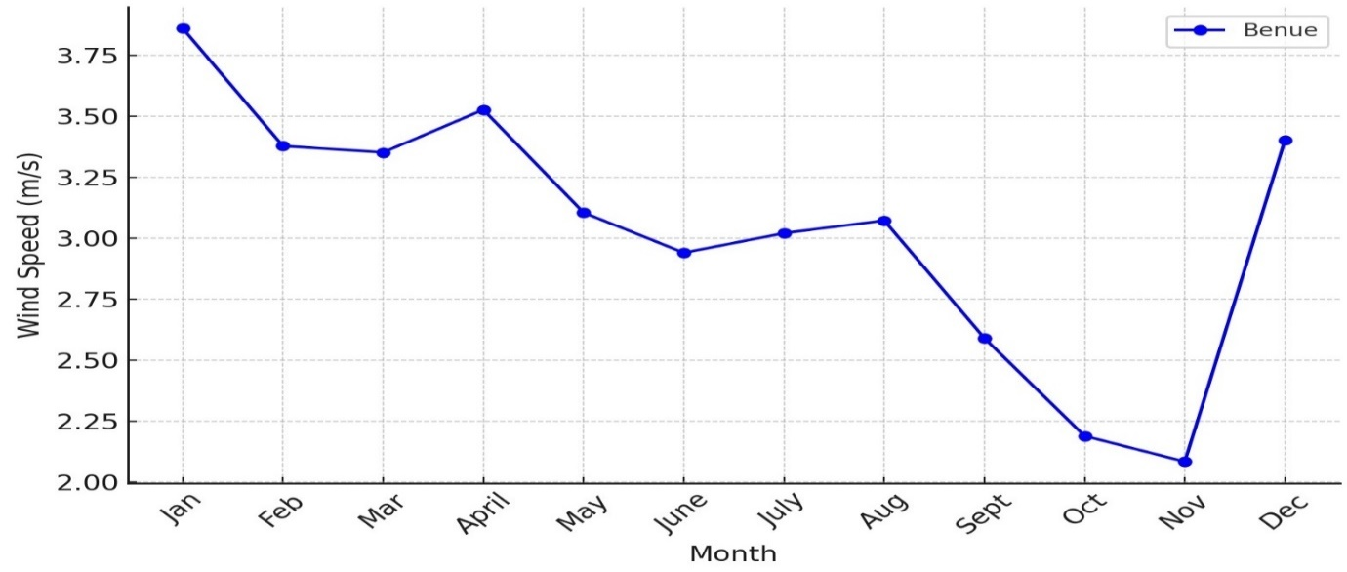
Fig 1: Average Wind Speed variation for different months for Benue State
Fig 1, shows that Benue exhibits moderate seasonal variation in wind speed, with higher values observed between December and March (dry season), and lower values between April and September (rainy season). This trend reflects the influence of the Harmattan winds, which enhance wind speeds during the dry months (Akinsanola & Ogunjobi, 2014).
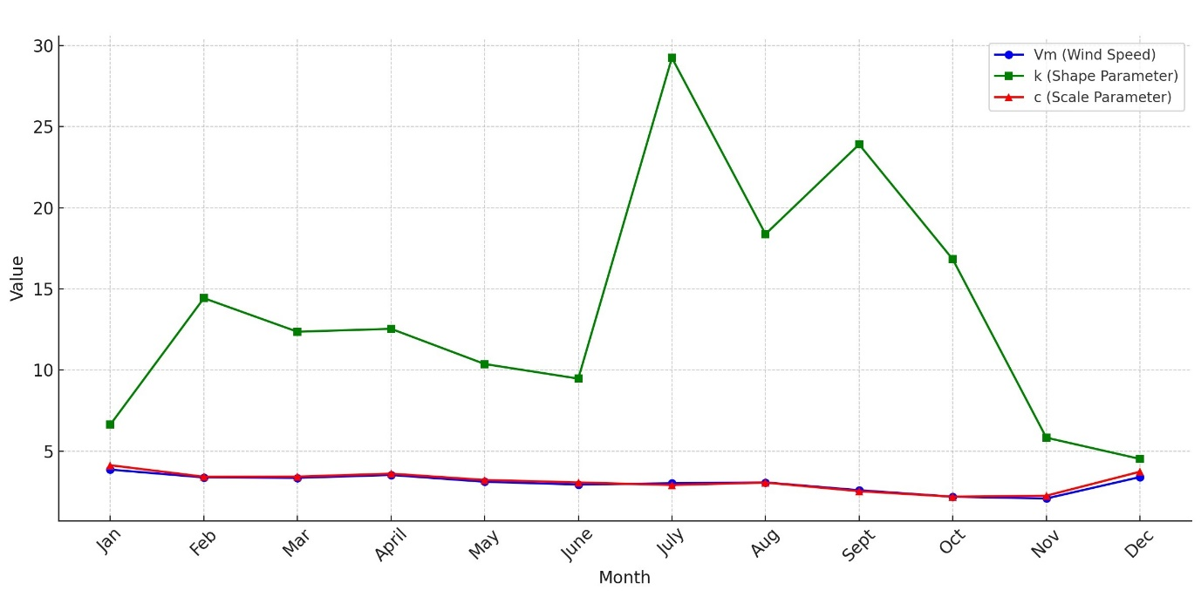
Fig 2: Variation of Wind Speed, k, and c for different months for Benue State
Fig 2, shows the Weibull Parameters, the Weibull scale factor (c) is relatively high during the dry season months, reflecting stronger winds, while the shape factor (k) indicates moderate consistency. This suggests that Benue has a more stable wind regime compared to other states in the region.
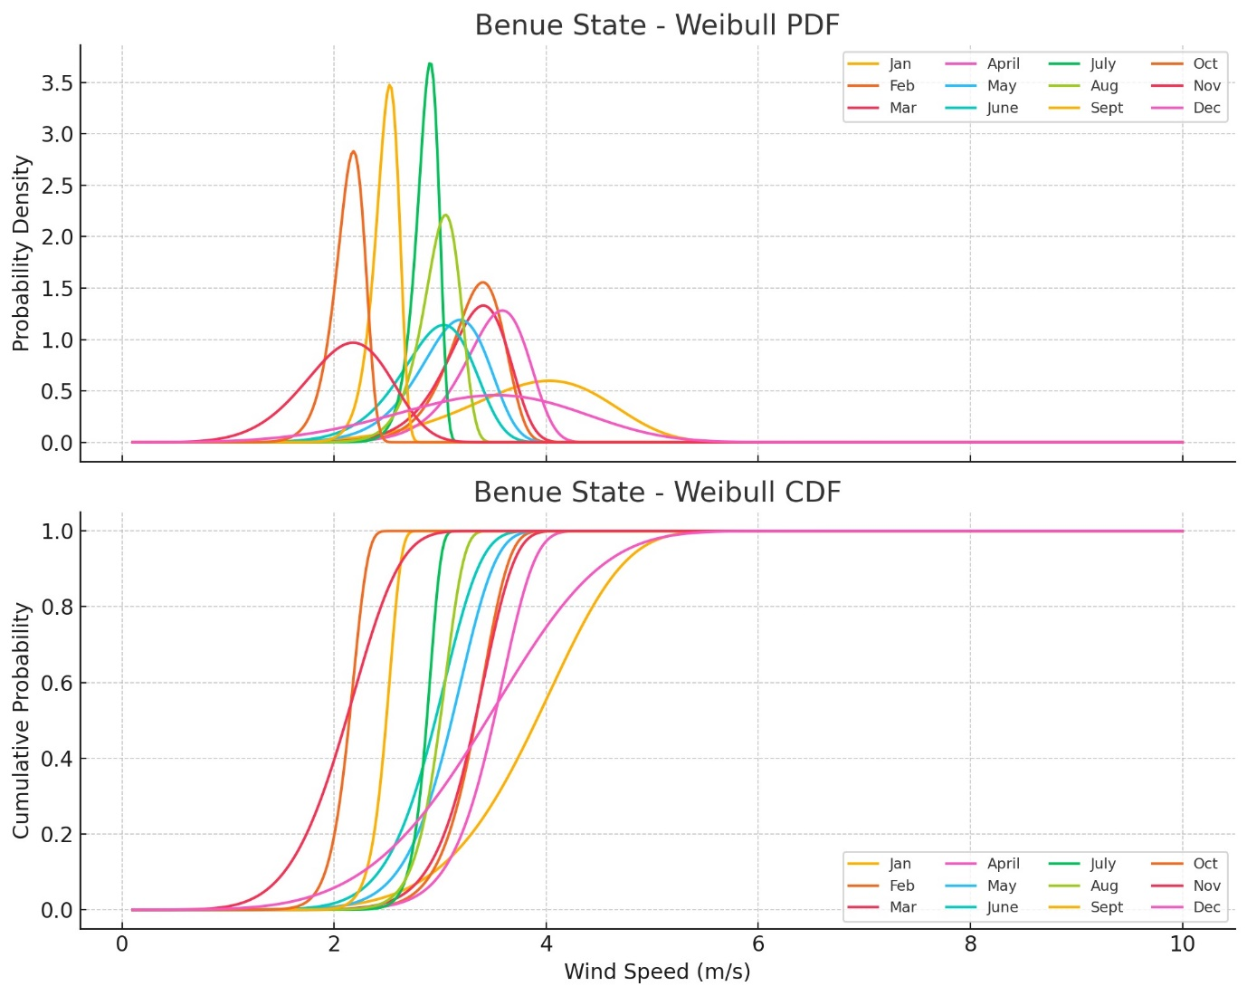
Fig 3: Wind Speed on a Monthly basis for Benue State (a) Probability Density Function and (b) Cumulative Distribution functions
The PDF indicates that wind speeds between 3–4 m/s occur most frequently. The CDF shows that wind speeds exceed the cut-in speed of 3 m/s approximately 55–60% of the time, making Benue one of the more promising locations in North Central Nigeria for small to medium-scale wind energy applications.
3.2 Wind Speed Data for FCT Abuja
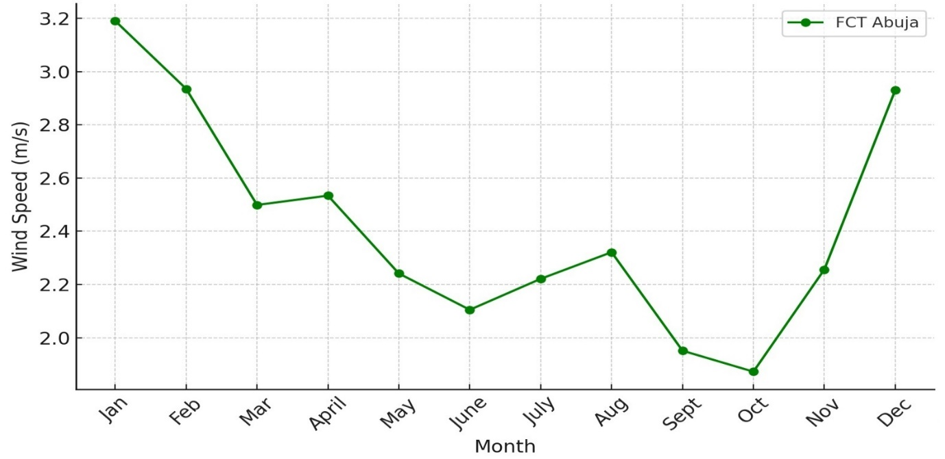
Fig 4: Average Wind Speed variation for different months for FCT Abuja
Abuja records relatively low wind speeds compared to Benue and Kwara. Wind speeds peak slightly in the dry season but remain generally low throughout the year. This suggests limited potential for standalone wind projects.
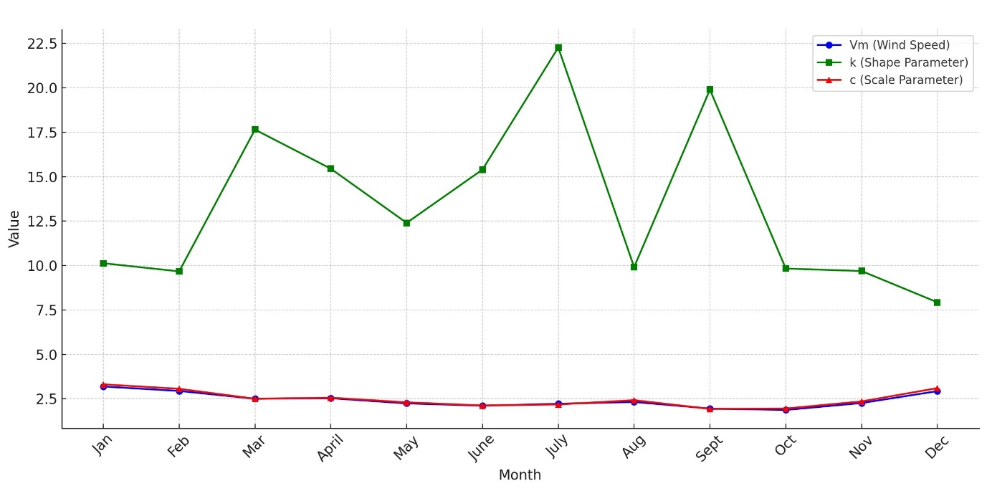
Fig 5: Variation of Wind Speed, k, and c for different months for FCT Abuja
The scale factor (c) values are lower than those of Benue, while the shape factor (k) varies widely, indicating that Abuja’s wind resource is less consistent. This variability reduces the reliability of wind power in the area.
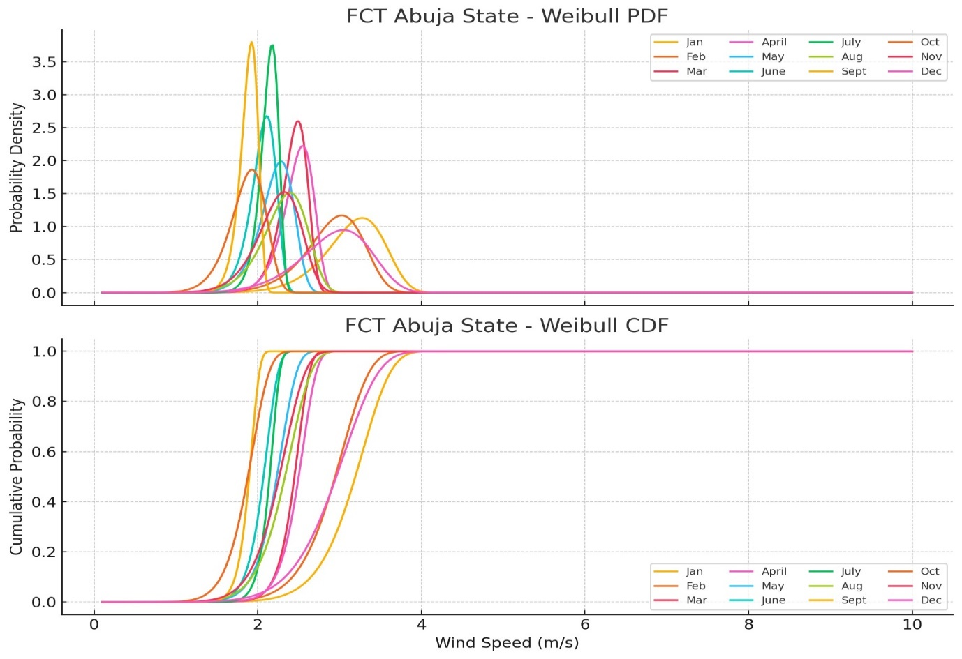
Fig 6: Wind Speed on a Monthly basis for FCT Abuja (a) Probability Density Function and (b) Cumulative Distribution functions.
The PDF shows that wind speeds are most frequently below 3 m/s, while the CDF reveals that winds exceed 3 m/s less than 40% of the time. This implies that large-scale wind power generation in Abuja would be unfeasible, but localized, small-scale wind systems may still be useful for hybrid applications with solar PV.
3.3 Wind Speed Data for Kogi State
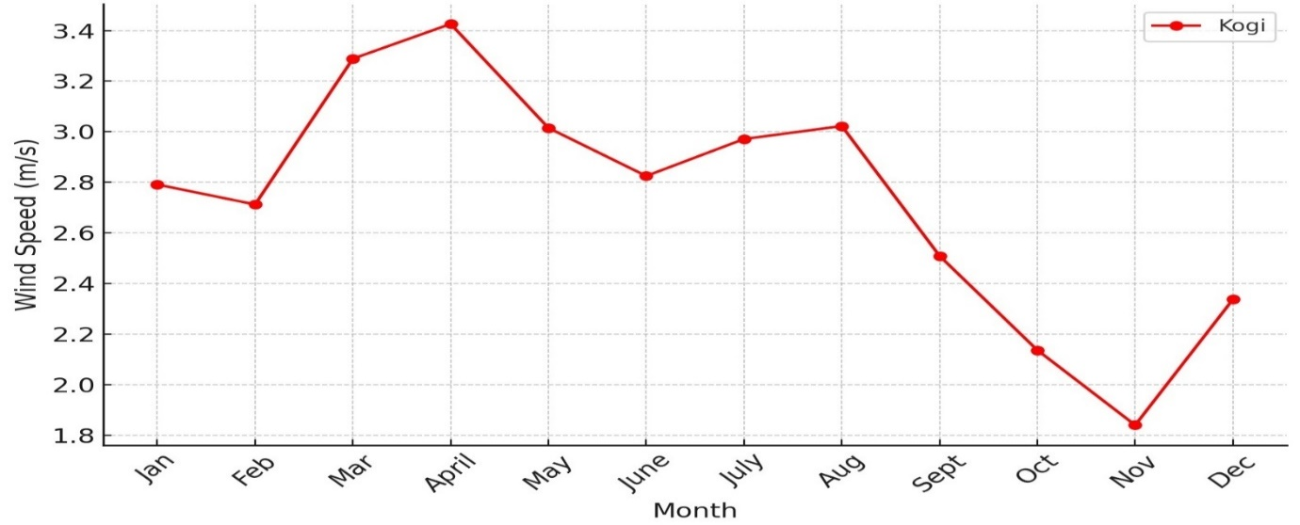
Fig 7: Average Wind Speed variation for different months for Kogi State
Kogi shows similar seasonal trends to other states, with slightly higher wind speeds in the dry season. However, average wind speeds remain relatively low, making wind energy potential limited.
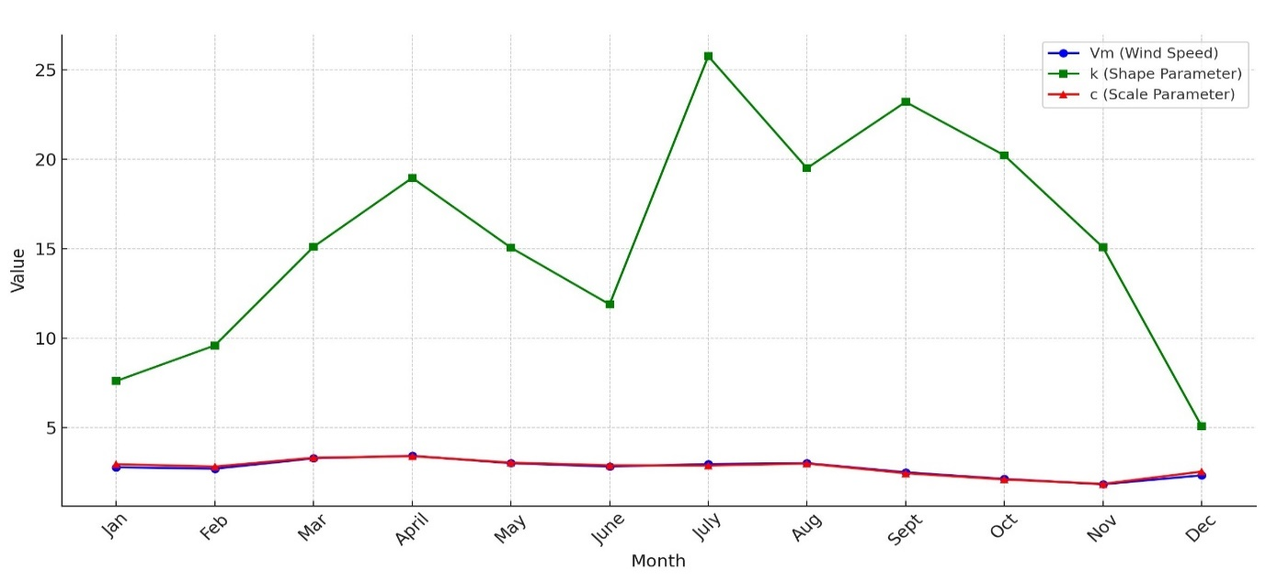
Fig 8: Variation of Wind Speed, k, and c for different months for Kogi State
The scale factor (c) values are modest, reflecting weak wind resources. The shape factor (k) is inconsistent, indicating variable winds with limited reliability for turbine operation.
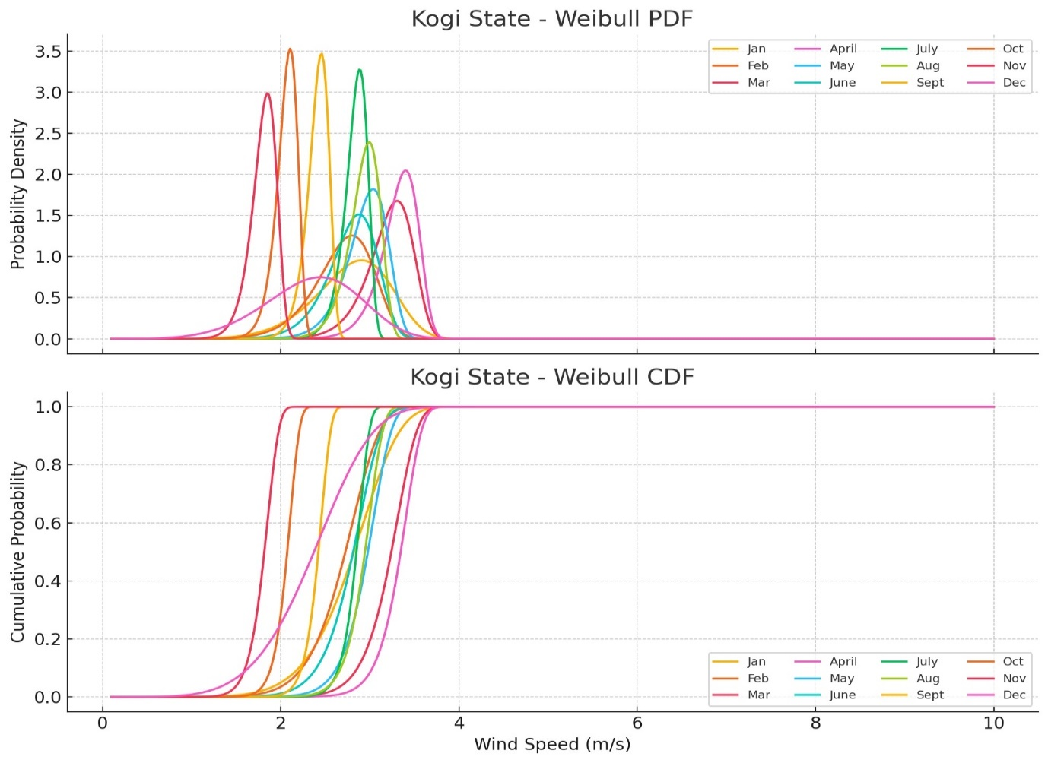
Fig 9: Wind Speed on a Monthly basis for Kogi State (a) Probability Density Function and (b) Cumulative Distribution functions
The probability distribution shows that wind speeds are most often in the 2–3 m/s range. The cumulative distribution reveals that wind speeds exceed 3 m/s less than 45% of the time. Thus, Kogi is more suitable for very small-scale wind applications, such as water pumping or supplementing hybrid systems, rather than large-scale electricity generation.
3.4 Wind Speed Data for Kwara State
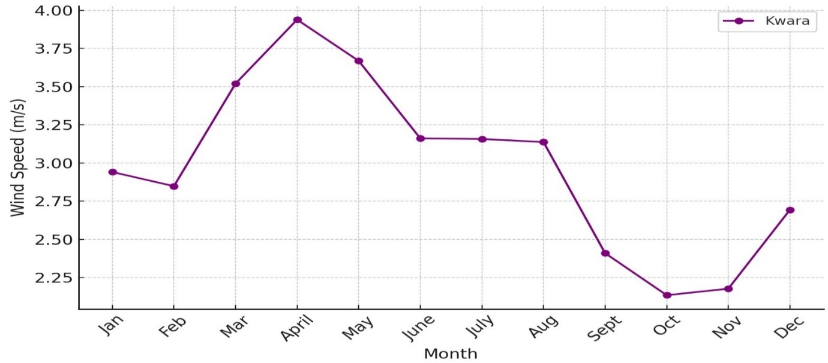
Fig 10: Average Wind Speed variation for different months for Kwara State
Kwara displays moderately higher wind speeds compared to Abuja and Kogi, particularly during the dry season. This suggests a more favorable environment for wind energy utilization.
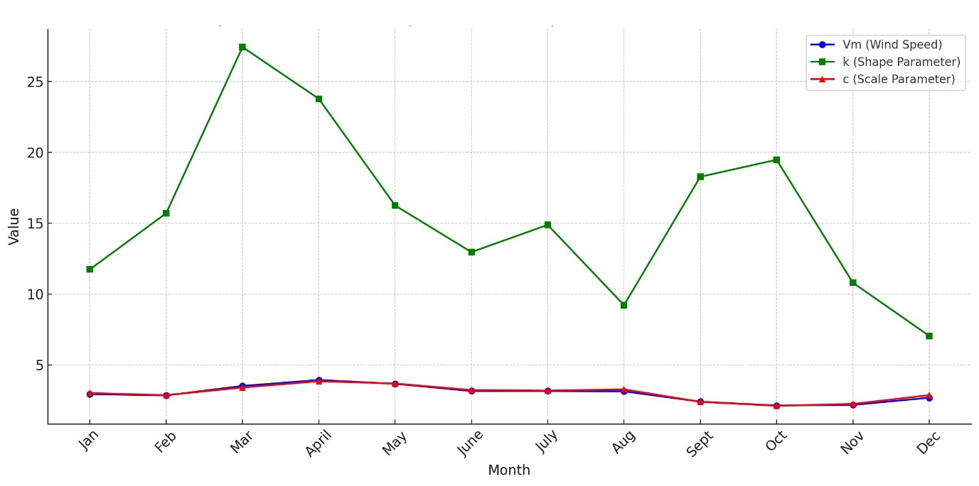
Fig 11: Variation of Wind Speed, k, and c for different months Kwara State
The scale factor (c) values are higher than in Abuja and Kogi, and the shape factor (k) suggests more stable winds. This means Kwara has a more consistent wind pattern, making it relatively better suited for wind energy exploitation.
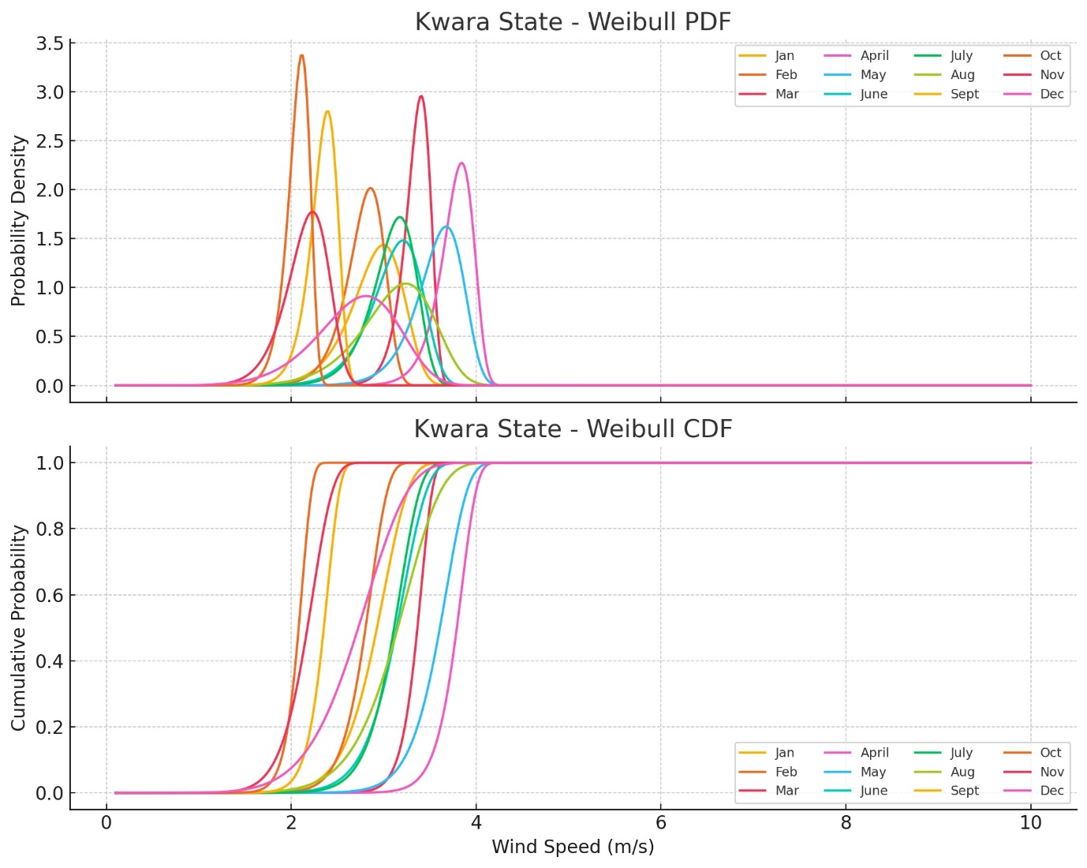
Fig 12: Wind Speed on a Monthly basis for Kwara State (a) Probability Density Function and (b) Cumulative Distribution functions.
3.5 Wind Speed Data for Nasarawa
The PDF shows that wind speeds around 3–4 m/s occur more frequently. The CDF indicates that wind speeds exceed 3 m/s for about 50–55% of the time. This places Kwara alongside Benue as one of the better-performing states for wind energy potential in the region.
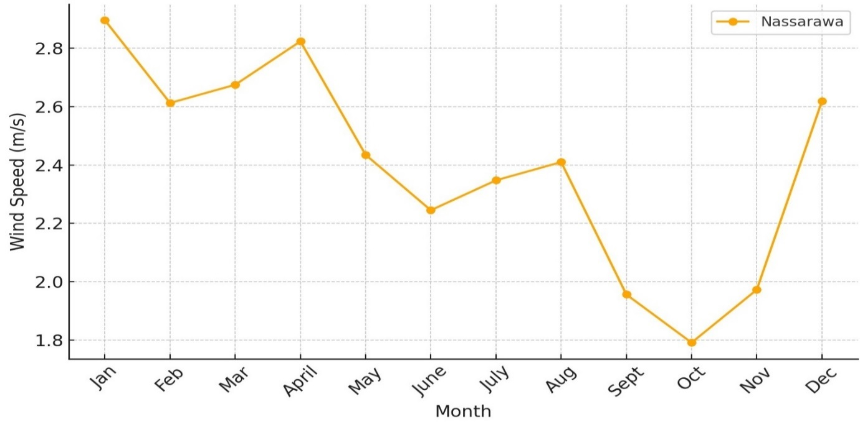
Fig 13: Average Wind Speed variation for different months for Nasarawa State
Nasarawa exhibits seasonal variation, with higher wind speeds in the dry season and lower speeds in the wet season. Overall, wind speeds are moderate, making the state’s potential intermediate between Kwara/Benue and Abuja/Kogi.
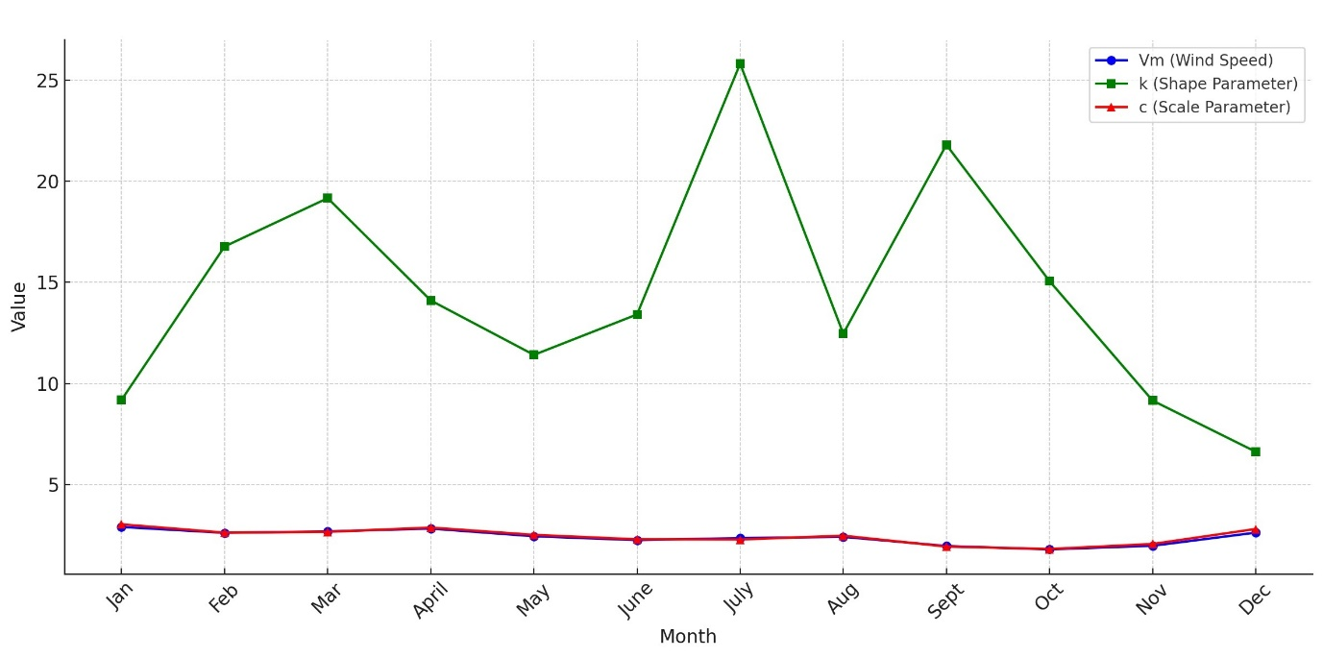
Fig 14: Variation of Wind Speed, k, and c for different months for Nasarawa State
The scale factor (c) is moderate, reflecting fair wind strength, while the shape factor (k) suggests moderate consistency. This indicates Nasarawa has usable but not outstanding wind resources.
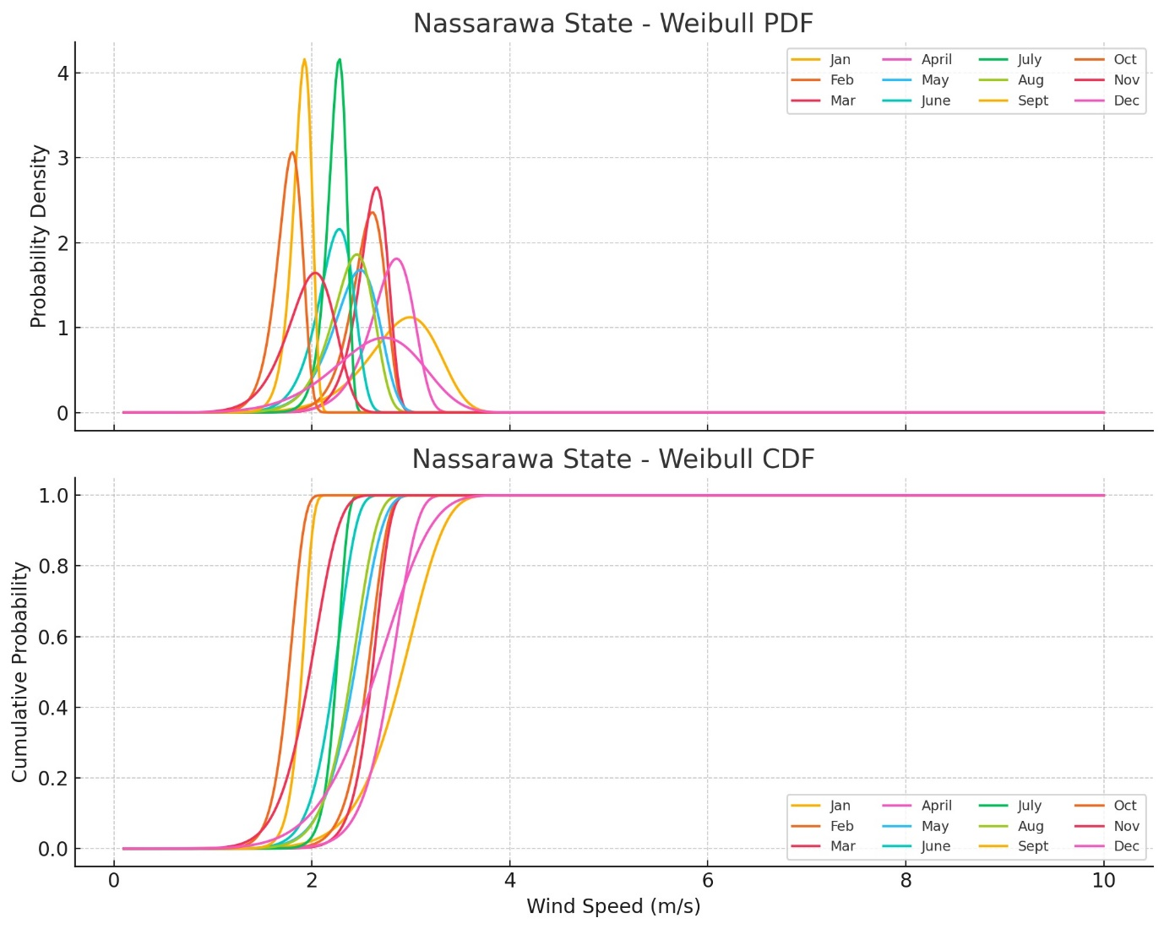
Fig 15: Wind Speed on a Monthly basis for Nasarawa state (a) Probability Density Function and (b) Cumulative Distribution functions
The PDF curve shows that 3–4 m/s winds are most frequent, while the CDF indicates wind speeds exceed 3 m/s for roughly 45–50% of the time. Thus, Nasarawa is suitable for small-scale wind power projects but unlikely to sustain large-scale wind farms.
3.6 Comparative Analysis
The analysis of wind characteristics across the five states shows both similarities and variations in wind speed, Weibull parameters, and probability distributions. Table 4.1 summarizes the comparative findings.

Table 1. Comparative Analysis of Wind Energy Potential in North Central Nigeria
State | Average Monthly Wind Speed (m/s) | Weibull Scale Factor (c) | Weibull Shape Factor (k) | % of Time Wind > 3 m/s | Overall Potential
Benue | 3.0 – 5.0 (higher in dry season) | Moderate–High (4–5) | Moderate (2–3) | ~55–60% | High (Best in study)
Kwara | 2.8 – 4.8 (seasonal variation) | Moderate (3.5–4.5) | Moderate (2–3) | ~50–55% | High–Moderate
Nasarawa | 2.5 – 4.5 (seasonal variation) | Moderate (3–4) | Moderate (2–3) | ~45–50% | Moderate
Kogi | 2.0 – 3.8 (lower overall) | Low–Moderate (2.5–3.5) | Variable (1.5–2.5) | ~40–45% | Low–Moderate
Abuja | 2.0 – 3.5 (weakest) | Low (2–3) | Variable (<2) | ~35–40% | Low (Least in study)

3.6.1 Discussion of Comparative Results
- Benue and Kwara: These two states demonstrate the most promising wind resources, with average wind speeds frequently exceeding 3 m/s and Weibull scale factors (c) higher than other states. The probability of wind speeds surpassing turbine cut-in thresholds is over 50% of the time, making them suitable for small to medium-scale wind projects such as community electrification and water pumping.
- Nasarawa: This state shows intermediate wind potential. While the wind speeds are not as high as in Benue and Kwara, they are still sufficient for localized applications and for integration into hybrid renewable systems.
- Kogi and FCT Abuja: These locations exhibit the weakest wind resources, with average speeds rarely exceeding 3.5 m/s and low Weibull scale factors. The probability of exceeding turbine cut-in speeds is below 45%, indicating that standalone wind systems are not feasible. However, wind can still play a supplementary role when combined with solar energy in hybrid systems.
4. Conclusion
The wind resource in North Central Nigeria is adequate for decentralized, small to medium-scale applications such as rural electrification, water pumping, and hybrid renewable energy systems. Benue and Kwara show the greatest promise, while Abuja and Kogi are the least favorable. a hybrid approach, integrating wind with solar energy, is the most viable pathway to maximize renewable energy exploitation in the region, ensuring reliability, cost-effectiveness, and sustainability.

References
Abiem, L. T., Ani, D., Igbawua, T., & Ortwer, F. I. (2025). Assessments of wind-energy potential of four Nigeria states for sustainable development. Nigerian Journal of Physics, 34(2), 158–171.
Akdag, S. A., & Dinler, A. (2009). A new method to estimate Weibull parameters for wind energy applications. Energy Conversion and Management, 50(7), 1761–1766. https://doi.org/10.1016/j.enconman.2009.03.020
Akinsanola, A. A., & Ogunjobi, K. O. (2014). Analysis of wind speed characteristics and wind energy potential in three selected locations in south-west Nigeria. International Journal of Energy and Environmental Engineering, 5(3), 151–157. https://doi.org/10.1007/s40095-014-0109-4
Energy Council. (2025, January 10). Energy Council proposes how Nigeria can gain 7GW from wind. Independent Newspaper Nigeria. https://independent.ng/energy-council-proposes-how-nigeria-can-gain-7gw-from-wind
Federal Government of Nigeria. (2025, April). FG targets five million Nigerians to access solar, wind, hydro, coal-based energy systems. Independent Newspaper Nigeria. https://independent.ng/fg-targets-five-million-nigerians-to-access-solar-wind-hydro-coal-based-energy-systems
GlobalData. (2025, June). Nigeria’s renewable power capacity to reach 1.7 GW in 2035, forecasts GlobalData. GlobalData Energy. https://www.globaldata.com/media/power/nigerias-renewable-capacity-reach-1-7gw-2035-forecasts-globaldata
Nwachuku, D. N., & Morka, J. C. (2024). Wind energy resource assessment in Nigeria: A methodological approach. Nigerian Journal of Physics, 33(4), 172–176.
Seguro, J. V., & Lambert, T. W. (2000). Modern estimation of the parameters of the Weibull wind speed distribution for wind energy analysis. Journal of Wind Engineering and Industrial Aerodynamics, 85(1), 75–84. https://doi.org/10.1016/S0167-6105(99)00122-1

