Case Report

Ocular and Dermatological Findings in an Immunocompromised Patient with Demodicosis : A Case Report

Abstract:
Background:
Demodex mites are common commensals of human skin and eyelids but may become pathogenic in immunocompromised individuals. Increased mite density has been associated with ocular surface disease, blepharitis, and dermatological manifestations, particularly in patients receiving long-term immunosuppressive therapy.
Case Presentation:
We report a woman in her late 60s with lupus nephritis on immunosuppressive therapy who presented with persistent facial dryness, erythema, scaly patches, and chronic eyelid itching unresponsive to antibacterial treatment. Dermatological assessment with Standardized Skin Surface Biopsy revealed a high density of Demodex mites (>5 mites/cm²). Ophthalmological examination demonstrated cylindrical dandruff, and eyelash epilation confirmed Demodex infestation. A combined treatment regimen of topical ivermectin 1% cream, tea tree oil–based eyelid wipes, and antibiotic ointment led to marked improvement within six weeks. By three months, both dermatological and ocular symptoms had resolved completely, and follow-up testing confirmed normalized mite density. No recurrence occurred during 12 months of follow-up.
Conclusion:
This case highlights the relationship between immunosuppression and Demodex overgrowth, underscoring the importance of considering demodicosis in patients with refractory blepharitis and dermatitis. Early recognition, interdisciplinary collaboration, and targeted acaricidal therapy can achieve full remission and prevent chronic ocular surface inflammation in immunocompromised individuals.
Keywords: Demodex; ocular demodicosis; blepharitis; immunosuppression; case report.

Introduction
There are more than 65 known species of Demodex mites, many of which exhibit host specificity across various mammals, including cats, dogs, pigs, cattle, and certain rodent species. In humans, Demodex represents the only permanent ectoparasite, having been first identified over 170 years ago and subsequently classified into two distinct species: Demodex folliculorum and Demodex brevis. These mites are obligate commensals, commonly inhabiting areas rich in sebaceous glands, such as the face and eyelids [1]. Ocular demodicosis is characterized by cylindrical dandruff at the base of the eyelashes and symptoms such as itching, lacrimation, and hyperemia [2]. D. folliculorum is more frequently found in ocular infestations than D. brevis [3].
Demodex mites are increasingly recognized in patients with systemic conditions such as obesity, high blood sugar levels, chronic renal failure, and immunosuppression [4]. Immunocompromised individuals, including those undergoing immunosuppressive treatment, are particularly susceptible to increased Demodex mite proliferation, often exacerbated by prolonged use of topical steroids or immunomodulators [5].
Case Presentation
We present the case of a woman in her late 60s diagnosed with lupus nephritis, who was undergoing immunosuppressive therapy for a few years. A few months prior to presentation, she noticed dryness on her face, which did not improve with moisturizing cream. Her dermatological examination revealed facial redness with dry, scaly, hyperpigmented patches on the face.(Figure1-3) She presented with persistent itching of the eyelids, severe dry eye symptoms, and blepharitis, which did not respond to antibacterial treatments.
Upon dermatological examination, a Standardized Skin Surface Biopsy (SSSB) was performed, confirming a high density of Demodex mites (>5 D/cm²) in samples taken from the central face, left cheek, and auricular areas. In ophthalmological examination, the presence of cylindrical dandruff was confirmed, indicating demodicosis. Additionally, an ophthalmological evaluation using eyelash epilation following the GAO method confirmed the presence of mites. Eight eyelashes were extracted—four from the lower eyelid and four from the upper eyelid [6].(Figure 4) The dermatology and ophthalmology departments coordinated the patient’s treatment plan. Permission obtained from the subject to use images for publication.
Discussion
The patient’s symptoms improved significantly after a combined treatment regimen. For cutaneous demodicosis, 1% topical ivermectin cream (Soolantra-Galderma) was applied once daily to the facial skin and periocular area. Ocular therapy included BlephaDemodex® eyelid wipes (Laboratoires Théa, France) applied twice daily for 6 weeks, followed by a maintenance regimen using BlephaClean® wipes twice daily for 6 months to maintain eyelid hygiene and prevent recurrence. Additionally, Terramycin (Pfizer) eye ointment (5 mg/10,000 IU) was applied once nightly to the eyelashes for 6 weeks.
By week 6, the patient reported a marked reduction in eyelid itching, dryness, and foreign body sensation. Dermatological symptoms, including erythema and scaling, resolved completely by the end of the second month.
At 3 months post-treatment:
A follow-up Standardized Skin Surface Biopsy (SSSB) demonstrated normalized mite density (<5 mites/cm²) across all previously affected facial sites. Repeat GAO eyelash epilation confirmed the absence of mites in all eight examined eyelashes (four upper, four lower).(Figure 5) No recurrence of dermatological or ocular symptoms was observed throughout the 12-month follow-up period.

Primary demodicosis is characterized by an abnormal increase in mite density without previous inflammatory dermatosis, while secondary demodicosis occurs in patients with a history of systemic disease or cutaneous lesions [7]. Increased Demodex mite populations have been linked to various dermatological conditions such as rosacea, perioral dermatitis, and suppurative folliculitis [8]. Demodex mites, once considered harmless commensals, are now known to exacerbate skin conditions, especially in immunocompromised individuals.
The correlation between immunosuppression and the proliferation of Demodex mites has been widely reported. For instance, Ayres (1961) was among the first to describe an increased infestation of Demodex in the pathogenesis of acne rosacea, particularly in patients who did not respond to conventional rosacea treatments [9]. Ozer et al. (2020) further explored this relationship, noting a higher prevalence of Demodex mites in patients with metabolic disorders such as obesity and high blood sugar, suggesting that underlying systemic conditions might influence mite proliferation [10]. In contrast, Kosik-Bogacka et al. (2013) reported that while Demodex prevalence was similar in both immunocompromised and healthy patients, the associated symptoms of blepharitis were more severe in the immunocompromised group, indicating that immune status may influence the severity of clinical manifestations rather than the mere presence of mites [1]. Moreover, aging itself has been linked to increased Demodex density, likely due to immunosenescence—the gradual decline of immune surveillance associated with age. This relationship parallels findings in veterinary medicine, where older dogs and cats exhibit a higher likelihood of symptomatic demodicosis, highlighting the role of diminished immune function across species[7,10,11].
In a study conducted by Karaman et al. (2005), demodicosis was found in 44.8% of patients with basal cell carcinoma and 31.6% of patients with squamous cell carcinoma, further reinforcing the notion that Demodex infestation is more likely in individuals with compromised immune systems [12]. This finding aligns with those of Uysal Sonmez et al. (2018), who identified demodicosis in 76.2% of cancer patients undergoing chemotherapy [13]. These studies suggest that humoral and cellular immune dysfunction, often seen in malignancies, promotes the overgrowth of Demodex mites.
Interestingly, not all research supports the direct role of immunosuppression in increased Demodex prevalence. For example, Ivy et al. (1995) reported cases of Demodex overgrowth in children with leukemia, where mite proliferation was linked to the severity of immunosuppression rather than mites per se [14]. Similarly, Akilov et al. (2004) suggested that Demodex mites might exert local immunosuppressive effects on the skin, enabling them to evade host defenses and increase their density, particularly in conditions where immune regulation is already compromised [15].
Studies have also highlighted topical treatments' role in managing demodicosis. Fujiwara et al. (2010) reported that the application of topical immunosuppressants like tacrolimus can lead to rosacea-like dermatitis, further complicated by Demodex overgrowth [16]. In this context, acaricidal treatments, such as ivermectin and tea tree oil (TTO), have shown promising results. Lam et al. (2022) demonstrated that a 50% concentration of TTO resulted in the direct death of mites, while lower concentrations (5%) inhibited mite proliferation [17]. However, resistance to these treatments has been observed, particularly in chronic demodicosis cases, leading to recurrent infestations [18].
Despite these findings, there is still debate about how many mites constitute a pathological overgrowth. Ozcan et al. (2018) suggested that the presence of more than five mites on a single eyelash could be considered overpopulation, while Akkaş et al. (2022) reported that up to 80.9% of immunosuppressed patients and 51.16% of immunocompetent patients harbored Demodex mites, yet not all showed symptoms [2,18]. This raises important questions about the threshold for symptomatic infestation and the role of host factors in modulating clinical presentations.
Moreover, Seyhan et al. (2004) emphasized the importance of screening for Demodex in patients with hematological malignancies, where a high density of mites was found, correlating with increased rates of blepharitis [3]. Similarly, Emre et al. (2009) reported a significant prevalence of demodicosis in patients with Behçet's disease, a condition characterized by immune dysregulation [19]. Both studies highlight the need for clinicians to consider demodicosis as a potential complication in patients with systemic immune disorders.
The pathogenesis of human demodicosis remains complex and multifactorial. Akilov et al. (2004) suggested that Demodex may contribute to local immune suppression, allowing the mites to survive in human skin, while Marquardt-Feszler et al. (2022) proposed that the duration and level of immunosuppression, as well as individual skin types, may influence susceptibility to demodicosis [15,5]. Further studies are needed to clarify the specific immune mechanisms involved and to develop standardized treatment protocols for both immunocompromised and immunocompetent individuals affected by Demodex infestations.
The patient's presentation of dry eye disease (DED) and blepharitis, resistant to antibacterial therapy, was likely multifactorial. Meibomian Gland Dysfunction (MGD) should also be considered as a contributor, particularly given its well-known association with both DED and ocular demodicosis. Inflammatory changes induced by Demodex can compromise meibomian gland function, while pre-existing MGD can create an environment conducive to mite proliferation [6].
Conclusion
This case highlights the critical relationship between immunosuppression and Demodex proliferation, particularly in patients with systemic diseases like lupus nephritis undergoing immunosuppressive therapy. It emphasizes the importance of considering Demodex infestation in immunocompromised patients presenting with ocular symptoms such as blepharitis and dry eye, especially when traditional antibacterial treatments fail.
Learning Points / Take Home Messages
- Immunosuppression, as in patients with lupus nephritis, may predispose to Demodex proliferation and symptomatic demodicosis.
- Ocular demodicosis should be considered in patients with chronic blepharitis and dry eye unresponsive to antibacterial therapy.
- Combined dermatological and ophthalmological evaluation is crucial for diagnosis and management.
- Targeted treatment with acaricidal agents, such as ivermectin and tea tree oil, can achieve complete resolution and long-term remission.
- Early recognition and management of demodicosis may prevent chronic ocular surface inflammation in immunocompromised patients.

- Patient consent: Written informed consent was obtained from the patient for publication of this case report and accompanying images.

References
1- Kosik-Bogacka DI, Łanocha N, Łanocha A, Czepita D, Grobelny A, Zdziarska B, et al. Demodex folliculorum and Demodex brevis in healthy and immunocompromised patients. Ophthalmic Epidemiol. 2013;20(3):159–63. doi:10.3109/09286586.2013.789532
2- Akkaş Ö, Aydemir S, Gürbüz E, Coşkun S, Ekici A, Halidi AG, et al. Relationship of Demodex mites in immunodeficiency, rosacea, blepharitis, and some clinical findings. Middle Black Sea J Health Sci. 2022;8(4):525–32. doi:10.19127/mbsjohs.1081234
3- Seyhan ME, Karıncaoğlu Y, Bayram O, Aycan İ, Kuku I. Density of Demodex folliculorum in hematological malignancies. J Int Med Res. 2004;32(4):411–5. doi:10.1177/147323000403200405
4- Sinan E, Aksoy S, Bayraktar A. What is the importance of Demodex folliculorum in Behçet’s disease? Turkiye Parazitol Derg. 2009;33(2):158–61. doi:10.5152/tpd.2009.158
5- Marquardt-Feszler A, Cekała K, Dębska-Ślizień A, Imko-Walczuk B. Demodicosis among immunocompromised patients: A review. Adv Dermatol Allergol. 2022;39(5):829–37. doi:10.5114/ada.2022.120879
6- Gao YY, Di Pascuale MA, Li W, Liu DT, Baradaran-Rafii A, Elizondo A, et al. High prevalence of Demodex in eyelashes with cylindrical dandruff. Invest Ophthalmol Vis Sci. 2005;46(9):3089–94. doi:10.1167/iovs.05-0275
7- Zhao YE, Peng Y, Wang XL, Wu LP. Facial dermatosis associated with Demodex: A case-control study. J Zhejiang Univ Sci B. 2011;12(12):1008–15. doi:10.1631/jzus.B1100081
8- Shamriz O, Lev A, Cohen L, Dinur-Schejter Y, Amariglio N. Chronic demodicosis in patients with immune dysregulation: An unexpected infectious manifestation of STAT1 gain-of-function. Clin Exp Immunol. 2021;206(1):56–67. doi:10.1111/cei.13636
9- Ayres S. Rosacea: A clinical review of Demodex infestation. Dermatology. 1961;124(6):711–3.
10- Ozer M, Yıldırım K, Aktepe A. Prevalence of Demodex mites in patients with metabolic disorders. Turk J Med Sci. 2020;50(4):1012–8. doi:10.3906/sag-1911-46
11- Lacey N, Ni Raghallaigh S, Powell FC. Demodex mites—commensals, parasites or mutualistic organisms? Dermatology. 2011;222(2):128–30. doi:10.1159/000324342
12- Karaman T, Akman C, Ozgen Z. Demodicosis prevalence in patients with basal and squamous cell carcinoma. Dermatol Ther. 2005;18(1):45–9. doi:10.1111/j.1529-8019.2005.05118.x
13- Uysal Sonmez O, Bilgehan A, Karaduman A. Prevalence of demodicosis in cancer patients undergoing chemotherapy. Arch Dermatol Res. 2018;310(2):123–9. doi:10.1007/s00403-018-1804-2
14- Ivy SP, Mackall CL, Gore L, Hartley G, Perkins S. Demodicidosis in childhood acute lymphoblastic leukemia: An opportunistic infection occurring with immunosuppression. J Pediatr. 1995;127(5):751–4. doi:10.1016/S0022-3476(95)70047-7
15- Akilov OE, Mumcuoglu KY. Immune response in demodicosis. J Eur Acad Dermatol Venereol. 2004;18(4):440–4. doi:10.1111/j.1468-3083.2004.00922.x
16- Fujiwara S, Okubo Y, Irisawa R, Tsuboi R. Rosaceiform dermatitis associated with topical tacrolimus treatment. J Am Acad Dermatol. 2010;62(6):1050–2. doi:10.1016/j.jaad.2009.04.033
17- Lam A, Li K, Sze P. Efficacy of tea tree oil in treating Demodex mites: A randomized controlled trial. J Ophthalmol. 2022;14(2):89–95. doi:10.1155/2022/8398564
18- Ozcan A, Yildiz S, Gokce C. Demodex infestation in rosacea: Diagnosis and treatment challenges. J Cosmet Dermatol. 2018;17(1):39–45. doi:10.1111/jocd.12422
19- Emre S, Ozbek Z, Dogan M. Demodex mites in patients with Behçet's disease: A prospective study. J Dermatol Sci. 2009;56(3):231–7. doi:10.1016/j.jdermsci.2009.08.001

Figure 1 Cylindrical dandruff appearance on the eyelashes
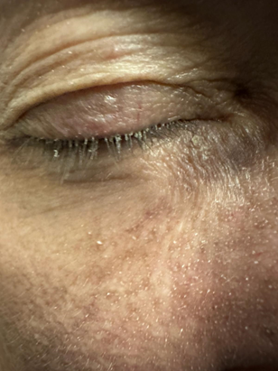
Figure 2 Demodex tails on the skin
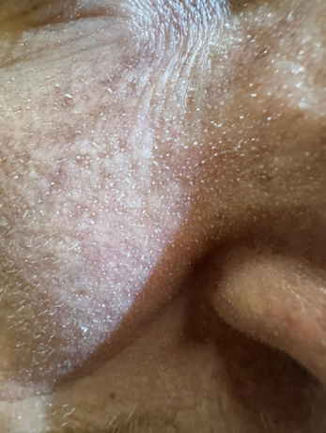

Figure 3 Frozen ear appearance of demodex overpopulation
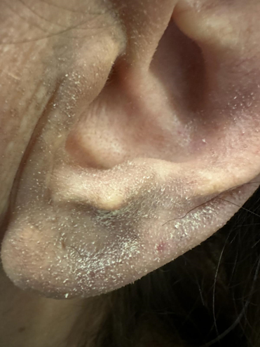

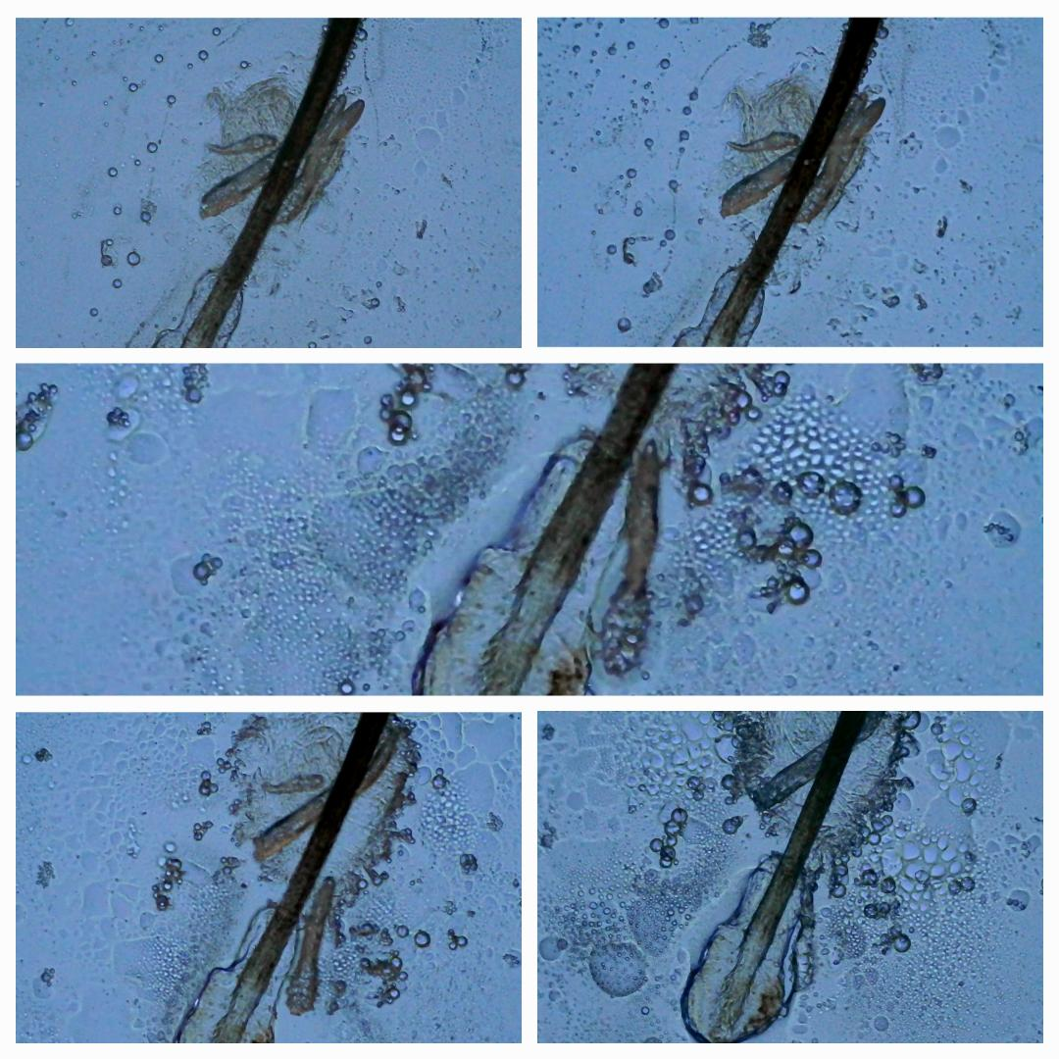
Figure 4 Demodex parasites at the eyelash under a digital light microscope

Figure 5. Eyelashes before and after treatment for ocular demodicosis.
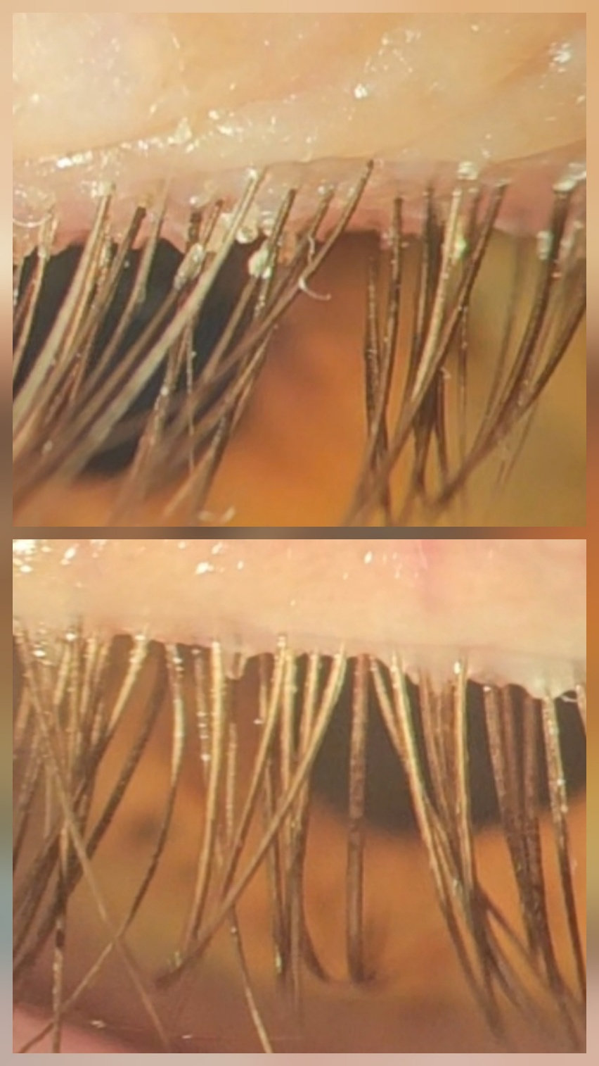
The upper panel shows pre-treatment eyelashes with prominent cylindrical dandruff, presenting as sleeve-like waxy debris at the base of the lashes—characteristic of active Demodex infestation. The lower panel shows post-treatment eyelashes with complete resolution of cylindrical dandruff, following combined therapy with topical ivermectin, BlephaDemodex®, and Terramycin® applied to the lash roots.

