Case report

A case report on Probable Vogt-Koyanagi-Harada disease

.
ABSTRACT

Abstract:Probable case of vogt-koyanagi-harada syndrome is very rare.The patient was diagnosed as a case of probable Vogt-Koyanagi-Harada disease as there was only ocular involvement with no dermatologic or neurologic involvement.Such cases are rarely encountered in clinical practice.Here we report a three cases of probable Vogt-Koyanagi-Harada disease managed aggressively based on a thorough preoperative evaluation that led to good visual outcomes.

Keywords: Probable VKH,Posterior Uveitis,Immunosuppressives.

1. INTRODUCTION

Vogt–Koyanagi–Harada (VKH) disease is a bilateral granulomatous panuveitis with a multitude of systemic manifestations, including neurologic, auditory, and integumentary system affection⁽¹⁾. The first international workshop defined VKH as bilateral uveitis without a history of trauma or ocular surgery and classified VKH disease as (a) complete VKH with ocular, neurological, or auditory and integumentary involvement; (b) incomplete VKH with ocular and either neurological/auditory or integumentary involvement; and (c) probable VKH without extraocular manifestation. Reports of probable VKH are meagre. Complete VKH syndrome with integumentary findings is commonly seen and managed, whereas probable VKH syndrome is rarely diagnosed. Therefore, we want to report these particular cases.

Case History:
Case-1 26 year old male presented with a history of sudden decrease in vision in both eye for 1 week(LE>RE).on examination BCVA was 6/36 N18 in RE and CF 3m N36 LE.normal anterior segment and IOP.Fundus examination of both eye shows normal optic disc,multifocal serous retinal detachment in the posterior pole (Fig 1a 1b).Fundus fluorescein angiography -multiple spots of pinpoint hyperfluorescence in the early arteriovenous phase with pooling and leakage of dye in the subretinal space in the late stage of angiogram (Fig 1c 1d).optical coherence tomography shows neurosensory detachment with subretinal fluid and subretinal septae(Fig 1e 1f).The patient was diagnosed with probable VKH disease.Patient was administered IVMP 1gm daily for three consecutive days followed by oral prednisolone was given according to bodyweight in tapering dose.The patient was prescribed immunosuppressive medication to prevent the recurrence. After 6 weeks, the BCVA in both eyes was 20/20, N6. IOP was normal bilaterally. The fundus was normal bilaterally.

Case 2-67 year old female came with complaints of blurring of vision in BE since 2 days.BCVA RE-3/60 N36 LE-6/36 N18.normal IOP and anterior segment. Fundus examination of both eye shows normal optic disc,multifocal serous retinal detachment in the posterior pole(Fig 2a 2b). OCT – shows large serous retinal detachments with subretinal septae and RPE undulation(Fig 2c 2d).patient was treated with IVMP followed by oral steroids and immunosuppression with Azathioprine.At 2 months follow up BCVA improved to 6/6 N6.

Case 3-58 year old female came with complaints of diminution of vision in both eyes since 3 months. She also gave history of redness in both eyes in the past. On ocular examination her Visual Acuity was 6/60 in right eye and 3/60 in left eye with N36 for near vision. Anterior segment examination revealed bilateral conjunctival congestion, old mutton fat KP’s, AC cells 2+ with Koeppe’s nodules. Pupil reaction was sluggish. Fundus had a hazy media due to vitritis, hyperemic blurred disc, dilated tortuous veins with macular edema and multiple fluid pockets around arcade in both eyes. FFA showed a hot disc, multiple hyper & hypoflourescent dots, multilobular pooling and window defect. On OCT - RPE undulations, increased choroidal thickness, numerous subretinal septae, subretinal fluid, macular edema was seen.The patient was started on:Tab. Prednisolone 60mg OD ,Topical Prednisolone acetate 1% eye drops 8 times a day and Topical Homatropine eye drops twice a day. At her first follow up after 1 week, vision had improved to 6/60 in both eyes with no ocular complaints. During her follow up visits Tab. Prednisolone was slowly tapered over months ,Tab. Azathioprine was started. On follow-up at 3 months, the disc and the macular edema had resolved ,BE BCVA improved to 6/9 N6.

Fig 1a,1b (Fundus photography of BE) - normal optic disc,multifocal serous retinal detachment in the posterior pole.

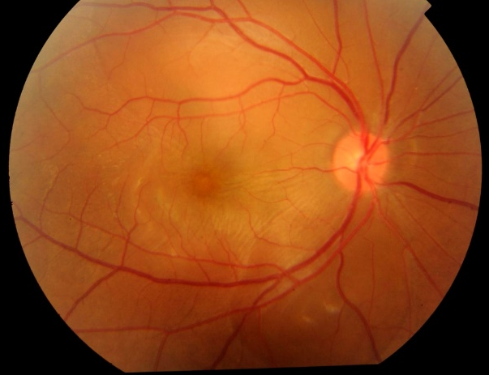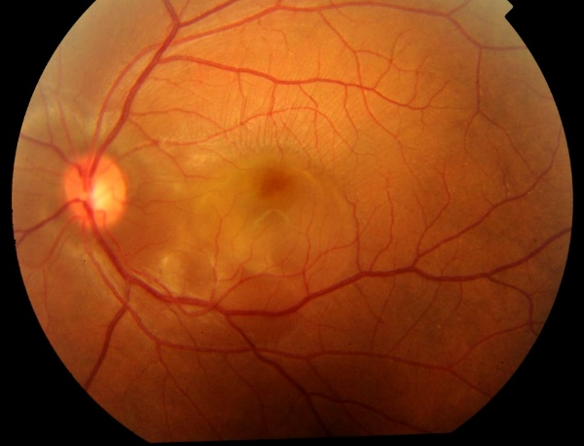
Fig 1c,1d (Fundus fluorescein angiography of BE)- pooling and leakage of dye in the subretinal space in the late stage of angiogram.

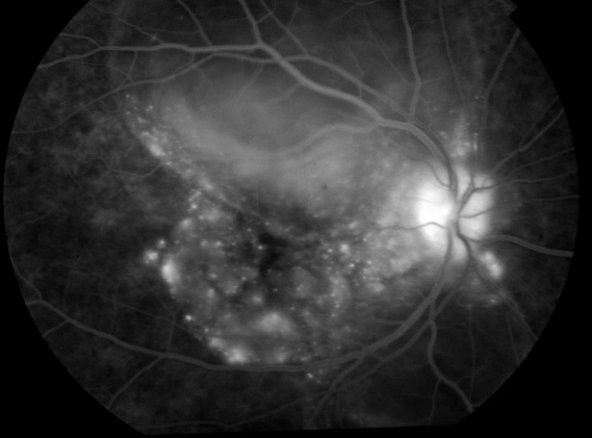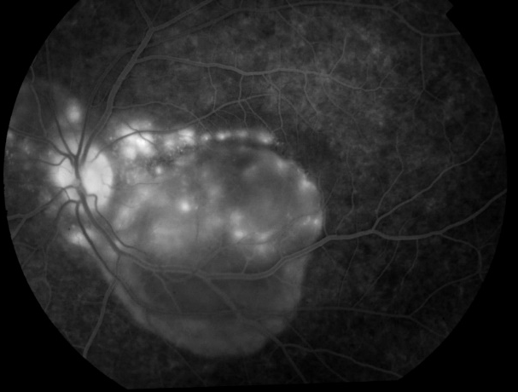
Fig 1e,1f (optical coherence tomography of BE) - multiple neurosensory detachment with subretinal fluid and subretinal septae.

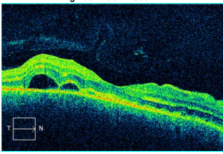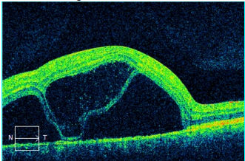

Fig 2a,2b (Fundus photography of BE) - shows normal optic disc,multifocal serous retinal detachment in the posterior pole.

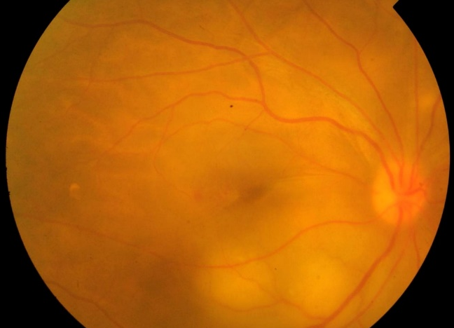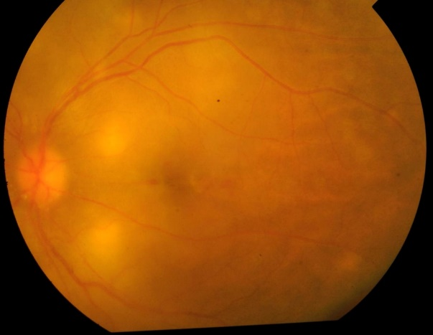

Fig 2c,2d (optical coherence tomography of BE) - large serous retinal detachments with subretinal septae and RPE undulation.

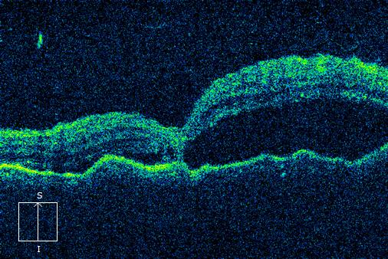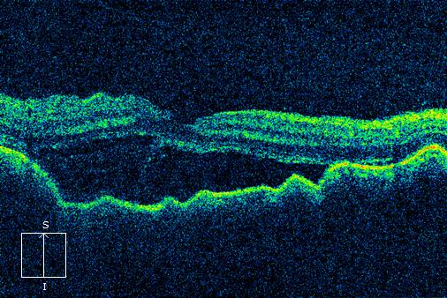

Discussion:

VKH disease was defined as a rare granulomatous inflammatory disease that affects the pigmented structures such as eye meninges inner ear skin-hair⁽²⁾. T-cell-mediated autoimmune reaction against one or more antigens found on or associated with melanocytes plays a role in the pathogenesis⁽³⁾⁽⁴⁾.The disease manifests more commonly in the age group of 20–50 years, with a female predilection.Its prevalence in developing countries like India is 1.4%–3.5%⁽⁵⁾ There are four specific phases of VKH – prodromal, acute uveitic, chronic uveitic, and recurrent chronic phase. prodromal phase of the disease will describe dizziness, eye pain, photophobia, headache, meningeal signs, or fever⁽⁶⁾.The acute uveitic phase consists of blurry vision and photophobia secondary to chorioretinal inflammation. Edema secondary to inflammation in this stage can extend to the retina, the optic nerve, or the ciliary body leading to the development of exudative retinal detachments, papillitis, and acute anatomic angle closure, respectively.The chronic phase of the disease develops subsequently. This phase represents the formation of extraocular manifestations, including hearing manifestations, skin depigmentation, and ciliary depigmentation - commonly noted at the eyebrows, eyelashes, and scalp. Hearing manifestations include tinnitus, dysacusis, and hearing loss.^{(7,8,9)}The recurrent chronic phase consists of symptoms of panuveitis, inflammation throughout the intraocular compartments, and subsequent vision-threatening signs such as sunset glow fundus, choroidal neovascular membranes, neovascularization of the iris, open- and closed-angle glaucoma, and subretinal fibrosis.Treatment regimens include corticosteroids (intravenous, oral,and regional),immunosuppressive agents and immunomodulators^{(10).}Our report showed a series of probable case of VKH. Age of presentation is between 2nd -6th decade.All three patients presented in acute uveitic phase ,most common presenting symptom was diminution of vision..out of three cases two cases presented with predominantely posterior segment involvement with serous retinal detachment.one case has a presentation of panuveitis.with no extraocular involvement..OCT shows the classical features of VKH,multifocal neurosensory detachment with subretinal fluid,fibrous septae and RPE undulation.All three patients treated with combination of steroidal and non-steroidal immunosuppression, as first-line therapy, could prevent chronic evolution and cure the disease.

4. Conclusion

Inflammation in VKH disease is exclusively originating from the choroidal stroma and choroidal space is easily accessible to systemic therapy.early and sustained treatment right at the onset of the disease process with dual corticosteroid and non-steroidal immunosuppressive therapy can result in full “healing” in many cases preventing sunset glow fundus which results from depigmentation from chronic uncontrolled inflammation.Recurrence of the disease is also very common, so all the patients of VKH syndrome should be counseled for regular follow-up to prevent further ocular complications.

Competing interests
No competing interest exist

Consent
Written and informed consent is taken from the patient for publication of case report and accomapanying images.

Ethical approval
“All authors hereby declare that all experiments have been examined and approved by the appropriate ethics committee and have therefore been performed in accordance with the ethical standards laid down in the 1964 Declaration of Helsinki.”

References

- Read, R. W., Rao, N. A., & Cunningham, E. T., Jr. (2000). Vogt-Koyanagi-Harada disease. Current Opinion in Ophthalmology, 11(6), 437-442. https://doi.org/10.1097/00055735-200012000-00009

- Lavezzo, M. M., Sakata, V. M., Morita, C., Rodriguez, E. E. C., Abdallah, S. F., da Silva, F. T. G., Hirata, C. E., & Yamamoto, J. H. (2016). Vogt-Koyanagi-Harada disease: review of a rare autoimmune disease targeting antigens of melanocytes. Orphanet Journal of Rare Diseases, 11(1), 29. https://doi.org/10.1186/s13023-016-0412-4

- Kobayashi, H., Kokubo, T., Takahashi, M., Sato, K., Miyokawa, N., Kimura, S., Kinouchi, R., & Katagiri, M. (1998). Tyrosinase epitope recognized by an HLA-DR-restricted T-cell line from a Vogt-Koyanagi-Harada disease patient. Immunogenetics, 47(5), 398–403. https://doi.org/10.1007/s002510050375

- Sugita, S., Takase, H., Taguchi, C., Imai, Y., Kamoi, K., Kawaguchi, T., Sugamoto, Y., Futagami, Y., Itoh, K., & Mochizuki, M. (2006). Ocular Infiltrating CD4+ T Cells From Patients With Vogt-Koyanagi-Harada Disease Recognize Human Melanocyte Antigens. Investigative Ophthalmology & Visual Science, 47(6), 2547-2554. https://doi.org/10.1167/iovs.05-1547

- Patil, Y. B., Garg, R., Rajguru, J. P., Sirsalmath, M., Bevinakatti, V. A., Kumar, M., & Sharma, S. (2020). Vogt-Koyanagi-Harada (VKH) syndrome: A new perspective for healthcare professionals. Journal of Family Medicine and Primary Care, 9(1), 31-35. https://doi.org/10.4103/jfmpc.jfmpc_787_19

- O'Keefe, G. A., & Rao, N. A. (2017). Vogt-Koyanagi-Harada disease. Survey of Ophthalmology, 62(1), 1-25. https://doi.org/10.1016/j.survophthal.2016.05.002

- Yang, P., Zhong, Y., Du, L., Chi, W., Chen, L., Zhang, R., Zhang, M., Wang, H., Lu, H., Yang, L., Zhuang, W., Yang, Y., Xing, L., Feng, L., Jiang, Z., Zhang, X., Wang, Y., Zhong, H., Jiang, L., ... Kijlstra, A. (2018). Development and Evaluation of Diagnostic Criteria for Vogt-Koyanagi-Harada Disease. JAMA Ophthalmology, 136(9), 1025-1031. https://doi.org/10.1001/jamaophthalmol.2018.2664

- Herbort, C. P., Tugal-Tutkun, I., Abu-El-Asrar, A., Gupta, A., Takeuchi, M., Fardeau, C., Hedayatfar, A., Urzua, C., & Papasavvas, I. (2022). Precise, simplified diagnostic criteria and optimised management of initial-onset Vogt–Koyanagi–Harada disease: an updated review. Eye (London), 36(1), 29–43. https://doi.org/10.1038/s41433-021-01573-3

- Sultan, M., Khan, A., Habib, S. S., & Abdulsalam, D. (2019). Unique clinical spectrum with distinguishing diagnostic features in Vogt-Koyanagi-Harada syndrome. BMJ Case Reports, 12(12), e231397. https://doi.org/10.1136/bcr-2019-231397

- Rahman, N., Artiaga, J. C. M., Bouras, K., Luis, J., Rees, A., & Westcott, M. (2023). Immunosuppressive therapy for Vogt-Koyanagi-Harada disease: a retrospective study and review of literature. Journal of Ophthalmic Inflammation and Infection. https://doi.org/10.1186/s12348-023-00333-6

