Case report
Bilateral cicatricial ectropion on necrotizing fasciitis: case report

Abstract:
Introduction: Necrotizing fasciitis is a severe infection of the subcutaneous tissue and superficial fascia, associated with necrosis of the overlying skin tissue. Periorbital involvement is rare. It can be responsible for multiple early deleterious complications and late cicatricial ones such as ectropion.
Observation: We report the case of bilateral cicatricial ectropion, 69-year-old patient, hypertensive and poorly controlled diabetic, with a history of hospitalization for bilateral palpebrojugal necrotizing fasciitis on maxillary sinusitis.
His examination found visual acuity at 6/10 in ODG, with severe bilateral ectropion, associated with adhesions, a more marked KPS in the inferior, a good anterior chamber, a round and regular pupil, a posterior cortical and subcapsular cataract. The posterior segment was normal.
Discussion: Ectropion is the most common eyelid malposition; it is an eyelid eversion associated with conjunctival and corneal exposure, more frequently affecting the lower eyelid. It can be congenital or acquired; the latter is classified according to the causal mechanism as involutional, paralytic, cicatricial, or mechanical.
Management depends on the type of damage: focal damage can be treated by excision of the scar tissue; severe damage requires transposition flaps or full skin grafts.
Conclusion: Several conditions can cause cicatricial ectropion, periorbital necrotizing fasciitis is one of them, requiring protective medical and restorative surgical management.
Introduction:
Necrotizing fasciitis is a severe infection of the subcutaneous tissue and superficial fascia, associated with necrosis of the overlying skin tissue. It mainly affects immunocompromised patients.
The most frequently affected locations are the groin crease, the abdomen and the lower limb (1).
Facial involvement is not common, and periorbital involvement is even rarer (2), this is mainly due to the rich vascularization of the face as well as the protective nature of the eyelid (3).
It can be responsible for multiple early deleterious complications, with a mortality rate of 10-14.42% due to sepsis and multi-organ failure.(4), and late scarring. We report the case of bilateral necrotizing fasciitis causing bilateral ectropion.
Case presentation:This is a 69-year-old patient, hypertensive and poorly controlled diabetic mellitus 2, with a history of hospitalization for bilateral palpebrojugal cellulitis on maxillary sinusitis, complicated by bilateral necrotizing fasciitis, investigations: leucocytosis at 18000/mm3, CRP 210, blood glucose 2.1g/l, facial CT scan: diffuse soft tissue infiltration of the maxillary regions with subcutaneous gas bubbles suggestive of necrotizing fasciitis.
Initial management : the patient underwent drainage, necrosectomy of necotic tissues. and triple IV antibiotic therapy(third generation cephalosporin,metronidazol,aminoglycosides), daily local care , glycemia control and hemodynamic monitoring.
Late phase : The patient presented for consultation with bilateral ectropion that had been developing for 8 months. On examination, visual acuity was 6/10 in ODG, with severe bilateral ectropion, associated with adhesions, a more marked KPS in the inferior region, a good anterior chamber, a round and regular pupil, a posterior cortical and subcapsular cataract. The posterior segment was unremarkable. After the local infection was controlled with antibiotics, the patient was taken up for correction of cicatricial ectropion under general anesthesia. Skin grafting was planned to cover the raw area after the first incision. Template was marked at preauricular donor site measuring about 2 cm × 2 cm and full-thickness skin graft was harvested. Graft was defatted and sutured to the defect using 4.0 ethilon. Compressive bolster over graft was placed for 5 days postoperatively. The patient was followed up for 1 year and was satisfactory with the outcome.

Discussion :
Ectropion is the most common eyelid malposition; it is an eyelid eversion associated with conjunctival and corneal exposure, more frequently affecting the lower eyelid.(5), it can be congenital or acquired, the latter is classified according to the causal mechanism as involutional, paralytic, cicatricial, or mechanical(6).Cicatricial ectropion is caused by the shortness of the anterior lamella following a facial burn, trauma, or chronic dermatitis complications of blepharoplasty, osteonecrosis secondary to bisphosphonate treatment, periorbital necrotizing fasciitis, Blastomyces dermatitidis, osteomyelitis of the frontal bone,. (4,7,8).Apart from imminent corneal damage, it is preferable to wait at least 6 months after trauma before offering surgical treatment. This surgical treatment will be preceded by medical treatment based on corticosteroids and massage (to soften the eyelid tissue). The best way to treat skin defects is with skin grafts; flaps are reserved for the most severe cases. Scar ectropion caused by chronic dermatological diseases appears to be more difficult to treat.
Necrotizing fasciitis less commonly affects the periorbital region (4).It can be responsible for multiple early deleterious complications, with a mortality rate of 10-14.42% due to sepsis and multi-organ failure or late functional scarring. A demographic study on cicatricial ectropion conducted on 145 patients found an average age of 75 years, with a male predominance (70%), 35% reported a notion of blepharoplasia, 10% a notion of trauma, and in 35% of cases the cause was undetermined (9).
The surgical management of cicatricial ectropion depends on the situation after the release of the scar traction in the lower lid area. Various techniques have been described for correcting cicatricial ectropion by lengthening the anterior lamella with transposition flaps or with full-thickness free skin grafts
The ideal donor site for skin graft for eyelid reconstruction is the periocular region, which is characterized by the same color and thickness. Skin graft can also be obtained from the postauricular and preauricular region (10).
Reconstructive options for lower eyelid cicatricial ectropion:

1. Full thickness skin graft (preauricular, post auricular, upper eyelid, supraclavicular)
2. Transposition flap from cheek (rhombic, nasolabial flap)
3. Tripier flap unipedicle or bipedicle from upper eyelid
4. Z plasty
5. V to Y plasty
6.Mustarde’ cheek rotation transposition flap
7. Lateral tarsal stip combined to any of the above options

Conservative treatment: In the initial cicatricial phase, non-surgical measures can support tissue healing and protect ocular structures. This includes frequent ocular lubrication, application of protective ointments, and meticulous skin care to prevent secondary damage or infection. These measures are particularly important when the eyelid margin is involved or the cornea is exposed.
Reconstructive surgery: Often necessary to restore both function and cosmesis, reconstructive strategies are tailored to the extent of tissue loss and cicatricial contracture. Options include:
- Autologous skin grafts, typically harvested from the upper eyelid, temporal region, or postauricular area, to replace lost eyelid skin.
- Local flap advancement to recruit adjacent tissue for better contour and tension-free closure.
- Canthal suspension or lateral tarsal strip procedures to stabilize and reposition the eyelid margin, correcting ectropion.
- In cases where the inner layer of the eyelid is involved, mucosal grafts (e.g., oral or nasal mucosa) can be used to reconstruct the posterior lamella and maintain eyelid integrity.
A staged, individualized approach combining prevention, conservative management, and reconstruction is crucial for achieving optimal functional and aesthetic outcomes, especially in patients with extensive tissue necrosis.
Conclusion
Eyelid static disorder, it is loss of contact between the tarsal and bulbar conjunctiva due to scarring.
Several contributing factors, hence the importance of accurately diagnosing the mechanisms leading to ectropion
Appropriate and tailored surgical treatments for better anatomical and functional results
References:
Brunworth, J., & Shibuya, T. Y. (2011). Craniocervical Necrotizing Fasciitis Resulting From Dentoalveolar Infection. Oral and Maxillofacial Surgery Clinics of North America, 23(3), 425–432. https://doi.org/10.1016/j.coms.2011.04.007
Wolf, H., Rusan, M., Lambertsen, K., & Ovesen, T. (2010). Necrotizing fasciitis of the head and neck. Head & Neck, 32(12), 1592–1596. https://doi.org/10.1002/hed.21367
Chandler, J. R., Langenbrunner, D. J., & Stevens, E. R. (1970). The pathogenesis of orbital complications in acute sinusitis. The Laryngoscope, 80(9), 1414–1428. https://doi.org/10.1288/00005537-197009000-00007
Amrith, S., Hosdurga Pai, V., & Ling, W. W. (2013). Periorbital necrotizing fasciitis – a review. Acta Ophthalmologica, 91(7), 596–603. https://doi.org/10.1111/j.1755-3768.2012.02420.x
Bedran, E. G. d. M., Pereira, M. V. C., & Bernardes, T. F. (2010). Ectropion. Seminars in Ophthalmology, 25(3). https://doi.org/10.3109/08820538.2010.488570
Tarallo, M., Rizzo, M. I., Monarca, C., Fanelli, B., Parisi, P., & Scuderi, N. (2012). Optimal Care for Eyelid Contraction After Radiotherapy: Case Report and Literature Review. Journal of Oral and Maxillofacial Surgery, 70(10), 2459–2465. https://doi.org/10.1016/j.joms.2011.10.017
Lazzeri, D., Lazzeri, S., Figus, M., Tascini, C., Bocci, G., Colizzi, L., Giannotti, G., Lorenzetti, F., Gandini, D., Danesi, R., Menichetti, F., Del Tacca, M., Nardi, M., & Pantaloni, M. (2010). Periorbital necrotising fasciitis. British Journal of Ophthalmology, 94(12), 1577–1585. https://doi.org/10.1136/bjo.2009.167486
Havenith R, de Vos L, Fröhlich A, Braegelmann C, Sirokay J, Landsberg J, et al. Disease—An Unmet Medical Need Equally Improved by Topical Imiquimod Cream and Lapacho Tea Wraps: A Case Report. Dermatol Ther. 2021 Feb 23;11(2):625–38.
Ehrlich, M. S., Richard, M. J., & Woodward, J. A. (2012). Demographic Characteristics of Patients Requiring Full-Thickness Skin Grafts for Cicatricial Ectropion at Duke Eye Center From 2000 to 2010. Ophthalmic Plastic and Reconstructive Surgery, 28(6), 476-477. https://doi.org/10.1097/IOP.0b013e3182674085
Sidana, S., & Kadam, S. (2021). Cicatricial Ectropion of Lower Eyelid: A Report of Two Cases. J Cutan Aesthet Surg. https://doi.org/10.4103/JCAS.JCAS_133_19

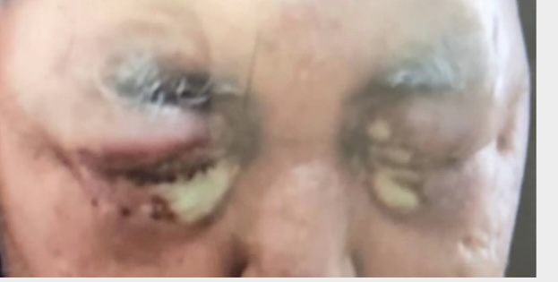
Figure 1 Periorbital necrotising fasciiti
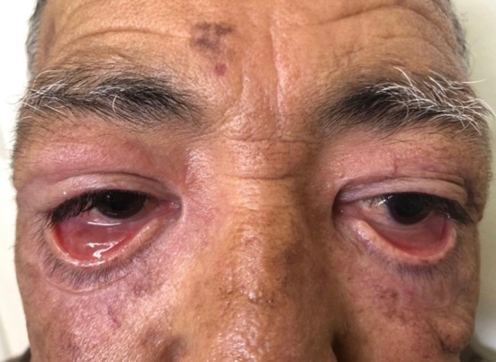
Figure 2 Cicatricial ectropion complicating necrotising fasciitis (1 month later)

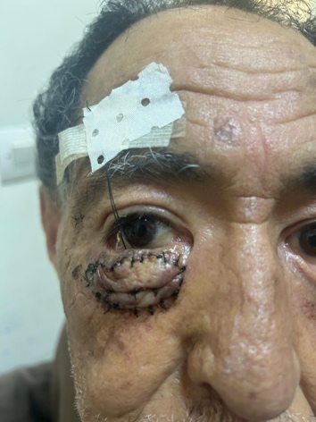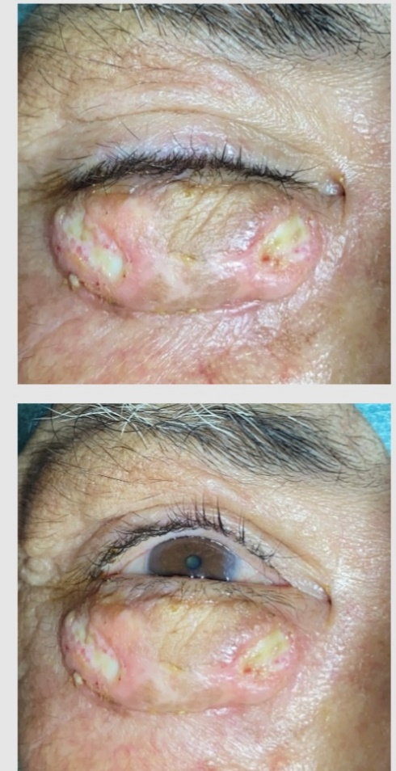
Figure 3 Post-operative appearance after skin graft

