Original Research Article
Design and Development of Peda forming machine

Abstract
India’s milk production has increased substantially in recent years, with nearly half of total milk output being converted into traditional dairy products, highlighting the need for efficient mechanization of indigenous product manufacturing. Peda, a popular khoa-based sweet, is traditionally shaped manually, leading to variations in size, productivity, energy efficiency, and overall process consistency. The present study focuses on the design, fabrication, and performance optimization of a peda forming machine to enhance production efficiency while maintaining process reliability. The machine was developed through systematic design and fabrication stages, followed by optimization of key operating parameters using response surface methodology. Three independent variables—khoa temperature, khoa moisture content, and forming plate speed—were optimized with respect to production rate, power requirement, and rework generation. The optimized operating conditions were identified as 20°C khoa temperature, 15.8% moisture content, and 6 rpm forming plate speed. Under these conditions, the machine achieved a production rate of approximately 132 kg h⁻¹ confirming the commercial feasibility of the developed system. The study demonstrates the potential of the developed peda forming machine for small to medium scale dairy enterprises seeking automation of traditional dairy product manufacturing.
Keywords: Peda forming machine; Traditional dairy products; Khoa processing; Process optimization; Energy efficiency; Dairy product automation.

- INTRODUCTION
Milk is a highly perishable commodity with a limited shelf life, particularly under tropical climatic conditions, necessitating its conversion into stable products for extended storage and consumption. In India, surplus milk has traditionally been utilized for the preparation of a wide range of indigenous dairy products. The conversion of milk into sweets and other value-added products has been practiced since ancient times, with Vedic Indians having mastered techniques for utilizing excess milk. Owing to their social, economic, religious, medicinal, and cultural significance, milk and milk products have remained integral to Indian dietary traditions (Dasture et al., 1971).
Most traditional dairy products are produced on a small scale using conventional methods, where product quality is largely dependent on the skill of homemakers or halwais. Although these products offer substantial socio-economic benefits such as employment generation, income support, and improved nutritional security, they often exhibit wide variability in compositional, physicochemical, sensory, and microbiological quality.
India currently produces approximately 239.9 million tonnes of milk annually, of which nearly 50% is consumed as liquid milk (NDDB, 2025). The remaining milk is converted into traditional Indian dairy products (Rasane et al., 2015). Consumption data reported in the Basic Animal Husbandry Statistics, DAHD&F, GOI-2021 indicate that liquid milk, butter/ghee, curd, khoa (peda/burfi), paneer, and milk powder/cheese account for 46%, 33%, 7%, 7%, 3%, and 4% of total consumption, respectively. These figures highlight the substantial market potential for indigenous dairy products and underscore the need for their mechanization and automation.
1.1 Need for Mechanization and Automation
Traditional methods of converting milk into indigenous dairy products are characterized by small batch sizes, high labour dependency, and limited control over energy efficiency, production cost, and product uniformity. To meet increasing consumer demand and ensure wider market penetration, several organized dairy industries have initiated mechanized production of selected traditional products at a larger scale. Mechanization has demonstrated advantages in terms of improved energy efficiency, enhanced microbial and physicochemical quality, and extended shelf life of products.
1.2 Scope of Investigation
With rapid growth in the Indian dairy sector and an annual increase of 20–24% in demand for value-added products (Rao, 2020), there is a growing need for innovation in dairy process equipment design. Small-scale technologies are often unsuitable for industrial applications, necessitating the development of efficient, scalable, and cost-effective machinery. Enhancing traditional dairy products through improved equipment design and mechanization is essential for increasing their competitiveness, both domestically and in global markets. Such advancements also offer opportunities for rural economic development through value addition and technology dissemination.
2. MATERIALS AND METHODS
2.1 Description of Peda Forming Machine
The Peda Forming Machine designed and developed for this study comprise of hopper, feeding screw, forming plate, drive systems, and controls. The Peda Forming Machine developed for the study is shown in Figure1.
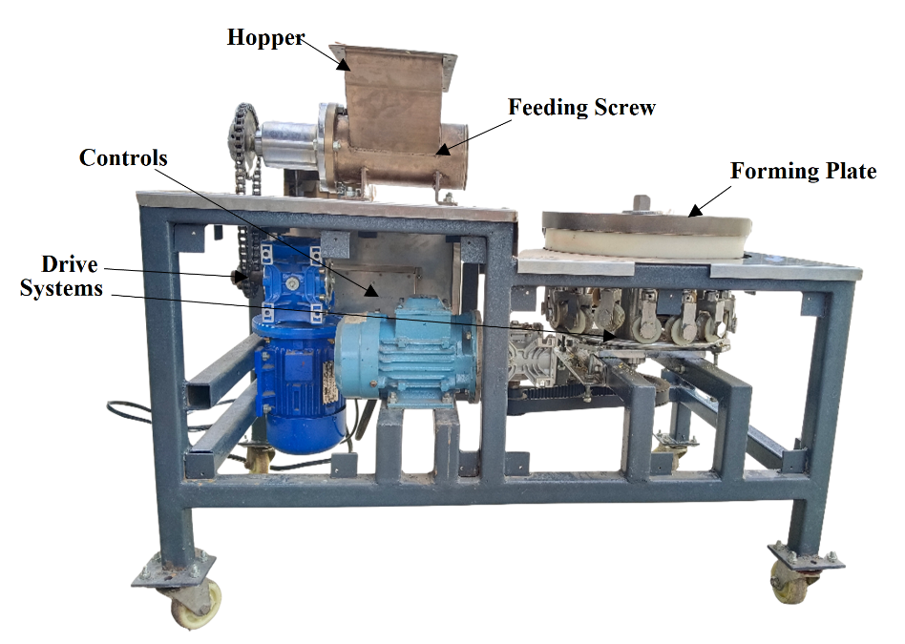
Figure 1: Pictorial view of Peda forming machine
To enable continuous and mechanized forming of Kesar Peda prepared from pindi khoa with moisture content in the range of approximately 14–18%, a peda forming machine with a design capacity of 100 kg h⁻¹ was developed. The design of the machine was carried out using standard engineering calculations, with screw feeder dimensions determined based on the equations suggested by Liu et al. (2020). Accordingly, the hopper and forming plate were designed to match the screw capacity. Key design considerations included machine throughput, screw geometry (pitch, flight, length, and thickness), forming plate dimensions, number of cavities, motor and gearbox selection, and overall power requirement. The forming plate was designed with 16 cavities, and its rotational speed range was selected to synchronize with the screw output for uniform filling and shaping of peda.
All components in contact with khoa were fabricated using food-grade materials and designed for easy dismantling and cleaning. The screw, shaft, barrel, and hopper were manufactured from SS-304 and coated with PTFE, while the forming plate was made of aluminium to facilitate precise machining and was also PTFE-coated. A Teflon bushing was provided between the barrel outlet and forming plate to prevent abrasion and product leakage, and a reducer bend was incorporated to ensure uniform filling of the forming cavities. The machine was operated using a single-phase electrical supply connected to two variable frequency drives (VFDs) to control separate gearbox motors for the screw and forming plate. Mechanical synchronization of a camshaft and piston system enabled automatic ejection of peda from the forming cavities without the need for compressed air, sensors, or manual stamping. The compact and hygienic design allows operation by a single person, with minimal additional labour for handling and packaging, resulting in a cost-effective system with reduced operational complexity and improved sanitary conditions.
2.2 Design of Components
2.2.1 Design of Hopper:
Hopper was designed with a holding capacity of 5 kg of Khoa to match the capacity of screw feeder. It was fabricated using SS 304 and was installed at the top of feeding screw with nut bolt arrangement. The hopper had top dimensions of 150 mm × 300 mm × 50 mm with a bottom opening of 150 mm × 100 mm, an overall height of 120 mm, and a slope of 45°. It was fabricated from SS 304 with a material thickness of 2.5 mm.
2.2.2 Design of Feeding Screw:
Half pitch single flight screw was designed, where Pitch is half of diameter of screw which is commonly used in inclined and vertical screw conveyor applications. 1/2 pitch is also used in some variable pitch screw feeder applications. The screw was designed with a diameter of 100 mm and a pitch of 50 mm, having a depth of 32 mm and a flight thickness of 10 mm. The shaft diameter was 35 mm with an overall screw length of 250 mm.
2.2.3 Design of Forming Plate:
The design of the forming plate with 16 cavities, incorporated a gearbox and motor for enhanced functionality. This innovative plate featured sixteen individual pistons and a Teflon roller assembly, specifically engineered to exert pressure, and elevate the Peda within the cavities. Each cavity, measuring 40 mm in diameter and 12 mm in depth, had the capacity to accommodate approximately 22 g of Peda, ensuring efficient production and consistent quality. The plate diameter and thickness were 1570 mm and 50 mm, respectively, with a piston length of 70 mm and a Teflon roller diameter of 25 mm.
The production rate can be calculated as follows:
Kg Peda per hour = Weight of 1 Peda x no. of cavities x rpm x 60 min.
= 22 x 16 x 7 x 60
= 1,47,840 g
≈ 147.8 kg per hour
2.2.5 Driving assembly for feeding screw:
The machine with a face that includes motors with gear box and chain drive to drive a screw, which pushes Khoa to form Peda. The drive system consisted of an Atlas make motor (0.75 kW, 1 HP, 1.9 A, 50 Hz, three-phase) coupled with a Cosmos Worm gearbox (Model NMRV063, gear ratio 30). Speed control was achieved using a Kinco make VFD with a frequency range of 0–60 Hz, converting single-phase input to three-phase output. Chain-driven spoke wheel pulleys of 120 mm diameter for the screw and 60 mm diameter for the gearbox were used. The barrel was fabricated from SS 304 with a length of 255 mm and a diameter of 100 mm, maintaining a screw–barrel clearance of 1 mm.
2.2.6 Driving Assembly for Forming Plate:
The forming plate attached with sixteen pistons and cam shaft assembly and additionally the driving motor with gear box and belt driving mechanism. The cam shaft mechanism, which is spring loaded, operates with a 75% downward motion and a 25% upward motion, as depicted in the drawing. Wet cloth cleaning is a method employed for cleaning machines effectively. Time required to formation of one Peda is about 10 sec. The forming plate assembly consisted of a shaft of 250 mm length and 10 mm diameter, driven through a RotoMotive gearbox (Model Box050, gear ratio 50) coupled with an ABB make motor (0.37 kW, 0.5 HP, 1.1 A, 50 Hz, three-phase, cos ϕ 0.65). Speed control was provided by a Kinco make VFD with a frequency range of 0–60 Hz, converting single-phase input to three-phase output. The forming plate had an inner diameter of 120 mm and an outer diameter of 1570 mm, operating within a speed range of 5–9 rpm, and was fabricated from PTFE-coated aluminium. Sixteen cavities were provided, each with a height of 40 mm and a diameter of 12 mm.
2.2.7 Design of Structural Frame:
The total dimensions of the frame measure 1080 millimetres in length, 580 millimetres in width, and 510 millimetres in height. The frame itself was constructed using square box tubing with a size of 40 square millimetres. This specific design choice not only contributes to the overall structural integrity of the frame but also influences its aesthetic appeal. Additionally, the frame underwent a powder coating treatment upon completion of fabrication. This protective coating serves to increase the frame's durability and longevity by providing a barrier against corrosion, scratches, and other forms of damage that may occur over time.
2.4 Performance Evaluation of Peda Forming Machine.
Evaluating machine’s performance or production capacity in terms of quantity of formed Peda (or weight of perfectly formed Peda). The evaluation criteria include the number of Peda formed and total weight of deformed Peda during one hour of run.
2.5 Physico-Chemical Analysis (Moisture)
Moisture percentage or Total solids (TS) were determined according to the procedure described in BIS handbook (BIS: Part XI., 1981). In a dry and clean previously weighed aluminium dish, 3 gm Peda was weighed, and the weight of Peda was recorded. The dishes were transferred to the oven, and maintained at a temperature of 100 ± 2°C. After three hours, covered the dishes and immediately transferred them to a desiccator, cooled and weighed, as before. Repeated, if necessary, until the loss of weight between successive weighing did not exceed 0.5 mg. Noted the lowest weight.
$$Moisture \left(\% w/w\right)= \frac{W1-W2}{W1-W} x 100 \%$$
Where;
W = Weight of the empty dish
W1 = Weight of the dish with paneer sample before drying
W2 = Weight of the dish with paneer sample after drying
2.6 Statistical Analysis
Response Surface Methodology (RSM) was employed to model and optimize the process parameters influencing peda formation (Anderson-Cook et al., 2009). RSM is particularly suitable for experiments involving continuous variables and multiple interacting factors. Statistical analysis, including experimental design, selection of parameter ranges, number of trials, replications, and data analysis, was carried out using Design-Expert software.
Three independent variables—khoa temperature, moisture content, and forming plate speed—were considered, and 20 experimental treatments were generated by RSM (Table 1). Based on the experimental results, an optimized treatment was suggested and executed in triplicate. The experimental outcomes were compared with RSM-predicted values using a t-test, which showed non-significant differences, confirming the suitability and reliability of the optimized operating conditions.
Table 1: List of combinations suggested by RSM tool.
Std | Run | Factor 1  A: Temperature  ℃ | Factor 2  B: Moisture  % | Factor 3  C: Forming plate’s rpm  rpm | Response 1  Production Rate  kg/h
12 | 1 | 27.5 | 17.4 | 7.0 | 131.04
2 | 2 | 35.0 | 12.0 | 6.0 | 131.33
4 | 3 | 35.0 | 16.0 | 6.0 | 131.90
7 | 4 | 20.0 | 16.0 | 8.0 | 125.95
6 | 5 | 35.0 | 12.0 | 8.0 | 128.26
18 | 6 | 27.5 | 14.0 | 7.0 | 130.37
5 | 7 | 20.0 | 12.0 | 8.0 | 131.33
1 | 8 | 20.0 | 12.0 | 6.0 | 134.21
10 | 9 | 40.1 | 14.0 | 7.0 | 139.10
19 | 10 | 27.5 | 14.0 | 7.0 | 135.07
16 | 11 | 27.5 | 14.0 | 7.0 | 131.04
11 | 12 | 27.5 | 10.6 | 7.0 | 129.70
20 | 13 | 27.5 | 14.0 | 7.0 | 136.42
15 | 14 | 27.5 | 14.0 | 7.0 | 135.07
14 | 15 | 27.5 | 14.0 | 8.7 | 118.35
8 | 16 | 35.0 | 16.0 | 8.0 | 123.65
17 | 17 | 27.5 | 14.0 | 7.0 | 132.38
3 | 18 | 20.0 | 16.0 | 6.0 | 133.06
13 | 19 | 27.5 | 14.0 | 5.3 | 127.13
9 | 20 | 14.9 | 14.0 | 7.0 | 131.71
*Performed in Design Expert, v-13.0.5.0
3. RESULTS AND DISCUSSION
3.1 Specification of Developed Peda Forming Machine
Table 2: Peda forming machine specifications.
Sr No. | Particulars | Remarks
1 | Capacity | ~100 kg Peda per hour
2 | Power requirement | 1-ϕ, 240 V, 50 Hz
3 | Dimensions | 1220 mm x 690 mm x 760mm
4 | Gross Weight | ~250 kg
5 | Cost | Rs. 2,51,000

3.3 Optimization of Operating Parameters for Optimum Production Efficiency Using RSM
The study aimed to optimize the operating parameters of the developed peda forming machine using Response Surface Methodology (RSM). Three independent variables—temperature of peda dough (khoa + sugar), moisture content of the dough, and rotational speed of the forming plate—were selected for optimization. A Central Composite Randomized Design was generated using Design-Expert software (v. 13.0.5.0), resulting in 20 experimental runs with different combinations of the selected variables. The responses evaluated was production rate (kg h⁻¹) (Table 1), enabling assessment of machine performance and production efficiency.
3.3.1 Optimization of Parameters for Peda Forming
The experimental runs and corresponding responses are presented in Table 1. Each response was analyzed individually using a quadratic randomized model in the software. Analysis of variance (ANOVA) was applied to evaluate model significance and the effects of individual variables. The most suitable model for each response was identified and is discussed in subsequent sections.
3.3.1.1 Influence of Independent Variables on Production Rate
Production rate, expressed in kg h⁻¹, was used as a key performance indicator of the mechanized process. The observed production rate varied from 118.35 to 139.10 kg h⁻¹ within the experimental domain. The corresponding maximum values of temperature, moisture content, and forming plate speed were 40.10 °C, 17.36%, and 8.7 rpm, respectively. These results indicate a significant influence of operating parameters on production rate and validate the suitability of RSM for process optimization.
Table 3: Regression coefficients and ANOVA of quadratic model of Peda Forming machine as influenced by Temperature, Moisture, and rpm (coded values)
Terms |  | Production Rate  (kg/h)
Intercept |  | 133.37
Linear Level | - Temperature ℃ | 0.2214
Linear Level | - Moisture % | -0.6077
Linear Level | - Forming plate rpm | -2.6400*
Interactive Effect | AB | 0.3120
Interactive Effect | AC | -0.1680
Interactive Effect | BC | -1.1800
Quadratic level | A² | 0.8586
Quadratic level | B² | -0.9233
Quadratic level | C² | -3.6200**
F Value |  | 4.61
p-Value |  | 0.0128
Lack of Fit |  | NS
Std. Dev. |  | 2.82
Mean |  | 130.85
C.V. % |  | 2.16
R² |  | 0.8057
Adjusted R² |  | 0.6306
Predicated R² |  | -0.0184
Adequate Precision value (APV) |  | 8.7615
Suggested Model |  | Quadratic
** Significant at 1.0 per cent level (P<0.01), *Significant at 5.0 per cent level (P<0.05); R²= Coefficient of determination; NS = Non-Significant.

Table 3 summarizes the quadratic model developed for production rate, which was found to be statistically significant (F = 4.61, P < 0.05), with a non-significant lack of fit, indicating good model adequacy. The coefficient of determination (R² = 0.80) suggests a satisfactory relationship between the variables, supported by an adequate precision value of 8.76, confirming the model’s suitability for navigating the design space. Among the process variables, forming plate rpm (C) showed a significant positive effect on production rate (P < 0.01), while khoa temperature (A) and moisture content (B) had non-significant effects. Interaction terms (AB, AC, and BC) were also non-significant (P > 0.05). The quadratic term of forming plate rpm (C²) exhibited a highly significant positive influence on production rate (P < 0.001), whereas quadratic terms of temperature (A²) and moisture (B²) were non-significant.

Production Rate (kg/h) = | - 109.74665 – 0.944385 * Temperature + 9.70339  * Moisture + 56.89817 * rpm + 0.0208 * Temperature  * Moisture – 0.0224 * Temperature * rpm – 0.588  * Moisture * rpm + 0.015264 * Temperature² – 0.230831 * Moistuer² – 3.62082 * rpm ²
Figure 2 depicts the combined effect of temperature (A) and moisture (B) on production rate, showing a slight decrease in production as moisture increased from 12% to 16%; however, this effect was statistically non-significant as reported in Table 3. The lowest production rates were observed at temperatures between 26 °C and 29 °C in combination with 16% moisture, indicating that this specific interaction adversely influenced production compared to other operating conditions.

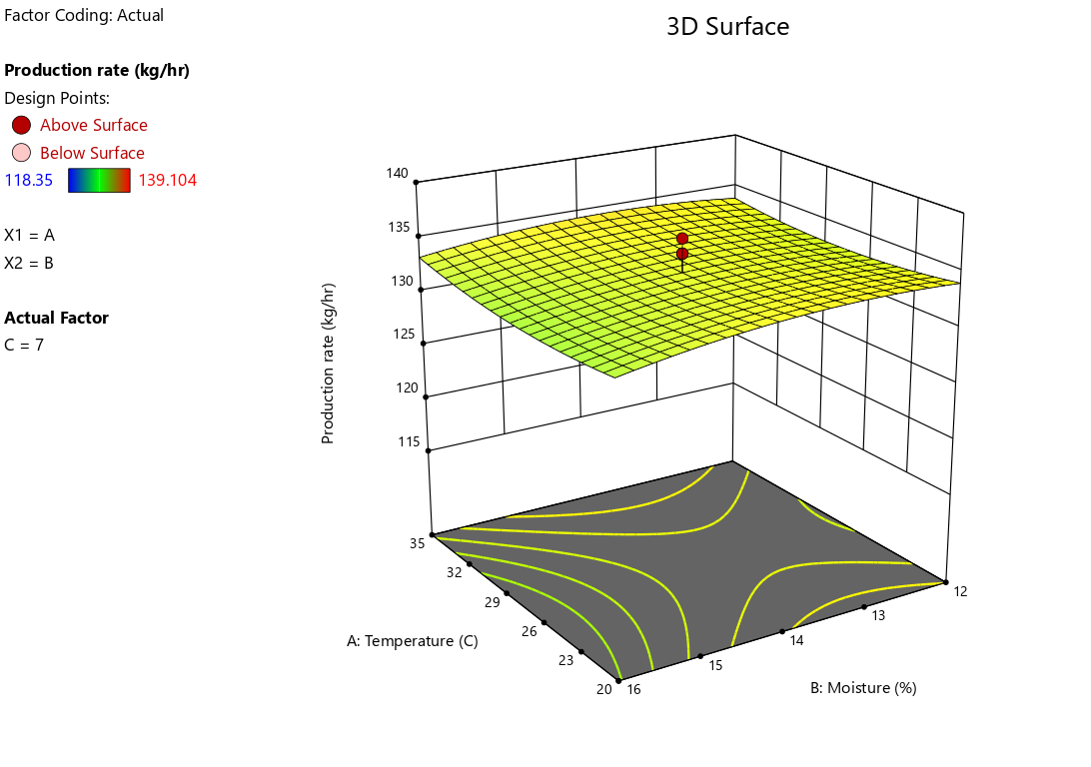
Figure 2: Response surface plot for production rate as influenced by temperature (A) and moisture (B)
The highest production rate was observed at around 6.5 rpm and 35°C, while the lowest occurred at 8 rpm and 27°C. Temperature showed a negligible effect on production rate, whereas rpm had a comparatively greater influence, with values ranging from 127 to 135 kg h⁻¹, consistent with the non-significant effects reported in Table 3.
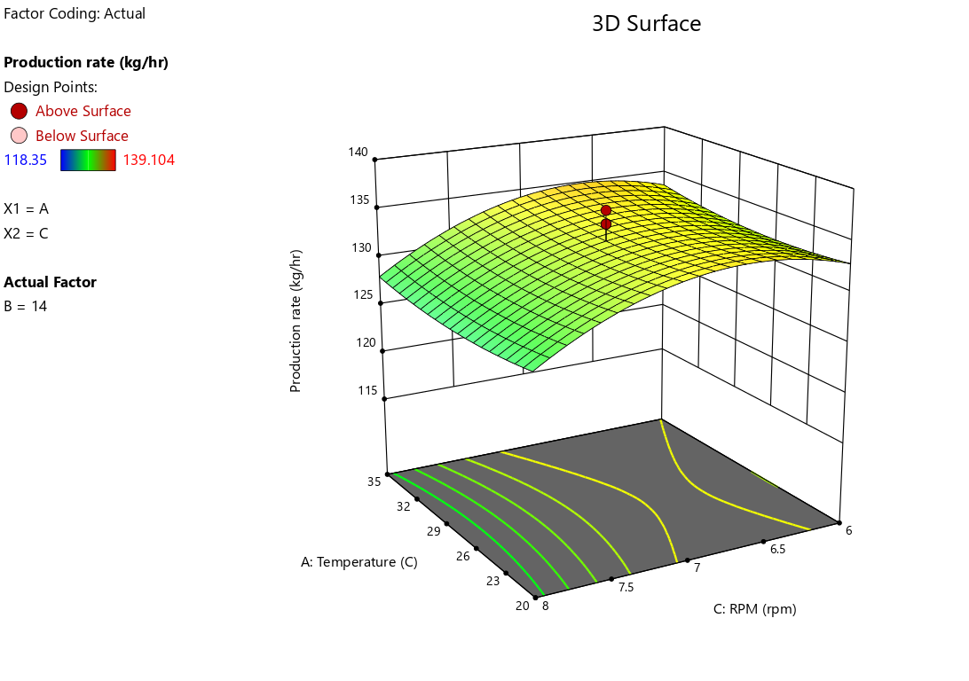
Figure 3: Response surface plot for production rate as influenced by temperature (A) and rpm (C).
Figure 3 and Figure 4 illustrate the combined effect of moisture (B) and forming plate rpm (C) on production rate. Although the interaction was found to be non-significant as per Table 3, the response surface shows maximum production near 13% moisture and 6.5 rpm. Lower production rates were observed across the moisture range of 12–16%, while higher production rates with respect to rpm were concentrated between 6.5 and 7, indicating rpm as the dominant influencing factor.

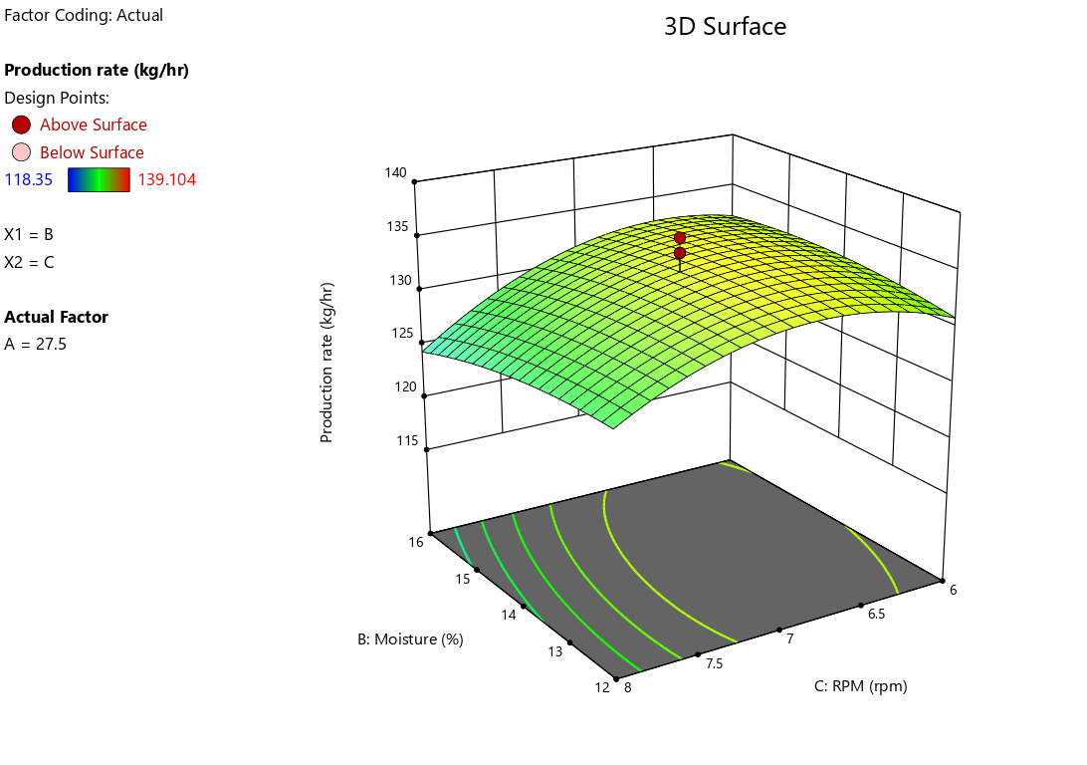
Figure 4: Response surface plot for production rate as influenced by moisture (B) and rpm (C).
Singh et al. (2018) reported that peda weight increased with higher temperature and pressure in a piston extrusion system due to enhanced flow of peda mix, with an average weight of 42.5g at 34°C and 810 kPa. Similarly, Yu (1997) demonstrated a strong linear relationship between mass output (kg h⁻¹) and screw rotational speed (rpm) in screw feeder systems.
4.3.1.4 Optimization of Peda forming machine’s operating factors using quadratic regression model.
The study optimized temperature (A), moisture (B), and forming plate rpm (C) to identify suitable operating conditions using Design-Expert software. Optimization criteria were defined as shown in Table 4. Based on the specified limits, Response Surface Methodology (RSM) suggested optimal conditions of 35 °C dough temperature, 15.3% moisture content, and 6 rpm forming plate with a model desirability of 83.3% (Table 5). The predicted response values under these optimized conditions are presented in Table 6.

Table 4: Selected criteria/goals for optimization for Peda forming machine.
Name | Criteria | Lower Limit | Upper Limit
Independent Variables/ Factors
A: Temperature ℃ | Is in range | 20 | 35
B: Moisture % | Is in range | 12 | 16
C: rpm | Is in range | 6 | 8
Dependent Variables/ Responses
Production Rate (kg/h) | Maximum | 118.35 | 139.10

Table 5: Optimized solution as suggested by quadratic model of RSM
Optimized Factors |  |  | Desirability of the model
Temperature ℃ | Moisture % | rpm | 90.3
20 | 15.8 | 6 | 90.3

Table 6: Validation of the optimized RSM model
Sr.  No. | Response | Predicted Value* | Actual  Value@ | P-value | Cal. t-  value# | Significance
1 | Production  Rate (kg/h) | 132.457 | 132.23±2.3158 | 0.8825 | 0.1673 | NS
*Predicated values of Design Expert 13.0.5.0,
@ Actual values are an average of 3 trials for optimized combination,
#T-values found non-significant at a 5.0 per cent level of significance,
NS = non-significant
Table t-value = 2.447

4. CONCLUSIONS
The peda forming machine was designed for a capacity of 100 kg h⁻¹; however, under optimized operating conditions it achieved a higher production rate of 132 kg h⁻¹. Optimization was carried out using Response Surface Methodology with a Central Composite Rotatable Design (CCRD), involving 20 experimental runs generated through Design-Expert software (v. 13.0.5.0). Three independent variables—peda dough temperature, moisture content, and forming plate rpm—were studied. Among these, forming plate rpm showed a significant linear and quadratic effect on production rate, while the effects of temperature and moisture were largely non-significant.
The optimized operating conditions suggested by RSM were 20°C dough temperature, 15.8% moisture content, and 6 rpm forming plate speed. Under these conditions, the predicted and experimentally observed values for production rate (≈132 kg h⁻¹) showed non-significant This demonstrates the technical and commercial viability of the developed peda forming machine.
5. REFERENCES
- Anderson-Cook, C. M., Borror, C. M., & Montgomery, D. C. (2009). Response surface design evaluation and comparison. Journal of statistical planning and inference, 139(2), 629-641.
- Dasture, N. N., Ganguli, N. C., Laxminarayan, H., & Patel, I. . M. (1971). Milk other than cows’ milk. IDF Seminar, Madrid, Spain.
- Liu, M., Wang, N., Chen, X., Shan, Y., & Li, J. (2020). Design of feed screw conveyor. Journal of Physics: Conference Series, 1601(6). https://doi.org/10.1088/1742-6596/1601/6/062005
- NDDB. (2025). Milk Production in India. https://www.nddb.coop/information/stats/milkprodindia
- Rao, K. J. (2020). Harnessing the potential of traditional Indian dairy products. National Seminar on “Traditional Indian Dairy Products- Prospects of Commercialization,” 17–19. https://nahep.icar.gov.in/API/Content/Uploads/345329b6-94e8-4971-9de5-3544fb035c31/3100619d-7b4b-4255-a824-74f2d577e614.pdf
- Rasane, P., Tanwar, B., & Dey, A. (2015). Khoa: a heat desiccated indigenous Indian dairy product. Research Journal of Pharmaceutical, Biological, and Chemical Science, 6(5), 39–48.
- Singh, G., Singh, M., Sawhney, I. ., & Minz, P. (2018). Design aspect of temperature controlled piston extrusion system for formation of peda- milk based sweet. Asian Journal of Dairy and Food Research, 37(of), 87–94. https://doi.org/10.18805/ajdfr.dr-1308
- Yu, Y. (1997). Theoretical modelling and experimental investigation of the performance of screw feeders [University of Wollongong]. http://ro.uow.edu.au/theses/1601

