Original Research Article

Exploitation of Census Data for Effective Planning and Sustainable Development in Mali

.
ABSTRACT

This study aims to demonstrate the contribution of census data combined with Geographic Information System (GIS) techniques to local development planning in Mali, with a particular focus on evaluating spatial accessibility to health infrastructure in a rural context. This research adopts a cross-sectional study design based on spatial and statistical analysis of census and geospatial data. The study was conducted in the rural commune of Kroukoto, located in the cercle of Kéniéba, Kayes Region, south-western Mali. The commune covers approximately 250 km² and has an estimated population of 12,000 inhabitants. The analysis was carried out during the study period using the most recent available census data and spatial datasets. Georeferenced census data were integrated with spatial layers representing settlements, road networks, health centers, and educational facilities within a GIS environment. Distance-based accessibility modeling was applied to assess population access to basic services. Threshold distances commonly used in rural planning were adopted, including 5 km for access to health centers. Population distribution was analyzed at village and hamlet levels to identify spatial inequalities. The results show that approximately 65% of the population lives within 5 km of a health center. However, a significant proportion of the population remains beyond these thresholds, mainly in peripheral and poorly connected areas. The spatial patterns reveal clear disparities in service accessibility related to settlement dispersion. The integration of census data with GIS based on the spatial analysis represents a decision-support tool for local planning. This approach facilitates the identification of underserved areas, supports equitable resource allocation, and contributes to improving access to essential services. It strengthens territorial planning in rural areas of Mali.

Keywords: Census data; Geographic Information System; Spatial accessibility; Rural planning; Mali

1. INTRODUCTION

The General Census of Population and Housing (RGPH) is the main and most reliable source of demographic and socio-economic information in Mali (UNFPA, 2020; INSTAT, 2023). These data, systematically collected at the national level, provide essential information on the size, structure and distribution of the population, as well as its socio-economic and cultural characteristics (Longley et al., 2021). They represent an indispensable strategic tool for the planning, management and evaluation of public policies, allowing informed decision-making in the fields of education, health, infrastructure and economic development (UNDP, 2022; World Bank, 2021). In a context of decentralization, where local authorities are increasingly responsible for implementing public policies, the exploitation of census data is essential to identify priority needs and design strategies adapted to local realities (Goodchild, 2018; Mennis, 2020). However, despite the richness and precision of the data, their exploitation often remains limited. This is mainly due to the lack of integrated systems allowing spatial analysis and geographic modeling of demographic information (Bivand et al., 2023). Without these tools, it is difficult to visualize territorial disparities, identify under-equipped areas and effectively plan public services (Talen & Anselin, 1998; Neutens, 2015). It is in this context that the use of Geographic Information Systems (GIS) proves particularly relevant (Goodchild, 2020; ESRI, 2022). GIS allows to cross demographic data with spatial information, thus offering a visual and analytical representation that facilitates evidence-based decision making (Wang, 2012; Weiss et al., 2020). This approach is in line with the work of Camara et al. (2024) on the exploitation of geospatial data from mobile laser scanning for modeling and spatial analysis, which demonstrate the potential of geomatic technologies for the fine detection of structural and spatial variations of territories. This study focuses on the municipality of Kroukoto, located in the region of Kayes, which has specific demographic and geographical characteristics. The population is dispersed, access to infrastructure remains limited and the distribution of inhabitants varies considerably between the urban center and the peripheral areas. These particularities require a spatial analysis approach (Jain et al., 2020; Kounadi & Leitner, 2014) in order to better understand the gaps in accessibility to infrastructure and to propose targeted interventions (Guagliardo, 2004; Delamater, 2013). The use of GIS in this context allows not only to produce accurate maps and analyses, but also to identify priority areas for development and local planning (Hansen, 1959; Church & Marston, 2003). The integration of GIS and census data thus constitutes a pillar for territorial planning and sustainable development (Goodchild, 2018; UNDP, 2022). This approach makes it possible to identify underequipped areas, measure accessibility gaps, plan new infrastructure, and monitor the impact of public policies on the population (Bivand et al., 2021; Weiss et al., 2020). Several studies and institutional reports highlight the importance of this approach: the World Bank (2021) indicates that the use of GIS optimizes resource allocation and allows for better targeting of infrastructures, while the UNDP (2022) shows that spatial analyses contribute to reducing inequalities in access to essential services and strengthening the resilience of populations. In summary, this article proposes a methodological approach aimed at enhancing census data through GIS for the analysis of accessibility to infrastructure in the municipality of Kroukoto. The objective is to demonstrate that combining demographic data and geomatic techniques constitutes a major lever for improving local planning, supporting sustainable development, and reducing territorial inequalities.

2. METHODOLOGY

This study employs a GIS-based geospatial analysis framework to evaluate spatial accessibility to health infrastructure in the rural commune of Kroukoto. The methodology integrates census data, georeferenced health infrastructure, road networks, administrative boundaries, and relief information within a Geographic Information System (GIS) environment. A structured analytical workflow comprising data preprocessing, geocoding, distance-based accessibility modeling, and spatial overlay operations is implemented to ensure spatial consistency and analytical reliability. This approach enables the identification of underserved areas, quantification of population coverage, and evaluation of territorial disparities in access to healthcare services. The resulting framework provides a reproducible and decision-oriented basis for evidence-based local planning and the optimization of health infrastructure allocation. In addition, the integration of both Euclidean and network-based distance measures allows a more realistic representation of accessibility conditions in rural settings. The methodology also facilitates scenario analysis, including the assessment of alternative locations for new health facilities, as illustrated in Figure 1.

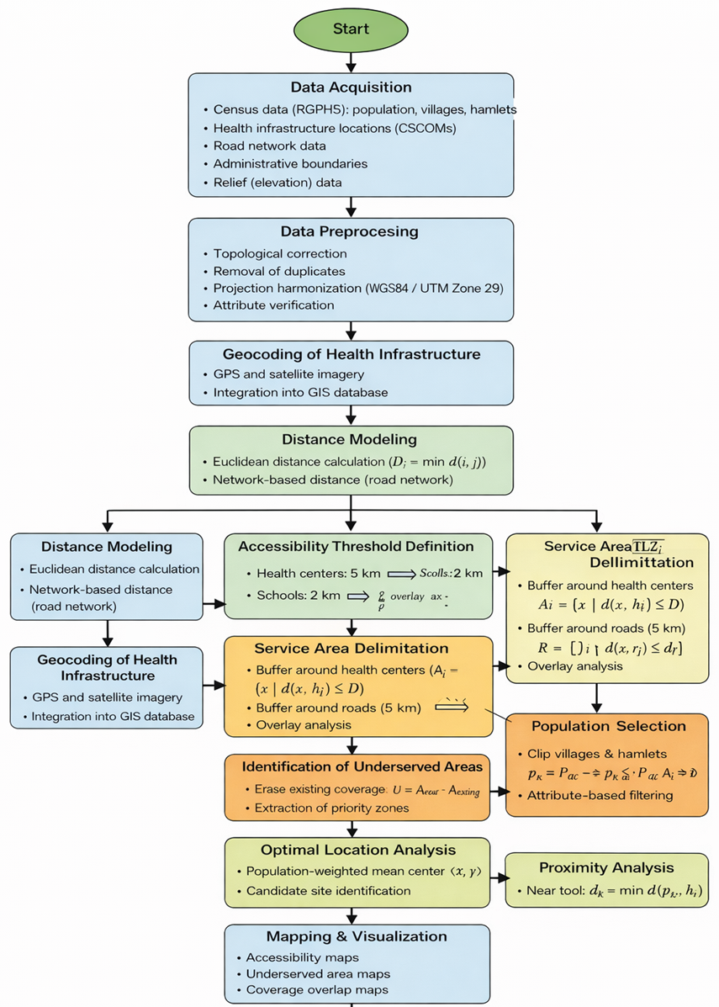

Fig 1. Flowchart of the methodological framework integrating census data and GIS for spatial accessibility analysis to health infrastructure in the rural commune of Kroukoto.
2.1 Study area presentation

The rural commune of Kroukoto is located in the cercle of Kéniéba, within the Kayes Region in south-western Mali. It covers an area of approximately 250 km², Figure 2. The commune is bordered by Sadiola to the north, Dabia to the south, Kéniéba to the east, a location that favors local mobility, trade, and cross-border socio-economic exchanges. Kroukoto has an estimated population of nearly 12,000 inhabitants, distributed among several villages and hamlets. The population is predominantly young and ethnically diverse, mainly composed of Malinké, Peulh, and Khassonke communities. Settlement patterns are largely rural, with extended family households, while population growth and mining-related migration increase pressure on land and natural resources. The commune is situated in the Sudano-Sahelian climatic zone, characterized by a rainy season from June to October and a dry season from November to May. Annual rainfall ranges between 700 and 1,100 mm, supporting agricultural activities but also exposing the area to climatic variability. The landscape is generally gently undulating, with low hills and seasonal watercourses, and the vegetation is dominated by savanna woodland interspersed with cultivated and fallow lands. The local economy relies mainly on subsistence agriculture, livestock rearing, and artisanal gold mining. Crop production focuses on millet, sorghum, maize, and groundnuts, while livestock farming involves cattle, sheep, and goats. Although mining provides an important source of income, it also generates environmental and social challenges. In terms of infrastructure, Kroukoto is equipped with primary schools, a community health center, and boreholes for drinking water. However, limited road infrastructure, particularly during the rainy season, restricts access to markets and basic services. Overall, Kroukoto represents a typical rural commune of south-western Mali, making it a relevant study area for analyzing land-use patterns, spatial dynamics, and socio-environmental interactions.
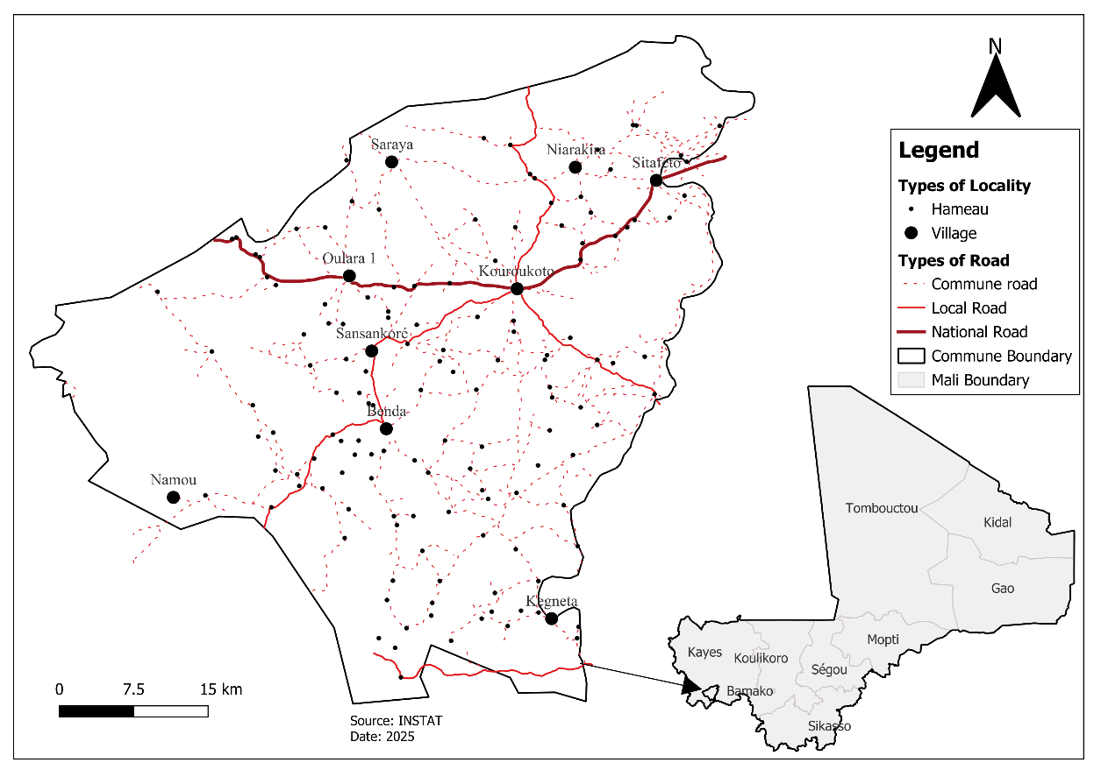
Fig. 1. Presentation of the rural commune of Kroukoto
2.2 Method
This study uses data from the General Census of Population and Housing (RGPH-5) conducted by the National Institute of Statistics (INSTAT). The datasets include administrative boundaries, enumeration units, health infrastructures, and the road network. These data provide a foundational basis for territorial planning and the management of essential public services. All datasets were integrated into a Geographic Information System (GIS) environment using Python, enabling detailed spatial analyses and the production of thematic maps that can be interpreted at multiple scales. The methodology follows a structured, stepwise approach, which ensures reliability and reproducibility of results:
2.2.1 Data Sources
The data used in this study are derived from the fifth General Census of Population and Housing (RGPH-5) conducted by the National Institute of Statistics (INSTAT) of Mali. These datasets form an up-to-date geospatial database that supports spatial analysis and local development planning by integrating demographic information with georeferenced spatial layers. As summarized in Table 1, the datasets include administrative and statistical boundaries (commune limits, villages, and enumeration sections), georeferenced health infrastructure, and the road network, which together structure the spatial framework for accessibility modeling. Population data at the locality level provide information on the spatial distribution of inhabitants, while relief data describe elevation, which influence accessibility and infrastructure planning.
Table 1. Datasets used for infrastructure accessibility analysis in the rural commune of Kroukoto

No | Data | Source | Year | Description
1 | Geographic entities | INSTAT | 2019 | Commune boundaries, villages, and enumeration section boundaries
2 | Health infrastructure | INSTAT | 2019 | Georeferenced infrastructure points
3 | Access roads | INSTAT | 2019 | Road network and access routes
4 | Population of localities | INSTAT | 2022 | Spatial distribution of population from the census
5 | Relief | INSTAT | 2022 | Distribution of elevation

These datasets were integrated into a GIS environment using QGIS software, allowing management, visualization, and spatial analysis of information. GIS plays a key role in structuring and representing spatial data, offering powerful tools for territorial modeling and decision-making. The integration of census and geospatial data enables the analysis of service accessibility, identification of territorial disparities, and informed planning of infrastructure and social services.
2.2.1 Data preprocessing
Before conducting spatial analyses, all datasets underwent careful preprocessing to ensure accuracy, consistency, and reliability. This process involved correcting topological errors, such as gaps between adjacent boundaries, overlapping polygons, and disconnected road segments, which could otherwise distort distance calculations and population coverage. Duplicate features, which may occur during data collection or digitization, were identified and removed to prevent overestimation of service availability and avoid statistical bias. In addition, all spatial layers were harmonized to a common coordinate reference system (WGS 84 / UTM Zone 29) to ensure correct alignment and accurate measurement of distances, areas, and spatial relationships. These preprocessing steps are critical because the quality of input data directly influences the accuracy of GIS analyses and accessibility modeling. By addressing errors, eliminating inconsistencies, and standardizing projections, the datasets became reliable and ready for detailed spatial modeling, enabling precise calculations of distances to infrastructure, identification of underserved areas, and the generation of meaningful thematic maps for local planning and decision-making.
2.2.2 Geocoding of infrastructures
Geocoding is the process of converting descriptive location information of infrastructure into precise geographic coordinates for use in a GIS environment. In this study, each health center was geocoded using field GPS surveys, high-resolution satellite imagery, and the Malian geocoding system, which includes administrative identifiers such as region, cercle, commune, and locality codes, in addition to longitude and latitude coordinates. This system ensures that every infrastructure point is uniquely identified and accurately located within the administrative hierarchy of Mali. Once geocoded, the infrastructure points were integrated into the GIS database, enabling spatial analysis relative to population settlements, road networks, and other layers. This process supports accessibility modeling, allows for the verification and updating of infrastructure inventories, and provides reliable data to assist local authorities in planning interventions and allocating resources effectively.
2.2.3 Euclidean distance and network-based distance calculations
Accessibility from residential areas to infrastructures was assessed using two complementary methods to provide a thorough understanding of service reach and potential constraints.
- Euclidean distance: This method calculates the straight-line distance between each residential point 𝑖 and infrastructure point 𝑗, using the following equation:

$$D_{i}=min⁡\sqrt{\left(x_{i}-x_{j})^{2}+(y_{i}-y_{j})^{2}\right.}$$
where 𝐷𝑖 represents the minimum straight-line distance between the residential location and the nearest infrastructure. Euclidean distance is a simple and widely used approach in geographic studies because it provides a quick estimate of proximity without considering specific travel routes or obstacles. It is particularly useful for identifying general patterns of accessibility and for highlighting areas that are potentially far from essential services. However, Euclidean distance assumes that people can move directly in a straight line, which is often unrealistic in rural or complex terrains.
- Road network distance: To obtain a more realistic measure of accessibility, distances were also calculated along the actual road network, taking into account the connectivity, layout, and length of roads. This method reflects the true travel paths that residents must follow to reach services, including detours, road conditions, and the presence of natural or man-made obstacles. Network-based distance is especially important in rural areas like Kroukoto, where terrain variability, limited road infrastructure, and seasonal accessibility constraints can significantly influence travel times and service reach.
By combining these two approaches, the analysis captures both the theoretical proximity (Euclidean distance) and the practical accessibility (network based on distance) to infrastructures. This dual method allows for a comprehensive assessment of spatial accessibility, identifying well-served areas, underserved localities, and locations where interventions such as new roads or facilities may be required. Moreover, it provides planners with insights into spatial inequalities in access to health and educational services, supporting evidence-based decision-making for equitable resource allocation and strategic infrastructure development.

3. Results

Evaluating spatial accessibility to health infrastructures is critical for identifying underserved areas and supporting evidence-based local planning. In Kroukoto, where settlements are widely dispersed and terrain varies, both distance and road connectivity significantly influence access to services. This experiment uses GIS-based modeling to assess accessibility to 12 primary schools and 4 community health centers (CSCOM). Accessibility was analyzed using distance and road network approaches, applying thresholds of 2 km for schools and 5 km for health centers, in line with national and international standards. The analysis provides a detailed understanding of service coverage, highlights areas with limited access, and informs potential interventions, including the planning of a second health center to improve equity and reduce territorial disparities.

3.1 Modeling of spatial accessibility to infrastructure

The municipality of Kroukoto is served by 12 primary schools and 4 community health centers (CSCOMs). To evaluate how effectively these infrastructures serve the population, spatial accessibility analyses were conducted using GIS data. Accessibility was modeled using both straight-line (Euclidean) distances and road network-based distances, applying distance thresholds aligned with national and international standards: 2 km for schools and 5 km for health centers. These thresholds follow operational recommendations from the World Health Organization (WHO, 2019) and global accessibility mapping practices (Weiss et al., 2020). Using GIS modeling, it was possible to identify underserved areas, quantify population coverage, and evaluate spatial disparities in access to basic social services (Neutens, 2015). Areas were classified according to their accessibility levels into low, medium, and good categories, using reference distances of 5 km and 10 km. Thematic maps were generated to visualize the spatial distribution of infrastructure, highlighting gaps and under-served localities. Summary tables quantified the population within each accessibility category, enabling a clearer understanding of territorial disparities. This methodological approach, drawing on ESRI (2022) and Bivand et al. (2021), transforms statistical and geospatial data into actionable information for decision-making. It provides a spatial perspective on inequalities, offering support for evidence-based planning and resource allocation.
3.1.1 Spatial distribution of localities

Figure 2 illustrates the spatial arrangement of localities in Kroukoto relative to key socio-community service centers, including the CSCOM. The map reveals that the mother locality nearest to these infrastructures is approximately 15 km away, while most villages and hamlets are situated more than 20 km from these services. This spatial pattern highlights the limited accessibility faced by a large portion of the population and underscores the necessity of strengthening health infrastructure coverage across the commune.

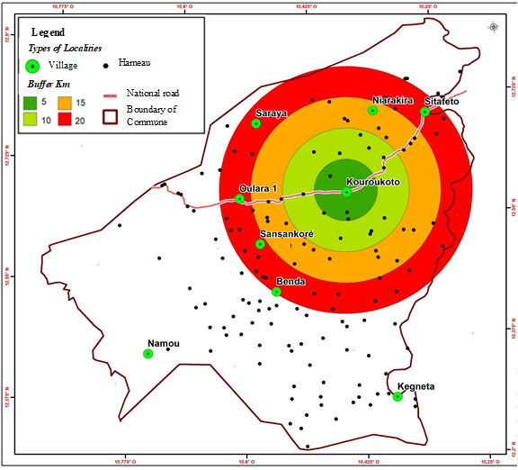

Fig.2. Spatial distribution of localities in Kroukoto commune

Figure 3 presents a spatial accessibility analysis of community health services in the municipality of Kroukoto. Accessibility was assessed using distance thresholds consistent with international standards, with good accessibility defined within 5 km of the existing CSCOM, moderate accessibility between 5 and 10 km, and low accessibility beyond 10 km. The analysis further incorporates altitude constraints, showing that settlements located at higher elevations (above approximately 300–400 m) experience reduced effective accessibility due to rugged terrain and limited road connectivity, even when geographically closer to the health center. These findings reveal pronounced territorial disparities and support the need to strengthen health infrastructure coverage, including the establishment of an additional community health center to improve equitable access.
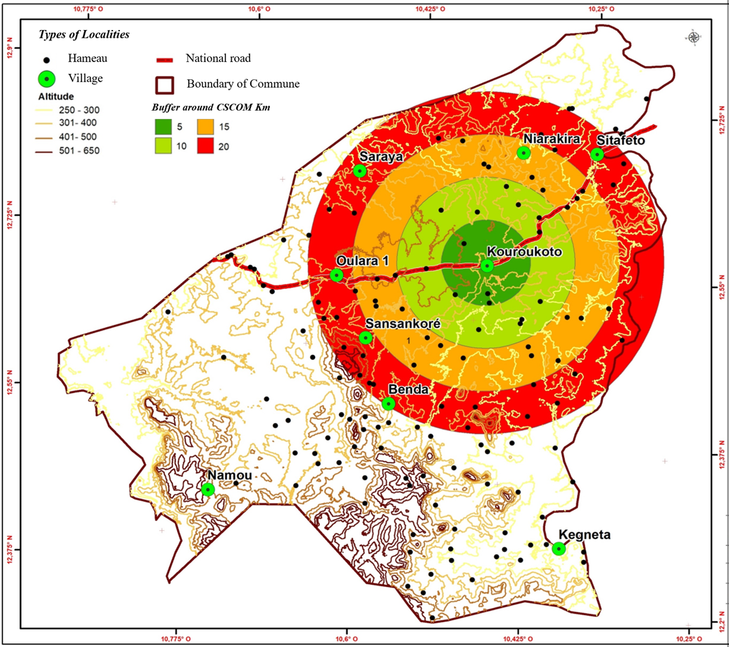

Fig.3. spatial accessibility analysis

3.1.2 Spatial Accessibility Model Description

The spatial accessibility model was developed using Python grogram to evaluate healthcare service coverage and to identify an optimal location for a new community health center in the rural commune of Kroukoto (cercle of Kéniéba, Kayes region). The model integrates spatial data on health facilities, transportation networks, population distribution, and administrative boundaries through a sequence of distance-based and overlay operations. The analytical framework is supported by explicit mathematical formulations to ensure transparency and reproducibility.

3.1.2.1 Definition of Healthcare Service Areas

Healthcare accessibility is modeled using a fixed-distance threshold approach. For each health center $h_{i}$, a service area $A_{i}$is defined as:
$$A_{i}=\{x∈R^{2}∣d(x,h_{i})≤D\}$$
where $d(x,h_{i})$denotes the Euclidean distance between location $x$and health center $h_{i}$, and $D=20$km represents the maximum acceptable travel distance for accessing primary healthcare services in rural contexts. This formulation corresponds to the Buffer operation applied to health facility locations.

3.1.2.2 Transportation Network Influence

To account for the role of transportation infrastructure in accessibility, road segments $r_{j}$are incorporated into the model. Areas influenced by the road network are defined as:
$$R=\bigcup_{j=1}^{n}{\{x∈}R^{2}∣d(x,r_{j})≤d_{r}\}$$
where $d_{r}$is the buffer distance around roads (5 km). This step reflects enhanced accessibility along transport corridors and is implemented through Route and Buffer tools.

3.1.2.3 Identification of Underserved Areas

Areas already served by the existing health center are excluded to identify priority zones for new infrastructure. The underserved area $U$is defined as:
$$U=A_{\text{potential}}∖A_{\text{existing}}$$
where $A_{\text{existing}}$and $A_{\text{potential}}$represent the service areas of the existing and proposed health centers, respectively. This spatial subtraction is performed using the Erase tool.

3.1.2.4. Selection of Population within Accessible Zones

Population settlements (villages and hamlets) are selected if they fall within the defined accessibility areas:
$$p_{k}∈P_{\text{acc}} ⟺ p_{k}∩A_{i}≠∅$$
where $p_{k}$denotes a population settlement and $P_{\text{acc}}$is the set of settlements with healthcare access. This operation corresponds to the Clip and Select Layer By Attribute steps in Model.

3.1.2.5 Population Coverage Estimation

The population served by each health center is computed as:
$$Pop_{i}=\sum_{k=1}^{m}{P_{k}}⋅I(p_{k}∈A_{i})$$
where $P_{k}$is the population of settlement $k$and $I(⋅)$is an indicator function equal to 1 when the condition is satisfied and 0 otherwise. These calculations were automated and validated using Python scripts.

3.1.2.6 Overlapping Service Areas

Zones benefiting from dual healthcare access are defined by the intersection of service areas:
$$A_{\text{overlap}}=A_{\text{existing}}∩A_{\text{new}}$$and the corresponding population is:
$$Pop_{\text{overlap}}=\sum_{k=1}^{m}{P_{k}}⋅I(p_{k}∈A_{\text{overlap}})$$
3.1.2.7 Optimal Location Determination Using Mean Center

The optimal location for the new health center is determined using a population-weighted mean center:
$$(\overset{ˉ}{x},\overset{ˉ}{y})=\left(\frac{\sum_{k=1}^{m}{w_{k}}x_{k}}{\sum_{k=1}^{m}{w_{k}}} , \frac{\sum_{k=1}^{m}{w_{k}}y_{k}}{\sum_{k=1}^{m}{w_{k}}}\right)$$
where $\left(x_{k} , y_{k}\right)$are the coordinates of settlement $k$, and $w_{k}=P_{k}$represents population weights. This step ensures equitable spatial positioning of the proposed health center and corresponds to the Mean Center tool.

3.1.2.8. Proximity Analysis

Finally, the minimum distance from each settlement to the nearest health facility is calculated as:
$$d_{k}=\underset{i}{min⁡}d(p_{k},h_{i})$$
This proximity evaluation is implemented using the Near tool to assess relative accessibility improvement
By combining GIS-based spatial operations with explicit mathematical formulations, the proposed model provides a robust, reproducible, and decision-oriented framework for healthcare accessibility analysis. The results support strategic planning by identifying underserved areas, quantifying population coverage, and optimizing the spatial allocation of new health infrastructure to reduce territorial inequalities.

3.1.3 Model Application: Spatial analysis of the project to install a second health

Figure 4 presents the rural commune of Kroukoto, located in the cercle of Kéniéba (Kayes region), as part of the project to install a second health center. The spatial analysis highlights two main localities: Kroukoto, which houses the old health infrastructure, and Dombaya, designated to host the new. Around each center, a radius of 20 km has been drawn in order to delimit the health coverage area. The choice of Dombaya for the new establishment allows to extend the coverage towards the southwest of the municipality, until then less served. According to calculations using the Python programming language, the new infrastructure covers about 5,089 people in 5 villages and 44 hamlets, while the old one in Kroukoto serves 4,671 people from 1 village and 43 hamlets. An intersection area between the two departments has also been identified, comprising 2,331 people living in 2 villages and 22 hamlets, thus benefiting from dual access to care. This spatial distribution shows that the new facility will contribute to better health accessibility and a reduction in territorial inequalities in terms of health coverage within the municipality.

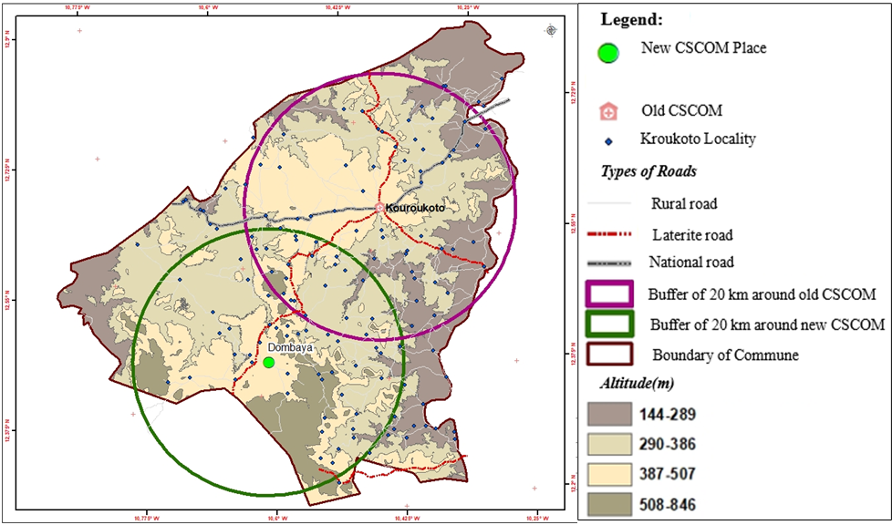
Fig 4. Spatial analysis of the project to install a second health in the commune of Kroukoto

4. Discussion

The accessibility patterns observed in Kroukoto commune reveal a clear spatial contrast between central and peripheral areas with respect to health services. While central zones benefit from relatively better access to health facilities, peripheral and low-density areas remain significantly underserved. This spatial imbalance indicates that the distribution of health infrastructure is strongly influenced by settlement patterns and transportation networks, thereby reinforcing existing territorial inequalities in access to basic healthcare services. These findings are consistent with previous studies demonstrating that spatial accessibility is largely determined by territorial configuration, infrastructure distribution, and road network quality (Neutens, 2015; Wang, 2012). In rural contexts, distance continues to represent a major barrier to healthcare access. The proportion of the population located beyond 5 km from a health center in this study aligns with observations reported by Weiss et al. (2020) for rural areas of sub-Saharan Africa, supporting the relevance of distance-based thresholds for evaluating healthcare accessibility. The results further highlight the effectiveness of GIS-based analysis in identifying spatial disparities that may not be evident through non-spatial indicators. By integrating census data with the spatial distribution of health facilities, the approach enables a detailed assessment of underserved areas. Similar conclusions were reached by Delamater (2013) and Talen and Anselin (1998), who emphasized that spatial equity in public service provision requires explicitly spatial analytical frameworks. From a planning perspective, the accessibility maps generated in this study provide valuable decision-support tools for local authorities. They facilitate the prioritization of health infrastructure investments and contribute to more efficient allocation of limited public resources. This approach is consistent with evidence-based governance frameworks promoted by international organizations, which advocate for the systematic use of geospatial information in public policy and territorial planning (World Bank, 2021; UNDP, 2022). Moreover, comparisons with other rural municipalities in the Kayes region reveal significant regional disparities in healthcare accessibility, largely driven by differences in population density, infrastructure quality, and financial capacity. Despite these contributions, several limitations should be acknowledged. The accessibility assessment relied primarily on distance-based measures and did not account for travel time, transport availability, or seasonal variability. Future research could enhance the robustness of the analysis by incorporating mobility models, road condition data, and temporal accessibility metrics. In addition, the integration of remote sensing data could support more frequent updates of local spatial databases, further strengthening the role of GIS in healthcare planning (Goodchild, 2020; Bivand et al., 2023).
Overall, this study confirms the relevance of GIS based on the accessibility analysis as a robust tool for diagnosing spatial inequalities in healthcare access and supporting more equitable territorial planning in rural contexts.

5. CONCLUSION

The integrated exploitation of census data and GIS analysis tools constitutes a strategic lever for territorial planning based on evidence and oriented towards sustainable development. The study conducted in the municipality of Kroukoto demonstrates the relevance of this approach to identify under-equipped areas, measure spatial disparities, and guide public decision-making in an objective and efficient manner. By combining demographic, geographical, and infrastructural dimensions, this approach strengthens the capacity of local authorities to plan, prioritize, and evaluate development interventions. The generalization of this methodology to all municipalities in Mali would promote a more equitable distribution of resources and better accessibility to basic social services, while supporting the implementation of national decentralization and territorial development policies. Finally, the systematic integration of GIS into local planning processes would contribute to establishing a more transparent, participatory, and resilient territorial governance in the face of sustainable development challenges.

Reference
- UNFPA. (2020). Le rôle des recensements dans la planification du développement en Afrique. Fonds des Nations Unies pour la Population (UNFPA), Dakar.
- INSTAT. (2023). Cinquième Recensement Général de la Population et de l’Habitat (RGPH-5) du Mali: Rapport de synthèse. Institut National de la Statistique du Mali.
- Longley, P. A., Goodchild, M. F., Maguire, D. J., & Rhind, D. W. (2021). Geographic Information Systems and Science (5th ed.). Hoboken, NJ: Wiley.
- UNDP (PNUD). (2022). Spatial Inequality and Local Development in Africa: A Policy Perspective. New York: United Nations Development Programme.
- World Bank (Banque Mondiale). (2021). World Development Report 2021: Data for Better Lives. Washington, DC: The World Bank.
- Goodchild, M. F. (2018). Revisiting the GIScience research agenda. International Journal of Geographical Information Science, 32(1), 1–12. https://doi.org/10.1080/13658816.2017.1327196
- Mennis, J. (2020). Mapping and modeling population accessibility. Annals of GIS, 26(3), 215–228. https://doi.org/10.1080/19475683.2020.1762395
- Bivand, R. S., Pebesma, E., & Gómez-Rubio, V. (2023). Applied Spatial Data Analysis with R (3rd ed.). Springer Nature.
- Talen, E., & Anselin, L. (1998). Assessing spatial equity: An evaluation of measures of accessibility to public playgrounds. Environment and Planning A, 30(4), 595–613. https://doi.org/10.1068/a300595
- Neutens, T. (2015). Accessibility, equity and health care: Review and research directions. Computers, Environment and Urban Systems, 49, 1–9. https://doi.org/10.1016/j.compenvurbsys.2014.12.002
- Goodchild, M. F. (2020). Spatial Data Science: Concepts and Applications. University of California Press.
- ESRI. (2022). GIS for Sustainable Development: Spatial Solutions for Policy and Planning. Redlands, CA: Environmental Systems Research Institute.
- Wang, F. (2012). Measurement, optimization, and impact of health care accessibility: A methodological review. Annals of the Association of American Geographers, 102(5), 1104–1112. https://doi.org/10.1080/00045608.2012.657146
- Weiss, D. J., Nelson, A., Vargas-Ruiz, C. A., et al. (2020). Global maps of travel time to healthcare facilities. Nature Medicine, 26, 1835–1848. https://doi.org/10.1038/s41591-020-1059-1
- Camara, M. (2024). Tunnel Cross-Section Deformation Monitoring Based on Mobile Laser Scanning Point Cloud. Journal of Geospatial Engineering and Geomatics, 12(3), 45–59.
- Jain, M., Singh, P., & Sharma, R. (2020). Geospatial data integration for monitoring health infrastructure. International Journal of Health Geographics, 19(1), 12–24. https://doi.org/10.1186/s12942-020-00205-9
- Kounadi, O., & Leitner, M. (2014). Why does geocoding matter? Examining the spatial dimensions of crime data. Environment and Planning B: Planning and Design, 41(6), 1143–1152. https://doi.org/10.1068/b39153
- Guagliardo, M. F. (2004). Spatial accessibility of primary care: Concepts, methods and challenges. International Journal of Health Geographics, 3(1), 3. https://doi.org/10.1186/1476-072X-3-3
- Delamater, P. L. (2013). Spatial accessibility in suboptimally configured health care systems. Health & Place, 24, 45–52. https://doi.org/10.1016/j.healthplace.2013.08.003
- Hansen, W. G. (1959). How accessibility shapes land use. Journal of the American Institute of Planners, 25(2), 73–76. https://doi.org/10.1080/01944365908978307
- Church, R. L., & Marston, J. R. (2003). Measuring accessibility for people with a disability. Geographical Analysis, 35(1), 83–96. https://doi.org/10.1111/j.1538-4632.2003.tb01102.x
- Bivand, R. S., Pebesma, E., & Gómez-Rubio, V. (2021). Applied Spatial Data Analysis with R (2nd ed.). New York: Springer.
- World Health Organization (WHO). (2019). Monitoring Health Inequality: An Integrated Approach. Geneva: WHO Press.

