Original Research Article

Development and Performance Evaluation of an AI-Based Wi-Fi Operated Weeder for Precision Weed Management

.
ABSTRACT

Aims: To study the weeds and existing weeding robots, design and develop a dual operated AI based weeder, and perform performance evaluation of Dual operated AI based weeder
Study design: Analytical (Observational) and Experimental (Interventional)
Place and Duration of Study: Department of Agriculture Engineering, East West College of Engineering Yelahanka, Bangalore, between January 2025 and December 2025.
Methodology: We installed a Raspberry Pi microcontroller in the weeder. The microcontroller was fed a code to perform different actions for crops and weeds. The weeder was run in an open field of Dichondra repens.
Results: The wifi range is 50 m. The theoretical field capacity is 0.0485 m²/s. The effective field capacity is 0.0289 m²/s. Fielding efficiency is 59.68 per cent. Weeding efficiency is 98.07 per cent.

Keywords: Weeding, Efficiency, Raspberry Pi, Robot

1. INTRODUCTION

Weeds are the super environmental stress tolerators in the plant kingdom, as they can survive in many extreme environments and have eluded human control for over 12,000 years. They are defined as any plants that have negative socio-economic and/or environmental impacts, threaten global food security, biodiversity, ecosystem services, and human health. Impacts of weeds in current systems are likely to get worse rather than better, due to increased long-distance trade, climate change, altered disturbance patterns, herbicide resistance and other factors, making improvements in weed management ever more urgent. Current trends suggest that weed problems will worsen in the next 10-20 years. Al-powered weed management systems offer precision, accuracy, cost-effectiveness, environmental conservation, labour efficiency, improved crop yields, time savings, scalability, data-driven insights, climate change resilience, and technological advancement. These systems reduce herbicide use, environmental risks, and labour costs, allowing farmers to allocate human resources more effectively. AI systems adapt to changing. conditions, ensuring farmers maintain productivity despite environmental uncertainties. Deploying Al in weed management is a crucial step towards sustainable and efficient farming practices, promoting innovation and investment in the agricultural sector.
Traditional weed control methods, such as widespread herbicide application, often result in ineffective treatment and environmental harm. The rise of precision farming and smart farming has opened opportunities for automation in agriculture, where convolutional neural networks (CNNs) play a crucial role in image classification, object detection, and fine-grained categorization with high accuracy.
Robotic weeders employ advanced technologies such as computer vision, Al, and mechanical tools to autonomously or semi-autonomously navigate through crops, identify weeds, and execute targeted removal.
Elizabeth Mosqueda and Richard Smith (2020) noted that the kill mechanism used by the currently available machines is either a split blade that open around keeper plants (eg. Robovator and Steketee IC) or a spinning blade that avoids the keeper plants by placing them in a notch in the blade. In 2015, evaluations found that Robovator and Steketee IC removed 51% of the weeds in the sidelines.
Xiaolong Wu and Philipp Lottes (2020) used a multi-camera system and a 3D multi-object tracking algorithm were used to ensure accurate weed detection and tracking. A 3D mapping layer and illumination-robust cost improved reliability under varying viewpoints and lighting. The system was tested in diverse terrain and crop conditions, showing reliable in-row weed removal performance in real-world scenarios.
Georg-Peter Naruhn and Andreas F. Butz (2021) found that depending on factors like location, weed density, time of weed emergence and weed types or weed composition, the yield losses range from 18-50% in various winter cereals and from 50-90% in sugar beet, maize, sunflowers and soybeans.
Pushpavalli M noted that the finger weeder operates using inputs from recognition and control units. When weeds are detected in an image, the motor activates the weeding mechanism.
Manisankar G and Sathiyabama N noted that the Vitirover solar bots use solar power to cut grasses and weeds of 2-3 cm in height The speed is 500 m per hour. They are used in grape vineyards. They use sensors and global positioning system.
Tertill requires some working condition for better performance. The garden must be surrounded by 3-5-inch-tall barrier to restrict the movement of tertill. The crops must be taller than the weeds, or Tertill will skip over them. The Tertill is a small (12 cm × 21 cm), solar-powered home-garden weeding robot effective in areas up to 18.6 m². It identifies weeds by height—cutting plants shorter than 2.5 cm with a spinning trimmer. Its drawbacks are that the garden bed must surround by 3-5-inch-tall barrier to arrest the weeder movement away from garden area. Otherwise, it moves away from the garden area and start chopping entire yard. During weeding, small plants to be retained by using protective barrier wires that to stick on to the ground on either side of the young plant to avoid Tertill chopping. It just bounces the tall weeds and unharms them. Its weeding efficiency is about 75-90% according to the studies.
Robocop is the first commercially available robotic weeding machine. During the weeding operation, it uses a digital video camera to capture images of the crop ahead to the toolbar. It uses a special disc shaped rotating axis to cultivate at a shallow depth of 10 to 20 mm within the crop row. Its limitation is that it performs well only for transplanted crops as the seeded crops are irregularly placed similar to weeds and faces difficulty in distinguishing between crops and weeds. Its weeding efficiency ranges from 80% to over 90% with minimal crop damage.
The IC weeder uses a digital camera to calculate the position of cultivated crops and unwanted weed, then hoe around them accurately and quickly. IC weeder at a working pressure of 7 bars, the steering blade will strike between a plant in just 50 milliseconds (0.05 seconds). Its weeding efficiency often ranges from 80-90%. Its drawbacks are that it is expensive and cannot be used for small fields.
Robovator gathers information about the vegetation by utilizing the high-quality camera placed over each crop row based on colour, size, and spacing between the crops. It is capable for operating 2.5 mph speed and available in 3-6 units. It has a weeding efficiency ranging from 80-90%. Its drawbacks are that it is expensive, weeds should be same in size and plants shouldn’t overlap for it to perform weeding.
We can see that, the AI based robots like Tertill, Naio Technologies, Farm Wise, Ecorobotix, Garford Robocrop, Vision Robotics, have some limitations. Tertill is not designed to navigate through terrain including large rocks, deep holes, thick mud, or other significant obstacles, and, only targets weeds that are only 2 inches or taller. Naio Technologies require high initial investement, and though capable of navigating various agricultural settings, the complexity of some terrains and the need for specific navigation strategies can be challenging. Farm Wise faced challenges developing AI system capable of adapting to the variety of crops, bed spacings, row spacings, and soil morphologies. Ecorobotix encountered efficiency problemss because the self-driving device was only 2m wide and could only operate very slowly due to the sequential operation of its robotic spot spraying arms. Ekobot WEAl possessed vision systems that may misidentify weeds, especially in early growth stages or in low light/dusty conditions.
Problem Statement
- Most AI-based weeders are expensive and unaffordable by small scale farmers.
- Some AI-based weeders give false negatives and false positives, struggling to distinguish between weeds and seedlings.
- They are sensitive to climate change.
- Small weeding robots like Tertill can cover only small areas.
- They cannot handle uneven terrain, slopes, or fields with obstacles.

2. material and methods

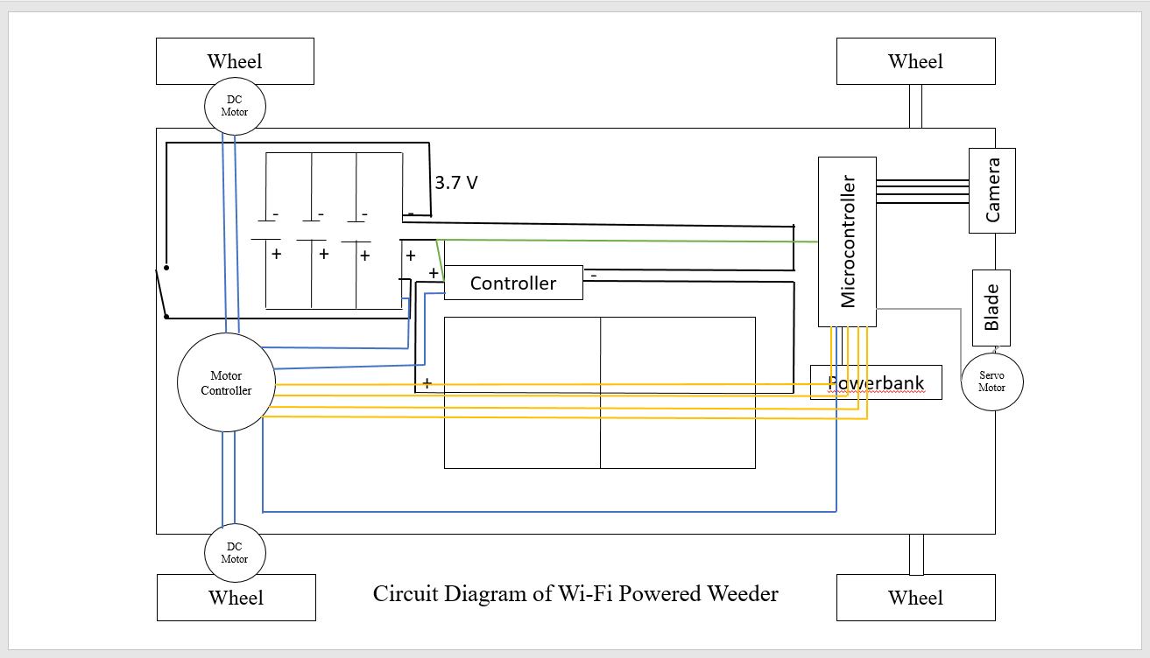
The project began with a hard board, which was already according to our requirements. The components were connected in two main systems: the power system, for charging and distribution, and the control system for movement and operation. Then, we connected 4 wheels of diameter of 7 cm and weight 70 grams. These wheels were picked as they‘ll give the machine the necessary traction while not bearing too much load onto the soil. We then connected a DC Motor to the wheels to provide the required speed of 0.22m/s. Then, we installed the Raspberry Pi and DC Motor Driver onto the chassis. We powered the Raspberry Pi microcontroller through the power bank. We connected the Raspberry Pi s GPIO (General Purpose Input/Output) pins to the input pins of the DC motor driver using wires. The Raspberry Pi will send control signals (such as speed and digital signals) to the motor driver through these wires. Then, we connected the terminals of the motor driver directly to the DC
Fig.1 Circuit Diagram of AI Powered Weeder

metal gear motors which were already attached to the wheels, using wires. The motor driver provides 5V power from the battery to run the motors according to Pi' s commands. The Pi camera module was placed at an angle of to the ground, at the front of the machine. This angle was used to provide a better visual access to the camera. Then, we connected the Pi camera module to the Raspberry Pi's CSI (Camera Serial Interface) port via its ribbon cable. We used a 12V DC battery as the primary power source to power the DC motor driver and the DC motors. A main switch was wired in series with the battery output to turn the entire weeder' s power on or off. Then, we connected the solar panels to be used as an alternative, sustainable source of power. Lastly, we connected the blade like an arm at the foremost part of the weeder, beside the camera.

The weeder can be used to weed both row crops, and open fields. The data set used for the row crop is that of a tomato plant (Solanum lycopersicum). Python was the programming language chosen to write the code. As the weeder moves forward, the Raspberry Pi microcontroller sends signals to the connected camera module to continuously scan the surroundings for weeds and crop. Once it detects a weed, the blade is lowered and pushed into the ground right below the weed, and the weed is lifted, along with its roots, and discarded. When a crop is detected, the blade is raised to avoid damage to the crops, and the machine moves backward till it detects another weed. In case of an open field, no initial data needs to be fed. The weeder weeds though all the weeds present in the field.
3. results and discussion

Laboratory tests conducted were:
a. Wi-Fi Test:
To calculate the distance of the Wi-Fi module, begin by setting up the module with a stable power source and pairing it with a Wi-Fi-enabled device, such as a smartphone or laptop. Establish a connection and verify data transmission using a Wi-Fi terminal or communication application. Position the Wi-Fi module in a fixed location and gradually move the paired device away in a straight line. Use a measuring tape or distance measurement tool to determine the separation at which the connection remains stable. Continue increasing the distance until the signal weakens or the connection drops entirely. Record this distance as the module's maximum range. For accurate results, conduct the test in an open area with minimal interference, and repeat the procedure in environments with obstacles to evaluate the module's performance under different conditions. The range was found to be 50 m.
b. Battery and Motor Test:
The researchers test the power supply of the battery by using three 3.7 V lead acid rechargeable batteries that are connected in parallel. The motors on wheels are also tested. Before testing, the batteries should be fully charged. The machine will be used continuously for one hour. After one hour, the capacity or voltage reduction of the battery was tested using the "Multimeter". If machine malfunctions, it means that it reaches the critical level of the battery or the battery is already low. The test is conducted again to check the charge of battery to determine the critical level of it. Then the voltage of the battery is tested first before charging it. After one hour, the battery will be tested again and will record the voltage increased every one hour until it becomes fully charged. In motor test, the Pi camera is shown images of crop and weed, the motors are synchronized and accurately moves up and down, depending on the image shown. A battery capacity of 3.89 Ah lithium-ion battery was used to power the lifting and lowering of the blade arm.
The field tests conducted were:
The developed “AI based Weeding Robot” was evaluated for its performance of weeding. During the evaluation of the weeder, the following parameters were considered.
They are:

a. Weeding efficiency:
The weeding efficiency was calculated as a percentage representing the ratio of weeds removed to the initial number of weeds.
W.E (%) = (W₁-W₂) / W₁×100
Where;
W₁ is the number of weeds per unit area before weeding
W₂ is the number of weeds per unit area after weeding.

b. Field efficiency:
Field Efficiency is the ratio of effective field capacity by theoretical field capacity expressed in percent.
$$Field efficiency \left(\%\right):\frac{Avg. Effective field capacity }{ Avg. Theoritical field capacity}×100$$
a. Effective field capacity (C):
Effective Field Capacity is defined as the actual area covered by the implement, based on its total time consumed and its width.
$$Effective Field Capacity (C):\frac{Area Covered }{ Actual Time Taken}$$
b. Theoretical field capacity:
Theoretical Field Capacity is the rate of field coverage of the implement, based on 100 percent of time at the rated speed and covering 100 percent pf its rated width.
$$Theoretical Field Capacity \left(C\right)= \frac{Width x Speed}{ 10}$$
Table.1 Results of developed Solar Wi-Fi Based Weeder
Sl. No. | Parameter | T1 | T2 | T3 | Average
01. | Theoretical Field Capacity (m²/s) | 0.0484 | 0.0487 | 0.0485 | 0.0485
02. | Effective Field Capacity (m²/s) | 0.0243 | 0.0256 | 0.0370 | 0.0289
03. | Fielding Efficiency (%) | 50.20 | 52.57 | 76.29 | 59.68
04. | Weeding Efficiency (%) | 97.25 | 98.73 | 98.22 | 98.07
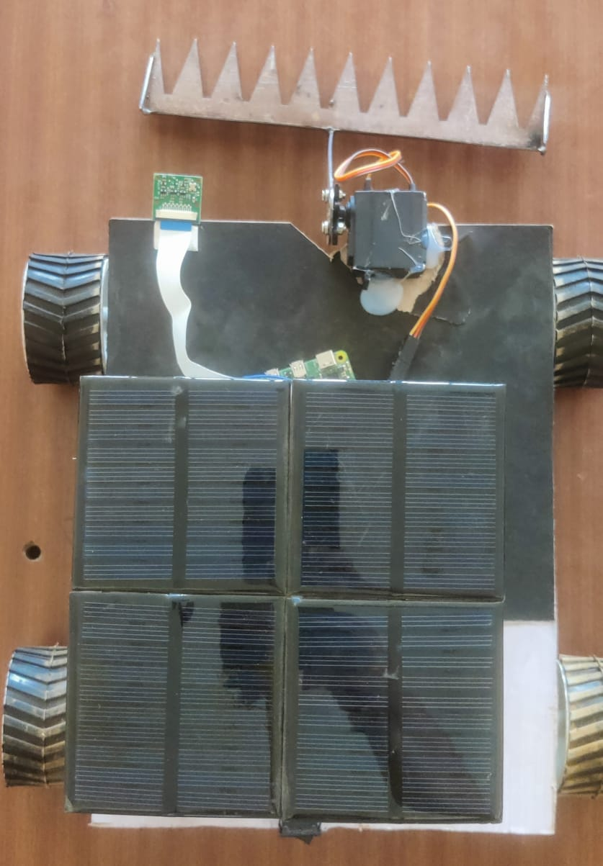
Wheel
Raspberry Pi Camera Module
Hardboard
Solar Panel
Servo Motor
Blade

Fig. (a)

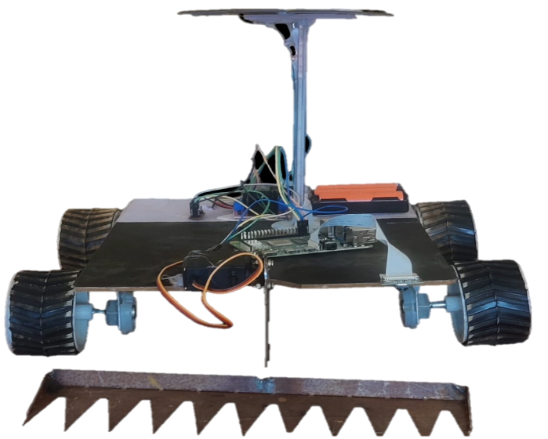
Connecting wires
Battery
Raspberry Pi Microcontroller
DC Gear Motor
Blade Arm
Fig. (b)

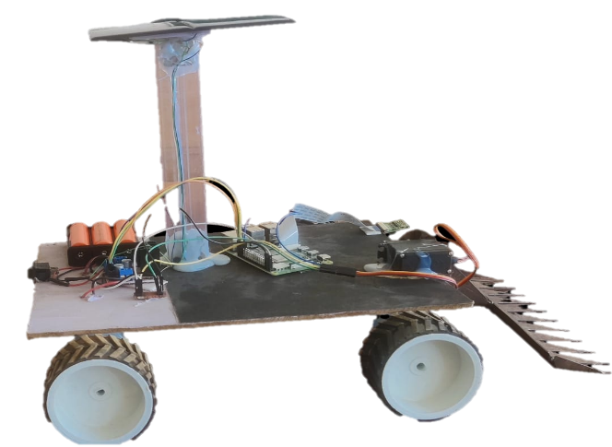
Switch
Motor Driver

Fig. (c)

Fig.2 Developed Wi-Fi Operated Weeder ((a). Top View (b). Front View and
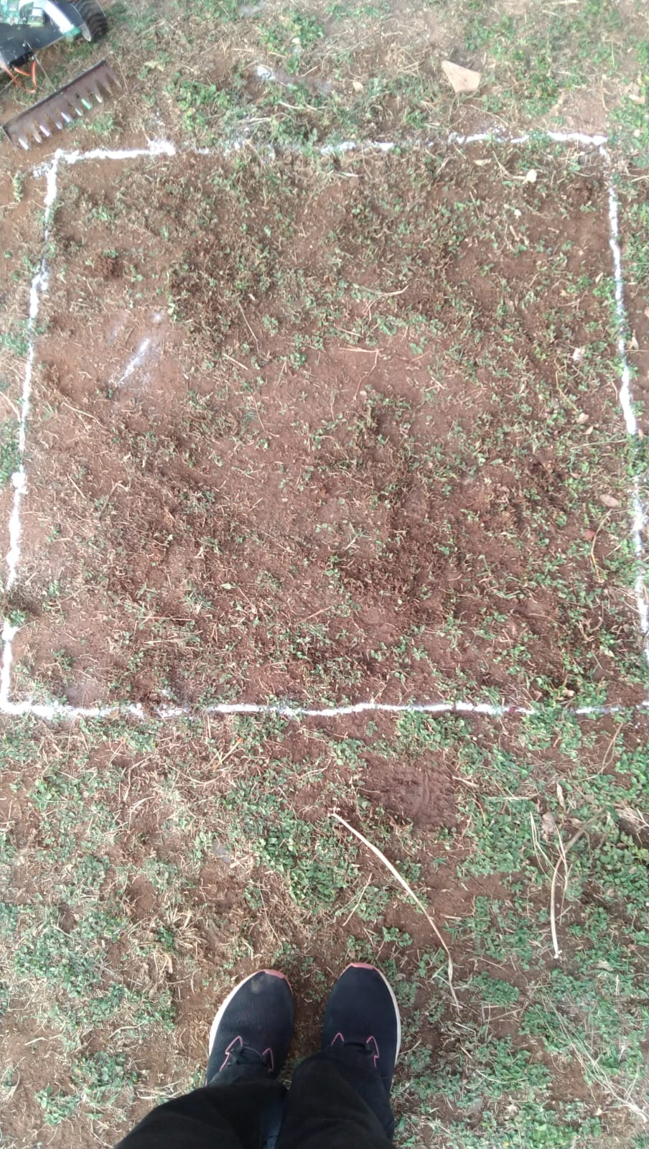
(c). Side View)
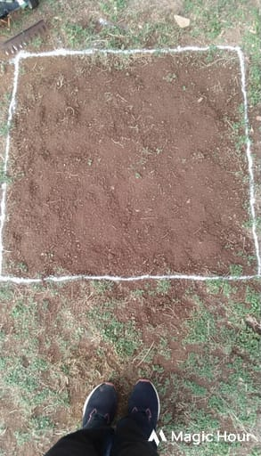

Fig.3 Before Weeding Fig.4 After Weeding

4. Conclusion
The Wi-Fi operated AI-based weeder proved to be an efficient and economical solution for automated weed control. It achieved a high weeding efficiency of 98.07% with a field efficiency of 59.68%, demonstrating reliable performance under field conditions. The operational cost of ₹71.04 h⁻¹ and a low fabrication cost of ₹17,677 make the system suitable for small and medium-scale farmers. Overall, the developed machine shows strong potential to reduce labour dependency while improving the effectiveness of weed management.
References

Adetola, O. A. (2019). A review on the performance of weeding machines. Futo J Ser, 5(2), 109-123.
Averill, K. M., Westbrook, A. S., Pineda-Bermudez, L., O’Briant, R. P., DiTommaso, A., & Ryan, M. R. (2022). Effects of Tertill® weeding robot on weed abundance and diversity. Agronomy, 12(8), 1754.
Bhan, V. M., Kumar, S., & Raghuwanshi, M. S. (1999). Weed management in India. Indian Journal of Plant Protection, 17, 71–202.
Ehrenfeld, J. G. (2010). Ecosystem consequences of biological invasions. Annual review of ecology, evolution, and systematics, 41(1), 59-80.
Farsani, T. M., Etemadi, N., Sayed-Tabatabaei, B. E., & Talebi, M. (2011). Assessment of genetic diversity of bermudagrass (Cynodon dactylon) using ISSR markers. International journal of molecular sciences, 13(1), 383-392.
Hamaoui-Laguel, L., Vautard, R., Liu, L. I., Solmon, F., Viovy, N., Khvorostyanov, D., ... & Epstein, M. M. (2015). Effects of climate change and seed dispersal on airborne ragweed pollen loads in Europe. Nature Climate Change, 5(8), 766-771.
Joshi, N.C. 2001. Weed Control Manual 5th Edition. Delhi Research Station Delhi, pp. 538.
Li, X., & Xiang, L. (2024). Photorealistic Robotic Simulation using Unreal Engine 5 for Agricultural Applications. arXiv preprint arXiv:2405.18551.
M. C. Siemens “Robotic weed control”. Proceedings of the California Weed Science Society, Monterey, California, 66, 76-80, 2014.
Manisankar, G., Banerjee, M., Malik, G. C., & Sathiyabama, N. (2022). Robotics in weed management: A review. AMA: Agricultural Mechanization in Asia, Africa & Latin America, 53(4), 7013-7030.
Manisankar, G., Banerjee, M., Malik, G. C., & Sathiyabama, N. (2022). Robotics in weed management: A review. AMA: Agricultural Mechanization in Asia, Africa & Latin America, 53(4), 7013-7030.
Manisankar, G., Banerjee, M., Malik, G. C., & Sathiyabama, N. (2022). Robotics in weed management: A review. AMA: Agricultural Mechanization in Asia, Africa & Latin America, 53(4), 7013-7030.
Mosqueda, E., Smith, R., Goorahoo, D., & Shrestha, A. (2018). Automated lettuce thinners reduce labor requirements and increase speed of thinning. California Agriculture, 72(2).
Naruhn, G.-P., Peteinatos, G. G., Butz, A. F., Möller, K., & Gerhards, R. (2021). Efficacy of Various Mechanical Weeding Methods—Single and in Combination—In Terms of Different Field Conditions and Weed Densities. Agronomy, 11(10), 2084. https://doi.org/10.3390/agronomy11102084
Neve, P., Barney, J. N., Buckley, Y., Cousens, R. D., Graham, S., Jordan, N. R., ... & Williams, M. (2018). Reviewing research priorities in weed ecology, evolution and management: a horizon scan. Weed Research, 58(4), 250-258.
Pala, F., & Mennan, H. (2021). Common weeds in cotton fields. In Cotton Production Under Abiotic Stress (pp. 257-288). Ikad Publishing House.
Paul, S., Nath, B. C., Huda, M. D., Bhuiyan, M. G. K., & Paul, H. (2025). Assessment of mechanical weeders in paddy fields: A study on operational effectiveness in Bangladesh. Heliyon, 11(4).
Simberloff, D. (2012). Risks of biological control for conservation purposes. BioControl, 57(2), 263-276.
Wu, X., Aravecchia, S., & Pradalier, C. (2019, May). Design and implementation of computer vision based in-row weeding system. In 2019 International Conference on Robotics and Automation (ICRA) (pp. 4218-4224). IEEE

