Estimation of Crop Water Requirement and Irrigation Scheduling for Broad Bean (Vicia faba)

Abstract
Water is an essential natural resource that must be used efficiently, especially in the face of increasing demand across agriculture, industry, domestic supply, and environmental management. Sustainable water use is the need of the hour. Drip irrigation has emerged as a highly efficient method for agricultural water management, with a water use efficiency of 90–93%. This study focuses on the estimation of crop water requirement and irrigation scheduling for broad bean (Bush Dolichos variety) cultivated in red sandy loam soils of Bapatla, Andhra Pradesh, India. The analysis was conducted using the CROPWAT 8.0 software. Irrigation scheduling was planned at a two-day interval. Meteorological data over a 14-year period were analysed and input into the model. The estimated crop water requirement for broad bean was found to be 354.2 mm. These findings support efficient water resource planning and crop management under drip irrigation systems. By optimizing irrigation strategies and integrating plastic mulch into crop production systems, farmers can significantly improve water use efficiency while minimizing overall resource consumption without compromising crop productivity in comparable agro-climatic regions. Such practices contribute to substantial water savings, enhance precision in crop water management, and support resilient production systems under conditions of increasing water scarcity. In the context of the United Nations Sustainable Development Goals, these interventions directly advance SDG 2 (Zero Hunger) by sustaining agricultural productivity, SDG 6 (Clean Water and Sanitation) through efficient water use, SDG 12 (Responsible Consumption and Production) by reducing input wastage, and SDG 13 (Climate Action) by strengthening climate-resilient farming systems. Overall, this approach represents a practical and scalable pathway toward sustainable agriculture in water-limited environments, promoting efficient resource utilization, environmental stewardship, and long-term food security.
Keywords: Broad Bean, CROPWAT 8.0, Drip Irrigation, Irrigation Scheduling, Water Requirement Estimation

- INTRODUCTION
Water is life for the whole world, and without water it is impossible to think about food security for the masses, industrial production, and the enrichment and conservation of biodiversity. Agriculture, being the backbone of food production systems, depends heavily on the timely and adequate availability of water. However, despite knowing the fact that the amount of usable freshwater resources is continuously declining and the world population is facing increasing water stress, humanity has largely remained complacent in its approach toward water conservation and management (Prüss-Üstün et al., 2008). Rapid population growth, climate change, erratic rainfall patterns, over-extraction of groundwater, and inefficient irrigation practices have collectively intensified the global water crisis. This alarming situation highlights the urgent need to save water and use it in a sustainable and judicious manner, particularly in the agricultural sector.
At the global level, these challenges are directly linked with the United Nations Sustainable Development Goals, especially SDG 2 (Zero Hunger), SDG 6 (Clean Water and Sanitation), SDG 12 (Responsible Consumption and Production), and SDG 13 (Climate Action). Achieving food security without ensuring sustainable water use is not feasible, as agriculture consumes nearly 70% of total freshwater withdrawals worldwide (Allen et al., 1998). Therefore, improving irrigation efficiency and optimizing water use in agriculture are critical steps toward meeting both food demand and sustainability targets under the SDG framework.
Water-saving irrigation methods, such as drip and sprinkler irrigation, play a crucial role in improving water use efficiency, particularly in rain fed, semi-arid, and water-scarce regions. These methods ensure that the right amount of water is supplied directly to the plant root zone, reducing losses due to evaporation, runoff, and deep percolation. However, the effectiveness of such irrigation systems largely depends on the accurate estimation of crop water requirements and proper irrigation scheduling. Supplying either excess or deficit water can adversely affect crop growth, yield, soil health, and nutrient use efficiency (Kaboosi & Kaveh, 2010). Hence, irrigation management should not only focus on the method of water application but also on scientific estimation of crop water demand.
The estimation of crop water requirement involves the assessment of several interrelated parameters, including effective rainfall, applied irrigation water, soil moisture availability, crop growth stage, and prevailing climatic conditions (Shengli et al., 2005; Prasad et al., 2006; Srinivasulu et al., 2003) . Accurate estimation of these parameters is essential for ensuring efficient use of irrigation water, especially under limited water availability. Improper estimation often leads to over-irrigation, resulting in water wastage, leaching of nutrients, waterlogging, and increased energy consumption for pumping, which ultimately affects farm profitability and environmental sustainability (Brouwer et al., 1986). For effective irrigation water management, several empirical and simulation-based models have been developed and widely used. Among these, the Food and Agriculture Organization-developed CROPWAT 8.0 model has gained global acceptance due to its simplicity, reliability, and applicability across different agro-climatic conditions (Allen et al., 1988; Smith, 1992). CROPWAT 8.0 is used to estimate reference evapotranspiration (ETo) using standard climatic data, calculate crop evapotranspiration (ETc) based on crop coefficients, and determine irrigation water requirements and scheduling. The model has been extensively applied for irrigation planning, water resource assessment, and climate change impact studies in both developed and developing countries.
The use of models such as CROPWAT directly supports SDG 6 by promoting efficient water use and reducing unnecessary withdrawals from surface and groundwater sources. At the same time, optimized irrigation scheduling contributes to SDG 13 by enhancing climate resilience of agricultural systems and reducing energy-related greenhouse gas emissions associated with excessive irrigation. Furthermore, precise water management helps farmers maintain crop productivity with fewer inputs, aligning with SDG 12 on responsible resource consumption. In the present study, broad bean, an important leguminous crop known for its high protein content, nutritional value, and soil fertility enhancement through biological nitrogen fixation, has been selected for analysis. Broad bean cultivation is sensitive to both moisture stress and excess water, particularly during flowering and pod development stages ((Kaboosi & Kaveh, 2010)). Therefore, accurate estimation of crop water requirement and irrigation scheduling is essential for achieving optimum yield and water productivity. This study aims to estimate the crop water requirement and irrigation intervals for broad bean using the CROPWAT 8.0 model by incorporating climatic data, effective rainfall, soil moisture status, and crop-specific parameters. The outcomes of this study are expected to contribute to improved irrigation water management, enhanced water use efficiency, and sustainable crop production in water-scarce agro-climatic regions, thereby supporting multiple Sustainable Development Goals simultaneously.
- METHODOLOGY
The methodology used here is selection of study area, metrological data study and feeding to CROPWAT8.0 and getting CWR and Scheduling of irrigation. The weather parameters were collected on a daily basis. The data of air temperature, humidity, wind speed, solar radiation and precipitation were collected. The data was used for the estimation of reference evapotranspiration using Penman-Monteith equation. Water use per crop, water availability, irrigation system and its efficiency and the other data of crop productivity under specific input of water and crop coefficient data were collected. The next step of work was the estimation of crop water requirements and irrigation requirements of broad bean crop. The estimation was done by using CROPWAT8.0 model. The whole is discussed below:
2.1 Study Area:
Bapatla, a district of Andhra Pradesh was selected where experiment was conducted. Geographically the experimental site is having a latitude of 15⁰54’56" N and longitude of 80⁰29’17" E with elevation of 6m from mean sea level. The cropping region lies in the sub-tropical humid region. During the time of summer season, it is hot and dry and cool in the winter season. Summer temperatures can reach as high as 40°C to 50°C, while winter temperatures can drop as low as 18°C to 25°C. This region is having an annual rainfall of about 700 - 1150 mm with an average of 980 mm.
The total gross area selected for experimental field for the study is with an area of 364 m2. The total area is divided into three blocks of 13m × 8m and each block is further divided into four sub-plots with 3m × 8m. Split plot design was taken for implementation of three irrigation levels for the experiment. Three irrigation levels selected are 100% of evapotranspiration, 80% of evapotranspiration and 60% of evapotranspiration for three blocks of plot. The details of treatments and layout show in Fig-1.
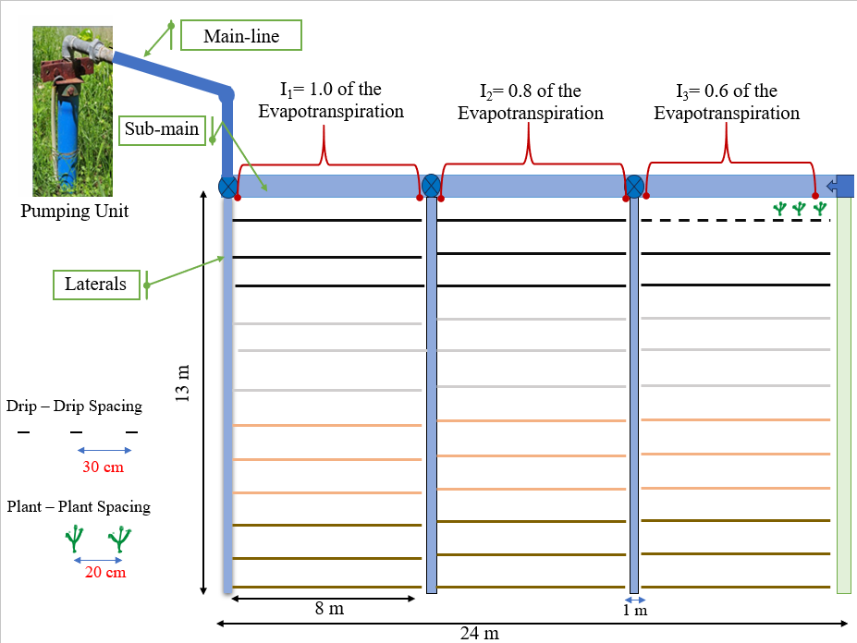
Fig 1: Layout of Experimental Field
2.2 Metrological Data:
The metrological data required in the model are average of minimum and maximum temperature and relative humidity of the day. It too needed the sun shine hour, rainfall and average wind velocity of whole day. These data were taken from Meteorological department, Bapatla for the years from 2007 to 2021. The 14 years of average of climatic data for Bapatla region is shown in Table-1.
Table 1: Mean climatic data of Bapatla month wise
Month | Min Temp | Max Temp | Humidity | Wind | Sun
Month | °C | °C | % | km/day | hours
January | 18 | 30.7 | 78 | 97 | 11.3
February | 19.4 | 32.2 | 77 | 115 | 11.6
March | 22.8 | 34.3 | 77 | 148 | 12
April | 25.5 | 35.9 | 77 | 210 | 12.5
May | 28.1 | 38.5 | 74 | 219 | 12.8
June | 27.4 | 38.2 | 72 | 219 | 13
July | 25.6 | 34.6 | 75 | 207 | 12.9
August | 25.8 | 36.1 | 78 | 171 | 12.6
September | 25.4 | 33.8 | 81 | 134 | 12.2
October | 24 | 33.1 | 82 | 104 | 11.8
November | 21.8 | 31.6 | 83 | 111 | 11.4
December | 19 | 30.9 | 82 | 102 | 11.2
Average | 23.6 | 34.2 | 78 | 153 | 12.1

The climatic conditions of Bapatla show a warm and humid tropical nature, where high temperature, humidity, wind movement, and sunshine prevail throughout the year. The mean minimum and maximum temperatures were 23.6 °C and 34.2 °C, respectively, and higher temperatures were mainly observed during the summer months. Relative humidity remained consistently high with an annual mean of about 78%. Along with this, higher wind speed (153 km day⁻¹) and longer sunshine duration (12.1 h day⁻¹) increase the atmospheric demand for water. Due to these conditions, reference evapotranspiration remains high, which clearly indicates the need for accurate estimation of crop water requirement and proper irrigation scheduling for sustainable crop production.
2.3 Crop Data:
The broad bean was selected and its crop coefficient values (Table-2) were taken from FAO data base. The experiment was conducted on red sandy loamy soil.

Table 2: Crop coefficients(K_{c}) of broad bean
S. No. | Name of crop | Crop coefficients
S. No. | Name of crop | K_{C1} | K_{C2} | K_{C3}
1 | Broad bean | 0.50 | 1.05 | 0.90

2.4 Rainfall Data:
About the last 14 years of rainfall data (2007–2021) were collected from the Meteorological Department, Bapatla, and fitted into the program. The long-term rainfall data help in understanding year-to-year variability and provide a reliable basis for estimating effective rainfall. Rainfall plays an important role in meeting crop water requirement and directly influences irrigation scheduling. Therefore, incorporation of historical rainfall data in the CROPWAT 8.0 model improves the accuracy of crop water requirement estimation and supports better irrigation planning under varying climatic conditions.
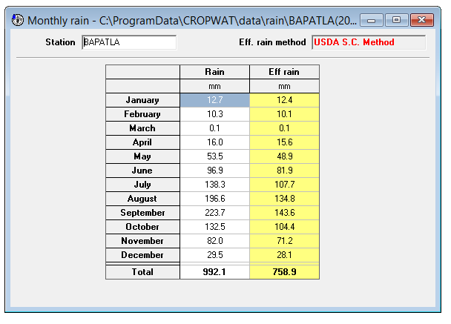
Fig 2: Rainfall data window in CROPWAT 8.0 model
2.5 Soil Data:
The present experiment was conducted under red sandy loamy soil conditions. For representing the soil profile in the software, the medium soil option was selected, as it closely resembles the physical characteristics of the experimental field. This soil profile provides information on total available moisture content, maximum rain infiltration rate, maximum rooting depth, and initial available moisture content, which are essential inputs for crop water requirement estimation and irrigation scheduling.
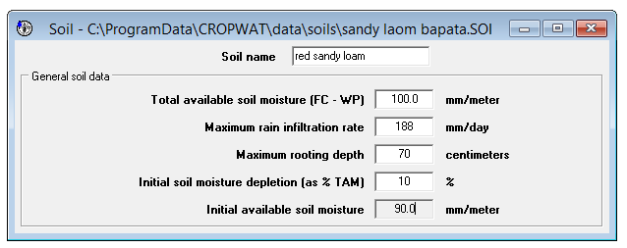
Fig 3: Soil data window in CROPWAT 8.0 model
2.6 Crop water Requirement:
For the present study, the crop water requirement of beans was calculated using the CROPWAT 8.0 model. Crop water requirement refers to the depth of water consumed by the crop during its growth period, including unavoidable irrigation application losses. It mainly depends on reference evapotranspiration (ETo), climatic factors, effective rainfall, soil characteristics, and crop-specific parameters. In this study, crop evapotranspiration (ETc) was estimated using CROPWAT 8.0 by applying crop coefficients for different growth stages to the calculated ETo. Based on ETc, effective rainfall, and available soil moisture, the gross irrigation water requirement was computed using standard numerical relationships provided in the model. Finally, irrigation scheduling was carried out by determining the irrigation depth and irrigation interval required to satisfy crop water demand at different growth stages.
The CROPWAT 8.0 models takes input data of location, climate, crop and soil for calculation of reference evapo-transpiration, crop water requirement, crop irrigation requirement and develops scheduling of irrigation. The method used for estimations are Penman and Monteith method and their equation is expressed as
$$ETo =\frac{0.408(Rn - G) + (900/ T+273) U2 (es - ea) }{ + (1+ 0.34 U2) }$$

Where,
ET_{O}= reference evapotranspiration (mm /day)
R_{n}= net radiation at the on surface (MJ/m² per day)
G= soil heat flux density (MH/m² per day)
T= mean daily air temperature at 2 m height (ºC)
U₂= wind speed at 2 m height (m/s)
e_{S} = saturation vapour pressure (kPa)
e_{a} = actual vapour pressure (kPa)
e_{S} = saturation vapour pressure deficit (kPa)
ϒ= psychometric constant
The summation of evaporation and transpiration by plant gives crop evapotranspiration. The expression follows as:
ET_{c} = K_{c} × ET_{o}
Where,
ET_{c} is the crop evapotranspiration,
Kc is crop coefficient
ET_{o} is the reference evapotranspiration.
- Adjustment for Wetted Area:
ET_{c},_{Adjusted}= ET_{c} ​× P_{c}
Where,
P_{c} =fraction of soil surface
- Plant Water Requirement
CWR_{Plant} ​= ET_{c} ​× Plant spacing × Row spacing× P_{c}

- Irrigation Scheduling and Volume Estimation
Irrigation Volume=CWR_{Plant} ​× Number of plants per paired row × Irrigation interval
$Time \left(min\right)=\frac{Irrigation Volume \left(l\right)}{Emitter discharge (l/h)} ×60$

- RESULTS AND ANALYSIS
The experimental findings of this study have been discussed below:
3.1 Crop Water Requirement for Broad Bean:
The crop water requirement of broad bean grown under drip irrigation in the Bapatla region during the rabi season was estimated using the CROPWAT 8.0 model. The results showed that the total seasonal crop water requirement (ETc) was 354.2 mm, whereas the net irrigation water requirement was 117.3 mm after considering effective rainfall (Fig. 2). This clearly indicates that the crop water demand in the study area mainly depends on climatic conditions, rainfall contribution, crop growth stages, and soil moisture availability. Similar influence of climatic and crop parameters on ETc has also been reported in FAO-based irrigation studies (Allen et al., 1998).
Crop evapotranspiration (ETc) varied significantly at different growth stages of broad bean, mainly due to changes in crop coefficient (Kc). During the initial stage, the Kc value was low (0.50), which resulted in lower ETc values ranging from 2.96 to 3.07 mm day⁻¹. This lower water requirement during the early stage is due to limited canopy development and reduced transpiration losses. This trend is in agreement with FAO-56 guidelines, which state that early growth stages require less water because of smaller leaf area (Allen et al., 1998).
As the crop advanced to the development stage, the Kc values increased from 0.51 to 0.81 due to rapid canopy expansion. Accordingly, ETc increased to a range of 3.50–4.23 mm day⁻¹, showing a clear rise in crop water demand compared to the initial stage. During this stage, effective rainfall contributed a major share of crop water requirement; however, supplemental irrigation was required during the later part of the stage. This stage contributed a considerable portion of the total seasonal ETc, emphasizing the need for proper irrigation management during canopy development, as also reported by (Kaboosi & Kaveh, 2010).
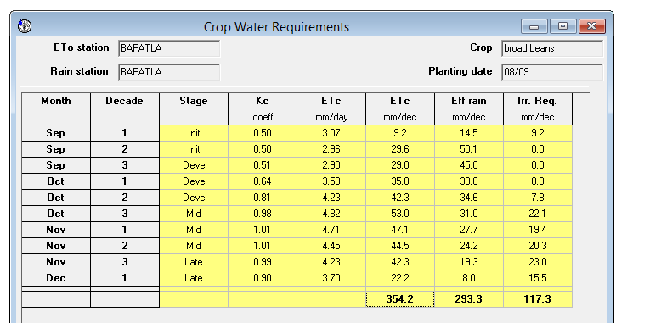
Fig 4: ET_{c} from CROPWAT 8.0 Model
The mid-season stage showed the highest crop water requirement, with Kc values reaching a maximum of 1.01 and ETc values ranging from 4.45 to 4.82 mm day⁻¹. This stage corresponds to flowering and pod development, when the crop is highly sensitive to moisture stress. The mid-season stage alone contributed about 38–40% of the total seasonal ETc, making it the most critical stage for irrigation scheduling. Similar observations have been reported for leguminous crops grown under warm tropical conditions (Allen et al., 1998). During this stage, effective rainfall was not sufficient to fully meet crop water demand, resulting in higher irrigation requirement.
During the late-season stage, the Kc values gradually decreased from 0.99 to 0.90, leading to lower ETc values ranging from 3.70 to 4.23 mm day⁻¹. This reduction in crop water requirement is mainly due to physiological maturity and reduced transpiration rate. Excess irrigation during this stage is not desirable, as it may cause water wastage and nutrient leaching, as reported by Brouwer and Heibloem (1986).
Overall, effective rainfall contributed 293.3 mm, which met about 82.8% of the total crop water requirement, while only 17.2% was supplied through irrigation. This clearly shows the significant role of rainfall in reducing irrigation demand during the rabi season in the Bapatla region. The relatively low irrigation water requirement under drip irrigation further confirms the effectiveness of precise irrigation scheduling in improving water use efficiency and conserving water resources, as suggested by FAO (2012).
3.2 Irrigation scheduling for Broad Bean
Irrigation scheduling for broad bean (Dolichos) was developed using the CROPWAT 8.0 model by adopting a user-defined irrigation interval of two days. Long-term climatic and rainfall data of 14 years (2007–2021) were used to generate a reliable irrigation schedule. The irrigation scheduling obtained from the model is presented in Fig. 5.
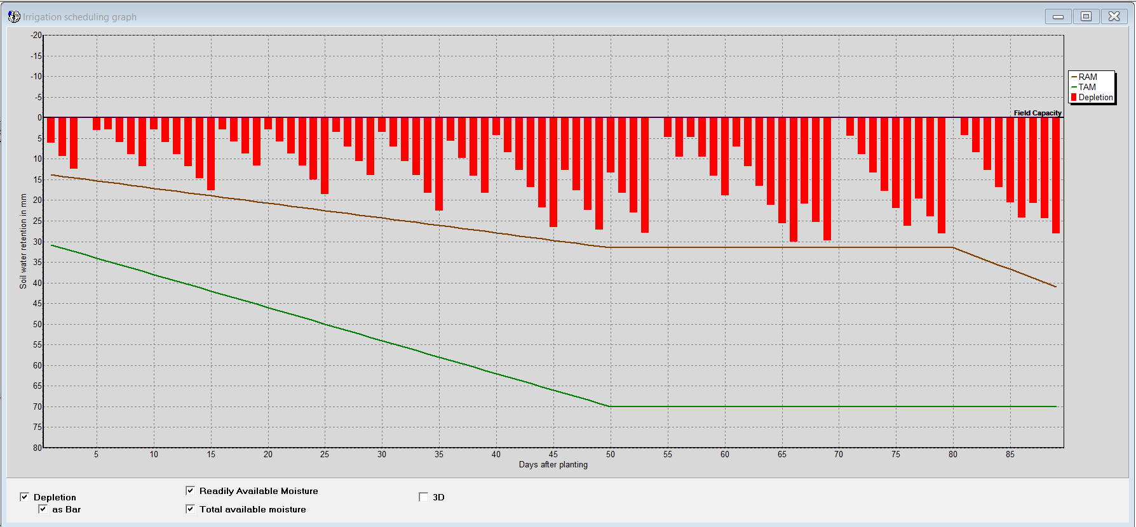
Fig 5: Irrigation Scheduling from CROPWAT8.0
The irrigation scheduling graph indicates that soil moisture depletion was maintained within permissible limits throughout the crop growth period. Irrigation was applied whenever soil moisture approached the readily available moisture level, ensuring adequate moisture in the root zone and avoiding moisture stress conditions, particularly during critical growth stages. Rainfall received during the crop period is shown in Fig. 6. The rainfall distribution was irregular, with a few high-intensity rainfall events contributing to soil moisture recharge and reducing irrigation requirement during certain periods. However, due to uneven rainfall distribution, supplemental irrigation was essential to meet crop water demand.

Fig 6: Rainfall received during crop season
Based on crop water requirement and rainfall pattern, irrigation scheduling was worked out for three irrigation levels, as depicted in Fig. 7. These treatments included I₁ (1.0 ETc), I₂ (0.8 ETc), and I₃ (0.6 ETc). The I₁ treatment supplied full crop water requirement and maintained higher soil moisture levels throughout the season. The I₂ treatment resulted in moderate irrigation levels with efficient moisture utilization, while the I₃ treatment received the least irrigation and showed higher soil moisture depletion, especially during mid-season stages.

Fig 7: Irrigation scheduling at different irrigation levels
The results indicate that irrigation demand was highest during the mid-season stage and comparatively lower during the initial and late stages. Overall, the study demonstrates that CROPWAT 8.0 is an effective tool for developing stage-wise and treatment-wise irrigation schedules for broad bean, supporting efficient water use and improved irrigation management.
4. CONCLUSIONS
The present study carried out in the Bapatla region focused on estimating the crop water requirement and irrigation requirement of broad bean during the rabi season using the CROPWAT 8.0 model. The results showed that the total crop water requirement was 354.2 mm, while the net irrigation water requirement was 117.3 mm after considering effective rainfall. The irrigation scheduling developed using the model indicated that water demand varied across crop growth stages, with the highest requirement during the mid-season stage.
The model used region-specific climatic data, crop parameters, soil characteristics, and long-term rainfall data, which helped in generating reliable estimates of crop water requirement and irrigation scheduling. The results demonstrate that scientific tools like CROPWAT 8.0 are effective for irrigation planning and efficient water management.
Overall, the study confirms that proper irrigation scheduling based on crop water requirement can reduce unnecessary water use and support sustainable crop production under drip irrigation conditions in the Bapatla region. In the context of the United Nations Sustainable Development Goals, the findings of this study directly contribute to SDG 2 (Zero Hunger) by supporting sustainable crop production, SDG 6 (Clean Water and Sanitation) through improved water use efficiency, SDG 12 (Responsible Consumption and Production) by optimizing irrigation inputs, and SDG 13 (Climate Action) by promoting climate-resilient and water-efficient agricultural practices. Overall, the study highlights the role of scientific irrigation scheduling in achieving sustainable agriculture and long-term water resource conservation.
REFERENCES
- Allen, R. G., Pereira, L. S., Raes, D., & Smith, M. (1998). Crop evapotranspiration - Guidelines for computing crop water requirements - FAO Irrigation and drainage paper 56. Food and Agriculture Organization of the United Nations. https://www.inrae.fr/sites/default/files/pdf/fao-56.pdf.
- Brouwer, C., & Heibloem, M. (1986). Irrigation water management: Irrigation water needs. Food and Agriculture Organization of the United Nations. https://www.fao.org/3/S2022E/s2022e00.htm#Contents.
- Monteith, J. L. (1965). Evaporation and environment. In G. E. Fogg (Ed.), The state and movement of water in living organisms (pp. 205-234). Cambridge University Press. https://pubmed.ncbi.nlm.nih.gov/5321565/).
- Kaboosi, K., & Kaveh, F. (2010). Sensitivity analysis of Doorenbos and Kassam (1979) crop water production function. African Journal of Agricultural Research, 5(17), 2399-2417. https://doi.org/10.5897/AJAR.9000628.
- Penman, H. L. (1948). Natural evaporation from open water, bare soil and grass. Proceedings of the Royal Society of London. Series A. Mathematical and Physical Sciences, 193(1032), 120-145. https://doi.org/10.1098/rspa.1948.0037.
- Prasad, A. S., Umamahesh, N. V., & Viswanath, G. K. (2006). Optimal irrigation planning under water scarcity. Journal of Irrigation and Drainage Engineering, 132(3), 228-237. https://doi.org/10.1061/(ASCE)0733-9437(2006)132:3(228).
- Prüss-Üstün, A., Bos, R., Gore, F., & Bartram, J. (2008). Safer water, better health: costs, benefits and sustainability of interventions to protect and promote health. World Health Organization. http://whqlibdoc.who.int/publications/2008/9789241596435_eng.pdf.
- Li, Q. S., Willardson, L. S., Deng, W., Li, X. J., & Liu, C. J. (2005). Crop water deficit estimation and irrigation scheduling in western Jilin province, Northeast China. Agricultural Water Management, 71(1), 47-60. https://doi.org/10.1016/j.agwat.2004.09.008.
- Smith, M. (1992). CROPWAT: A computer program for irrigation planning and management. Food & Agriculture Org. https://www.fao.org/3/t0473e/t0473e00.htm.
- Srinivasulu, A., Satyanarayana, T. V., Kumar, M. R., & Sai Sudha, J. L. N. (2003). Crop Water Requirements in Comparison to Actual Water Applied in Some Canal Commands of Krishna Western Delta. Journal of Agricultural Engineering, 40(4), 43-50. https://epubs.icar.org.in/index.php/JAE/article/view/14175.

