Evaluation of Garcinia butters for their sensory performance in traditional Indian sweets and cakes

Abstract:
The present study evaluated the sensory quality of butter derived from milk, kokum (Garcinia indica), cambodge (Garcinia gummi-gutta), and cocoa butter, along with their utilization in value-added products such as burfi and cake. Organoleptic evaluation was carried out using a nine-point hedonic scale by a semi-trained panel, assessing appearance, colour, flavour, texture, taste, after-taste, and overall acceptability. Significant differences were observed among the butters and their products for all sensory attributes. Milk butter consistently recorded the highest sensory scores across butter, burfi, and cake, indicating superior overall acceptability. Among the non-dairy butters, cocoa butter ranked next, while Garcinia butters showed comparable and acceptable sensory characteristics. Cambodge butter improved appearance and colour in burfi, whereas kokum butter imparted desirable softness and texture in cakes. The results demonstrate that kokum and cambodge butters possess good sensory potential and can be effectively used as alternatives to cocoa butter in value-added traditional and bakery products.
Keyboards: Cambodge butter, Kokum butter, Cocoa butter, Milk butter, Burfi, Cake
Introduction
The genus Garcinia (family Clusiaceae) comprises more than 200 species distributed throughout the tropical regions of Asia and Africa, several of which possess significant socioeconomic and medicinal value. India represents a major centre of Garcinia diversity, with seven species native to the Western Ghats, six to the Andaman and Nicobar Islands and four to the North-Eastern region (Kar et al., 2008). Among the fruiting species, Garcinia gummi-gutta (L.) Robs., commonly known as cambodge or Malabar tamarind, and Garcinia indica (Thouars) Choisy, widely known as kokum, are commercially exploited as culinary condiments and value-added products (Khapare et al., 2020). The acidic rind of cambodge is widely used in curries as a souring agent, whereas kokum rind is traditionally processed into refreshing beverages and seasoning ingredients.
Beyond their culinary roles, Garcinia fruits occupy an important place in Indian folk medicine and Ayurveda, where they are reputed to treat conditions such as flatulence, oedema, dysentery, chronic alcoholism, obesity and bowel disorders. These medicinal properties are predominantly attributed to bioactive constituents including hydroxycitric acid (HCA), alkaloids, glycosides, volatile oils, tannins, flavonoids and phenolic compounds (Leonhardt & Langhans, 2002; Kim et al., 2011). Notably, the fruit rinds of cambodge and kokum are among the richest known natural sources of HCA, a commercially important anti-obesity and cholesterol-reducing phytometabolite.
Although research has historically focused on the rind and medicinal attributes of Garcinia species, the seeds constitute an equally valuable yet largely underutilized component of the fruit. Kokum seeds yield a solid edible fat known as kokum butter, which contains high proportions of stearic and oleic acids and is characterized by mono-oleo disaturated glycerides Kokum butter exhibits high melting stability and excellent emollient properties, enabling its application in food, pharmaceutical and cosmetic sectors. Due to its triglyceride composition, kokum butter is considered a functional substitute for cocoa butter in confectionery products. Cambodge seeds also contain butter, but scientific characterization and commercial utilization remain minimal despite traditional knowledge of its household use in parts of Karnataka.
Currently, vast quantities of Garcinia seeds are discarded during rind processing and only limited seed volume is retained for seedling production. With the increasing domestic demand for edible and industrial fats, valorization of cambodge and kokum seeds represents a sustainable opportunity for rural livelihoods and bioresource-based industries. Preliminary studies have indicated that Garcinia seeds are rich in fat and protein and warrant further investigation as potential sources of nutritionally valuable lipids (Ajayi et al., 2007). Nevertheless, socio-economic constraints and lack of scientific research on extraction, physicochemical characterization, nutritional profiling and sensory evaluation of Garcinia butter have impeded industrial adoption.
Organoleptic acceptance is crucial for positioning seed-derived butters as ingredients in functional foods or value-added edible products. While traditional knowledge suggests that kokum butter enhances digestion and alleviates ailments such as dysentery, pain and heart complaints, empirical validation of sensory attributes and consumer acceptability of Garcinia butter and associated food products has not been documented.
In view of these knowledge gaps, the present study was undertaken with the objective of evaluating the sensory qualities of Garcinia seed butter and selected butter-based value-added food formulations. The research aims to generate scientific insights that could support future commercialization of Garcinia seed butter as an edible fat source and diversify economic opportunities linked to Garcinia cultivation and processing.
2. Materials and methods
2.1 Materials
Organoleptic qualities of extracted butter of Garcinia species were evaluated as well as compared with milk and cocoa butter. Milk butter was procured from the local market of Mannuthy under the brand name milky mist, whereas cocoa butter was procured from Cocoa Research Station, KAU, Vellanikkara, Thrissur. Cambodge and kokum butter were extracted traditionally through the hot water skimming method.
2.2 Preparation of value-added products
Value added products such as burfi and cake were prepared using four types of butter. The flow chart for preparation of burfi and cake was presented in Figure 1 and 2, respectively. 2.2.1. Preparation of Burfi
Ingredients:
Bengal gram powder – 500 g
Jaggery – 500 g
Raisin – 25 g
Cardamom – 10 g
Almond – 50 g
Cashew – 50 g
Burfi was prepared by using following treatments.
T₁: Milk butter (250 g) + ingredients
T₂: Kokum butter (250 g) + ingredients
T₃: Cambodge butter (250 g) + ingredients
T₄: Cocoa butter (250 g) + ingredients
2.2.2 Preparation of butter cake
Ingredients:
All purpose flour/ Maida flour – 100 g
Baking powder – 2.5 g
Sugar – 100 g
Eggs – 2
Milk – 4 table spoons
Vanilla essence – 1 tsp
A pinch of salt
Butter cake was prepared by using following treatments.
T₁: Milk butter (250 g) + ingredients
T₂: Kokum butter (250 g) + ingredients
T₃: Cambodge butter (250 g) + ingredients
T₄: Cocoa butter (250 g) + ingredients
Organoleptic evaluation of butter and its value-added products was conducted at the laboratory level using a panel of nineteen judges aged between 21 and 42 years. The sensory assessment was performed using a structured score card comprising seven quality attributes, namely appearance, colour, flavour, texture, taste, after-taste, and overall acceptability. Each attribute was evaluated using a nine-point hedonic scale, where panelists expressed their degree of liking for each sample. The standardized score card ensured uniformity in evaluation, and the nine-point hedonic scale used for assessment is presented in Table 1.
2.3 Statistical analysis
Organoleptic evaluation of butters was performed following Kendall’s W test using SPSS software.
Table 1. Nine point hedonic scale
Characteristics | Score card
Like extremely | 9
Like very much | 8
Like moderately | 7
Like slightly | 6
Neither like nor dislike | 5
Dislike slightly | 4
Dislike moderately | 3
Dislike very much | 2
Dislike extremely | 1

Prepare jaggery solution and cooked over fire until one thread consistency
Add the roasted bengal gram powder flour along with the butter to a jaggery syrup and mix it well
Stir well continuously until the mass separated from the sides of pan
Add raisins, almond, cashew and cardamom powder at the end of cooking
Switch off the flame and transfer the contents to a greased butter plate and allow to set
Cut burfi into desired shapes and serve

Figure 1. Flow chart for the preparation of burfi using different types of butter

Preheat oven to 180 ℃ and line a loaf pan with parchment paper and set aside
Take maida flour, baking powder and salt in a sieve and sift it together and set aside
Take butter, sugar and vanilla in a bowl and use a beater to whip it till fluffy
Add eggs to the bowl and mix it well
Add half of the flour and fold gently then add milk to it for proper mixing
Add remaining flour and fold gently
Spoon this into the pan and bake for 30 to 35 minutes (180℃)
Remove it from the oven and cool it down
Remove cake from the pan and allow it to cool completely
Slice the cake pieces and serve

Figure 2. Flow chart for the preparation of cake using different types of butter

3. Results and Discussion
Significant variation (Table 2) was observed among the different butters for all evaluated sensory attributes. Milk butter consistently recorded the highest mean scores and mean rank scores for appearance, colour, flavour, texture, taste, after-taste and overall acceptability, indicating superior sensory quality and consumer preference. The mean score for appearance ranged from 6.82 in cocoa butter to 8.64 in milk butter, while similar trends were observed for other attributes, with milk butter achieving the highest overall acceptability score (8.71). Non-dairy butter, cocoa butter ranked second particularly excelling in flavour, taste, after-taste and overall acceptability. Kokum butter showed better scores for appearance, texture, and after-taste, whereas cambodge butter performed relatively well in colour, taste, and overall acceptability. The cumulative sensory scores further supported these observations, with milk butter attaining the highest total score (60.70), followed by cocoa (53.48), kokum (51.96), and cambodge butter (51.36). These results suggest that although milk butter remains the most preferred, non-dairy butters possess acceptable sensory characteristics and potential for incorporation in food products.
Burfi prepared using different types of butter exhibited significant differences in sensory attributes (Table 3). Milk butter burfi was most preferred overall, recording the highest mean scores for flavour, texture, taste, after-taste and overall acceptability, along with the highest cumulative score (57.34). Cambodge butter burfi demonstrated superior appearance and colour compared to other variants, possibly due to the roasting of cambodge and kokum seeds prior to butter extraction, which may have enhanced sensory characteristics. Kokum butter burfi showed moderate acceptability, whereas cocoa butter burfi consistently recorded the lowest scores across most attributes. These findings align with the report of Nair (2002), who observed improved acceptability of burfi prepared using roasted cocoa mass, emphasizing the influence of processing treatments on sensory quality.
Cakes prepared with different butters also showed distinct variations in sensory quality (Table 4). Milk butter cake achieved the highest mean scores for appearance, colour, flavour, texture, taste and overall acceptability, with a total score of 57.20, indicating superior sensory performance. Kokum butter cake ranked second, particularly excelling in colour, flavour, taste, after-taste and overall acceptability, and was noted to impart desirable softness, texture, and leavening properties during baking. Cambodge butter cake showed moderate acceptability, while cocoa butter cake recorded the lowest sensory scores. Although fresh cakes prepared with kokum butter were highly accepted, their storability was comparatively less preferred. Overall, the results indicate that kokum and cambodge butter can effectively replace cocoa butter in cake preparation, with kokum butter showing particular promise for enhancing fresh cake quality.
The present findings are in agreement with earlier reports highlighting the potential of non-dairy butters in traditional and confectionery products. Abraham et al. (2007) reported the use of cambodge butter in traditional sweet dishes such as holige and pancha kajaye in Karnataka. Reddy and Prabhakar (1994) demonstrated the suitability of kokum fat and phulwara butter fractions as cocoa butter extenders in chocolate preparations, particularly under hot climatic conditions. Similarly, Maheshwari and Reddy (2004) reported successful replacement of cocoa butter with kokum butter up to 15% to enhance chocolate hardness in warm regions. Collectively, these studies, along with the present results, confirm the functional and sensory potential of kokum and cambodge butter as viable alternatives to cocoa butter in value-added food products.
4. Conclusion
Milk butter showed the highest overall sensory acceptability among all butters and their value-added products. However, Garcinia butters (kokum and cambodge) exhibited comparable sensory quality and were well accepted in butter as well as in products such as burfi and cake. Cambodge butter enhanced appearance and colour in burfi, while kokum butter improved softness and texture in cakes. Overall, the sensory evaluation confirms that Garcinia butters can effectively serve as acceptable alternatives to cocoa butter in value-added food products.
References
Abraham, Z., Malik, S. K., Rao, G. E., Narayanan, S. L., & Biju, S. (2006). Collection and characterisation of Malabar Tamarind [Garcinia cambogia (Gaertn.) Desr.]. Genetic Resources and Crop Evolution, 53(2), 401-406. https://doi.org/10.1007/s10722-004-0584-y
Ajayi, I. A., Oderinde, R. A., Ogunkoya, B. O., Egunyomi, A., & Taiwo, V. O. (2007). Chemical analysis and preliminary toxicological evaluation of Garcinia mangostana seeds and seed oil. Food Chemistry, 101(3), 999-1004. https://doi.org/10.1016/j.foodchem.2006.02.053
Kar, A., Borkakoti, S., and Borthakur, S. K. 2008. Extended distribution of the genus Garcinia L. in Sonitpur district, Assam, India. Pleione. 2: 165-170.
Khapare, L. S., Kadam, J. H., & Shirke, G. D. (2020). Garcinia a medicinally potential genus in Western Ghats. *Journal of Pharmacognosy and Phytochemistry*, *9*(5), 2750-2752. https://doi.org/10.22271/phyto.2020.v9.i5al.12971
Leonhardt, M., & Langhans, W. (2002). Hydroxycitrate has long-term effects on feeding behavior, body weight regain and metabolism after body weight loss in male rats. Journal of Nutrition. https://doi.org/10.1093/jn/132.7.1977
Maheshwari, B. K., & Reddy, S. Y. (2005). Application of kokum (Garcinia indica) fat as cocoa butter improver in chocolate. Journal of the Science of Food and Agriculture, 85(1), 135-140. https://doi.org/10.1002/jsfa.1967
Reddy, S. Y., & Prabhakar, J. V. (1994). Cocoa butter extenders from kokum (Garcinia indica) and Phulwara (Madhuca butyracea) butter. J. Am. Oil Chem. Soc., 71(2), 217-219. https://doi.org/10.1007/BF02541559
Treatments | Appearance | Colour | Flavour | Texture | Taste | After Taste | Overall acceptability | Total score
Milk butter | 8.64  (3.90) | 8.49  (3.63) | 8.73  (3.72) | 8.69  (3.63) | 8.80  (3.77) | 8.64  (3.73) | 8.71  (3.63) | 60.7
Kokum butter | 7.69  (2.43) | 7.58  (2.50) | 7.16  (1.81) | 7.47  (2.23) | 7.47  (1.67) | 7.55  (2.10) | 7.04  (1.63) | 51.96
Cambodge butter | 7.53  (2.27) | 7.82  (2.60) | 6.89  (1.44) | 7.29  (1.83) | 7.53  (1.90) | 7.15  (1.57) | 7.15  (1.73) | 51.36
Cocoa butter | 6.82  (1.40) | 6.64  (1.27) | 8.10  (3.03) | 7.64  (2.30) | 8.04  (2.67) | 7.98  (2.60) | 8.26  (3.00) | 53.48
Kendall’s W | 0.723** | 0.626** | 0.759** | 0.438** | 0.615** | 0.569** | 0.625**

Table 2. Organoleptic qualities for different types of butter

Values in parentheses are mean rank score based on Kendall’s W
**-Significant at 1% level

Table 3. Organoleptic qualities of burfi

Treatments | Appearance | Colour | Flavour | Texture | Taste | After Taste | Overall acceptability | Total score
T1 | 7.89  (3.34) | 8.10  (2.95) | 8.26  (3.13) | 8.31  (3.13) | 8.37  (3.16) | 8.10  (3.26) | 8.31  (3.26) | 57.34
T2 | 6.95  (2.26) | 6.95  (1.68) | 7.68  (2.45) | 7.47  (2.13) | 7.89  (2.76) | 7.68  (2.71) | 7.84  (2.58) | 52.46
T3 | 8.05  (2.55) | 8.11  (3.03) | 8.00  (2.76) | 8.00  (2.68) | 7.95  (2.71) | 7.42  (2.58) | 7.95  (2.76) | 55.48
T4 | 7.68  (1.84) | 7.68  (2.34) | 6.74  (1.66) | 7.42  (2.05) | 6.37  (1.37) | 6.00  (1.45) | 6.58  (1.39) | 48.47
Kendall’s W | 0.306** | 0.277** | 0.320** | 0.209** | 0.418** | 0.406** | 0.438**

**-Significant at 1% level
T1- Burfi prepared using milk butter T2- Burfi prepared using kokum butter T3- Burfi prepared using cambodge butter T4- Burfi prepared using cocoa butter

Table 4. Organoleptic qualities of cake

Treatments | Appearance | Colour | Flavour | Texture | Taste | After Taste | Overall acceptability | Total score
T1 | 8.31  (3.16) | 8.37  (3.18) | 8.10  (3.13) | 8.21  (3.34) | 8.10  (3.13) | 7.95  (3.08) | 8.16  (3.11) | 57.2
T2 | 7.84  (2.47) | 7.84  (2.63) | 7.89  (2.95) | 7.27  (2.26) | 7.95  (2.87) | 7.79  (3.11) | 7.95  (3.05) | 54.53
T3 | 7.74  (2.42) | 7.68  (2.34) | 7.53  (2.34) | 7.58  (2.55) | 7.68  (2.61) | 7.37  (2.42) | 7.53  (2.37) | 53.11
T4 | 7.31  (1.95) | 7.05  (1.84) | 6.16  (1.58) | 6.79  (1.84) | 6.10  (1.39) | 5.89  (1.39) | 6.53  (1.47) | 45.83
Kendall’s W | 0.179** | 0.249** | 0.361** | 0.306** | 0.415** | 0.506** | 0.396**

Values in parentheses are mean rank score based on Kendall’s W
**-Significant at 1% level
T1- Cake prepared using milk butter T2- Cake prepared using kokum butter
T3- Cake prepared using cambodge butter T4- Cake prepared using cocoa butter

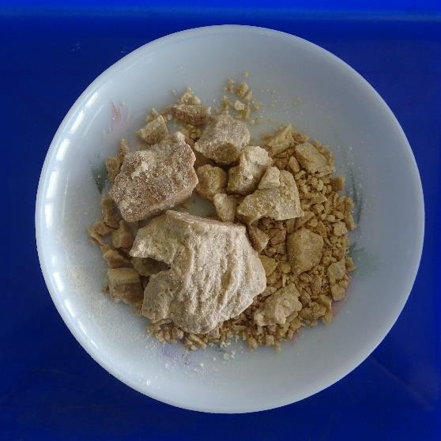
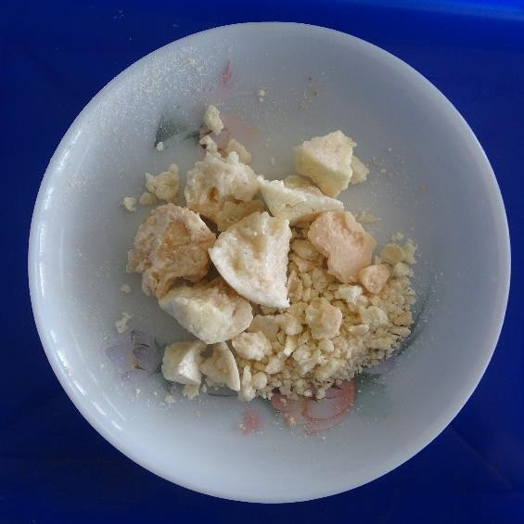
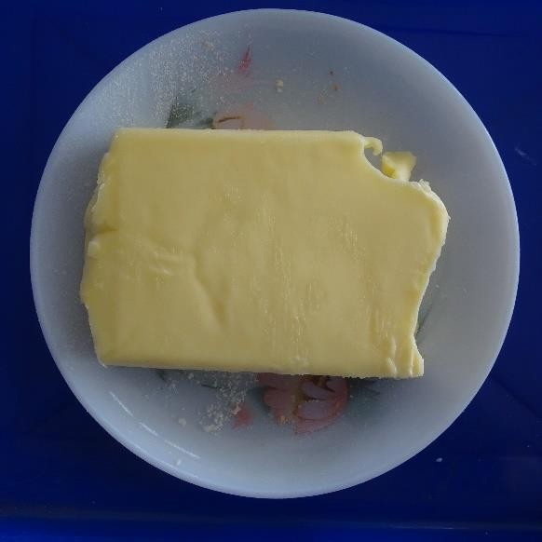
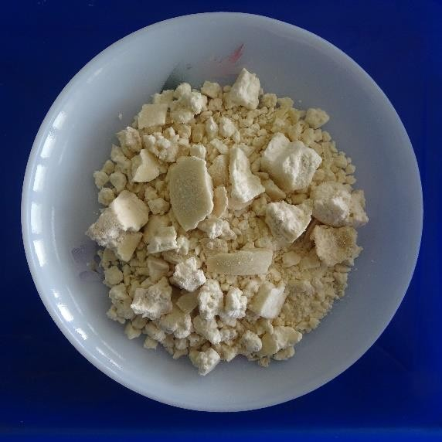
Cocoa butter
Cambodge butter
Kokum butter
Milk butter

Figure 3: Organoleptic evaluation of different butters

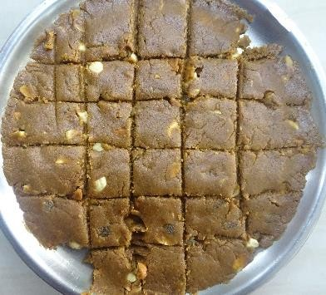
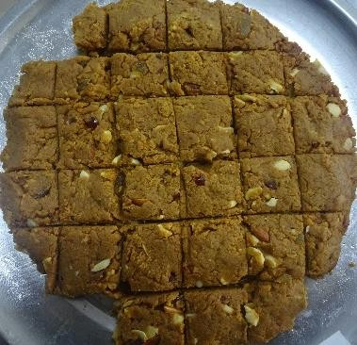

T₁- Burfi of milk butter
T₂- Burfi of kokum butter

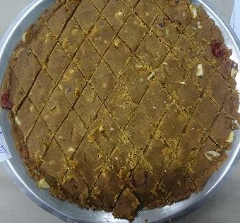
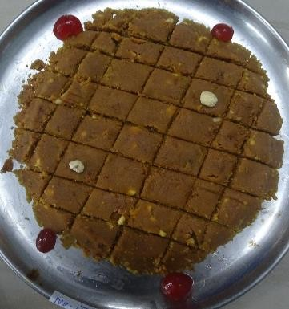

T₄- Burfi of cocoa butter
T₃- Burfi of cambodge butter

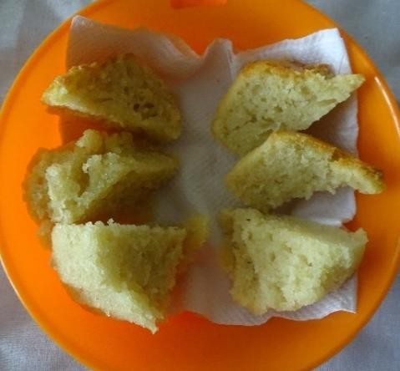
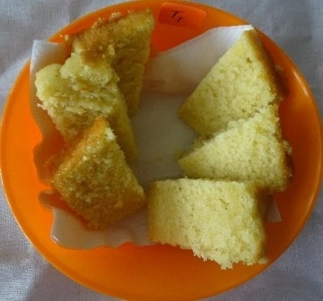
Figure 4. Burfi prepared using different butters
T₃- Cake of cambodge butter
T₃- Cake of cambodge butter
T₃- Cake of cambodge butter
T₃- Cake of cambodge butter
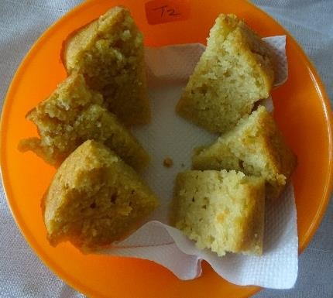

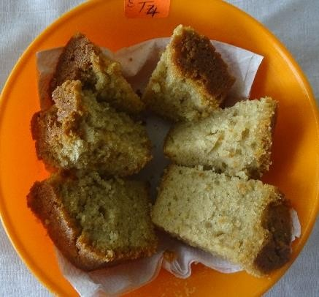

Figure 5. Cake prepared using different butters

10
9
8
7
6
5
4
3
2
1
0
Appearance
Colour
Flavour
Texture
Taste
After taste Overall acceptability
Organoleptic attributes
Milk butter
Kokum butter
Cambodge butter
Cocoa butter

Nine point scale

Figure 6. Mean score card for different types of butter

9

8

7

6

5

4

3

2

1

0
Appearance
Colour
Flavour
Texture
Taste
After taste
Overall acceptability
Organoleptic attributes
Milk burfi
Kokum burfi
Cambodge burfi
Cocoa burfi

Nine point scale

Figure 7. Mean score card for burfi prepared using different butters

9

8

7

6

5

4

3

2

1

0
Appearance
Colour
Flavour
Texture
Taste
After taste
Overall acceptability
Organoleptic attributes
Milk cake
Kokum cake
Cambodge cake
Cocoa cake

Nine point scale

Figure 8. Mean score card for cake prepared using different butters

