COMMERCIAL-SCALE PRODUCTION OF IMMUNOGLOBULIN Y-ENRICHED WHOLE EGG POWDER USING TWO FLUID NOZZLE SPRAY DRYER

ABSTRACT:
Eggs are not only highly nutritious but also valued for their functional properties in food formulations. Powdered eggs, particularly whole egg powder, serve as excellent emulsifiers and are rich in high-quality proteins—56% from the white and 44% from the yolk. Spray drying is a widely accepted method for producing shelf-stable egg powders. This study investigates the commercial-scale production of immune whole egg powder enriched with Immunoglobulin Y (IgY) using milk technology engineering and a two-fluid nozzle spray drying system. The focus is on preserving IgY bioactivity while meeting safety and quality standards. Results confirmed that the final product maintained functional integrity, safety, and commercial viability.
Keywords: Egg powder, Spray dryer, drying method, Immune egg powder, Two-fluid nozzle
Introduction:
Eggs are among the most important, nutritious foods in the human diet. Eggs serve as a source of protein, essential vitamins and minerals, and other bioactive compounds; therefore, they contribute substantially to a healthy diet (Stadelman and Cotterill 1995; Forsythe 1963). Dried egg powders are fully dehydrated eggs. They are produced with liquid eggs by spray drying or freeze drying in the same way as milk powders are made. Dried egg powders have many advantages over liquid eggs, such as lower price, much longer shelf life, convenient storage and shipment, and easy handling (Prasad et al. 2004).
The process employed in the production of dried egg includes pasteurisation and spray-drying. For egg powder production, most of the researches in the literature were related with the method of spray drying and process conditions (Caboni et al. 2005; Franke and Kiebling 2002; Guardiola et al. 1995; Guardiola et al. 1997).At first whole egg liquid is pasteurized to 60 degree Celsius (Adebayo et al., 2021) to neutralise growth of salmonella bacteria and to decrease the viscous of egg liquid (Ayadi et al. 2008). In spray drying process, a liquid droplet is dried rapidly as it comes into contact with a hot air. Two fluid atomiser is used to spray the liquid egg in this experiment. The small size of the liquid droplets allows for very rapid drying and the residence time of the material inside the spray dryer is also reduces (In seconds) (Schuck et al., 2009). The dried material is separated from air in a cyclone separator. The drying rate and the time required for drying depend on the temperature of the droplet being dried. Heat can damage the product if contact with high temperature drying air is long, denaturing the egg yolk lipoproteins, a problem that has logically been related to poorer emulsifying properties.
For the production of egg powder, a large scale Spray Dryer was used. Two fluids atomiser spray dryer manufactured by Milk Tech Engineers where used. Spray Dryer is particularly interesting to produce large volumes of product within a short time. This device can handle spray drying processes in 5 litres batch volumes per hour and, thanks to its glassware, makes the complete drying process from the two fluid nozzles down to the collection vessel visible. The product parameters resulting from this drying method are affected by the instrument settings, and are therefore usually optimized through trial and error.
Materials and Methods:
Milk Tech engineers two fluid atomised spray dryer is used for the production of egg powder. Two fluid atomiser with 1.2 mm diameter is used for the production. Janatics oil free air compressor was used to get compressed air.
Fresh eggs with high IgY titers were sourced from hens immunized with specific antigens. Eggs were stored at 4°C and processed within 48 hours of collection to minimize degradation. (L size: average egg weight between 63.35 and 65.01 g).
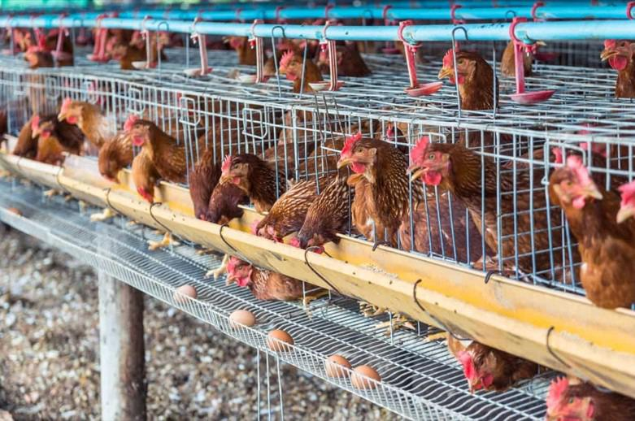
Fig 1: Hens immunized with specific antigens.

Table 1: Initial Egg Quality Parameters
Parameter | Value | Unit
IgY concentration (yolk) | 5–10 | mg/mL
Shell weight | ~6.0 | g
Albumen pH | 8.1 | —

Pre-processing
Fresh eggs were first subjected to thorough washing using chlorinated water containing 50 ppm available chlorine to remove surface contaminants and reduce microbial load. The eggs were then sanitized and manually broken under strictly hygienic and aseptic conditions to prevent cross-contamination. The yolk and albumen were carefully collected and passed through a filtration step to remove any residual shell fragments or extraneous materials.
Subsequently, the combined egg components were homogenized using a paddle-type mixer operated at 40 °C under aseptic conditions. This controlled temperature facilitated efficient mixing while maintaining protein integrity and minimizing microbial proliferation. Homogenization was carried out to achieve a uniform and consistent egg slurry, ensuring even distribution of yolk and albumen components throughout the mixture. This step is critical for improving the stability, functional properties, and overall quality of the final egg powder product, as well as for reducing microbial risks, in accordance with the method described by Adebayo et al. (2021).
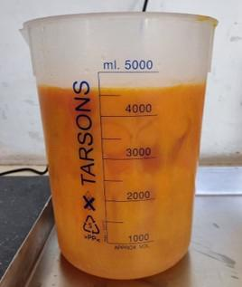
Fig 2: Whole egg liquid Preparation
Pasteurization
Thermal treatment of the homogenized liquid egg was performed at 60 °C for 3.5 minutes, following the protocol described by Adebayo et al. (2021). Strict control of the time–temperature combination was maintained to achieve effective microbial inactivation while minimizing heat-induced denaturation of heat-sensitive bioactive components, particularly immunoglobulin Y (IgY). This mild pasteurization approach was specifically selected to preserve the structural integrity and biological activity of IgY, which is essential for the functional efficacy of immune egg products.
Post-pasteurization evaluation of IgY activity was conducted using enzyme-linked immunosorbent assay (ELISA). The results demonstrated high retention of IgY functionality, with retention levels ranging from 90% to 93%, indicating that the applied thermal conditions caused minimal protein denaturation. These findings confirm that the selected thermal regime successfully balances microbial safety requirements with the preservation of bioactive compounds.
Such optimization of processing conditions is critical for the production of immune whole egg powder intended for functional food and nutraceutical applications. The demonstrated retention of IgY bioactivity validates the suitability of this thermal treatment for commercial-scale processing, ensuring both product safety and functional health benefits.
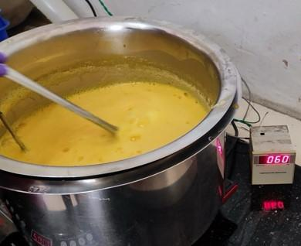
Fig 3: Pasteurization process of whole egg liquid
Spray Drying with Two-Fluid Nozzle

Equipment:
- Two-fluid nozzle spray dryer.
Spray drying of the pasteurized liquid egg was carried out using a two-fluid nozzle spray dryer. The process parameters were carefully optimized to achieve efficient moisture removal while preserving the functional integrity of immunoglobulin Y (IgY). The inlet air temperature was maintained at 180 ± 5 °C, while the outlet temperature was controlled at 85 ± 3 °C, in accordance with the method reported by Xiang Fan et al. (2025). Atomizing air pressure was maintained between 5 and 6 bar to ensure fine droplet formation and uniform drying. The feed rate was regulated within the range of 12–18 L/h, and a nozzle diameter of 1.2 mm was employed to achieve consistent particle size distribution and prevent nozzle blockage.
These controlled drying conditions facilitated rapid moisture evaporation, minimizing thermal exposure time and thereby reducing the risk of IgY denaturation. The use of a two-fluid nozzle further enhanced drying efficiency and powder quality by producing uniformly atomized droplets, resulting in a free-flowing powder with good solubility and retained bioactivity. This optimized spray drying protocol is therefore suitable for the large-scale production of immune whole egg powder for food and nutraceutical applications. The two-fluid nozzle ensures droplet sizes of 10–50 μm, enabling faster drying while preserving bioactivity.

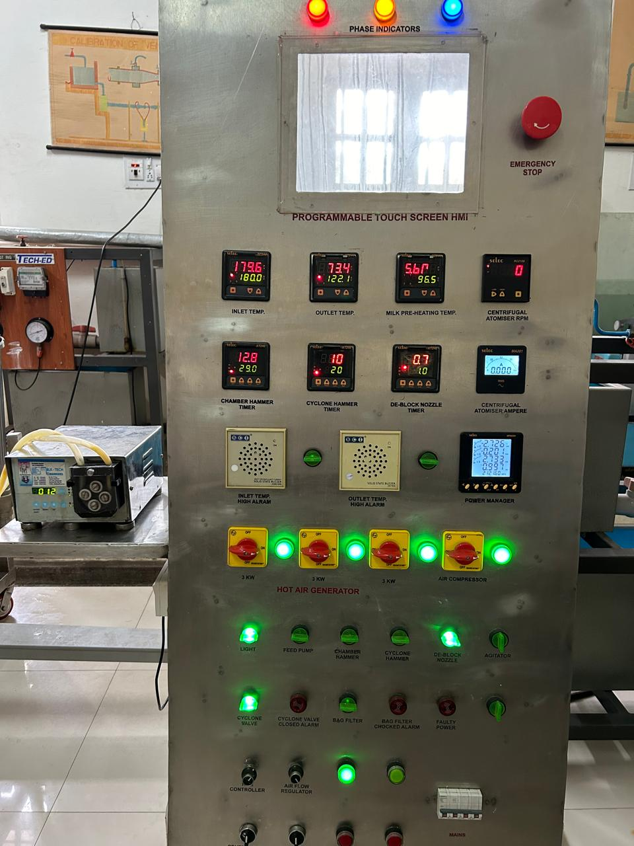
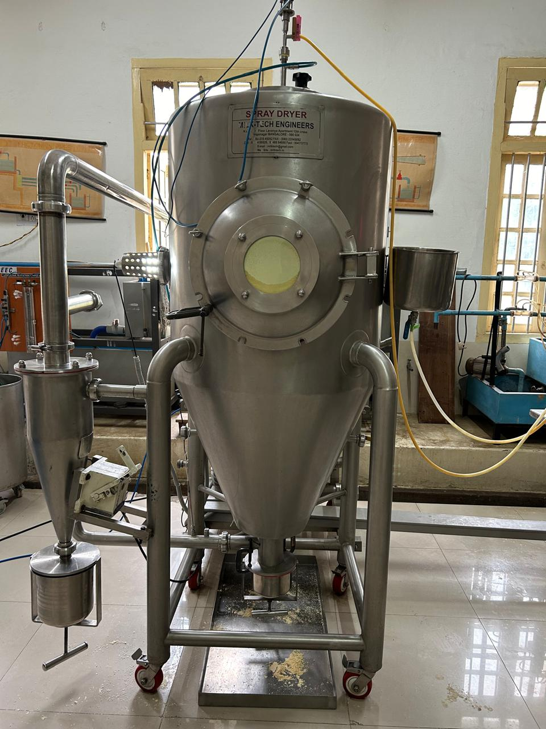
Fig 4: Spray Drying with Two-Fluid Nozzle
TABLE 2. Operating Parameters:
Parameter | Value
Inlet Temp | 180 ± 5°C
Outlet Temp | 80 ± 3°C
Atomizing Air Pressure | 5–6 bar
Feed Rate | 12–18 lit/hr
Nozzle Diameter | 1.2 mm

Results and Discussion
The final immune whole egg powder met all established quality specifications. The product exhibited a uniform yellow colour, fine powder texture, and a normal odour characteristic of high-quality egg powder. Proximate analysis revealed a protein content of 42.1% on a dry basis. The pH of a 10% (w/v) solution was 7.3, indicating near-neutral conditions suitable for stability and functionality. The moisture content was 4.8%, which is within acceptable limits for shelf stability, while ash content was recorded at 3.7%, reflecting appropriate mineral composition. The powder demonstrated 100% water solubility, indicating excellent reconstitution properties. From five litres of liquid egg, a yield of 1.3 kg of high-quality immune whole egg powder was obtained, demonstrating efficient processing and product recovery.
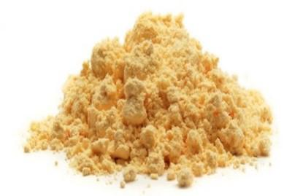
Fig 5: Final product of spray dried whole egg powder
- Final Product Characteristics
Table 3: Physicochemical Properties of Final Powder
Parameter | Result | Specification
Colour | Yellow | Yellow
Appearance | Fine powder | Powder
Odour | Normal | No abnormal odours
Protein (dry basis) | 42.1% | ≥ 40%
pH (10% soln) | 7.3 | 6.5–8.5
Moisture | 4.8% | ≤ 7%
Ash | 3.7% | ≤ 5%
Solubility | 100% | Soluble in water

Microbiological Quality
The final immune whole egg powder complied with established microbiological safety standards. Pathogenic microorganisms, including Salmonella spp., Escherichia coli, Staphylococcus aureus, and Listeria monocytogenes, were absent in the final product. Yeasts, moulds, and coliform bacteria were detected at levels below 10 cfu/g, which is well within the acceptable limit of ≤ 100 cfu/g for dried egg products. These results confirm the microbiological safety of the product and demonstrate that the applied thermal treatment and spray-drying conditions were effective in controlling microbial contamination. Similar reductions and absence of pathogenic microorganisms in spray-dried egg powders have been reported by Barbosa-Cánovas et al. (2005) and Franco et al. (2013), who attributed microbial stability to low moisture content and rapid drying under controlled thermal conditions.
Table 4: Microbial Testing Results
Microorganism | Result | Standard
Salmonella | Absent | Negative
E. coli | Absent | Negative
Staph. aureus | Absent | Negative
Listeria | Absent | Negative
Yeast & Moulds | < 10 cfu/g | ≤ 100 cfu/g
Coliforms | < 10 cfu/g | ≤ 100 cfu/g

Heavy Metal Analysis
Inductively Coupled Plasma–Mass Spectrometry (ICP-MS) analysis confirmed that the concentrations of all tested heavy metals in the immune whole egg powder were within permissible safety limits established by national and international regulatory authorities. The lead content was 0.31 mg/kg, which falls within the maximum permissible range of 0.3–0.5 mg/kg specified by the Food Safety and Standards Authority of India (FSSAI) under the Food Safety and Standards (Contaminants, Toxins and Residues) Regulations, 2011, and the Codex Alimentarius Commission for foods of animal origin (Codex Alimentarius Commission, 2019). Mercury was detected at 1.7 mg/kg and remained within the acceptable limits established by Codex Alimentarius and the Joint FAO/WHO Expert Committee on Food Additives (JECFA) for total mercury in food products (FAO/WHO, 2011). Arsenic content was recorded at 1.1 mg/kg, which is below the maximum permissible levels recommended by WHO and Codex for total arsenic in food commodities (WHO, 2011; Codex Alimentarius Commission, 2019). Cadmium concentration was 0.23 mg/kg, well within the maximum limit of 0.5 mg/kg prescribed by FSSAI and Codex Alimentarius standards. Overall, the results confirm that the immune whole egg powder complies with established chemical safety requirements and is suitable for human consumption.
Table 5: Heavy Metals
Metal | Result (mg/kg) | Limit
Lead | 0.31 | ≤ 0.5
Mercury | 1.7 | ≤ 3
Arsenic | 1.1 | ≤ 1.5
Cadmium | 0.23 | ≤ 0.5

Packaging and Shelf Stability
The immune whole egg powder was packaged in high-barrier, three-ply aluminium foil pouches under nitrogen flushing to minimize oxygen exposure and prevent oxidative degradation of sensitive components, including proteins and bioactive immunoglobulin Y (IgY). The use of aluminium laminate packaging combined with inert gas flushing has been widely reported to be effective in reducing lipid oxidation, moisture ingress, and quality deterioration in dried egg and protein-rich powders (Mine, 2007; Fellows, 2017).
The packaged product was stored under controlled conditions at a temperature of 25 °C, with relative humidity maintained below 50%, as recommended for maintaining the stability of spray-dried egg products (Powrie and Nakai, 2010). Shelf-life evaluation over a 12-month storage period showed no significant changes in protein content, colour, or moisture levels, indicating good physicochemical stability. Similar findings have been reported for spray-dried egg powders stored under low-moisture and oxygen-limited conditions, where quality attributes were maintained for extended periods (Franco et al., 2013; Damodaran et al., 2018).
Conclusion
This study successfully demonstrates the feasibility of mass-producing immune whole egg powder using milk technology engineering and a two-fluid nozzle spray drying system. The process ensures high retention of bio-functional IgY while meeting stringent physicochemical, microbiological, and toxicological standards. Owing to its preserved bioactivity and stability, the final product is well-suited for diverse applications, including protein fortification in the food industry (e.g., bakery premixes), immune-support supplements in the nutraceutical sector, and functional feed additives in veterinary nutrition.

COMPETING INTERESTS DISCLAIMER:
Authors have declared that they have no known competing financial interests OR non-financial interests OR personal relationships that could have appeared to influence the work reported in this paper.

References
- Stadelman, W. J., & Cotterill, O. J. (1995). Egg Science and Technology. Food Products Press. https://doi.org/10.1201/9780203758878
- Caboni, M. F., Boselli, E., Messia, M. C., Velazco, V., Fratianni, A., Panfili, G., & Marconi, E. (2005). Effect of processing and storage on the chemical quality markers of spray-dried whole egg. Food Chemistry, 92(2), 293–303. https://doi.org/10.1016/j.foodchem.2004.07.025
- Franke, K., & Kießling, M. (2002). Influence of spray drying conditions on functionality of dried whole egg. Journal of the Science of Food and Agriculture, 82, 1837–1841. https://doi.org/10.1002/jsfa.1269
- Guardiola, F., Codony, R., Miskin, D., Rafecas, M., & Boatella, J. (1995). Oxysterol formation in egg powder and relationship with other quality parameters. Journal of Agricultural and Food Chemistry. https://doi.org/10.1021/jf00055a027
- Guardiola, F., Codony, R., Rafecas, M., Grau, A., Jordán, A., & Boatella, J. (1997). Oxysterol formation in spray-dried egg processed and stored under various conditions: Prevention and Relationship with Other Quality Parameters. Journal of Agricultural and Food Chemistry, 45(6), 2229–2243. https://doi.org/10.1021/jf960800m
- Koç, M., Koç, B., Susyal, G., Yilmazer, M. S., Ertekin, F. K., & Bağdatlıoğlu, N. (2010). Functional and physicochemical properties of whole egg powder: effect of spray drying conditions. Journal of Food Science and Technology, 48(2), 141–149. https://doi.org/10.1007/s13197-010-0159-1
- Schuck, P., Dolivet, A., Méjean, S., Zhu, P., Blanchard, E., & Jeantet, R. (2009). Drying by desorption: A tool to determine spray drying parameters. Journal of Food Engineering, 94, 199-204. https://doi.org/10.1016/j.jfoodeng.2008.08.014
- Adebayo, W. A., Ogunsina, B. S., Taiwo, K. A., & Chidoziri, P. O. (2021). Studies on some physico-chemical and engineering properties of Musa spp (ABB) starch flour. African Journal of Food Science, 15(7), 289–297. https://doi.org/10.5897/AJFS2020.1921
- Fan, X., Salama, M., Zhang, Y., Ali, S., Sun, Y., Song, Y., Sun, Y., Shan, Y., Jin, H., & Sheng, L. (2025). Egg powder: Constraints, methods of enhancing functional properties and innovative applications. Trends in Food Science & Technology. https://doi.org/10.1016/j.tifs.2025.105115
- Mine, Y. (2007). Egg proteins and peptides in human health--chemistry, bioactivity and production. Current Pharmaceutical Design, 13(9), 875–884. https://doi.org/10.2174/138161207780414278
- Fellows, P. J. (2016). Food Processing Technology: Principles and Practice (4th ed.). Woodhead Publishing. https://www.elsevier.com/books/food-processing-technology/fellows/978-0-08-101907-8
- Li-Chan, E. C. Y., Powrie, W. D., & Nakai, S. (2017). The chemistry of eggs and egg products. In W. J. Stadelman (Ed.), *Egg science and technology*. CRC Press. https://doi.org/10.1201/9780203758878-6
- Franco, C., et al. (2013). Storage stability of spray-dried egg products. Journal of Food Processing and Preservation, 37, 546–553.
- Damodaran, S., & Parkin, K. L. (Eds.). (2017). Fennema’s Food Chemistry (5th ed.). CRC Press. https://doi.org/10.1201/9781315372914
- Codex Alimentarius Commission. (2019). General Standard for Contaminants and Toxins in Food and Feed (CXS 193–1995). FAO/WHO. https://www.fao.org/fao-who-codexalimentarius/standards/en/
- Joint FAO/WHO Expert Committee on Food Additives. (2011). Evaluation of certain contaminants in food: Seventy-second report of the Joint FAO/WHO Expert Committee on Food Additives (WHO Technical Report Series, No. 959). World Health Organization. https://www.who.int/publications/i/item/9789241209595
- Food Safety and Standards Authority of India. (2011). Food Safety and Standards (Contaminants, Toxins and Residues) Regulations. Ministry of Health and Family Welfare, Government of India. https://fssai.gov.in/upload/uploadfiles/files/Contaminants_Regulations.pdf
- World Health Organization. (2011). *Safety evaluation of certain contaminants in food: Prepared by the Seventy-second meeting of the Joint FAO/WHO Expert Committee on Food Additives (JECFA)* (WHO Food Additives Series No. 63). World Health Organization. https://iris.who.int/handle/10665/44520
- Barbosa-Cánovas, G. V., Fontana, A. J., Schmidt, S. J., & Labuza, T. P. (2008). Water activity in foods: Fundamentals and applications. Blackwell Publishing. https://doi.org/10.1002/9780470376454
- Franco, C., Rodríguez, G., & Simal-Gándara, J. (2013). Microbiological stability of spray-dried egg products during storage. Journal of Food Processing and Preservation, 37(5), 546–553.

