UNRAVELING PEST-WEATHER DYNAMICS: A STEPWISE REGRESSION APPROACH ON MAJOR PESTS IN RICE

Abstract
Rice (Oryza sativa L.) is a crucial staple crop extensively cultivated in the Godavari delta region of Andhra Pradesh. Its productivity faces threats from insect pests such as Yellow Stem Borer (YSB), Brown Plant hopper (BPH), Gall Midge, and Leaf Folder (LF), whose dynamics are influenced by weather parameters. Understanding the pest-weather relations is essential for developing effective pest management strategies. Long-term weekly data recorded according to Standard Meteorological Weeks (SMWs) was collected from the Regional Agricultural Research Station, Maruteru, Andhra Pradesh from 2002 to 2023 for kharif and from 2003 to 2023 for the Rabi season. The meteorological parameters examined included maximum and minimum temperatures (TMAX and TMIN), morning and evening relative humidity (RHM and RHE), rainfall (RF) and sunshine hours (SSH). As the weather factors are multicollinear, a stepwise regression analysis was carried out to identify key weather variables that influence the major pests in rice. The analysis showed that different pests were affected by various weather conditions in different seasons. For Yellow Stem Borer, TMIN, RHE and SSH are the major contributors during kharif, whereas TMIN and RHE showed an impact during Rabi. For Gall Midge, SSH was the key influencer in kharif, while TMIN and RHM are more impactful in Rabi. For Leaf Folder, RHE and TMAX were significant in kharif, whereas RHE, RHM and TMIN were crucial in deciding Leaf Folder during Rabi. The BPH incidence during kharif was influenced by RHM, SSH, and TMAX, similarly, in Rabi, instead of RHM, RHE was pivotal. These models, based on over two decades of data, showed a lower range of R² value indicating that the models were not a strong fit due to non-linearity and high heterogeneity exists in the occurrence of insect pests. Anyhow, these models offer valuable insights into the climatic triggers of pest outbreaks, enabling reliable pest forecasting and aiding climate-responsive integrated pest management practices in rice cultivation across coastal Andhra Pradesh.
Keywords: Rice, Pest forecasting, Weather parameters, Multicollinearity and Stepwise regression.
1. Introduction:
Rice (Oryza sativa) is a staple food for more than half of the global population, particularly in tropical and subtropical regions, where it thrives in warm, humid, and water-rich environments, mainly in flooded fields. In Asia, it is central to food security. During 2023–24, India ranked first in rice area (7.8 million ha) and second in production (137.9 million tonnes; productivity 2,882 kg/ha). Andhra Pradesh alone accounted for 1.9 million ha and 7.3 million tonnes, with higher productivity (3,822 kg/ha) (https://www.indiastat.com, Indiastat, 2023–24). However, major insect pests such as Yellow Stem Borer (YSB), Gall Midge (GM), Leaf Folder (LF), and Brown Plant hopper (BPH) continue to threaten rice yields.
Among them, Yellow Stem Borer (YSB), Scirpophaga incertulas (Lepidoptera: Pyralidae), is a serious pest post-Green Revolution, causing yield losses of 20% in early crops and up to 70% in late planted crops (Reddy et al., 2022). Krishnaiah and Varma (2011) reported losses of 11.2–40.1% from dead hearts and 27.6–71.7% from white ears. The economic threshold is 2 egg masses/m² or 10% dead hearts (Prakash et al., 2014). For Cnaphalocrocis medinalis (leaf folder), insecticidal control is advised when two infested leaves per hill are found (Prakash et al., 2014). The Brown Plant hopper (BPH), Nilaparvata lugens (Hemiptera: Delphacidae), can cause up to 60% yield loss in susceptible varieties. Asian Gall Midge (GM) Orseolia oryzae (Diptera: Cecidomyiidae), causes major economic damage, especially in southern India, with yield losses of 0.8% (~US$80 million). The Rice Leaf folder (RLF), Cnaphalocrocis medinalis (Guenee) (Lepidoptera:Pyralidae) it is a predominant foliage feeder and one of the most destructive pests, affecting in all the rice ecosystems in Asia (Luo, S. J., 2010).once it considered to a minor pest, emerged as a major threat since the late 1980s, causing 30–80% yield loss under epidemic conditions (Nanda & Bisoi, 1990; Shah et al., 2008).
Several studies report that weather strongly influences pest population dynamics. Ali et al. (2022) used stepwise regression to relate six epidemiological weather variables to leaf rust severity in wheat, finding positive associations with all except minimum RH. They also developed a predictive model for lentil wilt, explaining 94.39% of variation and successfully validating it. Gholap et al. (2022) identified rainy days as positively, and wind speed, SSH, and minimum temperature as negatively, affecting Bt cotton yield by using stepwise regression analysis. Khan et al. (2006) applied stepwise regression to whitefly and mung bean yellow mosaic virus, with environmental factors (minimum and maximum air temperature, rainfall, and relative humidity) models explaining 81–92% variation across years. Kadam et al. (2022) applied stepwise regression and found that the weather factors significantly influencing cotton pests, with R² values ranging from 0.41 (aphids) to 0.66 (thrips, whiteflies); maximum and minimum temperatures and SSH were key predictors. Manikandan et al. (2024) reported that weather explained 50–61% variation in moringa pest infestations, with maximum temperature positively affecting budworm and ants, while rainfall and RH had opposite effects depending on pest species. For rice pests, Reddy et al. (2022) showed minimum temperature, SSH, and evening RH significantly influenced YSB populations, while Baswaraj et al. (2023) created statistical models to analyze the connection between weather conditions and the populations of lepidopteran pests in Kalyan Karnataka. Rathod et al,. (2021) Stepwise regression analysis was conducted to identify climatological factors affecting gall midge population buildup. Significant variables included TMIN, RHE, SSH at Warangal; RHM at Maruteru; TMAX, RHM, and SSH at Pattambi; and TMIN, RHM, RHE, and SSH at Jagdalpur. However, the low R² values across all centers suggest that the model is not a strong fit, potentially due to non-linearity and high variability in the dependent variables. Udayababu et al. (2021) linked weather to several rice pests, noting negligible gall midge incidence in 2017–18 but a sharp peak in 2019. Minruhi et al. (2023) identified TMAX, TMIN, RHM, and RF as significant factors affecting EW populations in the Kharif season. TMAX and RHM had negative effects, while TMIN and RF had positive effects. The model's low R² suggests a weak fit due to non-linearity and high heterogeneity in catches at RARS, Tirupati.
2. Objectives:
1. To study the season wise pest scenario in Rice.
2. To identify the key weather parameters for incidence of season wise and pest wise in Maruteru, Andhra Pradesh.
3. Materials and Methodology:
3.1 Data collection:
Standard meteorological weeks (SMWs) were used to record long-term weekly data on rice from the Regional Agricultural Research station (RARS) in Maruteru, Andhra Pradesh. Typically, weekly data on the main pests of rice are gathered from 2002 to 2023 during the kharif season and from 2003 to 2023 during the Rabi season. These pests include Yellow Stem Borer (YSB), Brown Plant Hopper (BPH), Rice Leaf Folder (RLF), and Gall Midge (GM). Likewise, gather meteorological information on sunlight hours (SSH), relative humidity morning (RHM), relative humidity evening (RHE), maximum temperature (TMAX), and minimum temperature (TMIN) for the relevant crop period. For this study, weekly averages of weather factors and weekly pest data broken down by standard meteorological weeks (SMWs) were taken into account.
3.2 Statistical Models:
Descriptive statistical parameters, which are crucial for illustrating the characteristics of the data under study, such as mean, standard error (SE), skewness, kurtosis, minimum, maximum, and coefficient of variation (CV), were the first to be used in statistical modeling. Essential information about the dataset's properties is provided by these measurements. Time series plots were also used to visually depict the trends in the data across time. The degree of interdependence between the variables was measured using Pearson's correlation coefficient analysis, which was used to investigate the correlations between the variables employed in the study. In order to examine the causal association between exogenous meteorological variables and rice pest populations, stepwise multiple regression models were utilized.
The regression equation in matrix notation is expressed as:
Y=Xβ+e…(1.1)
Where Y is the dependent variable representing the Rice pest population, X is the matrix of independent variables comprising the exogenous weather variables, β is the vector of regression coefficients and e is the residuals term assumed to be normally distributed with e ~N (0, $σ^{2}$). Correlation analysis and stepwise regression analysis were carried out in SPSS Ver.28 (Licensed).

4. Results and Discussions
4.1. YSB PEST - KHARIF
4.1.1. Descriptive Statistics
This study employs a methodological framework starting with descriptive statistics, followed by correlation analysis and stepwise regression, to explore the relationship between Yellow Stem Borer (YSB) incidence during the Kharif season and weather parameters. The dataset, compiled weekly from 2002 to 2023, highlights significant YSB populations during the 25th and 52nd SMWs, essential for understanding pest dynamics. Table 1 summarizes the descriptive statistics for YSB population and related weather variables. A coefficient of variation (CV) of 229.37% indicates high variability in pest incidence, with skewness and kurtosis values suggesting a non-normal distribution. The weather variables also show considerable variability, confirming diverse characteristics within the dataset.
Table 1: Summary statistics of Yellow Stem Borer (YSB) during Kharif Season at RARS, Maruteru
Statistics
 | YSB | TMAX | TMIN | RHM | RHE | RF | SSH
N | 616.0 | 616.0 | 616.0 | 616.0 | 616.0 | 616.0 | 616.0
Mean | 532.2 | 30.4 | 24.0 | 87.1 | 70.6 | 30.3 | 4.9
Median | 149.5 | 30.3 | 24.7 | 87.3 | 71.9 | 9.8 | 5.0
Mode | 0.0 | 30.0 | 25.0 | 89.0 | 73.0 | 0.0 | 3.0
Std. Deviation | 1220.7 | 2.3 | 2.9 | 4.4 | 9.9 | 48.0 | 2.0
Variance | 1490087.2 | 5.2 | 8.2 | 19.4 | 97.3 | 2299.6 | 4.1
Skewness | 7.0 | 0.5 | -0.7 | -0.6 | -0.4 | 3.3 | 0.0
Kurtosis | 74.3 | 1.3 | -0.1 | 0.6 | 0.1 | 17.4 | -0.5
Range | 17428.0 | 16.7 | 14.5 | 27.0 | 54.7 | 428.6 | 9.6
Minimum | 0.0 | 22.9 | 16.2 | 69.9 | 40.4 | 0.0 | 0.0
Maximum | 17428.0 | 39.6 | 30.7 | 96.9 | 95.1 | 428.6 | 9.6
CV% | 229.4 | 7.5 | 11.9 | 5.1 | 14.0 | 158.2 | 41.3

4.1.2. Correlation Analysis
The Pearson correlation coefficients between Yellow Stem Borer (YSB) populations and the weather variables analyzed are shown in Table 2. A minimal negative and non-significant correlation was found between the YSB population and TMAX (-0.028) and RHM (-0.02). Additionally, a minimal negative and significant correlation was observed between the YSB population and TMIN (-0.236), RHE (-0.225), and RF (-0.147). Conversely, a minimal positive and significant correlation between the YSB population and SSH (0.19) was noted.
Table 2: Pearson correlation coefficients between Yellow Stem Borer (YSB) populations and weather variables during Kharif Season
Correlations
 | YSB | TMAX | TMIN | RHM | RHE | RF
TMAX | -0.028
TMAX | -0.494
TMIN | -.236** | .527**
TMIN | (<0.0001) | (<0.0001)
RHM | -0.02 | -.334** | -.196**
RHM | -0.614 | (<0.0001) | (<0.0001)
RHE | -.225** | -.370** | .150** | .401**
RHE | (<0.0001) | (<0.0001) | (<0.0001) | (<0.0001)
RF | -.147** | -.124** | .143** | .203** | .233**
RF | (<0.0001) | -0.002 | (<0.0001) | (<0.0001) | (<0.0001)
SSH | .190** | .212** | -.242** | -.147** | -.357** | -.342**
SSH | (<0.0001) | (<0.0001) | (<0.0001) | (<0.0001) | (<0.0001) | (<0.0001)

4.1.3. Step Wise Regression Analysis
A stepwise regression analysis was performed to identify the most influential predictors of the weather parameters affecting the YSB pest. The criteria for variable entry and removal were set with an F-to-enter ≤ 0.050 and a probability of F-to-remove ≥ 0.100. In the first step, minimum temperature (TMIN) was entered into the model, resulting in a significant improvement (F(1,614) = 36.252, p < 0.001). In the second step, relative humidity (RHE) was added, leading to another significant enhancement (F(2,613) = 31.276, p < 0.001). In the third step, soil moisture (SSH) was included, which further enhanced the model (F(3,612) = 22.305, p < 0.001). In the final model, which included TMIN, RHE, and SSH, there was a strong fit, accounting for a substantial proportion of the variance (R² = 0.099; adjusted R² = 0.094). In the first step, the regression equation is:
YSB (Kharif) = 2956.485-100.868(TMIN)
This highlights the significant positive impact of minimum temperature on YSB pest growth (t = 7.291, p < 0.001, β = -0.236). In the second step, with the addition of RHE, the regression equation is:
YSB (Kharif) = 4352.566-88.394(TMIN) -24.028 (RHE)
Both TMIN (t = -5.317, p = 0.001, β = -0.207) and RHE (t = -4.989, p = 0.001, β = -0.194) showed positive standardized coefficients, indicating their contribution to the growth of YSB. In the third step, with the addition of SSH, the regression equation becomes:
YSB (Kharif) = 3693.918 -81.45(TMIN) -20.599(RHE) +51.170(SSH)
In this final model, TMIN (t = -4.808, p = 0.0001, β = -0.191), RHE (t = -4.808, p = 0.0001, β = -0.166), and SSH (t = 2.012, p = 0.045, β = 0.084) all demonstrate positive standardized coefficients, suggesting their contributions to the growth of the yellow stem borer (YSB). In conclusion, minimum temperature (TMIN), relative humidity (RHE), and Sun Shine Hours (SSH) are the three major weather factors influencing the growth of the YSB pest in paddy fields.
Table 3: Stepwise regression model for population Yellow Stem Borer (YSB) during kharif and weather variables
ANOVA
Model |  | Sum of Squares | df | Mean Square | F | Sig.
1 | Regression | 51090747 | 1 | 51090747 | 36.252 | .000^{b}
1 | Residual | 865312896 | 614 | 1409304.4
1 | Total | 916403642 | 615
2 | Regression | 84854472 | 2 | 42427236 | 31.276 | .000^{c}
2 | Residual | 831549171 | 613 | 1356523.9
2 | Total | 916403642 | 615
3 | Regression | 90321380 | 3 | 30107127 | 22.305 | .000^{d}
3 | Residual | 826082262 | 612 | 1349807.6
3 | Total | 916403642 | 615

Model Summary
Model | R | R Square | Adjusted R Square | Std. Error of the Estimate
1 | .236ª | .056 | .054 | 1187.141
2 | .304^{b} | .093 | .090 | 1164.699
3 | .314^{c} | .099 | .094 | 1161.812

Coefficientsª
Model |  | Unstandardized Coefficients |  | Standardized Coefficients | t | Sig.
 |  | B | Std. Error | Beta | t | Sig.
1 | (Constant) | 2956.485 | 405.474 |  | 7.291 | .000
1 | TMIN | -100.868 | 16.753 | -.236 | -6.021 | .000
2 | (Constant) | 4352.566 | 486.372 |  | 8.949 | .000
2 | TMIN | -88.394 | 16.625 | -.207 | -5.317 | .000
2 | RHE | -24.028 | 4.816 | -.194 | -4.989 | .000
3 | (Constant) | 3693.918 | 585.234 |  | 6.312 | .000
3 | TMIN | -81.451 | 16.939 | -.191 | -4.808 | .000
3 | RHE | -20.599 | 5.097 | -.166 | -4.041 | .000
3 | SSH | 51.170 | 25.426 | .084 | 2.012 | .045

4.1.4. Discussion:
In this study, the stepwise regression model showed a weak fit, with a low R² value of 9%. This poor fit is likely due to non-linear relationships and high variability in the dependent variable, which makes it challenging to establish a strong association between yellow stem borer populations and external weather variables during the kharif season (Fig. 1). The analysis identified TMIN, RHE, and SSH as the key weather parameters significantly influencing YSB population growth in paddy fields. However, it should be noted that several other potential factors affecting YSB incidence were not considered in this study. Similarly, A related study by Sagar et al. (2017) reported that stepwise regression highlighted TMIN, RH1 (RHM), and SSH as important predictors of Helicoverpa armigera trap catches.
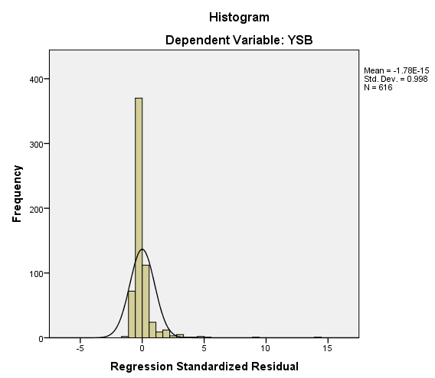 | 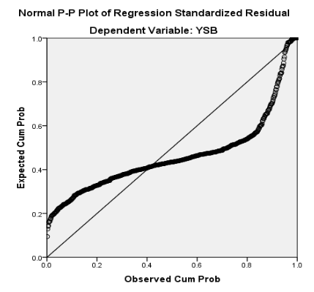 | 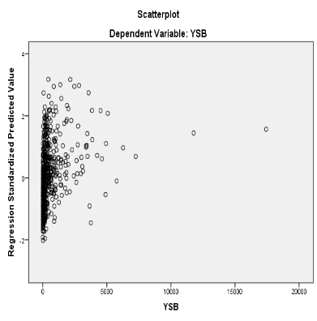
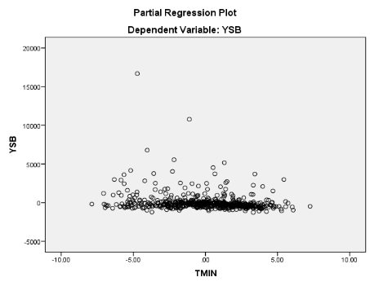 | 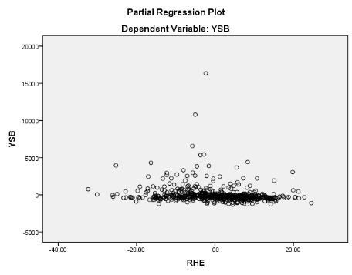 | 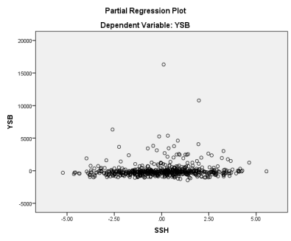
Fig 1: Regression diagnosis of Kharif YSB population with weather parameters
4.2. YSB-RABI
4.2.1. Descriptive Statistics:
The methodological approach involves descriptive statistical analysis, correlation assessment, and stepwise regression to explore the links between Yellow Stem Borer (YSB) infestation during the Rabi season and various weather parameters. The dataset, compiled weekly from 2003 to 2023, reveals peak YSB populations in the 1st and 20th SMWs, highlighting key periods for understanding pest behavior. The coefficient of variation (CV) for YSB population was 195.4%, indicating significant variability. Skewness and kurtosis values indicated non-normal distribution patterns. Weather parameters also showed substantial variability, confirming the unique traits of the examined factors.
Table 4: Summary statistics of Yellow Stem Borer (YSB) during Rabi Season at RARS, Maruteru
Statistics
 | YSB | TMAX | TMIN | RHM | RHE | RF | SSH
N | 420.0 | 420.0 | 420.0 | 420.0 | 420.0 | 420.0 | 420.0
Mean | 1216.6 | 31.3 | 22.5 | 87.8 | 61.5 | 3.9 | 7.6
Median | 301.0 | 31.4 | 22.5 | 88.6 | 64.3 | 0.0 | 7.8
Mode | 0.0 | 31.0 | 20.6 | 90.00ª | 66.29ª | 0.0 | 7.62ª
Std. Deviation | 2376.8 | 2.9 | 2.9 | 4.8 | 12.0 | 17.1 | 1.3
Variance | 5649387.8 | 8.6 | 8.4 | 23.3 | 144.0 | 292.9 | 1.7
Skewness | 4.1 | 0.2 | 0.0 | -2.0 | -0.7 | 6.1 | -1.1
Kurtosis | 22.0 | 1.0 | -0.2 | 7.8 | -0.1 | 42.3 | 1.9
Range | 20648.0 | 23.5 | 17.7 | 40.1 | 62.9 | 152.0 | 8.5
Minimum | 0.0 | 19.3 | 12.0 | 57.4 | 24.7 | 0.0 | 1.4
Maximum | 20648.0 | 42.8 | 29.7 | 97.6 | 87.6 | 152.0 | 9.9
CV% | 195.4 | 9.3 | 12.8 | 5.5 | 19.5 | 439.2 | 17.2

4.2.2. Correlation Analysis
The Pearson correlation coefficients between Yellow Stem Borer (YSB) populations and the weather variables analysed are shown in Table 5. A minimal negative and significant correlation was found between the YSB population and RHE (-0.339) and RHM (-0.18). Additionally, a minimal positive and significant correlation was observed between the YSB population and TMAX (0.331), TMIN (0.343) and SSH (0.147) conversely, a minimal positive and non-significant correlation between the YSB population and RF (0.06) was noted.
Table 5: Pearson correlation coefficients between Yellow Stem Borer (YSB) populations and weather variables during Rabi Season
 | YSB | TMAX | TMIN | RHM | RHE | RF
TMAX | .331**
TMAX | (<0.0001)
TMIN | .343** | .811**
TMIN | (<0.0001) | (<0.0001)
RHM | -.180** | -.138** | -.215**
RHM | (<0.0001) | (0.005) | (<0.0001)
RHE | -.339** | -.358** | -.156** | .152**
RHE | (<0.0001) | (<0.0001) | (<0.001) | -0.002
RF | 0.06 | .111* | .162** | -0.026 | 0.046
RF | (0.216) | (0.024) | (<0.001) | (0.589) | (0.351)
SSH | .147** | .261** | .131** | 0.021 | -.130** | -.147**
SSH | (0.002) | (<0.0001) | (0.007) | (0.667) | (0.007) | (0.003)

4.2.3. Step Wise Regression Analysis
A step wise regression analysis was performed to identify the most influential weather parameter of YSB Pest .The criteria, for variable entry & removal were set at a probability of F-to enter ≤0.050 and a probability of F-to remove ≥0.100. In the first Step min temp is entered into the model; resulting in a significant Improvement F (1, 418) = 55.823 , P<0.001. In the second step Relative humidity entering was added, leading to another significant enhancement. F (2, 417) =52.492, P<0.001. The final model Including both TMIN, RHE demonstrated the most Influential Weather parameter for YSB growth with $(R^{2}=$0. 201, adjusted $R^{2}$ = 0. 197) in the first step, the regression equation is
YSB (Rabi) = -5129+281.965(TMIN)
Highlighting the significant Positive Impact of minimum temperature on YSB growth (t = 7. 471 P<0.001, beta = 0. 343) in second step, with the addition of RHE the regression equation became
YSB (Rabi) = - 725. 651 + 244. 395 (TMIN) -57.882 (RHE).
Both TMIN (T =6.713, P = 0.001, β= 0.299) and RHE (t=-6.594, P = 0.0001, beta =0.292) showed positive standardized co-efficient, suggesting their contribution to the growth of YSB. Final conclusion is the two weather factors TMIN and RHE are the majorly influence the growth of YSB pest in paddy.
Table 6: Stepwise regression model for population Yellow Stem Borer (YSB) during Rabi and weather variables
ANOVAª
Model |  | Sum of Squares | df | Mean Square | F | Sig.
1 | Regression | 278875428.892 | 1 | 278875428.892 | 55.823 | .000^{b}
1 | Residual | 2088218068.642 | 418 | 4995737.006
1 | Total | 2367093497.533 | 419
2 | Regression | 476080373.368 | 2 | 238040186.684 | 52.492 | .000^{c}
2 | Residual | 1891013124.165 | 417 | 4534803.655
2 | Total | 2367093497.533 | 419

Model Summary
Model | R | R Square | Adjusted R Square | Std. Error of the Estimate
1 | .343ª | .118 | .116 | 2235.115
2 | .448^{b} | .201 | .197 | 2129.508

Coefficientsª
Model |  | Unstandardized Coefficients |  | Standardized Coefficients | t | Sig.
 |  | B | Std. Error | Beta | t | Sig.
1 | (Constant) | -5129.801 | 856.397 |  | -5.990 | .000
1 | TMIN | 281.965 | 37.739 | .343 | 7.471 | .000
2 | (Constant) | -725.651 | 1054.409 |  | -.688 | .492
2 | TMIN | 244.395 | 36.404 | .298 | 6.713 | .000
2 | RHE | -57.882 | 8.777 | -.292 | -6.594 | .000

4.2.4. Discussion
In this study, the stepwise regression model demonstrated a weak fit, indicated by a low $R^{2}$ value (20%). This weakness is likely due to non-linearity and considerable variation in the dependent variable (High Heterogeneity), making it difficult to establish a strong link between yellow stem borer populations and exogenous weather variables during the Rabi season. This trend is also evident in Fig. 2. Stepwise regression results identified TMIN, RHE, as the two main weather factors significantly influencing the growth of the YSB pest in paddy fields. It is also important to acknowledge that other potential factors affecting yellow stem borer incidence were not included in this analysis. A related study by Rana et al. (2017) found that the occurrence of YSB depended solely on minimum temperature in both 2014 and 2015, with variability ranging from 34 to 42 per cent. Notably, stepwise regression using pooled data from both years indicated that rainfall was the most influential factor for YSB incidence.
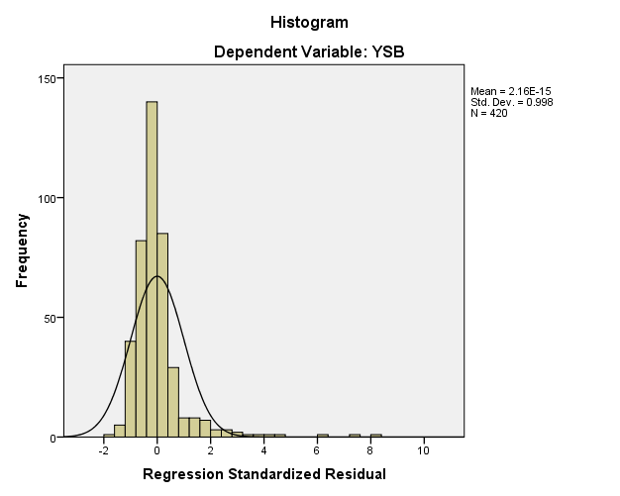 | 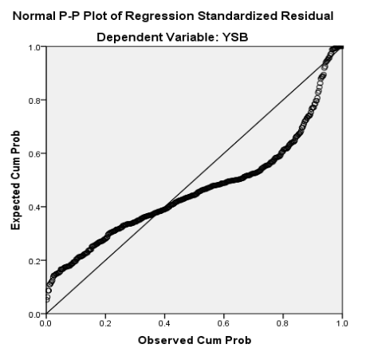 | 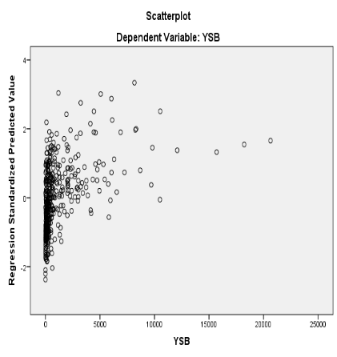
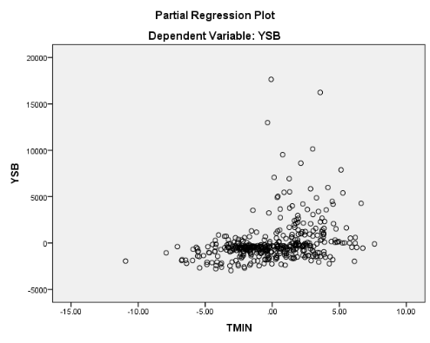 | 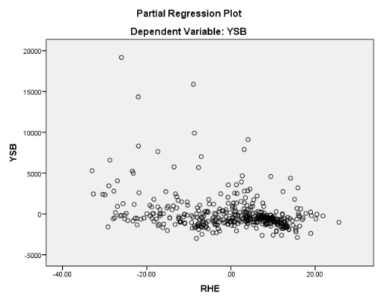
Fig 2: Regression diagnosis of Rabi YSB population with weather parameters
4.3. Gall Midge-Kharif
4.3.1. Descriptive Statistics
The methodological framework begins with descriptive statistics, correlation analysis, and stepwise regression to examine the relationships between Gall Midge (GF) populations during the Kharif season and various weather factors, using weekly data from 2002 to 2023. Significant GM populations were noted in the 25th and 52nd SMWs, key for understanding pest dynamics over 22 years. Table 7 summarizes GM population statistics alongside weather variables. The high coefficient of variation (CV) of 295.7% reflects data heterogeneity, while skewness and kurtosis indicate a deviation from normal distribution, emphasizing irregularity. Summary statistics for weather variables in Table 7 also reveal significant variability, highlighting distinct characteristics of the data.
Table 7: Summary statistics of Gall Midge (GM) during Kharif Season at RARS, Maruteru
Statistics
 | GM | TMAX | TMIN | RHM | RHE | RF | SSH
N | 616.0 | 616.0 | 616.0 | 616.0 | 616.0 | 616.0 | 616.0
Mean | 157.5 | 30.4 | 24.0 | 87.1 | 70.6 | 30.3 | 4.9
Median | 18.0 | 30.3 | 24.7 | 87.3 | 71.9 | 9.8 | 5.0
Mode | 0.0 | 30.0 | 25.0 | 89.0 | 73.0 | 0.0 | 3.0
Std. Deviation | 465.7 | 2.3 | 2.9 | 4.4 | 9.9 | 48.0 | 2.0
Skewness | 6.3 | 0.5 | -0.7 | -0.6 | -0.4 | 3.3 | 0.0
Kurtosis | 51.2 | 1.3 | -0.1 | 0.6 | 0.1 | 17.4 | -0.5
Minimum | 0.0 | 22.9 | 16.2 | 69.9 | 40.4 | 0.0 | 0.0
Maximum | 5187.0 | 39.6 | 30.7 | 96.9 | 95.1 | 428.6 | 9.6
CV% | 295.7 | 7.5 | 11.9 | 5.1 | 13.9 | 158.2 | 41.3

4.3.2. Correlation Analysis
The Pearson correlation coefficients between Gall Midge (GM) populations and the weather variables analysed are shown in Table 8. A minimal negative and non-significant correlation was found between the GM population and RF (-0.069) and RHE (-0.017). Additionally, a minimal negative and significant correlation was observed between the GM population and, RHM (-0.083). Additionally, a minimal positive and non-significant correlation between the GM population and TMAX (0.03) and TMIN (0.005). Conversely a minimal positive and significant correlation between the GM population and SSH (0.108) was noted.
Table 8: Pearson correlation coefficients between Gall Midge (GM) populations and weather variables during Kharif Season
 | GM | TMAX | TMIN | RHM | RHE | RF
TMAX | 0.03
TMAX | 0.464
TMIN | 0.005 | .527**
TMIN | 0.904 | (<0.0001)
RHM | -.083* | -.334** | -.196**
RHM | 0.039 | (<0.0001) | (<0.0001)
RHE | -0.017 | -.370** | .150** | .401**
RHE | 0.666 | (<0.0001) | (<0.0001) | (<0.0001)
RF | -0.069 | -.124** | .143** | .203** | .233**
RF | 0.088 | 0.002 | (<0.0001) | (<0.0001) | (<0.0001)
SSH | .108** | .212** | -.242** | -.147** | -.357** | -.342**
SSH | 0.008 | (<0.0001) | (<0.0001) | (<0.0001) | (<0.0001) | (<0.0001)
4.3.3. Step Wise Regression Analysis
A step wise regression analysis was performed to identify the most Influential predictors of weather parameter of gall midge in kharif season. The criteria for variable entry & removal were set at a of F-to enter ≤ 0.050 and a probability of f-to-remove ≥ 0.100 In this only SSH is entered into the model: resulting in a significant Improvement, F (1,614) = 7.186, P<.001. in the final model only SSH is the most influential weather parameter for gall midge growth with (R²=0.012; adj R² = 0.010). the final regression equation is
Gall Midge (Kharif) = 36.138+24.862 (SSH)
Highlighting the significant positive impact of SSH for gall midge growth (t =2.681, p =0.008, beta=0.108). Finally we conclude that SSH is the major influential weather parameter for growth of gall midge in kharif season in paddy crop.
Table 9: Stepwise regression model for population Gall Midge (GM) during Kharif and weather variables

ANOVAª
Model |  | Sum of Squares | df | Mean Square | F | Sig.
1 | Regression | 1543173.217 | 1 | 1543173.217 | 7.186 | .008^{b}
1 | Residual | 131846428.465 | 614 | 214733.597
1 | Total | 133389601.682 | 615

Model Summary
Model | R | R Square | Adjusted R Square | Std. Error of the Estimate
1 | .108ª | .012 | .010 | 463.394

Coefficientsª
Model |  | Unstandardized Coefficients |  | Standardized Coefficients | t | Sig.
 |  | B | Std. Error | Beta | t | Sig.
1 | (Constant) | 36.138 | 48.963 |  | .738 | .461
1 | SSH | 24.862 | 9.274 | .108 | 2.681 | .008

4.3.4. Discussion:
In this study, the stepwise regression model showed a weak fit, as indicated by a low value (1.2%). This likely results from non-linearity and significant variation in the dependent variable (high heterogeneity), making it challenging to establish a strong relationship between Gall Midge populations and external weather variables during the kharif season. This pattern is also visible in Fig. 3. Stepwise regression analysis identified SSH as the primary weather factor significantly affecting Gall Midge pest growth in paddy fields. It is important to note that other possible factors influencing Gall Midge incidence were not considered in this analysis. Similarly, a recent study by Reddy et al. (2022) conducted a stepwise regression analysis (SAS 9.3, ICAR-IIRR Hyderabad) throughout the year and found that SSH significantly and positively influences YSB populations. However, the low R² value at Rajendra Nagar indicates a poor model fit, likely due to non-linearity and high heterogeneity in the dependent variable.

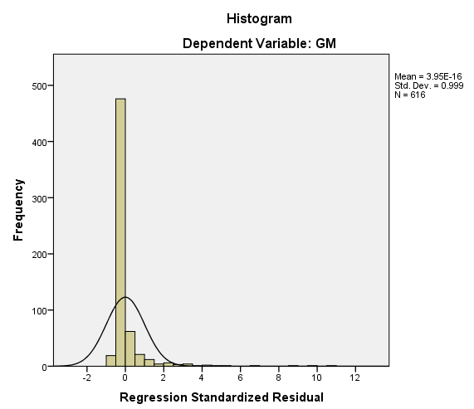 | 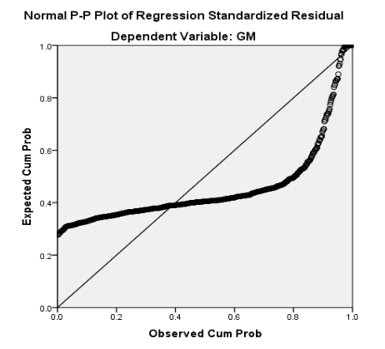  Partial Regression Plot  Dependent Variable: GM | 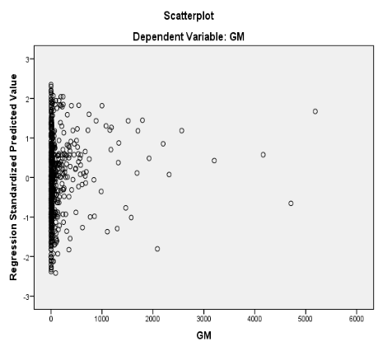
 | 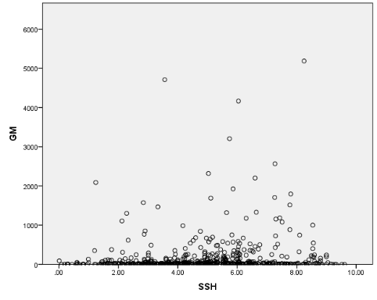
Fig 3: Regression diagnosis of Kharif Gall Midge population with weather parameters

4.4. Gall Midge- Rabi
4.4.1. Descriptive Statistics
The methodological framework starts with basic descriptive statistics, correlation analysis, and stepwise regression to investigate the relationships between Gall Midge (GF) populations during the Rabi season and various weather factors. Data is collected weekly from 2003 to 2023, revealing significant GM populations during the 1st and 20th SMWs, crucial for understanding pest dynamics in the region. Table 10 summarizes GM population statistics alongside weather variables, with a high coefficient of variation (CV) at 206.4%, indicating data heterogeneity. Skewness and kurtosis values show significant deviation from normal distribution, highlighting data irregularities. Overall, the statistics illustrate considerable variability in the weather factors studied.
Table 10: Summary statistics of Gall Midge (GM) during Rabi Season at RARS, Maruteru
 | GM | TMAX | TMIN | RHM | RHE | RF | SSH
N | 420.0 | 420.0 | 420.0 | 420.0 | 420.0 | 420.0 | 420.0
Mean | 204.9 | 31.3 | 22.5 | 87.8 | 61.5 | 3.9 | 7.6
Median | 58.5 | 31.4 | 22.5 | 88.6 | 64.3 | 0.0 | 7.8
Mode | 0.0 | 31.0 | 20.6 | 90.00 | 66.29 | 0.0 | 7.62
Std. Deviation | 422.9 | 2.9 | 2.9 | 4.8 | 12.0 | 17.1 | 1.3
Variance | 178831.7 | 8.6 | 8.4 | 23.3 | 144.0 | 292.9 | 1.7
Skewness | 3.6 | 0.2 | 0.0 | -2.0 | -0.7 | 6.1 | -1.1
Kurtosis | 14.4 | 1.0 | -0.2 | 7.8 | -0.1 | 42.3 | 1.9
Range | 3000.0 | 23.5 | 17.7 | 40.1 | 62.9 | 152.0 | 8.5
Minimum | 0.0 | 19.3 | 12.0 | 57.4 | 24.7 | 0.0 | 1.4
Maximum | 3000.0 | 42.8 | 29.7 | 97.6 | 87.6 | 152.0 | 9.9
CV% | 206.4 | 9.4 | 12.8 | 5.5 | 19.5 | 439.2 | 17.2

4.4.2. Correlation Analysis
The Pearson correlation coefficients between populations Gall Midge (GF) and the weather variables analysed are shown in Table 11. A minimal negative and non-significant correlation was found between the GM population and RF (-0.031) and RHE (-0.013). Additionally, a minimal negative and significant correlation was found between the GM population and RHM (-0.168). Additionally, minimal positive and significant correlation was observed between the GM population and TMAX (0.128) and TMIN (0.190). Conversely, a minimal positive and non-significant correlation between the GM population and SSH (0.037) was noted.
Table 11: Pearson correlation coefficients between populations Gall Midge (GM) and weather variables during Rabi Season
 | GM | TMAX | TMIN | RHM | RHE | RF
TMAX | .128**  .009
TMIN | .190**  (<0.0001) | .811**  (<0.0001)
RHM | -.168**  (0.001) | -.138**  (0.005) | -.215**  (<0.0001)
RHE | -.013  (0.79) | -.358**  (<0.0001) | -.156**  (0.001) | .152**  (0.002)
RF | -.031  (0.529) | .111*  (0.024) | .162**  (<0.001) | -.026  (0.589) | .046  (0.351)
SSH | .037  (0.447) | .261**  (<0.0001) | .131**  (0.007) | .021  (0.667) | -.130**  (0.007) | -.147**  (0.003)

4.4.3. Step Wise Regression Analysis
A step wise regression analysis was performed to identify the most influential weather parameter of gall midge Pest .The criteria, for variable entry & removal were set at a probability of F-to enter ≤0.050 and a probability of F-to remove ≥0.100. In the first Step min temp is entered into the model; resulting in a significant Improvement F (1, 418) = 15.645, P<0.001. In the second step Relative humidity entering was added, leading to another significant enhancement. F (2, 417) =11.670, P<0.001. The final model Including both TMIN, RHM demonstrated the most Influential Weather parameter for gall midge growth with ( $R^{2}=$0. 053 , adjested $R^{2}$ = 0. 048) in the first step, the regression equation is
Gall Midge (Rabi) = -419.992+27.761(TMIN),
Highlighting the significant Positive Impact of minimum temperature on gall midge growth (t = 3.955 P<0.001, beta = 0. 190) in second step, with the addition of RHM. The regression equation became
Gall Midge (Rabi) = 698.527 + 23.565 (TMIN) -11.661 (RHM).
Both TMIN (t =3.304, P = 0.001, β= 0.161) and RHM (t=-2.730, P = 0.007, beta = -0.133) showed positive standardized co-efficient, suggesting their contribution to the growth of gall midge. Finally conclusion is that two weather factors TMIN and RHM are the majorly influence the growth of gall midge pest in paddy.
Table 12: Stepwise regression model for population Gall Midge (GM) during Rabi and weather variables
ANOVAª
Model |  | Sum of Squares | df | Mean Square | F | Sig.
1 | Regression | 2703361.540 | 1 | 2703361.540 | 15.645 | .000^{b}
1 | Residual | 72227137.172 | 418 | 172792.194
1 | Total | 74930498.712 | 419
2 | Regression | 3971680.406 | 2 | 1985840.203 | 11.670 | .000^{c}
2 | Residual | 70958818.306 | 417 | 170165.032
2 | Total | 74930498.712 | 419

Model Summary
Model | R | R Square | Adjusted R Square | Std. Error of the Estimate
1 | .190ª | .036 | .034 | 415.683
2 | .230^{b} | .053 | .048 | 412.511

Coefficientsª
Model |  | Unstandardized Coefficients |  | Standardized Coefficients | t | Sig.
 |  | B | Std. Error | Beta | t | Sig.
1 | (Constant) | -419.992 | 159.271 |  | -2.637 | .009
1 | TMIN | 27.761 | 7.019 | .190 | 3.955 | .000
2 | (Constant) | 698.527 | 439.129 |  | 1.591 | .112
2 | TMIN | 23.565 | 7.133 | .161 | 3.304 | .001
2 | RHM | -11.661 | 4.271 | -.133 | -2.730 | .007

4.4.4. Discussion
In this study, the stepwise regression model demonstrated a weak fit, as reflected by the low R² value (5.3%). This weak explanatory power is likely due to non-linearity and the considerable variation in the dependent variable (high heterogeneity), which makes it difficult to establish a strong relationship between Gall Midge populations and exogenous weather variables during the Rabi season (Fig. 4). The analysis identified minimum temperature (TMIN) and morning relative humidity (RHM) as the two main weather factors significantly influencing Gall Midge incidence in paddy fields. It is also important to note that other potential factors influencing pest buildup were not included in this study. Similar findings were reported by Rathod et al. (2022), who conducted stepwise regression analyses across multiple centers and identified different sets of significant variables, including TMIN, RHE, and SSH at Warangal; RHM at Maruteru; TMAX, RHM, and SSH at Pattambi; and TMIN, RHM, RHE, and SSH at Jagdalpur. However, they also observed low R² values across all centers, suggesting that the models provided only a weak fit, most likely due to non-linearity and the high variability in Gall Midge populations.
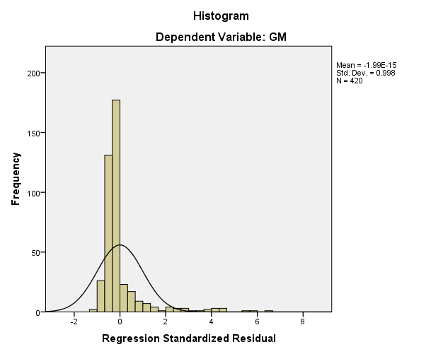 | 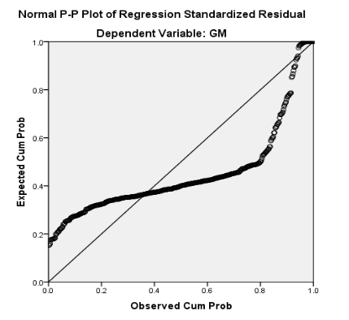 | 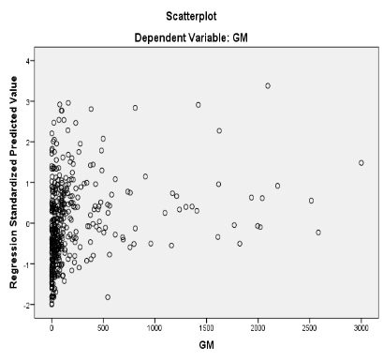
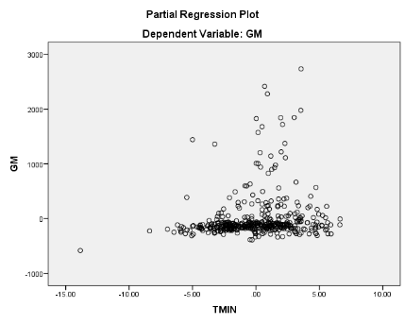 | 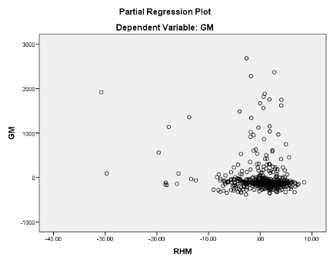
Fig 4: Regression diagnosis of Rabi Gall Midge population with weather parameters
4.5. BPH Pest- Kharif
4.5.1. Descriptive Statistics
The methodological framework begins with descriptive statistics, correlation analysis, and stepwise regression to investigate the causal relationships between the Brown Plant Hopper (BPH) during the Kharif season and various weather factors. Data is collected weekly from 2002 to 2023. Significant BPH populations were observed in the 25th and 52nd standard meteorological weeks (SMWs). Table 13 summarizes BPH population statistics and external weather variables, revealing a high coefficient of variation (CV) of 182.1%, indicating data heterogeneity. Skewness and kurtosis values suggest departures from normal distribution, further emphasizing data irregularity. The weather variables also show significant variability, offering insights into their characteristics.
Table 13: Summary statistics of Brown Plant Hopper (BPH) during Kharif Season at RARS, Maruteru
 | BPH | TMAX | TMIN | RHM | RHE | RF | SSH
N | 616 | 616 | 616 | 616 | 616 | 616 | 616
Mean | 2228.7 | 30.4 | 24.0 | 87.1 | 70.6 | 30.3 | 4.9
Median | 488.0 | 30.3 | 24.7 | 87.3 | 71.9 | 9.8 | 5.0
Mode | 0.0 | 30.0 | 25.0 | 89.0 | 73.0 | 0.0 | 3.0
Std. Deviation | 4059.2 | 2.3 | 2.9 | 4.4 | 9.9 | 48.0 | 2.0
Variance | 16477132.9 | 5.2 | 8.2 | 19.4 | 97.3 | 2299.6 | 4.1
Skewness | 3.2 | 0.5 | -0.7 | -0.6 | -0.4 | 3.3 | 0.0
Kurtosis | 12.7 | 1.3 | -0.1 | 0.6 | 0.1 | 17.4 | -0.5
Range | 28820.0 | 16.7 | 14.5 | 27.0 | 54.7 | 428.6 | 9.6
Minimum | 0.0 | 22.9 | 16.2 | 69.9 | 40.4 | 0.0 | 0.0
Maximum | 28820.0 | 39.6 | 30.7 | 96.9 | 95.1 | 428.6 | 9.6
CV% | 182.1 | 7.5 | 11.9 | 5.1 | 14.0 | 158.2 | 41.3

4.5.2. Correlation Analysis
The Pearson correlation coefficients between Brown Plant Hopper (BPH) populations and the weather variables analysed are shown in Table 14. A minimal negative and non-significant correlation was found between the BPH population and RF (-0.051) and TMIN (-0.075). Additionally, a minimal negative and significant correlation was observed between the BPH population and, TMAX (-0.12). Additionally, a minimal positive and non-significant correlation between the BPH population and RHE (0.046). Conversely a minimal positive and significant correlation between the BPH population and SSH (0.108) and RHM (0.129) was noted.
Table 14: Pearson correlation coefficients between Brown Plant Hopper (BPH) populations and weather variables during Kharif Season
Correlations
 | BPH | TMAX | TMIN | RHM | RHE | RF
TMAX | -.120**  (0.003)
TMIN | -.075  (0.064) | .527**  (<0.0001)
RHM | .129**  (<0.0001) | -.334**  (<0.0001) | -.196**  (<0.0001)
RHE | .046  (0.252) | -.370**  (<0.0001) | .150**  (<0.0001) | .401**  (<0.0001)
RF | -.051  (0.211) | -.124**  (0.002) | .143**  (<0.0001) | .203**  (<0.0001) | .233**  (<0.0001)
SSH | .102*  (0.011) | .212**  (<0.0001) | -.242**  (<0.0001) | -.147**  (<0.0001) | -.357**  (<0.0001) | -.342**  (<0.0001)

4.5.3. Step Wise Regression Analysis
A step wise regression analysis was performed to identify the most Influential predictors of weather parameter of BPH pest. The criteria for variable entry & removal were set at a of F-to enter ≤ 0.050 and a probability of F to remove ≥ 0.100. In the 1st step RHM was entered into the Model: resulting in a significant Improvement, F (1,614) = 10.411) P<0.001. In second step, SSH was added, Leading to and significant enhancement, F (2,613) = 10.044, P< 0.0001. In third step TMAX was added, Leading to another significant enhancement F (3,612 = 9.076, P<0.001). In the final model Including RHM,SSH TMAX are demonstrated a strong fit, accounting for demonstrated the most influential weather parameters for BPH pest growth (R²=0.043; adj R² = 0.038) in the first step, the regression equation is
BPH (Kharif) = -8148.784+119.153(RHM)
highlighting the significant Positive Impact of RHM in BPH( t = 3.227,p<0.001,β= 0.129). In second step, with the addition of SSH the regression equation became
BPH (Kharif) = -10833.519+135.974(RHM) +249.922(SSH)
RHM (t = 3.667, p=0.001, beta = 0.147) and SSH (t=3.087, P= 0.002, beta = 0.124) showed positive Standardized co-efficient, suggesting their contribution to the growth of BPH. In third step with the addition of MAX TEMP the regression equation becomes
BPH (Kharif) = -2172.098+103.937(RHM)+287.522(SSH)-199.256(MAX T)
In RHM(t =2.675,p =0.008,beta= 0.113) ,SSH(t = 3.514,p =0.001,beta = 0.143) and MAX TEMP(t =-2.635,p = 0.009,beta =-0.112) these three weather factors are showing positive standardized coefficients ,suggesting their contribution to the growth of BPH . Finally we conclude that RHM, SSH, and TMAX are the 3 major weather factors influence the growth of BPH in kharif season in paddy.

Table 15: Stepwise regression model for population Brown Plant Hopper (BPH) during Kharif and weather variables
ANOVAª
Model |  | Sum of Squares | df | Mean Square | F | Sig.
1 | Regression | 168953204.389 | 1 | 168953204.389 | 10.411 | .001^{b}
1 | Residual | 9964483585.449 | 614 | 16228800.628
1 | Total | 10133436789.838 | 615
2 | Regression | 321521605.259 | 2 | 160760802.629 | 10.044 | .000^{c}
2 | Residual | 9811915184.579 | 613 | 16006386.924
2 | Total | 10133436789.838 | 615
3 | Regression | 431617515.936 | 3 | 143872505.312 | 9.076 | .000^{d}
3 | Residual | 9701819273.902 | 612 | 15852645.872
3 | Total | 10133436789.838 | 615

Model Summary
Model | R | R Square | Adjusted R Square | Std. Error of the Estimate
1 | .129ª | .017 | .015 | 4028.499
2 | .178^{b} | .032 | .029 | 4000.798
3 | .206^{c} | .043 | .038 | 3981.538

Coefficientsª
Model |  | Unstandardized Coefficients |  | Standardized Coefficients | t | Sig.
 |  | B | Std. Error | Beta | t | Sig.
1 | (Constant) | -8148.784 | 3220.359 |  | -2.530 | .012
1 | RHM | 119.153 | 36.929 | .129 | 3.227 | .001
2 | (Constant) | -10833.519 | 3314.329 |  | -3.269 | .001
2 | RHM | 135.974 | 37.077 | .147 | 3.667 | .000
2 | SSH | 249.922 | 80.950 | .124 | 3.087 | .002
3 | (Constant) | -2172.098 | 4656.327 |  | -.466 | .641
3 | RHM | 103.937 | 38.850 | .113 | 2.675 | .008
3 | SSH | 287.522 | 81.814 | .143 | 3.514 | .000
3 | TMAX | -199.256 | 75.610 | -.112 | -2.635 | .009

4.5.4. Discussion
In this study, the stepwise regression model showed a poor fit, as indicated by a low $R^{2}$ value (4.3%). This likely results from non-linearity and significant variation in the dependent variable (high heterogeneity), making it challenging to establish a strong relationship between Gall Midge populations and external weather variables during the Rabi season. This pattern is also visible in Fig. 5. The stepwise regression identified RHM, SSH, and TMAX as the three main weather factors significantly affecting the growth of the BPH pest in paddy fields. It is important to note that other possible factors influencing BPH incidence were not considered in this analysis. Similarly, a related study by Minruhi et al. (2023) found that stepwise regression identified TMAX, TMIN, RHM, and RF as important factors influencing EW populations in the Kharif season; TMAX and RHM had negative effects, while TMIN and RF had positive effects. The model was constructed sequentially, beginning with WS (R² = 0.0291) and gradually adding TMAX, TMIN, RHM, SSH, and RF, which increased the final R² to 0.1287. Although these variables explained some variation in EW populations, the low R² indicates a weak model fit due to non-linearity and high heterogeneity in catches at RARS, Tirupati.
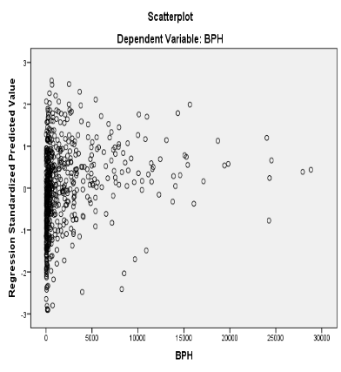 | 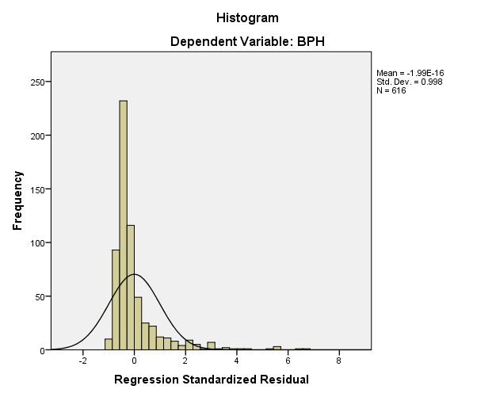 | 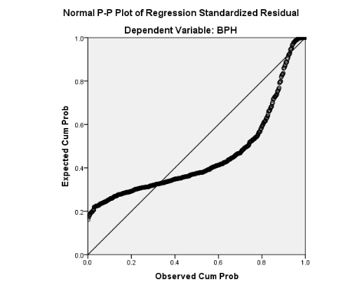
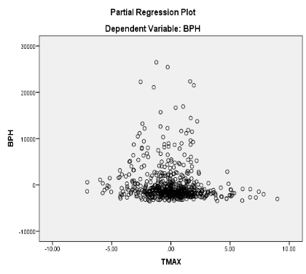 | 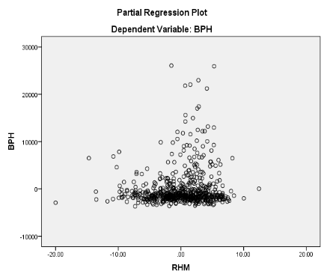 | 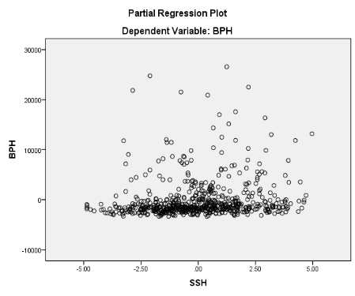
Fig 5: Regression diagnosis of Kharif BPH population with weather parameters
4.6. BPH Pest- Rabi
4.6.1. Descriptive Statistics
The methodological framework begins with descriptive statistics, correlation analysis, and stepwise regression to investigate the relationships between the Brown Plant Hopper (BPH) and various weather factors during the Rabi season from 2003 to 2023. Data is analyzed weekly, revealing significant BPH populations in the 1st and 20th SMWs, which is crucial for understanding pest dynamics over the past 21 years. Table 16 summarizes BPH population statistics and external weather variables, showing a high coefficient of variation (CV) at 212.3% that indicates data heterogeneity. Additionally, skewness and kurtosis values suggest deviations from normal distribution. The weather variables also exhibit considerable variability, underscoring the diverse characteristics of the data.

Table 16: Summary statistics of Brown Plant Hopper (BPH) during Rabi Season at RARS, Maruteru
 | BPH | TMAX | TMIN | RHM | RHE | RF | SSH
N | 420.0 | 420.0 | 420.0 | 420.0 | 420.0 | 420.0 | 420.0
Mean | 4454.3 | 31.3 | 22.5 | 87.8 | 61.5 | 3.9 | 7.6
Median | 706.0 | 31.4 | 22.5 | 88.6 | 64.3 | 0.0 | 7.8
Mode | 2400 | 31.0 | 20.6 | 90.00 | 66.29 | 0.0 | 7.6
Std. Deviation | 9455.2 | 2.9 | 2.9 | 4.8 | 12.0 | 17.1 | 1.3
Variance | 89400600.4 | 8.6 | 8.4 | 23.3 | 144.0 | 292.9 | 1.7
Skewness | 3.8 | 0.2 | 0.0 | -2.0 | -0.7 | 6.1 | -1.1
Kurtosis | 17.6 | 1.0 | -0.2 | 7.8 | -0.1 | 42.3 | 1.9
Range | 77725.0 | 23.5 | 17.7 | 40.1 | 62.9 | 152.0 | 8.5
Minimum | 0.0 | 19.3 | 12.0 | 57.4 | 24.7 | 0.0 | 1.4
Maximum | 77725.0 | 42.8 | 29.7 | 97.6 | 87.6 | 152.0 | 9.9
CV% | 212.3 | 9.4 | 12.9 | 5.5 | 19.5 | 439.2 | 17.2

4.6.2. Correlation Analysis
The Pearson correlation coefficients between populations Brown Plant Hopper (BPH) and the weather variables analysed are shown in Table 17. Minimal positive and significant correlation was observed between the BPH population and TMAX (0.209), TMIN (0.204), RF (0.107) and SSH (0.144). Conversely, a minimal positive and non-significant correlation between the BPH population and RHM (0.043) and RHE (0.038) was noted.
Table 17: Pearson correlation coefficients between populations Brown Plant Hopper (BPH) and weather variables during Rabi Season
 | BPH | TMAX | TMIN | RHM | RHE | RF
TMAX | .209**  (<0.0001)
TMIN | .204**  (<0.0001) | .811**  (<0.0001)
RHM | .043  (0.373) | -.138**  (0.005) | -.215**  (<0.0001)
RHE | .038  (0.437) | -.358**  (<0.0001) | -.156**  (<0.001) | .152**  (0.002)
RF | .107*  (0.029) | .111*  (0.024) | .162**  (0.001) | -.026  (0.589) | .046  (0.351)
SSH | .144**  (0.003) | .261**  (<0.0001) | .131**  (0.007) | .021  (0.667) | -.130**  (0.007) | -.147**  (0.003)

4.6.3. Step Wise Regression Analysis
A step wise regression analysis was performed to identify the most Influential predictors of weather parameter of BPH pest. The criteria for variable entry & removal were set at of F-to enter ≤ 0.050 and a probability of F-to-remove ≥ 0.100. In the 1st step MAX TEMP was entered into the Model: resulting in a significant Improvement, F(1,418) = 19.102) P<0.001. In second step, RHE was added, Leading to and significant enhancement, F (2,417) = 12.918, P 0.0001. In third step SSH was added, Leading to another significant enhancement F (3,416) = 10.096, P<0.0001. In the final model Including TMAX,RHE,SSH are demonstrated a strong fit, accounting for demonstrated the most influential weather parameters for BPH growth (R²=0.068; adj R² = 0.061) in the first step, the regression equation is
BPH (Rabi) = -16605.672+672.88(TMAX)
highlighting the significant Positive Impact of T MAX in BPH growth( t = 4.371,p<0.001,β= -0.209). In second step, with the addition of RHE the regression equation became
BPH (Rabi) = -27561.907+822.364(TMAX)+40.104(RHE)
Both TMAX (t = 5.019, p=0.0001, beta = 0.255) and RHE (t=2.546, P= 0.011, beta = 0.130) showed positive Standardized co-efficient, suggesting their contribution to the growth of BPH. In third step with the addition of SSH the regression equation becomes
BPH (Rabi) = -30840.824+742.382(TMAX)+39.982(RHE)+354.922(SSH)
In TMAX (t =4.426,p =0.0001,beta= 0.231) ,RHE (t= 2.638,p =0.009,beta = 0.134) and SSH(t =2.062,p = 0.040,beta =0.101) these three weather factors are showing positive standardized coefficients ,suggesting their contribution to the growth of BPH. Finally we conclude that TMAX, RHE and SSH are the 3 major weather factors influence the growth of BPH of Rabi season in paddy.
Table 18: Stepwise regression model for population Brown Plant Hopper (BPH) during Rabi and weather variables
ANOVAª
Model |  | Sum of Squares | df | Mean Square | F | Sig.
1 | Regression | 1636999063.544 | 1 | 1636999063.544 | 19.102 | .000^{b}
1 | Residual | 35821852516.971 | 418 | 85698211.763
1 | Total | 37458851580.514 | 419
2 | Regression | 2185404920.884 | 2 | 1092702460.442 | 12.918 | .000^{c}
2 | Residual | 35273446659.630 | 417 | 84588601.102
2 | Total | 37458851580.514 | 419
3 | Regression | 2542270627.847 | 3 | 847423542.616 | 10.096 | .000^{d}
3 | Residual | 34916580952.668 | 416 | 83934088.829
3 | Total | 37458851580.514 | 419

Model Summary
Model | R | R Square | Adjusted R Square | Std. Error of the Estimate
1 | .209ª | .044 | .041 | 9257.333
2 | .242^{b} | .058 | .054 | 9197.206
3 | .261^{c} | .068 | .061 | 9161.555

Coefficientsª
Model |  | Unstandardized Coefficients |  | Standardized Coefficients | t | Sig.
 |  | B | Std. Error | Beta | t | Sig.
1 | (Constant) | -16605.672 | 4839.714 |  | -3.431 | .001
1 | TMAX | 672.888 | 153.959 | .209 | 4.371 | .000
2 | (Constant) | -27561.907 | 6452.513 |  | -4.271 | .000
2 | TMAX | 822.364 | 163.837 | .255 | 5.019 | .000
2 | RHE | 102.115 | 40.104 | .130 | 2.546 | .011
3 | (Constant) | -30840.824 | 6621.288 |  | -4.658 | .000
3 | TMAX | 742.382 | 167.748 | .231 | 4.426 | .000
3 | RHE | 105.488 | 39.982 | .134 | 2.638 | .009
3 | SSH | 731.840 | 354.922 | .101 | 2.062 | .040

4.6.4. Discussion
In this study, the stepwise regression model demonstrated a weak fit, indicated by a low $R^{2}$ value (6.8%). This weakness is likely due to non-linearity and considerable variation in the dependent variable (High Heterogeneity), making it difficult to establish a strong link between BPH populations and exogenous weather variables during the Rabi season. This trend is also evident in Fig.6. Stepwise regression results identified that TMAX, RHE and SSH are the three main weather factors significantly influencing the growth of the BPH pest in paddy fields. It is also important to acknowledge that other potential factors affecting BPH incidence were not included in this analysis. A related study by Prasannakumar et al (2014) a stepwise regression revealed that RH2 (RHE), RF, and TMAX were significant factors influencing BPH light trap captures. By using stepwise regression, it was discovered that RF and TMAX were significant factors influencing BPH light trap captures. Their absence from the analysis led to lower R2 values of 0.80 (P=0.010), 0.46 (P=0.16), and 0.26 (P=0.4), respectively.
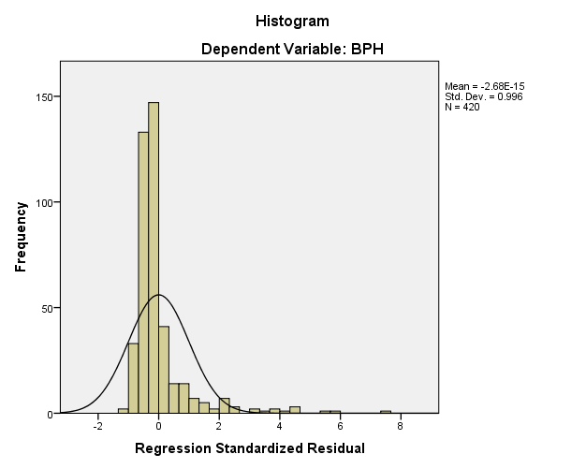 | 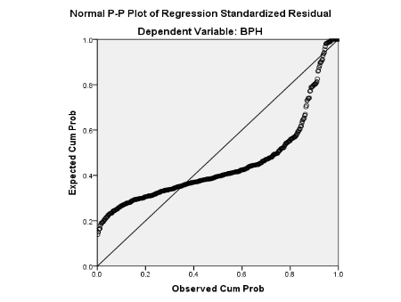 | 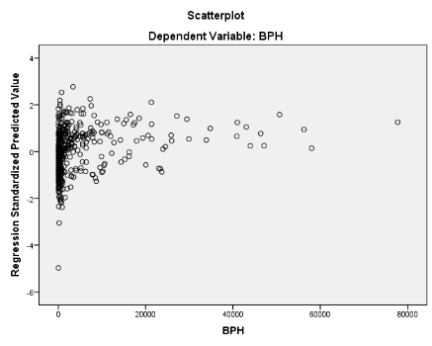
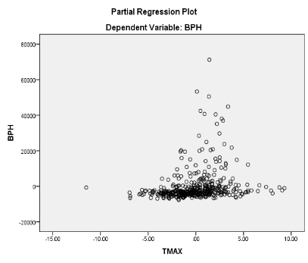 | 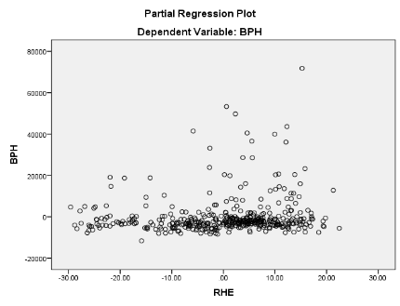 | 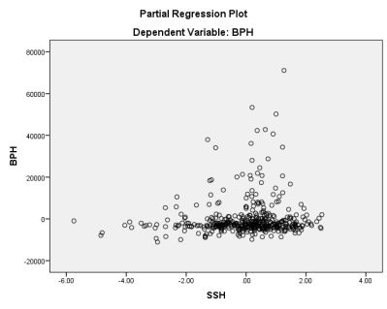
Fig 6: Regression diagnosis of Rabi BPH population with weather parameters
4.7. Leaf Folder Pest- Kharif
4.7.1. Descriptive Statistics
The methodological framework begins with descriptive statistics, correlation analysis, and stepwise regression to investigate the relationships between the Rice Leaf Folder (RLF) during the Kharif season and weather factors from 2002 to 2023. Weekly data reveals significant RLF populations in the 25th and 52nd SMWs, crucial for understanding pest dynamics. Table 19 summarizes the RLF population and weather variables, indicating a high coefficient of variation (CV) at 323.8%, reflecting data heterogeneity. Skewness and kurtosis values suggest deviations from normal distribution, highlighting data irregularity. Overall, the weather variables exhibit considerable variation and distinct characteristics.
Table 19: Summary statistics of Rice Leaf Folder (RLF) during Kharif Season at RARS, Maruteru
Statistics
 | LF | TMAX | TMIN | RHM | RHE | RF | SSH
N | 616 | 616 | 616 | 616 | 616 | 616 | 616
Mean | 57.4 | 30.4 | 24.0 | 87.1 | 70.6 | 30.3 | 4.9
Median | 8.0 | 30.3 | 24.7 | 87.3 | 71.9 | 9.8 | 5.0
Mode | 0.0 | 30.0 | 25.0 | 89.0 | 73.0 | 0.0 | 3.0
Std. Deviation | 185.9 | 2.3 | 2.9 | 4.4 | 9.9 | 48.0 | 2.0
Variance | 34560.4 | 5.2 | 8.2 | 19.4 | 97.3 | 2299.6 | 4.1
Skewness | 10.2 | 0.5 | -0.7 | -0.6 | -0.4 | 3.3 | 0.0
Kurtosis | 149.2 | 1.3 | -0.1 | 0.6 | 0.1 | 17.4 | -0.5
Range | 3247.0 | 16.7 | 14.5 | 27.0 | 54.7 | 428.6 | 9.6
Minimum | 0.0 | 22.9 | 16.2 | 69.9 | 40.4 | 0.0 | 0.0
Maximum | 3247.0 | 39.6 | 30.7 | 96.9 | 95.1 | 428.6 | 9.6
CV% | 323.8 | 7.5 | 11.9 | 5.1 | 14.0 | 158.2 | 41.3

4.7.2. Correlation Analysis
The Pearson correlation coefficients between Rice Leaf Folder (RLF) populations and the weather variables analysed are shown in Table 20. A minimal negative and non-significant correlation was found between the RLF population and RHM (-0.048) and RF (-0.023).Additionally, a minimal negative and significant correlation was observed between the RLF population and, TMAX (-0.096), TMIN (-0.096) and RHE (-0.102).Conversely a minimal positive and significant correlation between the RLF population and SSH (0.089) was noted.
Table 20: Pearson correlation coefficients between populations Rice Leaf Folder (RLF) and weather variables during Kharif Season
 | LF | TMAX | TMIN | RHM | RHE | RF
TMAX | -.096*  (0.017)
TMIN | -.096*  (0.017) | .527**  (<0.0001)
RHM | -.048  (0.237) | -.334**  (<0.0001) | -.196**  (<0.0001)
RHE | -.102*  (0.011) | -.370**  (<0.0001) | .150**  (<0.0001) | .401**  (<0.0001)
RF | -.023  (0.575) | -.124**  (0.002) | .143**  (<0.0001) | .203**  (<0.0001) | .233**  (<0.0001)
SSH | .089*  (0.027) | .212**  (<0.0001) | -.242**  (<0.0001) | -.147**  (<0.0001) | -.357**  (<0.0001) | -.342**  (<0.0001)

4.7.3. Step Wise Regression Analysis
A step wise regression analysis was performed to identify the most Influential predictors of weather parameter of leaf folder pest. The criteria for variable entry & removal were set at of F-to enter ≤ 0.050 and a probability of F-to-remove ≥ 0.100 In the 1st step RHE was entered into the model: resulting in a significant Improvement, F (1,614) = 6.444) P<.011. In second step, TMAX was added, Leading to another significant enhancement, F (2,613) = 9.822, P = 0.001.In the final model Including both RHE and TMAX are demonstrated a strong fit, demonstrated the most influential weather parameters for leaf folder growth (R²=0.176; adj R² = 0.031). In the first step, the regression equation is
RLF (Kharif) =192.994 -1.921(RHE)
High lighting the significant Positive Impact of RHE on leaf folder pest growth (t = -2.5391, p<0.001, β= -0.102). In second step, with the addition of TMAX the regression equation became
RLF (Kharif) = 651.124-2.999(RHE)-12.573(MAX T)
Both RHE(t=-3.718,p=0.0001,beta=-0.159) and MAX TEMP(t=-3.616,p=0.0001,beta=-0.155). These two weather parameters are showing positive standard coefficients, suggesting their contribution to the growth of leaf folder. Finally we conclude that RHE and MAX TEMP are the two major weather parameters influence the growth of leaf folder in kharif season in paddy crop.
Table 21: Stepwise regression model for population Rice Leaf Folder (RLF) during Kharif and weather variables

ANOVAª
Model |  | Sum of Squares | df | Mean Square | F | Sig.
1 | Regression | 220763.127 | 1 | 220763.127 | 6.444 | .011^{b}
1 | Residual | 21033857.287 | 614 | 34257.097
1 | Total | 21254620.414 | 615
2 | Regression | 659977.539 | 2 | 329988.770 | 9.822 | .000^{c}
2 | Residual | 20594642.875 | 613 | 33596.481
2 | Total | 21254620.414 | 615

Model Summary
Model | R | R Square | Adjusted R Square | Std. Error of the Estimate
1 | .102ª | .010 | .009 | 185.087
2 | .176^{b} | .031 | .028 | 183.293

Coefficientsª
Model |  | Unstandardized Coefficients |  | Standardized Coefficients | t | Sig.
 |  | B | Std. Error | Beta | t | Sig.
1 | (Constant) | 192.994 | 53.923 |  | 3.579 | .000
1 | RHE | -1.921 | .757 | -.102 | -2.539 | .011
2 | (Constant) | 651.124 | 137.499 |  | 4.735 | .000
2 | RHE | -2.999 | .806 | -.159 | -3.718 | .000
2 | TMAX | -12.573 | 3.477 | -.155 | -3.616 | .000

4.7.4. Discussion
In this study, the stepwise regression model demonstrated a weak fit, indicated by a low R² value (17.6%). This weakness is likely due to non-linearity and the considerable variation in the dependent variable (high heterogeneity), which makes it difficult to establish a strong relationship between Rice Leaf Folder (RLF) populations and exogenous weather variables during the Kharif season (Fig. 7). The analysis identified maximum temperature (TMAX), evening relative humidity (RHE), and sunshine hours (SSH) as the three main weather factors significantly influencing RLF incidence in paddy fields. It is also important to note that other potential factors affecting RLF populations were not included in this analysis. A related study by Manikandan et al. (2024) reported that different weather parameters have varying relationships with the populations of budworms, ants, and pod flies. Their analysis showed that maximum temperature, evening relative humidity, and rainfall significantly influenced these insect pest populations, while other factors such as minimum temperature, morning relative humidity, and wind speed exhibited weaker associations.

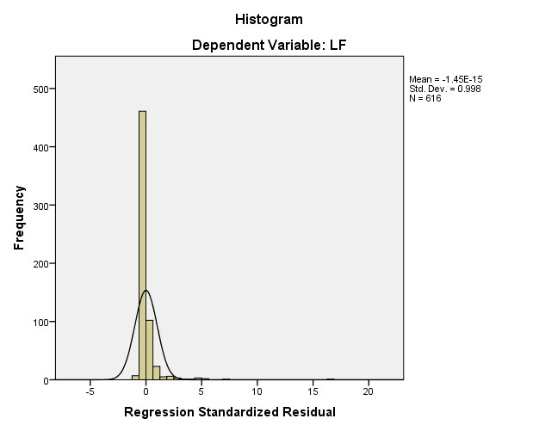 | 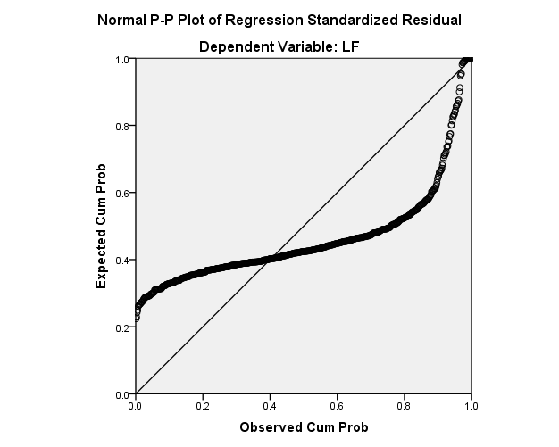 | 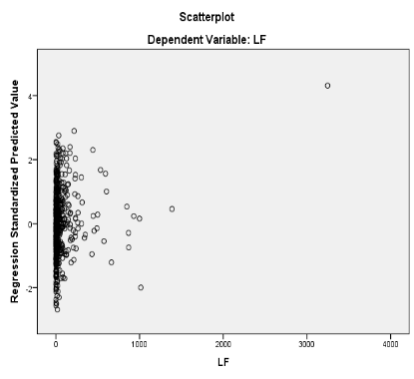
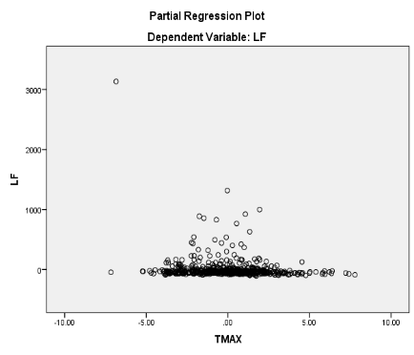 | 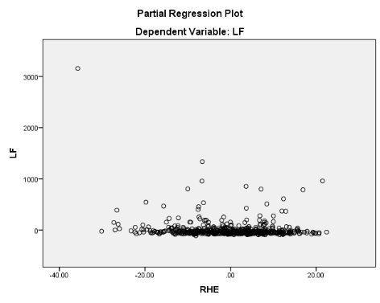
Fig 7: Regression diagnosis of Kharif RLF population with weather parameters
4.8. Rice Leaf Folder Pest-Rabi
4.8.1. Descriptive statistics
The methodological framework begins with basic descriptive statistics, correlation analysis, and stepwise regression to examine the relationships between the Rice Leaf Folder (RLF) during the Rabi season and weather factors. Data is analyzed weekly from 2003 to 2023, highlighting significant RLF populations in the 1st and 20th SMWs. Table 22 summarizes RLF population statistics and weather variables, revealing a high coefficient of variation (CV) of 187%, indicating data heterogeneity. Skewness and kurtosis values suggest a departure from normal distribution. Overall, the statistics demonstrate significant variability in the weather variables studied.
Table 22: Summary statistics of Rice Leaf Folder (RLF) during Rabi Season at RARS, Maruteru
 | LF | TMAX | TMIN | RHM | RHE | RF | SSH
N | 420.0 | 420.0 | 420.0 | 420.0 | 420.0 | 420.0 | 420.0
Mean | 16.6 | 31.3 | 22.5 | 87.8 | 61.5 | 3.9 | 7.6
Median | 4.0 | 31.4 | 22.5 | 88.6 | 64.3 | 0.0 | 7.8
Mode | 0.0 | 31.0 | 20.6 | 90.00ª | 66.29ª | 0.0 | 7.62ª
Std. Deviation | 31.0 | 2.9 | 2.9 | 4.8 | 12.0 | 17.1 | 1.3
Variance | 962.2 | 8.6 | 8.4 | 23.3 | 144.0 | 292.9 | 1.7
Skewness | 3.5 | 0.2 | 0.0 | -2.0 | -0.7 | 6.1 | -1.1
Kurtosis | 17.0 | 1.0 | -0.2 | 7.8 | -0.1 | 42.3 | 1.9
Range | 279.0 | 23.5 | 17.7 | 40.1 | 62.9 | 152.0 | 8.5
Minimum | 0.0 | 19.3 | 12.0 | 57.4 | 24.7 | 0.0 | 1.4
Maximum | 279.0 | 42.8 | 29.7 | 97.6 | 87.6 | 152.0 | 9.9
CV% | 187.0 | 9.4 | 12.8 | 5.5 | 19.5 | 439.2 | 17.2

4.8.2. Correlation Analysis
The Pearson correlation coefficients between Rice Leaf Folder (RLF) populations and the weather variables analysed are shown in Table 23. A minimal negative and significant correlation was found between the RLF population and RHE (-0.29) .Additionally, a minimal positive and non-significant correlation was observed between the RLF population and RHM (0.074), RF (0.046) and SSH (0.089).Conversely a minimal positive and significant correlation between the RLF population and TMAX (0.174) and TMIN (0.163) was noted.
Table 23: Pearson correlation coefficients between populations Rice Leaf Folder (RLF) and weather variables during Rabi Season
 | LF | TMAX | TMIN | RHM | RHE | RF
TMAX | .174**  (<0.0001)
TMIN | .163**  (<0.001) | .811**  (<0.0001)
RHM | .074  (<0.129) | -.138**  (<0.005) | -.215**  (<0.0001)
RHE | -.290**  (<0.0001) | -.358**  (<0.0001) | -.156**  (<0.001) | .152**  (<0.002)
RF | .046  (<0.344) | .111*  (<0.024) | .162**  (<0.001) | -.026  (<0.589) | .046  (<0.351)
SSH | .089  (<0.068) | .261**  (<0.0001) | .131**  (<0.007) | .021  (<0.667) | -.130**  (<0.007) | -.147**  (<0.003)

4.8.3. Step Wise Regression Analysis
A step wise regression analysis was performed to identify the most Influential predictors of weather parameter of leaf folder pest. The criteria for variable entry & removal were set at of F-to enter ≤ 0.050 and a probability of F-to-remove ≥ 0.100. In the 1st step RHE was entered into the Model: resulting in a significant Improvement, F (1,418) = 38.509) P<0.001. In second step, RHM was added, Leading to and significant enhancement, F (2,417) = 22.823, P 0.0001. In third step MIN TEMP was added, Leading to another significant enhancement F(3,416=18.853, P<0.001. In the final model Including RHE,RHM,TMIN are demonstrated a strong fit, accounting for demonstrated the most influential weather parameters for leaf folder growth (R²=0.120; adj R² = 0.113 in the first step, the regression equation is
RLF (Rabi) = 62.748-0.751(RHE)
High lighting the significant Positive Impact of RHE in leaf folder growth (t=-6.206, p<0.001, β= -0.290). In second step, with the addition of RHM the regression equation became
RLF (Rabi) = -2.565-0.798(RHE)+0.777(RHM)
Both RHE (t = -6.565, p=0.001, beta = -0.309) and RHM (t=2.573,P= 0.001, beta = -0.121) showed positive Standardized co-efficient, suggesting their contribution to the growth of leaf folder . In third step with the addition of min temp the regression equation becomes
RLF (Rabi) = -58.277-0.749(RHE)+0.966(RHM)+1.605(MIN T)
In RHE(t =-6.176,p =0.0001,beta= -0.290) ,RHM(t = 3.169,p =0.002,beta = 0.150) and MIN TEMP(t =3.152,p = 0.002,beta =0.150) these three weather factors are showing positive standardized coefficients ,suggesting their contribution to the growth of leaf folder . Finally we conclude that RHE, RHM, TMIN are 3 major weather factors influence the growth of leaf folder in Rabi season in paddy.
Table 24: Stepwise regression model for population Rice Leaf Folder (RLF) during Rabi and weather variables
ANOVA
Model |  | Sum of Squares | df | Mean Square | F | Sig.
1 | Regression | 34008.043 | 1 | 34008.043 | 38.509 | .000^{b}
1 | Residual | 369143.336 | 418 | 883.118
1 | Total | 403151.379 | 419
2 | Regression | 39776.590 | 2 | 19888.295 | 22.823 | .000^{c}
2 | Residual | 363374.789 | 417 | 871.402
2 | Total | 403151.379 | 419
3 | Regression | 48252.888 | 3 | 16084.296 | 18.853 | .000^{d}
3 | Residual | 354898.491 | 416 | 853.121
3 | Total | 403151.379 | 419

Model Summary^{d}
Model | R | R Square | Adjusted R Square | Std. Error of the Estimate
1 | .290ª | .084 | .082 | 29.717
2 | .314^{b} | .099 | .094 | 29.520
3 | .346^{c} | .120 | .113 | 29.208

Coefficientsª
Model |  | Unstandardized Coefficients |  | Standardized Coefficients | t | Sig.
 |  | B | Std. Error | Beta | t | Sig.
1 | (Constant) | 62.748 | 7.578 |  | 8.281 | .000
1 | RHE | -.751 | .121 | -.290 | -6.206 | .000
2 | (Constant) | -2.565 | 26.478 |  | -.097 | .923
2 | RHE | -.798 | .122 | -.309 | -6.565 | .000
2 | RHM | .777 | .302 | .121 | 2.573 | .010
3 | (Constant) | -58.277 | 31.603 |  | -1.844 | .066
3 | RHE | -.749 | .121 | -.290 | -6.176 | .000
3 | RHM | .966 | .305 | .150 | 3.169 | .002
3 | TMIN | 1.605 | .509 | .150 | 3.152 | .002

4.8.4. Discussion
In this study, the stepwise regression model demonstrated a weak fit, indicated by a low $R^{2}$ value (12%). This weakness is likely due to non-linearity and considerable variation in the dependent variable (High Heterogeneity), making it difficult to establish a strong link between BPH populations and exogenous weather variables during the Rabi season. This trend is also evident in Fig.8. Stepwise regression results identified that RHE, RHM and TMIN are the three main weather factors significantly influencing the growth of the RLF pest in paddy fields. It is also important to acknowledge that other potential factors affecting RLF incidence were not included in this analysis. similarly, a related study by Venkataviswateja et al. (2023), the minimum temperature had a significant negative relationship with the leaf folder, but the maximum temperature, rainfall, relative humidity in the morning, and relative humidity in the evening did not have a significant relationship. Rainfall and the highest temperature were found to be significant negative effects using stepwise regression. However, the low R² at Bapatla indicates weak model fit due to non-linearity and high heterogeneity.

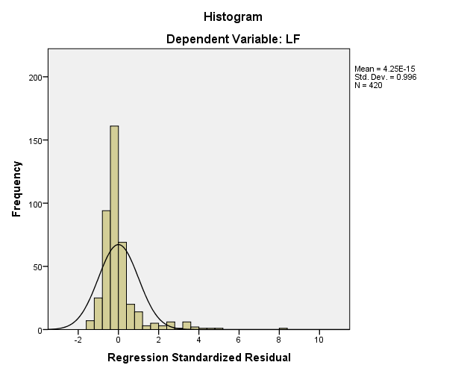 | 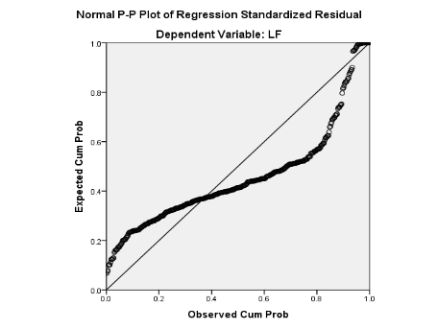 | 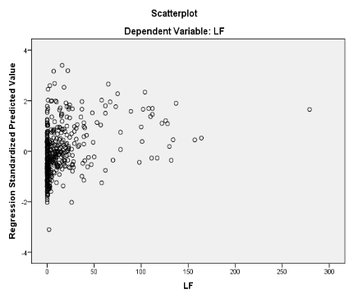
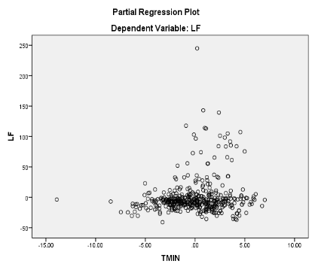 | 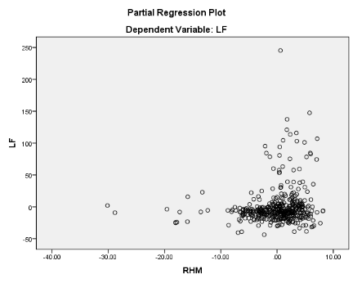 | 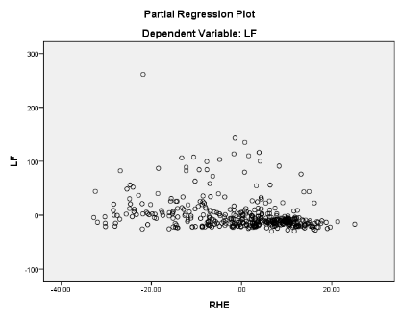
Fig 8: Regression diagnosis of Rabi RLF population with weather parameters

5. Conclusion
In the present study, different regression models were developed to examine the relationship between weather variables, namely maximum temperature (TMAX), minimum temperature (TMIN), total rainfall (RF), morning relative humidity (RHM), evening relative humidity (RHE), and sunshine hours (SSH). These models, based on more than two decades of data, showed a lower range of R² values, indicating that they were not a strong fit for a linear model due to non-linearity and high heterogeneity in insect pest occurrence. The results revealed that the stepwise linear regression model was unable to capture the patterns in the heterogeneous count data, as it yielded high RMSE values, whereas the count regression model performed better identifying the relationship between weather variables and Rice pest population
Anyhow, these models offer valuable insights into the climatic triggers of pest outbreaks, enabling reliable pest forecasting and aiding climate-responsive integrated pest management practices in rice cultivation across coastal Andhra Pradesh. As per the recent studies weather pest relations can be unrevealed with Machine Learning models.
7. REFERENCES

Ali, Y., Raza, A., Iqbal, S., Khan, A. A., Aatif, H. M., Hassan, Z., Hanif, C. M. S., Ali, H. M., Mosa, W. F., Mubeen, I., & Sas-Paszt, L. (2022). Stepwise regression models-based prediction for leaf rust severity and yield loss in wheat. *Sustainability*, *14*(21), 13893. https://doi.org/10.3390/su142113893
Ali, Y., Qin, A., Aatif, H. M., Ijaz, M., Khan, A. A., Ahmad, S., Shahzad, U., Yasin, M., & Rahman, S. U. (2022). A stepwise multiple regression model to predict Fusarium wilt in lentil. Meteorological Applications, 29(4), e2088. https://doi.org/10.1002/met.2088
Biradar, B., Kulkarni, S. A., Shobharani, M., Sidramappa, G. B., Rathod, S., Naveena, K., Chitikela, G., & Arabhanvi, F. (2023). Enhancing legume crop protection: Machine learning approach for accurate prediction of lepidopteran pest populations in Kalyan Karnataka. The Pharma Innovation Journal, 12(4), 2319-2326. https://www.thepharmajournal.com/
Gholap, S.V., Asewar, B.V. and Kale, A.S., 2022. Development of regression model to predict BT cotton (Gossypium spp.) yield using meteorological variables for Parbhani and Nanded locations.
Kadam, D. R., Timke, S. H., Dakhore, K. K., & Kadam, Y. E. (2022). Seasonal abundance of major insect pest on Bt cotton vis-à-vis weather parameters in Marathwada region, Maharashtra. Journal of Agrometeorology, 24(4), 430-433. https://doi.org/10.54386/jam.v24i4.1753
Khan, M.A., Rasheed, S. and Ali, S., 2006. Evaluation of multiple regression models based on epidemiological factors to forecast Bemisia tabaci and mungbean yellow mosaic virus. Pak. J. Phytopathol, 18(2): 107-110.
Krishnaiah, K., & Varma, N. R. G. (2011). Changing insect pest scenario in the rice ecosystem—A national perspective. *Rice Knowledge Management Portal*, *1*, 1-28. http://www.rkmp.co.in
Luo, S.J. (2010) Occurrence of rice leaf roller in China and its identification and prevention. Plant Diseases and Pests 1: 13–18.
Manikandan, P., & Rengalakshmi, R. (2024). Influence of weather factors on population dynamics of major insect pests in Moringa (Moringa oleifera Lam.) in south Tamil Nadu. Journal of Agrometeorology, 26(2), 238-242. https://doi.org/10.54386/jam.v26i2.2405
Minruhi, P., Kumari, P. L., Rathod, S., Murthy, B. R., & Devaki, K. (2023). Statistical evaluation of stepwise regression method for earwig population in groundnut (Arachis hypogaea L.). The Pharma Innovation, 12(12), 397-403. https://www.thepharmajournal.com/archives/2023/vol12issue12/PartF/12-12-10-974.pdf
Nanda, V.K. and R. C. Bisoi, 1990. Bionomics of rice L7 C.M. Orissa J. Agrl. Res., 3(2): 130-135.
Kumari, P. L., Paramasiva, I., Vineetha, U., Veeraiah, A., Shameem, S., Harathi, P. N., Kumar, A. D. V. S. L. P. A., Krishna, M. S. R., Rao, N. S., Udayababu, P., Manjunath, J., Kamakshi, N., & Visalakshmi, V. (2025). Modeling and Predicting Rice Gall Midge Populations Using Climate Data and Machine Learning Techniques in Andhra Pradesh. International Journal of Environment and Climate Change, 15(10), 467–484. https://doi.org/10.9734/ijecc/2025/v15i105076
Kumari, P. L., Paramasiva, I., Vineetha, U., Veeraiah, A., Shameem, S., Harathi, P. N., Anand Kumar, A. D. V. S. L. P., Siva Rama Krishna, M., Sambasiva Rao, N., Udayababu, P., Manjunath, J., Kamakshi, N., Visalakshmi, V., & Siva, P. (2025). Climate-Driven Forecasting of Brown Planthopper in Rice Fields Using Hybrid Machine Learning and Time Series Models. International Journal of Environment and Climate Change, 15(6), 494–514. https://doi.org/10.9734/ijecc/2025/v15i64905
Prakash, A., Bambawale, O. M., & David, B. V. (2014). Plant Protection in India: Challenges & Research Priorities. Applied Zoologists Research Association (AZRA). https://www.azraindia.org/publications.html
Prasannakumar, N. R., & Chander, S. (2014). Weather-based brown planthopper prediction model at Mandya, Karnataka. Journal of Agrometeorology, 16(1), 126–129. https://doi.org/10.54386/jam.v16i1.1497
Rana, R., Singh, G., Tanwar, A. K., & Kumar, R. (2017). Effect of weather parameters on the infestation of yellow stem borer, Scirpophaga incertulas Walker in basmati rice. Journal of Entomology and Zoology Studies, 5(3), 24-27. https://www.entomoljournal.com/archives/2017/vol5issue3/PartA/5-2-10-100.pdf
Rathod, S., Yerram, S., Arya, P., Katti, G., Rani, J., Padmakumari, A. P., Somasekhar, N., Padmavathi, C., Ondrasek, G., Amudan, S., Malathi, S., Rao, N. M., Karthikeyan, K., Mandawi, N., Muthuraman, P., & Sundaram, R. M. (2022). Climate-based modeling and prediction of rice gall midge populations using count time series and machine learning approaches. Agronomy, 12(1), 22. https://doi.org/10.3390/agronomy12010022
Razzaque, Q.M.A., Heinrichs, E.A and Rapusas, H.R. 1985. Mass rearing technique for the rice green leafhopper Nephotettix nigropictus (Stal). Philippine Entomologist. 6(4): 398-404.
Reddy, B. N. K., Rathod, S., Kallakuri, S., Sridhar, Y., Admala, M., Malathi, S., Pandit, P., & Jyostna, B. (2022). Modelling the Relationship between Weather Variables and Rice Yellow Stem Borer Population: A Count Data Modelling Approach. International Journal of Environment and Climate Change, 12(11), 3623-3632. https://doi.org/10.9734/ijecc/2022/v12i111410
Reddy, B. N. K., Rathod, S., Sridhar, Y., Kallakuri, S., Pandit, P., Jyostna, B., Malathi, S., & Kumar, R. S. (2025). An innovative two-stage, zero-inflated, hybrid count time series model for predicting rice yellow stem borer using weather parameters in hotspot locations of India. Smart Agricultural Technology, 12, 101381. https://doi.org/10.1016/j.atech.2025.101381
Sagar, D., Nebapure, S. M., & Chander, S. (2017). Development and validation of weather based prediction model for Helicoverpa armigera in chickpea. Journal of Agrometeorology, 19(4), 328–333. https://doi.org/10.54386/jam.v19i4.600
Shah, S., Ali, M., Rehman, U. H., Rehman, A., Abbasi, F. M., Khalil, I. H., and Ali, A. 2008. Characterization of wild rice species in response to leaf folder (C. madenalis). Sarh. J. Agri. 24(1):69-74.
Udayababu, P., Sowjanya, P., & Jogarao, P. (2021). Population Dynamics of Rice Insect Pests through Light Trap Catches and Its Relation to Abiotic Factors in High Altitude Tribal Zone of Seethampeta in Andhra Pradesh, India. International Journal of Environment and Climate Change, 11(12), 187–194. https://doi.org/10.9734/ijecc/2021/v11i1230570
Venkataviswateja, B., Rao, V. S., Dhandapani, A., Reddy, G. R., Ramesh, D., & Kumar, A. A. (2023). Modelling of leaf folder populations (Cnaphalocrocis medinalis) in Paddy: A count time series approach. International Journal of Statistics and Applied Mathematics, 8(4S), 257-261. https://doi.org/10.22271/maths.2023.v8.i4Sd.1078

