Original Research Article

What is the Effect of the DBT policy on Nitrogen Use Intensity in India? Evidence from Interrupted Time Series Analysis

.
ABSTRACT

This study investigates whether the introduction of India’s Direct Benefit Transfer (DBT) system for fertilizer subsidies influenced nitrogen use intensity. Employing an interrupted time series analysis framework with annual national and state-level data, we estimate both immediate and long-term effects of DBT while controlling for key structural determinants of fertilizer demand including cropping intensity, irrigation coverage, institutional agricultural credit, urea subsidy allocation, rainfall variability, and adjusting for prior fertilizer policy reforms. At the national level, DBT implementation did not produce a statistically significant change in nitrogen use intensity, suggesting that enhanced subsidy delivery and transaction monitoring alone are insufficient to modify aggregate fertilizer application behavior. State-level analysis, however, reveals considerable heterogeneity, with short-term adjustments and selective responses emerging in a limited number of states, underscoring the context-dependent nature of delivery-oriented reforms in shaping fertilizer use outcomes. Qualitative evidence from farmer and retailer interactions indicates that DBT has strengthened transparency, product availability, and accountability in fertilizer distribution, thereby reinforcing the institutional infrastructure of subsidy administration. Taken together, these findings offer policy-relevant insights into the potential and limitations of DBT as a reform mechanism and highlight the need to combine governance improvements with complementary agronomic and incentive-based interventions to achieve meaningful and sustained gains in nitrogen use efficiency.

Keywords: Nitrogen use intensity; fertilizer subsidy; Direct Benefit Transfer; interrupted time series analysis.

1. INTRODUCTION

Over the past five decades, nitrogen fertilizer has played a central role in supporting India's agricultural growth and food security. National fertilizer consumption rose from approximately 6-7 million tonnes in the early 1980s to over 30 million tonnes in recent years (Tiwari, 2024), highlighting the increasing reliance of Indian agriculture on external nutrient inputs. Nitrogen accounts for the largest share of fertilizer use, primarily due to the expansion of irrigated cereal-based production systems and ongoing policy support through price subsidies (FAI, 2024). Although this intensification has significantly contributed to yield growth and national food availability, it has also raised persistent concerns regarding nutrient imbalance, declining nitrogen use efficiency, groundwater contamination, and broader environmental impacts. These agronomic challenges are closely linked to fiscal pressures, as fertilizer subsidies constitute one of the largest recurring expenditures in India’s agricultural budget (Kishore et al., 2021) The prolonged administered pricing of urea has widened the gap between domestic and international prices, leading to excessive nitrogen application relative to phosphorus and potassium and reinforcing structural nutrient imbalances across regions (Varshney et al., 2021).
To address concerns regarding subsidy leakages, diversion, and inadequate monitoring, the Government of India implemented the Direct Benefit Transfer (DBT) system for fertilizer subsidies as a significant institutional reform. The fertilizer DBT system links subsidy disbursement to authenticated retail transactions recorded via point-of-sale (PoS) devices, aiming to enhance transparency, reduce diversion, and strengthen accountability in fertilizer distribution (Roy, 2019). Unlike traditional DBT programmes that transfer cash directly to beneficiaries, the fertilizer DBT system maintains subsidised retail prices, with subsidy payments directed to manufacturers based on verified (Koovalamkadu Velayudhan et al., 2022). As a result, fertilizer DBT constitutes primarily a governance and delivery reform rather than a direct intervention in farmers’ price incentives for fertilizer use.
The majority of existing research on fertilizer DBT has concentrated on its administrative and operational aspects, such as improvements in tracking fertilizer flows, reductions in ghost sales, and challenges associated with PoS deployment, biometric authentication, and network connectivity (Koovalamkadu Velayudhan et al., 2021). While these studies offer valuable insights into governance outcomes, relatively little attention has been given to the potential behavioural effects of DBT on fertilizer use. Notably, DBT was not specifically designed to reduce fertilizer consumption or nitrogen use intensity, rather, it aims to reform subsidy delivery and monitoring while keeping subsidised retail prices largely unchanged. However, by increasing transaction oversight, limiting informal and duplicate purchases, and enhancing the visibility of fertilizer use at the retail level, DBT may indirectly affect fertilizer use behaviour over time. Whether such an institutional reform, absent direct price or quantity controls, can alter nitrogen use intensity remains an unresolved empirical question.
In this context, the present study assesses the impact of fertilizer DBT on nitrogen fertilizer use in India using a long-term national time-series framework. Using interrupted time-series analysis, the study investigates whether the introduction of DBT is associated with statistically significant changes in nitrogen use intensity at the level or trend, controlling for pre-existing consumption patterns and major structural determinants of fertilizer demand. By considering nitrogen use intensity as an outcome variable rather than a direct policy target, the analysis offers policy-relevant evidence on whether improvements in subsidy governance alone can lead to measurable changes in fertilizer use behaviour, informing the future design of fertilizer subsidy reforms in India.

2. materials and methods

2.1 DATA SOURCES

The analysis uses annual national and state-level data on nitrogen fertilizer use and related agricultural variables for India. Nitrogen consumption data were obtained from publications of the Fertilizer Association of India (FAI. 2024). Information on cropping intensity, gross irrigated area and gross cropped area (used to construct irrigation intensity), and institutional agricultural credit was compiled from the Reserve Bank of India (RBI. 2024). Data on urea subsidy allocation were sourced from fertilizer statistics published by FAI, while rainfall data were obtained from the Ministry of Earth Sciences (IMD. 2024). Together, these variables provide a consistent time-series framework to examine changes in nitrogen use intensity while accounting for major structural determinants of fertilizer demand. The study period spans multiple policy regimes, allowing identification of DBT effects while controlling for earlier fertilizer policy reforms.

2.2 EMPIRICAL STRATEGY
The effect of the Direct Benefit Transfer (DBT) system on nitrogen use intensity is examined using an Interrupted Time Series Analysis (ITSA) framework. ITSA is appropriate for evaluating policy interventions implemented at a clearly defined point in time when randomized experimentation is not feasible (Hartmann et al., 1980). The method allows identification of both an immediate level change and a change in trend following the introduction of DBT, which was implemented nationally in 2018 and is treated as the policy intervention of interest. To ensure that the estimated DBT effect reflects its incremental impact, the empirical specification accounts for structural breaks associated with major fertilizer policy reforms that occurred earlier in the study period. The estimating equation is specified as:
$$Y_{t}=β_{0}+β_{1}T_{t}+β_{2}X_{t}+β_{3}X_{t}T_{t}+\sum_{k}{γk}Z_{kt}+ϵ_{t}$$
where $Y_{t}$​ denotes nitrogen use intensity (kg ha⁻¹) in year $t$, $T_{t}$ is a running time trend, $X_{t}$​ is a post-DBT indicator taking the value 0 before 2018 and 1 thereafter, and $X_{t}T_{t}$​ captures the change in trend following DBT. The coefficient $β_{2}$ measures the immediate level change associated with DBT, while $β_{3}$​ captures changes in the post-intervention trend. The control vector $Z_{kt}$ includes cropping intensity, irrigation intensity measured as the ratio of gross irrigated area to gross cropped area (GIA/GCA), institutional agricultural credit, urea subsidy allocation, and percentage of normal rainfall. In extended specifications, analogous step and slope terms corresponding to major policy shifts that occurred earlier in the study period were included to ensure that DBT coefficients capture the net effect of DBT rather than contemporaneous policy influences. The ITSA framework is applied first at the national level and subsequently at the state level to examine heterogeneous responses across regions.

2.4 PRIMARY SURVEY

To complement the time-series analysis, limited primary data were collected through a field survey conducted in the Tumakuru district of Karnataka. The district was purposively selected for its diversified cropping system and substantial fertilizer use, making it suitable for capturing ground-level implementation experiences with DBT. The survey covered 50 farmers across different farm-size categories and 10 fertilizer retailers, using pre-tested structured schedules. Farmer interactions focused on fertilizer purchase procedures, PoS-based authentication, transaction-related frictions, and perceptions of DBT. Retailer interactions captured operational aspects, including PoS functionality, authentication challenges, stock management, and compliance requirements. The primary survey is used to provide contextual insights for interpreting the econometric results and does not form the basis for causal inference.

3. RESULTS AND DISCUSSION

3.1 TRENDS IN NITROGEN USE INTENSITY

Descriptive statistics for nitrogen use intensity and key explanatory variables employed in the ITSA are presented in Table 1. Nitrogen use intensity varies considerably over the study period, reflecting differences in cropping intensity, irrigation coverage, and climatic conditions. The broad range in institutional agricultural credit and urea subsidy allocation underscores the magnitude of fiscal and financial support linked to fertilizer use, while rainfall variability captures significant inter-annual production shocks. Collectively, these statistics demonstrate adequate temporal variation to support policy impact analysis (Yang et al., 2024).

Table 1. Summary statistics of the control variables used in the analysis

Variable | Mean | Std. Dev. | Min | Max
Nitrogen use intensity (kg/ha)  Cropping intensity (%)  GIA / GCA (%)* | 69.46  138.06  44.27 | 16.96  7.52  6.12 | 40.52  128.10  33.93 | 94.42  155.90  55.75
Institutional agricultural credit (₹ crore) | 472617 | 606246 | 9829 | 2155163
Urea subsidy allocation (Million USD) | 3286.03 | 3027.77 | 536.34 | 11770.07
Normal rainfall (%) | 97.82 | 8.71 | 77 | 119
*Gross irrigated area / Gross cropped area

Prior to presenting the econometric estimates, it is important to outline the long-term trajectory of nitrogen use intensity in India. Throughout the study period, nitrogen use intensity increased steadily from relatively low levels in the early 1990s to more than double by the mid-2010s, reflecting the combined influence of expanding irrigation, cereal-dominated cropping patterns, and sustained fertilizer subsidies (Koovalamkadu Velayudhan et al., 2022). In the years immediately preceding the introduction of DBT, the growth rate of nitrogen use intensity slowed, followed by a period of relative stabilisation rather than decline. Figure 1 displays the observed nitrogen use intensity series alongside predicted counterfactual trends from the ITSA model, with major policy breakpoints indicated. Visual analysis indicates that the implementation of DBT in 2018 does not correspond with a clear downward shift in the national series. Instead, post-DBT observations generally align with the projected trajectory based on pre-existing trends, underscoring the need for formal econometric testing to determine policy effects.

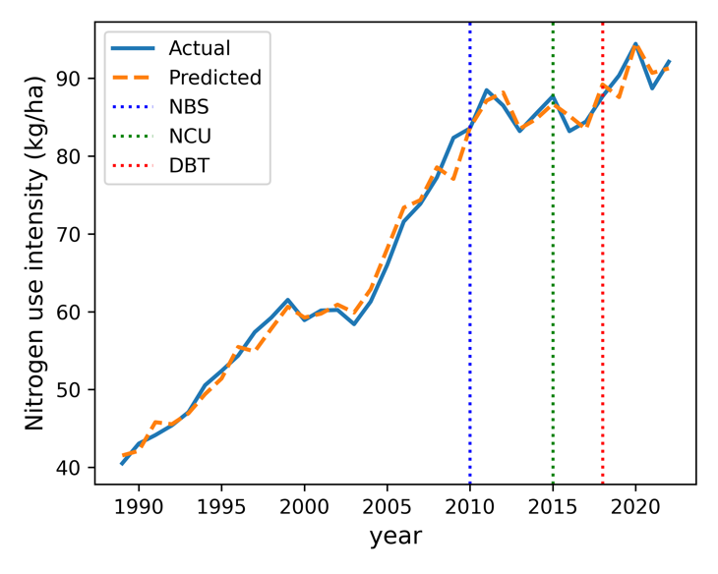
Fig. 1. Actual and predicted nitrogen use intensity with policy breakpoints (1989-2023)
3.2 NATIONAL-LEVEL IMPACT OF DBT

National ITSA estimates evaluating the effect of DBT on nitrogen use intensity are presented in Table 2. The estimated immediate (level) effect of DBT is positive (5.52 kg/ha) but statistically insignificant (P = 0.61), suggesting that nitrogen use intensity did not decline abruptly following DBT implementation. Similarly, the estimated long-term (slope) effect is negative (-3.14 kg/ha per year) but statistically insignificant (P = 0.56), suggesting that DBT did not result in a sustained moderation in the growth trajectory of nitrogen use intensity at the national level.

Table 2. Summary statistics of the control variables used

Variable | Coefficient | Standard error | P value
Intercept  Immediate effect  Long term effect | -3.03  5.52  -3.14 | 52.45  10.85  5.48 | 0.95  0.61  0.56
Time trend | Yes
Control variables | Yes
Consideration of NBS, NCU policies * | Yes
*Consideration of nutrient based subsidy (year) and neem coated urea (2015) policies

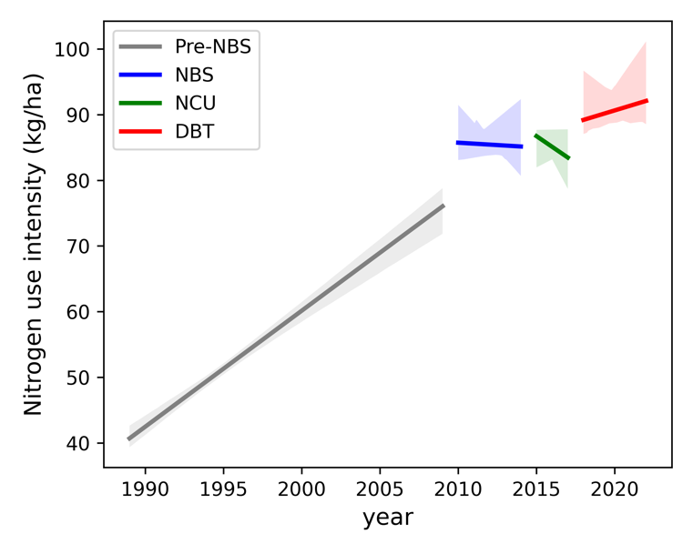
Fig. 2. Policy-period slope comparison for nitrogen use intensity

These results are further illustrated in Figure 2, which compares regime-specific slopes across policy periods. The post-DBT slope is statistically indistinguishable from the pre-intervention trend, as confidence intervals overlap zero. The lack of a statistically significant national effect indicates that DBT, despite being administratively transformative, did not substantially change fertilizer use behaviour at the aggregate level. This finding aligns with DBT's design as a subsidy-delivery reform rather than a price-based or demand-side intervention (Koovalamkadu Velayudhan et al., 2022). Since retail fertilizer prices for farmers remained unchanged, the primary incentives influencing nitrogen application, such as yield maximisation in irrigated cereal systems and the relative affordability of urea, likely continued to shape fertilizer use decisions (Itin‐Shwartz, 2024). Nevertheless, national averages may conceal heterogeneous responses across states, necessitating a disaggregated analysis.
3.3 State-level heterogeneity in DBT effects

State-level ITSA estimates demonstrate considerable heterogeneity in the response of nitrogen use intensity to DBT. Given the substantial inter-state variation in cropping systems, irrigation intensity, baseline fertilizer use, and administrative capacity, such heterogeneity is anticipated (Móring et al., 2021). The immediate effects across states are summarised in Supplementary Table 1 and Figure 3. Jharkhand shows a statistically significant negative immediate effect (P = 0.0059), indicating a short-term reduction in nitrogen use intensity following DBT implementation. This finding suggests that DBT may have addressed pre-existing diversion or leakages in a low-input, predominantly rainfed context (Koovalamkadu Velayudhan et al., 2022). Conversely, Bihar (P = 0.0089) and Telangana (P = 0.0078) exhibit statistically significant positive immediate effects, indicating an immediate increase in nitrogen use following DBT. In these states, the introduction of DBT coincided with expanding irrigated cereal cultivation and strong underlying nitrogen demand, potentially counteracting any disciplining effect of enhanced transaction monitoring . For most other states, immediate effects are minor and statistically insignificant.

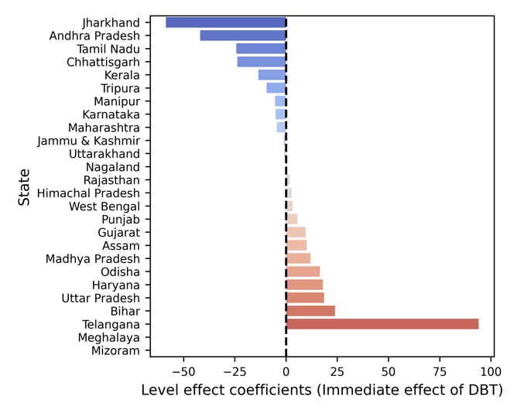
Fig. 3. Immediate (level) effect coefficients of DBT on nitrogen use intensity
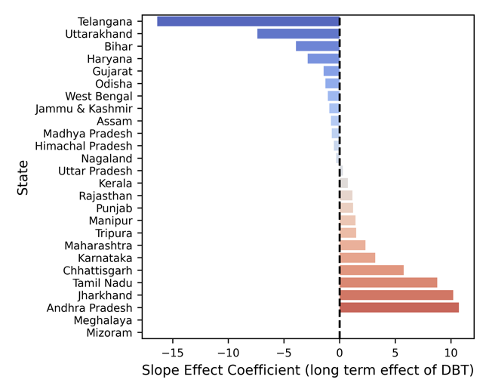
Fig. 4. Long-term (slope) effect coefficients of DBT on nitrogen use intensity

The long-term effects are presented in Supplementary Table 1 and Figure 4. In most states, DBT does not significantly alter the long-term run trajectory of nitrogen use intensity. However, several states exhibit contrasting short-term and long-term dynamics. This pattern indicates that initial adjustments were not sustained and that nitrogen use intensity has changed over the post-DBT period, consistent with strong structural demand driven by intensive irrigated cropping systems (Chaudhuri et al., 2023). In Telangana, an initial positive level effect is followed by a negative slope coefficient, reflecting short-term intensification with subsequent moderation, although the long-term effect remains statistically weak. Jharkhand and Andhra Pradesh display significant short-term reductions that diminish over time, suggesting that DBT’s influence in these states was immediate rather than persistent. Overall, the state-level evidence demonstrates that DBT effects are uneven, context-specific, and infrequently sustained. These results underscore that DBT’s effectiveness in influencing nitrogen use is highly dependent on regional conditions, including baseline fertilizer use intensity, enforcement practices, and the presence of complementary agronomic or informational interventions (Nayak et al., 2024).
3.4 INSIGHTS FROM PRIMARY SURVEY EVIDENCE

Primary survey data from farmers and fertilizer retailers provide valuable context for interpreting the econometric findings. Farmer responses indicate high awareness of DBT and perceived improvements in fertilizer availability, especially during peak seasons (Table 2). This suggests that DBT has achieved its administrative objectives related to supply tracking and distribution efficiency. However, a significant proportion of respondents reported longer transaction times, inconsistent biometric authentication, and procedural challenges during fertilizer purchases. Retailer feedback corroborates these observations, with reports of enhanced record-keeping and inventory monitoring under DBT, as well as a perceived reduction in diversion (Table 3). Nevertheless, retailers also identified operational challenges, including connectivity issues, longer transaction durations, and difficulties in enforcing Aadhaar-based authentication. In some instances, strict compliance was relaxed to prevent disruptions in fertilizer distribution during peak demand periods. Collectively, national, state-level, and field-based evidence indicate that DBT has been effective in improving governance, transparency, and monitoring within fertilizer distribution, but has had a limited impact on aggregate nitrogen use intensity.

Table 3. Farmer feedback on DBT policy (n=50)

 | Frequency (n=50) | Percent
Aware of DBT (Yes) | 41 | 82
Access to fertilizer increased (Yes) | 40 | 80
No shortage during peak season (Yes) | 30 | 60
Source of awareness
Farmers | 11 | 22
Agriculture Dept | 10 | 20
Retailer | 18 | 36
ICT | 2 | 4
Practice
Asked for Aadhaar | 39 | 78
Biometric authentication | 31 | 62
Asked for Soil Health Card | 7 | 14
Given receipt | 13 | 26
Denied fertilizer | 2 | 4
Perception after DBT
More time consuming | 26 | 52
Easier | 13 | 26
Cheaper | 6 | 12
Costlier | 5 | 10
Indicator
Denied due to biometric mismatch (Yes) | 9 | 18
Preference
Want DBT to continue (Yes) | 39 | 78
Want direct subsidy to account & willing to pay market price (Yes) | 3 | 6

Table 4. Farmer feedback on DBT policy (n=10)
 | Frequency(n=10) | Percentage
DBT resulted in
Reduced work load for record maintenance | 4 | 40
Better real time stock management | 5 | 50
Reduction in the diversion of urea | 4 | 40
Made transaction easier | 4 | 40
Reduction in number of transactions | 4 | 40
Increase in time taken for each transaction | 6 | 60
After DBT
Easy log in to the PoS in one or two attempts | 5 | 50
Transactions affected due to poor connectivity and signal | 7 | 70
Enter into argument with the farmers who are not having Adhaar | 8 | 80
After DBT, retailers supplied fertilizers to
Farmers who produced Aadhar card and whose biometric authentication was possible | 10 | 100
Farmers who produced any other identity proof | 4 | 40
All the farmers who approached them, without asking for their identity proof | 3 | 30

The lack of a national-level behavioural response should not be viewed as policy failure, but rather as evidence that delivery-side reforms alone are insufficient to change fertilizer application decisions when underlying price incentives and production objectives remain constant (Kishore et al., 2021). Simultaneously, the presence of short-term adjustments and selective state-level responses suggests that DBT can influence fertilizer use outcomes under specific regional conditions, particularly where baseline use intensity is lower and diversion-related inefficiencies are more significant (Deng et al., 2025). These findings clarify the scope and limitations of DBT as a policy instrument and underscore the importance of complementary agronomic, informational, and incentive-based interventions to achieve sustained improvements in nitrogen use efficiency.

4. Conclusion

This study assessed the impact of the Direct Benefit Transfer (DBT) system for fertilizer subsidies on nitrogen use intensity in India, using a national and state-level interrupted time-series framework. The findings indicate that DBT did not result in a statistically significant change in nitrogen use intensity at the national level, suggesting that improvements in subsidy delivery and transaction monitoring alone are insufficient to modify aggregate fertilizer use behavior. However, state-level analysis reveals heterogeneous, context-specific responses, with short-term adjustments observed in only a limited number of states. Evidence from farmer and retailer interactions further demonstrates that DBT has significantly enhanced transparency, availability, and accountability in fertilizer distribution, even as fertilizer application decisions remain primarily driven by production imperatives and structural demand factors. Overall, the results suggest that DBT has achieved its governance objectives and provides a necessary institutional foundation for layering complementary price, agronomic, and extension-based policies to address persistent challenges of nitrogen overuse.

Consent (WHEREVER applicable)
The study did not involve medical or clinical experimentation. Primary data were collected through voluntary interviews with farmers and fertilizer retailers after explaining the purpose of the study. Participation was based on informed verbal consent, and no personally identifiable information was recorded.

Ethical approval (WHEREVER applicable)
This study is based on secondary data from publicly available sources and a non-interventional field survey involving voluntary participants. No medical, clinical, or experimental procedures were involved. Therefore, formal ethical committee approval was not required.

References

Chaudhuri, S., Roy, M., McDonald, L. M., & Emendack, Y. (2023). Land Degradation–Desertification in Relation to Farming Practices in India: An Overview of Current Practices and Agro-Policy Perspectives. Sustainability, 15(8), 6383. https://doi.org/10.3390/su15086383
Deng, L., Wan, P., Ye, F., & Zhao, J. (2025). Impact of agricultural subsidy on chemical fertilizer use: Empirical evidence of China's Organic-Substitute-Chemical-Fertilizer policy based on double machine learning. PLOS One, 20(11), e0334751 https://doi.org/10.1371/journal.pone.0334751
The Fertilizer Association of India. (2024). Fertiliser Statistics. https://www.faidelhi.org/annual-statistics
Hartmann, D. P., Gottman, J. M., Jones, R. R., Gardner, W., Kazdin, A. E., & Vaught, R. S. (1980). Interrupted time-series analysis and its application to behavioral data. Journal of Applied Behavior Analysis https://doi.org/10.1901/jaba.1980.13-543
Saxena, R., Muppa, S., & Manik, S. K. (2024). Rainfall Statistics of India – 2024. India Meteorological Department (Ministry of Earth Sciences). https://hydro.imd.gov.in/hydrometweb/(S(at3bej55s1djes55453tg045))/PRODUCTS/Publications/Rainfall%20Statistics%20of%20India%20%202024/Rainfall%20Statistics%20of%20India%202024.pdf
Itin-Shwartz, B. (2024). Survey based assessment of sustainable agricultural practices: Evidence from Indian plots. Agribusiness, 40(2), 416–457. https://doi.org/10.1002/agr.21890
Kishore, A., Alvi, M., & Krupnik, T. J. (2021). Development of balanced nutrient management innovations in South Asia: Perspectives from Bangladesh, India, Nepal, and Sri Lanka. Global Food Security, 28, 100464. https://doi.org/10.1016/j.gfs.2020.100464
Koovalamkadu Velayudhan, P., Singh, A., & Korekallu Srinivasa, A. (2022). Effect of Direct Benefit Transfer Policy on Fertilizer Sales in India. National Academy Science Letters, 45(6), 481–484. https://doi.org/10.1007/s40009-022-01172-0
Koovalamkadu Velayudhan, P., Singh, A., Kumar, P., Jha, G. K., Immanuel, K., & Korekallu Srinivasa, A. (2021). Indian fertilizer subsidy conundrum: Tracking the recent developments. The Indian Journal of Agricultural Sciences, 91(4), 608–612. https://doi.org/10.56093/ijas.v91i4.112704
Móring, A., Hooda, S., Raghuram, N., Adhya, T. K., Ahmad, A., Bandyopadhyay, S. K., Barsby, T., Beig, G., Bentley, A. R., Bhatia, A., Dragosits, U., Drewer, J., Foulkes, J., Ghude, S. D., Gupta, R., Jain, N., Kumar, D., Kumar, R. M., Ladha, J. K., ... Sutton, M. A. (2021). Nitrogen Challenges and Opportunities for Agricultural and Environmental Science in India. Frontiers in Sustainable Food Systems. https://doi.org/10.3389/fsufs.2021.505347
Nayak, H. S., McDonald, A. J., Kumar, V., Craufurd, P., Dubey, S. K., Nayak, A. K., Parihar, C. M., Peramaiyan, P., Poonia, S., Tesfaye, K., Malik, R. K., Urfels, A., Gautam, U. S., & Silva, J. V. (2024). Context-dependent agricultural intensification pathways to increase rice production in India. Nature Communications, 15(1). https://doi.org/10.1038/s41467-024-52448-6
Reserve Bank of India. (2025). Annual Report 2024-25. https://rbidocs.rbi.org.in/rdocs/AnnualReport/PDFs/01ASSESSMENT290520252C1E3001DF03471CA4DB97E69C306
Roy, T. N. (2019). Direct Benefit Transfer (DBT) of Fertilizer Subsidy in India–Issues and Related Aspects. International Journal of Bio-Resource and Stress Management, 10(3), 329–334. https://doi.org/10.23910/IJBSM/2019.10.3.1960
Tiwari, P. (2024). Fertilizer Consumption and Productionin India. International Journal of Agriculture and Animal Production, 04(44), 10–18. https://doi.org/10.55529/ijaap.44.10.18
Varshney, D., Kumar, A., Mishra, A. K., Rashid, S., & Joshi, P. K. (2021). India’s COVID-19 social assistance package and its impact on the agriculture sector. Agricultural Systems https://doi.org/10.1016/j.agsy.2021.103049
Yang, S., Chen, H., Li, Z., Ruan, Y., & Yang, Q. (2024). Temporal and spatial analysis of fertilizer application intensity and its environmental risks in China from 1978 to 2022. Environmental Sciences Europe. https://doi.org/10.1186/s12302-024-01011-7

APPENDIX

Supplementary table 1. P values of immediate and long-term effect of DBT policy state wise
State | Immediate effect (p-value) | Long term effect (P-value)
Andhra Pradesh | 0.0032 | 0.0001
Assam | 0.0047 | 0.1631
Bihar | 0.0651 | 0.1168
Chhattisgarh | 0.2863 | 0.0482
Gujarat | 0.6033 | 0.5823
Haryana | 0.0791 | 0.1135
Himachal Pradesh | 0.5030 | 0.4190
Jammu & Kashmir | 0.9704 | 0.7887
Jharkhand | 0.0059 | 0.0476
Karnataka | 0.6687 | 0.1005
Kerala | 0.0979 | 0.8420
Madhya Pradesh | 0.0182 | 0.4075
Maharashtra | 0.7635 | 0.2684
Manipur | 0.6453 | 0.4925
Nagaland | 0.6996 | 0.0994
Odisha | 0.0022 | 0.3173
Punjab | 0.7360 | 0.6559
Rajasthan | 0.7107 | 0.3580
Tamil Nadu | 0.1812 | 0.0107
Telangana | 0.0089 | 0.0078
Tripura | 0.0517 | 0.2714
Uttar Pradesh | 0.0600 | 0.8920
Uttarakhand | 0.9518 | 0.0555
West Bengal | 0.6899 | 0.6058

