ERGONOMIC EVALUATION OF DRUDGERY AND CARDIOVASCULAR STRESS AMONG FARM WOMEN IN CUCURBIT CULTIVATION UNDER PANDAL SYSTEMS

ABSTRACT

Women in Indian agriculture, particularly those engaged in vegetable cultivation under the Pandal system, face significant occupational health challenges due to physically intensive activities. This study aimed to assess the physiological workload, ergonomic risks and drudgery experienced by farm women during bottle gourd cultivation in the Pandal system. Fifty women from Kaveliguda village, Shamshabad mandal, Telangana, aged 25–45 years, were evaluated using ergonomic tools and physiological measurements. Parameters such as heart rate, energy expenditure and oxygen saturation were measured. The results revealed high cardiovascular and musculoskeletal stress, with women performing repetitive tasks in awkward postures using traditional tools. Tasks such as transplanting and harvesting scored highest in drudgery and postural discomfort. The study underscores the need for ergonomic interventions and gender-sensitive agricultural tools to reduce occupational health risks among farm women.

KEYWORDS: Ergonomics, Farm women, Drudgery, Pandal system, Musculoskeletal discomfort, Occupational stress, Energy expenditure

Introduction

Agricultural work in developing countries remains predominantly manual, with women playing a crucial yet often underappreciated role (Kumari et al., 2018). These women are essential to food production but are routinely exposed to labor-intensive tasks that impose substantial physical strain and health risks due to ergonomically unfavorable conditions (Borah & Borah, 2020). One such demanding system is cucurbit cultivation under pandal structures, which necessitates prolonged static postures, repetitive movements, overhead tasks and working in confined spaces (Moharana et al., 2020). These conditions elevate physiological costs, cardiovascular stress and musculoskeletal issues, reducing both productivity and overall well-being (Kumari et al., 2018; Anusha & Mehta, 2021).
This study aims to comprehensively assess the ergonomic challenges, drudgery and cardiovascular strain experienced by farm women engaged in cucurbit cultivation under pandal systems. By employing detailed physiological measurements, anthropometric analysis and subjective evaluations, this research seeks to quantify the physical workload and its health implications (Awasthi et al., 2019). The findings are intended to guide the development of ergonomic interventions and women-centric tools that alleviate physiological stress (Singh & Arora, 2010; Ekale et al., 2018).
Additionally, farm women often juggle agricultural tasks with domestic chores and livestock care, contributing to cumulative physical stress from a young age (Suthar & Kaushik, 2013). The absence of ergonomically designed tools or adequate rest leads to chronic fatigue and a heightened risk of work-related health problems (Meenakshi & Panneer, 2020). This continuous strain contributes to high incidences of musculoskeletal disorders, including pain in the lower back, shoulders and wrists—often linked to age, work hours and experience (Jain et al., 2018; Kaur et al., 2020). These issues, if unaddressed, can escalate into chronic conditions and permanent disabilities, resulting in productivity loss and increased healthcare costs (Gangwar & Kwatra, 2017).
Moreover, cucurbit cultivation poses unique ergonomic challenges, especially during tasks like vine training and overhead harvesting, which demand repetitive and constrained movements (Meyers et al., 1995). This research intends to fill that gap by evaluating the physiological and biomechanical stresses faced by farm women, contributing to the design of improved tools and practices that promote health, safety and efficiency.
By analyzing heart rate, energy expenditure, perceived exertion and posture during key tasks, the study will identify critical stressors in cucurbit cultivation. The results are expected to support the development of tailored ergonomic interventions, ultimately improving occupational health and sustaining the workforce as agriculture evolves (Fathallah, 2010; Mahapatra et al., 2020).

MATERIAL AND METHODS

This experimental study was conducted in Kaveliguda village, Telangana, with a purposive sample of 50 farm women aged 25–45 years. Participants were healthy, actively engaged in bottle gourd cultivation and within acceptable physiological limits for workload assessment.
Parameters Measured:
- Physiological Workload: Heart rate, energy expenditure (EER), TCCW, PCW, blood pressure, SpO₂.
- Pain Mapping: Visual Analog Scale (VAS).
- Drudgery Index: Using six parameters rated on a 5-point scale.
- Cardiovascular Stress Index (CSI): Estimated using standard formulae.
Tools Used: Polar Heart Rate Monitors, BP Monitors, Oximeters Data were analyzed using descriptive statistics and Pearson’s
correlation for physiological parameters.

RESULTS AND DISCUSSION

The demographic data indicated that a majority of the respondents are middle-aged (36–55 years) and illiterate, with considerable farming experience ranging between 11–20 years. This prolonged exposure to unmechanized agricultural work, especially in pandal systems, predisposes them to cumulative musculoskeletal stress and fatigue (Gangwar & Kwatra, 2017). Illiteracy can also act as a barrier to understanding proper postures and the importance of ergonomic tools. The dominance of smaller family sizes suggests limited redistribution of labor, thereby placing greater workload on individual women.

Table 1: Demographic Profile of Respondents (N=50)

Personal and Social Variables | Frequency | Percentage (%)
Age
Young (18-35 years) | 15 | 30.0
Middle (36-55 years) | 25 | 50.0
Old (Above 55 years) | 10 | 20.0
Education
Illiterate | 20 | 40.0
Primary school education  (up to 7th standard) | 18 | 36.0
Secondary school education  (8th to 10th standard) | 12 | 24.0
Work experience
Below 10 years | 10 | 20.0
Between 11-20 years | 20 | 40.0
Between 21-30 years | 15 | 30.0
Between 31-40 years | 5 | 10.0
Above 41 years | 0 | 0.0
Size of family
Small (up to 4 members) | 25 | 50.0
Medium (5 to 8 members) | 15 | 30.0
Large (Above 8 members) | 10 | 20.0

This increases the burden during peak labor-intensive tasks like transplanting and harvesting, as observed in the physiological and drudgery data. Factors such as age, daily working hours and work experience significantly correlate with the prevalence of musculoskeletal disorders in various body regions, including the lower back, fingers, shoulders and wrists (Jain et al., 2018).

Cardiovascular Responses During Harvesting
A statistically significant increase in heart rate and energy expenditure during harvesting underscores the high cardiovascular workload farm women experience. The heart rate rises from a resting 86 bpm to 114 bpm during activity, signifying moderate to high physical stress levels. Despite partial recovery post-task (93 bpm), the incomplete return to baseline indicates residual fatigue. The energy expenditure more than doubles during harvesting, confirming the strenuous nature of the task. An unusual spike in oxygen saturation may be explained by hyperventilation due to overexertion. These findings confirm harvesting as a high-energy-demand activity needing ergonomic intervention.

Table 2: Cardiovascular Responses During Harvesting (N=50)
Parameter | At Rest | During Activity | Recovery | t-value
Heart Rate (b.min⁻¹) | 86 | 114 | 93 | 7.06*
Energy Expenditure (kJ/min) | 6.59 | 10.67 | 3.78 | 7.029*
Oxygen Saturation (%) | 93.32 | 102.16 | 95.89 | —

These findings aligned with studies by Sharma et al. (2022) emphasizing elevated heart rates during repetitive agricultural tasks. The oxygen saturation spike may be attributed to physical stress-induced hyperventilation. Another study on wearable-derived cardiovascular responses to stressors in free-living conditions reported that physically stressful events, such as manual labor tasks, were associated with a significant rise in heart rate and other physiological parameters, reflecting the cardiovascular strain experienced by the workers (Presby et al., 2023).

Drudgery Assessment of Transplanting vs. Harvesting
Transplanting registered a slightly higher average drudgery score (3.82) compared to harvesting (3.57), particularly in terms of exhaustion and workload perception. This is attributed to the prolonged squatting and bending postures involved in planting under the pandal canopy, often performed without supportive tools. On the other hand, harvesting, though perceived as more difficult due to handling sharp tools an heavy gourds, involved slightly less physical exhaustion.

Both operations, however, exceeded the moderate drudgery threshold, highlighting the urgent need for posture-friendly and load-reducing technologies such as gourd pluckers and adjustable transplanting tools.

Table 3: Drudgery Assessment of Transplanting vs. Harvesting
Drudgery Parameter | Transplanting | Harvesting
Work Demand | 3.42 | 3.50
Feeling of Exhaustion | 4.54 | 3.45
Posture Assumed | 3.48 | 3.65
Manual Load Operative | 3.74 | 3.12
Difficulty Perception | 3.25 | 3.90
Work Load Perception | 4.51 | 3.80
Total Score | 22.94 | 21.42
Average Drudgery Score | 3.82 | 3.57

Transplanting was more exhausting (score: 4.54) than harvesting due to repetitive squatting, which impacts the lower back and knees. Harvesting, while slightly easier physically, scored higher in difficulty perception due to handling sharp tools and heavy gourds. Ergonomic interventions like adjustable transplanting tools or gourd harvesters could reduce this strain. The drudgery scores justified introducing ergonomic redesign in both operations. A study on the drudgery experienced by farm women in mango and cashew nut orchards reported that the women often adopted unnatural body postures during their work, leading to increased physiological workload and musculoskeletal problems (Ekale et al., 2018).

Relationship Between Age Group and Perceived Drudgery
Figure 1. represents the relationship between different age groups of farm women and their perceived drudgery scores during cucurbit cultivation under pandal systems. The cross-tabulation showed that farm women in the older age group (above 40 years) consistently reported higher drudgery scores, especially for tasks such as transplanting and harvesting (Verma et al., 2018). This suggested a positive correlation between age and drudgery perception, indicating that older women are more prone to fatigue, musculoskeletal discomfort and cardiovascular stress due to reduced physical resilience. The findings highlighted the importance of age-specific ergonomic interventions in task allocation and tool design.

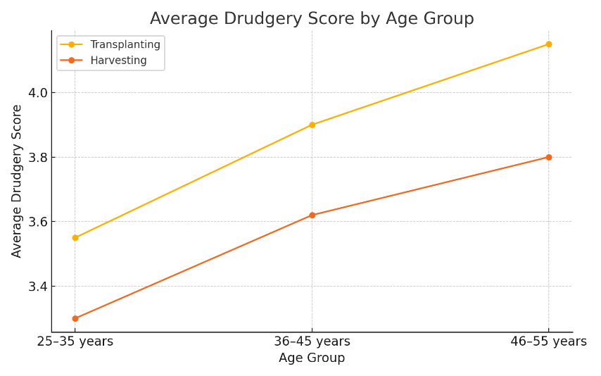
Fig 1: Cross-tabulation of Age Group and Perceived Drudgery Scores

Interrelationship Between Drudgery Dimensions During Transplanting
In Figure 2. correlation matrix is represented showing interrelationships among various dimensions of drudgery viz., workload perception, exhaustion, posture assumed, difficulty perception and manual load in the context of transplanting. Strong positive correlations were observed between feeling of exhaustion and posture, as well as between workload perception and difficulty level. These patterns revealed that drudgery is a multidimensional construct, influenced by both physical and perceptual variables. The data emphasized the need for integrated ergonomic solutions such as posture aids and task rotation to effectively reduce the composite drudgery load among farm women (Potdar et al., 2021; Zend et al., 2020).

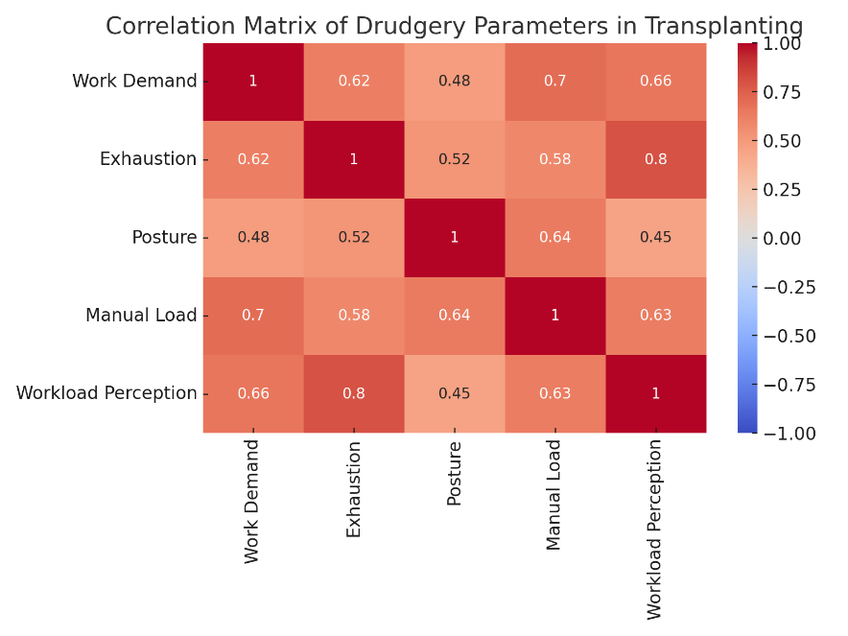
Fig 2: Correlation Matrix between Drudgery Parameters in Transplanting

Conclusion

This study revealed the substantial ergonomic risks and cardiovascular stress were faced by farm women in Pandal-based cucurbit cultivation. Transplanting and harvesting were identified as high-drudgery tasks with significant physiological tolls. Most women operated with traditional tools in high-temperature, high-humidity environments and exacerbating health risks.

References
Anusha, M., & Mehta, A. K. (2021). Drudgery Reduction through Ergonomic Evaluation of Women Farm Workers using Local Sickle and Serrated Sickle During Harvesting in Wheat Crop of Udaipur District. International Journal of Current Microbiology and Applied Sciences. https://doi.org/10.20546/ijcmas.2021.1001.130
Awasthi, V. J., Singh, M., Mishra, R., Chaudhary, R., Pandey, M., Parihar, D. S., Gautam, S., & Kumar, D. (2019). Ergonomic and Workload Assessment in Weeding Operation Conducted for Wheat Crop for Male Respondents. International Journal of Current Microbiology and Applied Sciences, 8(9), 2597-2609. https://doi.org/10.20546/ijcmas.2019.809.301
Borah, S., & Borah, N. (2020). Ergonomic Assessment of Upper Limbs of Workers Involved in Vegetable Cultivation. International Journal of Current Microbiology and Applied Sciences. https://doi.org/10.20546/ijcmas.2020.905.380
Ekale, J. V., Kulkarni, M. V., Chavhan, P. N., & Dudhal, H. S. (2018). Study of Relationship between the Profile of Farm Women Labourer and Drudgery Involved in Farm Operations. International Journal of Current Microbiology and Applied Sciences, 7(2), 1411-1416. https://doi.org/10.20546/ijcmas.2018.702.170
Fathallah, F. A. (2010). Musculoskeletal disorders in labor-intensive agriculture. Applied Ergonomics, 41(6), 738-743. https://doi.org/10.1016/j.apergo.2010.03.003
Gangwar, S., & Kwatra, S. (2017). Prevalence of Musculoskeletal Problems among Sugarcane Workers in Uttar Pradesh. International Journal of Advanced Engineering Research and Science, 4(7), 25-28. https://doi.org/10.22161/ijaers.4.7.4
Hayati, A., & Marzban, A. (2020). Linkage between machine power utilization and ergonomics, with reference to reducing exertions at work. WORK. https://doi.org/10.3233/WOR-203345
Jain, R., Meena, M. L., Dangayach, G. S., & Bhardwaj, A. (2018). Risk factors for musculoskeletal disorders in manual harvesting farmers of Rajasthan. Industrial Health, 56(3), 241. https://doi.org/10.2486/indhealth.2016-0084
Kumari, P., Yaranal, R., Veerangouda, M., & Maski, D. (2018). Estimation of Physiological Cost of Female Agricultural Workers for Weeding Operation. International Journal of Current Microbiology and Applied Sciences, 7(8), 2364-2374. https://doi.org/10.20546/ijcmas.2018.708.238
Mahapatra, T. K., Satapathy, S., Panigrahi, I., & Sahoo, A. K. (2020). Drudgery assessment of farmers tool in paddy harvesting. AIP Conference Proceedings, 2291, 50047. https://doi.org/10.1063/5.0024557
Meenakshi, J. R., & Panneer, S. (2020). Occupational health of agricultural women workers in India. Indian Journal of Community Medicine, 45(4), 546–549. https://doi.org/10.4103/ijcm.IJCM_397_19
Meyers, J. M., Bloomberg, L., Faucett, J., Janowitz, I., & Miles, J. A. (1995). Using ergonomics in the prevention of musculoskeletal cumulative trauma injuries in agriculture: Learning from the mistakes of others. Journal of Agromedicine, 2(3), 11-24. https://doi.org/10.1300/J096v02n03_02
Moharana, G., Babu, N., Mhatre, C. S., Rout, P. K., & Panda, R. S. (2020). Occupational Health Hazards of Farm Woman Engaged in Mango and Cashew Nut Orchards. International Journal of Current Microbiology and Applied Sciences, 9(9), 3455-3462. https://doi.org/10.20546/ijcmas.2020.909.429
Potdar R.R., Tiwari P.S., Shukla Prabhakar, Patel Anurag, Jyoti Bikram 2021. Drudgery reduction in operation of cleaner-cum-grader: An ergonomic intervention. Bhartiya Krishi Anusandhan Patrika. 35(4): 219-225. doi: 10.18805/BKAP257.
Presby, D. M., Jasinski, S. R., & Capodilupo, E. R. (2023). Wearable derived cardiovascular responses to stressors in free-living conditions. PLoS ONE, 18(6) https://doi.org/10.1371/journal.pone.0285332
Singh, S., & Arora, R. (2010). Ergonomic Intervention for Preventing Musculoskeletal Disorders among Farm Women. Journal of Agricultural Sciences, 1(2), 61-71. https://doi.org/10.1080/09766898.2010.11884655
Sharma, M., Suri, N. M., & Kant, S. (2022). Analyzing occupational heat stress using sensor-based monitoring: a wearable approach with environmental ergonomics perspective. International Journal of Environmental Science and Technology, 19(11), 11421-11434. https://doi.org/10.1007/s13762-021-03862-6
Suthar, N., & Kaushik, V. D. (2013). Musculoskeletal Problems among Agricultural Female Workers. Studies on Home and Community Science, 7(3), 145-149. https://doi.org/10.1080/09737189.2013.11885405
Verma, N., Chaudhary, V. P., Nath, A., Singh, M. P., & Panwar, A. S. (2018). Feminine farm operations and drudgery associated in pre dominant farming systems of Western plain zone of Uttar Pradesh. Bhartiya Krishi Anusandhan Patrika, 33(4), 256-260. https://doi.org/10.18805/bkap129
Zend, J. P., Revanwar, M. S., & Gaikwad, S. S. (2020). Promotion of Low-Cost Package of Technologies for Drudgery Mitigation in Turmeric Production System. Journal of Scientific Research and Reports. https://doi.org/10.9734/jsrr/2020/v26i130208
******

